3/24/2025
University of Wales Trinity Saint David
London campus
Module Name: Learning In the Digital Era
Module Code: ACCA 4025

Student Name: Atanas Angelov Panchev
Student ID: 2425773
Group: 1

Lecturer’s Name: Koushik Modak

LDE Assignment 1
E-Portfolio
Table of Contents
Introduction 2
Main Body 2
Task 1: Essential Academic and Employment Skills for the future career Path 2
Task 1 (a): Report on Essential Academic and Employment Skills 2
Task 1 (b): Evaluation of Task 1 (a) based on Similarity report 3
Task 2: Collaborative Mind Map and Individual Poster 3
Mind Map (Collaborative) 3
Poster (Individual) 3
Task 3: Virtual Collaboration and RefWorks 3
Report on Virtual Collaboration 3
Step-by-step process of using RefWorks with visuals 3
Task 4: E-Portfolio Creation and Evaluation 3
Task 4 (a): E-Portfolio Creation 3
Task 4 (b): Illustrative Review of E-Portfolio tool Selection 3
Conclusion 3
References 3
Task 1 References: 3
Task 3 References: 3
Bibliography 4

Introduction
In today’s competitive world, academic and employment skills are so much important in our success at work and at the universities. These are the skills needed to attain educational excellence & professional development [1]. These are skills that are directly connected to my chosen career in cyber security — my ability to solve complex problems and work effectively with others, the flexibility of the field, and thus helping me succeed.
BACKGROUND: Today’s uncertain economic and social dynamics are leading companies to seek the sort of human talent that will help them to survive and thrive. Training demands are thus arising for specific skills and competencies that would make current students and employment seekers more employable. OBJECTIVE: The aim of this study was to identify the twenty-first century’s major employability skills and competencies as well as the main demand trends for skills and competencies. METHODS: An international panel of experts (from Spain, Thailand and Poland), from both, academic and professional business backgrounds, were asked to quantitatively project the importance of different generic and specific skills and competencies over the next five years. They were asked to do so twice, once before and once after a four-year interval (in 2016 and in 2019). Each time, they were interviewed to discuss the results. RESULTS: The most valued employability skills were of a generic nature, in all three countries. Regarding specific skills, those of a social and managerial nature were the most highly valued. Work experience and formal education became less relevant for employability. CONCLUSIONS: The study’s results can lead to recommendations on how to design a more employability-oriented curriculum in educational institutions. [2]

Main Body

Task 1: Essential Academic and Employment Skills for the future career Path

Task 1 (a): Report on Essential Academic and Employment Skills
Skills for Academic Success
To excel academically, several fundamental skills are necessary:
Critical Thinking: Analysis of the information in a reasonable, objective manner, critical thinking on the arguments presented and reasons for the decision are part of the process. It improves understanding of complex concepts and the growth of strong problem-solving abilities.
[3]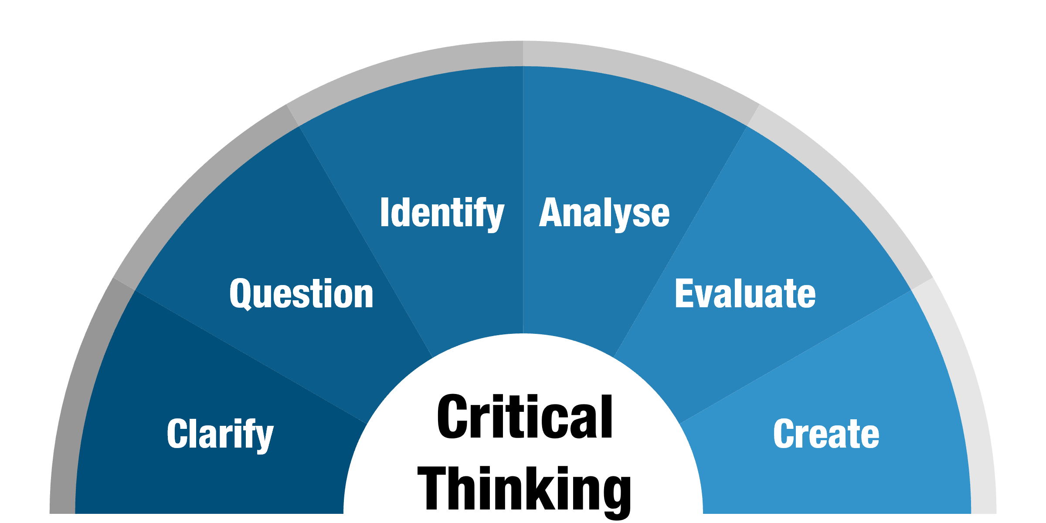
Figure 1Critical Thinking
Research Skills: I have researched effective research skills which allow me to gather relevant information, get a critical sense of it, making use of it to support my academic work. Completing of assignment, papers, and project is necessary to their existence.
[4]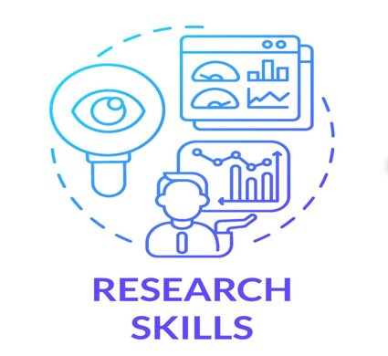
Figure 2 Research Skills
Deadlines: An important part of time management for a student to create a balance between workload and other duties is the deadlines . [5] Organizing and being productive confirms I’d be scoring good grades.
[6]
Figure 3 Deadlines
Communication: Verbal and written communication skills are very important to present your ideas, talk with fellow and professors, discussing or visiting. Academically, these skills are important, like a key element to showing that I understand and offering something to the scholarship.
 [7]
Figure 4 Communication
This will be the basis for my success with my degree program and directly applicable experience for my future career, as I will be able to quickly research, analyse and communicate technical ideas.

Skills for Career Success
In the professional world, specific skills will further define my success as a software engineer:
Leadership: In software development, collaboration is key and leading teams or mentoring others, and driving projects forward are important aspects of your ability as a developer. [8]
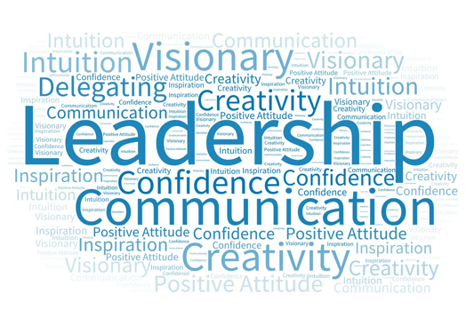 [9]
Figure 5 Leadership
Problem-Solving: Creativity is important for problem-solving and innovation experimenting with new ideas, challenging assumptions, and seeking out diverse perspectives are all great ways to develop your creativity skills. [10]
Problem-solving has always been an essential part of your job as a Ciber Security.
 [11]
Figure 6 Problem solving [11]
Emotional intelligence: Emotional intelligence is important for building positive relationships, managing conflict, and fostering teamwork…
Self-Awereness: Take some time to reflect on your emotions, thoughts, and behaviours. Consider how they affect your relationships and interactions with others.
Active listening: Focus on listening to others without interrupting or judging them. Try to understand their perspective and emotions.

Empathy: Put yourself in other people's shoes and try to understand their emotions and experiences.
Effective communication: Be clear and concise in your communication, and try to convey your thoughts and emotions in a respectful manner. [10]
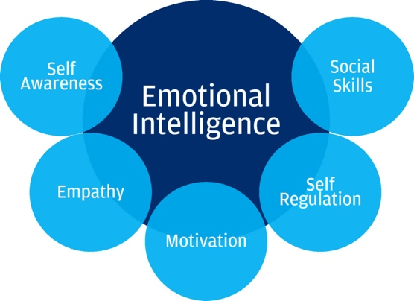 [12]
Figure 7 Emotional Intelligence

Task 1 (b): Evaluation of Task 1 (a) based on Similarity report

Task 2: Collaborative Mind Map and Individual Poster

Mind Map (Collaborative)

Poster (Individual)

Task 3: Virtual Collaboration and RefWorks

Report on Virtual Collaboration

Step-by-step process of using RefWorks with visuals

Task 4: E-Portfolio Creation and Evaluation

Task 4 (a): E-Portfolio Creation

Task 4 (b): Illustrative Review of E-Portfolio tool Selection

Conclusion

References

Task 1 References:

Task 3 References:

Bibliography

[1] | M. Z. F. S. Yanzhi Zhao, “Integrating Moral Education and Educational Information Technology: A Strategic Approach to Enhance Rural Teacher Training in Universities,” 23 12 2023. [Online]. Available: https://link.springer.com/article/10.1007/s13132-023-01693-z.
[2] | A. Rakowska and S. de Juana-Espinosa, “Ready for the future? Employability skills and competencies in the twenty-first century: The view of international experts,” Human Systems Management, vol. 40, no. 5, pp. 669-684, 2021.
[3] | M. University, “www.monash.edu,” [Online]. Available: https://www.monash.edu/student-academic-success/enhance-your-thinking/critical-thinking/what-is-critical-thinking.
[4] | Vecteezy.com, “www.vecteezy.com,” [Online]. Available: https://www.vecteezy.com/vector-art/5349458-research-skills-blue-gradient-concept-icon.
[5] | A. M. N. W. Viki Sulistia, “www.ejbmr.org,” 3 2 2023. [Online]. Available: https://www.ejbmr.org/index.php/ejbmr/article/view/1797.
[6] | B. Collins, “medium.com,” 2 3 2018. [Online]. Available: https://medium.com/the-mission/5-powerful-ways-to-manage-your-creative-deadlines-like-a-pro-a5aa4c0ec81e.
[7] | Churchillsquareconsulting, “churchillsquareconsulting.com,” [Online]. Available: https://churchillsquareconsulting.com/course/communications-for-small-business-owners-2/.
[8] | M. S. S. Z. E. F. C. K. Kattiana Constantino, “onlinelibrary.wiley.com,” 24 10 2021. [Online]. Available: https://onlinelibrary.wiley.com/doi/10.1002/smr.2393.
[9] | N. Leaders, “www.newleaders.org,” 1 11 2024. [Online]. Available: https://www.newleaders.org/blog/10-leadership-actions-that-make-great-principals.
[10] | Dreami, “www.linkedin.com,” 17 5 2023. [Online]. Available: https://www.linkedin.com/pulse/10-essential-skills-career-development-guide-building-your-professional.
[11] | A. Eason, “www.adam-eason.com,” 3 11 2010. [Online]. Available: https://www.adam-eason.com/apply-problem-solving-to-yourself-and-solve-your-own-problems/.
[12] | A. Neurosurgical, “/www.neurosurgicalatlas.com,” [Online]. Available: https://www.neurosurgicalatlas.com/volumes/non-technical-skills-in-neurosurgery/emotional-intelligence.

