Gallwch ychwanegu’ch targedau o’ch aseiniad diwethaf (Ond yn berthnasol os yr ydych wedi cwblhau aseiniad) / Please add your targets from the previous assignment (Only relevant if you have completed an assignment)
 | Targed/target | Yr hyn yr wyf wedi'i wneud yn yr aseiniad hwn  What I have done in this assignment...
Targed/Target 1
Targed/Target 2
Targed/Target 3

How a school develops one aspect of its SDP: a report that critically reflects on the actions, impact and evidence base.

Introduction (200 words)
This report required collecting evidence from a member of staff who holds responsibility over the School Development Plan (SDP) within a current school context during Professional Teaching Experience. The purpose was to gain a deep understanding of the school evaluation process. In addition, this report will focus on the chosen action point from the school’s strategic target of tracking progress of identified groups. This report aims to demonstrate how the target has been identified, actioned and measured via a research-informed lens and will feature a literature review, reflection and evaluation.

The school context is a semi-urban primary school in South Wales. The surrounding area is affluent, with many parents employed in political positions. Furthermore, pupils eligilble for free school meals (eFSM) is 5 times lower than the local authority and seven times lower than the national average (My Local School, 2022). Thus, school spaces and expectations from parents are high. The school has recently appointed a new headteacher and are preparing for an imminent Estyn inspection that has been delayed due to Coronavirus restrictions.

As it is relevant to the action point of traking identified groups, the Figure below is the latest data on the gender of pupils enrolled in the school:

Fig. 1.
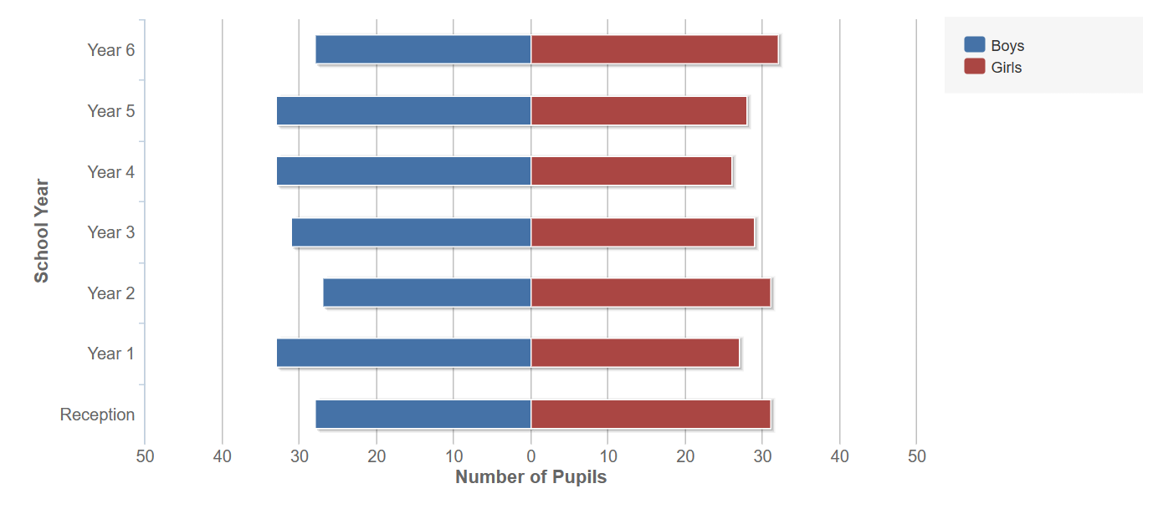
Figure 1 - Number of Pupils divided by gender (sex). Taken from My Local School (2022)

Literature Review

Effective School Improvement

Tracking of Progress

It is expected for schools to track the progress of identified groups in English because the SDP Guidance published by Welsh Government (2014) outlines a need to show how they are ‘raising the standards of education in relation to literacy’ which is a national priority for Wales (Welsh Government, 2014, pg.3).

However, there is a glaring issue with how the SDP refers to the subject “English” 20 times with no reference to Literacy throughout the document. Arguably, this does not consider the transformation of the Welsh Curriculum which no longer refers to explicit subjects. Instead, the national mission of “Cymraeg 2050” which has now placed a priority on raising the status of the Welsh language alongside the English language. This coincides with the development of the CfW framework, triggered by the recommendations in Successful Futures to combine languages with literacy and communication in one Area of Learning and Experience (Welsh Government, 2017 and Donaldson, 2015). As such, it is likely the school’s tracking of English now relates to progression of learners across the Literacy Competency Framework [LCF] and not English as a subject, however this may lead to issues in translation between government guidance and school development documents when developing a ‘shared understanding of progression’ (Welsh Government, 2023). However, the fault cannot simply be placed on the school. The SDP guidance document has also not been updated since CfW; it was published the year prior to Donaldson’s (2015) Successful Futures document.

Developing an action point
Fig.2.
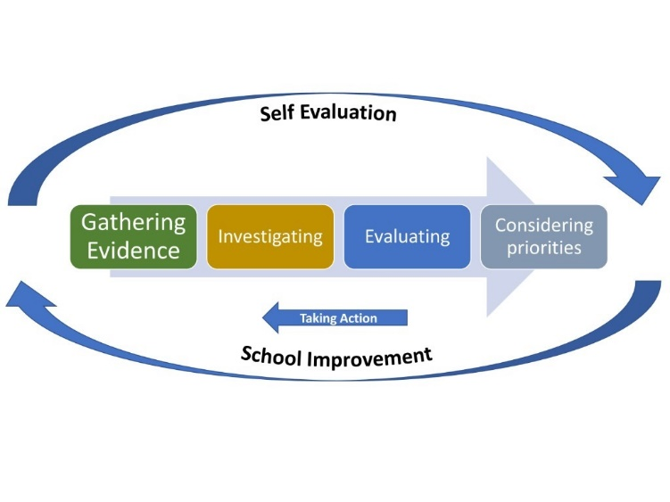
Figure 2 - Graphic to show the School Improvement Process. From: Welsh Government (2022)
Monitoring progression of learners should work alongside curriculum design. Government guidance for progression explicitly states ‘Purposeful curriculum and assessment design is the key to supporting progression’ At the heart of the Curriculum for Wales framework [CfW] are the four purposes which includes ‘ambitious capable learners who…seek and enjoy challenge’ (Welsh Gov, 2015). Therefore, targets for improvement should reflect this idea of challenge. The alignment between the four purposes and the SDP are directly aligned as they form the first element as seen in Fig.2. below. This provides strong evidence that the school is aiming for cohesion between curriculum design and their priorities in assessment.
Fig.2.
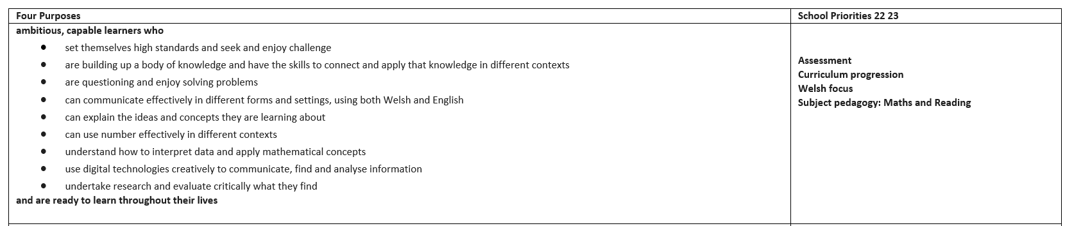
Figure 3 - SDP: Four Purposes and School Priorities. (From: School Name 2022, pg.2)
However, it is imperative to consider equity when making targets, so that “no learner (is) left behind”; this is priority raised by Public Health England (2020) where individual vulnerability factors in children includes ‘lower educational attainment’ (ibid, pg.9). Although this is an English publication, it was published after the Coronavirus Pandemic, therefore it is relevant to learners in Wales.

Welsh Government (2020) state it is “vital” for expectations of learners to be both ‘challenging and realistic’ (ibid, Welsh Gov, 2014, pg.1.). Similarly, much action planning literature emphasises the importance of Specific (concrete), Measurable, Achievable and Time-bound [SMART] targets (Schildkamp, 2017, pg.256, Locke and Latham, 2002, Fielding 1999, and Wade, 2009). Despite this, the concept of SMART targets has received criticism, with alternatives emerging such as the “POWER” acronym, which include criteria such as a positive lens, individuals’ own roles within the target and an ‘ecology check’ of the impact of the meeting of a target on relationships and internal cues such as if a decision ‘feels right’ (Day and Tosey, 2011, pg.522).

Formal and Informal Data
Schildkamp (2019) identifies four types of data collection for school improvement purposes: formal, informal, research results and “Big Data” (ibid, pg.262 and Veldkamp, 2017, cited in ibid, pg.259). Most relevant to the school context’s SDP is the collection of formal and informal data as these were the types mentioned by the school leader.

'assessment should not be used to make a one-off judgement’ of learners at specific points in their learning journey (Welsh Gov, 2022). Similarly, progress ‘should be informed by a wide range of information and evidence’. This has been championed by the school leader who explained establishing the drive of the school’s vision meant that she needed to collect evidence from a range of sources. These included learning walks, pupil progress reviews and lesson observations. These combined to create a picture of what was already working well and what could be improved. These methods are characterised as informal data (Shildkamp,2019).

Reflection and evaluation
One recommendation would be for the school to review the language that is used when referring to progression in skills and subjects. The fact the SDP does not refer to Literacy, but the individual responsible for carrying out improvement in English refers to themselves as Literacy Lead suggests that leaders show understanding of the AoLE headings and Competency Frameworks, but this language is not used within a key document for school improvement. This could conflate the understanding of progression within the AoLE of Languages, Literacy and Communication and the Literacy Competency Framework, which are separate within the CfW Framework. However, this is reflective of the ongoing nature of the rollout of CfW, where it appears the school context is at the beginning of its journey to map progression for learners. This could be due to how the Head is new to the school, with the exit of the previous headteacher creating an additional barrier to implementing the new curriculum.

References
Day, T. and Tosey, P. (2011) “Beyond SMART? A new framework for goal setting,” The Curriculum Journal, 22(4), pp. 515–534. Available at: https://doi.org/10.1080/09585176.2011.627213.

Estyn (2023) ‘Leadership and School Improvement’ [Online]. Gov.Wales. Available at: https://www.estyn.gov.wales/system/files/2023-03/Estyn_Leadership%20and%20school%20improvement_A3%20poster%284pp%29_E%282%29.pdf. Pp.1-4. Accessed [25/03/22].

Fielding, M. (1999) “Target setting, policy pathology and student perspectives: Learning to labour in New Times,” Cambridge Journal of Education, 29(2), pp. 277–287. Available at: https://doi.org/10.1080/0305764990290210.

Locke, E.A. and Latham, G.P. (2002) “Building a practically useful theory of goal setting and task motivation: A 35-year Odyssey.,” American Psychologist, 57(9), pp. 705–717. Available at: https://doi.org/10.1037/0003-066x.57.9.705.

My Local School (2022) ‘School Name’ [Online]. Available at: https://mylocalschool.gov.wales/School/REDACTED. Gov Wales. [Accessed: 22/03/23].
Schildkamp, K. (2019) “Data-based decision-making for School Improvement: Research Insights and gaps,” Educational Research, 61(3), pp. 257–273. Available at: https://doi.org/10.1080/00131881.2019.1625716.

Public Health England (2020) No child left behind: A public health informed approach to improving outcomes for vulnerable children. London: Public Health England. Pp. 7-11.

Wade, D.T. (2009) “Goal setting in rehabilitation: An overview of what, why and how,” Clinical Rehabilitation, 23(4), pp. 291–295. Available at: https://doi.org/10.1177/0269215509103551.

Welsh Government (2022) ‘Evaluating learner progress: Guidance around evaluating learner progress, the principles of progression and using data’ [Online]. Hwb: Gov.Wales. Available at: https://hwb.gov.wales/evaluation-improvement-and-accountability/the-national-resource-evaluation-and-improvement/evaluation-and-improvement-principles/evaluating-learner-progress/ [Accessed: 25/03/23].

Welsh Government (2014) School Development Plans. Cardiff: Department for Education and Skills. Pp.2-17.

Welsh Government (2023) ‘Supporting materials for curriculum, assessment, and evaluating learner progress’ [Online]. Hwb: Gov.Wales. Available at: https://hwb.gov.wales/curriculum-for-wales/supporting-materials-for-curriculum-assessment-and-evaluating-learner-progress/ [Accessed: 25/03/23].

APPENDIX


