The impact of SKIP on Scottish secondary S1 pupils’ motor competence

A quasi-experimental, school-based intervention study with pre-test, post-test and retention measures

By Colette Wadha



A dissertation submitted to the Department of management and health.

In partial fulfilment of the requirements for the degree

MA Physical Education, Physical Literacy and Sport.

The University of Wales St Trinity David.

Word count: 15011
Date of submission: September 2025

CONTENTS

Title page | 1
Contents | 2
Declaration | 3
Abstract | 4 - 5
Acknowledgements | 6
Glossary of terms | 7- 8
List of Tables (if applicable) | 9
List of Figures (if applicable) | 9
Chapter 1: Introduction | 10 - 17
Chapter 2: Review of Literature | 18 - 37
Chapter 3: Methodology | 38 - 42
Chapter 4: results and findings | 43 - 68
Chapter 5: Discussion | 69 - 76
Chapter 6: Conclusion | 77 - 82
Bibliography | 83 - 88
Appendix 1: Research ethics board approval | 89 - 104
Appendix 2: Plain English information sheet to participants and consent form | 105 - 106
Appendix 3: SKIP lesson examples | 107 - 109
Appendix 4: Theory diagrams - Seefeldt (1980) Gallahue et al., (2012), Hulteen et al., (2018) and Clark & Metclafe (2002). | 110 - 113


DECLARATION FORM

Master’s Degrees by Examination and Dissertation Declaration Form

- This work has not previously been accepted in substance for any degree and is not being concurrently submitted in candidature for any degree.

Signed: CWadha

Date:

- This dissertation is being submitted in partial fulfilment of the requirements for the degree of MA in Physical Education, Physical Literacy and Sport.

Signed: CWadha

Date:

- This dissertation is the result of my own independent work / investigation, except where otherwise stated.

Other sources are acknowledged by explicit references. A bibliography is appended.

Signed (candidate): CWadha

Date:

- I hereby give consent for my dissertation, if accepted, to be available for photocopying, inter-library loan, and for deposit in the University’s digital repository.

Signed (Candidate): CWadha

Date:

Supervisor’s Declaration.

I am satisfied that this work is the result of the student’s own efforts.

Signed: ………………………………………

Dated: ………………………………………….

Abstract
Rationale:
This dissertation investigated the effectiveness of an eight-week SKIP (Successful Kinesthetic Instruction for Pre-schoolers) intervention on the development of fundamental motor skills (FMS) in Year 1 secondary pupils aged 11–12. The study aimed to address three main research questions: firstly, whether pre-test differences existed by group and sex across TGMD-2 and TGMD-3 assessment tools. Secondly, what was the influence of the SKIP intervention on FMS (Fundamental Motor Skills) total, Locomotor (LM), and Object Control (OC) skills? Lastly, to what extent the intervention effects were retained. Four hypotheses (H1a-d) were tested.

Design:
Using a quasi-experimental design, pupils were allocated to either the SKIP intervention or a wait group. FMS competence was assessed at pre, post, and retention stages using both TGMD-2 and TGMD-3. The data were analysed to compare baseline similarity, group differences, and changes over time.

Findings:
Findings supported both H1a and H1b: the intervention and wait groups did not differ at the pre-test, and boys outperformed girls in object control but not in locomotor skills. H1c was strongly supported, with the SKIP group showing significant improvements in FMS, particularly locomotor skills, compared to the wait group. H1d received partial support: although some gains were maintained, regression was observed, particularly in object control skills.

Conclusion:
The study concludes that the SKIP programme can produce meaningful short-term improvements in FMS. However, the gains made during intervention may not be sustained without reinforcement. The findings contribute to theoretical debates surrounding Seefeldt’s proficiency barrier, schema theory, and physical literacy, while highlighting the need for age-appropriate measurement tools. Practical implications emphasise that embedding FMS practice into the everyday Physical Education curriculum, addressing sex disparities, and supporting long-term sustainability through teacher training and school policy would further support FMS in the long term.

Acknowledgements

I would like to say a special thanks to my supervisors, Nalda Wrainwright and Amanda John, for their guidance, support and encouragement throughout the course of this research. Their expertise and feedback have been essential in the development of this dissertation.

I am also grateful to the staff and pupils at Levenmouth Academy for their cooperation and involvement, which made this study possible.

Glossary of Terms

FMS = Fundamental Motor Skills

TGMD-2 = Test of Gross Motor Development 2

TGMD-3 = Test of Gross Motor Development 3

SKIP = Successful Kinesthetic Instruction for Pre-schoolers

PE = Physical Education

DST = Dynamic Systems Theory

SPSS = Statistical Package for the Social Sciences

ANOVA = Analysis of Variance

SD = Standard Deviation

M = Mean

CI = confidence interval

P = probability value from statistical tests

Df = Degrees of freedom

$η$²/ partial $η$² = Eta squared / partial Eta squared for effect size measures for ANOVA

Cohens d- effect size measure for comparing two means

Locomotor Skills (LM) = Movements that transport the body from one place to another, including running, hopping, skipping.

Object Control Skills (OC) = Skills that involve manipulating or controlling objects, for example, dribbling, throwing, kicking, striking.

Motor Development = The process which children acquire and refine movements and skills over time which can be influenced by biological, environmental and experiential factors.

Intervention = A structured programme or set activities to produce measurable improvements in a targeted area.

Year 1 Secondary Pupils = Pupils in the first year of high school in Scotland ages 11-12, the pupils targeted in this study.

List of Tables
Table 1.1 Descriptive statistics of participants Pre-test Scores
Table 1.2 Pre-test and Post Test Scores for FMS total scores, Locomotor and Object Control raw scores by Group and Sex for TGMD-2 and TGMD-3.
Table 1.3 Post-test and Retention Scores for FMS total scores, Locomotor and Object Control raw scores by Group and Sex for TGMD-2 and TGMD-3
List of Figures
Figure 1.1 Pre-test and Post-test Total Raw FMS scores by Group TGMD-2.
Figure 1.2 Pre-test and Post-test Total Raw FMS scores by Group TGMD-3
Figure 1.3 Pre-test and Post-test Locomotor Raw Scores by Group TGMD-2.
Figure 1.4 Pre-test and Post-test Locomotor Raw Scores by Group TGMD-3.
Figure 1.5 Pre-test and Post Test Object Control Scores by Group TGMD-2.
Figure 1.6 Pre-test and Post Test Object Control Scores by Group TGMD-3.
Figure 1.7 Post-test and Retention FMS scores TGMD-2.
Figure 1.8 Post-test and Retention FMS scores TGMD-3.
Figure 1.9 Post-test and Retention LM scores TGMD-2.
Figure 2.0 Post-test and Retention OC scores TGMD-2.
Figure 2.1 Post-test and Retention OC scores TGMD-3.
Figure 2.2 pre, post and retention FMS TGMD-2.

Figure 2.3 pre, post and retention FMS TGMD-3.

Figure 2.4 pre, post and retention LM TGMD-2

Figure 2.5 pre, post and retention LM TGMD-3
Figure 2.6 pre, post and retention OC TGMD-2.
Figure 2.7 pre, post and retention OC TGMD-3

Chapter 1: Introduction

Background and Rationale

Fundamental motor skills (FMS) can be described as basic learnt movement patterns that do not occur naturally through play (Barnett et al., 2016). FMS represent a crucial foundation for participation in physical activity, sport and lifelong engagement in positive health outcomes and behaviours (Clark & Metcalfe, 2002; Hulteen et al., 2018). These skills are generally categorised into three domains: locomotor skills, such as running, hopping, and jumping; object control skills, including throwing, catching, and kicking; and stability skills, which encompass balancing and twisting. The mastery of these competencies in childhood are related to higher physical activity participation and improved fitness levels, supporting positive health outcomes in adolescence into adulthood (Lubans et al., 2010; Stodden et al., 2008).

A substantial proportion of children fail to reach age-appropriate levels of FMS competence (Hardy et al., 2010; O’Brien et al., 2016). The “proficiency barrier” (Seefeldt, 1980), whereby insufficient development of FMS in childhood creates obstacles to participating in advanced movement patterns required for sports and physical activities later in life. Therefore, children may become less confident in their own abilities. This may cause them to avoid physical activity opportunities, leading to inactivity, low perceived competence, and lower fitness levels (Stodden et al., 2008).

As children progress through their schooling, their relationship between physical activity and motor competence becomes more apparent. A high skill level and motor competence will enable the child to engage in a wide variety of physical activities, sports, and games (Gallahue et al., 2012). These children are more likely to pick challenging activities to engage with as they perceive themselves as competent. This should lead to a positive spiral in engagement and a healthy, active lifestyle across the lifespan (Gallahue et al., 2012).

Most intervention efforts to improve FMS have focused on early childhood and primary school settings, based on the assumption that early intervention offers the best chance of equipping children with essential movement skills (Barnett et al., 2016). This has left a relative gap in research and practice at the transition into adolescence. This is concerning, as physical activity levels tend to decline significantly during the transition from primary to secondary school (Riddoch et al., 2004; Cooper et al., 2015). The ages of 11–12, therefore, represent a critical period of development. At this stage, young people are navigating the biological changes associated with puberty, shifts in social and educational environments, and adjustments in physical activity habits. Addressing motor competence at this stage may therefore provide an important “second chance” to support children who have not yet achieved sufficient FMS mastery.

The present study addresses this gap by evaluating the effectiveness of the SKIP (Successful Kinesthetic Instruction for Preschoolers) intervention, originally designed for preschool-aged children (Goodway & Branta, 2003). This study has been adapted from SKIP to suit an older cohort, allowing for an investigation of whether structured, evidence-based FMS interventions remain effective in early adolescence and whether such gains are sustained over time.

Physical Literacy and Policy Context

The importance of FMS is closely linked to the concept of physical literacy, defined as “the motivation, confidence, physical competence, knowledge and understanding to value and take responsibility for engagement in physical activities for life” (IPLA, 2025). Physical literacy can provide a holistic framework for motor competence, it recognises that skill development on its own is inadequate without considering psychosocial and motivational factors. Schools can play a key role in promoting physical literacy, as they provide structured opportunities through Physical Education lessons for skill development, social support, and access to resources required to learn these specific skills (Whitehead, 2010).

Despite National and international policy frameworks increasingly emphasising the need to support children’s physical activity and motor competence (Scottish Government, 2017; Sport England, 2025; Welsh Government, 2025), implementation is still an issue. Many adolescents leave secondary school without adequate FMS. The evaluation of such interventions, such as SKIP in secondary settings, is not only of academic interest but also relevant to policy.

Adolescence as a Critical Period

Early adolescence represents a developmental “window of opportunity” but also a period of vulnerability. Physical changes associated with puberty alter children’s body proportions, strength, and coordination, which may temporarily disrupt motor performance (Thelen & Smith, 1994). At this crucial time point, young people experience shifts in motivation, peer influence and self-perceptions, which strongly influence and shape their physical activity behaviours (Brian et al., 2017).

Evidence consistently shows a steep decline in physical activity around the ages of 11–12 (Riddoch et al., 2004; Cooper et al., 2015; School Sports Survey Wales, 2022). This is often greater in girls than boys, affecting their motor competence levels significantly (Barnett et al., 2009). Therefore, without an effective intervention, many young people enter their adolescence with insufficient skills and a lack of confidence to participate in a wide range of activities, thus reinforcing cycles of inactivity and poor health outcomes.

This dissertation focuses on secondary Year 1 pupils in Scotland, situating itself at a crucial stage, where those with poor motor competence may benefit from the targeted support in the SKIP intervention and have meaningful, lasting effects.

The Intervention Landscape

A large body of literature supports the effectiveness of school-based interventions for improving FMS in young pre-school children. Logan et al. (2012) meta-analysis found that structured motor skill programmes had a moderate to large effect on children’s FMS competence. Morgan et al. (2013) systematic review further confirmed that interventions are most effective when delivered by trained instructors, involve high levels of practice, and provide developmentally appropriate instruction.

Though there is less evidence and literature surrounding the impact of FMS interventions in early adolescence, many programmes stop or are discontinued once children reach secondary school. This is due to the presumption that this age has already mastered FMS. However, there is evidence to support that this if often not the case (Issartel et al., 2017). Furthermore, standard PE provision in secondary schools may not provide structured, repetitive and scaffolded practice, which is necessary for pupils to overcome the proficiency barrier (Seefeldt, 1980).

The SKIP programme is a well-established intervention model for FMS, with evidence supporting its effectiveness among preschool and early years primary children (Goodway & Branta, 2003; Hamilton et al., 1999). The SKIP intervention emphasises developmentally appropriate play-based activities that provide opportunities for repeated practice in a supportive environment. The use of a SKIP based intervention for older children allows the exploration of the principles which underpin it, evaluating its effectiveness when adapted in this context.

Research Aims and Questions

This dissertation aims to evaluate the impact of an eight-week SKIP intervention on FMS competence in Year 1 Secondary pupils in Scotland. It specifically seeks to:
- Determine whether pre-test differences exist by group (intervention vs wait) and sex, and between TGMD-2 and TGMD-3 scores.
- Evaluate the effectiveness of SKIP in improving FMS total, locomotor, and object control skills from pre-test to post-test.
- Assess the extent to which gains from SKIP are retained at follow-up.

Hypotheses:
- H1a: No pre-test differences will be observed between intervention and wait groups.
- H1b: Boys will outperform girls in object control but not locomotor skills.
- H1c: The intervention group will show significantly greater improvements than the wait group from pre- to post-test.
- H1d: No significant differences will exist between post- and retention test scores in the intervention group.

Theoretical Framework

Multiple theoretical perspectives informed this dissertation. Seefeldt’s (1980) “proficiency barrier” hypothesis emphasises the risks of failing to acquire FMS, as inadequate competence creates barriers to more advanced skill development. Clark and Metcalfe’s (2002) “mountain of motor development” metaphor similarly conceptualises FMS as a foundational stage upon which future movement is built. Stodden et al.’s (2008) model further suggests a reciprocal relationship between motor competence and physical activity, whereby improvements in one domain facilitate improvements in the other. Motor learning theories also underpin this study, including Schema theory (Schmidt and Lee, 2014), which emphasises the importance of repeated practice for development, and Dynamic Systems theory (Thelen and Smith, 1994), which highlights the interactions between individual tasks and environmental constraints. Together, these frameworks provide a rationale for testing SKIP in secondary school pupils.

Contribution of the Study

This dissertation makes several contributions to the field of motor development and Physical Education. Firstly, it covers the evidence base for FMS interventions used in the early years of Secondary School pupils. This group is often overlooked in existing FMS research. Secondly, it evaluates the SKIP programme’s adaptability beyond its original preschool and early years context. Thirdly, using both TGMD-2 and TGMD-3 provides a comparison between the two assessment tools, allowing more insights into the challenges when using these tools to assess older children. Finally, it contributes to theoretical debates surrounding the sustainability of intervention effects. Thus, further reinforcing the importance of embedding FMS practice into everyday PE curriculum to allow for a long-term impact.

Following the introduction, Chapter 2 outlines the methodology, including design, participants, procedures and data analysis. Chapter 3 presents a literature review situating the study within existing research and theoretical frameworks. Chapter 4 presents the results of the intervention. Chapter 5, provides a discussion linking the findings to the research questions and hypotheses. Finally, Chapter 6 concludes the study by summarising the study’s contributions, reflecting on strengths and limitations, and identifies implications for future practice and research.

Chapter 2: Literature Review

Introduction to Fundamental Motor Skills
Fundamental motor skills (FMS) can be described as basic learnt movement patterns that do not occur naturally through play (Barnett et al., 2016). These can be categorised into three main areas: locomotion (e.g., running), object control (e.g., catching), and balancing (Barnett et al., 2016). These FMS play a key role in supporting physical activity and engagement throughout life (Seefeldt, 1980). Clark and Metcalfe (2002) theorise this as the ‘mountain of motor development’. FMS can build a strong foundation for children from which they can then go on to participate competently in context-specific sports and physical activity. However, each child must develop movement competence to climb the mountain of skilfulness (Clark and Metcalfe, 2002). To continue developing, children must overcome what Hulteen et al. (2018) and Seefeldt (1980) refer to as a proficiency barrier. If this barrier is not broken, children will not develop sufficient competence in their FMS and will struggle to establish healthy habits related to physical activity throughout their lifespan.
As children progress through their schooling, their relationship between physical activity and motor competence becomes more apparent. A high skill level and motor competence will enable the child to engage in a wide variety of physical activities, sports, and games (Goodway et al., 2019). Children who lack competent motor skills are more likely to opt out of physical activity or engage at lower levels, thereby limiting their opportunities for physical activity. This can lead to a negative spiral of disengagement, resulting in an inactive and unhealthy lifestyle (Goodway et al., 2012; Lubans et al., 2010).

The development of FMS in early childhood is closely linked to physical literacy. This concept can be defined as “the motivation, confidence, physical competence, knowledge and understanding to value and take responsibility for engagement in physical activities for life” (IPLA, 2025).

FMS proficiency is not considered a natural outcome from growth and maturation from a developmental perspective. It requires deliberate practice and instruction to develop and attain (Gallahue et al., 2012). Some FMS skills, particularly the locomotor skills, may be more easily attained and emerge through unstructured play. However, object control skills often require structured and repetitive learning environments to reach the mature patterns (Barnett et al., 2016; Logan et al., 2012). Therefore, without targeted interventions or opportunities to practice these skills, children may plateau at more immature stages of skill development, which can limit their ability to participate in a range of activities confidently. This is consistent with Seefeldt’s (1980) “proficiency barrier” concept, which warns that insufficiently developed FMS can block progression to more advanced motor skills.

Studies globally have identified FMS trends that are deemed concerning in terms of proficiency. Hardy et al. (2010) state that less than half of Australian preschool children have demonstrated mastery in most FMS skills, both LM and OC. Similarly, deficits have been reported in both the UK and the United States, with large-scale assessments showing a large portion of primary-aged children are performing below the expected age levels (Okely & Booth, 2004; Brian et al., 2017). These findings underscore the importance of early intervention and the necessity of equitable access to high-quality skill instruction across school systems, particularly during the transition from late childhood to adolescence, when physical activity levels tend to decline (Cooper et al., 2015; Duncan et al., 2022).
Furthermore, Issartel et al. (2016) and De Meester et al. (2018) state that neither children nor adolescents are meeting the national and international PA recommendations. There is strong evidence to support a positive association between PA and FMS competency during childhood, indicating that PA and FMS are sustainable interventions for children and adolescents (Lai et al., 2014). There are consistent findings to support the notion that low levels of FMS proficiency are prevalent during adolescence, which impedes the development of specialised movement that makes up the majority of their Physical Education (Booth et al., 1999).

The strong links associated with FMS, physical literacy, lifelong activity, and the assessment and development of these have become a key priority and focus for educators, coaches, and policymakers. The Test of Gross Motor Development (TGMD) is one of the most widely used assessment tools, used in both research and practice. This assessment tool evaluates LM and OC skills, providing a process-based measurement of skill performance, not the outcome of the movement. This provides identification for areas for targeted intervention (Ulrich, 2000; Ulrich, 2013). However, there are implications for applicability across different age groups, cultural contexts and intervention types, particularly in adolescence (Issartel et al., 2017).
In summary, FMS are a foundation for motor development. These skills must be targeted for early intervention. The literature emphasises the need for structured, repetitive and developmentally appropriate instruction which can be targeted in school settings. This should be underpinned by robust assessment and informed by developmental frameworks. This next part of the review examines baseline differences in motor competence, the effectiveness of school-based FMS interventions, retention, and theoretical models that guide practice.
Baseline Differences in Motor Competence

Research indicates that baseline motor competence consistently shows differences between individuals and subgroups, such as boys and girls, which are evident from an early age. The disparities can influence the design of FMS interventions and expectations of outcomes. The start point must be considered when planning intervention studies, this is crucial for ensuring fair comparisons and tailoring activities to specific needs (Barnett et al., 2016; Hardy et al., 2010; Logan et al., 2012).
1.1 Group-level differences before intervention
Before implementing a structured FMS programme, it is essential to examine the baseline differences in competence levels between both the intervention and control groups. The use of random allocation or selecting groups can minimise differences, which ensures that post-intervention outcomes can be attributed to the programme rather than pre-existing abilities and advantages (Kirk & Miller, 1986). In large-scale studies and evaluations, such as those by Okely and Booth (2004) and Hardy et al. (2010), baseline testing has revealed a wide variation in FMS proficiency between schools and regions, even among participants of similar age. These differences can be attributed to a variety of factors, such as physical activity opportunities, differences in PE provisions and curriculum, or disparities in access to sports and recreation facilities in their area (Lubans et al., 2010).

In deprived and disadvantaged communities, there is a lack of opportunities for structured sport, and practice may be limited. It is quite often found that baseline scores are lower (Goodway & Branta, 2003). Hamilton et al. (1999) stated that children who come from lower socio-economic backgrounds frequently demonstrate significantly poorer OC skills than their more affluent peers. This is a gap that persists even after controlling for age and sex. These findings highlight the importance of considering socio-economic contexts when assessing and interpreting motor competence baselines. This should also be taken into consideration when designing interventions which aim to be equitable and inclusive.
1.2 Sex differences in FMS proficiency
FMS literature consistently presents the difference in skill proficiency by sex. This is primarily found in OC skills. Several studies globally, across different age groups, have identified that boys tend to outperform girls in skills such as throwing, catching, and striking. Whereas locomotor skills, such as running, hopping, and skipping, show much smaller or no sex differences (Barnett et al., 2016; Hardy et al., 2010; Logan et al., 2012; Okely & Booth, 2004). This has been replicated across studies using both TGMD-2 and TGMD-3 assessment tools. This suggests that it is a robust assessment measure (Ulrich, 2000, 2013; Palmer et al., 2021, 2024; Johan et al., 2025).
The reasons for these differences are complex and multifaceted, involving both biological and socio-cultural factors. From a biological viewpoint, differences occur in natural growth patterns, muscle mass distribution and coordination development. These factors can contribute to early differences in throwing and striking performances (Thomas & French, 1985). Nevertheless, the main body of literature emphasises that socio-cultural factors are the most significant influence on FMS development (Barnett et al., 2010; Nikolić et al., 2016; Zheng et al., 2022). For example, boys tend to receive more encouragement to participate in ball-related activities from an early age, whereas girls are encouraged to participate in other activities, such as dance and gymnastics (Lubans et al., 2010; Booth et al., 1999). These socio-economic differences in sex can create a positive feedback loop, where greater proficiency leads to higher enjoyment and participation, which in turn can further develop the skill (Barnett et al., 2009). However, this can also explain the differences we see in sex through the FMS skills.

In contrast, locomotor skills are often developed more equally between sexes. Activities such as running, hopping, skipping, and jumping are more accessible in both structured and unstructured play opportunities (Gallahue et al., 2012). This suggests that when practice opportunities are equal, both boys and girls have the capacity to reach similar levels of LM proficiency in childhood.
1.3 Implications for intervention design

These baseline patterns are essential when planning interventions. FMS programmes which aim to raise overall FMS competence should include adequate OC practice opportunities for girls and those from disadvantaged backgrounds, as these groups are more likely to have lower starting points (O’Brien et al., 2016). Interventions like SKIP-Cymru, which embed both LM and OC skill practice into structured PE lessons, can help close these gaps by ensuring all pupils are given equitable time and feedback on each skill type (Wainwright et al., 2020; Wainwright et al., 2025).
From an evaluation perspective, accounting for baseline differences ensures that improvements are accurately and fairly interpreted. The intervention and control groups can start at a similar level, and any post-test gains can be attributed to the programme rather than natural development progression or prior experience (Kirk & Miller, 1986).
Effectiveness of School-Based FMS Interventions
Developing fundamental movement skills (FMS) within school contexts has been the focus of extensive research. This is due to the inclusivity of the education system and can be used as a delivery platform to reach a large portion of the population. The growing body of literature suggests that structured curriculum-aligned interventions can produce significant improvements in both LM and OC skills in children and adolescents. This can have potential long-term benefits for physical literacy and health (Barnett et al., 2016; Logan et al., 2012; Lubans et al., 2010).
2.1 General efficacy of school-based interventions
Meta-analyses and systematic reviews indicate that school-based FMS interventions can yield significant improvements in motor competence levels. Logan et al. (2012), in a meta-analysis of 26 studies, found medium-to-large effect sizes for both LM and OC skill gains following targeted programmes, with larger effects in interventions of higher intensity and frequency. Similarly, Lai et al. (2014) concluded that interventions delivered during school hours, particularly those embedded within the physical education (PE) curriculum, tend to produce more sustained impacts than extracurricular or short-term programmes. FMS programmes that follow evidence-based design principles, including frequent opportunities for practice, high-quality demonstrations, and individualised feedback, are more effective than standard PE provision alone (Morgan et al., 2013). This reflects the findings from the motor learning literature, which highlight the importance of deliberate practice, feedback, and varied practice in contexts that promote skill acquisition and transferability (Schmidt & Lee, 2014).
2.2 The SKIP approach and its adaptations
SKIP emphasises structured skill instruction in a supportive, playful environment. Lessons look to explicitly target both LM and OC skills through a sequence of progressive practices and activities (Goodway & Branta, 2003; Wainwright et al., 2020).
Goodway et al. (2013) and Brian et al. (2017) suggest that SKIP-based interventions can lead to significant gains in OC. This is particularly true in children who start with an initial lower proficiency. The structured nature of the programme, combined with repeated opportunities for practice, seems to be effective in closing the skill gaps associated with socio-economic disadvantages or sex differences. The combination of SKIP principles in SKIP-Cymru ensures that instruction is developmentally appropriate and aligns with curriculum objectives (Wainwright et al., 2020).
2.3 Locomotor versus object control gains
Intervention studies commonly report differing scales of improvement between LM and OC skills. In numerous cases, greater gains are observed in OC skills. This may be due to LM being more frequently practised through informal settings or through play. This can cause ceiling effects for older children (O’Brien et al., 2016). Barnett et al. (2016) suggest that OC skills often require more deliberate and structured repetitive practice to reach mature performance patterns, which can help them become more responsive to intervention. This is particularly relevant to the study, which focuses on older children.
2.4 Curriculum integration versus extracurricular delivery
A key consideration for school-based FMS interventions is whether they are delivered as part of the core PE curriculum or as an extracurricular activity. Lai et al. (2014) and Morgan et al. (2013) both highlight that embedded curriculum-based interventions tend to achieve greater reach and equity, ensuring all pupils, regardless of their background, can access the skill development opportunities. Extra-curricular programmes, while they are beneficial, can limit the number of children it is delivered to. For example, the cost of transport after school and voluntary participation may reinforce existing skill disparities.
The use of curriculum integration allows for higher sustained exposure. These skills can be revisited and reinforced throughout the school year and in subsequent years during PE curriculum time. This consistent exposure is linked to better retention, this theme is further explored in section 4 of the review.
2.5 The role of teacher training and fidelity of delivery
The success of FMS interventions is mainly dependent on the quality and consistency of delivery. Teachers’ professional development is a crucial factor in ensuring reliability across programme design, which enables instructors to provide practical demonstrations and feedback (Morgan et al., 2013). Wainwright et al. (2020;2025) report that PE teachers who receive specific training in delivering the SKIP-Cymru programme were more confident and more likely to implement the intended activities, which can lead to greater improvements in pupils’ FMS scores.

Consequently, without adequate training, even well-designed programmes may fail to produce the intended outcomes due to inconsistent delivery or insufficient practice time. Therefore, teacher capacity-building is an essential component of sustainable FMS interventions in school settings.
3.1 Evidence from follow-up studies
Longitudinal research indicates that retention of FMS gains can vary considerably depending on the intervention design, duration, and the extent to which skills are reinforced post-intervention. Lai et al. (2014), in a systematic review of follow-up studies, found that while many interventions achieved immediate post-test improvements, fewer maintained significant differences at follow-up without ongoing support. Retention was strongest in studies that integrated FMS activities into the regular PE curriculum beyond the initial intervention period.
Foweather et al. (2008) observed that children who participated in a nine-week multi-skills club retained most of their LM and OC gains after a three-month break. This was most evident when schools continued to offer a variety of activities in PE. In contrast, FMS programmes that delivered as short-term blocks or without follow-ups and integration to PE curriculum saw levels regress to baseline levels within six months (O’Brien et al., 2016).
3.2 Locomotor versus object control retention

Patterns between LM and OC skills can differ in retention, as OC skills can be more commonly susceptible to decline due to their need for more repetitive practice time (Barnett et al., 2016), unlike LM skills, which can be more easily acquired through free play and games (Gallahue et al., 2012). The differences between LM and OC skills emphasise the importance of embedding OC skills into the everyday PE curriculum, particularly for girls and disadvantaged groups, who may not participate in ball activities outside of school (Okely & Booth, 2004). Barnett et al. (2016) supports this further by stating that OC skills are more sensitive to environmental influences. This means that social encouragement, access to equipment, and cultural attitudes towards skill-based play can strongly affect retention outcomes.
3.3 Sex differences in retention

Numerous studies have stated that sex-specific retention patterns, particularly with girls’ OC gains, have a greater possibility to decline after the intervention period (O’Brien et al., 2016; Booth et al., 1999). This can be linked to the fewer opportunities for girls to participate in OC-related activities outside of school, which can lead to lower perceived competence in these skills, making them less motivated to practice them (Lubans et al., 2010). These findings suggest that retention strategies for OC should target activities for girls to ensure they can continue to develop them, this can be achieved by including them in PE curriculum and offering them in extra-curricular contexts.

3.4 Implications for programme design

Evidence suggests that FMS interventions should be designed with retention in mind. This suggests that the focus of interventions should not just be on the immediate results or gains in mind, but also on the long-term results and effects it can have. Ongoing reinforcement throughout the year would allow for better retention. Through aligning theoretical models of motor development, such as Seefeldt’s (1980) proficiency barrier and Clark & Metcalfe’s (2002) mountain of motor development, educators and policymakers can plan skill progression in a way that supports long-term competence and physical literacy.
In summary, retention of FMS gains is achievable. However, it depends on how deliberate the planning, sustained exposure and equitable access to practice FMS skills are. Therefore, without these elements, a well-designed intervention can risk losing its impact over time.
Theoretical Frameworks

Motor development theories help us to understand the design for FMS interventions. These frameworks explain how skills emerge and progress, they also provide a rationale for intervention timing, sequencing and reinforcement. The most significant theories are Seefeldt’s proficiency barrier (1980) and Clark & Metcalfe’s mountain of motor development (2002). Also, the perspectives such as Dynamic Systems Theory and Ecological Dynamics give further insights by highlighting the interactions between, the individual, task and environmental factors when acquiring skills.
4.1 Seefeldt’s proficiency barrier
Seefeldt (1980) conceptualised motor skill development as a progression from fundamental movement patterns to more complex, sport-specific skills. Seefeldt (1980) states that inadequate proficiency in FMS can create a barrier which prevents children from engaging and participating in more advanced activities in life. This proficiency barrier is particularly interesting when looking at skills such as OC which make up the foundations for many team sports and ball games (Barnett et al., 2016).
Seefeldt’s model suggests that children who do not meet the mature FMS by the end of the fundamental movement phase (age 7-10) are more likely to be excluded from activities or choose to self-exclude as they do not have the skills required to participate. This can reduce physical activity participation across the lifespan, negatively impacting the individual and their health (Stodden et al., 2008). Therefore, this model support early targeted interventions such as SKIP-Cymru which aim to ensure all children have the skills needed to participate and can progress onto more challenging activities in life.
4.2 Clark & Metcalfe’s mountain of motor development
Clark & Metcalfe (2002) proposed a metaphorical “mountain” to describe motor development as a cumulative, hierarchical process. At the bottom of the mountain are reflexive and basic movement phases, which can provide a platform for the fundamental movement phase. As children “climb” the mountain, each stage builds on the last, with the highest stages involving specialised and complex skills used for competitive sport or advanced physical activities. (see Appendix 4)

This model emphasises the importance of progression and practice. Children who have not had appropriate exposure may struggle to master these skills and advance. This model acknowledges that both biological factors, such as maturation, and environmental factors can influence motor development. This supports the need for diverse movement opportunities in various contexts during critical periods. In school-based interventions carried out during PE lessons, they should be structured and reinforced to allow for previously learned skills to develop and gradually introduce more complex skills and challenges.
4.3 Dynamic Systems Theory
Dynamic Systems Theory (DST) offers a more modern lens. This model frames motor development as the result of complex interactions between the individual, the task, and the environment (Thelen & Smith, 1994). According to DST, skill acquisition is not linear and can be influenced by multiple constraints, such as physical growth, cognitive development, equipment availability, social norms, and the physical environment. This perspective has practical implications for FMS interventions such as this study. For example, modifying task constraints, environmental changes and individual adaptations. Therefore, acknowledging the interacting constraints, DST complements traditional models by explaining how and why skill acquisition trajectories differ between individuals even when exposed to similar interventions and settings.
4.4 Ecological Dynamics
Ecological Dynamics integrates Gibson’s concept of affordances and opportunities for action that the environment can offer (Davids et al., 2013). FMS development requires a rich environment to develop, including a variety of PE equipment and a diverse activity setting, which can influence the range of skills that children explore and master. FMS programmes, such as SKIP-Cymru, implicitly influence this by providing a variety of equipment and different activity contexts. This allows children to maximise opportunities to practice and adapt skills as they develop.
4.5 Integrating theoretical perspectives

These frameworks offer insight, although they are not mutually exclusive. Seefeldt’s (1980) proficiency barrier and Clark & Metcalfe’s (2008) mountain of motor development models provide developmental sequences and highlight the importance of mastering early FMS skills and the consequences of failing to master them. Both of these theories, along with DST and Ecological dynamics, help to explain the mechanisms of change and how environmental and task modifications can help optimise skill acquisition and learning. Together, these perspectives can offer a strong theoretical foundation to support the design, delivery and evaluation of school-based FMS interventions.
5. Comparative research on TGMD-2 and TGMD-3

There have been direct comparisons made between the two versions. Palmer et al. (2021;2024) found that children often scored lower on TGMD-2 than TGMD-3 for both LM and OC skills. This may reflect the normative sampling groups or the changes in some of the skills. For intervention research, this means that the TGMD-2 may show smaller gains, even when participants have improved, because it scores them lower. This is important to consider when evaluating the programme’s impact. It should also be noted that TGMD-3 may attribute higher gains, as most children score higher than they did when using TGMD-2.
Issartel et al. (2017) examined TGMD-2 in an adolescent population. They found that it was a reliable assessment tool. However, they noted that there were challenges when using this on the adolescent population. These issues are most likely to occur when using TGMD-3, which suggests the need for cautious interpretation when using these assessment tools on older children.

5.1 Practical applications in intervention studies
By using both TGMD-2 and TGMD-3 in a SKIP-Cymru programme, it can provide complementary perspectives. TMGD-2 can provide connections to a vast body of intervention-based research, facilitating comparisons. TGMD-3 may be more suited to noticing smaller improvements in more competent participants, thus providing assessors are well-trained in using the scoring system. Using both versions of the assessment tool allows for triangulation, increasing confidence in findings and helping to account for any potential measurement defects. For example, if both assessment tools show improvements in LM or OC skills, it will strengthen the validity that the intervention gains are genuine and not due to scoring thresholds or ceiling effects.
5.2 Limitations in adolescent populations
A limitation when using TGMD-2 and TGMD-3 in adolescent populations is the lack of studies and normative data available for this age group. The TGMD assessment tools are process-orientated and depend on age-based norms. Thus, without age-appropriate based norms, it can make it complicated to interpret scores (Barnett et al., 2014). Additionally, some TGMD skills may not fully reflect the wide range of movements adolescents can perform. For example, movements required for competitive sports and more advanced games are lacking in the TGMD assessment tools.
5.3 Summary

The literature on FMS clearly establishes that they are the foundation for lifelong physical activity and physical literacy (Barnett et al., 2016; Gallahue et al., 2012; Hulteen et al., 2018). LM and OC skills contribute to the foundation of FMS, with research consistently showing that OC skills tend to require more robust and repetitive practice to achieve proficiency, particularly in girls and children from low socio-economic backgrounds (Okely & Booth, 2004; Lubans et al., 2010). The disparities emerge in early life, and without intervention, they can persist into adolescence, limiting access to a range of activities and sports (Barnett et al., 2009).
Evidence from meta-analyses and intervention studies suggests that well-designed school-based interventions and programmes can have a meaningful effect on FMS, particularly when they are embedded in the PE curriculum. This provides opportunities for structured, repetitive practice, which is most effective when delivered by a trained instructor (Logan et al., 2012; Lai et al., 2014; Morgan et al., 2013). Interventions like SKIP and SKIP-Cymru have been shown to reduce baseline disparities by improving OC skills in girls and disadvantaged children who start with lower proficiency levels (Goodway & Branta, 2003; Wainwright et al., 2020).
Maintaining retention gains remains a challenge in the FMS literature. Some programmes have shown that can maintain improvements over months and other programmes seem to see regression towards baseline once structured instructions ends (Foweather et al., 2008; O’Brien et al, 2016). Retention is usually stronger when the FMS programme is integrated into everyday PE curriculum and reinforced with extra-curricular or booster sessions, and a variety of activity contexts are used (Lai et al, 2014). Notably, sex differences in relation to retention particularly decline in OC skills among girls. Again, highlighting the importance of sustained equitable opportunities for all across a variety of activity settings (Booth et al., 1999; Lubans et al., 2010).
The theoretical models, such as Seefeldt’s (1980) proficiency barrier and Clark & Metcalfe’s (2002) mountain of motor development, provide a developmental rationale for early structured intervention. Whereas, DST and Ecological Dynamics emphasise the importance of adapting the task and environment to optimise learning for each individual (Thelen & Smith, 1994; Davids et al., 2013). When combined, these theoretical perspectives suggest that interventions should aim to be both developmentally sequenced and contextually adaptable to maximise engagement and learning across a diverse population.

TGMD remains a widely used assessment tool for evaluating the competence of FMS. TGMD-2 offers a broad literature base, which provides continuity. TGMD-3 can offer refinements, which may reduce some ceiling effects and improve sensitivity. The differences between editions can complicate comparisons, and both versions of the assessment tool have their own limitations when applied to an adolescent population due to the lack of age-specific norms for this age group (Issartel et al., 2017; Palmer et al., 2021). By using both editions, studies can benefit from robustness, yet the results should be interpreted with caution and evaluated in conjunction with observations of skill application.
The next chapter will outline the research design and methodology using TGMD2 and TGMD3 to assess the impact of the SKIP intervention.

Chapter 3: Methodology
This chapter outlines the research paradigm and design methods used during this study. This chapter has been divided into several sections. Firstly, discussing the research paradigm and methodology. Secondly, the research instruments and how the data was analysed. Thirdly, the research participants, ethical considerations and timescale.
This study was adopted using a positivist approach. This paradigm suggests that there is a straight forward relationship between the world, our perception and our understanding (Willig, 2008). The positivist epistemology implies that the ‘goal of research is to produce objective knowledge, which is impartial, unbiased, based on a view from the outside, not impacting the results of the research’ (Kirk & Miller, 1986, p.3). My method of data collection reflected that of a positivist paradigm through collecting quantitative data. I collected information on participants motor competence levels in comparisons to norms. This shows a positivist epistemological approach as it used a pre-established method to assess my participants motor competence levels (Mortari & Tarozzi, 2010).
To ensure the positivist approach was adhered to during this study, a research diary was used. This ensured each intervention session and all testing was carried out in the same manner. This ensured all work was impartial, unbiased, and not impacting the results of the research. I aimed to be a facilitator to the study and as such not directly impact or influence the participants in anyway. I was conscious to ensure I provided only the information required to the participants and followed all procedures and protocols outlined by TGMD-2 and TGMD-3.
In this study, the research tools that were used were TGMD-2 and TGMD-3 (Ulrich, 2000; Ulrich, 2013). Both the TGMD-2 and TGMD-3 were used to measure pupils’ motor competence levels, as the pilot study identified discrepancies between the raw scores and percentile ranks generated. All skills across both tests were assessed; TGMD-2 (run, gallop, hop, leap, jump, slide, striking a stationary ball, stationary dribble, catch, kick, overhead throw and underhand roll) and TGMD-3 (run, gallop, hop, skip, jump, slide, two handed strike, one handed strike, dribble, catch, kick, overhand throw and underarm throw). These skills were assessed following the protocol outlined in the examiner’s manual during the participants’ Physical Education lessons.

Intervention
A SKIP programme was used as an intervention in this study (Goodway et al., 2013; 2018; Wainwright et al., 2019). All aspects of the intervention programmes carried out used the same equipment, environment and timeframe to ensure validity and reliability. The intervention devised from the SKIP programme was implemented for 8 weeks after the initial testing. The SKIP programme looked at the fundamentals, drawing on the initial programme devised at the Ohio State University (Goodway et al., 2018) and from SKIP Cymru (Wainwright et al., 2019). These programmes were adapted to suit children aged 11-12 years old, ensuring the pupils were engaged in the programme and allowing for the effectiveness of the programme to be ascertained. This included a variety of activities, games, and ideas designed to address the gap in pupils’ motor development.

Example SKIP session
An example SKIP lesson would focus on locomotor skills through warm-up games, with conditions that require pupils to practice locomotor skills such as skipping, hopping, and jumping. The second part of the SKIP lesson would involve skill-based stations or skill circuits where pupils would work on object control skills such as dribbling, striking a ball, catching, and throwing. The final part of the SKIP programme lesson would focus on a conditioned game to engage learners but keeping FMS the primary focus. (More information on sessions can be found in Appendix 3).
The programme was delivered to pupils during their Physical Education lessons, consisting of two 50-minute lessons per week, over an 8-week duration.
All data were analysed using the TGMD-2 and TGMD-3 scoring protocols (Ulrich, 2000; Ulrich, 2013). This was then entered into a Microsoft Excel spreadsheet for further analysis using SPSS Statistics. All participants were video recorded while completing the test to ensure the most accurate scores were collected for each skill.
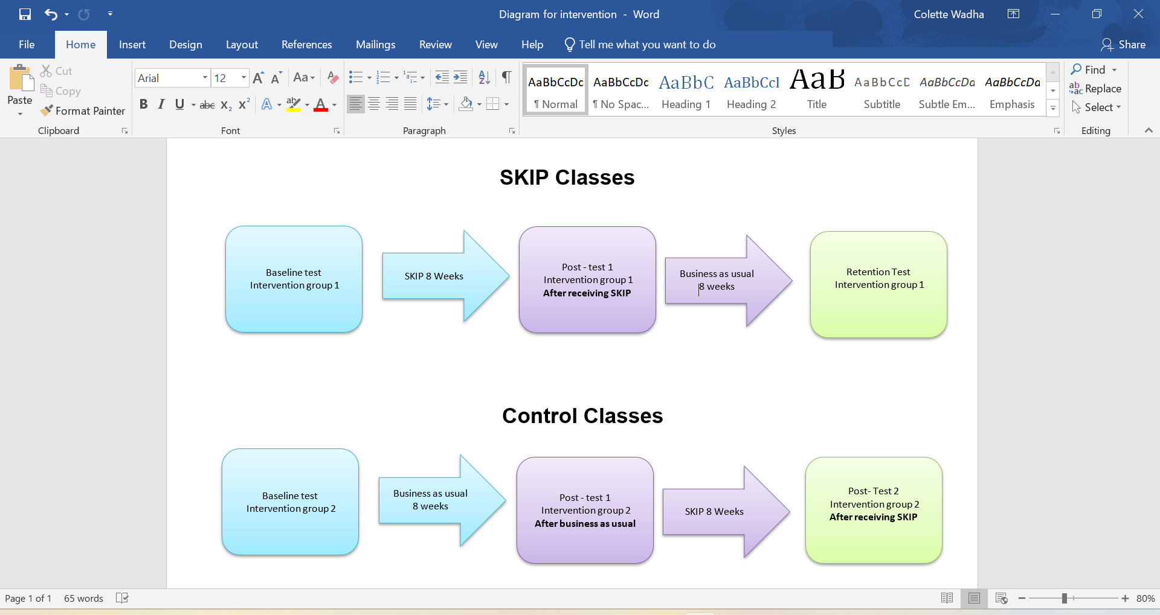
Research Design

All participants were tested initially at the start of the school year (August 2023). Participants in Group 1 received the SKIP intervention, while Group 2 served as the control group, carrying out PE as usual (August 2023 – December 2023). All participants were then re-tested after group 1 received the intervention (December 2023 – January 2024). Group 2 then received the same SKIP intervention, while Group 1 continued with PE as usual (January 2024 - March 2024). All participants were then re-tested after both groups had received the intervention (April 2024 – May 2024).
Participants
A convenience sample was used from a specific cohort (Secondary year 1, ages 11-12) (n= 72 Females= 46 Males=26). This comprised of 4 Secondary year 1 classes. Group 1 received the intervention first after initial testing (n= 31, F=20, M=11). Group 2 (n=42, F=24, M=17) was the control (wait) group and received no intervention after initial testing. Both groups were tested after group 1 received the intervention, then again at a third time point after group 2 had received the intervention. All equipment used for the testing and intervention was the same for all participants and environments to ensure validity and reliability. All scores were then compared and contrasted using the raw scores and norms. Both intra-rater reliability and inter-rater reliability were used to ensure all test scores were accurate and fair to ensure the validity of scores. Inter-rater reliability was scored at 90% for both TGMD-2 and TGMD-3.
All participants, raw scores, standard scores, sum of standard scores, percentiles and ratings have been analysed and compared through SPSS.
Several ethical considerations were present in this research. In my role as a teacher, I had to ensure that I did not influence, alter, or misinterpret any of the participants' results, which kept me in line with the positivist approach. I also had to ensure that all procedures and guidelines were followed in line with the TGMD-2 and TGMD-3 testing protocols. All participants and their parents/guardians were informed that their information would be anonymised, confidential, and kept safe throughout the duration of the study. All participants and their parents/guardians had the right to request information about the research and had the right to withdraw at any point, this kept in line with the UWTSD and BERA guidelines. All participants and their parents/guardians were required to provide consent for their participation in this study and had the right to decline participation. As the pupils’ class teacher, it was ethically wrong to influence or pressure pupils into participating in the study, by ensuring a positivist approach and by keeping to the UWTSD and BERA guidelines, no pupils were forced to participate or continue to participate if they did not wish to.

This chapter has outlined the research design and methodology used to evaluate the impact of the SKIP intervention. The next chapter presents the data analysis and results.

Chapter 4: Results and Findings
This chapter reports the impact of an 8-week SKIP secondary school-based intervention delivered to Year 1 secondary school pupils. This study included 72 participants, x1 SKIP- Cymru group (n= 31) and x1 wait group (n=41). The study examined the impact on pupils’ physical competence levels of the SKIP intervention, using both the second and third editions of the TGMD (Test of Gross Motor Development). The chapter presents statistics of the participants. The first section reports the pre-test differences between the groups and sex. The second section reports the differences between the pre-test and post-test, as well as the effects of the SKIP intervention. The final section reports retention scores of the SKIP group and the effects of the SKIP programme on the wait group/control.
Cleaning of the Data
IBM SPSS version 29 was used for all statistical analyses. Before undertaking statistical analyses, the quantitative data were examined separately to identify missing values and inspected for accuracy, maximum and minimum values, means and Standard deviations of each variable. This was considered to be accurate for pre-test, post-test, and retention with no missing data. Assessing normality was conducted prior to parametric tests. The alpha level of .05 was used for all statistical analyses, unless stated.
At all testing points, pre, post and retention, 100% of participants (n=72) completed both TGMD-2 and TGMD-3 product measures (run, gallop, hop, leap, jump, slide, striking, stationary dribble, catch, kick, throw and roll). The descriptive statistics for FMS pre-test scores by group and sex are presented in Table. 1.1.
Table 1.1 Descriptive statistics of participants’ Pre-test Scores
TEST | SKIP TOTAL  (N=31) | SKIP  GIRLS (N=21) | SKIP BOYS  (N=10) | WAIT  TOTAL (N=41) | WAIT  GIRLS  (N=24) | WAIT BOYS  (N=17)
 | Mean (SD) | Mean (SD) | Mean (SD) | Mean (SD) | Mean (SD) | Mean (SD)
TGMD-2 LM | 30.58  (7.23) | 31.62  (7.21) | 28.40  (7.14) | 31.85  (6.88) | 30.92  (8.03) | 33.18  (1.15)
TGMD-2 OC | 27.71  (7.34) | 26.81  (4.37) | 29.60  (11.46) | 25.83  (7.22) | 22.66  (6.14) | 30.29  (6.32)
TGMD-2 TOTAL FMS | 58.29  (12.68) | 58.43  (9.91) | 58.00  (17.81) | 57.68  (12.92) | 53.58  (13.55) | 63.47  (9.62)
TGMD-3 LM | 30.45  (6.86) | 31.71  (6.18) | 27.80  (7.77) | 31.27  (6.07) | 30.71  (7.08) | 32.06  (4.16)
TGMD-3 OC | 28.87  (7.41) | 28.24  (5.04) | 30.20  (11.11) | 27.88  (8.29) | 24.33  (7.11) | 32.89  (7.32)
TGMD-3 TOTAL FMS | 59.32  (12.58) | 59.95  (9.06) | 58.00  (18.49) | 59.15  (13.14) | 55.04  (13.54) | 64.94  (10.35)
Notes: TGMD-2 Total FMS score: Raw total score (Ulrich, 2000); TGMD-3 Total FMS score: Raw total score (Ulrich, 2013); LM: Locomotor (Ulrich, 2000), OC: Object Control (Ulrich, 2000). TGMD-2 (Ulrich, 2000) TGMD-3 (Ulrich, 2013).

    - Pre-test scores for TGMD-2 Variables
To establish whether there were pre-test differences for group and sex for LM, OC, and total FMS scores, a two-way between-groups (SKIP, wait) x2 sex (Girls, Boys) analysis of variance (ANOVA) was conducted.
Research question 1 – Are there pre-test differences by group (SKIP and wait), (Girls and Boys) for Fundamental Motor Skills (FMS) raw score total, Locomotor (LM) raw score total and Object Control (OC) raw score total and is there a difference for TGMD-2 and TGMD-3?
Hypothesis 1a: There would be no pre-test differences for groups motor competence (TGMD-2 and TGMD-3).
Hypothesis 1b: There would be sex differences for OC but not for LM skills in both TGMD-2 and TGMD-3.
Results question 1
TGMD-2
The results for total FMS scores indicated that there were no significant differences for group (p = .746), sex (p = .207), and the Group × Sex interaction (p = .062).
The LM scores revealed no significant differences for group (p = .247), sex (p = .784), and the Group × Sex interaction (p = .121).
The OC scores revealed no significant differences between groups (p = .306). However, there were significant sex differences (F[1,68] = 9.68, p=.003, $η$².125). The means in Table 1.1 indicate that boys scored higher than girls in OC scores. The Group x Sex interaction (p = .153) was not significant; therefore, sex differences did not differ across groups.
TGMD-3
The results for total FMS scores indicated that there were no significant differences for group (p = .746), sex (p = .207), and the Group × Sex interaction (p = .062).
The LM score revealed no significant differences for group (p = .307), sex (p = .420), and the Group × Sex interaction (p = .100).
The OC scores revealed no significant differences for group (p=.738). However, there were significant sex differences (F [1,68] = 8.32, p=.005, $η$².109). The Group x Sex interaction (p = .075) was not significant; therefore, sex differences did not differ across groups.
Table 1.2 Pre-test and Post-test Scores for FMS total scores, Locomotor and Object Control raw scores by Group and Sex for TGMD-2 and TGMD-3.
 |  | Pre-test | Post-test | Pre-test | Post-test
Measure |  | SKIP TOTAL (N=31) |  | CONTROL TOTAL (N=41)
 |  | Mean (SD) |  | Mean (SD)
TGMD- 2 LM Raw score | Girls | 31.62 (7.21) | 34.81 (6.33) | 30.92 (8.03) | 31.21 (7.73)
TGMD- 2 LM Raw score | Boys | 28.40 (7.14) | 31.90 (1.86) | 33.18 (1.15) | 33.41 (4.50)
TGMD- 2 LM Raw score | Total | 30.58 (7.23) | 33.87 (6.24) | 31.85 (6.88) | 32.12 (6.61)
TGMD-2 OC Raw score | Girls | 26.81 (4.37) | 29.43 (4.01) | 22.66 (6.14) | 23.42 (5.60)
TGMD-2 OC Raw score | Boys | 29.60 (11.46) | 31.40 (10.22) | 30.29 (6.32) | 30.53 (6.07)
TGMD-2 OC Raw score | Total | 27.71 (7.34) | 30.06 (6.55) | 25.83 (7.22) | 26.37 (6.74)
TGMD- 2 Total Raw score | Girls | 58.43 (9.91) | 64.24 (8.88) | 53.58 (13.55) | 54.63 (12.73)
TGMD- 2 Total Raw score | Boys | 58.00 (17.81) | 63.30 (15.49) | 63.47 (9.62) | 63.94 (9.25)
TGMD- 2 Total Raw score | Total | 58.29 (12.68) | 63.94 (11.17) | 57.68 (12.92) | 58.49 (12.20)
TMGD-3 LM Raw score | Girls | 31.71 (6.18) | 34.81 (5.45) | 30.71 (7.08) | 30.96 (6.89)
TMGD-3 LM Raw score | Boys | 27.80 (7.77) | 31.80 (6.41) | 32.06 (4.16) | 32.12 (4.12)
TMGD-3 LM Raw score | Total | 30.45 (6.86) | 33.32 (11.08) | 31.27 (6.07) | 31.43 (5.87)
TGMD-3 OC Raw score | Girls | 28.24 (5.04) | 32.14 (4.53) | 24.33 (7.11) | 25.13 (6.58)
TGMD-3 OC Raw score | Boys | 30.20 (11.11) | 33.20 (9.92) | 32.89 (7.32) | 33.12 (7.06)
TGMD-3 OC Raw score | Total | 28.87 (7.41) | 32.84 (6.59) | 27.88 (8.29) | 28.44(7.79)
TGMD-3 Total Raw score | Girls | 59.95 (9.06) | 66.95 (8.25) | 55.04 (13.54) | 62.63 (7.42)
TGMD-3 Total Raw score | Boys | 58.00 (18.49) | 65.00 (15.98) | 64.94 (10.35) | 68.29 (7.34)
TGMD-3 Total Raw score | Total | 59.32 (12.58) | 66.32 (11.08) | 59.15 (13.14) | 59.88 (12.53)

    - Pre-test to Post-test Scores for TGMD-2 and TGMD-3 Variables
The effects of the SKIP using TGMD-2 and TGMD-3 scores were analysed by three separate 2-time (Pre, Post) x2 Group (SKIP, wait) x2 Sex (Girls, Boys) ANOVAS for each subtest (total FMS, LM, OC). The analysis was conducted to assess changes in FMS skills over time and whether these changes differed by group and sex. While main effects of group and sex were included in the analysis, the primary focus was on the Time x Group interaction, which indicates whether the SKIP intervention produced differential improvements between groups from Pre-test to Post-test. Additionally, the Time x Group interaction was examined to explore whether boys and girls responded differently to the SKIP intervention across groups. As these interactions address the research questions, the main effects of group and sex are not interpreted in detail unless they are relevant to a significant interaction.
Research question 2 - What is the influence of the SKIP programme on FMS total scores, LM scores and OC scores from pre-test to post-test and is there a difference between TGMD-2 and TGMD-3?
Hypothesis 1c: The SKIP group would score significantly higher for total FMS, LM and OC than the wait group from Pre-test to Post-test across TGMD-2 and TGMD-3.
Results question 2
TGMD-2 - FMS
There was a significant effect for Time (F[1,68] = 101.44, p <.001, $η$²=.599), indicating improvements in FMS scores from pre-test to post-test. A significant Time x Group interaction was found (F[1,68] = 78.01, p <0.01, $η^{2}$ = .002). The Group × Sex interaction (p = .142) was not significant. The three-way interaction of Time x Sex x Group (p = .901) was not significant, indicating that sex did not influence the pattern of improvement across groups.
TGMD-3 – FMS
There was a significant effect for Time (F[ 1,68] = 72.41, p <.001, $η$² = .516), indicating an improvement in total FMS scores between pre-test and post-test across both groups. There was no significant interaction between Time x Group (p = .300), suggesting the magnitude of improvement did not differ significantly between the SKIP group and the wait group. No significant interactions were found between Time x Sex (p = .153) nor the three-way interaction Time x Group x Sex (p = .153). These results suggest that FMS scores changed over time. However, the pattern of change did not differ significantly between groups or sexes.

The means in Table 1.2 and the bar chart shown in Figures 1.1 and 1.2 show that the SKIP group scored higher than the wait group for both TGMD-2 and TGMD-3 overall FMS scores from pre-test to post-test.
Figure 1.1 Pre-test and Post-test Total Raw FMS scores by Group TGMD-2.
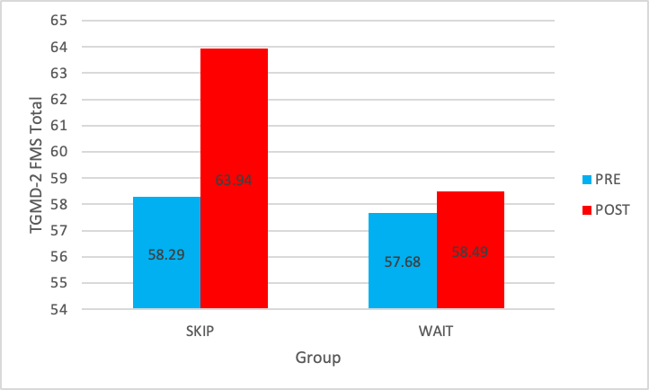

TGMD-2
Two paired-sample t-tests were calculated to investigate the differences between pre- and post-test total FMS scores for each group. There was a significant difference for the SKIP group between pre-test (M = 58.35, SD = 12.68) and post-test scores (M= 63.94, SD= 11.17), t (30) = 4.34, p < .001. There were no significant differences in the wait group between pre-test (M = 57.68, SD = 12.92) and post-test (M = 58.49, SD = 12.20), t(40) = 1.09, p = .282.

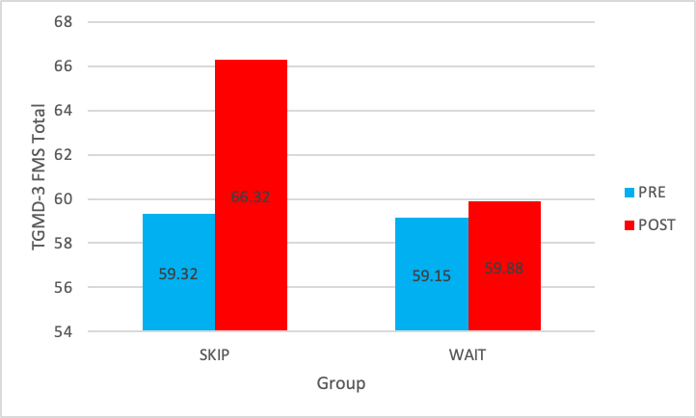
Figure 1.2 Pre-test and Post-test Total Raw FMS scores by Group TGMD-3

TGMD- 3
Two paired-sample t-tests were calculated to investigate whether there were differences between pre- and post-test total FMS scores for each group. There was a significant difference between the pre-test scores (M = 59.32, SD = 12.58) and post-test scores (M = 66.32, SD = 11.08) for the SKIP group, t(30) = 4.91, p < .001. There were no significant differences in the wait group between the pre-test (M = 59.15, SD = 13.14) and the post-test scores (M = 59.88, SD = 12.53), t(40) = 1.23, p = .226.
The means in Table 1.2 and the bar chart shown in Figures 1.3 and 1.4 show that the SKIP group scored higher than the wait group for both TGMD-2 and TGMD-3 LM scores from pre-test to post-test.

TGMD-2 LM
There was a significant effect for Time, indicating overall improvements for raw LM scores from pre-test to post-test (F[1,68] = 125.505, p <.001, $η$² = .649). There was also a significant Time x Group interaction (F[1,68] = 91.527, p <.001, $η$² = .574), suggesting that the extent of the improvements between girls and boys differed between groups. However, the Time x Sex interaction was not significant (p = .696). Similarly, the three-way interaction of Time × Group × Sex was not significant (p = .572).
TGMD-3 LM
There was a significant effect for Time, indicating a significant improvement in LM from pre-test to post-test across all participants (F[1,68] = 47.24, p < .001, $η$² = .410). A significant Time x Group interaction was also found (F[1,68] = 7.54, p = .008, $η$² = .100), suggesting the degree of improvement differed between the SKIP group and wait group. However, there was no significant Time x Sex interaction (p.884), nor a Time x Group x Sex interaction (p = .359), indicating that changes overtime did not significantly differ between girls and boys or between sex within groups.
Figure 1.3 Pre-test and Post-test Locomotor Raw Scores by Group TGMD-2.
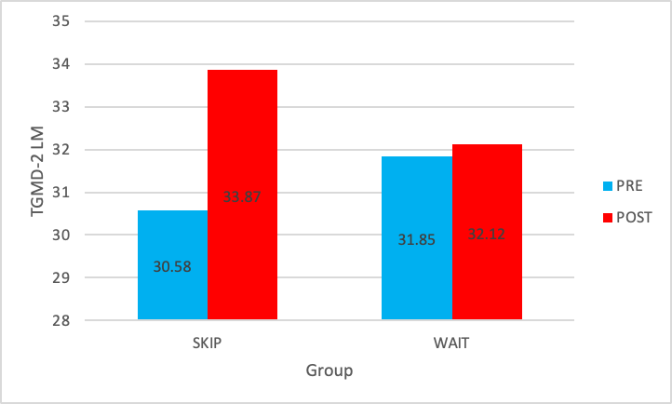

TGMD-2
Two paired sample t-tests were calculated to investigate If there were differences between pre- and post-test total LM scores for each group. There was a significant difference for the SKIP group between pre-test (M=30.58, SD=7.23) and post-test scores (M = 33.87, SD= 6.24), t (30) =, p.001. There were no significant differences for the wait group between the pre-test (M=31.85, SD=6.88) and the post-test scores (M=32.12, SD=6.67), t (40) =0.68, p.501.
Figure 1.4 Pre-test and Post-test Locomotor Raw Scores by Group TGMD-3.
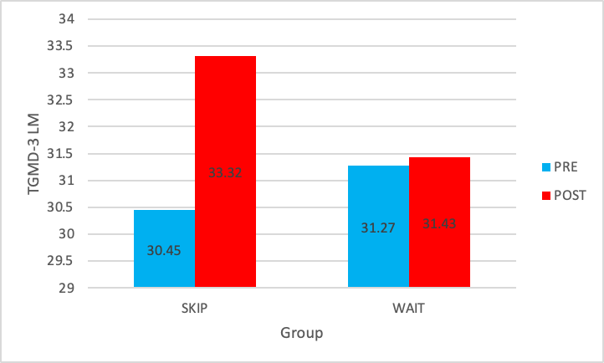

TGMD-3
Two paired sample t-tests were calculated to investigate If there were differences between pre- and post-test total LM scores for each group. There was a significant difference for the SKIP group between pre-test (M=30.45, SD=6.86) and post-test scores (M = 33.32, SD= 11.08), t (30) = 2.38, p.024. There were no significant differences for the wait group between the pre-test (M=31.27, SD=6.07) and the post-test scores (M=31.43, SD=5.87), t (40) =0.43, p.668.
TGMD-2 OC
There was a significant effect for Time, indicating overall improvements for OC scores (F[1,68] = 105.17, p <.001, $η$² = .60). There was also a significant Time x Group interaction (f [1,68] = 78.01, p <.001, $η$² = .53), suggesting groups differed in their improvement over time. No significant interaction was observed for Time x Sex (p = .732) or for the three-way interaction between Time x Group x Sex (p = .901).

TGMD-3 OC
There was a significant effect for Time, indicating significant improvements in OC scores from pre-test to post-test for all participants (F[1,68] = 127.89, p < .001, $η$². = .653). A significant Time x Group interaction was also observed (f [1,68] = 70.23, p <.001, $η$² = .508), suggesting that the extent of improvement differed between the SKIP group and the wait group. Additionally, a significant Time × Sex interaction was found (F[1,68] = 4.34, p = .041, η² = .060), indicating that improvements over time varied between boys and girls. However, the Time × Group × Sex interaction was not significant (p = .621), suggesting that sex differences in change over time were consistent across groups.
The means in Table 1.2 and the bar chart shown in Figures 1.5 and 1.6 show that the SKIP group scored higher than the wait group for both TGMD-2 and TGMD-3 overall OC scores from pre-test to post-test.

Figure 1.5 Pre-test and Post Test Object Control Scores by Group TGMD-2.
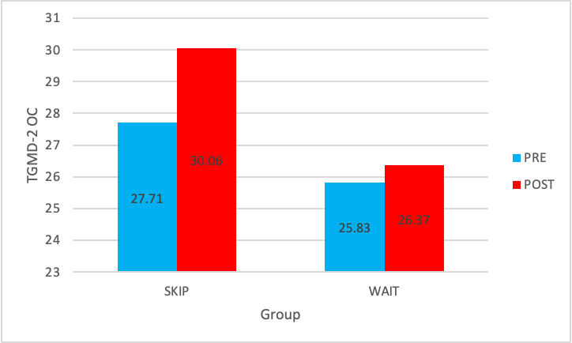

TGMD-2
Two paired-sample t-tests were calculated to investigate whether there were differences between pre- and post-test total OC scores for each group. There was a significant difference for the SKIP group between the pre-test (M=27.71, SD=7.34) and the post-test scores (M = 30.06, SD= 6.55), t (30) = 3.57, p.001. There were no significant differences for the wait group between the pre-test (M=25.83, SD=7.22) and the post-test scores (M=26.37, SD=6.74), t (40) = 1.03, p.310.
Figure 1.6 Pre-test and Post Test Object Control Scores by Group TGMD-3.
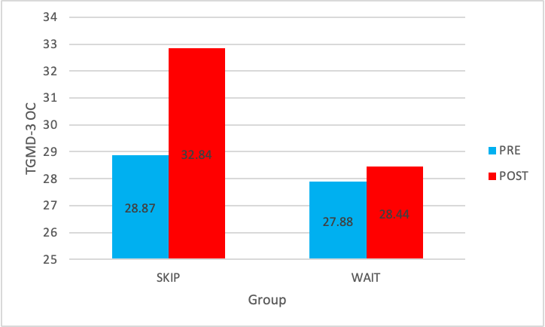

TGMD-3
Two paired sample t-tests were calculated to investigate If there were differences between pre- and post-test total LM scores for each group. There was a significant difference for the SKIP group between pre-test (M=28.87, SD=7.41) and post-test scores (M = 32.84, SD= 6.59), t (30) =3.86, p < .001. There were no significant differences for the wait group between pre-test (M=27.88, SD=8.29) and post-test scores (M=28.44, SD=7.79), t (40) = 0.17, p.867.
Table 1.3 Post-test and Retention Scores for FMS total scores, Locomotor and Object Control raw scores by Group and Sex for TGMD-2 and TGMD-3.
 |  | Post-test | Retention | Post-test | Test 3
Measure | Sex | SKIP TOTAL (N=31) |  | CONTROL TOTAL (N=41)
 |  | Mean (SD) |  | Mean (SD)
TGMD- 2 LM Raw score | Girls | 34.81 (6.33) | 36. 57 (5.94) | 31.21 (7.73) | 33.21 (5.85)
TGMD- 2 LM Raw score | Boys | 31.90 (1.86) | 34.40 (4.95) | 33.41 (4.50) | 34.12 (3.69)
TGMD- 2 LM Raw score | Total | 33.87 (6.24) | 35.87 (5.65) | 32.12 (6.61) | 33.59 (4.94)
TGMD-2 OC Raw score | Girls | 29.43 (4.01) | 29.62 (4.08) | 23.42 (5.60) | 26.63 (3.77)
TGMD-2 OC Raw score | Boys | 31.40 (10.22) | 32.10 (9.21) | 30.53 (6.07) | 31.35 (5.17)
TGMD-2 OC Raw score | Total | 30.06 (6.55) | 30.42 (6.16) | 26.37 (6.74) | 28.59 (4.94)
TGMD- 2 Total Raw score | Girls | 64.24 (8.88) | 66.19 (8.64) | 54.63 (12.73) | 59.83 (9.20)
TGMD- 2 Total Raw score | Boys | 63.30 (15.49) | 66.50 (13.45) | 63.94 (9.25) | 65.47 (7.16)
TGMD- 2 Total Raw score | Total | 63.94 (11.17) | 66.29 (10.20) | 58.49 (12.20) | 62.17 (8.78)
TMGD-3 LM Raw score | Girls | 34.81 (5.45) | 37.66 (4.25) | 30.96 (6.89) | 34.21 (4.54)
TMGD-3 LM Raw score | Boys | 31.80 (6.41) | 34.80 (4.13) | 32.12 (4.12) | 34.12 (4.12)
TMGD-3 LM Raw score | Total | 33.32 (11.08) | 36.74 (4.36) | 31.43 (5.87) | 34.17 (4.04)
TGMD-3 OC Raw score | Girls | 32.14 (4.53) | 32.43 (4.62) | 25.13 (6.58) | 28.42 (4.61)
TGMD-3 OC Raw score | Boys | 33.20 (9.92) | 34.60 (9.11) | 33.12 (7.06) | 34.18 (3.33)
TGMD-3 OC Raw score | Total | 32.84 (6.59) | 33.13 (6.34) | 28.44(7.79) | 30.80 (5.80)
TGMD-3 Total Raw score | Girls | 66.95 (8.25) | 70.06 (7.32) | 56.08 (12.85) | 62.63 (7.42)
TGMD-3 Total Raw score | Boys | 65.00 (15.98) | 69.40 (10.93) | 65.24 (10.15) | 68.29 (7.34)
TGMD-3 Total Raw score | Total | 66.32 (11.08) | 69.87 (8.46) | 59.88 (12.53) | 64.98 (7.82)

    - Post-test to Retention Scores for TGMD-2 and TGMD-3 Variables
To evaluate the sustainability of the SKIP interventions' effects on pupils' FMS, a series of 2-time (Post, Retention) x2 Group (SKIP, wait) x2 Sex (Girls, Boys) ANOVAS for each subtest (total FMS, LM, OC). These analyses aimed to determine whether improvements observed at post-test were maintained at the retention stage and whether these differed by group and sex. While the main effects of group and sex were examined, the primary focus was on the Time x Sex interaction, indicating whether the SKIP group sustained improvements differently over time in comparison to the wait group. Additionally, the Time x Group x Sex interaction was assessed to explore potential retention differences between girls and boys. Main effects of group and sex are discussed only when pertinent to significant interactions, aligning with the study’s central research questions.
Research question 3- To what extent did the SKIP group retain intervention effects from post-test to a retention test?
Due to ethical reasons, the wait group did not receive a retention test and began the skip intervention.
Hypothesis 1d: There will be no significant differences in FMS total, LM skill total and OC skill total scores from post-test to retention.

Results question 3
TGMD-2 FMS
There was no significant effect for Time (F[1,68] = 0.001, p = .975, $η$² = .000), indicating no overall change in FMS scores from post-test to retention. However, a significant Time x Group interaction was found (F[1,68] = 40.25, p <.001, $η$² = .372), suggesting that the pattern of change over time differed between the SKIP group and wait group. The Time x Sex interaction (p = .215, n² = .023) was not significant. A significant three-way Time x Group x Sex interaction was found (F[1,68] = 4.81, p= .032, $η$² = .066), indicating that sex influenced the pattern of change in FMS differently across the two groups.
TGMD-3 FMS
There was a significant effect for Time (f [1,68] = 20.23, p < .001, n² = .229), indicating improvements in TGMD-3 total FMS scores from post-test to retention. A significant Time x Group interaction was also found (F[1,68] = 20.23, p < .001, $η$². = .229), suggesting that the extent of improvement varied by group. There was no significant Time x Sex (p = .456) or Time x Group x Sex (p = .456) interactions, indicating that sex did not influence the pattern of change across groups.

Figure 1.7 Post-test and Retention FMS scores TGMD-2.
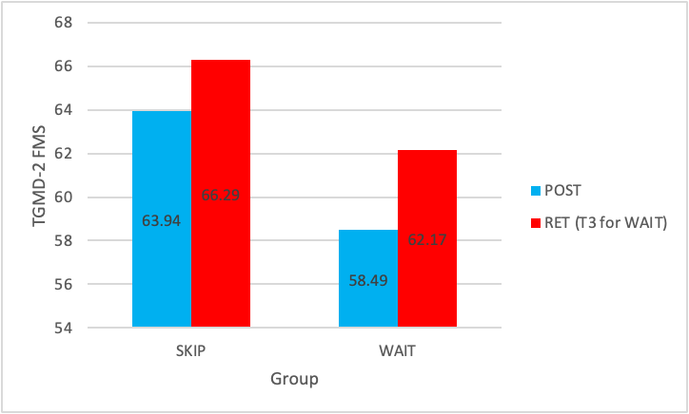

RET (PT2 for WAIT)

TGMD-2 FMS
Two paired-sample t-tests were conducted to evaluate differences in TGMD-2 total FMS scores between the post-test and retention. The SKIP group showed no significant difference between post-test (M = 63.94, SD = 11.17) and retention (M = 66.29, SD = 10.20), t (30) = -0.437, p = .665. Similarly, the wait group also showed no significant change from post-test (M = 58.49, SD = 12.20) to post-test 2 (M = 62.17, SD = 8.78), t (40) = -1.000, p = .323.

Figure 1.8 Post-test and Retention FMS scores TGMD-3.
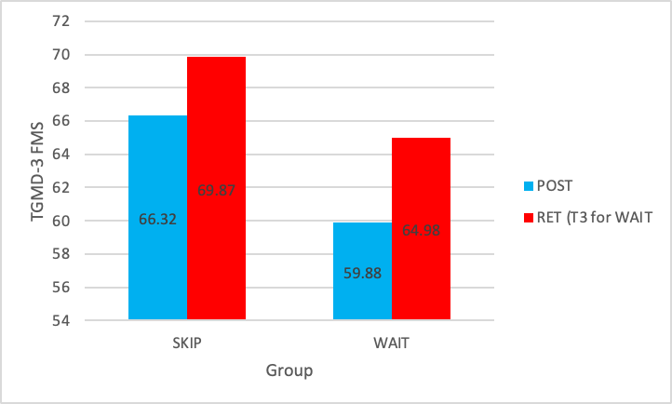

RET (PT2 for WAIT)

TGMD-3 FMS
Two paired sample t-tests were conducted to assess differences in TGMD-3 total FMS scores from post-test to retention. The SKIP group demonstrated a significant improvement between post-test (M = 66.32, SD = 11.08) and retention (M = 69.87, SD = 8.46), t (30) = -5.272, p < .001. In contrast, the wait group showed no significant difference between post-test (M = 59.88, SD = 12.53) and post-test 2 (M = 64.98, SD = 7.82), t (40) = -1.379, p = .176.
TGMD-2 LM
There was a significant effect for Time (F[1,68] = 49.68, p <.001, $η$²= .422), indicating improvements in LM scores from post-test to retention. The time x Group interaction was not significant (F[1,68] = 2.48, p = .120, $η$² = .035), suggesting that both groups improved similarly over time. The Time x Sex interaction was also not significant (F[1,68] = 0.32, p = .576, $η$² = .005). However, a significant three-way Time x Group x Sex interaction was found (F[1,68] = 4.23, p= .044, $η$² = .059), indicating that the pattern of the improvement between post-test retention differed depending on group and sex.
TGMD-3 LM
There was a significant effect for Time (F[1,68] = 19.97, p < .001, $η$² = .227), indicating improvements in TGMD-3 Locomotor scores from post-test to retention. However, the Time × Group interaction was not significant (F[1,68] = 0.06, p = .808, $η$² = .001), suggesting that both groups followed a similar pattern over time. Additionally, there were no significant effects for the Time × Sex interaction (F[1,68] = 0.198, p = .657, $η$² = .003) or the three-way Time × Group × Sex interaction (F [1,68] = 0.314, p = .577, $η$² = .005), indicating sex did not influence locomotor score retention across groups.
Figure 1.9 Post-test and Retention LM scores TGMD-2
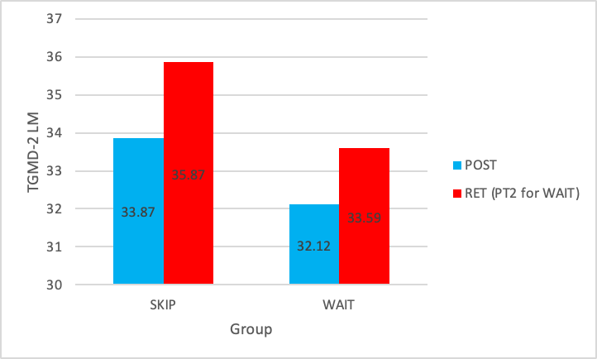

TGMD-2 LM
Two paired sample t-tests were conducted to assess differences in TGMD-2 locomotor scores from post-test to retention for each group. For the SKIP group, there was no significant difference between post-test (M = 33.87, SD = 6.24) and retention (M = 35.87, SD = 5.65), t (30) = -0.468, p = .643. Similarly, the wait group showed no significant change between post-test (M = 32.12, SD = 6.61) and post-test 2 (M = 33.59, SD = 4.94), t (40) = -0.939, p = .353.
Figure 1.9 Post-test and Retention LM scores TGMD-3.
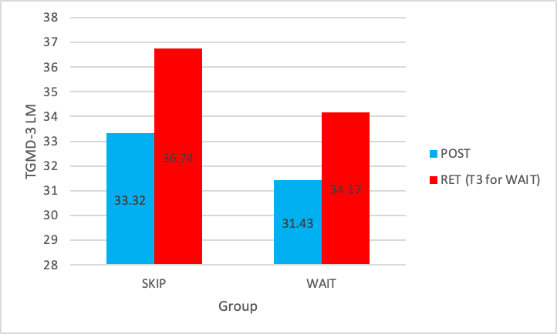

RET (PT2 for WAIT)

TGMD-3 LM
Two paired sample t-tests were conducted to explore differences in TGMD-3 locomotor scores between post-test and retention. The SKIP group demonstrated a significant increase from post-test (M = 33.32, SD = 11.08) to retention (M = 36.74, SD = 4.36), t (30) = -4.667, p < .001. The wait group, however, showed no significant change between post-test (M = 31.43, SD = 5.87) and post-test 2 (M = 34.17, SD = 4.04), t (40) = 0.882, p = .383.
TGMD-2 OC
There was a significant effect for Time (F[1,68] = 31.36, p <.001, $η$² = .316), indicating improvements in OC scores from post-test to retention. A significant Time x Group interaction was observed (F[1,68] = 12.77, p <.001, $η$² = .158), suggesting that the extent of improvement differed between the groups. A significant Time x Sex interaction was also found (F[1,68] = 4.55, p = .037, $η$² = .063), indicating different improvement patterns between girls and boys. Finally, a significant three-way Time x Group x Sex interaction was observed (F[1,68] = 10.84, p = .002, $η$² = .138), showing that changed in OC score across time varied depending on group and sex.
TGMD-3 OC
There was a significant effect for Time (F[1,68] = 35.85, p < .001, $η$² = .345), indicating improvements in TGMD-3 Object Control scores from post-test to retention. A significant Time × Group interaction was also found (F[1,68] = 6.99, p = .010, $η$² = .093), suggesting differences in retention between groups. The Time × Sex interaction was not significant (F[1,68] = 1.23, p = .271, $η$² = .018). However, a significant three-way Time × Group × Sex interaction was observed (F[1,68] = 11.02, p = .001, $η$² = .139), indicating that sex may have influenced how each group retained object control skills over time.

Figure 2.0 Post-test and Retention OC scores TGMD-2.
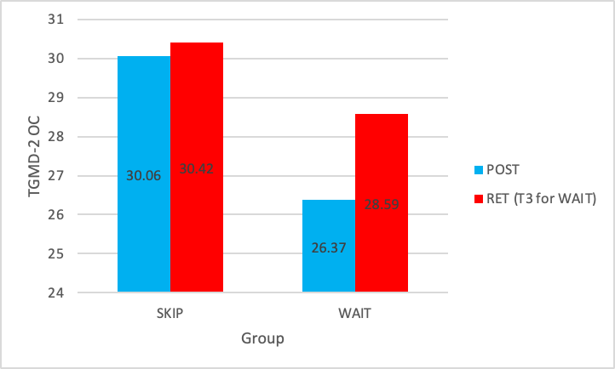

RET (PT2 for WAIT)

TGMD-2 OC
Two paired sample t-tests were conducted to determine whether TGMD-2 object control scores differed between post-test and retention. The SKIP group showed no significant difference from post-test (M = 30.06, SD = 6.55) to retention (M = 30.42, SD = 6.16, t (30) = -0.119, p = .906. Likewise, the wait group also showed no significant difference between post-test (M = 26.37, SD = 6.74) and retention (M = 28.59, SD = 4.94), t (40) = -0.704, p = .486.
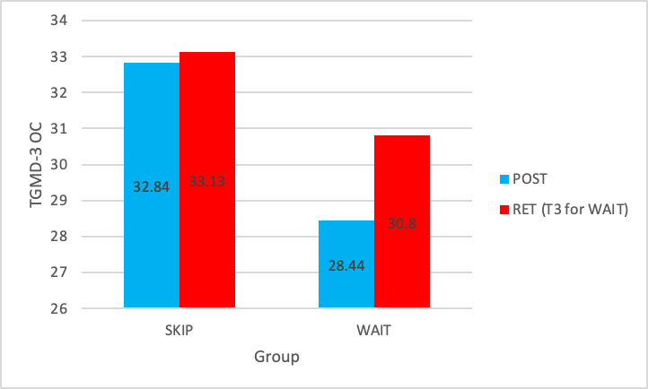
Figure 2.1 Post-test and Retention OC scores TGMD-3.

RET (PT2 for WAIT)

TGMD-3 OC
Two paired sample t-tests were run to examine post-test to retention differences in TGMD-3 object control scores. The SKIP group showed a significant improvement from post-test (M = 32.84, SD = 6.59) to retention (M = 33.13, SD = 6.34), t (30) = -3.428, p = .002. In contrast, the wait group showed no significant difference between the post-test (M = 28.44, SD = 7.79) and retention (M = 30.80, SD = 5.80) scores, t(40) = 0.219, p = .828.

    - Pre-test, Post-test, Retention Scores for TGMD-2 and TGMD-3 Variables

To examine the long-term effects of the SKIP intervention, a series of paired-sample t-tests were conducted to compare post-test and retention scores for the SKIP group. As the wait group began receiving the intervention after the post-test due to ethical considerations, retention data was not collected for this group. The analyses focused on determining whether the improvements observed immediately following the intervention were maintained at the retention stage across total FMS, LM and OC. Results are reported separately for TGMD-2 and TGMD-3.

A series of paired-sample t-tests was conducted to examine the sustainability of the SKIP intervention’s effects from pre-test to post-test and retention. Only the SKIP group completed the retention test, as the wait group began receiving the intervention after the post-test phase. The wait group were still tested at this point.

The means in Table 1.2 and Table 1.3, along with the line graphs shown in Figures 2.2 and 2.3, illustrate the changes across the three testing points.
Figure 2.2 pre, post and retention FMS TGMD-2

Figure 2.3 pre, post and retention FMS TGMD-3

The means in Table 1.2 and Table 1. 3 and the line graphs shown in Figures 2.4 and 2.5 show the changes across the three testing points for LM.

Figure 2.4 pre, post and retention LM TGMD-2
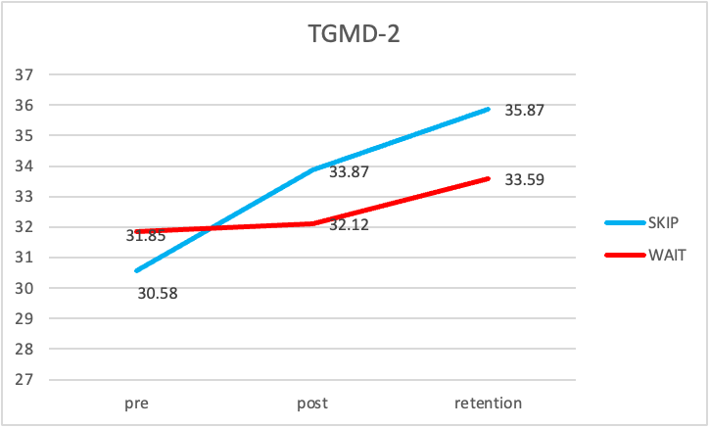

Figure 2.5 pre, post and retention LM TGMD-3

The means in Table 1.2 and Table 1.3, along with the line graphs shown in Figures 2.6 and 2.7, illustrate the changes across the three testing points for OC.
Figure 2.6 pre, post and retention OC TGMD-2.

Figure 2.7 pre, post and retention OC TGMD-3

This chapter has reported the quantitative data for each of the research questions. Analyses explored whether any pre-test differences existed between groups and sexes, assessed the effects of the SKIP intervention from pre- to post-test, and examined the retention of those effects over time. Key findings from both TGMD-2 and TGMD-3 assessments were reported for total FMS, locomotor, and object control scores. These results provide a data-driven foundation for interpreting the efficacy and sustainability of the SKIP programme. The next chapter will discuss these findings, addressing each of the research questions.

Chapter 5: Discussion

The purpose of this study was to examine the effects of an eight-week SKIP intervention on the development of fundamental motor skills (FMS) in Year 1 secondary school pupils. The discussion aims to critically analyse the findings of this investigation in relation to the specified hypotheses, positioning them within the broad range of FMS literature on development, physical literacy, and physical activity engagement. By doing so, this chapter explores not only whether the intervention was effective in enhancing FMS competence but also the implications of these findings for both theoretical perspectives and practical applications in school-based physical education programs.

Research Question 1 (RQ1) asked whether there were pre-test differences by group (SKIP vs wait and boys vs girls) in fundamental motor skills (FMS) total scores, locomotor (LM) scores, and object control (OC) scores, and whether outcomes differed when assessed by TGMD-2 versus TGMD-3.

In relation to Hypothesis 1a, which predicted that there would be no pre-test differences in motor competence between groups, the findings largely supported this expectation. At baseline, the SKIP and wait groups demonstrated similar levels of FMS, suggesting that the use of random allocation had been effective and that any later differences observed were likely attributable to the intervention rather than pre-existing disparities. This result is consistent with previous intervention studies (Goodway & Branta, 2003; Logan et al., 2012), which have emphasised the importance of ensuring comparable starting points to avoid contradictory results. The absence of significant group-level differences at pre-test strengthens the internal validity of the current study and assures that the SKIP programme’s observed effects were genuine and not due to baseline imbalances.
Hypothesis 1b, proposed that sex differences would be evident in object control (OC) but not in locomotor (LM) skills, the findings again aligned with these predictions. Boys outperformed girls in OC tasks, while LM scores were more comparable across sexes. This pattern is widely reported in the literature. Barnett et al. (2016) and Issartel et al. (2017) state that boys consistently demonstrate better OC and ball-related skills, which reflects both the sociocultural influences and opportunities to practice. Whereas Girls tend to excel or perform comparably in LM skills, such as running or skipping, which are commonly reinforced through school and recreational activities, girls play.
The implications of these baseline sex differences are essential for interpreting later outcomes. If boys and girls start from different points in specific skill domains, then any intervention which does not consider this may produce imbalanced results. For instance, if girls’ OC skills are poorer than those of boys, then they may require more practice time or targeted feedback to ensure their progress is comparable to that of their male classmates. This is further supported by Goodway et al. (2013), who state that disadvantaged pre-school girls improved less in ball skills than boys unless they were given additional specific support. Thus, while the SKIP intervention is designed to benefit all, findings suggest that sex-specific needs must be considered to ensure the intervention has maximum impact.

Finally, the comparison between TGMD-2 and TGMD-3 measures provided further nuance to RQ1. As Palmer et al. (2021) state, TGMD-3 tends to give slightly higher scores than TGMD-2. This pattern was also reflected in the present study. This difference may be due to modifications in scoring criteria and updated test items in TGMD-3. Both TGMD-2 and TGMD-3 are valid assessment tools. However, the discrepancy between them raises questions of comparability across studies. This study has remained consistent with a large body of literature surrounding FMS and TGMD (Barnett et al., 2016; Hardy et al., 2010). However, future research may benefit from also using dual scoring to capture a more comprehensive picture of pupils’ competence.

Taken together, the results for RQ1, Hypothesis 1a and Hypothesis 1b demonstrate that while the intervention and control groups began on an equal footing, sex-related differences were present, particularly in OC skills, and that measurement choice may subtly influence outcomes. These findings establish an essential foundation for interpreting subsequent analyses of intervention effects.
Research Question 2 (RQ2) examined the influence of the SKIP programme on FMS total scores, locomotor (LM) scores, and object control (OC) scores from pre-test to post-test, and whether outcomes differed when assessed using TGMD-2 versus TGMD-3.

In relation to Hypothesis 1c, which predicted that the SKIP group would score significantly higher than the wait group from pre-test to post-test across FMS total, LM, and OC skills. The findings provided strong support, where pupils in the SKIP group demonstrated significant improvements in overall FMS competence, with particularly noticeable gains in LM skills. The improvements made surpassed those of the wait group, which indicates that the intervention had a positive effect. This supports Logan et al.’s (2012) meta-analysis, which states that structured motor skill programmes can enhance FMS in children, particularly when delivered in schools.

The most substantial effects were observed in locomotor skills, such as running, hopping, and skipping. These findings are consistent with previous research (Goodway & Branta, 2003; Foweather et al., 2008), which suggests that locomotor skills may be more responsive to short-term interventions because they draw on movement patterns that children often already possess, making them easier to refine and improve. In contrast, gains in OC skills, while present, were more modest. This echoes the observations of Barnett et al. (2016), who found that ball skills require more extensive and repetitive practice and feedback for mastery. Prior experiences and gendered expectations may disproportionately influence this.

TGMD can provide an additional layer of insight. The scores on TGMD-3 tend to be higher than those on TGMD-2. This reflects Palmer et al.’s (2021, 2024) observations that the revisions made in TGMD-3 make it easier for children to demonstrate competence. Nevertheless, both assessment tools show consistent patterns of improvement when used to test children’s motor competence levels. This reinforces the robustness of the results. It is essential to consider the alignment of findings across both assessment tools. Studies suggest that the positive impact of interventions cannot be solely attributed to the coincidence of the assessment tool but reflects genuine skill development.

The broad literature helps to provide a context for these findings. By looking at them through a theoretical lens, Clark and Metcalfe’s (2002) “mountain of motor development” metaphor looks at FMS as a foundation from which more complex movement skills can develop. The improvements observed in this study represent not only short-term gains but also an investment in pupils’ future ability to engage with sport and physical activity throughout their lives (Hulteen et al., 2018). This emphasises the relationship between motor skill proficiency and physical activity participation and engagement.

It is essential to reflect on the practical devices which underlie these improvements. The SKIP programme features structured, developmentally appropriate activities that incorporate repetition and feedback. The key features identified by Logan et al. (2012) and Lubans et al. (2010) are essential for FMS interventions to be effective. Through providing consistent and focused opportunities for practice, the programme in this study appeared to accelerate pupils' progression in comparison to their peers in the wait group who received standard PE curriculum.

Together, the results for RQ2 and Hypothesis 1c confirm that the SKIP intervention was successful in enhancing pupils’ FMS, especially in LM skills. However, challenges remain in producing equal gains in OC skills. These outcomes can support that the intervention is not only effective but also contributes to the broader evidence that FMS should be included in structured programmes in schools.

Research Question 3 (RQ3) investigated the extent to which the SKIP group retained intervention effects from the post-test to the retention test. Due to ethical considerations, the wait group did not complete a retention assessment, so this analysis focused solely on the SKIP group.

Hypothesis 1d predicted that there would be no significant differences in FMS total, LM and OC scores between post-test and retention test. The findings did not fully support the prediction. Some skills were maintained, yet there was evidence of regression in certain skills, particularly in OC. This suggests that although the intervention was successful in increasing competence in the short term, the gains did not continue without the intervention, which limits the durability of the short-term benefits.

These results reflect a challenge which is stated in the literature. Short-term interventions are often not sustainable. Lai et al.’s (2014) systematic review highlights that many school-based FMS interventions can produce short-term, immediate improvements, yet they often diminish without reinforcement or continued deliberate instruction. Logan et al. (2012) further supports this by stating short-term interventions can speed up learning, whereas long-term retention requires opportunities for continued practice and feedback. The findings in this study align with previous literature, which suggests that motor skill acquisition requires sustained engagement and reinforcement over time.

Motor learning theory, Schmidt and Lee (2014) schema can explain some of the regression observed. This theory relies on repeated practice across various contexts to consolidate motor patterns into long-term memory. The use of an eight-week intervention may provide sufficient time to trigger initial improvements. However, it is not likely to cause stable formation. Similarly, Thelen and Smith’s (1994) DST approach suggests that when the task and environmental supports are removed, pupils’ skill trajectories shift, which can lead to declines. These perspectives conclude that if practice opportunities are removed, improvements cannot be made.
The findings raise practical implications which should be considered. Schools often face many restraints, such as time and resources. This can make it difficult to sustain an FMS programme further than an initial trial. Furthermore, without reinforcement, any improvements and benefits can prove to be temporary. Thus, there is an importance in embedding FMS practice into the PE curriculum. By integrating these skills into PE, active classroom breaks, and extracurricular activities, this can contribute to improved retention. Teacher development opportunities can also play a role in supporting educators in facilitating FMS practice time within everyday lessons, which can further help sustain retention.

The regression observed after SKIP has implications for the proficiency barrier hypothesis (Seefeldt, 1980). Although the intervention allowed some pupils to cross this threshold, the loss of competence at retention suggests that without the continued support, any progress would not be sustained. Pupils would be at risk of going back below the barrier. This emphasises that short-term interventions only provide temporary improvements, meaning they would not be able to access more advanced movements and forms of physical activities without ongoing intervention.
Taken together, the results for RQ3 and Hypothesis 1d highlight both the strengths and limitations of SKIP. While improvements were initially achieved, their durability was mixed, reinforcing the need for long-term integration of FMS practice into schools if benefits are to be sustained.
The findings of this study provide a refined understanding of how the SKIP intervention impacted fundamental motor skills (FMS) among Year 1 secondary school pupils. The three research questions (RQ1–RQ3) and their corresponding hypotheses (H1a–d) received varying degrees of support. This highlights both the effectiveness and the limitations of short-term interventions in this area.

The next chapter will discuss the limitations of this study, practical limitations and any future considerations.

Chapter 6: Conclusion

This dissertation aimed to investigate the effectiveness of an eight-week SKIP intervention in developing fundamental motor skills (FMS) among Year 1 Secondary school pupils (aged 11-12) in Scotland. The study was based on three main research questions and four hypotheses. These addressed baseline differences, sex differences, intervention effects, and retention gains. TGMD, the Test of Gross Motor Development, was used to examine the immediate and long-term changes in FMS competence. These findings were situated within theoretical frameworks of motor competence and physical literacy.

The results provide partial, though meaningful, support for the hypotheses. Hypothesis 1a predicted that no pre-test differences would be present between the intervention group and the wait group. This was supported, confirming the study’s practical and effective design and strengthening the validity of the consequent comparison. Hypothesis 1b was also supported, with boys outperforming girls in OC skills but not LM skills. This is supported by a large body of literature, which also follows this pattern (Barnett et al., 2016; Issartel et al., 2017). Hypothesis 1c was strongly supported, where pupils in the SKIP group demonstrated significant improvements in both LM and OC skill scores from pre-test to post-test, with LM skills showing the most gains. Lastly, Hypothesis 1d received partial support. While some improvements were retained, regression was evident, mostly in OC skills. This further highlights the challenge of sustaining improvements and gains beyond the short-term immediate effects.

The findings can be amalgamated across the three research questions. RQ1 can confirm that groups were the same at baseline. This provides a foundation for evaluation while still highlighting sex differences that can shape different skill development trajectories. RQ2 can provide strong evidence that SKIP is effective in demonstrating that structured, targeted interventions can produce improvements in motor competence within a short timeframe. RQ3 has emphasised that these improvements are delicate and can be unsustainable without constant reinforcement. Furthermore, the mixed evidence for retention at follow-up shows that there are limitations for the short-term school-based FMS intervention.

The findings extend existing models of motor development. Seefeldt’s (1980) proficiency barrier hypothesis was both supported and challenged. The intervention enabled some pupils to temporarily cross the barrier by improving their FMS. However, the slight regression at the retention stage shows that without the sustained reinforcement, progress will not be permanent. Schmidt & Lee’s (2014) schema theory can explain why any improvements made over time faded. The lack of practice opportunities and repetition time can limit long-term consolidation. Thelen and Smith’s (1994) dynamic systems theory (DST) approach can further contextualise the findings. The removal of a supportive environment which provides adapted practices, through task constraints, can shift pupils’ developmental trajectories. Together, these frameworks suggest that short-term interventions can be valuable, but to achieve lasting changes, they must be integrated into the curriculum to allow for long-term effects to take place.

The research highlighted discrepancies between the editions of TGMD-2 and TGMD-3. Palmer et al. (2021; 2024) also found that TGMD-3 tends to give pupils higher scores than TGMD-2, which can raise questions about the comparability and sensitivity. The use of TGMD assessment tools with 11-12-year-olds can signify limitations, as the tests are intended for use with children aged 3-10 years old and are only validated for children of these ages. TGMD has been used in adolescent populations in previous research (Issartel et al., 2017). However, its appropriateness for capturing adolescents’ skill range is debatable. During adolescence, it is possible that some skills can plateau, potentially reducing sensitivity. When this happens, the test may fail to capture more advanced skill abilities relevant to this age group. This limitation can affect the strength of the conclusion and emphasises the need to use age-appropriate assessment tools in future research.

The strengths of this study include the use of structured, evidence-informed interventions, the use of similar groups with baseline equivalence, and the inclusion of analyses of both LM and OC. The research was situated within robust theoretical frameworks, which it benefited from. This enabled it to connect with broader debates in motor development and physical literacy contexts. Another strength was the alignment of findings with prior literature supporting the study, enhancing validity. The comparison between TGMD-2 and TGMD-3 adds methodological value to this study.

There are several weaknesses within the study which must be acknowledged. The short time frame for the intervention restricted the opportunity for skill consolidation, which was evident in the regression at the retention phase. Also, the lack of retention assessment for the wait group restricted comparisons between groups and may have limited the strength of conclusions about the potential long-term impact. The moderate sample size and single school context also limit this study in terms of socioeconomic and cultural factors, which impact motor competence development (Booth et al., 1999; Okely & Booth, 2004). Lastly, only using TGMD to assess pupils’ motor competence levels restricted the study's ability to determine how skills were applied in sporting contexts. This may have been more applicable to view this in an adolescent population and was identified as an environmental issue highlighted by the ecological dynamics approach (Davids et al., 2013).

Practical implications also appear from the findings in this study. In schools, the results suggest that FMS need to be embedded into the everyday PE curriculum rather than relying on short-term interventions. LM skills can be improved more easily through structured practice and play. However, OC requires more time and targeted attention, specifically for girls and disadvantaged groups. Teachers, educators, and policymakers should aim to adopt inclusive, sustainable strategies that can address sex disparities to ensure equitable improvements can be made across all skill domains. For practitioners, this study suggests that professional development is essential. Teachers should be equipped with the knowledge and tools to consistently reinforce FMS development, helping children reach skill acquisition, cross the proficiency barrier, and maintain their progress beyond the intervention's short-term effects.

The study highlights several priorities for researchers. Firstly, longitudinal research is necessary to track the long-term effects of school-based FMS interventions. This would help clarify whether early improvements actually predict greater physical activity participation and better health outcomes in adolescence and adulthood (Stodden et al., 2008; Wainwright et al., 2020). Secondly, interventions should consider integrating different assessment measures. For example, perceived competence, motivation and enjoyment levels. Brian et al. (2017) state that this is key to sustaining engagement in physical activities. Thirdly, methodological development is required, including the adaptation of assessment tools which are more suited to the adolescent population. Lastly, repeating the study across a diverse school context or multiple schools would help determine if the findings are generalisable and how contextual factors influence the results.

In conclusion, this dissertation provides evidence that SKIP interventions can effectively improve FMS in Year 1 secondary pupils in Scotland. Moreover, in LM skills, without reinforcement of these skills, the improvements made will not be fully sustained. The study confirms that FMS is responsive to structured interventions and emphasises that sex differences exist. This adds to discussions about measurement and retention. The intervention demonstrated short-term benefits. However, the long-term effects remain uncertain. This supports the importance of using sustained, holistic approaches to develop FMS in schools.

The key messages from this study are that fundamental motor skills are not only a developmental milestone but also essential for lifelong physical activity. Interventions such as SKIP have the potential to provide young people with the skills, confidence, and motivation required to engage in sport and physical activity, but only if they can be effectively embedded within educational provisions and strategies. Through addressing the technical skill and psychosocial foundations of physical literacy, schools and researchers can help to ensure interventions deliver lasting benefits. Finally, this dissertation emphasises both the promise and challenges of developing FMS in the adolescent population. These points pave the way towards more sustainable, inclusive and impactful practices which can foster lifelong physical literacy.

Bibliography

Barnett, L.M., Lai, S.K., Veldman, S.L.C., Hardy, L.L., Cliff, D.P., Morgan, P.J., Zask, A., Lubans, D.R., Shultz, S.P., Ridgers, N.D. and Okely, A.D., (2016) Correlates of gross motor competence in children and adolescents: A systematic review and meta-analysis. Sports Medicine, 46(11),1663–1688.

Barnett, L.M., Stodden, D.F., Cohen, K.E., Smith, J.J., Lubans, D.R., Lenoir, M., Iivonen, S., Miller, A.D., Laukkanen, A., Dudley, D. and Morgan, P.J., (2014) Fundamental movement skills: An important focus. Journal of Teaching in Physical Education, 33(1), 56–72.

Barnett, L.M., Van Beurden, E., Morgan, P.J., Brooks, L.O. and Beard, J.R., (2009) Childhood motor skill proficiency as a predictor of adolescent physical activity. Journal of Adolescent Health, 44(3), 252–259.

Barnett, L. M., Van Beurden, E., Morgan, P. J., Brooks, L. O., & Beard, J. R. (2010) Gender differences in motor skill proficiency from childhood to adolescence: A longitudinal study. Research quarterly for exercise and sport, 81(2), 162-170.

Booth, M.L., Okely, A.D., McLellan, L., Phongsavan, P., Macaskill, P., Patterson, J., Wright, J., Holland, B. and Nelson, L., (1999) Mastery of fundamental motor skills among New South Wales primary school children: Prevalence and sociodemographic distribution. Journal of Science and Medicine in Sport, 2(2), 93–105.

Brian, A., Bardid, F., Barnett, L.M., Deconinck, F.J., Lenoir, M. and Goodway, J.D., (2017) Actual and perceived motor competence levels of Belgian and US preschool children. Journal of Motor Learning and Development, 5(1), 131–147.

Cattuzzo, M.T., Dos Santos Henrique, R., Ré, A.H., de Oliveira, I.S., Melo, B.M., de Sousa Moura, M., de Araújo, R.C. and Stodden, D., (2016) Motor competence and health-related physical fitness in youth: A systematic review. Journal of Science and Medicine in Sport, 19(2),123–129.

Clark, J.E. and Metcalfe, J.S., (2002) The mountain of motor development: A metaphor. In: J.E. Clark and J.H. Humphrey, eds. Motor Development: Research and Reviews. Reston, VA: NASPE, 163–190.

Coakley, J., (2015) Sports in Society: Issues and Controversies. 11th ed. New York: McGraw-Hill.

Cooper, A.R., Goodman, A., Page, A.S., Sherar, L.B., Esliger, D.W., van Sluijs, E.M., Andersen, L.B. and Ekelund, U., (2015) Objectively measured physical activity and sedentary time in youth: The International Children’s Accelerometry Database (ICAD). International Journal of Behavioral Nutrition and Physical Activity, 12(1), 113.

Davids, K., Araújo, D., Vilar, L., Renshaw, I. and Pinder, R., (2013) An ecological dynamics approach to skill acquisition: Implications for development of talent in sport. Talent Development and Excellence, 5(1), 21–34.

De Meester, A., Stodden, D., Goodway, J., True, L., Brian, A., Ferkel, R., & Haerens, L. (2018) Identifying a motor proficiency barrier for meeting physical activity guidelines in children. Journal of science and medicine in sport, 21(1), 58-62.

Duncan, M. J., Foweather, L., Bardid, F., Barnett, A. L., Rudd, J., O’Brien, W., ... & Clark, C. C. (2022) Motor competence among children in the United Kingdom and Ireland: An expert statement on behalf of the international motor development research consortium. Journal of Motor Learning and Development, 10(1), 7-26.

Foweather, L., Knowles, Z., Ridgers, N.D., O’Dwyer, M.V., Foulkes, J.D. and Stratton, G., (2008) Fundamental movement skills in relation to weekday and weekend physical activity in preschool children. Journal of Science and Medicine in Sport, 11(2), 146–154.

Gallahue, D.L., Ozmun, J.C. and Goodway, J.D., (2012) Understanding Motor Development: Infants, Children, Adolescents, Adults. 7th ed. New York: McGraw-Hill.

Goodway, J.D. and Branta, C.F., (2003) Influence of a motor skill intervention on fundamental motor skill development of disadvantaged preschool children. Research Quarterly for Exercise and Sport, 74(1), 36–46.

Goodway, J.D., Robinson, L.E. and Crowe, H., (2013) Gender differences in fundamental motor skill development in disadvantaged preschoolers. Research Quarterly for Exercise and Sport, 81(1), 17–24.

Goodway, J. D., Ozmun, J. C., & Gallahue, D. L. (2019) Understanding motor development: Infants, children, adolescents, adults: Infants, children, adolescents, adults. Jones & Bartlett Learning.

Hamilton, M., Goodway, J. and Haubenstricker, J., (1999) Parent-assisted instruction in a motor skill program for at-risk preschool children. Adapted Physical Activity Quarterly, 16(4), 415–426.

Hardy, L.L., King, L., Farrell, L., Macniven, R. and Howlett, S., (2010) Fundamental movement skills among Australian preschool children. Journal of Science and Medicine in Sport, 13(5), 503–508.

Hulteen, R.M., Morgan, P.J., Barnett, L.M., Stodden, D.F. and Lubans, D.R., (2018) Development of foundational movement skills: A conceptual model for physical activity across the lifespan. Sports Medicine, 48(7), 1533–1540.

IPLA (2025) Defining Physical Literacy. https://www.physical-literacy.org.uk/blog/defining-physical-literacy/.

Issartel, J., Williams, K. and Bradley, A., (2017) Assessing gross motor competence in Irish adolescents using the TGMD-2: The impact of age and gender. Journal of Motor Learning and Development, 5(2), 147–164.

Johan. Y., Jiang, S., Chan, C. H., & Ha, A. S. (2025) Assessing fundamental movement skills using the Test of Gross Motor Development (TGMD): Challenges and solutions to comparability and standardization. Sports Medicine and Health Science, 7(4), 299-301.

Kirk, R. and Miller, M.L., (1986) Reliability and Validity in Qualitative Research. Beverly Hills, CA: Sage.

Lai, S.K., Costigan, S.A., Morgan, P.J., Lubans, D.R., Stodden, D.F., Salmon, J. and Barnett, L.M., (2014) Do school-based interventions focusing on physical activity, fitness, or fundamental movement skill competency produce a sustained impact in children and adolescents? A systematic review of follow-up studies. Sports Medicine, 44(1), 67–79.

Logan, S.W., Robinson, L.E., Wilson, A.E. and Lucas, W.A., (2012) Getting the fundamentals of movement: A meta-analysis of the effectiveness of motor skill interventions in children. Child: Care, Health and Development, 38(3), 305–315.

Lubans, D.R., Morgan, P.J., Cliff, D.P., Barnett, L.M. and Okely, A.D., (2010) Fundamental movement skills in children and adolescents: Review of associated health benefits. Sports Medicine, 40(12), 1019–1035.

Morgan, P.J., Barnett, L.M., Cliff, D.P., Okely, A.D., Scott, H.A., Cohen, K.E. and Lubans, D.R., (2013) Fundamental movement skill interventions in youth: A systematic review and meta-analysis. Pediatrics, 132(5), 1361–1383.

Nikolić, I., Mraković, S., & Kunješić, M. (2016) Gender differences of preschool children in fundamental movement skills. Croatian Journal of Education: Hrvatski časopis za odgoj i obrazovanje, 18(Sp. Ed. 1), 123-131.

O’Brien, W., Belton, S., Issartel, J. and O’Keeffe, B., (2016) Fundamental movement skill proficiency and physical activity levels in Irish primary school children. Journal of Physical Activity and Health, 13(9), 964–971.

Okely, A.D. and Booth, M.L., (2004) Mastery of fundamental movement skills among children in New South Wales: Prevalence and sociodemographic distribution. Journal of Science and Medicine in Sport, 7(3), 358–372.

Palmer, K.K., Chinn, K.M. and Robinson, L.E., (2021) The effect of the TGMD-3 on children’s scores compared to the TGMD-2. Research Quarterly for Exercise and Sport, 92(1), 168–176.

Palmer, K. K., McKheen, A., Palmer, S. A., Wood, A. P., Stodden, D. F., & Robinson, L. E. (2024) Using 2 Versions of the Test of Gross Motor Development to Classify and Screen Young Children’s Motor Skills: A Comparison Study. Pediatric Exercise Science, 1(aop), 1-7.
Riddoch, C.J., Andersen, L.B., Wedderkopp, N., Harro, M., Klasson-Heggebø, L., Sardinha, L.B., Cooper, A.R. and Ekelund, U.,(2004) Physical activity levels and patterns of 9- and 15-yr-old European children. Medicine & Science in Sports & Exercise, 36(1), 86–92.

Schmidt, R.A. and Lee, T.D., (2014) Motor Learning and Performance: From Principles to Application. 5th ed. Champaign, IL: Human Kinetics.

School Sports Survey Wales, (2022) State of the Nation Report. Wales. https://www.sport.wales/download/file/2116/#:~:text=The%202022%20School%20Sport%20Survey%20shows%20that%20in%20the%202021,in%20year%203%20(33%25).
Scottish Government, (2017) A More Active Scotland: Scotland’s Physical Activity Delivery Plan. Edinburgh: Scottish Government.

Seefeldt, V., (1980) Developmental motor patterns: Implications for elementary school physical education. In: C. Nadeau, W. Holliwell, K. Newell and G. Roberts, eds. Psychology of Motor Behavior and Sport. Champaign, IL: Human Kinetics, pp.314–323.

Sport England, (2025) Uniting the Movement: Our mission. London: Sport England. https://www.sportengland.org/about-us/uniting-movement/our-mission

Stodden, D.F., Goodway, J.D., Langendorfer, S.J., Roberton, M.A., Rudisill, M.E., Garcia, C. and Garcia, L.E., (2008) A developmental perspective on the role of motor skill competence in physical activity: An emergent relationship. Quest, 60(2), 290–306.

Thelen, E. and Smith, L.B., (1994) A Dynamic Systems Approach to the Development of Cognition and Action. Cambridge, MA: MIT Press.

Thomas, J.R. and French, K.E., (1985) Gender differences across age in motor performance: A meta-analysis. Psychological Bulletin, 98(2), pp.260–282.

Ulrich, D.A., (2000) Test of Gross Motor Development-2. Austin, TX: Pro-Ed.

Ulrich, D.A., (2013) Test of Gross Motor Development-3. Austin, TX: Pro-Ed.

Wainwright, N., Goodway, J.D., Whitehead, M., Williams, A. and Kirk, D.,(2020) The foundation for developing physical literacy in children: The contribution of fundamental movement skills. Journal of Teaching in Physical Education, 39(3), 233–242.

Wainwright, N., Goodway, J., John, A., Thomas, K., Piper, K., Williams, K., & Gardener, D. (2020) Developing children’s motor skills in the Foundation Phase in Wales to support physical literacy. Education 3-13, 48(5), 565-579.

Wainwright, N., Goodway, J. D., John, A., Stevenson, A., & Thomas, K. (2025) SKIP-Cymru: evaluating the long-term impact of SKIP teacher professional development on children’s motor competence. Journal of Motor Learning and Development, 1(aop), 1-20.
Welsh Government, (2025) Healthy Weight: Healthy Wales. Cardiff: Welsh Government. https://www.gov.wales/sites/default/files/publications/2019-10/healthy-weight-healthy-wales_0.pdf

Whitehead, M., (2010) Physical Literacy: Throughout the Lifecourse. London: Routledge.

Zheng, Y., Ye, W., Korivi, M., Liu, Y., & Hong, F. (2022) Gender differences in fundamental motor skills proficiency in children aged 3–6 years: A systematic review and meta-analysis. International Journal of Environmental Research and Public Health, 19(14), 8318.

Appendix

Appendix 1:

APPLICATION FOR ETHICAL APPROVAL

RESEARCH STUDENTS
This form is to be completed by the student within SIX months for full-time students and TWELVE months for part time students, after the commencement of the research degree or following progression to Part Two of your course.

Once complete, submit this form via the MyTSD Doctoral College Portal at (https://mytsd.uwtsd.ac.uk).

This document is also available in Welsh.

RESEARCH STAFF ONLY
All communications relating to this application during its processing must be in writing and emailed to pgresearch@uwtsd.ac.uk , with the title ‘Ethical Approval’ followed by your name.

STUDENTS ON UNDERGRADUATE OR TAUGHT MASTERS PROGRAMMES should submit this form (and receive the outcome) via systems explained to you by the supervisor/module leader.

In order for research to result in benefit and minimise risk of harm, it must be conducted ethically. A researcher may not be covered by the University’s insurance if ethical approval has not been obtained prior to commencement.

The University follows the OECD Frascati manual definition of research activity: “creative work undertaken on a systematic basis in order to increase the stock of knowledge, including knowledge of man, culture and society, and the use of this stock of knowledge to devise new applications”. As such this covers activities undertaken by members of staff, postgraduate research students, and both taught postgraduate and undergraduate students working on dissertations/projects.

The individual undertaking the research activity is known as the “principal researcher”.

Ethical approval is not required for routine audits, performance reviews, quality assurance studies, testing within normal educational requirements, and literary or artistic criticism.

Please read the notes for guidance before completing ALL sections of the form.

This form must be completed and approved prior to undertaking any research activity. Please see Checklist for details of process for different categories of application.

SECTION A: About You (Principal Researcher)

1 | Full Name: |  | Colette Wadha
2 | Tick all boxes that apply: |  | Member of staff: | ☐ | Honorary research fellow: | ☐
 | Undergraduate Student | ☐ | Taught Postgraduate Student | ☐ | Postgraduate Research Student | ☒

3 | Institute/Academic Discipline/Centre: | School of Sport, Health and Outdoor Education
4 | Campus: | Carmarthen
5 | E-mail address: | Colette.auch@outlook.com  2104173@student.uwtsd.ac.uk
6 | Contact Telephone Number: | 07469246547
 | For students:
7 | Student Number: | 2104173
8 | Programme of Study: | MA Physical Literacy, Physical Education and Sport.
9 | Director of Studies/Supervisor: | Nalda Wainwright

1 | Has the research activity received approval in principle?  (please check the Guidance Notes as to the appropriate approval process for different levels of research by different categories of individual) |  | YES | ☐ | NO | ☒
 |  |  |  |  | Date
2 | If Yes, please indicate source of approval (and date where known): Approval in principle must be obtained from the relevant source prior to seeking ethical approval | Research Degrees Committee |  | ☐
2 |  | Institute Research Committee |  | ☐
2 |  | Other (write in) |  | ☐
SECTION B: Approval for Research Activity

SECTION C: Internal and External Ethical Guidance Materials
 | Please list the core ethical guidance documents that have been referred to during the completion of this form (including any discipline-specific codes of research ethics, location-specific codes of research ethics, and also any specific ethical guidance relating to the proposed methodology). Please tick to confirm that your research proposal adheres to these codes and guidelines. You may add rows to this table if needed.
1 | UWTSD Research Ethics & Integrity Code of Practice | ☒
2 | UWTSD Research Data Management Policy | ☒
3 | BERA Guidelines | ☒

SECTION D: External Collaborative Research Activity
If there are external collaborators then you should gain consent from the contact persons to share their personal data with the university. If there are no external collaborators then leave this section blank and continue to section E.
1 | Institution
2 | Contact person name
3 | Contact person e-mail address
4 | Is your research externally funded? |  | YES | ☐ | NO |  | ☐
5 | Are you in receipt of a KESS scholarship? |  | YES | ☐ | NO |  | ☐
6 | Are you specifically employed to undertake this research in either a paid or voluntary capacity? | Voluntary | YES | ☐ | NO | ☐
7 |  | Employed | YES | ☐ | NO | ☐
8 | Is the research being undertaken within an existing UWTSD Athrofa Professional Learning Partnership (APLP)? | If YES then the permission question below does not need to be answered. | YES | ☐ | NO |  | ☐
9 | Has permission to undertake the research has been provided by the partner organisation? | (If YES attach copy)  If NO the application cannot continue | YES | ☐ | NO |  | ☐

Where research activity is carried out in collaboration with an external organisation
10 | Does this organisation have its own ethics approval system? | YES | ☐ | NO | ☒
 | If Yes, please attach a copy of any final approval (or interim approval) from the organisation (this may be a copy of an email if appropriate).

SECTION E: Details of Research Activity
1 | Indicative title: | The impact of SKIP on Scottish secondary S1 pupils motor competence.
2 | Proposed start date: | August 24th 2023 | Proposed end date: | 31st May 2024
Introduction to the Research (maximum 300 words per section)
Ensure that you write for a Non-Specialist Audience when outlining your response to the points below:
- Purpose of Research Activity
- Proposed Research Question
- Aims of Research Activity
- Objectives of Research Activity
Demonstrate, briefly, how Existing Research has informed the proposed activity and explain
- What the research activity will add to the body of knowledge
- How it addresses an area of importance.
3 | Fundamental motor skills (FMS) can be described as basic learnt movement patterns that do not occur naturally through play (Barnett et al, 2016). These can be split into three categories, locomotion (e.g. running), object control (e.g. catching) and balancing (Barnett et al, 2016). These FMS play a key role in supporting physical activity and engagement throughout life (Seefeldt, 1980). Clark and Metclafe (2002) theorise this as the ‘mountain of motor development’. FMS build a strong foundation for children which they can then go on to participate competently in context specific sports and physical activity. However, each child must develop movement competence to develop up the mountain of skilfulness (Clark and Metcalfe, 2002). In order to continue developing, children must overcome what Hulteen et al (2017) and Seefeldt (1980) call a proficiency barrier. If this barrier is not broken, children will not develop sufficient competence in their FMS and will have difficulty creating healthy habits towards physical activity throughout their lifespan.  Issartel et al (2016) states that it is well established that children and adolescents are not meeting the national and international PA recommendations. There is strong evidence to support a positive association between PA and FMS competency during childhood, indicating that PA and FMS are sustainable interventions for children and adolescents (Lai et al, 2014). There are consistent findings to support that there are low levels of FMS proficiency during adolescence, which this lack of FMS maturity impedes the development of specialised movement which makes up the majority of their Physical Education (Booth et al, 1999). The new generation of adolescents do not possess the FMS proficiency level they should have acquired during childhood (Issartel et al, 2016). Thus, identifying the need to research this area in adolescents further.  Goodway and Branta (2003) state that there is a higher chance of children from disadvantaged backgrounds displaying FMS developmental delays. A number of studies support this claim which suggest these delays derive from the lack of environmental support in which the children were raised (Goodway & Rudisill, 1997; Hamilton et al 1999). Goodway and Branta (2003) conducted a study using an intervention to improve the children’s motor competence and tested using TGMD. During the baseline testing TGMD indicated that 100% of the participants in the intervention group were below the 50 percentile in locomotor skills and 90% were at or below the 50 percentile in the object control skills. This study demonstrated that through the use of an intervention the children demonstrated large gains in both locomotor and object control skills. This further supports the use of an intervention with the demographic of adolescents that will participate in my study.  O’Brien et al (2016) has identified that there is a need for targeting the weak FMS components in both Physical Education settings and outside of school hours, which may improve these, subsequently increasing FMS and PA levels of school aged children and youth. Issartel et al (2016) further supports this by stating that the shift from FMS to sport specific skills may happen at a later stage. This further supports the need for FMS development in adolescents with the use of an appropriate intervention. Wainwright et al (2019) study developed an intervention called SKIP-Cymru based on Goodway, and colleagues SKIP programme developed in Ohio state university. The SKIP programme uses a variety of pedagogical approaches aiming to support the acquisition of motor competence in a positive learning environment (Wainwright et al, 2019). The SKIP programme has also been identified has being particularly successful for children in areas of social-economic deprivation (Goodway & Branta, 2003; Goodway et al, 2013; Robinson & Goodway, 2009). This supports the use of the SKIP programme within my school due to the high rates of social-economic deprivation. There are many studies which have used the SKIP programme which supports the use of it in my study (Brian et al, 2017; Goodway & Branta, 2003; Goodway, Crone & Ward, 2003; Goodway & Robinson, 2006; Robinson & Goodway, 2009). Wainwright et al (2019) concludes that the SKIP programme could result in the improvement in pupils motor competence in both locomotor and object control skills. By adapting SKIP to make it more age appropriate to adolescents this supports the use of the programme in my study.  (this box should expand as you type)
4 | Research Question  Does SKIP as an intervention impact S1 pupils motor competence levels using TGMD-2 and TGMD-3 as measurement tools.  (this box should expand as you type)
5 | Aims of Research Activity  - To see the effectiveness of SKIP on Secondary year one pupils motor competence.  - To see if retention is possible with FMS after completing SKIP.  - To test Secondary year one pupils motor competence using TGMD-2 and TGMD-3.  - To compare boys and girls TGMD-2 and TGMD-3 scores.  - To see if there is a connection between social deprivation and low motor competence.  (this box should expand as you type)
6 | Objectives of Research Activity  - To look at the difference in raw scores and compare to norms both in TGMD-2 and TGMD-3 prior to SKIP and after completing SKIP using a control group.  - To compare the difference of boys and girl’s locomotor and object control scores across the 2 tests.  - To identify if S1 pupils engage more in PE and extra-curricular activities after the completion of SKIP.  (this box should expand as you type)
Proposed methods (maximum 600 words)
Provide a brief summary of all the methods that may be used in the research activity, making it clear what specific techniques may be used. If methods other than those listed in this section are deemed appropriate later, additional ethical approval for those methods will be needed. You do not need to justify the methods here, but should instead describe how you intend to collect the data necessary for you to complete your project.
7 | Video Observation  TGMD-2  TGMD-3  SKIP intervention aimed/adapted for adolescents.  (this box should expand as you type)
Location of research activity
Identify all locations where research activity will take place.
8 | Scotland  Levenmouth Academy  Methilhaven Rd,  Buckhaven,  Leven  KY8 1EA  Large Gameshall  (this box should expand as you type)
Research activity outside of the UK
If research activity will take place overseas, you are responsible for ensuring that local ethical considerations are complied with and that the relevant permissions are sought. Specify any local guidelines (e.g. from local professional associations/learned societies/universities) that exist and whether these involve any ethical stipulations beyond those usual in the UK (provide details of any licenses or permissions required). Also specify whether there are any specific ethical issues raised by the local context in which the research activity is taking place, for example, particular cultural and/or legal sensitivities or vulnerabilities of participants. If you live in the country where you will do the research then please state this.
9 | (this box should expand as you type)

10 | Use of documentation not in the public domain: Are any documents NOT publicly available? | NO | ☒
10 |  | YES | ☐
11 | If Yes, please provide details here of how you will gain access to specific documentation that is not in the public domain and that this is in accordance with the current data protection law of the country in question and that of England and Wales.  (this box should expand as you type)

 | Does your research relate to one or more of the seven aims of the Well-being of Future Generations (Wales) Act 2015? | YES | NO
12 | A prosperous Wales | ☐ | ☒
13 | A resilient Wales | ☐ | ☒
14 | A healthier Wales | ☐ | ☒
15 | A more equal Wales | ☐ | ☒
16 | A Wales of cohesive communities | ☐ | ☒
17 | A Wales of vibrant culture and thriving Welsh language | ☐ | ☒
18 | A globally responsible Wales | ☐ | ☒
19 | If YES to any of the above, please give details:
 | (this box should expand as you type)

SECTION F: Scope of Research Activity
 | Will the research activity include: | YES | NO
1 | Use of a questionnaire or similar research instrument? | ☐ | ☒
2 | Use of interviews? | ☐ | ☒
3 | Use of focus groups? | ☐ | ☒
4 | Use of participant diaries? | ☐ | ☒
5 | Use of video or audio recording? | ☒ | ☐
6 | Use of computer-generated log files? | ☒ | ☐
7 | Participant observation with their knowledge? | ☒ | ☐
8 | Participant observation without their knowledge? | ☐ | ☒
9 | Access to personal or confidential information without the participants’ specific consent? | ☐ | ☒
10 | Administration of any questions, test stimuli, presentation that may be experienced as physically, mentally or emotionally harmful / offensive? | ☐ | ☒
11 | Performance of any acts which may cause embarrassment or affect self-esteem? | ☐ | ☒
12 | Investigation of participants involved in illegal activities? | ☐ | ☒
13 | Use of procedures that involve deception? | ☐ | ☒
14 | Administration of any substance, agent or placebo? | ☐ | ☒
15 | Working with live vertebrate animals? | ☐ | ☒
16 | Procedures that may have a negative impact on the environment? | ☐ | ☒
17 | Other primary data collection methods. Please indicate the type of data collection method(s) below. | ☐ | ☐
 | Details of any other primary data collection method:  (this box should expand as you type) | ☐ | ☐
If NO to every question, then the research activity is (ethically) low risk and may be exempt from some of the following sections (please refer to Guidance Notes).

If YES to any question, then no research activity should be undertaken until full ethical approval has been obtained.

SECTION G: Intended Participants
If there are no participants then do not complete this section, but go directly to section H.

 | Who are the intended participants: | YES | NO
1 | Students or staff at the University? | ☐ | ☒
2 | Adults (over the age of 18 and competent to give consent)? | ☐ | ☒
3 | Vulnerable adults? | ☐ | ☒
4 | Children and Young People under the age of 18? (Consent from Parent, Carer or Guardian will be required) | ☒ | ☐
5 | Prisoners? | ☐ | ☒
6 | Young offenders? | ☐ | ☒
7 | Those who could be considered to have a particularly dependent relationship with the investigator or a gatekeeper? | ☐ | ☒
8 | People engaged in illegal activities? | ☐ | ☒
9 | Others. Please indicate the participants below, and specifically any group who may be unable to give consent. | ☐ | ☒
 | Details of any other participant groups:  (this box should expand as you type) | ☐ | ☒

Participant numbers and source
Provide an estimate of the expected number of participants. How will you identify participants and how will they be recruited?
10 | How many participants are expected? | 80 - 96  (this box should expand as you type)
11 | Who will the participants be? | Secondary year one pupils – male and female  (this box should expand as you type)
12 | How will you identify the  participants? | They will be numbered for anonymity.  (this box should expand as you type)
 | Information for participants: | YES | NO | N/A
13 | Will you describe the main research procedures to participants in advance, so that they are informed about what to expect? | ☒ | ☐ | ☐
14 | Will you tell participants that their participation is voluntary? | ☒ | ☐ | ☐
15 | Will you obtain written consent for participation? | ☒ | ☐ | ☐
16 | Will you explain to participants that refusal to participate in the research will not affect their treatment or education (if relevant)? | ☒ | ☐ | ☐
17 | If the research is observational, will you ask participants for their consent to being observed? | ☒ | ☐ | ☐
18 | Will you tell participants that they may withdraw from the research at any time and for any reason? | ☒ | ☐ | ☐
19 | With questionnaires, will you give participants the option of omitting questions they do not want to answer? | ☐ | ☐ | ☒
20 | Will you tell participants that their data will be treated with full confidentiality and that, if published, it will not be identifiable as theirs? | ☒ | ☐ | ☐
21 | Will you debrief participants at the end of their participation, in a way appropriate to the type of research undertaken? | ☒ | ☐ | ☐
22 | If NO to any of above questions, please give an explanation
 | (this box should expand as you type)

 | Information for participants: | YES | NO | N/A
24 | Will participants be paid? | ☐ | ☐ | ☒
25 | Is specialist electrical or other equipment to be used with participants? | ☒ | ☐ | ☐
26 | Are there any financial or other interests to the investigator or University arising from this study? | ☐ | ☒ | ☐
27 | Will the research activity involve deliberately misleading participants in any way, or the partial or full concealment of the specific study aims? | ☐ | ☒ | ☐
28 | If YES to any question, please provide full details
The use of iPad’s will be used to video record participants.

(this box should expand as you type)

SECTION H: Anticipated Risks

Outline any anticipated risks that may adversely affect any of the participants, the researchers and/or the University, and the steps that will be taken to address them.

If you have completed a full risk assessment (for example as required by a laboratory, or external research collaborator) you may append that to this form.
1 | Full risk assessment completed and appended? |  | Yes | ☒
1 |  |  | No | ☐
2 | Risks to participants  For example: sector-specific health & safety, emotional distress, financial disclosure, physical harm, transfer of personal data, sensitive organisational information
 | Risk to participants:  - Data protection  - Slips, trips and falls during TGMD testing.  - Any musical strains that may be a result of physical activity participation.  (this box should expand as you type) | How you will mitigate the risk to participants:  - All data will be anonymised and kept securely.  - All surface areas will be checked prior to use.  - Warm up will be carried out to ensure participants are ready for carrying out physical activity.  (this box should expand as you type)
3 | If research activity may include sensitive, embarrassing or upsetting topics (e.g. sexual activity, drug use) or issues likely to disclose information requiring further action (e.g. criminal activity), give details of the procedures to deal with these issues, including any support/advice (e.g. helpline numbers) to be offered to participants. Note that where applicable, consent procedures should make it clear that if something potentially or actually illegal is discovered in the course of a project, it may need to be disclosed to the proper authorities
NA.

(this box should expand as you type)
4 | Risks to the investigator  For example: personal health & safety, physical harm, emotional distress, risk of accusation of harm/impropriety, conflict of interest
 | Risk to the investigator:  - Data protection.  - Conflict of interest.  (this box should expand as you type) | How you will mitigate the risk to the investigator:  - Ensuring all participants are briefed prior to study and ensured their data will be handled in a professional manner.  - All measures and protocols of the testing will be followed to ensure there are no conflicts of interest in the study.  (this box should expand as you type)
5 | University/institutional risks  For example: adverse publicity, financial loss, data protection
 | Risk to the University:  - Data protection.  (this box should expand as you type) | How you will mitigate the risk to the University:  - All participants will be anonymised for data protection and all data will be held securely.  (this box should expand as you type)
6 | Environmental risks  For example: accidental spillage of pollutants, damage to local ecosystems
 | Risk to the environment:  (this box should expand as you type) | How you will mitigate the risk to environment:  (this box should expand as you type)

 | Disclosure and Barring Service
 | If the research activity involves children or vulnerable adults, a Disclosure and Barring Service (DBS) certificate must be obtained before any contact with such participants. | YES | NO | N/A
7 | Does your research require you to hold a current DBS Certificate? | ☒ | ☐ | ☐
8 | If YES, please give the certificate number. If the certificate number is not available please write “Pending”; in this case any ethical approval will be subject to providing the appropriate certificate number.

SECTION I: Feedback, Consent and Confidentiality

1 | Feedback  What de-briefing and feedback will be provided to participants, how will this be done and when?
Sharing of results after study if requested by participant.

(this box should expand as you type)
2 | Informed consent  Describe the arrangements to inform potential participants, before providing consent, of what is involved in participating. Describe the arrangements for participants to provide full consent before data collection begins. If gaining consent in this way is inappropriate, explain how consent will be obtained and recorded in accordance with prevailing data protection legislation.
All information is included in consent form provided to parents.

Debriefing to participants prior to study.
(this box should expand as you type)
3 | Confidentiality / Anonymity  Set out how anonymity of participants and confidentiality will be ensured in any outputs. If anonymity is not being offered, explain why this is the case.
Remove names to ensure anonymity.

Ensure all data is secure and not shared.
(this box should expand as you type)

SECTION J: Data Protection and Storage

 | Does the research activity involve personal data (as defined by the General Data Protection Regulation 2016 “GDPR” and the Data Protection Act 2018 “DPA”)? | YES | NO
1 | “Personal data” means any information relating to an identified or identifiable natural person (‘data subject’). An identifiable natural person is one who can be identified, directly or indirectly, in particular by reference to an identifier such as a name, an identification number, location data, an online identifier or to one or more factors specific to the physical, physiological, genetic, mental, economic, cultural or social identity of that natural person. Any video or audio recordings of participants is considered to be personal data. | ☒ | ☐
 | If YES, provide a description of the data and explain why this data needs to be collected:
2 | Video footage will be used as part of the TGMD-2 and TGMD-3 testing. This will be used to ensure all scores given to participants are as accurate as possible to provide a more valid method of testing.  (this box should expand as you type)
 | Does it involve special category data (as defined by the GDPR)? | YES | NO
3 | “Special category data” means sensitive personal data consisting of information as to the data subjects’ –  (a) racial or ethnic origin,  (b) political opinions,  (c ) religious beliefs or other beliefs of a similar nature,  (d) membership of a trade union (within the meaning of the Trade Union and Labour Relations (Consolidation) Act 1992),  (e) physical or mental health or condition,  (f) sexual life,  (g) genetics,  (h) biometric data (as used for ID purposes), | ☐ | ☒
 | If YES, provide a description of the special category data and explain why this data needs to be collected:
4 | (this box should expand as you type)

 | Will data from the research activity (collected data, drafts of the thesis, or materials for publication) be stored in any of the following ways? | YES | NO
5 | Manual files (i.e. in paper form)? | ☒ | ☐
6 | University computers? | ☐ | ☒
7 | Private company computers? | ☐ | ☒
8 | Home or other personal computers? | ☐ | ☒
9 | Laptop computers/ CDs/ Portable disk-drives/ memory sticks? | ☒ | ☐
10 | “Cloud” storage or websites? | ☒ | ☐
11 | Other – specify: | ☐ | ☒
12 | For all stored data, explain the measures in place to ensure the security of the data collected, data confidentiality, including details of backup procedures, password protection, encryption, anonymisation and pseudonymisation:
All data will be kept in a password protected cloud storage on the university office 356 system which will not be shared. Visual data will be also be storage on the system and will not be shared. Any USB sticks or iPad’s used to store or transfer will be password protected. All participants will be given a unique identifier to ensure confidentiality and this list will be kept securely in the password protected folder.
(this box should expand as you type)

 | Data Protection
 | Will the research activity involve any of the following activities: | YES | NO
13 | Electronic transfer of data in any form? | ☒ | ☐
14 | Sharing of data with others at the University outside of the immediate research team? | ☐ | ☒
15 | Sharing of data with other organisations? | ☐ | ☒
16 | Export of data outside the UK or importing of data from outside the UK? | ☐ | ☒
17 | Use of personal addresses, postcodes, faxes, emails or telephone numbers? | ☐ | ☒
18 | Publication of data that might allow identification of individuals? | ☐ | ☒
19 | Use of data management system? | ☐ | ☒
20 | Data archiving? | ☐ | ☒
21 | If YES to any question, please provide full details, explaining how this will be conducted in accordance with the GDPR and Data Protection Act (2018) (and any international equivalents, where appropriate):
All data will be encrypted and kept in password protected cloud storage on the University Office 365 system which will not be shared. Any USB sticks or ipad’s used to store or transfer data will be password protected. All data transfers will be encrypted and password protected. All participants will be given a unique identifier to ensure confidentiality and this list will be kept securely in the password protected folder. The data will be stored until the completion of the project and then deleted. In accordance with the DPA2018, participants will have the right to ask to see what data is held relating to them, and this data will be deleted immediately if the participant requests this, in which case the data will not be used in the project.

(this box should expand as you type)
22 | List all who will have access to the data generated by the research activity:
Colette Wadha – researcher
Nalda Wainwright – supervisor

(this box should expand as you type)
23 | List who will have control of, and act as custodian(s) for, data generated by the research activity:
Colette Wadha

(this box should expand as you type)
24 | Give details of data storage arrangements, including security measures in place to protect the data, where data will be stored, how long for, and in what form. Will data be archived – if so how and if not why not.
All data will be encrypted and kept in password protected cloud storage on the University Office 365 system which will not be shared. Any USB sticks or ipad’s used to store or transfer data will be password protected and will be reformatted at the end of the project in order to destroy the data. The data will be stored until the completion of the project and then deleted.

(this box should expand as you type)
25 | Please indicate if your data will be stored in the UWTSD Research Data Repository (see https://researchdata.uwtsd.ac.uk/ ). If so please explain. (Most relevant to academic staff)
 | (this box should expand as you type)
26 | Confirm that you have read the UWTSD guidance on data management (see https://www.uwtsd.ac.uk/library/research-data-management/) | YES | ☒
27 | Confirm that you are aware that you need to keep all data until after your research has completed or the end of your funding | YES | ☒

SECTION K: Declaration
The information which I have provided is correct and complete to the best of my knowledge. I have attempted to identify any risks and issues related to the research activity and acknowledge my obligations and the rights of the participants.

In submitting this application I hereby confirm that I undertake to ensure that the above named research activity will meet the University’s Research Ethics and Integrity Code of Practice which is published on the website: https://www.uwtsd.ac.uk/research/research-ethics/
1 | Signature of applicant: | CWadha | Date: 7/08/2023

For STUDENT Submissions:
2 | Director of Studies/Supervisor: |  | Date:
3 | Signature: |  | Date:

For STAFF Submissions:
4 | Academic Director/ Assistant Dean: |  | Date:
5 | Signature: |  | Date:

Checklist: Please complete the checklist below to ensure that you have completed the form according to the guidelines and attached any required documentation:
☒ | I have read the guidance notes supplied before completing the form.
☒ | I have completed ALL RELEVANT sections of the form in full.
☒ | I confirm that the research activity has received approval in principle
☒ | I have attached a copy of final/interim approval from external organisation (where appropriate)
☒ | I have attached a full risk assessment (where appropriate) ONLY TICK IF YOU HAVE ATTACHED A FULL RISK ASSESSMENT
☒ | I understand that it is my responsibility to ensure that the above named research activity will meet the University’s Research Ethics and Integrity Code of Practice.
☒ | I understand that before commencing data collection all documents aimed at respondents (including information sheets, consent forms, questionnaires, interview schedules etc.) must be confirmed by the DoS/Supervisor, module tutor or Academic Director.

RESEARCH STUDENTS ONLY
Once complete, submit this form via the MyTSD Doctoral College Portal at (https://mytsd.uwtsd.ac.uk).

RESEARCH STAFF ONLY
All communications relating to this application during its processing must be in writing and emailed to pgresearch@uwtsd.ac.uk , with the title ‘Ethical Approval’ followed by your name.

STUDENTS ON UNDERGRADUATE OR TAUGHT MASTERS PROGRAMMES should submit this form (and receive the outcome) via systems explained to you by the supervisor/module leader.

Appendix 2:




Date: 16/08/2023

Masters research project into motor development

Information for parents

We know from research that fundamental motor skills build a strong foundation for children which they can then go on to use while participating in sport specific contexts competently.

These fundamental motor skills can be split into three categories, locomotion (e.g. running), object control (e.g. catching) and balancing.

As part of my master’s project this is an area which interests me and I would like to research further. There is a growing body of literature which supports that if a child has proficient fundamental motor skills they are more likely to engage with physical activity across their lifespan and live a healthier lifestyle.

I feel that it is important to ensure all children develop these fundamental motor skills so they can access many different physical activity contexts and feel competent and confident while participating.

In order to capture the children’s level of motor development I will be using an assessment tool called The Test of Gross Motor Development – Second edition and Third edition (TGMD-2 /TGMD-3). They will be asked to complete a variety of skills such as a jump, throw, catch, strike, dribble etc. These are all activities that they would do in their Physical Education lessons so they are used to performing them. The children will then complete a variety of sessions focussing on developing these skills over the course of an 8-week block in their PE lessons. The children will then be re-assessed after the 8-week block to see if there motor development has improved.

If you are happy for your child to take part in the study, can you please read and sign the consent form below.

If you have any questions please do not hesitate to contact me.

Many thanks,

Mrs C. Wadha

Teacher of Physical Education
Levenmouth Academy
01592 583118

CONSENT FORM

Name of Child:
Please initial box
- I confirm that I have read the information sheet dated 16/08/23 for the
above study. I have had the opportunity to consider the information, ask questions and have
had these answered satisfactorily.

- I understand that my child’s participation is voluntary and that I am free to withdraw them at any time without giving any reason, without my legal rights being affected.

- I understand that data collected during the study may be looked at by university academics supporting this project, where it is relevant to my taking part in this research.
I give permission for these individuals to have access to this data.

- I understand and agree to the use of video recording as part of the study, with the possible use of verbatim quotation or use of video/photographs as a means of communicating the research study findings.
- I understand that any personal data collected will be treated with full confidentiality and
that, if published, it will not be identifiable. I understand that it may also be used to support
other research in the future and may be shared anonymously with other researchers.

- I agree for my child ……………………………………………to take part in the above study.

Name of Parent/ Guardian Date Signature

Mrs C Wadha
Name of Researcher Date Signature
Appendix 3:

Lesson number | Warm up | Task 1 | Game / cool down
1 | Floor is lava  LM focus  Equipment is out to avoid lava.  - Pupils must move in different ways, skip, hop, jump, run, side step, gallop, backwards skipping.  - Must get to object before time is up. | Skill circuit  OC focus  Dribbling  Passing  Striking a stationary ball  Rolling a ball to a partner  Throwing tennis ball into bucket.  (Lots of feedback on skills) | Bench ball tournament  - Gradual build up of rules.  - Cannot move with ball.  - 3 steps with ball, must dribble to move.  - Pass to person on bench to score.  - Swap person on bench with person who scores.  - Clap before you receive the ball.
2 | Red light, green light  LM focus  - Person at wall decides faces wall, class can move to reach class mate.  - Person at wall decides how the class must move e.g. hop, skip, crawl, gallop etc.  - If they move when class mate turns around they have to become an obstacle for the other class mates. | Passing and dribbling  OC focus  - Try to get as many passes as possible on the different coloured spots.  - Working with partner.  - Using different passes. | Bench ball tournament  - Gradual build-up of rules.  - Cannot move with ball.  - 3 steps with ball, must dribble to move.  - Pass to person on bench to score.  - Swap person on bench with person who scores.  - Clap before you receive the ball.
3 | Jungle’s on fire  - Run to the other side without being caught. Must move in a different way every time.  - Add in ball to make it more challenging.  - Catchers must throw ball at runners to get them out. | Passing practice  - Passing in a group. Numbers 1, 2, 3, 4…  - Reverse the numbers.  - Circle race with numbers.  - Play time bomb, player with ball at end will lose a life.  Hot potato game  - Group vs group.  - In quarter of the hall.  - If ball is in your section on the whistle you lose a life. | Mini games  - No moving with the ball (handball – dribbling)  - Using different passes.  - Proper technique for shooting.  - X4 passes before you can shoot.  - Nominate x2 shooters and x2 defenders.
4 | Chain tag  - Pupils have to get from one side to the other without being caught.  - Moving in different ways skip, hop, chase, side step etc.  - If caught they must join the chain. | Capture the flag  - Using a ball instead of ‘Flag’  - If caught must give ball back.  - If caught must go to jail, another team member must save them.  - Can move in different ways e.g. skip, hop, chase, side step…  - Must pass ball back to own half. | Mini game – numbers  - Each person is given a number, when called they must run into the middle, pass the ball and try to score.  - Different numbers to create different teams.  - Same person cannot score twice.  - Use of different balls to allow for different contexts and activities.
5 | Cat and mouse  - Bibs used as tails  - X2 cats will try to pull mouse tails.  - Will be instructed to move in different ways e.g. skip, hop, chase etc.  - X5 star jumps to get back in. | Around the world  - Pupils will stand on spot in circle.  - Have to try and shoot from each point.  - X2 balls  - Have to make shot before the next ball comes.  Obstacle course  - In teams race to score.  - First team to score win.  - Each player on spot.  - If they miss have to move up spot and start again.  - Only 3 tries to score. | Mini games/ corners  - When numbers are called try to score before the other team.  - Must pass to team members.  - Cannot move with ball.
6 | Sharks game  - Get into groups of 2, 3, 4, 5…. Moving around in different ways e.g skip, hop, jump.  - If you are too slow, one of the sharks will catch you and you will become a shark as well. | Hoop challenge  - Work out different ways to get through the hoop.  - Moving different ways  - Timed challenge  Mat challenge  - Using 2 mats, make your way across the ‘lava’.  - You cannot touch the floor  - Timed challenge | Mini game – benchball/netball  - X4 passes  - Different person must score each time  - No contact
7 | Remote  - play, pause, slow motion and fast forward.  - I will instruct different movements e.g. skip, hop, jump, etc.  Human knot  - In groups of 4/5 complete a human knot.  - Emphasise team work. | Commando line/ conga line  - Use of team work  - In conga line with hands on shoulders  - Run, skip, hop, jump, etc.. | Games  - Positions  - X4 passes before shooting  - Different person must score each time  - Cannot move with ball  - Distance from player with ball  - Ask pupils to add in rule
8 | Order game  - On a bench in your group stand in a line in order, 1,2,3.. .  - I will call an order and the team must move into that order without falling of the bench.  - If you fall off you must complete a forfeit of skipping, hopping, jumping. Etc | Organisers and messies  - Organisers must put correct coloured bibs into hoops.  - Messies must muddle the bibs up.  - Moving in different ways.  - Team with most in order or a mess wins! | Games  Benchball/netball  - X4 passes before shooting.  - Different person to shoot each time.  - Different pass each time.  - Follow position.

Appendix 4:

Seefeldt (1980)

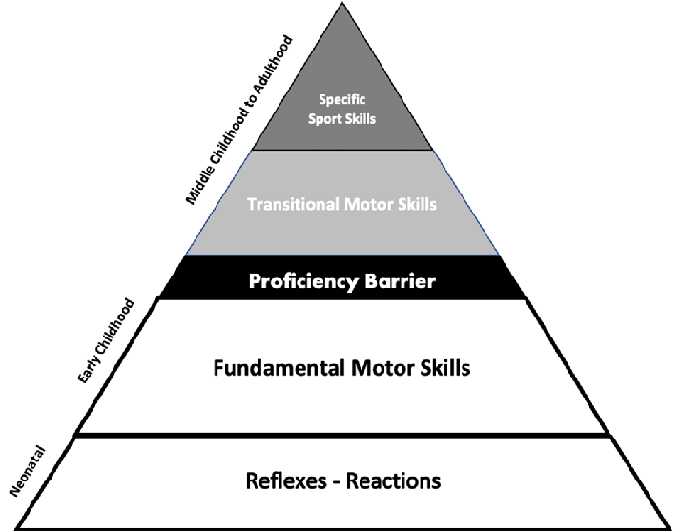

Gallahue et al. (2012)

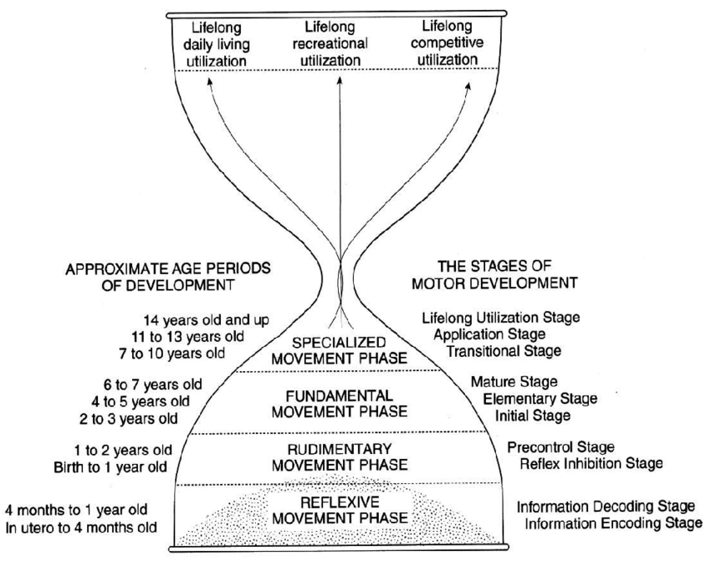

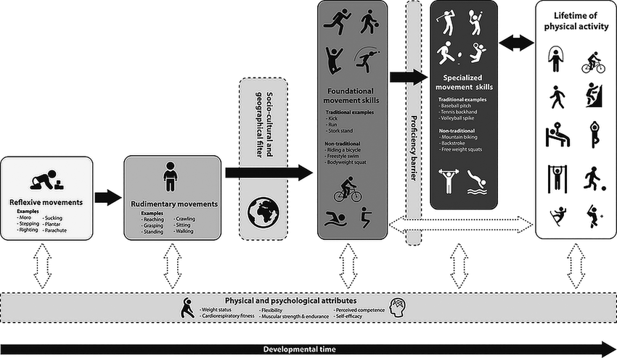
Hulteen et al. (2018)

Clark & Metclafe (2002)



