Chloe Burgess - 1600608
International trade
SBUS6113 - IFM

Executive Summary
During this report I gained an understanding of Islamic law and finance whilst analysing the success of it by investigating beneficial factors with the use of relevant sources. I then went on to evaluate whether Islamic finance is a means to financial institutions and money markets by investigating the growth of Islamic finance and the GDP growth rate of Malaysia. It was established that the main principles of Islamic finance, being the prohibition of riba and gharar are the reasons Islamic institutions were untouched by the 2008 financial crisis unlike traditional banks whose principles are based on interest and debt. Thus, leading them towards Islamic financial instruments themselves.

Contents page
Executive Summary 1
Introduction 3
What is Islamic law and finance? 3
Main Findings 4
The success and evaluation of Islamic finance 4/5
Recommendations 6
Conclusion 6
Appendices 7-10
References 11/12
Introduction
During this report I hope to understand and analyse the success of Islamic finance by investigating the positive impacts it has had in the countries that have adopted the model. I also aim to evaluate whether Islamic finance is a means to financial institutions such as banks and money markets when it comes to avoiding the peaks and troughs that have occurred in the financial markets. I hope to do so by looking at the GDP statistics in Malaysia and analysing the fluctuations as well as the use of relevant sources on statistics and growth.
Based on my findings I will make 3 recommendations as to whether Islamic finance is the way forward for International banks that adopt a different process.
What is Islamic Law and Finance?
Islamic Finance is a financial and banking system that operates in compliant with the Sharia law (Islamic law). The Bank of London and the Middle East (BLME), a Sharia compliant bank, stated that the main principle of Islamic Finance is to avoid all harmful (haram) activities such as charging interest (riba). In addition, Islamic financial institutions must ensure that ambiguity (gharar) or speculation/gambling (maysair) is minimal in all contracts and transactions. To comply with Sharia law financial institutions investing in alcohol, pornography, gambling or pork is impermissible (Warwick-Ching, 2010).
As all forms of interest are forbidden, the model works based on risk-sharing. This is where both the customer and the bank share the risk of any investment on fixed terms and divide any profits/losses between them (Warwick-Ching, 2010).
The main types of financial contracts offered by institutions include:
Fixed income contracts:
- Murabaha (form of credit sale)
- Sukuk (bond/debt finance)
- Ijara (form of lease)
Equity contracts:
- Mudaraba (partnership contract)
- Musharaka (joint venture)
(Burns, 2018)
The Sharia governance is a key part of Islamic financial institutions as it is the mechanism which determines the “Islamicity” of any specific Islamic business, financial institution and the whole system. Their main role is to ensure that the industry is always in accordance with the main principles of the Sharia law stated above (Laldin, 2018).

Main Findings
The success and evaluation of Islamic finance
Islamic finance hardly existed 30 years ago, yet today it is a $2.2 trillion industry with hundreds of specialised institutions in more than 60 countries. Islamic banks account for $1.5 trillion in assets and are expected to grow to $3.5 trillion by 2021 proving to be more valuable than conventional finance (Domat , 2018). Bankers in Dubai say that Islamic finance is becoming an important revenue generator for some of the world biggest lenders as revenue in the United Arab Emirates increased by 65% in 2011 compared to 2010 (Hall, 2012).
The main reason for the growth of Islamic finance occurred during the debt crisis in 2008 as Ozturk, cited by Ahmed (2011), declared that “Islamic finance entered a new stage of development, emerging after the global financial crisis as a more equitable and efficient alternative to the Western approach”. Thus, Islamic banks were not affected compared to traditional banks because they do not deal with debt trading and speculation whereas conventional banking (Western) does. As a result, David Cameron announced that the UK is to become the first non-Muslim country to issue Sharia compliant bonds with a special Islamic index being created on London’s Stock Exchange. This decision supports the recognition of the unique Islamic financial models as well as the important role it has in providing stable economic growth (Conversation, 2013).
According to Khan & Bhatti (2008) some of the core factors contributing to the success of Islamic finance are product innovation, spiralling oil prices, prolonged boom in Middle Eastern economies and IT advancements. Another factor being the growing population of Muslims who deposit their funds with sharia-compliant banks as North Africa is one of many places Islamic banking is growing due to the increase in Muslim population (Powell, 2018) (see appendix 1).
Malaysia is a strong example of a country where sharia-compliant banks have really exceeded globally in terms of return on assets and asset growth over the years, giving them a strong position in dominating the global sukuk (bond) market (King, 2015). Not only this but according to Mosaid & Boutti (2014) Malaysia accounted for 67% of issuing’s between 2009 and 2012 (see appendix 2) resulting in strong growth in the economy and sharia-compliant banks.
There have been multiple studies on examining the relationship between Islamic finance and economic growth. Moussa & Boukhatem (2018) focus on this study and concluded that economic growth encourages Islamic banking institutions to evolve and develop. Therefore, the relationship between Islamic banking and economic growth is bidirectional. Thus, I will be examining the GDP statistics of Malaysia who are known to have multiple Islamic institutions to identify fluctuations and whether Islamic finance has had an impact on their economic growth.
A healthy GDP rate is considered one that is sustainable (around 2-3%), so the economy always stays in the expansion phase of the business cycle (see appendix 3) for as long as possible (Amadeo, 2018). The expansion phase is between the trough and peak stages; this is when the economy is growing, with the GDP measuring the economic output of a country (Amadeo , 2018).
Looking at Malaysia’s annual GDP (see appendix 4) we can see the fluctuations in the bar chart and that they have never gone below 4% indicating that they are continuously in the expansion phase of the business cycle and have stable economic growth. Furthermore, by looking at their predictions (see appendix 5) we can see that they expect to continue being in the expansion phase as they estimate their lowest GDP growth rate of around 3.2%. This indicates there might be macro-environmental implications such as a shortage of demand, however it is still above the sustainable average of 2-3%. Economics (2018) states that this steady growth is mainly driven by domestic demand such as investments of Islamic finance. In relation to this, past studies have shown that GDP growth has a significant positive relationship with an Islamic institution’s profitability (Abduh & Idrees, 2013).
Now the regulators of Malaysia are using Islamic finance and diversifying into the green market by using investments to achieve a public good. July 2017, a Malaysian company issues $464million worth of bonds to finance a 50-megawatt solar power plant called the “green sukuk”, a bold new tool for development (Kwakwa, 2017).
It is thought that throughout the financial and economic crisis, one contrarian statistic stood out; the financial assets offered by the IFSI being Sharia-compliant, were less affected by the crisis. It is suggested that Islamic banks were untouched by the economic crisis due to the principles of their banking and especially because of the prohibition of riba (interest) and gharar (gambling) (Awsat, cited by Ahmed, 2011). The IFSI also proposes that they have replaced interest rates with rates of profit on equity, markup transactions and profit sharing finance.
The Islamic finance industry is viewed as a small one. However, it has developed significantly since the economic crisis and established itself as a globally viable alternative to the traditional banking industry. QIIB’s detection of excellence in Islamic financing is driven as much by shareholders desire to promote the growth of Sharia-compliant businesses as it is to generate returns for its customers (Finance, 2012). Not only this, but the banking sector has also been the driving force with Islamic banking assets from MENA, GCC, Sub-Saharan Africa, Asia and other regions going from an estimated 600bln in 2008 to an estimated 1.6bln in 2014 (see appendix 6) (House, 2014). Other regions include the UK who became increasingly interested in Islamic finance in the early 2000’s to aid in market growth and provide choice to the more than 2.5 million Muslim residents in the UK by introducing fully sharia-compliant banks and Islamic financial instruments into their banks (see appendix 7). The Islamic bond market started in the UK in 2007 and has continued to grow with 57 sukuk listings on London’s Stock Exchange, gaining a total value of $51bln by 2015 proving Islamic finance is slowing replacing traditional (Ord-Smith, 2015).
There are four key growth drivers to the Islamic banking industry as stated by House (2014) (see appendix 8). The main driver I picked up during this report is how the “financial crisis adversely affects the conventional banking systems”. Therefore, Islamic economists believe that if countries were to have used Islamic finance the crisis wouldn’t have happened hence why more non-Muslim countries like France, UK, Japan and Singapore are encouraging the use of it (Tutton, 2009).
Recommendations
- Other countries such as the U.S. who don’t use many Islamic financial instruments would benefit from Sukuk like the UK have with their sharia-compliant bonds as it has been recognised to boost economic growth.
- Islamic finance has an important role in the world of finance. However, to grow even further and have maximum efficiency the Sharia law can be altered to resonate with more people, not just Muslims and Sharia-compliant institutions and investments.
- Islamic finance can grow further by approaching and educating non-governmental organisations and communities who might not know much about Islamic finance and the benefits like until recently, myself.
Conclusion
To conclude, it is evident Islamic finance has been a success over the years since Islamic financing is based on producing money from tangible assets Islamic institutions are able to avoid economic crisis’s like the debt crisis in 2008, unlike conventional banking whose system is based on debt-trading – making money from money. However, it is considered that there are limitations when it comes to putting Islamic finance theory into practice in terms of laws, politics, regulations, taxation and consumer behaviour (Hayat, 2016). It is also clear that Islamic finance is becoming more of a means to institutions when it comes to avoiding troughs and peaks as the main principle is to inject equity into the economy through risk-sharing. Therefore, projects are thought about more carefully by both investor and investee before they are financed.

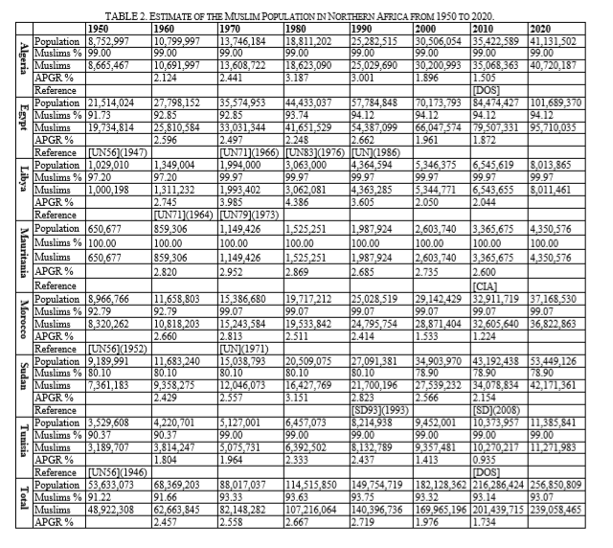
Appendices
Appendix 1:

A table illustrating an estimation of the Muslim population in North-Africa between 1950 and 20
(Kettani, 2010)
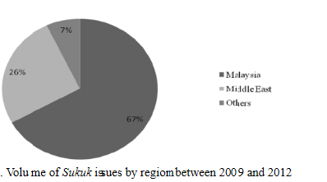
Appendix 2:

(Mosaid & Boutti, 2014)
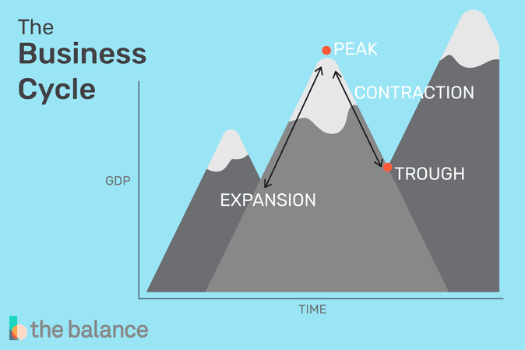
Appendix 3:

The business cycle showing the stages an economy goes through. Expansion is when money is being injected into the economy whereas contraction is when not enough money is being injected into the economy.
(Amadeo , 2018)
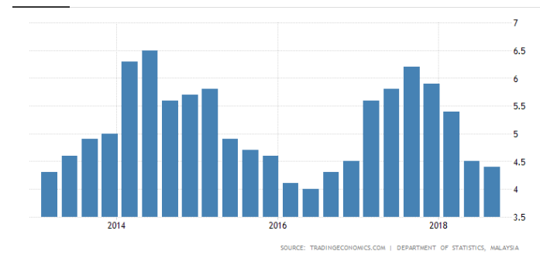
Appendix 4:

This chart illustrates the GDP growth rate for Malaysia between the years 2013-2015
(Economics, 2018)
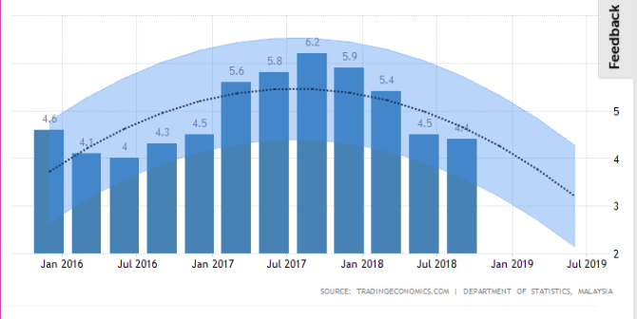
Appendix 5:

This chart illustrates the forecasted GDP growth rate for Malaysia from January 2016 to July 2019
(Economics, 2018)

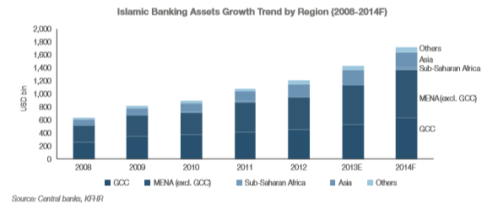
Appendix 6:
The growth of Islamic banking assets by region between the period 2008 and 2014.
(House, 2014)
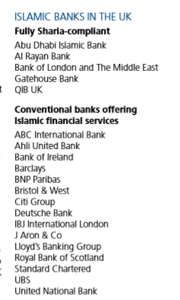
Appendix 7:

A list displaying the fully Sharia-compliant and conventional banks offering Islamic financial services in the UK

(Ord-Smith, 2015)
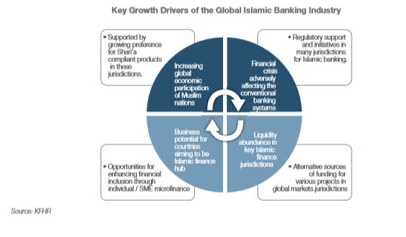
Appendix 8:
This appendix demonstrates the four key growth drivers of the global banking industry considered by (House, 2014) with the “financial crisis adversely affecting the conventional banking systems” picked up as one of the main factors for the success of Islamic finance.

References
Abduh, M. & Idrees, Y., 2013. Determinants of Islamic Banking Profitability in Malaysia. [Online]
Available at: http://www.academia.edu/8737586/Determinants_of_Islamic_Banking_Profitability_in_Malaysia
[Accessed 03 December 2018].
Ahmed, P., 2011. The Current Economic Crisis - Is Islamic Finance a Solution?. [Online]
Available at: https://www.huffingtonpost.com/parvez-ahmed/the-current-economic-cris_b_516965.html
[Accessed 04 December 2018].
Amadeo , K., 2018. What is the Business Cyle?. [Online]
Available at: https://www.thebalance.com/what-is-the-business-cycle-3305912
[Accessed 03 December 2018].
Amadeo, K., 2018. What is the Ideal GDP Growth Rate?. [Online]
Available at: https://www.thebalance.com/what-is-the-ideal-gdp-growth-rate-3306017
[Accessed 03 December 2018].
Burns, A., 2018. Week 6 Lecture 2 - Islamic Finance. Wales: Moodle.
Conversation, T., 2013. Explainer: how does Islamic finance work?. [Online]
Available at: http://theconversation.com/explainer-how-does-islamic-finance-work-19670
[Accessed 28 November 2018].
Domat , C., 2018. The first installment of a Global Finance FAQ web series on Islamic finance.. [Online]
Available at: https://www.gfmag.com/topics/blogs/islamic-finance-faq-what-islamic-finance-and-how-does-it-work
[Accessed 28 November 2018].
Economics, T., 2018. Malaysia GDP Annual Growth Rate. [Online]
Available at: https://tradingeconomics.com/malaysia/gdp-growth-annual#calendar-table
[Accessed 03 December 2018].
Finance, W., 2012. Global demand for Islamic Finance model. [Online]
Available at: https://www.worldfinance.com/banking/islamic-banking/global-demand-for-islamic-finance-model
[Accessed 04 December 2018].
Hall, C., 2012. Islamic banking: Impressive growth underscores success. [Online]
Available at: https://www.ft.com/content/09a99422-7291-11e1-9be9-00144feab49a
[Accessed 02 December 2018].
Hayat, U., 2016. Is the Islamic Finance Industry a Success or Failure?. [Online]
Available at: https://blogs.cfainstitute.org/investor/2015/02/18/is-the-islamic-finance-industry-a-success-or-failure/
[Accessed 02 December 2018].
House, K. F., 2014. Islamic Finance Outlook 2014. [Online]
Available at: http://www.mifc.com/index.php?ch=28&pg=72&ac=63&bb=uploadpdf
[Accessed 07 December 2018].
Kettani, H., 2010. Muslim Population in Africa: 1950 – 2020. [Online]
Available at: http://www.ijesd.org/papers/27-D436.pdf
[Accessed 03 December 2018].
Khan, M. & Bhatti, I., 2008. Islamic banking and finance: on its way to globalization. Emerald Insight, 34(10), pp. 708-725.
King, J., 2015. Malaysia's recipe for Islamic finance success. [Online]
Available at: https://www.thebanker.com/Markets/Islamic-Finance/Malaysia-s-recipe-for-Islamic-finance-success
[Accessed 03 December 2018].
Kwakwa, V., 2017. How Islamic finance is helping fuel Malaysia’s green growth. [Online]
Available at: https://www.scmp.com/comment/insight-opinion/article/2110938/how-islamic-finance-helping-fuel-malaysias-green-growth
[Accessed 04 December 2018].
Laldin, M. A., 2018. Duties and Responsibilities of Shari’ah Boards from a Legal and Regulatory Perspective. [Online]
Available at: http://www.amanieacademy.com/articles/item/duties-and-responsibilities-of-shari-ah-boards-from-a-legal-and-regulatory-perspective
[Accessed 29 November 2018].
Mosaid, F. E. & Boutti, R., 2014. Sukuk and Bond Performance in Malaysia. International Journal of Economic and Finance, 6(2), p. 227.
Moussa, F. B. & Boukhatem, J., 2018. The effect of Islamic banks on GDP growth: Some evidence from selected MENA countries. Borsa Istanbul Review, 18(3), pp. 231-247.
Ord-Smith, R., 2015. Islamic Finance in the UK. [Online]
Available at: https://assets.publishing.service.gov.uk/government/uploads/system/uploads/attachment_data/file/503491/2015047_Is_Fin_A5_AW_ENG_WEB.pdf
[Accessed 07 December 2018].
Powell, A., 2018. Islamic Banking Grows in Africa Amid Booming Muslim Population. [Online]
Available at: https://www.voanews.com/a/4626914.html
[Accessed 02 December 2018].
Tutton, M., 2009. Recession sparks interest in Islamic finance. [Online]
Available at: http://edition.cnn.com/2009/BUSINESS/08/25/islamic.finance/index.html
[Accessed 03 December 2018].
Warwick-Ching, L., 2010. Beginners' Guide to Islamic Finance. [Online]
Available at: https://www.ft.com/content/8c9bc2fc-8845-11df-a4e7-00144feabdc0
[Accessed 28 November 2018].

Islamic Financial Services Industry
Qatar International Islamic Bank’s

