University of Wales Trinity Saint David
Module: Effective team working and communication (BMSW4002_LON)
Lecturer: Mr Soban Sadiq
Student: Nevyana Nikolova (2111481)
Task: 1

Communication

Table of Contents

ⅠIntroduction 3
1. Definition of Communication 3
2. importance of communication at work 3
3. Communication Barriers 3
4. Consequences of a lack of communication 4
ⅡMain body 4
5. Communication Models 4
6. Schramm model of communication (1954) 8
7. Berlo's model of communication (1964) 9
8. Communication Skills 11
9. Communication Technology 12
Ⅲ. Conclusion 12
Ⅳ. References 13

ⅠIntroduction

1. Definition of Communication

Transmitting information from one person, place, or group to another is communication; the process usually consists of one sender, message, and recipient. Communication may seem simple, but it is to be highly complex.

2. importance of communication at work

The key to success in the workplace is communication; this principle applies to all industries and can boost teamwork and improve collaboration on projects. Communicating effectively helps ensure that management and the team below have the same viewpoint.

3. Communication Barriers

3.1. Language Barriers
A language barrier is a significant stumbling block to effective communication and the most common method of communication. Having different languages in each significant region is one of the communication barriers.

3.2. Barriers to psychological
Communication may be hindered by various psychological and mental issues, stage fright, speech disorders, or depression that can affect some people.

3.3. Barriers to emotional
A high emotional IQ determines how easily and comfortably a person can communicate; when a person is emotionally mature, they can communicate effectively. In contrast, people who allow their emotions to run the show will have difficulties.

3.4. Communication barriers caused by physical barriers
Generally, these barriers are relatively easy to remove; barriers such as noise, closed doors, faulty communication equipment, and closed cabins can affect communication. It is common for physical separations and faulty equipment in large offices to create severe barriers to effective communication.

3.5. Communication barriers based on culture
Globalisation continues to increase the possibility of having people from many different parts of the world working in a large office. Some fundamental values in society are understood differently in different cultures. Religion, food, and general behaviour are all significantly different across cultures

3.6. Barriers to technology
Keeping up with the newest developments is becoming increasingly difficult due to the fast pace of technology development. Technological advancement can sometimes be a barrier and sometimes expensive.

4. Consequences of a lack of communication

4.1. Incomplete understandings
Often, misunderstandings due to a lack of communication can cause problems in the workplace and always be misunderstandings, especially if the communication is unclear. When responsibilities are not spelt clearly, an employee could misunderstand what they are. If they did not fully understand, they might not do their job as well as possible.

4.2. Opportunities missed
When communications are lacking, opportunities are often missed, especially at work. Employees can be overlooked because they do not effectively communicate their interest in a promotion.

4.3. Unnecessary conflict
People may have assumed the other person was not doing a specific task, so they took it upon themselves, only to learn that the other person had already done it.

ⅡMain body

5. Communication Models

5.1. Shannon and Weaver's Model of Communication (1948/49)

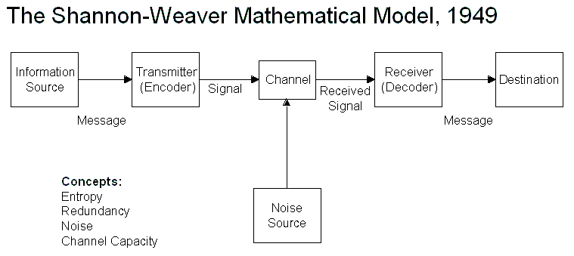
Source: (https://medium.com/2022)

5.2. Definition
This model is specifically designed to improve communication between sender and receiver; factors affecting the processes, such as "noise", are found. Models describe concepts such as sources of information, transmitters, channels, noise, messages, receivers, channels, information destinations, and encode and decode.

5.3. Essential points of Shannon and Weaver's model
- Sender
In communication, the sender is the one who drafts the message, chooses the channel, and sends it.

- Encoder
The encoder is the one who uses a machine, which converts messages into signals or binary data, or it can also refer directly to the machine.

- Channel
A channel is a medium for sending messages.

- Decoder
The decoder is the machine that translates signals or binary data into messages or the receiver that translates messages from signals.

- Receiver
The receiver is the person or location to whom the message is delivered. The receiver provides feedback regarding the message.

- Noise
The word "noise" refers to a physical disturbance to the message caused by the environment or by people.

5.4 Description of how Shannon and Weaver were probably thinking of physical noise
To improve the quality of communication, people who use this theory try to identify and minimise the causes of noise in communication.

A. Internal noise
- A message is decoded incorrectly when the sender encodes it incorrectly

- In the encoding process: for example, spelling mistakes in text messages

- People who have a headache cannot concentrate, speak with an accent, or mumble when speaking

B. External noise
- Results from something outside interfering with the message when the channel is being transmitted.

- For example, when we are having a conversation on a busy highway, the receiver is having difficulty hearing the discussion over the roar of the traffic.

5.5 Would it be possible to avoid any misunderstandings according to Shannon and Weaver's model

- The source of the noise should be detected, eliminated, or reduced. The speakers can reduce outside noise by closing doors and windows or locating themselves in an inner area of the place.

- Increase the speech volume; the speaker can raise their voice if they believe the listener cannot hear them well. Listeners who have difficulty understanding the speaker due to noise can ask the speaker to speak louder.

- The listener should attempt active listening. Listening closely means hearing what the speaker has to say and interpreting it from their point of view.

- Keeping the language clear and easy to follow prevents unnecessary confusion and misinterpretation.

5.6 Case study - Maria and Pedro
The story tells of a phone conversation between Maria and her husband, Pedro. Pedro receives a call from his wife Maria while working on the building site. Maria calls Pedro to ask him to buy a chicken when he comes home, but he understands Maria will wait for him in the kitchen. Pedro probably did not understand the telephone conversation with Maria because of the outside noise from the building site. The story explains Shannon and Weaver's model; the situation explains poor conversation because of the external noise. As a result of interrupted communication channels, messages cannot be effectively transmitted. Communication noise influences effective communication, affecting how conversations between Pedro and Maria are interpreted. The situation can be avoided if the noise is eliminated or reduced to detect the noise source or move the speakers to an inner building area to reduce outside noise.

5.7. Workplace example
I had an experience working as a nursery assistant a few years ago; I got a call from my daycare centre colleague. My colleague told me to buy flowers for our manager's birthday party, when I come to work, okay, no worries, I said. I went to work and got flour, I said to my colleague. She was looking at me very confused, and she said, but I said to buy flowers, no flour. It was very embarrassing, sorry I understood to buy flour to bake a cake for the party instead flowers. The problem is the noise; the situation can be avoided if my colleague had tried to go to a quieter room.

6. Schramm model of communication (1954)

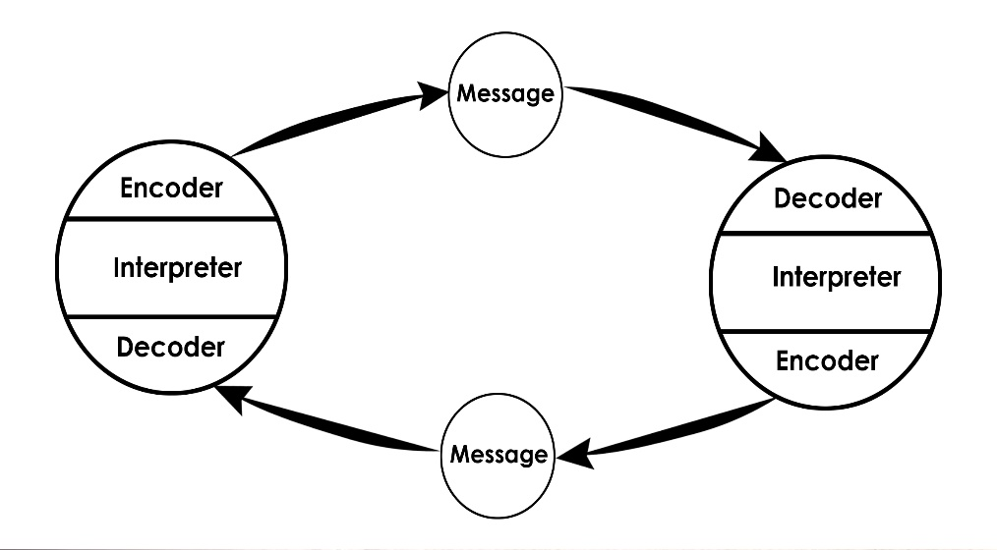
Source: (https://www.communicationtheory.org/2022)

6.1 Definition

The Schramm Model offers a classical view analysis and clarification for communication. Communication can be measured by examining how two people exchange information, attitudes, or ideas.
Coding and decoding are two essential processes of communication, according to Schramm.

6.2 Differences

The Schramm Model improves Shannon-Weaver. However, it does not address all communication elements. Shannon-Weaver lacks one element of communication: feedback, a unidirectional communication method. Using the Schramm model creates a two-way communication process since it recognises the importance of feedback.

6.3 Circular communication

There is a circular nature to the communication, as the model breaks the sender-receiver relationship nearly. Communication may happen within us or between two people; each person serves as both sender and receiver and thus uses interpretation.

6.4 How can interference be avoided?

The Schramm model can avoid interference and identify and understand the components and relationships within a communication process. Communication can be simple by considering concepts such as field of experience and commonality between the communicators. In order to plan for an effective communication system, we use models that represent new ideas on different aspects of communication.

6.5 Case Study, feedback: Maria and Pedro

Communication can be challenging when around is noise, and Pedro tries to understand Maria's messages. Pedro did not consider the construction noise, so he did not understand Maria's message. The moment his wife rang, Pedro had to go to a quiet place, but he neglected her call importance,

6.6 Workplace experience
In my workplace- the daycare centre, when my colleague called me to buy flowers, I bought flour: The problem was similar- the noise, she called me when the centre was busy and full of kids. My colleague had to call me in a quiet place, speak louder, and put the call on speaker.

7. Berlo's model of communication (1964)


Source: (www.communicationtheory.org/2022)

7.1 Definition
As an acronym, SMCR stands for Sender, Message, Channel, and Receiver and represents the entire communication system in its simplest form. In addition to the codes and decodes, this communication tool provides more efficient communication because it emphasises the coding and decoding of the message.

- Communication skills – speaking, listening, and reading
- Knowledge – Communicating requires the communicator to be knowledgeable about the subject or topic at hand

7.2 Case study: 'The Professor and the Village People.'
The story is about a professor who seeks help for his burning house from the villagers in the village, but they do not understand his academic and formal English. The villagers ignored the professor because he spoke too complicated English and used unfamiliar words about them. The professor had to use simple English and simple words so that they could understand it. In this situation, Berlo's model shows: The village people got the right message, but the message was not composed correctly. As a result of their poor communication skills, they could not understand the message since communication is more than just talking and about listening and understanding.

7.3 Workplace experience
I remember my first job in London as a nursery assistant and meeting with my manager. She was a British lady with a typical London cockney accent. I found it very difficult to understand, and I had to ask her to repeat what she was saying because English is not my first language, and I studied pure English in Bulgaria. The lady was very kind and said not to worry and that I would get used to the London accent at work.

7.4 Refer to theory from literary sources
Several factors can impair a listener's ability to understand a speaker, according to Hadley (1993). "For example, at my study place, the new German teacher, who came from Germany, came into the classroom. He started speaking directly to us in German, and we only studied German for a year, and we did not speak German outside the university. All the students looked at each other because we did not understand what he said, but we did not dare ask. If feedback had been provided to Maria and Pedro, confusion would have been avoided. In the same way, our teacher should ask us if we understand what he said. In this way, accidents will be avoided".

8. Communication Skills

8.1. Verbal or Spoken Communication
Generally, verbal communication means sharing information with other people by using words.

A. Case study – 'A Day with the Chief.'
Mrs Brown asks many questions salesman about the right approach and how people buy products. Mark begins to feel comfortable and shares about the irregularities in the London office. With this talk, he gains her disapproval, and she makes him leave.

8.2. Non-Verbal
Nonverbal communication includes body language, gestures, acting or dressing in a certain way, and even scents.

A. Case study – 'A Day with the Chief.'
Mrs Brown greets the salesman in her office with nonverbal communication, smiling and greeting him with a handshake. Mark calmed down, and as a sign of understanding, he sent non-verbal communication signals to the manager using actions rather than words. He loosens his tie, crosses his legs, and starts talking about the irregularities in the London office. In response, she sends non-verbal signals, squinting that she is unhappy and asking the secretary to ask him to leave. This story shows how important non-verbal communication is in the business environment and how we can make a wrong impression.

8.3. Active Listening - concentrating on the other person and not reading the phone, assuming what they say, or completing their sentences.

8.4. Empathetic listening - attempting to put them in the speaker's shoes as they speak.

A. Case study – 'Max the Multitasker'
The case study shows listening empathy; Max is an event organiser and tries to do several things at once to answer calls to take care of his mother and listen to and follow the instructions of his client Tamara who wants him to organise the 50th anniversary of her parents. Due to his many commitments, he failed to call Tamara on the changed date of the event and thus disappointed the guests. The situation could have been avoided by using active listening. Max had to concentrate and listen to the event and ignore everything else. In this situation, Tamara is suitable to be disappointed because the anniversary organisation was his responsibility; he had to use effective communication and proper delegation of tasks.

9. Communication Technology covers all types of technology such as phones, fax, television, video, and more recent computer-based technologies.

9.1 Advantages of Communication Technology
- Method of communication technology during emergencies that is faster
- The ability to communicate from anywhere in the world
- Reduces time spent on processes and tasks

9.2 Disadvantages of Communication Technology
- People of older generations find it harder to use
- The possibility of cyber-bullying and cyber-skyping
- Reduces personalisation in communication

Ⅲ. Conclusion

Communicating effective is perhaps the most critical life skill. The ability to communicate with other people, as well as to understand what they say to us, depends on understanding. Understanding the components and relationships of the communication process under study can be made more accessible by using communication models. We can plan for an effective communication system using models that introduce new ideas and thinking on various aspects of communication.

Ⅳ. References

Applegate, M., 2019. Advantages of Technology-Based Communication. [Online]
Available at: https://smallbusiness.chron.com/advantages-technologybased-communication-24971.html
[Accessed 01 May 2022].
Bonebright, D. A., 2010-02. 40 years of storming: a historical review of Tuckman's model of small group development. Human resource development international, 13(1), pp. 111-120.
Duck, S., 2021. Communication in everyday life: a survey of communication. 4 ed. Los Angeles: SAGE.
Saud, S., Jufri, A., Rahman, M. A. & Salam, 2014. Learning Devices Development on Descriptive Writing for Foreign Language Based on Berlo's SMCR Communication Model of Secondary School Student. Journal of Language Teaching and Research; London, 5(5), pp. 1033-1041.
Sypher, B. D., Bostrom, R. N. & Seibert, J. H., 19891001. Listening, Communication Abilities, and Success at Work. Journal of Business Communication, 26(4), 293-304.

