Marketing plan written for

Marriot International

Student Name: Valentina Teliban

Student ID number: 2210054

The module title: Marketing Essentials BMIH4005

Name of Teacher: Gayathri Mudiyanselage

Contents

Introduction 3
Situation Analysis 3
Objectives 6
Strategy 6
Tactics 8
Action 8
Control 9
Conclusion 9
Reference 10

Introduction
Marriot International, Inc. is an American multinational hospitality company that runs and franchises a large number of hotels and other lodging establishments. Marriot is a big hotel with a big staff and a lot of resources. It was started in 1927, and now they do business in about 131 countries. To serve their large number of customers, they have more than 150k employees. They have more brands than just hotels, but most people know them for their hotels. The hospitality business has a great deal of potential here to acquire new customers and raise its overall revenue by taking use of the multiple opportunities available. As a result of the spread of the Covid-19 virus, the hospitality sector is facing issues in terms of both retaining existing customers and acquiring new ones. This study's objective is to come up with a marketing plan that can be implemented at the chosen Hotel (Shykina, 2019).

Situation Analysis
The SWOT analysis of Marriot Int.
A SWOT analysis may be used to comprehend a company's advantages, disadvantages, opportunities, and threats. Marriot International is furthermore obliged to use the aforementioned devices to analyse these components (Pandi, 2020).
Strength | The name Marriot International is recognized the world over as the gold standard in the hospitality business. Marriot International places a premium on expanding into new international markets, and the corporation is making good use of the opportunities presented by globalization (Evans, 2019).
Weakness | While expanding into new overseas markets is a priority, the company's success will ultimately come from its domestic market dominance. Market volatility is therefore a risk it must consider. The worldwide division of Marriot is dedicated to constructing reliable and reputable brands. This makes the firm vulnerable to a downturn in overseas markets, not to mention the growing threat posed by smaller firms (Pandi, 2020).
Opportunities | Customers' preferences have shifted in recent years, with more and more solo and family vacationers opting for higher-end, more comfortable accommodations. The firm has invested in refurbishment since hotel guests like staying in historic properties with modern conveniences. The corporation views this as a chance to expand into a new market by restoring historic structures (El-Sawalhy & Farid, 2017).
Threats | There are certain parts of the hospitality sector, such as natural catastrophes, economic fluctuations, and assaults on visitors, that are, at times, unavoidable, and so social and economic unpredictability poses a danger to the firm. Customers' needs for travel and hotel bookings globally are shifting as a consequence of the unpredictability (El-Sawalhy & Farid, 2017).

Competitors
To know the position of Marriott Int. in the competitive market, Porter’s five Forces analysis can help.
Power of Suppliers | Suppliers have low bargaining power as suppliers are many in the market.
Power of customer | Customers have high power as there are low shifting cost to another hotel.
Threat of Substitutes | There are so many substitutes in the market due to new products and ideas (Zhang et al., 2015).
Threats of New Entry | In the fully competitive market, it is possible for anyone to entry in the market.
Competitive Rivalry | There are many rivals in the market (Zhang et al., 2015).

Customer
Segmentation: The hotel industry now caters separately to visitors and those of a more senior age bracket. The majority of younger individuals come here in search of adventure, while senior people come to enjoy their free time in a calm environment (Woldemariam, 2022).
Targeting: The young adults who spend a significant amount of time and money traveling and who spend nights in hotels are the primary demographic that the Marriot International aims to attract as customers (Woldemariam, 2022).

Collaborators
The company is now operated as a franchisee business, while in the past it was operated as a partnership business. On the other hand, the company is now considering entering into partnerships with major hotels in order to expand its operations around the globe.
Climate
The macroenvironmental variables in which an organization must operate are examined using the PESTEL study tool. There is evidence that major influences on a company's day-to-day operations come from the political, economic, social, technological, environmental, and legal spheres.
Political | Govt. policies, taxation and trade policies can affect the business.
Economic | Financial decision, budget and economic policies of govt. can have impact on Marriot Int.
Socio-cultural | Different taste of visitors from various cultures can influence the company.
Technology | Adapting rapid technological change in the world can affect in competition (Han et al., 2022).
Environmental | Environment ethics and environment friendly operation should practice (Han et al., 2022).
Legal | Legal rules and code can have impact on Marriot’s business policy (Zhiyong, 2017).

Objectives
The objectives of Marriot international should have been focused on some criteria which include that goals should be clear and specific, measurable so that progress can be tracked, realistic as to be attainable and time specific. SMART goal of Marriot international is-
Specific | All the goals of Marriot should be specific and clear.
Measurable | Marriott International should prioritize indicators that are in line with the priorities of its stakeholders.
Attainable | Marriott Int. can teach its employees to acquire the appropriate level of skills to fulfill the objectives established (Wernick & Von Glinow, 2012).
Realistic | All levels of management at Marriott Int. should include worker input when establishing attainable objectives.
Time Bound | In order to achieve the objectives stated by Marriott International, the details must be laid out in great detail (Wernick & Von Glinow, 2012).

Strategy
Value Proposition and Customer Segment
Marriott provides four major value propositions: accessibility, customization, cost reduction, and brand/status. The organization has made accessibility possible by offering several services and products (Hinterhuber, 2017). It manages a broad range of hotels under various names and pricing ranges, from the budget-friendly Fairfield Inn & Suites to the ultra-luxurious Ritz-Carlton. By providing vacation packages that highlight certain traits, like family-friendliness or adventurous dining, the firm facilitates personalization (Gale & Swire, 2011). Various programs are provided by the firm in an effort to save expenses. The hotel chain keeps up its Marriott Rewards guest loyalty program so that visitors may get rewards for their stays (Hormby et al., 2010).
Marriott has a segmented market business strategy, with clients that have somewhat varied wants. Through its several hotel chains, which cater to customers with differing budgets, the firm aims to appeal to a wide range of customers (Hormby et al., 2010).
Bowman’s strategy clock is used to determine the perceived customer value in case of the price of a product or service. However, Marriot International should use Bowman’s strategy clock while determining the price of the services provided as it has a major significant impact on the company’s revenue (Graça & Barry, 2019).
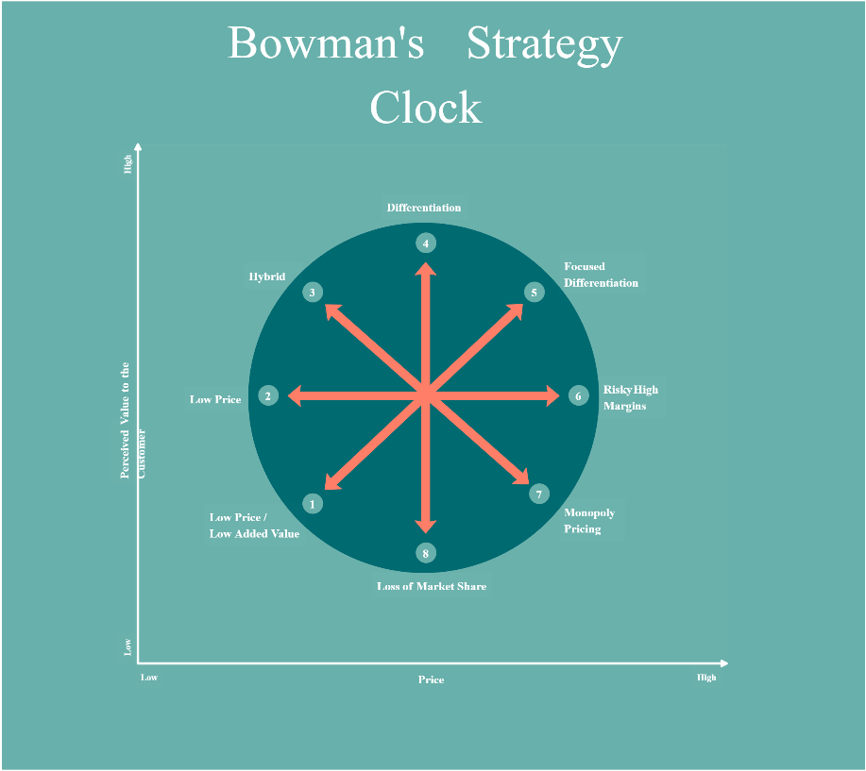

Tactics
Marketing Mix of Marriot International
The four P's of marketing are essential components of every successful advertising campaign. Product, pricing, promotion, and location are the four Ps of marketing. Managers and owners of organizations employ the 4Ps to guarantee client pleasure, set themselves apart from the competition, and increase their company's worth.
Product: Services and goods provided by Marriot are included. Since the company is in charge of the product's quality, warranty, appearance, packaging, and functionality, it has a responsibility to make sure its consumers are aware of and satisfied with all of these aspects (Hilal & Mubarak, 2015).
Price: Marriott should include not just the price in its pricing choices but also credit terms, payment plans, discounts, and any price matching services in its pricing determinations. Take the 10% off your whole purchase that Marriot may provide if you spend above a particular amount.
Promotion: Business name recognition may be achieved via advertising. For this purpose, the company will engage in public relations, advertising, and sponsorship. This may take the form of a business-oriented Twitter, Instagram, or Facebook account.
Place: When a company's goods and services are conveniently located, customers may buy them without much trouble and the company can maximize its profits. A nice spot would guarantee that Marriott can simply reach their items and therefore enhance their sales (Kiráľová, 2015).

Action
Gantt Chart
Gantt charts are useful for planning any form of activity since they show how long that activity will take. The goal of this Gantt chart is to keep track of Marriott International's marketing strategy from November 2022 to November 2023.

Control
The USP has been used as a means of tracking the control operations. To ensure that everything is okay with the company's promotional operations, a unique selling point has been set up at each target location. One of the main advantages of having a USP is that it allows you to provide better service to your clients while also making it easier for them to access your offering. One drawback of this novel approach to marketing is that it requires substantial financial investment by the organization to set up the distinctive selling proposition. The Marriot International will evaluate success by the improvement of the company operations and offering superior service to its clients. A strong marketing strategy will bring in more guests and lead to a higher profit margin.

Conclusion
The execution of all of the specified tactics and plans will determine whether or not this marketing strategy is effective. If visitors are concerned about the hotel's cleanliness or safety, it will be difficult for it to re-establish its positive image. Convincing visitors that the Marriot International Hotel has taken the necessary efforts to guarantee the cleanliness of their facilities and is using cutting-edge technology to enhance their infrastructure as a whole during COVID-19 is one of the biggest obstacles. Marriot International must research market trends and learn about the tastes of its clients in order to decide which areas need the most attention and which amenities should be extended. Marriot International has to have a solid understanding of the market's current status and what lies ahead in order to remain ahead of the competition and draw in new customers.

Reference
El-Sawalhy, H. and Farid, M.bellah (2017) “Hospitality Industry Development via scientific research: SWOT analysis,” Journal of Association of Arab Universities for Tourism and Hospitality, 14(2), pp. 133–139. Available at: https://doi.org/10.21608/jaauth.2017.48151. (Accessed: 23 November).
Evans, N. (2019) “SWOT analysis for tourism, hospitality and event organizations,” Strategic Management for Tourism, Hospitality and Events, pp. 337–348. Available at: https://doi.org/10.4324/9780429437601-12. (Accessed: 23 November).
Gale, B.T. and Swire, D.J. (2011) “Implementing strategic B2B pricing: Constructing Value Benchmarks,” Journal of Revenue and Pricing Management, 11(1), pp. 40–53. Available at: https://doi.org/10.1057/rpm.2011.44. (Accessed: 26 November)
Graça, S.S. and Barry, J.M. (2019) “A global examination of Cognitive Trust in business-to-business relationships,” New Insights on Trust in Business-to-Business Relationships, pp. 7–36. Available at: https://doi.org/10.1108/s1069-096420190000026005. (Accessed: 27 November).
Han, Y., Yang, Y. and Mohamed, R. (2022) “A bibliometric analysis of work engagement in the hospitality and Tourism Industry,” Journal of Hospitality and Tourism Insights [Preprint]. Available at: https://doi.org/10.1108/jhti-06-2022-0235. (Group,” International Journal of Psychosocial Rehabilitation, 24(5), pp. 1872–1877. Available at: https://doi.org/10.37200/ijpr/v24i5/pr201860. (Accessed: 28 November).
Hilal, M.I. and Mubarak, K.M. (2015) “Influence of selected groceries' marketing mix elements on business performance in the Eastern Province of Sri Lanka: Retailers' perspective,” International Journal of Business Performance Management, 16(2/3), p. 198. Available at: https://doi.org/10.1504/ijbpm.2015.068712. (Accessed: 30 November).
Hinterhuber, A. (2017) “Implementing pricing strategies,” Journal of Revenue and Pricing Management, 17(1), pp. 1–2. Available at: https://doi.org/10.1057/s41272-017-0129-6. (Accessed: 30 November).
Hormby, S. et al. (2010) “Marriott international increases revenue by implementing a group pricing optimizer,” Interfaces, 40(1), pp. 47–57. Available at: https://doi.org/10.1287/inte.1090.0482. (Accessed: 1 December).
Kiráľová, A. (2015) “Sustainable Tourism Marketing strategy,” Emerging Innovative Marketing Strategies in the Tourism Industry, pp. 54–77. Available at: https://doi.org/10.4018/978-1-4666-8699-1.ch004. (Accessed: 1 December).
Pandi, D.G.R. (2020) “SWOT analysis of Joint Liability Group,” International Journal of Psychosocial Rehabilitation, 24(5), pp. 1872–1877. Available at: https://doi.org/10.37200/ijpr/v24i5/pr201860. (Accessed: 1 December).
Shykina, O. (2019) “Research of operation of Marriott International Hotel Chain,” Pryazovskyi Economic Herald [Preprint], (6(17). Available at: https://doi.org/10.32840/2522-4263/2019-6-41. (Accessed: 3 December).
Wernick, D.A. and Von Glinow, M.A. (2012) “Reflections on the evolving terrorist threat to luxury hotels: A case study on Marriott International,” Thunderbird International Business Review, 54(5), pp. 729–746. Available at: https://doi.org/10.1002/tie.21496. (Accessed: 3 December).
Woldemariam, S.H. (2022) “Market segmentation strategy and excellent global brand positioning,” SSRN Electronic Journal [Preprint]. Available at: https://doi.org/10.2139/ssrn.4248439. (Accessed: 5 December).
Zhang, Y. et al. (2015) “A study of the commercial application of Big Data of the International Hotel Group in China: Based on the case study of marriott international,” 2015 IEEE First International Conference on Big Data Computing Service and Applications [Preprint]. Available at: https://doi.org/10.1109/bigdataservice.2015.59. (Accessed: 6 December).
Zhiyong, X. (2017) “Pestel model analysis and legal guarantee of tourism environmental protection in China,” IOP Conference Series: Earth and Environmental Science, 81, p. 012092. Available at: https://doi.org/10.1088/1755-1315/81/1/012092. Accessed: 6 December).



