
Bibek Khatri
Student Id - 2503477
CONSTRUCTION MATERIALS (ACBA4016)
HNC / HND / BSc Quantity Surveying
Lecturer – Alan Nantel
Contents
1.0. Introduction 1
2.0. Selection of Concrete Framed Building 1
2.1. Elements of the original design 1
2.2. Purpose and Location 2
2.3. Structural and architectural design features 2
2.4. Method of Construction 3
3.0. Framing Material (Reinforced Concrete) 4
3.1. Strength, Durability and climatic resistance 5
3.2. Time, Labour, programme and cost compared to steel framing 6
3.3. Ease of assembly and adaptability over building cycle 7
3.4. Integration of services and the way to overcome the problems 7
3.5. Concrete demolition challenges 7
4.0. Negative Impact of concrete production 8
5.0. Sieve Analysis 8
5.1. Sieve analysis particle size distribution table 9
5.2. Fine and Coarse aggregate mix calculation 9
5.3. Particle size distribution graph 10
5.4. Suitability of given sample 10
6.0. Conclusion 11
7.0. References 11

1.0. Introduction
Concrete is widely used in construction because it is strong and durable. It can handle harsh weather and chemical exposure. Its versatility in shaping makes it suitable for both structural and architectural uses. Over the years, concrete has shown to be a dependable material in building projects (Smarzewski and Stolarski, 2022).
Concrete-framed buildings use columns and beams as their main structure. These rest on a concrete foundation and support the floors, roof, walls, and cladding. This design is strong and can handle heavy loads from things like earthquakes and wind. Steel reinforcement makes the structure even stronger. Concrete frames also reduce noise, making them a safe choice for building design (www.designingbuildings.co.uk, 2020).

2.0. Selection of Concrete Framed Building
This assignment examines how concrete framing works, its performance in various situations, and the challenges involved. It also discusses the environmental impact of concrete production and reviews aggregate properties through sieve analysis.
This report uses the COPR 33 apartment block as a case study to show how concrete frames work in practice. The building mainly uses reinforced concrete for its columns, ramps, staircases, and floor slabs (Thamesvalleyconstruction.com, 2021).

2.1. Elements of the original design
The Copr Bay Phase One project cost £135 million and was led by Swansea Council with help from partners like Rivington Hark. The development added several new features, including:
- A 3,500-seat arena
- A new Bay Bridge crossing over Oystermouth Road
- A 1.1-acre coastal park
- A 33-apartment block managed by Pobl Group (which this report will focus on)
- New car-parking facilities (Swansea, 2025).

2.2. Purpose and Location
These new high-quality apartments and other city centre housing projects aim to enhance living standards for local residents. All Copr Bay apartments are affordable homes intended for people working in Swansea, with a focus on key workers.
The project is funded by Pobl Group and the Welsh Government. It provides 13 one-bedroom flats for two people and 20 two-bedroom flats for up to three people. Copr Bay supports the city’s regeneration by delivering quality, affordable homes for those who wish to live and work in the city centre (Swansea, 2022).

2.3. Structural and architectural design features
AFL Architects designed this building and later redesigned the 33-unit residential block as well (Afl-architects.com, 2025).
Taylor Maxwell provided six different colours of Corium brick-cladding tiles for the project, and Buckingham Group installed them. This cladding was chosen to make the building look attractive and stand out both day and night, as shown in the image below (Taylor Maxwell, 2017).

Picture showing colourful facade (Taylor Maxwell, 2017)
The picture below shows the Copr Bay 33 block apartment during construction, where the main components RC columns, beams, and slabs are clearly visible (Thamesvalleyconstruction.com, 2021).
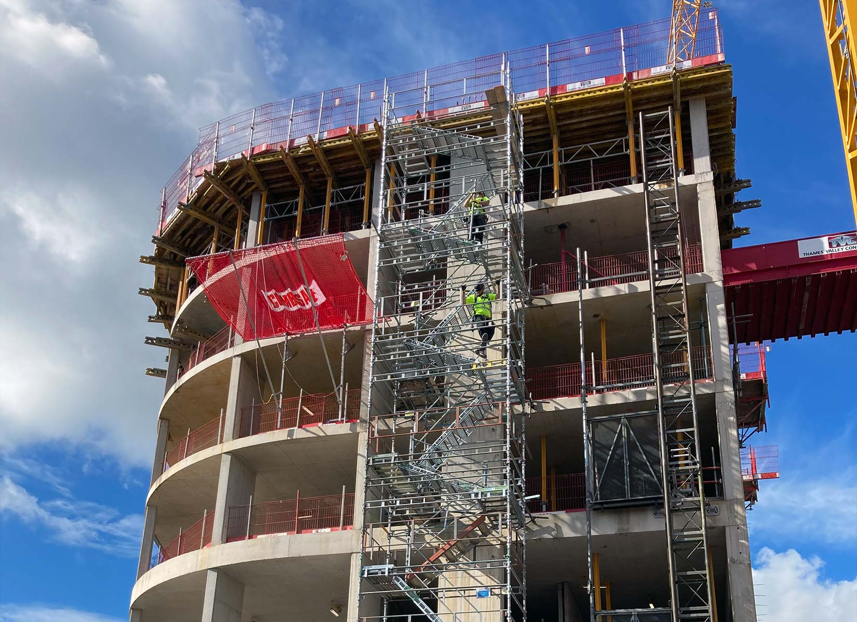
33 block apartment Copr Project Swansea (Thamesvalleyconstruction.com, 2021)

2.4. Method of Construction
Buckingham Group was first hired to deliver the £135 million Copr Bay Phase 1 project. The 33-apartment block was finished before the company went into administration. After Buckingham collapsed, Swansea Council brought in Andrew Scott Ltd to complete any remaining work (Youle, 2024).
Online sources and visual evidence show that the 33-apartment building in the Copr Bay project is a hybrid construction:
- The main structure adopts a traditional reinforced-concrete frame (Thamesvalleyconstruction.com, 2021).
- The exterior uses the Corium clip-on brick-cladding system, a modern prefabricated panelised facade technology (Taylor Maxwell, 2017).
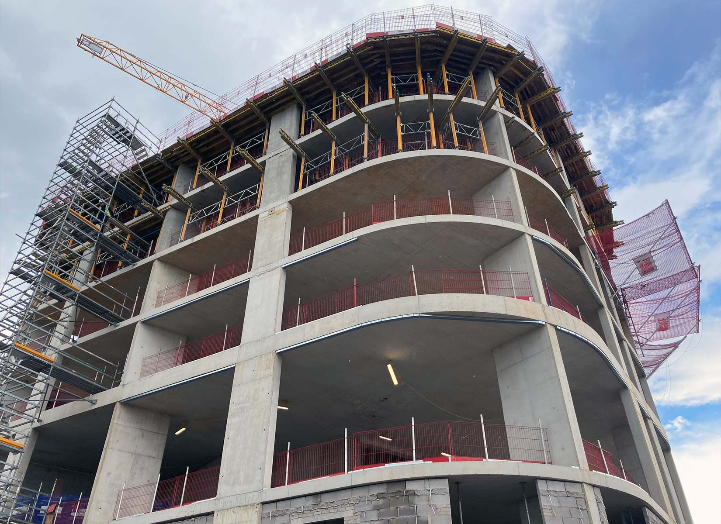
33 block apartment Copr Project Swansea (Thamesvalleyconstruction.com, 2021)

3.0. Framing Material (Reinforced Concrete)
A reinforced concrete (RC) frame is made up of columns, beams, and slabs that work together to support and spread the building’s load. Concrete is strong under compression, while steel reinforcement gives the frame the strength it needs to resist bending and stretching. Each part of the frame has a specific role:
- Columns carry the weight from the floors above and pass it down to the foundations.
- Beams link the columns and support the floor slabs.
- Slabs form the floors and ceilings of each storey.
These elements combine to create a strong, stable structure that can support many types of building designs. The Copr Bay 33-apartment block uses all these RC components in its construction (Frame, 2019).

3.1. Strength, Durability and climatic resistance
Concrete strength means how well hardened concrete can resist compression. It is measured in MPa or N/mm² and is important because it affects how concrete carries loads, resists cracking, and performs in various conditions. The main factors that affect strength are:
- Water–cement ratio
- Quality of compaction
- Curing conditions
- Cement type and amount
- Aggregate quality
- Admixtures (Concretemath.co.uk, 2025)
Concrete durability is its ability to handle weather, chemical attack, and abrasion while staying strong over time. The main tests for durability include:
- Compressive strength
- Permeability
- Rapid chloride penetration
- Carbonation resistance
- Freeze–thaw resistance
- Abrasion (Team, 2023).
Coastal areas like Swansea create extra risks for reinforced concrete, such as:
- Chloride attack from sea salts
- Faster corrosion of reinforcement
- Carbonation
- Freeze–thaw damage
Despite these risks, the Copr Bay 33 apartment block can stay durable if the right steps are taken. Using good materials, low-permeability mixes, proper compaction, enough concrete cover, correct curing, and protective coatings all help the building last longer. Regular inspection and maintenance are also important.
If these steps are followed, the RC frame of the Copr Bay 33 building can last a long time, even with chloride exposure and freeze-thaw cycles. This makes reinforced concrete a good choice for this coastal location (Moses, 2025).

3.2. Time, Labour, programme and cost compared to steel framing
When planning a new building, a major cost decision is whether to use a concrete frame or a steel frame. Both options offer good design flexibility and long-term performance.
Concrete is generally inexpensive, but costs go up when you add reinforcement, formwork, or complex shapes. Steel is usually made off-site, which can save on labour and on-site costs. In general, concrete uses cheaper materials, while steel can lower total costs by making installation faster (Profound Estimates, 2025).
For labour and construction speed, concrete requires skilled workers for formwork and steel fixing, plus time for curing. Bad weather can slow things down. Steel comes pre-made and ready to put together, so it needs fewer workers and has fewer on-site delays. This often makes steel faster and more efficient than concrete for many projects (Bob, 2025).
For the Copr Bay 33-apartment block, concrete framing is a better fit because the design needs good fire resistance, sound insulation, and lower long-term maintenance costs (Profound Estimates, 2025).
The Copr Bay 33-apartment block was built as part of a £135 million regeneration program. This meant the project had organized planning, funding, and efficient delivery. The larger scheme also boosted the local economy by creating jobs and attracting investment (Thamesvalleyconstruction.com, 2021).

3.3. Ease of assembly and adaptability over building cycle
Concrete framing takes longer to build and needs more workers because it requires formwork, reinforcement, and curing time, which can take 7 to 28 days. Concrete structures are also heavier and more rigid, so making changes later is hard. While concrete is durable, it is tough to modify unless the design is well planned from the beginning (Profound Estimates, 2025).
The Copr Bay 33-apartment building’s mid-rise height, simple layout, and planned internal spaces make it good for long-term residential use and allow some flexibility for future changes. The Corium brick-cladding facade also makes maintenance and replacement easy without affecting the main concrete frame during the building’s life (Taylor Maxwell, 2017).

3.4. Integration of services and the way to overcome the problems
Modern buildings need many systems, like mechanical, electrical, and plumbing. Since concrete frames are heavy and rigid, cutting into them after construction can weaken the structure. That’s why it’s important to plan ahead and include all needed services from the start. As technology changes, adding new systems later is hard because concrete frames are less flexible. So, the design should also allow for future upgrades (Jonnyhough, 2025).
The Copr Bay 33-apartment block was built with modern service integration in mind, including key building services, fire safety systems, and space for future telecom upgrades. Even though reinforced concrete can make service installation challenging, the project was completed to a high standard by experienced contractors like Buckingham Group. The building’s facade uses a non-load-bearing cladding system, so service updates and replacements can be done in the future without affecting the main structure (Thamesvalleyconstruction.com, 2021).

3.5. Concrete demolition challenges
Demolishing concrete structures is complicated and needs careful planning. There are different ways to do it, such as selective demolition, mechanical demolition, and controlled implosion. The best method depends on the building’s size, location, and safety needs.
The Copr Bay 33-apartment block is part of Swansea’s long-term sustainable regeneration plan. It uses modern reinforced concrete and a Corium brick-cladding facade. Since sustainability is a main goal, the building materials were chosen to support recycling and reuse. The reinforcement steel is fully recyclable, the Corium facade can be removed easily, and crushed concrete can be reused in new construction, like road bases and foundations (Concrete Reinforcing Steel Institute, n.d.).

4.0. Negative Impact of concrete production
Concrete is one of the most commonly used construction material Concrete is one of the most widely used building materials, but it has both advantages and disadvantages. Making concrete involves several energy-intensive steps that can harm the environment and nearby communities. Its production requires heating limestone to very high temperatures, which releases large amounts of carbon dioxide. This process is a primary source of greenhouse gas emissions. Other ingredients such as sand, gravel, and water are sourced from natural areas like rivers, coastlines, and quarries, which can cause erosion, habitat loss, and ecosystem disruption. The cement industry is estimated to produce around 8% of global CO₂ emissions (Team, 2025).
From an environmental point of view, the Copr Bay 33-apartment block is better than older concrete buildings because it uses modern materials and design methods. Much of the concrete can be recycled, the reinforcement steel is fully recyclable, and the Corium brick-cladding system can be removed and replaced as needed. These choices, along with the long life of reinforced concrete frames, make the building more durable over time (Concrete Reinforcing Steel Institute, n.d.).

5.0. Sieve Analysis
Sieve analysis is a test that checks the particle size distribution of aggregates. It shows how well the material is graded, which matters because particle size affects concrete’s strength, workability, and performance. This makes sieve analysis an important step when choosing the right materials (hitechciviltestlabspvtltd@gmail.com, 2025).
The following particle size distribution comes from a sieve analysis of ‘all-in’ aggregate used for making concrete. The original sample weighed 1250 g, and the test results are shown in the table below.

5.1. Sieve analysis particle size distribution table
Sieve Size (mm) | Mass(g) | % on sieve | % Passing
125 | 0 | 0 | 100
75 | 0 | 0 | 100
63 | 0 | 0 | 100
37.5 | 120 | 9.6 | 90.4
20 | 137 | 10.96 | 79.44
10 | 143 | 11.44 | 68.00
6.3 | 105 | 8.4 | 59.60
3.35 | 45 | 3.6 | 56.00
2 | 130 | 10.4 | 45.60
1.18 | 63 | 5.04 | 40.56
0.6 | 105 | 8.4 | 32.16
0.3 | 102 | 8.16 | 24.00
0.212 | 109 | 8.72 | 15.28
0.15 | 98 | 7.84 | 7.44
0.063 | 55 | 4.4 | 3.04

5.2. Fine and Coarse aggregate mix calculation
given total sample = 1250 gm
Sieve size >6.3mm will comes under coarse aggregate they are, 37.5, 20, 10 and 6.3 mm.
Total of these 4 sieves is = 120+137+143+105
= 505 gm
Conver to percentage = (505/1250) x 100 = 40.4 %
Rest comes under fine which will be = total sample – coarse aggregate
= 1250 gm – 505 gm
=745 gm
Convert to percentage = (745/1250) x 100 = 59.6 %

5.3. Particle size distribution graph
Below is the graph for particle size distribution,

5.4. Suitability of given sample
The aggregate sample provided is not suitable for the Copr Bay 33-apartment building because it has too many fine particles and not enough coarse ones. This poor grading can lower concrete quality. Poor gradation can cause several problems, such as:
- Honeycombing
- Higher water demand
- Segregation and bleeding
- Lower strength and durability
- Increased cost due to more cement being required
Because the project is in a coastal area, the concrete needs to be very durable and made with well-graded aggregates to handle harsh weather and environmental exposure.
If aggregates are not properly graded, more cement and water are needed, which weakens the concrete and lowers its long-term durability (https://www.facebook.com/engineerrahulkushwaha, 2025).

6.0. Conclusion
The 33 Copr Bay apartments are well suited to Swansea’s coastal environment because the reinforced concrete (RCC) structure resists wind, moisture, and salt air. RCC also gives the building a stable and long-lasting frame, making it a reliable choice for harsh coastal conditions.
Economically, the apartments help Copr Bay’s regeneration by bringing more people to the city centre. This supports local businesses and encourages long-term investment in the area.

7.0. References
Smarzewski, P. and Stolarski, A. (2022). Properties and Performance of Concrete Materials and Structures. Crystals, [online] 12(9), p.1193. doi: https://doi.org/10.3390/cryst12091193.
- www.designingbuildings.co.uk. (2020). Concrete frame. [online] Available at: https://www.designingbuildings.co.uk/Concrete_frame.
- Thamesvalleyconstruction.com. (2021). thamesvalleyconstruction.com | Swansea Arena. [online] Available at: https://thamesvalleyconstruction.com/portfolio_page/swansea-arena/ [Accessed 16 Feb. 2026].
- ‌LITERATURE REVIEW OF CONCRETE DURABILITY & SERVICE LIFE REQUIREMENTS IN GLOBAL CODES AND STANDARDS. (2020). Available at: https://www.acifoundation.org/Portals/12/Files/PDFs/ACIFDurabilitySLGlobalCodesandStandards-10Aug2020.pdf.
- Swansea. (2025). Copr Bay phase one - Swansea. [online] Available at: https://www.swansea.gov.uk/coprbayphaseone?lang=en [Accessed 2 Mar. 2026].
- Swansea. (2022). Residents start moving in to new Copr Bay apartments - Swansea. [online] Available at: https://www.swansea.gov.uk/CBapartments?lang=en [Accessed 2 Mar. 2026].
- Afl-architects.com. (2025). Page Restricted. [online] Available at: https://www.afl-architects.com/projects/swansea-central.
- Taylor Maxwell. (2017). Copr Bay Apartments | Corium Brick Cladding. [online] Available at: https://www.taylormaxwell.co.uk/projects/copr-bay-apartments [Accessed 2 Mar. 2026].
- Frame?, C. (2019). HYB Construction. [online] HYB Construction. Available at: https://www.hybconstructionltd.co.uk/blogs/understanding-rc-frames-in-construction.
- Concretemath.co.uk. (2025). Understanding Concrete Strength | ConcreteMath.co.uk. [online] Available at: https://concretemath.co.uk/uk-concrete-guide/guide-basics/understanding-concrete-strength/.
- Team, C.E. (2023). What is Durability of Concrete? Tests and Factor Affecting. [online] Civil Engicon- Civil Engineering and Construction Technology. Available at: https://www.civilengicon.com/2023/11/test-for-durability-of-concrete.html.
- Moses (2025). Protecting Reinforced Concrete Structures in Coastal Areas: Addressing Corrosion and Ensuring Durability. [online] Building and Construction. Available at: https://build-construct.com/structures/protecting-reinforced-concrete-structures-in-coastal-areas/ [Accessed 2 Mar. 2026].
- Profound Estimates. (2025). Concrete vs. Steel Framing: Which Is More Cost-Effective? — Profound Estimates. [online] Available at: https://profoundestimates.com/explanations/concrete-vs-steel-framing-cost-effectiveness.
- Bob (2025). Is Steel Or Concrete Cheaper? A Comprehensive Cost Comparison For Your Construction Project - ConcreteCaptain.com. [online] ConcreteCaptain.com. Available at: https://concretecaptain.com/steel-or-concrete-cheaper/ [Accessed 9 Mar. 2026].
- jonnyhough (2025). Integration of building services | Concrete Society. [online] Concrete Society. Available at: https://www.concrete.org.uk/fingertips/integration-of-building-services/.
- Team, I. (2025). Why is concrete bad for the environment? - The Institute for Environmental Research and Education. [online] The Institute for Environmental Research and Education. Available at: https://iere.org/why-is-concrete-bad-for-the-environment/.
- ‌https://www.facebook.com/engineerrahulkushwaha (2025). Complete Guide to Grading of Aggregates in Construction - Civil Tutorials. [online] Civil Tutorials. Available at: https://civiltutorials.com/grading-of-aggregates/.
- Concrete Reinforcing Steel Institute (n.d.). Green Construction. [online] CRSI: Concrete Reinforcing Steel Institute. Available at: https://www.crsi.org/reinforced-concrete-benefits/green-construction/.
- hitechciviltestlabspvtltd@gmail.com (2025). What is Sieve Analysis and Why It Matters in Construction - Hitech Civil Test Labs Pvt. Ltd. [online] Hitech Civil Test Labs Pvt. Ltd. -. Available at: https://hitechciviltestlab.com/what-is-sieve-analysis-and-why-it-matters-in-construction/.

