3/5/2023
CIVILS OPTION B – PEDESTRIAN FOOTBRIDGE WITH MINOR HIGHWAY WORKS fEASABILITY REPORT

Integrated Project personal submission
Brett Thomas Project Manager

Springfield Designs LTF
Document record
Name |  | Reviewed (Date)
Design Team
 | Brett Thomas – Project Manager | 25/01/2023
Client Team

Document Version – V0.1
Table of Contents
1. Introduction 3
1.1. General Information 3
1.2. Client Information 3
1.3. Outline Brief 3
2.6 Ecology Survey 5
2. Site Constraints 5
2.1. Highway Implications 6
2.2. Contractors Site Compound 7
Programme Constraints 9
Minutes of Meetings 10
Structural Calculations 25
Reference List 26

Introduction

General Information
With the continuing development and growth of the Prince of Wales Dock and its surrounding areas, a new pedestrian bridge is to be constructed from the Langdon Road roundabout to the Prince of Wales Dock. Currently to gain access between the two points mentioned above, it means a pedestrian walk of 750m taking approximately 9 minutes. The new proposed footbridge will mean this can be reduced to 150m taking approximately 2 minutes.
The moorings will look to further develop the area as a multi-use area and potentially bring further income into the University as the moorings can be hired out.
The feasibility study will ascertain through several initial assessments whether the practicality of the footbridge and additional works is a viable option.
The feasibility study will complete initial investigations which will look at the site location, any development constraints which can be linked to planning (planning consent, environmental issues, National resources Wales etc), the design specifications and initial design ideas for the client, estimates of cost of the programme, the phasing and length of the programme.
This information will be presented to the client with all findings, with feedback to be received at this early stage on design, programme, costings, and any other requirements. The development of the project will also be in accordance with BIM Level 2 which is the national standard.

Client Information
The client as part of the project has supplied the following information to the Design Team.
- Project AIR
- Project EIR
- Proposed Preferred Location
- Outline Brief

Outline Brief
The brief supplied by the client is as follows;
‘To meet the desired access requirements of the pedestrian traffic anticipated within the new development, your company is required to provide road access at the Langdon Road roundabout (adjacent to Beacon Health Centre) to the Prince of Wales Dock, and a pedestrian foot bridge crossing this dock from the plot site A14B to the plot B5. This bridge should be innovative in aesthetic and a landmark structure, it is also required to have a design inspired by the industrial heritage of the city.
It is also required that this footbridge is illuminated at nightfall. You are also required to provide walkway-linked moorings for the berthing of 60 motorboats on the eastern side of this bridge, within the Prince of Wales dock.’
.

2.6 Ecology Survey
A visual ecological survey has been carried out. There are no trees, grass, bushes or shrubbery in the area therefore, there will be no ecological implications when considering that. There may be implications due to working near a watercourse. Considerations will need to be made to protect the marine life. NRW will need to be informed and further investigations will need to be carried out to determine the scale of the extent of the measures required.

Site Constraints
The closest listed building is a tier-2 building at the western side of the dock which is the J-Shed Waterhouse, protected trees within the area are sparse and due to the nature of our works I do not believe there will be any involvement with protection orders on site. The dock retaining walls around the dock are listed grade II and need to be carefully considered during construction
The adjacent buildings on the north side of the bridge include the HMT Sancta Maria hospital which has a very modern design and is a new build that was developed in 2019-20. On the southern side we have the University of Wales Trinity Saint David SA1 IQ Campus and Student accommodation which are both new builds developed in 2018.
Planning consent from the Swansea council would be required due to planning permission from the UK Government for any development within towns and cities, we would have to submit an application to Swansea Council when we complete planning our build for them to approve it.
CADW will not need to be considered as our build is not in the vicinity of any CADW locations
Through previous ecology reports I have discovered that within the sea there is protected wildlife which include harbour porpoises, common dolphins, basking sharks, grey seals, leatherback turtles and sea birds. An archaeological desk-based assessment was made prior to the wider development of the SA1 Waterfront area commencing that indicate that archaeological remains are likely to be present in the application area which could present difficult development constraints, these include potential buried maritime archaeology, there is also a potential for buried prehistoric archaeology and potential buried inter-tidal archaeology
Foul water discharges must be drained separately from the site and no surface water shall be allowed to connect (either directly or indirectly) to the public foul sewerage system. Grey Water and Sewage may not be discharged into the dock. Arrangements must be made for disposal to road tanker at a designated berth within the dock system prior to berthing or on departure. All disposals of sewage to shore must be disclosed on the waste return forms.
The services in the area are adequate due to drainage in the dock already existing, Feeder pillars for power are also in the area There is also a need for utilities like rigging machines, platforms and lifts, generators and power-generating systems, and specialized tools and vehicles. Our bridge design also serves the purpose that it is intended and provides adequate service to pedestrians.

Highway Implications
Pedestrian and Vehicle Access must be maintained as part of the proposed brief. The existing footway is above minimum width requirements as outlined in design standards. As such minimal width capacity must be maintained during the design process.
The existing northern circulatory system is single file which is currently above design requirements for a single vehicle system. Langdon Road is above 5.5m width allowing for full access, Kings Road carriageway is above 5.5m allowing for 2-way vehicle flows.
Traffic management systems will need to be put into place to allow the proposed construction to take place, these systems will be placed in accordance with Chapter 8 (Traffic Management Regulations). Footway closures will need to be put into place to allow construction along the dock wall, there is currently alternative footway routes as such the placement of these systems will cause pedestrian disruption however is not envisioned to require additional measures except as those outlined in Chapter 8.
The SA1 Area has been in constant development for the past few years, the development has been a mix of commercial and residential builds. It has provided around 2,000+ new apartments and houses, business/offices, commercial leisure, there has also been hotel development, institutional facilities, and the planned construction of an onshore facility called the tidal lagoon. We will need to be mindful towards specific development during construction due to proximity like the development of private hospital HMT Sancta Maria, the new lock tidal basin connecting the Prince of Wales Dock directly with the River Tawe, the Discovery Leisure Quarter, with a multi-storey car park is also being part of the plan. a range of office developments and housing on King's road and a 645-bedroom student apartment complex. Thankfully it is predicted that none of these will clash with our project, so we won't need to be too cautious.

Contractors Site Compound
Proposed Site Compound would be as below;
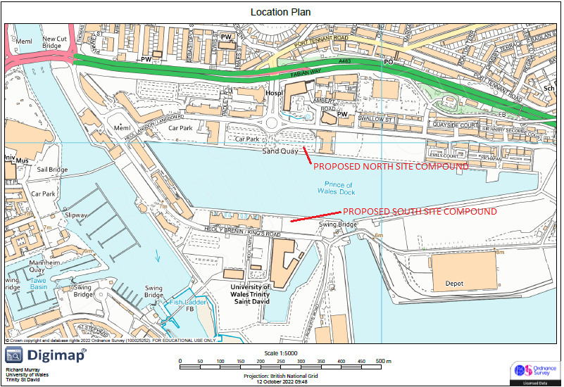
North Site Compound
Proposed northern site compound would utilise the existing hardstanding area located east of the existing vehicle access off Langdon Roundabout, this would allow easy access to the site. However, the car park is surrounded by chain link fencing. The fencing should therefore be removed to allow easy access to the proposed construction site.
Additionally, the existing access to the site would be through the proposed minor highway works off Langdon roundabout, a recommendation would be to create a temporary access to the site compound along Langdon Road involving removal of fence line and installation of temporary ramp facilities for the existing 125mm Half Battered Kerb line.
This area is also not publicly owned, as such additional site investigation would be required and negotiation with landowner would need to be considered with possible financial or accommodation works requiring to be carried out depending on results of negotiation.

South Compound
Proposed south compound would be directly adjacent to the proposed site with existing access shown in Figure 10. The height restriction would need to be removed with additional barriers (Harras Fencing or Banding) utilised along edge of site compound. Access would be provided from Kings Road with sufficient width to allow construction machinery to access the site.
Large vehicles utilising the site would need to make sure of Kings Road junction with Langdon Road or crossing A483, as A483 is a busy major road delivery of bridge base would need to be programmed to be during quiet period (i.e., outside of rush hour).
This area is also not publicly owned, as such additional site investigation would be required and negotiation with landowner would need to be considered with possible financial or accommodation works requiring to be carried out depending on results of negotiation.

Programme Constraints
- Location – due to the location on the dock and risk of adverse weather conditions additional float has been built into some of the activities to allow for down time due to poor weather conditions.
- Marine Life – there may be a requirement to have watching briefs from the NRW when works are ongoing within the dock area.
- External Utilities – delays on site regularly occur due to external utilities etc.
The scope currently has no weekend working and the full Christmas break. Dependant on the programme there are sufficient areas to make up any delays on site if required.
Comparisons were made on the two options of the bridges in terms of the programme.
There would be minimal difference in the terms of programme as reduction in some construction processes on the tilt bridge would be gained in some other activities on the vertical lift bridge.

Email from NRW – re advice on works in dock
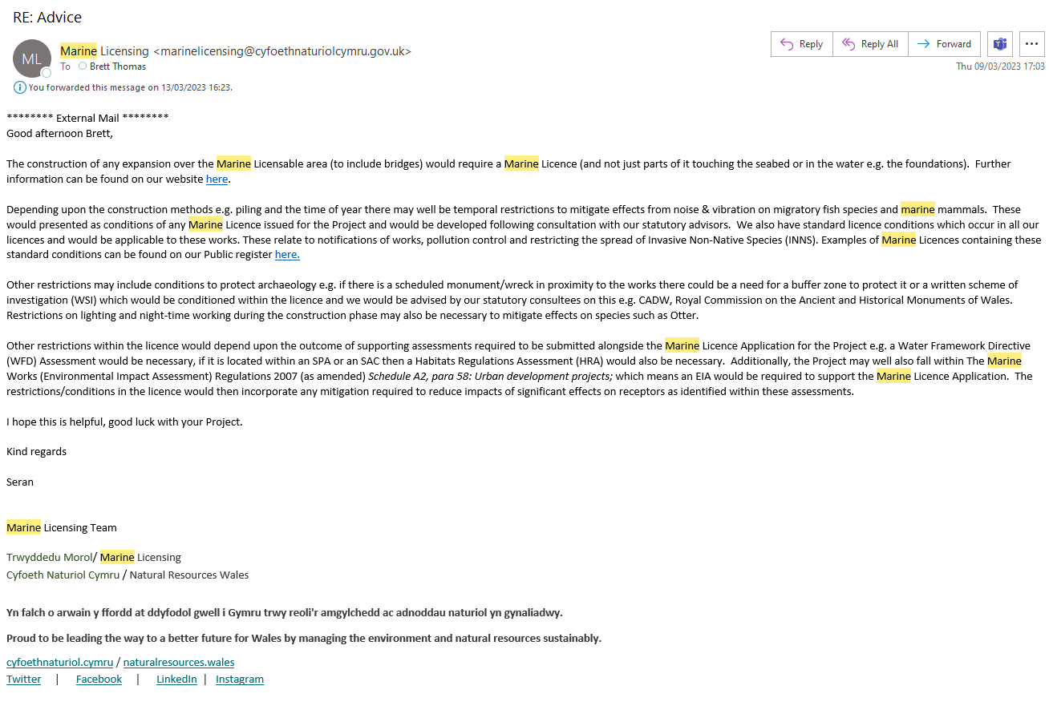

Minutes of Meetings
SPRINGFIELD Designs

Kick Off Meeting
10:30am, Wednesday 12th October 2022
Swansea Campus

- PRESENT
Brett Thomas (BT) Student – Project Manager
Rhys Ratner (RR) Student – Site Engineer
Jonathan Triggs (JT) Student – Quantity Surveyor
Richard Murray (RM) Student – Design Engineer
Ben Davies (BD) Student – Planning Engineer

- Following the first integrated project session the team met straight after to discuss roles – discuss preferred project moving forward and assign tasks.

- After all members of the team introduced themselves, discussion was undertaken around the different options of the three projects that were available as part of the civil cohort.
- Following the discussions – Project B was selected to move forward as the project for the team
- RM advised his experience with cad and civils 3d would make him ideal candidate for completing the design as part of the project. The team agreed and confirmed RM would be design engineer.
- BT confirmed his strengths of planning a project and managing the team so team agreed BT would be project manager.
- RR confirmed his site experience with on site work so RR would be the site engineer.
- JT predominantly worked on site but was happy to take on quantity surveyor
- BK was happy to take on planning engineer and look at the environmental impact and other planning information requires.

- Following further discussion the name Springfield Designs was created for the team.
- RM created a Whatsapp group for the team to communicate for proposed meetings, work assistance etc.
- Discussion around roles for the feasibility report and how to proceed with the different aspects of the report.

Meeting Ended – Next Meeting arranged for 19th October 2023

SPRINGFIELD Designs

Pedestrian Footway Bridge – Prince of Wales Dock
10:30am, Wednesday 19th October 2022
Swansea Campus/Microsoft Teams

- PRESENT
Brett Thomas (BT) Student – Project Manager
Rhys Ratner (RR) Student – Site Engineer

On Teams
Jonathan Triggs (JT) Student – Quantity Surveyor
Richard Murray (RM) Student – Design Engineer
Ben Davies (BD) Student – Planning Engineer

- Meeting started – BT introduces and advised meeting with clients confirmed for 02/11/2023 – Update from each team member on progress.

- BT confirmed he has completed the General Information for feasibility report – Introduction. Discussion on how to progress with a programme prior to design. Further information to be discussed with clients.
- RM has started looking and designing some ideas for the footbridge – team discuss a few potential options. RM had drawn some of the designs for the team to understand and discuss going forward.
- RR has attended the north connection of the site and completed an OGL – looking to complete the south connection point today.
- JT discussed concern around the costing part of the work without a design, team understood and discussed options. Potential to look at baseline costs off of spons civil engineer information, for length of footbridge and general works. JT to investigate and speak to Deborah Hughes.
- BK advised he is looking into planning information for the project. BT advised the council portal was a good location to look at the work.

Meeting Ended – Next Meeting arranged for 26th October 2023 – Campus/Teams

SPRINGFIELD Designs

Pedestrian Footway Bridge – Prince of Wales Dock
11am, Wednesday 26th October 2022
Whats App

- PRESENT
Brett Thomas (BT) Student – Project Manager
Rhys Ratner (RR) Student – Site Engineer
Jonathan Triggs (JT) Student – Quantity Surveyor
Richard Murray (RM) Student – Design Engineer
Ben Davies (BD) Student – Planning Engineer

- Catch – up via Whats App group

- Unfortunately, team unable to meet due to a variety of reasons.
- BT confirms information has been uploaded regarding the feasibility report.
- BT suggests team have a meeting before first presentation to collate information each member has completed and put into a presentation for the following morning meeting with the client.
- RM agrees and discusses points for us to discuss – what the site is, how are we going to deliver the project, concepts of the design being explored etc.
- JT, RR and Bk all agree with above. Date and time confirmed and planned for next meeting.

Meeting Ended – Next Meeting arranged for 01/11/2022 – Microsoft Teams

SPRINGFIELD Designs

Pedestrian Footway Bridge – Prince of Wales Dock
5pm, Tuesday 1st November 2022
Whats App

- PRESENT
Brett Thomas (BT) Student – Project Manager
Rhys Ratner (RR) Student – Site Engineer
Jonathan Triggs (JT) Student – Quantity Surveyor
Richard Murray (RM) Student – Design Engineer
Ben Davies (BD) Student – Planning Engineer

- Catch – up via Microsoft Teams

- Team discusses format for presenting the information to client team.
- Headings of work for each of the roles to be completed.
- Followed by next steps slide for each of the team members.
- BT advised presentation to be used that RM had uploaded to teams.
- BK required assistance for locating some information. BT advised of access to some information through workstream so sent over to BK
- RR confirmed site info and pictures taken.
- Team to meet tomorrow morning on campus to collate slides. (02/11/2022)

Meeting Ended – Next Meeting arranged for 02/11/2022 – Microsoft Teams

SPRINGFIELD Designs

Pedestrian Footway Bridge – Prince of Wales Dock
10:30, 02/11/2022
IQ – Client Team Meeting

- PRESENT
Brett Thomas (BT) Student – Project Manager
Rhys Ratner (RR) Student – Site Engineer
Jonathan Triggs (JT) Student – Quantity Surveyor
Richard Murray (RM) Student – Design Engineer
Ben Kneeshaw (BK) Student – Planning Engineer

Gavin Traylor (GT) Lecturer
Deborah Hughes (DH) Lecturer
Allan Nantel (AN) Lecturer

- Meeting on Teams to discuss updates in preparation for client meeting

- BT starts with introduction – outline programme, questions on BIM strategy – confirms teams being used as a sharing platform. Further work on feasibility report.
- RR updates on site – site investigation, RAMS and other potential associated works being considered.
- BK confirms number of planning applications in the area, potential protections on dock wall. No other major constraints at this time.
- JT confirms some potentials for consideration for the costs.
- GT advises 5 designs too much to take forward – feedback on 2 to take forward will be received.
- DH asks question around programme, and any potential issues with marine and timing of programme.
- AN discusses materials and advises to be innovative as possible.

Meeting Ended – next meeting – client meeting – 30th Nov 22 – 10:30

SPRINGFIELD Designs

Pedestrian Footway Bridge – Prince of Wales Dock
8:30pm, Monday 28th November 2022
Microsoft Teams

- PRESENT
Brett Thomas (BT) Student – Project Manager
Rhys Ratner (RR) Student – Site Engineer
Jonathan Triggs (JT) Student – Quantity Surveyor
Richard Murray (RM) Student – Design Engineer
Ben Davies (BD) Student – Planning Engineer

- Meeting on Teams to discuss updates in preparation for client meeting

- BT starts with introduction – confirms information the client wants to be updated with – individual updates, design concepts, bim strategy, questions for client, feasibility report update and next steps.
- BT confirms an outline programme – this to be progressed further once the design has been selected by the client team due to specific actions for the programme. Introduction confirmed for feasibility report. BIM – teams to be used a sharing source by the team.
- RR updates on site – access to OGL findings – site investigation work from desktop – new boreholes required. marine access concern – further info required – existing utilities to the area.
- BK confirms notes of contaminated land around the dock, further precautions may be required. surface water discharge allowed. No foul. No flood reports required.
- RM shows first developed concept idea with some measurements and details for materials.
- JT confirms different aspects for consideration for the costs of project, capital costs, contractor costs, whole life costs, maintenance costs, misc costs.
- Details all collated in presentation ready for client meeting

Meeting Ended – next meeting – client meeting – 30th Nov 22 – 10:30

SPRINGFIELD Designs

Pedestrian Footway Bridge – Prince of Wales Dock
17:00 – Tuesday 10th January 2023
Whats App/Teams

- PRESENT
Brett Thomas (BT) Student – Project Manager
Rhys Ratner (RR) Student – Site Engineer
Jonathan Triggs (JT) Student – Quantity Surveyor
Richard Murray (RM) Student – Design Engineer
Ben Kneeshaw (BK) Student – Planning Engineer

- Team updates in preparation for client meeting

- BT starts with introduction – confirms update requirements for 11th.
- Team discuss progress with feasibility report link to make sure all bases are covered.
- RR updates on feasibility report section for assigned work 90% complete. Site investigations discussions. Location information etc all completed.
- BK confirms additional information for marine work located and will be updated in feasibility.
- JT confirms outline costs 80% complete – feasibility report updated.
- RM confirms detailed design for 2 no bridges nearly complete with feasibility report. RM offers to compile the feasibility report based on previous reports hes completed. Team agrees.
- Bt confirms outline programme complete ready for feasibility report.

Meeting Ended – 11th January 2023 – Client meeting update

SPRINGFIELD Designs

Pedestrian Footway Bridge – Prince of Wales Dock
10:30 – Wednesday 11th January 2023
IQ Campus

- PRESENT
Brett Thomas (BT) Student – Project Manager
Rhys Ratner (RR) Student – Site Engineer
Jonathan Triggs (JT) Student – Quantity Surveyor
Richard Murray (RM) Student – Design Engineer
Ben Davies (BD) Student – Planning Engineer

Gavin Traylor (GT) Lecturer

- Client Meeting – Brief update in readiness for feasibility report

- BT starts with introduction – confirms update requirements for 11th.
- Team discuss progress with feasibility report link to make sure all bases are covered.
- RR updates on feasibility report section for assigned work 90% complete. Site investigations discussions. Location information etc all completed.
- BK confirms additional information for marine work located and will be updated in feasibility.
- JT confirms outline costs 80% complete – feasibility report updated.
- RM confirms detailed design for 2 no bridges nearly complete with feasibility report. RM offers to compile the feasibility report based on previous reports hes completed. Team agrees.
- Bt confirms outline programme complete ready for feasibility report.
- GT confirms expectation for feasibility and the requirement of information that is due.

Meeting Ended – 25th January 2023 – Viva Presentation

SPRINGFIELD Designs

Pedestrian Footway Bridge – Prince of Wales Dock
10:30 – Wednesday 25th January 2023
IQ Campus – Viva Presentation

- PRESENT
Brett Thomas (BT) Student – Project Manager
Rhys Ratner (RR) Student – Site Engineer
Jonathan Triggs (JT) Student – Quantity Surveyor
Richard Murray (RM) Student – Design Engineer
Ben Davies (BD) Student – Planning Engineer

Gavin Traylor (GT) Lecturer
Deborah Hughes (DH) Lecturer
Allan Nantel (AN) Lecturer
Shaker Bitar (SB) Lecturer

- Client Meeting – Viva Presentation of the Feasibility Report

- BT starts with introduction of team – roles and responsibilities, discusses the scope of the works, background of the scheme, outline brief, BIM requirements, Programme, funding requirements.
- RR updates site location, site investigations, any issues on site and other utilities.
- BD updates the client on site information for development, any constraints through planning, investigations of any restrictions to the site.
- JT confirms potential costs associated with the project. Capital costs, contractor costs, additional specialist costs.
- RM shows clients detailed design for 2 no bridges – discusses the different options available and the different mechanisms of both designs.
- GT confirms selection of which bridge to develop into full scheme will be advised to the team once the client has reviewed.
- AN touches on calculations for the beams of the bridge, types of materials to consider additionally.
.

Meeting Ended

SPRINGFIELD Designs

Pedestrian Footway Bridge – Prince of Wales Dock
18:00 – Monday 13th March 2023
Microsoft Teams

- PRESENT
Jonathan Triggs (JT) Student – Quantity Surveyor
Richard Murray (RM) Student – Design Engineer

APOLOGIES
Brett Thomas (BT) Student – Project Manager
Rhys Ratner (RR) Student – Site Engineer

NO RESPONSE
Ben Davies (BD) Student – Planning Engineer

- Team catch up

- RM starts meeting and transcript
- Apologies confirmed from BT and RR due to work commitments.
- RM discusses work completed since last meeting, design drawings have been nearly finished to a point – some annotation required.
- RM confirms with completion of design information index and database to be produced.
- RM touches on steel calculations and assistance required in calculating these.
- JT confirms he required more information from programme and works in order to start collating the cash flow and forecasting. Further info required from client to assist with this also.
.

Meeting Ended

SPRINGFIELD Designs

Pedestrian Footway Bridge – Prince of Wales Dock
Wednesday 22nd March 2023
Microsoft Teams

- PRESENT
Brett Thomas (BT) Student – Project Manager
Rhys Ratner (RR) Student – Site Engineer
Richard Murray (RM) Student – Design Engineer
Jonathan Triggs (JT) Student – Quantity Surveyor

APOLOGIES

NO RESPONSE
Ben Davies (BD) Student – Planning Engineer

- Team catch up

- BT starts meeting and transcript
- No response for second meeting from Ben, discussion in the team for next steps. BT confirms he will contact Gavin to see if there is any information on BD whereabouts. And whether we try to progress without him in the team. But at this late stage picking up bens work will be difficult.
- BT goes through word document to see assigned roles and tasks within the team. Discussion on the points each member of the team have left, if there is any assistance required and/or extra points to pick up.
- Allocation of the work and who has completed what as part of the information for the integrated project.
- The team confirm their points and how much work of each point they feel they have completed in a percentage to allow the PM (BT) to track the progress of each individual.
- RM touches on steel calculations again, this is largest area of concern within the team. Meeting arranged with Shaker Bitar to assist.
.

Meeting Ended – Next Meeting Scheduled for 29th March 2023

SPRINGFIELD Designs

Pedestrian Footway Bridge – Prince of Wales Dock
Wednesday 29th March 2023
IQ - Campus

- PRESENT
Brett Thomas (BT) Student – Project Manager
Rhys Ratner (RR) Student – Site Engineer
Richard Murray (RM) Student – Design Engineer
Jonathan Triggs (JT) Student – Quantity Surveyor

Shaker Bitar (SB) Lecturer

APOLOGIES

NO RESPONSE
Ben Davies (BD) Student – Planning Engineer

- Team catch up – meeting with SB

- Team have a general catch up on the progress so far.
- Each member updates on their work to date.
- SB arrives and team go through assistance with structural calculations for a steel beam.
- RM confirms he will look at some initial calcs and team will review and then calculate where possible.
With Easter Break team confirm meetings to commence following easter break unless there are any urgent issues and whats app to be used.
.

Meeting Ended – Next Meeting Scheduled for 19th April 2023

SPRINGFIELD Designs

Pedestrian Footway Bridge – Prince of Wales Dock
Wednesday 21st April 2023
MS Teams Meeting

- PRESENT
Brett Thomas (BT) Student – Project Manager
Rhys Ratner (RR) Student – Site Engineer
Richard Murray (RM) Student – Design Engineer
Jonathan Triggs (JT) Student – Quantity Surveyor

APOLOGIES

NO RESPONSE
Ben Davies (BD) Student – Planning Engineer

- Team catch up

- Team have a general catch up on the progress so far.
- Each member updates on their work to date.
- No issues to discuss on the call
- BT confirms he will compile the minutes of meetings as part of the document.
- Team confirm plans to print off and collate work, BT happy as PM to collate the information in the folder. RM offers to assist. Date confirmed to be done on campus.

.

Meeting Ended – Next Meeting Scheduled for 24th April 2023

SPRINGFIELD Designs

Pedestrian Footway Bridge – Prince of Wales Dock
Monday 24th April 2023
MS Teams Meeting

- PRESENT
Brett Thomas (BT) Student – Project Manager
Rhys Ratner (RR) Student – Site Engineer
Richard Murray (RM) Student – Design Engineer
Jonathan Triggs (JT) Student – Quantity Surveyor

APOLOGIES

NO RESPONSE
Ben Davies (BD) Student – Planning Engineer

- Team catch up

- Team have a general catch up on the progress so far.
- Each member updates on their work to date.
- Issue around BD discussed. Further contact to clients but assumption BD is not continuing with the project.
- RM confirms issues with calculations. Team discuss. Each member going to attempt and confirm in whats app group.
- Team discuss meeting 03/05/2023 in am to compile printed data. – RR and JT unable to attend to BT to compile their info.
- RM will attend with his details.

.

Meeting Ended – Next Meeting Scheduled for 26/04/2023

SPRINGFIELD Designs

Pedestrian Footway Bridge – Prince of Wales Dock
Wednesday 26th April 2023
MS Teams Meeting

- PRESENT
Brett Thomas (BT) Student – Project Manager
Rhys Ratner (RR) Student – Site Engineer
Richard Murray (RM) Student – Design Engineer
Jonathan Triggs (JT) Student – Quantity Surveyor

APOLOGIES

NO RESPONSE
Ben Davies (BD) Student – Planning Engineer

- Team catch up

- Team have a general catch up on the progress so far.
- Each member updates on their work to date.
- Issue around BD discussed. Further contact to clients but assumption BD is not continuing with the project.
- RM confirms issues with calculations. Team discuss. Each member going to attempt and confirm in whats app group.
- Team discuss meeting 03/05/2023 in am to compile printed data. – RR and JT unable to attend to BT to compile their info.
- RM will attend with his details.

.

Meeting Ended – Next Meeting Scheduled

Structural Calculations
Based on initial calculations completed by Richard Murray.
I have attempted to calculate an I beam suitable to carry the load of the structure.
Dead Load – 25.826 kn/m
Live Load – 5kn/m
UDL – 44.16KN/m
Moment $\frac{ωl^{2}}{8}=\frac{44⋅16×60}{8}=19872 kn/m$ –
Shear - $\frac{wl}{2}=\frac{44.16*60}{2}$= 1324.80
Deflection Limit = $\frac{span}{250}$ $\frac{span}{500}$ $\frac{span}{360}$ = 240mm total load – 120mm dead load = 160mm live load
$$I\operatorname{Re}{Q}=\frac{5}{384}x_{\overline{ε55}}^{wl^{4}}$$
$$\frac{5}{384}×\frac{30.824×{60000}^{4}}{{20500}^{0}×{240000}^{4}}=10,572256$$

Based on this calc we can compare to the blue book of steel.
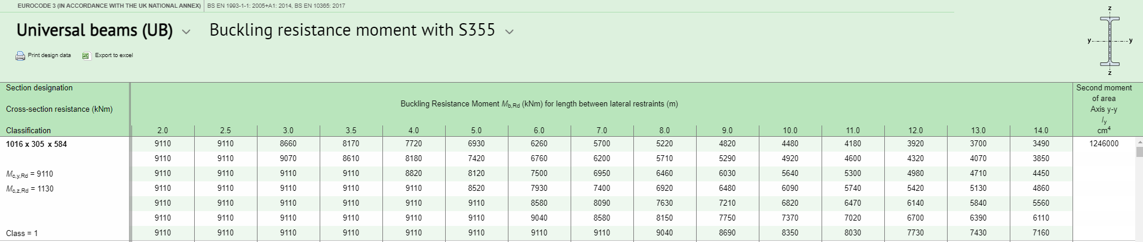
This gives a max buckling limit of 1246000 < 10577256.
This indicated the largest UB for this project would not be sufficient.
This would require additional supports or specially fabricated beams for this project.
Reference List
Er Lles Pawb. for us all, to keep. (no date) Cadw. Available at: https://cadw.gov.wales/ (Accessed: May 3, 2023).
Universal beams (UB) (no date) Buckling resistance moment with S355 - Blue Book - Steel for Life. Available at: https://www.steelforlifebluebook.co.uk/ub/ec3-ukna/buckling-resistance-s355/ (Accessed: May 3, 2023).

