University Trinity Saint David
Institute of science & art

Engine Performance Characteristics
Motorsport Technology ACHA4004

Calum Campbell
2001090
Date (03/22)

Contents
1 Introduction 1
1.1 Uses of Dynometers 1
1.2 Types of Dynometers 1
1.3 Aims and objectives 1
2 Methodology of UWTSD’s Dynometer 2
2.1 How it works 2
3 MATLAB 3
3.1 Methodology 3
4 Results and Analysis of MATLAB Data 4
4.1 Torque and Corrected power Vs RPM graph 4
4.2 BMEP vs Thermal Efficiency 4
4.3 SFC Heat Map 6
4.4 Pressure Vs RPM and Crank Angle 6
5 Conclusions 8
6 Referances 9

Figure 1 - Functions Produced from MATLAB 5
Figure 2 - Dyno Graph 6
Figure 3 - BMEP and Thermal efficency Vs RPM 7
Figure 4 - SFC Heat Map 8
Figure 5 - Pressure Vs RPM and Crank Angle 8
Figure 6 - pressure vs Crank angle diagram 9

Introduction

Uses of Dynometers
Dynometers are widely used throughout the automotive industry to measure an engines performance, with data sets such as BHP, KW, Torque, Load and emissions being able to be recorded to name but a few. As supported in the article below in regards to testing methods
(Menon et al., 2006)

Types of Dynometers
There are three main types of dynometer’s, There is a friction based dyno which can only withstand low load and low rpm use. A water based Dyno using mechanical and fluid interaction and is very dependent on calibration. An Eddy current Dyno, this uses magnetic fields and the disruption through the magnetic field provides more accuracy as electricity does not degrade, It is capable of transient measurements.

Aims and objectives
The aims and objectives of this report are to discuss how Dynometers operate, understanding how to use MATLAB And discussing results obtained while using MATLAB software when reviewing the dyno information of a Honda D16 engine.

Methodology of UWTSD’s Dynometer
UWTSD’s Dyno is an Eddie Current dyno, model SCHENCH WS230, able to withstand a max of 230KW and a maximum of 10000RPM.

How it works
To supply fuel to the engine, a lift pump is used to pump fuel from a fuel tank into the fuel filter, up to the fuel flow meter which then goes to a swirl pot, this is then fed into the main fuel pump going to the engine via the fuel flow meter.(this enables running a fuel injection systems or non fuel injected engines). The fuel return line is placed after the fuel flow metre so that the fuel flow metre only registers what fuel is used during running conditions. An extraction pipe is attached to the exhaust truemove exhaust gases. Some sensors on the engine are maintained, with those being the coolant temperature sensor, the fuel flow metre and the Lambda sensor.
The throttle is controlled by a throttle actuator box which gives recorded throttle position readings. Ultimately, basic functions are controlled by the sensor modules and main controls on the dynometer.
The engine is connected to the dyno by a drive shaft bolted directly to the crankshaft via 1:1 direct drive. Sensors on the dynamometer itself are a coolant temperature sensor and a speed sensor this dyno has the capability to fit over 2000 different sensors depending on the use and the engine.
On the dyno the inner core spins via the drive shaft to the engine, the outer casing produces an emf which puts a load on the inner core reducing the engine rpm.
A strain gauge is used and sends a voltage of 1 to 10 volts to the control cell to give information on the dyno parameters, the system is calibrated by calibration arms with a length of 815.776 millimetres. This is the distance from the dyno centre to the hook eye, a mass is then hung from the arm to work out what torque is applied to the centre of the dyno via the strain gauge. The dyno is cooled by a coolant tank which has a radiator and fan to maintain a constant and consistent temperature during running.

MATLAB

Methodology
MATLAB was used as part of this report to produce varius sets of code to complete large matrix maths equations and calculations in order to obtain figures and graphs based on the given information about the Dynometer results of a D16 Honda engine.
Incorporating a live script and importing information from excel to use in the software, the result of this was nearly 40 different functions using matrics as shown below in Figure 1

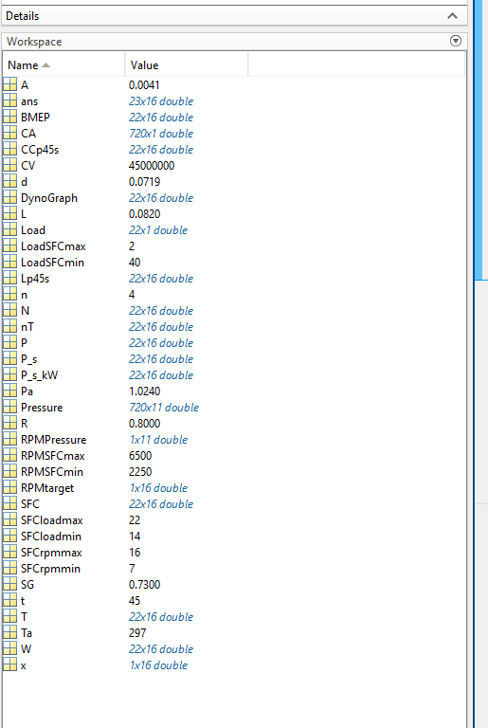
Figure 1 - Functions Produced from MATLAB
From these data sets, graphs were created to present the data in a visually appealing image as well as making it easier to understand what is happening to the engine under different operating loads.

Results and Analysis of MATLAB Data

Torque and Corrected power Vs RPM graph
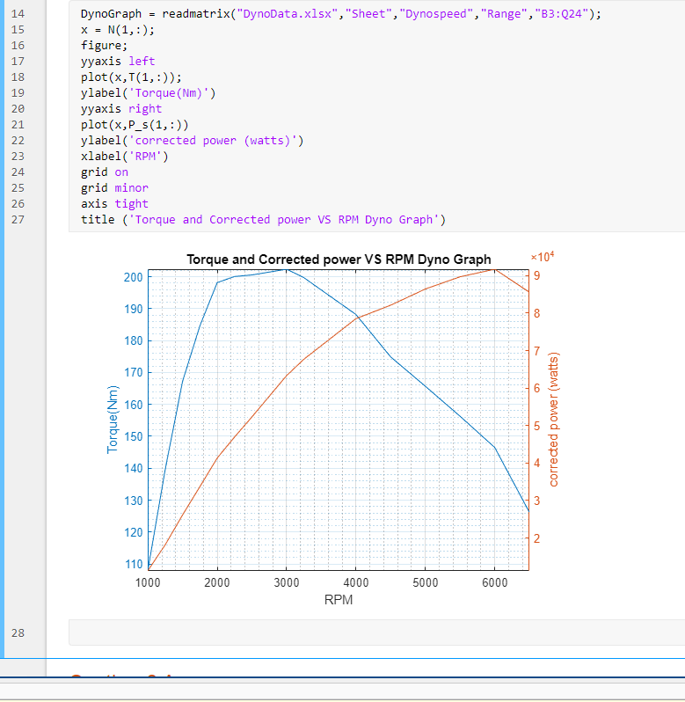
Figure 2 - Dyno Graph
Figure 2 demostatrates the coding used to produce the Dyno graph from the functions mentioned in Figure 1, it can be seen that the torque increases exponentially with a slight trough trendline before the engine reaches its max torque of 200 Nm at 3000 RPM, the torque then starts to deacrease from 3000 RPM to redline at 6500 RPM. The decrease in torque is due to the fact the engine cannot bring in enough air and fuel between each revolution, as engine speed (RPM) increases, torque after reaching its max volumetric efficiency will decrease.
The corrected power measured in watts also increases exponentially with a slight trough trendline making max power at 6000 RPM, producing 90000 watts (9*10^4). The reason the graph has this trend is due to when RPM increases, the ignitions events per second increase and therefore the amount of energy you're generating by burning more fuel.

BMEP vs Thermal Efficiency
Figure 3 shows the brake mean effective pressure (BMEP) and Thermal efficiency vs rpm graph along with the coding used in MATLAB to produce this graph.

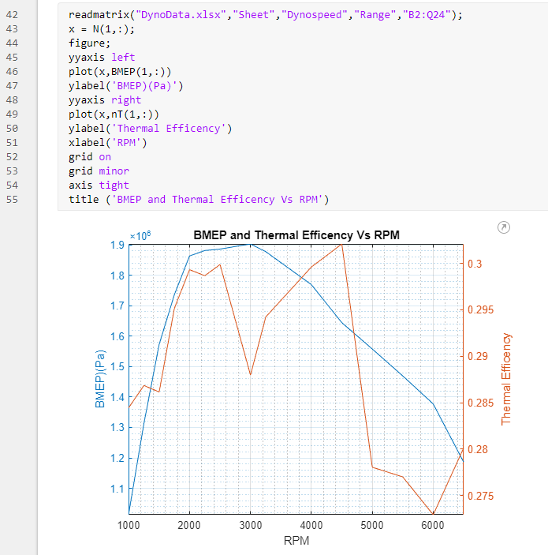
Figure 3 - BMEP and Thermal efficency Vs RPM
The BMEP in figure 3 measured in pascals (Pa) which is effectively the average pressure needed to force the piston down to provide a measured torque value. It can be seen in the graph that it rises exponentially in a trough trendline up 3500 RPM at which is produces its maximum Pascals of force of 1900000 Pa, after 3500 RPM the output drops off, decreasing all the way to redline due to variables such as intake restrictions, valve timing and engine speed being to high to gather sufficient air and fuel. (Zhang et al., 1998)Dicsusses ways in which to improve BMEP incorporating the restrictions and alleviations mentioned above.

Thermal efficiency for this D16 VTEC engine has an expected trendline of that of an engine with variable valve timing, it can be seen that there are two peaks and troughs in the graph, with max thermal efficiency being seen at 4500 RPM with a value of 0.302, the two peaks are due to the VTEC altering the valve timing to compensate for the increased RPM to allow more fuel and air into the chamber earlier to improve the flame front and burn duration of the mixture to increase the thermal efficiency.

SFC Heat Map
Figure 4 beow shows the heat map produced from load vs RPM
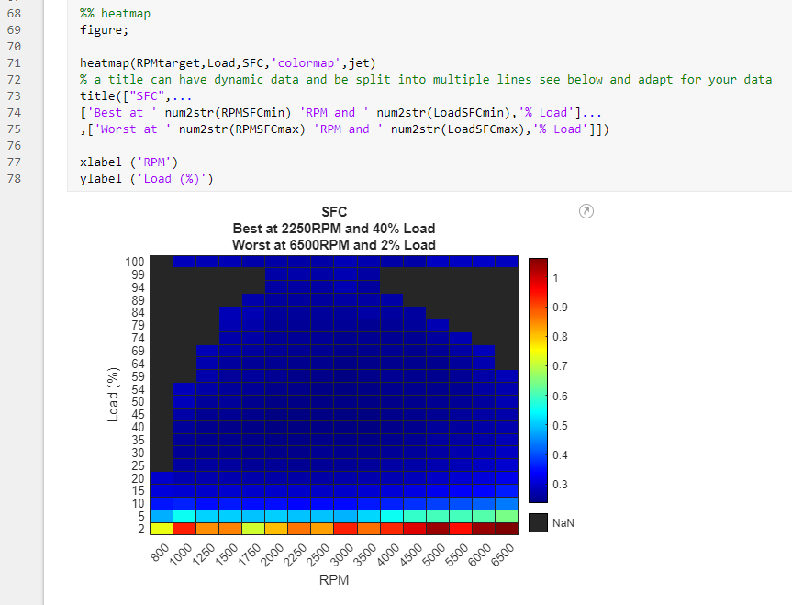
Figure 4 - SFC Heat Map

Specific Fuel Consumption, as shown above in figure 4 was the product of putting load against RPM and calculating the CC of fuel used over 45 seconds in this instance. By using min and max coding in MATLAB, the values of best SFC and worst SFC were calculated, with the D16 engine being most Fuel efficient at 2250 RPM at 40% load and worst at 6500 RPM with 2% load.

Pressure Vs RPM and Crank Angle
Figure 5 Represents a 3D model of the pressures in the engine at different RPM and Position of the piston represented by the crank angle.
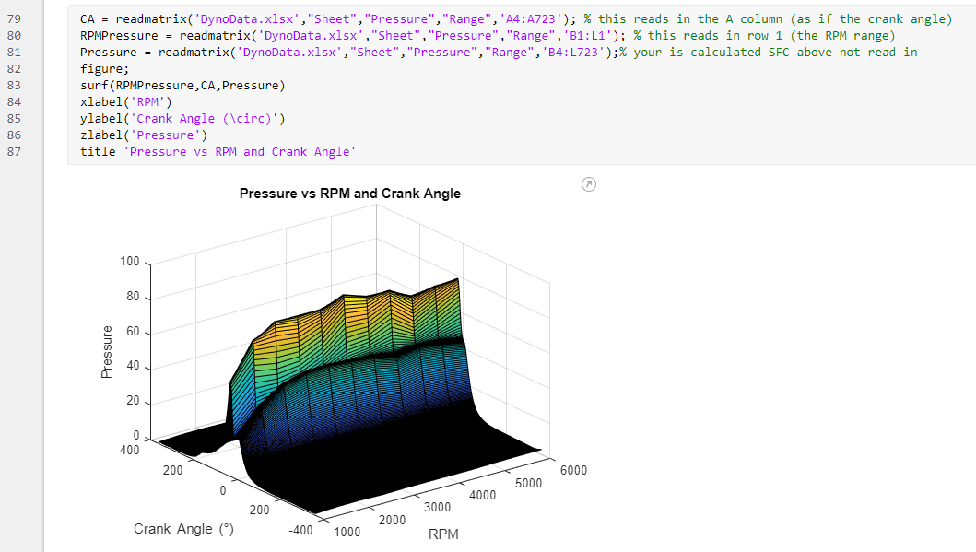
Figure 5 - Pressure Vs RPM and Crank Angle
Shown in figure 5 it can be seen that the most highest pressure is achieved at 0 degrees or top dead centre (TDC), this is the highest point of compression in the otto cycle when fuel and air is in the chamber and has just been ignited, generally most engines without a variable valve train will see a decrease after this more so than being shown in this heat map.
To help explain what is happening in this graph, a diagram in figure 6 below is imported.

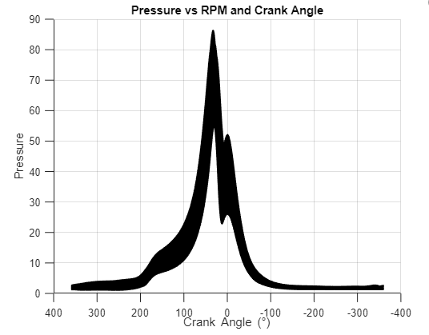
Figure 6 - pressure vs Crank angle diagram

Figure 6 shows a 2d image of where the events are happening on the graph in figure 5, helping to invisage the events occurring in the engine under different pressures and Crank angle with peak pressure occurring around 30 degrees of crank angle.

Conclusions
To conclude this report, discussed has been the varius types of dynos in use, the dyno that was used for this experiment, an explamation of the use of MATLAB for this report and a analysis section of the results and graphs that were produced.
Also excellently shown as part of this assignment has been the benefits of using a variable valve timing on an engine to increase its overall thermal efficiency which is shown and proven via the dyno graphs displayed in the above sections.

Referances
Menon, S. et al. (2006) “Development of a dynamometer for measuring small internal-combustion engine performance,” arc.aiaa.org, 23(1), pp. 194–202. doi:10.2514/1.19825.
Zhang, F.R. et al. (1998) “Methods of Increasing the BMEP (Power Output) for Natural Gas Spark Ignition Engines,” SAE Technical Papers [Preprint]. doi:10.4271/981385.

