Doing History: The Past in Practice
Maps, in general, is a representation of a specific area of land or sea which will show physical features such as; cities (Collins English Dictionary, 2011). Simple maps help people to travel from A to B, with a route of direction, a physical representation of a certain area that helps people when travelling, so they don’t get lost. Charting maps started in Ancient Greece with Ptolemy with the idea of a map still surviving today (Hune-Brown, 2013). Therefore, Maps can hold a large amount of information on specific places. Information can be gathered about a specific place over time with the changes that have occurred, for example, the building of new houses and this information can be linked to a growth in population. One site that changes can be seen in is Dover Castle, by looking at four different maps we can look at the changes that occurred. With a site like Dover Castle, we can look at the changes in the site and relate them to military defence. Dover Castle and looking at these maps have potential in helping to develop an idea for a final dissertation in looking at the development of the site as a tourist site.
Dover Castle has stood its ground for the past nine centuries looking over England’s coast and the straits of Dover. Dover being twenty-two miles from the coast of France makes it the closest point to mainland Europe. The history of Dover Castle starts with the Roman Pharos/ lighthouse (2nd century AD), a late Saxon Church (1000 AD St Mary-in-Castro) to more modern history of the World Wars and the Cold War (Brindle, 2012). The Castle has been garrisoned and manned since the Middle Ages until the 1963 (Brindle, 2012). Since there is a vast history of the Castle, this essay will look at the time from 1750 to now.
Map 1 is the earliest source of the four being dated 1756 (Board of Ordnance, 1756). Map 1 was created by the Board of Ordnance, this means that the map is government produced. This means multiple things, this makes it reliable but also less reliable since they might keep anything that’s highly importance, so will not appear, for example, the medieval tunnels. The board of ordnance focused more on the aspects of place in terms of the military as they were a resource of equipment and information for the military. It’s also likely more reliable as they would want to provide accurate information on the buildings at the castle and accurate as they would be used to help the Military with its prime aim.
Map 2 is less reliable out of the four of them because there’s little known on the provenance of the source. The map is from a newspaper and so would be less reliable anyway especially as the site is under the military control and so if all the secret were on display in the map, like the Napoleonic tunnels that don’t appear on the map but were there at the time of the map in 1869 (Emsile & Spragua, 1869). This is why map 2 is less reliable, as things are missing that are there.
On both Map 1 and 2, there is very little sign of anything beneath the cliff surface. This reason could be due to the fact that if the information was on the map, due to the fact that the map is in available to the public would mean it would provide vital information to the enemy invading England.
Map 3 was created by the Royal Engineers, they are a part of the country’s military. They have been a part of the army for a long time. Making the map reliable due to the fact that the document would be kept a secret from the public and other countries and so they could put a lot of detail of the northern side of the castle. Also due to this it only shows the north side off the castle that excluded the Tunnels, and more. The royal engineers would be reliable and know what they were doing as they supply information about underground works e.g. sewage. In addition, to this, they helped develop the Western Heights on the other side of Dover and would have fully analysed the castle and the records.
Map 4 is the most modern map out of all them, as it was produced in 2012. The site of Dover Castle and creator of the Map is English Heritage a charity. This would be accurate and very reliable, for many reasons. For one the map is on the back of a tourist guide and so would be used to help visitors, go round the site. Another reason would be because that English Heritage has produced this map and so would have all of the up-to-date information that there was at the time the map was created in 2012 (Brindle, 2012). English Heritage used to be part of the government and so would have the information about buildings and the changes. The map is colour coded, to help draw in money, as a product for customers to buy as, Dover Castle is one of the three top sites for English Heritage, second to Stonehenge (English Heritage, 2016-17). This, therefore, would make it less reliable for the purpose of the source but would still be reliable as a map of the site.
At Point H (Board of Ordnance, 1756), there is the Cinque Port Prison, this prison was mainly used in the 18th and 19th century as a Debtors Prison used by the Cinque Ports. The Cinque Ports developed in the 13th Century as a collection of Port towns on the South East Coast, that included towns such as; Hastings, Romney Marsh, Hythe, Dover and Sandwich. These towns helped to the defend trade across the channel (Lyon, April 1814). In the Second Map (Emsile & Spragua, 1869), the Debtors Prison has changed shape. As in 1796, the Board of Ordnance extended the debtors prison by adding 3 extra rooms and an exercise yard. However, looking at maps there is only so much information that can be gotten from a map as, for example, the debtor's prison later became married quarters for the soldiers stationed at the castle. It is also believed that the prison also held conscious objectors during the First World War (Brindle, 2012). And this information is not seen in any maps and that changes help to defend the country.
Certain places on the Site of the castle have undergone a major amount of changes over the past two hundred years. In Map 1 (Board of Ordnance, 1756), there are new buildings that were used as barracks for officer and soldiers (Point O and P), then in Map 2 that particular area is empty (Emsile & Spragua, 1869). Then in Map 3, that particular area is labelled the drill ground (Royal Engineers, 1922), but in Map 4 (English Heritage, 2012) that specific site became the Car Park.
Map 1 has other points of interest that have been modified, or have gone. For example, at Point G (Board of Ordnance, 1756) is the Saxon Church named the Church Of St Mary in Castro also seen in Map 2 and 4. It is labelled as “a Church, which is in ruins” (Board of Ordnance, 1756). The Church fell into disarray and then was repaired twice and was left to decay in the 17th Century and gradually became a ruin (Brindle, 2012). During the Napoleonic Wars, the church was a form of entertainment with a game called games of fives and then a storage area (Brindle, 2012). In 1862 the church was restored and reroofed by Sir George Gilbert and used as a Garrison Church (Brindle, 2012) (Brown, 1981). Three of the maps show the Church, however, the three maps don’t actually show the changes made.
Other points of interest on Map 1, at point K (Board of Ordnance, 1756), there is a gun battery that was finished in July 1756, and this was when they were modernizing the site. This point is on Map 3 and is actually named Caesar’s battery (Royal Engineers, 1922). On Map 1 is the outer curtain wall that was built in the late 12th century and was later modified in 1755-56, this is seen more in Map 2 (Emsile & Spragua, 1869).
During the years of the 1793- 1815, the Napoleonic Wars were on. The threat of invasion from France became real. In 1797, the Royal Engineers miners began digging a set of tunnels beneath the surface, designed by Lieutenant Colonel William Twiss (Coad, 2007). Finished in 1810, two groups of three parallel tunnels with a connecting tunnel at the back and little communicating tunnels in the middle of the tunnels. The tunnels were then used in the Second World War, the eastern casemate in use with the naval staff and Vice-Admiral Bertram Ramsay as planning room for Operation Dynamo, the evacuation of British Troops from Dunkirk. Evacuations began the 26th May and ended on the 3rd June 1940. They expected to rescue 45,000 troops, in the end, they had rescued 338,000 troops (Coad, 2012). Dover after this now became the frontline against German attack and was nicknamed ‘Hellfire Corner’ from the number of shells dropped on Dover. The casemate tunnels became a New Combined Headquarters for the Military, they even thought about planning Operation Overload (D-Day Landings) there (Coad, 1995). They also started building new underground tunnels, the First being Annexe, this held, a dressing station, dorms, kitchens, mess facilities, this then developed into a 500-bed hospital with two operating theatres (Humphreys, 2010) (Coad, 2012) (Coad, 1993).
Two other set of tunnels were being dug at the same time. The one that still survives is the Dumpy Level the lowest tunnel, this was completed in May 1943 (Brindle, 2012). The Level Codename Bastion is another set of tunnels that were planned and started to dig, however, there was an accident where it caved in. They buried the entrance and is lost. Due to that, it would not appear on any map due to the fact that no one knows where it is located. The Dumpy Level was used more in the Cold War as, after the end of the War, the British Government started creating the Regional Seats of Government. The Dumpy tunnels became one of twelve seats for the country, Dumpy being for the Kent area (Coad, 2012) (Coad, 1993). However, not much is known about that period of the Castle because most of the information is still under the Official Secrets Act. The Dumpy Level also isn’t on Map 4, because it is the only tunnels that are closed off to the Public and they only let a certain amount of people down there each year (English Heritage, 2012). The other two levels of tunnels only appear on Map 4 (English Heritage, 2012). This has a huge potential to do further look at the tunnels due to the fact that there are a lot of documents and a lot of information on the tunnels.
In Map 4 there is a building labelled Admiralty Lookout (English Heritage, 2012). Originally, the building was built in 1874 as a gun battery that was stationed next to the hospital that no longer remains. Admiralty lookout later closed in 1887-8 due to thoughts that the cliff would collapse. In 1905, they put a building on top of the central gun of the gun battery, which was the Fire Command Post, they oversaw the guns that defended the straights of Dover. At the start of the First World War on the 3rd September 1914 the Port War Signal Station was finished (Coad, 1995) (Coad, 2000) (Coad, 2007). Here they controlled the Royal Navy ships that came in and out of port. In 1918, a concrete cover was built over the Fire command as a form of protection against the bombs that were being dropped. The building was closed and then was reopened at the beginning of the war and a blast wall was erected and a concrete covering the building (Coad, 2007). However, from Map 4 only some of this information is seen due to the fact of how the Map is colour coded purple meaning 20th century, however, only that amount of information can be gathered (English Heritage, 2012).
Overall, Maps are very good sources to look at to look at the development of a certain area over a specific time. However, you must be careful with what you trust in the sources especially if they have been released to the public and there are wars going on and that the secrets must be kept. As if they openly had the maps available then it would make it easy for the other countries to invade. Dover Castle has a varied history wider than what’s covered in this 2,000-word essay. This makes it have potential as a final dissertation for me on not just the history but how English Heritage has developed it into a tourist site and even further with what they could do with the future.

References
Board of Ordnance, 1756. A Plan Of Dover Castle. Dover: Board of Ordnance.
Brindle, S., 2012. Dover Castle. 1st ed. London: English Heritage.
Brown, R. A., 1981. Dover Castle. 5th ed. London: Her Majesty's Stationery Office, Anceint Monuments and Historic Buildings, Department of the England.
Coad, J., 1993. Hellfire Corner: Dover Castle's Secret Tunnels and The Dunkirk Evacuation. 1st ed. Dover: English Heritage.
Coad, J., 1995. Dover Castle. 1st ed. London: B.T. Datsford Ltd/ English Heritage.
Coad, J., 2000. Dover Castle. 2nd ed. Dover: English Heritage.
Coad, J., 2007. Dover Castle. 1st ed. London: English Heritage.
Coad, J., 2012. Dover Castle: A Frontline Fortress and its Wartime Tunnels. 2nd ed. London: English Heritage.
Collins English Dictionary, 2011. Collins English Dictionary. 11 ed. Glasgow: Collins.
Emsile, J. & Spragua, W., 1869. Plan of Dover Castle. London: The Architecture and Co.
English Heritage, 2012. Plan of Dover Castle. London: English Heritage.
English Heritage, 2016-17. Annual Report- 2016-17, Swindon: English Heritage.
Humphreys, R., 2010. Dover Castle England's First Line Of Defense. 1 ed. Gloucestershire: THe History Press.
Hune-Brown, N., 2013. Why We Make Maps?. Canadian Business, 86(5), pp. 84-85.
Lyon, J., April 1814. The History of the Town and Port of Dover and of Dover Castle; with a Short Account of the Cinque Ports. Kent: Ledger and Shaw.
Mannion, J., n.d. Discover Castle from Above. London: Myriad .
Oman, C. W., 1989. British Castles. London: Dover Publications.
Royal Engineers, 1922. Copy of a plan of the northern part of Dover Castle with ground-floor plans of the buildings and the position of water, electricity and drainage systems marked. Dover: Royal Egineers.
Snow, D., 2012. Battle Castles: 500 years of knights and seige warfare. 1st ed. London: HarperPress.
Toy, S., 1985. Castles; Their Construction and History. New York: Dover Publications, Inc.

Appendix

Map 1- A Plan of Dover Castle (Board of Ordnance, 1756)

Map 2-
Plan of Dover Castle - (Emsile & Spragua, 1869)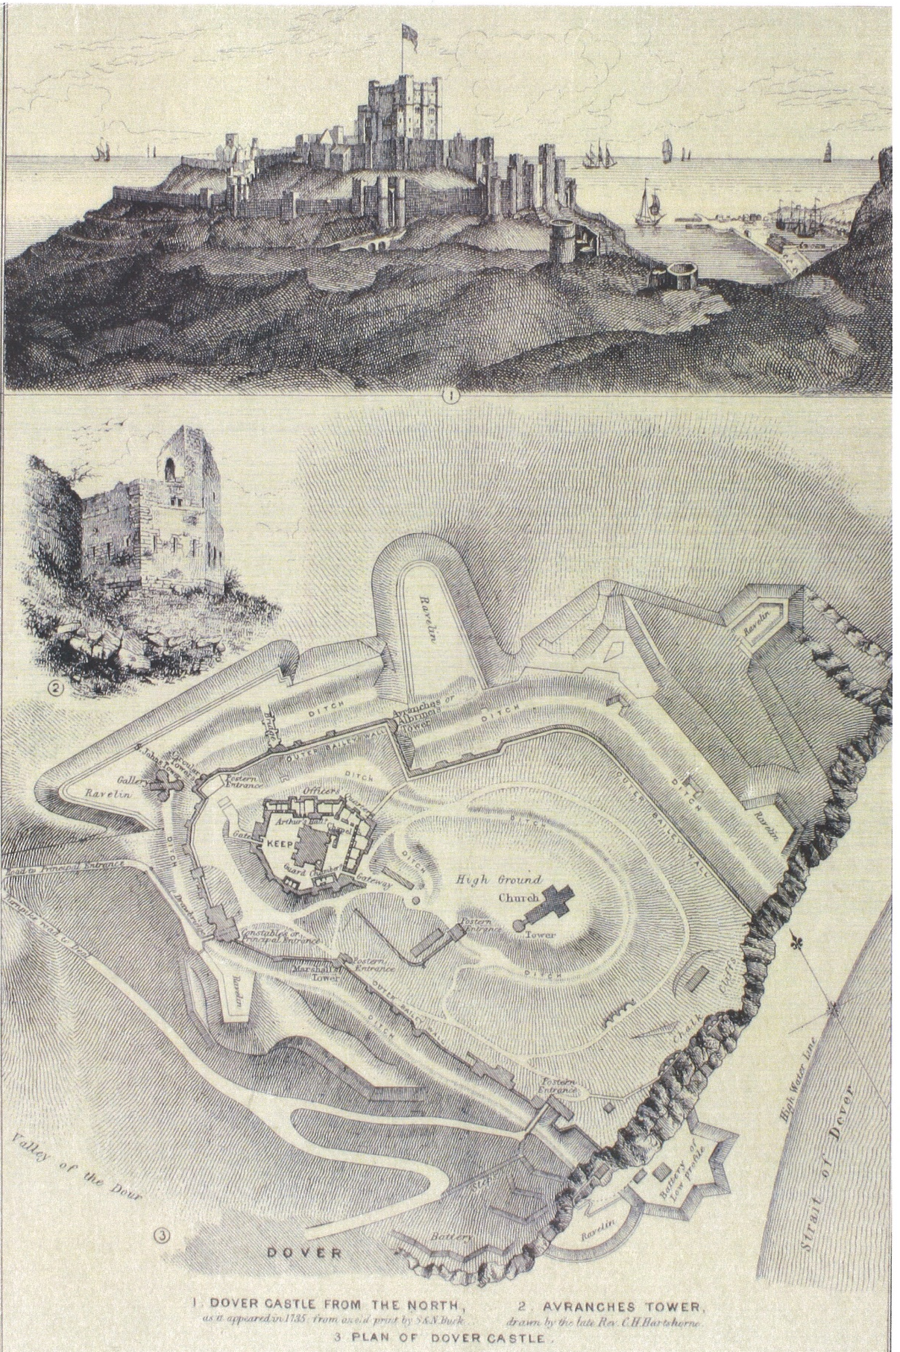

Map 3- Dover Eastern Heights- Dover Castle- Ground Floor- 1923 (Royal Engineers, 1922)

Map 4- Dover Castle Floor Plans (English Heritage, 2012)


