
Submitted by: Leonie Nsimba
Student Number: 1708020
Assignment Title:
“Digital Skills and Research Methods”
Module Lecturer’s Name:

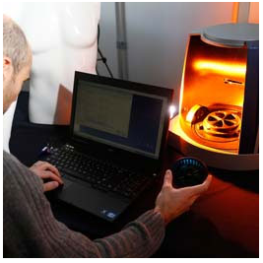

Abstract:
This is the age of modern and digital technology. People of this mechanical era are now using many technology based products in their daily life to make life easier and efficient. Cell phones are one of the greatest gifts of this new technology based era. Cell phones and using cell phones solves the problem of communication as surprisingly that anyone can connect with each other from anywhere of the globe instantly just by pushing a button or touching on the screen of cell phone. Collecting necessary information, sending mails, browsing over the web, thus accessing the network of the world and carrying it in pocket is made possible by the invention of cell phones. But it has many negative impacts too. Younger people of the society are affected more negatively by using cell phones. Using cell phones has some influence on the sleeping pattern of people. In this report it will be discussed about impacts of using cell phones on sleeping pattern of students and young adults. Primary and secondary data collection is done to collect the related information. For collecting necessary information of primary data a structured questionnaire is used and assessed. Some participants also interviewed shortly and directly. Secondary research is done through surfing over the internet based on some articles and journals found. It comes clear after conducting the research that, sleeping pattern of young adults have changed by using cell phones and they are facing sleeping problems more frequently. It can be concluded that, People have to be conscious and careful about using cell phones and their negative impacts on health and sleep.

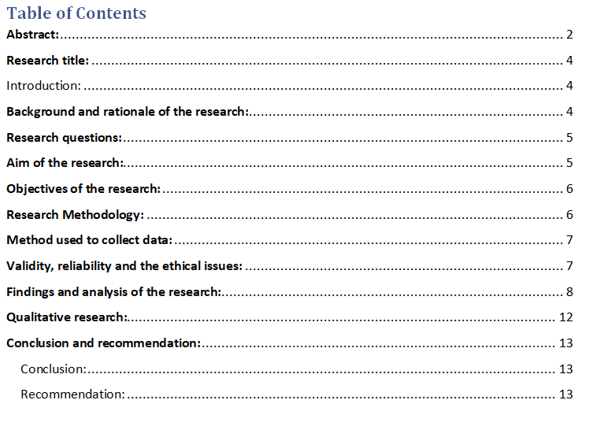

  - Chapter- One

Research title:
Impacts of cell phone usage on sleeping pattern of students

Introduction:

Sleeping is necessary for all living creatures. Sufficient and quality sleep is essential for a human being, for the health of the person and also for ensuring productivity of the individual. Insufficient and poor sleep may harm the health of people and may be a reason behind many health related problems. In this age of technology, cell phones are an unavoidable device used by peoples. It is now using beyond the need of communication only rather cell phones are now being used for official and business works along with different health related issues as well. But using cell phones have some of the negative impacts too. Most of the negative impacts of cell phone usage are associated with the physical and mental health of the people. It is going to be discussed and analysed in this report about the impact of cell phone usage on the sleeping pattern of young adults by using research methods and some methods of research.

Background and rationale of the research:
Both physical and mental health is the prime and obvious concern of people of the society. Sleep, duration of the sleep and the quality of sleep are some of the important determinants of public health. Various kinds of physical and mental problem may arise for sleep deprivation and poor quality of sleep. Students are basically young and young adults and young aged people are trendier to use technology based products and different applications of the cell phones. They tend to spend a long time in different social Medias thus on internet or by using cell phones. It is wasting their time as well as impacting on the sleeping pattern or quality of the sleep as well. But the need of sound and adequate sleep is necessary to maintain the mental stability of the students and to ensure proper body functioning too. Lack of sleeping is decreasing the learning capability of students as well as creating problem on concentrating while studying. Some students fall in slumber in class or the time of important lecture provided by the professors and instructors. Productivity of the students also hampered and decreased a lot by sleep deprivation. This research will unfold one of the primary and main reasons behind insufficient and poor quality sleep along with finding the impacts of cell phone usage on the sleeping pattern of students. Providing some useful suggestions and making the student’s conscious about the negative impacts of the cell phone usage in their sleeping pattern and productivity is implied rationale of the study.

Research questions:

- Does the usage of cell phones have direct or indirect impact on sleeping pattern of students or young adults?
- How the usage of cell phones is impacting the sleeping pattern of the users?
- Why using cell phones become a concern of health?
- How the usage of cell phones increases the health risk for both the user and the community as well?

Aim of the research:
Aim of this research is based on two different dimensions, one is direct and another is implied. Direct aim of this research is finding the impacts of using cell phones on sleeping pattern of students as well as the young adults. Implied aim of the project is making the students aware about the negative impacts of using excessive cell phones and their safe usage.

Objectives of the research:
- Finding the impacts of excessive cell phone usage on the sleeping pattern of students.
- Communicating effective means of cell phone usage by healthier way.
- Discovering the influence of sleep deprivation and poor sleep quality on mental health of the students.
- To analyse how insufficient sleep affecting negatively on study, concentration and regularity of the study.
- Providing some specifications for further research.

Research Methodology:

Strategy applied for conducting the research:
It is essential to find and communicate appropriate information for conducting the research. Success of the research based on success of data collection and proper mean of converting them in to information. According to Russell Ackoff, “Data are symbols that represent the properties of objects and events. Information consists of processed data, the processing directed at increasing its usefulness. For example, census takers collect data. The Bureau of the Census processes that data, converting it into information that is presented in the numerous tables published in the Statistical Abstracts. Like data, information also represents the properties of objects and events, but it does so more compactly and usefully than data. The difference between data and information is functional, not structural”, (Ackoff, 1999). For conducting and collecting necessary information for the research both qualitative and quantitative research is done. Qualitative research is done for digging the root causes of the phenomenon beneath. And for representing the information and findings of the research as a visual and numeric value quantitative data are used and converted as information.

Method used to collect data:
For collecting necessary data to conduct the research successfully it is used both the primary and secondary data. Primary data is collected by providing structured questionnaire to the participants selected randomly. Participants of the research are mostly students in the campus of Wales University and age range of the participants is 19-29 years (McIlroy, 2013). Some of the participants are also interviewed directly with unstructured interview method. Secondary data are collected by surfing over the internet and by using some of the articles, journals and books.
- Population: Population of the research is considered the students and young adults in the boundary of UK.
- Plan of sampling: It is critical and both time and money consuming to conduct the research on whole population (Bell, 2005). So the research is done in the campus of “University of Wales” and 100 students were selected randomly as sample for the research.
- Analysing the collected data: MS Excel is used to analyse the data collected.

Validity, reliability and the ethical issues:
Validity and reliability of the collected data and analysed data used on this research can be assured as primary data collected for the research is done from authentic source and directly from the respondents. Secondary data are also collected from reliable and authentic sources. Data are collected by programmed software and the data input was correct too. The software was error and fault free. So the data collected and analysed as information was reliable and valid.
- Ethical issues: The standards of the research methods are followed to conduct the research properly. The data and information of the respondents of the research are also remaining confidential and the privacy of the participants is protected too. Ethical concern and guidelines provided by the research ethics committee of “University of Wales” are followed appropriately to conduct and implemented in the research. It is ensured, “To support a research environment that is underpinned by a culture of integrity and based on good governance, best practice and support for the development of researchers; to ensure that transparent, robust and fair processes to deal with allegations of research misconduct should they arise”, (Maund, 2017).

  - Chapter- Two

Findings and analysis of the research:
Necessary data and information of the research is done through providing and asking questions to the participants by structured and printed questionnaire. It is used and done to analyse the data collected and find appropriate and accurate information for the research done (Creme, 2015). The questions asked to the participants of the research are as follows-
Research title: Impacts of cell phone usage on sleeping pattern of students.
Questionnaire asked to the participants:
Q1. Do you feel compulsive to use your cell phone till very late in the night?
Q2. Do you feel that, you require more time to fall asleep after using cell phones?
Q3. Does your mind stay occupied for a long time at night with thought of your virtual activities that you have conducted through your cell phone and delay your sleep?
Q4. Do you prefer using cell phone more than a good night sleep?
It is used the likert scale for scaling the answers of the respondents and the items of the likert scales are Strongly Disagree, Disagree, Neutral, Agree and Strongly Agree(Burns, 2013).

  - In the following section data analysis and interpretation is presented and communicated-

Q1. Do you feel compulsive to use your cell phone till very late in the night?
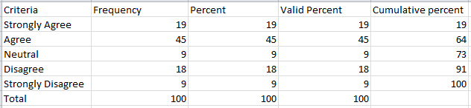
Table1: students fells compulsive to use cell phones late in the night
The study done in the previous section clearly states that, students feel compulsive to use cell phones late at night. 19% respondents strongly agreed that, they fell compulsive to use the cell phones late at night. 45% participants agreed; 9% remained neutral about the question. Only 18% disagreed with the question and 9% strongly disagreed.

Figure 1: Students fells compulsive to use cell phones late in the night

Q2. Do you feel that, you require more time to fall asleep after using cell phones?
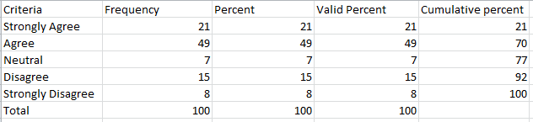
Table 2: It requires more time to fall asleep after using cell phones.
21% respondents strongly agreed that it requires more time after using cell phones just before going to sleep. 49% participants agreed with the question and 7% respondents were neutral. Only a 15% disagreed with the question and 8% respondents strongly disagreed with the condition.

Figure 2: It requires more time to fall asleep after using cell phones.

Q3. Does your mind stay occupied for a long time at night with thought of your virtual activities that you have conducted through your cell phone and delay your sleep?
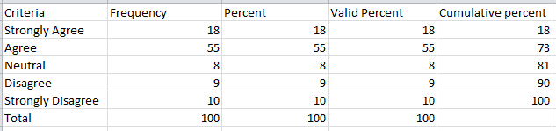
Table 3: Mind of the users stay occupied and delay the sleep.
Findings of the research clearly states that mind of the cell phone users stay occupied and thus it delays their sleep. 18% respondent was strongly agreed, 55% respondent was agreed, 8% participants were neutral, only a 9% disagreed and 10% respondents strongly disagreed with the question.

Figure 3: Mind of the users stay occupied and delay the sleep.

Q4. Do you prefer using cell phone more than a good night sleep?
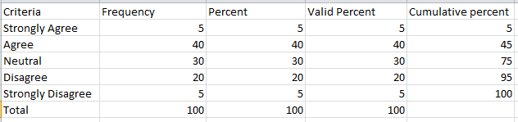
Table 4: Cell phones are preferred to use.
It is found by the specific research that, most of the students prefer to use cell phones rather than a good night sleep, though the data findings show a mixed opinion. Only 5% respondents strongly agreed, 40% agreed and 30% participants were neutral. 20% respondents disagreed and 5% strongly disagreed with the question.

Figure 4: Cell phones are preferred to use.

Qualitative research:
Some of the respondents are interviewed directly and focused on the topic. The findings cannot be visually presented or illustrated as they are qualitative type (Cottrell, 2016). It was interviewed to those using cell phones at night. It is found that respondents tend to awake deep at night and sleep late. Sleeping hour and quality of the interviewed persons were poor too.
  - Chapter- Three

Conclusion and recommendation:

Conclusion:

Sleeping is necessary for ensuring and maintaining mental and physical health of human being. It is essential sufficient sleep and accepted quality of sleep for health and productivity. Cell phone is a significant and vital device of communication and recreation. But it is impacting negatively on sleeping pattern of students and young adults. In this research it is done some of the specific findings and analysis to find the impacts of cell phone usage on sleeping pattern of students and young adults. Both quantitative and qualitative research is done.

Recommendation:

- It is necessary for the students to beware about the negative impacts of cell phone usage on sleep and health.
- Students and young adults have to limit their cell phone usage at night.
- Using cell phones and electronic devices have to be done in proper manner and not excessive or more than need as it has many negative consequences.

References:
Maund, A. Schriek, M. and Tinkler, P. (2017). Certificate in Higher Education: Skills for the Workplace Student Yearbook. Sage Publications
Ackoff, R. L. (1999) Ackoff’s Best. New York: John Wiley & Sons, pp 170 – 172.
Cottrell, S. (2016). The study skills handbook. Basingstoke, U.K.: Palgrave Macmillan.
Burns, T. and Sinfield, S. (2013). Essential study skills. London: SAGE Publications.
Creme, P. and Lea, M. (2015). Writing at university. Buckingham: Open University Press.
McIlroy, D. (2013). Studying @ university. London: Sage Publications.
Bell, J. (2005). Doing your research project. 4th ed. Maidenhead: McGraw-Hill Open University Press.

