

Module name: Introduction to Independent Research Skills
Module code: BMHP5019
Component 2: Written Assignment (Research report)

Title: The impact of social isolation on elderly mental health in the UK

Student name: Elena Daniela Virlan
Student ID: 2216277

Abstract
The research will focus on the influence of social isolation on mental health of elderly individuals in the United Kingdom relative to emotional wellbeing, cognitive abilities and social connectedness. The secondary qualitative method of data collection was utilised and peer reviewed journal articles published between 2020 to 2025 were utilised. As the thematic analysis showed, four major themes were identified, and they are emotional wellbeing, cognitive health, social support and networks, and digital inclusion. The findings show that depression, anxiety, loneliness, and cognitive impairment in old age have a strong relationship with long-term isolational experience.
It was found that the social networks, interaction with the community and the facilities of digital communication revealed protective roles related to maintaining mental resilience and preventing emotional degradation. Another important aspect indicated in the article is that digital exclusion, health disparities, and absence of community interaction have remained a severe problem for the majority of the aged, particularly during and after the COVID-19 pandemic. The results demonstrate the need to implement certain health and social care initiatives that promote inclusion, digital literacy, and emotional support. It concludes that social isolation is a national health challenge and that the mitigation of this challenge is necessary so that the quality of life and mental wellbeing of older adults in the UK can be enhanced.

List of figures
Figure 1: Emotional Wellbeing………………………………………………………………………….12
Figure 2: Cognitive Health………………………………………………………………………………12
Figure 3: Social Support and Networks……………………………………………………………….13
Figure 4: Digital and Social Inclusion………………………………………………………………….14

List of tables
Table 1: Search Strategy………………………………………………………………………………..10
Table 2: Thematic Analysis……………………………………………………………………………..12

Table of Contents
Abstract 2
List of figures 3
List of tables 3
1. Introduction 6
1.1 Introducing Main Concepts 6
1.2 Rationale of the Research 6
1.3 Research Aim 6
1.4 Review Question 7
1.5 Research Objectives 7
2. Background 8
3. Methods 9
3.1 Research Design 9
3.2 Data Collection and Search Strategy 9
3.3 Data Analysis 10
3.4 Ethical Considerations 10
4. Results 11
4.1 Thematic Analysis Table 11
4.2 Interpretation of results 12
4.2.1 Emotional Wellbeing 12
4.2.2 Cognitive Health 13
4.2.3 Social Support and Networks 14
4.2.4 Digital and Social Inclusion 15
5. Discussion 16
5.1 Discussion of the Findings 16
5.2 Importance of the Findings for Health and Social Care 17
5.3 Limitations of the Research 17
6. Conclusion and Recommendations 19
6.1 Summary of the Main Points of the Research 19
6.2 Recommendations for Future Policy and Health and Social Care Practice 19
References 20
Appendix 24
Summary of findings 24

Introduction

Introducing Main Concepts
Social isolation may be understood as a lack of socialisation, the absence of friends or a companion sphere or community participation, which may lead to the existence of loneliness and isolation. This has been causing concern among the aged in the UK, especially those above 65 years of age, due to the effect of demographic ageing, the change of the family structure, and the low probability of social interactions (Dahlberg, McKee, Frank and Naseer, 2022). Absence of proper networks can have a tremendous influence on psychological well-being, thus causing depression, anxiety and loss of thought (Dahlberg, McKee, Lennartsson and Rehnberg, 2022).
Isolation causes are typically compounded with the retirement, bereavement, physical disability, and digital exclusion causes. The pandemic has aggravated these issues since it has restricted socialisation and access to mental health due to COVID-19 (Czaja et al., 2021). The usefulness of mental health and social isolation correlation is essential to the development of effective programmes of community interventions and the establishment of a plan in the general health domain (Cheng et al., 2025). The proposed research will also explain the level, causes and consequences of social isolation of the aged people in the UK and provide insights into how the mental state of the aged people in the UK can be improved.

Rationale of the Research
Old age social isolation is slowly emerging as a serious issue to the wellbeing and health of the UK people. The sources of research indicate that loneliness may be a causal disorder to depression, anxiety and dementia, yet nevertheless, there are many older adults who are employed underemployed (Dahlberg, McKee, Lennartsson and Rehnberg, 2022). Since these figures are likely to rise as people age, one has a reason to establish how deleterious the impact of isolation is on mental well-being and how successful the community and healthcare reactions to it has become (Bu et al., 2020). The study will also be relevant in policy and practise since it will provide the gaps and the recommendations of what should be put in place to enable inclusion and psychological resilience of old people.

Research Aim
To analyse the effects of the social isolation on mental health of elderly people in the United Kingdom and to define the efficient strategies that can provide the means of minimising its negative consequences.

Review Question
How does social isolation affect the mental health of the elderly in the United Kingdom?

Research Objectives
- To recognise the extent to which social isolation is common amongst older people in the UK
- To examine the effects of social isolation on mental health outcomes, including depression, anxiety, or cognitive decline
- To discuss the key factors contributing to the social isolation of elderly people
- To evaluate which current programs and services are helping to reduce isolation and increase mental health in older adults.

Background
One of the issues that has become relevant in the United Kingdom in the context of an ageing population is social isolation. Most of them will not be interacting with their family, friends and community groups, hence disconnected from society, as most of these people will have become old and aged (Dahlberg, McKee, Frank and Naseer, 2022). This isolation entails physical isolation and lack of emotional support and socialisation that add meaning to life. Since older people lose partners or retire, and their health is fading away, many people do not have the opportunity to communicate with each other on a regular basis. Such breaking in the long run can have a critical effect on their emotional and psychological well-being (Choi et al., 2023).
Social isolation can bring about many psychological issues, such as depression and anxiety and even memory impairment. Other problems that a number of elderly citizens go through when they feel unaccepted by others are low self-esteem and lack of purpose (Czaja et al., 2021). The shift to digital communication has also made the distance because the majority of the old-aged people are not comfortable with the technology of social interaction (Cheng et al., 2025). In addition to this, they also struggle with the fact that they have to live alone, they have low mobility and are unable to have access to transport, which further limits their ability to socialise.
The issue has become more severe over the past years due to the changes and limitations in the lifestyle imposed by the pandemic. Different elderly individuals were not in a position to interact with family members or participate in communal activities, which resulted in the emergence of loneliness and mood swings (Choi et al., 2023). Healthcare providers and other community organisations have also had challenges in seeking to minimise isolation. The context of this issue can be utilised to reveal why social isolation and mental health of ageing individuals are such critical subjects to study (Axén et al., 2023). It implies that the social support networks are to be stronger, the access to services is to be increased, and new ways of helping the ageing population stay connected and in good mental condition are to be used.

Methods

Research Design
This is secondary qualitative research that is founded on the examination of prevailing scholarly and institutional studies. The research problem will be to understand the effect of social isolation on the mental health of older adults in the UK by reviewing the projects in the literature (Flick, 2020). This design will be appropriate, as it may be applied to investigate already existing evidence without the need of gathering new data that will be time-consuming and unethical. The research will synthesise a number of studies in order to determine common themes, trends and potential policy implications.

Data Collection and Search Strategy
Known online academic databases and published reports will be used in the collection of the information. The search will rely on the search of articles, systematic reviews, and governmental publications dealing with the aspects of social isolation, ageing, and mental illness among the elderly in the UK (Salkind, 2020). Only the published research composed in less than two years (but not more than 2025) will be included.
Database /  Source | Keywords Used | Inclusion Criteria | Exclusion  Criteria | Time  Frame
Google Scholar | “social isolation,” “elderly,” “mental health,” “United  Kingdom” | Peer-reviewed studies focusing on elderly mental  health in the UK | Non-UK or non-  elderly studies | 2015–  2025
PubMed | “older adults,”  “loneliness,” “psychological wellbeing,” “UK” | Articles discussing isolation and its mental effects | Studies unrelated to mental health | 2015–  2025
ProQuest | “social exclusion,” “mental health,” “older people,” “UK  population” | Qualitative or mixed-method research | Quantitative-only studies or those outside the UK | 2015–  2025
NHS and  Government  Reports | “elderly wellbeing,” “community mental  health,” “UK policy” | Official reports or programme evaluations | Non-academic blogs or news  pieces | 2015–  2025

Table 1: Search Strategy (Source: Author)

Data Analysis
The thematic analysis approach will be used to extract meanings out of the qualitative data that will be collected by available studies. This will require the in-depth reading of the selected articles and identifying the shared issues or patterns that are associated with the mental health outcomes, e.g., depression, anxiety, or brain deterioration (Edlund and Nichols, 2019). A further breakdown of the information will be done in these themes to incorporate the major factors that lead to social isolation and, consequently, its impact on mental well-being. The current analysis shall also focus on the various interventions or programmes that have been done to alleviate isolation and promote mental health in the elderly.

Ethical Considerations
The study will not involve any direct interactions with the participants, as secondary data obtained in the published sources will be used. The most important ethical requirement is to ensure that the references are cited, and the data is presented in a reasonable and accurate manner (Kumar, 2019). Only publicly available and ethically accepted research will be used. It will guarantee transparency and objectivity and even integrity of the intellectual input of the original authors.

Results

Thematic Analysis Table
Theme | Codes | Key Findings (Summarised from Studies)
Emotional  Wellbeing | Depression  Anxiety  Loneliness  Self-esteem | - Older adults experiencing prolonged isolation report higher rates of depression and anxiety. (Lee et al., 2020; McKinlay et al., 2021)  - Loneliness contributes to poor self-image and emotional instability in individuals over 65. (Choi et al., 2023; Tapia-  Munoz et al., 2024)  - The loss of social roles or partners often intensifies sadness and emotional withdrawal. (McDaid and Park,  2024; Axén et al., 2023)
Cognitive  Health | Memory  Focus  Decline  Dementia Risk | - Continuous lack of social engagement is associated with memory loss and slower cognitive processing. (Liu and Jiang, 2025; Dahlberg et al., 2022)  - Reduced stimulation from social interaction can increase the risk of cognitive decline and early dementia. (Litwin and  Levinsky, 2022; Schäfer et al., 2023)  - Maintaining strong emotional ties and frequent conversations may protect against cognitive deterioration.  (Vasile et al., 2023)
Social Support and Networks | Family contact  Community groups  Participation | - Elderly individuals who participate in community programmes report stronger mental resilience and a sense of belonging. (Lee et al., 2022; Noone and Yang, 2022) • Social support from friends or neighbours significantly reduces loneliness and stress. (Czaja et al., 2021; Torres and Oliver, 2024)  - Rural participation and community involvement help maintain positive wellbeing despite physical distance. (Ohta et al., 2024; Ohta and Sano, 2025)
 | Belonging
Digital and  Social Inclusion | Technology use  Accessibility  Engagement  Connectivity | - Many older adults lack access or skills to use technology, leading to deeper social exclusion during lockdowns. (Czaja et al., 2021; Noone and Yang, 2022)  - Those who used video calls or online platforms maintained higher emotional wellbeing. (Torres and Oliver, 2024;  McKinlay et al., 2021)  - Digital education programmes for seniors help rebuild confidence and encourage interaction. (Lee et al., 2022)

Table 2: Thematic Analysis (Source: Author)

Interpretation of results

Emotional Wellbeing
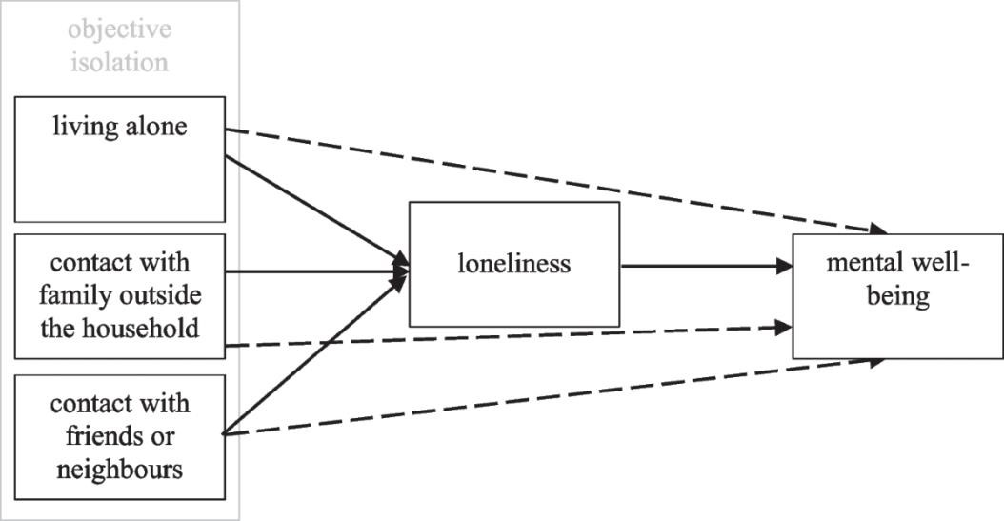
Figure 1: Emotional Wellbeing (Dahlberg et al., 2022)
Isolation is extremely instrumental in how older adults perceive themselves and their lives. According to a study that was carried out in the UK, there is an imminent rise in anxiety and depressive thoughts, particularly among individuals who live alone or those who are bereaved after losing the social interaction that they enjoy daily. Studies concerning the pandemic experience indicate that the loss of physical affection daily was unhealthy and led to the emotional void (McKinlay et al., 2021). The same trends are seen in the research of personality and loneliness, in which the people who developed the feeling of social utility had fewer symptoms of sadness and restlessness (Tapia-Munoz et al., 2024). The information shows that loneliness is damaging to the emotional equilibrium just as any material illness, but meaningful interaction, be it a community or a family, restores a sense of identity and tranquillity (Axeén et al., 2023).

Cognitive Health
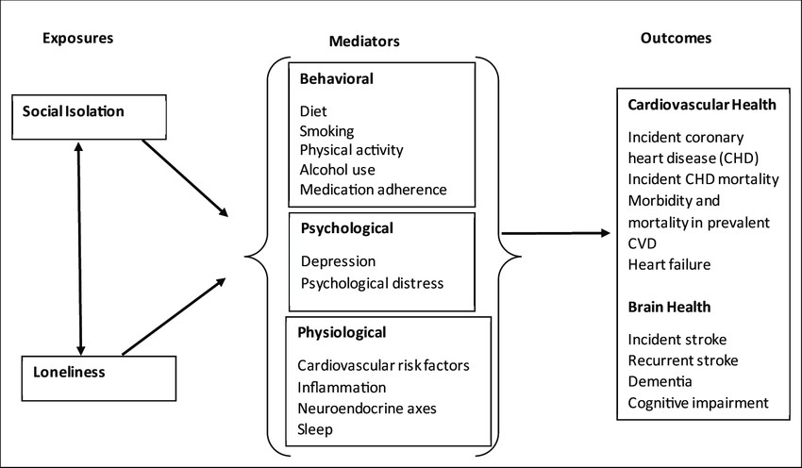
Figure 2: Cognitive Health (Liu and Jiang, 2025)
The elderly who do not talk much when reminiscing about their past and other challenging activities tend to show slower thinking and have less memory as they age. The research onsubjective cognitive decline has reached the conclusion that isolation is often the initial evidence of forgetfulness and attention lapse, in part because the mental activity is reduced as a result of emotional disconnectivity (Liu and Jiang, 2025). Loneliness can also be noted as a silent risk factor of dementia (Dahlberg et al., 2022), physical frailty or poor sleep that are also mentioned in ageing review articles. On the other hand, cognitive resilience will be improved, and the decline will be reduced as soon as the older individuals keep talking and solving with other people or playing social games (Litwin and Levinsky, 2022). Those conclusions demonstrate that it is impossible to maintain the mind actively without maintaining it socially.

Social Support and Networks
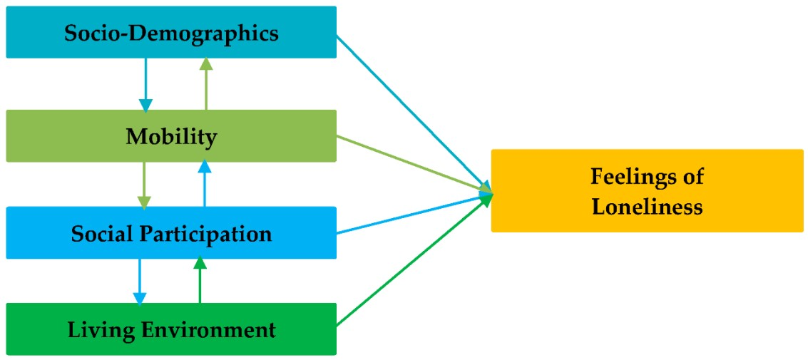
Figure 3: Social Support and Networks (Noone and Yang, 2022)
The sense of belonging to one of the groups, like family, neighbours or a community club, ensures the mental health of the elderly. The purpose of older adults cannot be replaced by only medication since it is offered by programmes with small-group meetings and volunteering (Lee et al., 2022). According to the interviews in the community, it is stated that it enhances mood and alleviates stress when being recognised and greeted on an average basis (Noone and Yang, 2022). The patients were appreciated and did not feel so alienated even during the informal events such as tea mornings, even in the small hospitals that are located in the country (Ohta and Sano, 2025). The trend is apparent through the entire evidence, which is that real relationships are a protective trait against loneliness and emotional corrosion.

Digital and Social Inclusion
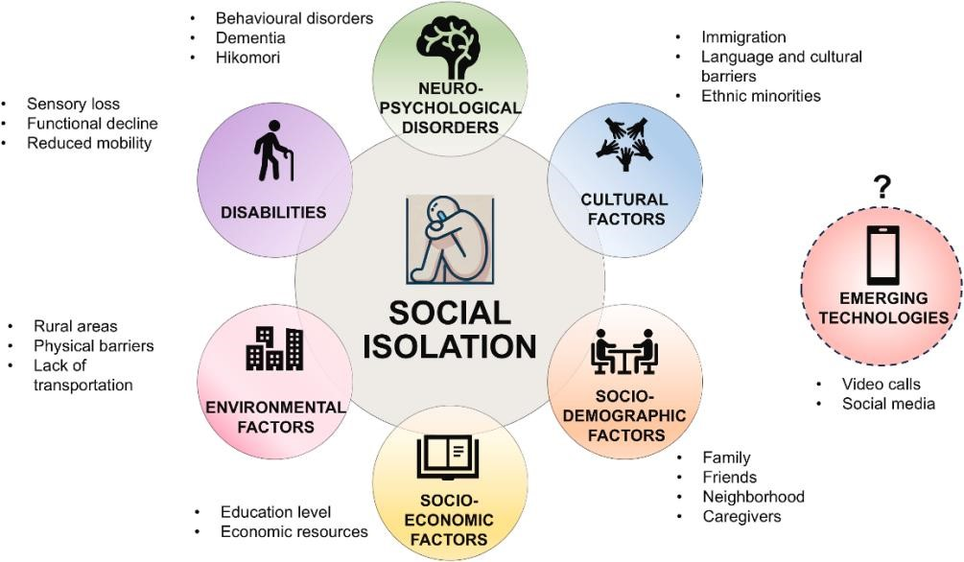
Figure 4: Digital and Social Inclusion (Torres and Oliver, 2024)
Most of the older adults believed that technology was a lifeline because they no longer had to meet face-to-face. Those who were comfortable with video calls or online groups stated that they felt less isolated and more comfortable (Torres and Oliver, 2024). Nevertheless, the number of individuals who are marginalised because of their inability to have internet connection or hesitate to use new equipment remains high (Czaja et al., 2021). The projects have already involved teaching the necessary online skills, such as messaging or sharing photos, which have contributed to regaining trust and connection (Lee et al., 2022). Digital inclusion therefore has no foundation on gadgets; it has a foundation on equality, where the elderly are provided with the tools to continue participating in the everyday discussions that keep them sane.

Discussion

Discussion of the Findings
The present review has discussed the effect of social isolation on the mental well-being of the elderly individuals in the United Kingdom. In all the studies, isolation has remained one of the major factors of emotional distress and worsening of thinking. It was not a temporary state that comes and goes but a deep-seated long-term state that impacts on the thoughts, emotions, and behaviours of elderly people in their day-to-day life. The most apparent sphere was the one of emotional wellbeing. Declining daily life and social activities cause more and more people to get drained and stressed out. According to the qualitative study that took place during the pandemic, people were deprived of their identities due to the loss of routines, physical affection, and social purpose (McKinlay et al., 2021).
Other studies have reported low confidence and self-worth by low social contact people, especially during bereavement or retirement (Axeén et al., 2023). The thing is that loneliness, as the evidence shows, is the chronic stress which suppresses self-esteem and emotional control rather than a momentary emotion. It also has poor cognitive functioning with the deterioration of social interaction. Isolated individuals are likely to have poorer memory and attention, and research has even related loneliness with premature cognitive disability. It was shown in the English Longitudinal Study of Ageing that discussions and group activities aid the older adults in having their minds reasonably on point (De Main et al., 2023).
Another risk factor of subjective cognitive decline was also found to be social withdrawal (Liu and Jiang, 2025). Isolation seems to stagnate the brain and make it forget its flexibility because the social interaction triggers the brain. The other effective one is the buffering effect of social support. As the elderly members of the community, who remain club members, become volunteers in community organisations or join them, they feel much better and emotionally stronger (Lee et al., 2022). Even such a simple activity as talking to neighbours or joining one of the local clinic clubs can restore the feeling of belonging and reduce stress.
The social mission and sense of belonging are given to the older adults through the regular visits and shared amenities like hospitals or churches in less developed regions (Ohta and Sano, 2025). This finding confirms that social connectedness is a protective determinant to mental health, as are diet and exercise. Technology is also now playing a bigger role in the relationship of older adults. People who were conditioned to use digital technology during the pandemic, e.g., video calls, online communities, or social media, felt their moods better and maintained their lives with their families more effectively (Torres and Oliver, 2024). Nevertheless, it remains an issue of access or confidence to many. Research in digital literacy indicates that deficiency in these capabilities causes isolation, particularly to the population in the lower-income group or rural community (Czaja et al., 2021).
On a positive note, the number of the elderly who actively participate and have confidence in their online learning and social support programmes has grown (Cheng et al., 2025). The implication of this sort of result is that the digital divide is no longer a technical issue but a determinant of emotional welfare. Finally, various studies indicate various consequences of isolation on groups. Those and other elderly members of the LGBT+ population have indicated that they felt excluded not only by regular ageing services but also by their own communities during lockdown periods (Hafford-Letchfield et al., 2022).
Similarly, physically challenged or chronically ailing people did not stand a chance to engage in physical activities that raised the level of loneliness (Nanthamongkolchai et al., 2023). These findings indicate that the uneven distribution of social isolation depends on the identity, income, and geography. This means that generalised interventions will have limited chances of winning the favours of policymakers.

Importance of the Findings for Health and Social Care
The implications of these findings on the UK health and social-care practice are obvious. Loneliness is a problem that should be considered as preventive care and not an optional service. Standard care should include community involvement, training to use digital apps, and peer support programmes that are delivered to the elderly to ensure that they have less depression and cognitive degradation and increasing autonomy. Social prescribing has been demonstrated as an effective concept with the use of social prescribing schemes where older adults are associated with volunteers/hobby groups, which should be expanded. Workers can reduce the risk of reduced long-term healthcare costs since they are able to develop emotional stability by making social connections a health priority.

Limitations of the Research
The review has been pegged into purely secondary data, and therefore, its inferences will be informed by the quality of existing research. A majority of them were conducted during the COVID19 period, where the isolation was too high, and it would overemphasise its impact over time. The studies were different in magnitude and topic of interest and could not be readily compared directly, and most of them relied on self-reported indices of research rather than clinical review.
Moreover, the review was not a statistical one but an interpretative one; therefore, it cannot be causative. Future research should adopt longitudinal mixed-method research designs to investigate recovery, resilience, and post-pandemic adaptations among various groups of the aged in the UK.

Conclusion and Recommendations

Summary of the Main Points of the Research
The research has determined that social isolation is a very negative factor on the mental health of older individuals in the United Kingdom. The realities had been found by where that isolation leads to more depression, anxiety, and withdrawal of emotions, in addition to leading to cognitive deterioration. Social participation and community support were reported to be protective measures against loneliness in that the older adults can enjoy a feeling of purpose and confidence. However, vulnerable populations are still isolated due to digital exclusion, health inequality, and impediments to identity. The findings elicit the reality that prevention of loneliness is an interplay between the level of health and the social care and community services, which must be offered at the system level.

Recommendations for Future Policy and Health and Social Care Practice
Social isolation as a determinant of mental health should be recognised in future policies and included in the ageing and wellbeing policies. Community-based programmes giving the opportunity of participation, volunteering, and emotional interaction should be applied to health and social care organisations since they develop a sense of belonging and emotional resilience. The nationalisation should occur in the models of social prescribing where healthcare professionals are allowed to refer older adults to local clubs or group activities. The digital inequality should also be addressed by providing cheaper net connectivity, user-friendly technologies, and training to be more digital to ensure the older adults are not left behind in terms of social interaction.
The gaps in participation in rural or marginalised communities can be bridged by personal outreach based on mobile service and local partnerships. Care workers should be sensitised to know about the circumstances that may cause loneliness and the ways of fostering inclusion. Finally, national strategies for preventing loneliness should involve cross-sector collaboration of the local councils and voluntary groups and health services. These social connection aspects in the care policy integration model will not only augment emotional wellbeing but also healthcare burdens and solidarity within the community.

References
Axén, A., Taube, E., Sanmartin Berglund, J. and Skär, L. (2023). Loneliness in relation to social factors and self-reported health among older adults: A cross-sectional study. Journal of Primary Care and Community Health, 14, Article 21501319231198644.
Bu, F., Abell, J., Zaninotto, P. and Fancourt, D. (2020). A longitudinal analysis of loneliness, social isolation and falls amongst older people in England. Scientific Reports, 10(1), Article 20064.
Cheng, Z., van der Schaar, J., Larkin, C., Shaikh, Z., Anderson, D., Alshaikh, M., Simsekler, M.C.E. and Young, T. (2025). A camera-based social prescribing system for reassurance and wellbeing in older adults.
Choi, E.Y., Choi, K.W. and Marti, C.N. (2023). Changes in social lives and loneliness during COVID-19 and associations with mental health in older adults. International Psychogeriatrics, 35(12), pp.1184–1196.
Czaja, S.J., Sharit, J., Hernandez, M.A., Morrow, D.G. and Lee, C.C. (2021). Social support, isolation, loneliness, and health among older adults. Frontiers in Psychology, 12, 728658.
Dahlberg, L., McKee, K.J., Frank, A. and Naseer, M. (2022). A systematic review of longitudinal risk factors for loneliness in older adults. Aging and Mental Health, 26(2), pp. 225–249.
Dahlberg, L., McKee, K.J., Lennartsson, C. and Rehnberg, J. (2022). A social exclusion perspective on loneliness in older adults in the Nordic countries. European Journal of Ageing, 19(2), pp. 175–188.
De Main, A.S., Bone, J.K., Rajagopalan, M., Mak, H.W. and Fancourt, D. (2023). Association between social connectedness and mental health and well-being in adults aged 55 years and older: evidence from the English Longitudinal Study of Ageing (ELSA). Aging and Mental Health, 27(7), pp. 1300–1312.
Edlund, J. E. and Nichols, A. L. (2019) Advanced Research Methods for the Social and Behavioral Sciences. Cambridge: Cambridge University Press.
Flick, U. (2020) Doing Qualitative Data Collection – Charting the Routes. London: SAGE Publications.
Hafford-Letchfield, T., Toze, M. and Westwood, S. (2022). Unheard voices: a qualitative study of LGBT+ older people’s experiences during the first wave of the COVID-19 pandemic in the UK. Health and Social Care in the Community, 30(4), e1233–e1243.
Jin, X., Tong, W., Wei, X., Wang, X., Kuang, E., Mo, X., Qu, H. and Fan, M. (2024). Exploring the opportunity of augmented reality (AR) in supporting older adults explore and learn smartphone applications.
Johnson, L., Guthrie, B., Kelly, P.A.T., Anand, A., Marshall, A. and Seth, S. (2024). Frailty or frailties: exploring frailty index subdimensions in the English Longitudinal Study of Ageing.
Kumar, R. (2019) Research Methodology: A Step-by-Step Guide for Beginners (5th edn.). London: SAGE Publications.
Lee, C., Kuhn, I., McGrath, C., Wilson, A., Gray, R. and Borschmann, R. (2022). A systematic scoping review of community-based interventions for the prevention of mental ill-health and the promotion of mental health in older adults in the UK. Health and Social Care in the Community, 30(1), pp.27–57.
Lee, S.L., Pearce, E., Ajnakina, O., Johnson, S. and Lewis, G. (2020). The association between loneliness and depressive symptoms among adults aged 50 years and older: a 12-year population-based cohort study. The Lancet Psychiatry, 7(11), pp. 1035–1043.
Litwin, H. and Levinsky, M. (2022). Social networks and mental health change in older adults after the COVID-19 outbreak. The Journals of Gerontology: Series B, 77(7), pp.e167–e176.
Liu, Y. and Jiang, H. (2025). The impact of social isolation on subjective cognitive decline in older adults: a study based on network analysis and longitudinal mode. arXiv preprint arXiv:2506.13914.
McDaid, D. and Park, A.-L. (2024). Addressing loneliness in older people through a personalised support and community response programme. Journal of Aging and Social Policy, 36(5), pp. 1062–1078.
McKinlay, A.R., Fancourt, D. and Burton, A. (2021). A qualitative study about the mental health and wellbeing of older adults in the UK during the COVID-19 pandemic. BMC Geriatrics, 21, 439.
Mogavi, R., Huynh, D., Lane, J., Martin, C., Parry, M., Robinson, H., Rochester, L., Yarnall, A.,
Liao, W.-H., Chi, W.-J. and Connelly, A. (2024). Stepping into connection: exergaming to support social interaction and mental wellbeing in older adults. Proceedings of the CHI Conference on Human Factors in Computing Systems (CHI ’24).
Nanthamongkolchai, S., Tojeen, A., Yodmai, K. and Suksatan, W. (2023). Factors influencing access to health services among chronically ill older adults with physical disabilities in the era of the COVID-19 outbreak. International Journal of Environmental Research and Public Health, 20(1), Article 398.
Noguchi, T., Saito, M., Aida, J., Cable, N., Tsuji, T., Koyama, S., Ikeda, T., Osaka, K. and Kondo, K. (2021). Association between social isolation and depression onset among older adults: a crossnational longitudinal study in England and Japan. BMJ Open, 11(3), e045834.
Noone, C. and Yang, K. (2022). Community-based responses to loneliness in older people: A systematic review of qualitative studies. Health and Social Care in the Community, 30(4), pp. e859–e873.
Ohta, R. and Sano, C. (2025). Loneliness and the associating factors among regular patients in rural community hospitals: A cross-sectional study. Cureus, 17(1), Article e77723.
Ohta, R., Yakabe, T., Adachi, H. and Sano, C. (2024). The association between community participation and loneliness among patients in rural community hospitals: A cross-sectional study.
Cureus, 16(3), Article e56501.
Salkind, N. J. (2020) Exploring Research (10th edn.). London: Pearson.
Schäfer, S.K., Lindner, S., Kunzler, A.M., Meerpohl, J.J. and Lieb, K. (2023). The mental health impact of the COVID-19 pandemic on older adults: a systematic review and meta-analysis. Age and Ageing, 52(9), afad170.
Suhaimi, N., Yongsatianchot, N., Zhang, Y., Amiji, A., Patel, S.A., Marsella, S., Kim, M., Griffin, J. and Parker, A. (2021). Examining older adults’ information exposure, wellbeing, and adherence to protective measures during the COVID-19 pandemic.
Tapia-Munoz, T., Bayer, J.K., Ravindran, A. and Calvo, R.A. (2024). Personality traits and loneliness among older people in the UK: longitudinal evidence. Activities, Adaptation and Ageing, 48(2), pp. 141-156.
Torres, Z. and Oliver, A. (2024). Older adults’ mental health during the COVID-19 pandemic: the association with social networks. Social Networks, 78, pp.164–172.
Van As, B.A.L., Imbimbo, E., Franceschi, A., Menesini, E. and Nocentini, A. (2022). The longitudinal association between loneliness and depressive symptoms in the elderly: a systematic review. International Psychogeriatrics, 34(7), pp. 657–669.
Vasile, M., Aartsen, M., Precupetu, I., Tufă, L.-A. and Dumitrescu, D.-A. (2023). Association between social isolation and mental well-being in later life: what is the role of loneliness?. Applied Research in Quality of Life, 19, pp. 245-267.
Wei, Q., Wei, X., Liang, Y., Lin, F., Si, N. and Fan, M. (2025). RemoteChess: Enhancing older adults’ social connectedness via designing a virtual reality Chinese Chess (Xiangqi) community.

Appendix

Summary of findings
Theme | Summary of Findings
Emotional Wellbeing | Isolation increases depression, anxiety, and low self-esteem; social contact improves mood and resilience.
Cognitive Health | Lack of interaction leads to memory loss and cognitive decline; social engagement protects brain health.
Social Support &  Networks | Family, friends, and community groups reduce loneliness and strengthen wellbeing.
Digital Inclusion | Limited tech access deepens isolation; online engagement and digital literacy improve mental health.

