Child A Safeguarding Review
25/09/2026

- Introduction
- Child Protection Issues
- Adverse Childhood Experiences
- Critical Analysis
- Relevant UK Legislation, Statutory Guidance and Policy
- Care, Support and Professional Plan
- Recommendations Plan
- Conclusion

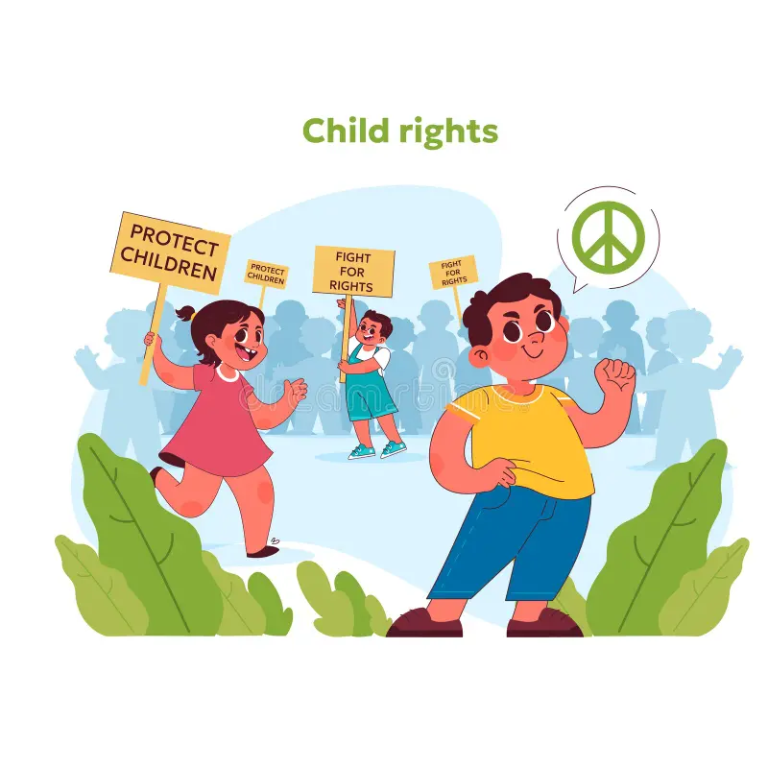

- Name: Nigget Saddiq
- ID NO: 2440130
- Module Code: BMHP5021
- Lecturer: Kennedy Obohwemu and Olufemi Oluranti
- Module title: Protecting and Supporting Families in Health and Care
- Assignment Title: Component 1: Presentation (Round-The-Table Group Discussion)

Child A Safeguarding Review

Reference List
1. Children Act 1989, c.41. London: HMSO.
2. Doherty, J. (2023) “Local Child Safeguarding Practice Review commissioned by The Bradford Partnership: Concerning Child A”. Bradford: The Bradford Partnership.
3. Department for Education (2026a) “Working together to safeguard children”. London: Department for Education. Available at: https://www.gov.uk/government/publications/working-together-to-safeguard-children--2 (Accessed: 11 September 2026).
4. Department for Education (2026b) “Keeping children safe in education 2026”. London: Department for Education. Available at: https://www.gov.uk/government/publications/keeping-children-safe-in-education--2 (Accessed: 12 September 2026).
5. Education Act 2002, c.32. London: The Stationery Office.
6. National Institute for Health and Care Excellence (NICE) (2017) “Child abuse and neglect (NG76)”. London: NICE. Available at: https://www.nice.org.uk/guidance/ng76 (Accessed: 13 September 2026).
7. Department for Education (2018) “Mental health and behaviour in schools”. London: Department for Education. Available at: https://www.gov.uk/government/publications/mental-health-and-behaviour-in-schools--2 (Accessed: 14 September 2026).
8. Department for Education (2026) “Information sharing to safeguard children and young people”. London: Department for Education. Available at: https://www.gov.uk/government/publications/information-sharing-to-safeguard-children-and-young-people (Accessed: 15 September 2026).
9. Education and Inspections Act 2006, c.40. London: The Stationery Office.
10. Department for Education (2018) “Mental health and wellbeing provision in schools”. London: Department for Education.

