
Approaches to Innovation and Organistional Change (ACMA5007)
Owen Bell - 2316885

May 12, 2025
University of Wales Trinity Saint David

Executive Summary

The purpose of this report is to analyse the process for introducing change within an organisation and the effectiveness of Lewin’s unfreeze, change and refreeze model and Kotter’s 8-step model for change, reviewing how successfully Aston Martin was when following the change models highlighted.
The change will be around the introduction of the “Ferrari Style Trolleys” at Aston Martin's St Athan manufacturing site, investigating the reason for the change and the conceptualisation of the trolleys. Overcoming the resistive force against the trolleys and how applying the change models from Lewin and Kotter helped progress in implementing the change. Reviewing the benefits of following Lewin’s and Kotter’s processes and the positive impact they can have on the culture within the organisation, making the organisation a place which encourages collaboration and problem solving. Moreover, this report will review the benefits of the change to the organisation regarding the cost to the business in terms of time and hours per car (HPC) and potential improvements in lean manufacturing.
However, this report will also analyse the risks and damage that can be caused to the culture of the organisation and how change can be negatively viewed by deviating from the change models established by Lewin and Kotter or poor execution of these models, alongside reviewing the impact the new CEO has had on the “Ferrari Style Trolleys” through a change on the resources available and the new challenge faced to successfully implement the “Ferrari Style Trolleys”.

Table of Contents
Executive Summary 1
Introduction 3
Main Findings 4
Unfreeze 4
Changing/Moving 5
Refreeze 6
Conclusion 8
Bibliography 9

Introduction

“On 15th January 1913 Lionel Martin and Robert Bamford established as ‘dealers in manufacturers and repairers of Motor cars’; this was the company that grew into Aston Martin Lagonda Ltd” (Loveys, 2015), renowned for its luxury British vehicles. “On Monday afternoon of March 30, 2020, Aston Martin Lagonda (AML) organised a general meeting and approved a £536 million rescue deal composed of a placement of shares to a consortium led by Lawrence Stroll” (Ventura, 2021). Making Lawrence Stoll and his consortium the current owners of AML.
They aim to be the best in class in the luxury car market. To achieve this, the organisation is looking at opportunities to reduce costs or improve efficiency using Lean Six Sigma (LSS) across Aston Martin's Manufacturing sites. LSS “can be described as a methodology that focuses on the elimination of waste and variation, following the DMAIC structure to achieve customer satisfaction with regards to quality, delivery and costs” (Salah, Rahim and Carretero, 2010).
In September 2024, Aston Martin appointed new CEO Adrian Hallmark, previously of Bentley Motors, intending to make the business more profitable and improve the quality of vehicles which are manufactured. Since Adrian Hallmark's introduction to Aston Martin, the manufacturing sites have experienced a period of transition with a greater emphasis on reducing current costs, leading to changes that were in the process of being implemented being halted.

Main Findings

The change this report will discuss is the introduction of “Ferrari Style Trolleys” that will be used at the St Athan manufacturing site and their application to the centre console sub-assembly stations. The introduction of these trolleys began at the start of 2024 before Adrian Hallmark was appointed as the new CEO. The “Ferrari Style Trolleys” were conceptualised to simplify the manufacturing process by removing packaging and the walking distance to obtain parts for technicians before they receive the parts to build by “kitting” the parts, and saving space by removing racking that previously stored parts needed to assemble the centre console providing either a cost saving or improving the efficiency of the centre console stations preventing downtime resulting in the production line to be halted until a completed centre console could be delivered to the main line.

Unfreeze
During the process of implementing the “Ferrari Style Trolleys”, Kotter’s 8 Step & Lewin’s Three Step Model of Change were used. “The first stage in Kotter’s eight stage process is to create a sense of urgency; an awareness of the need for the organisation to change.” (Pollack and Pollack, 2014), the need that drove the change was the issues faced during the assembly of the centre console with new parts failing and additional time being required to complete the centre console with a cost to the business of £0.03 per second. Once the impact of the problem was understood a multifunctional team involving various departments was formed with all relevant parties that the change would impact could work collaboratively to think of a solution in line with Kotter’s second step being “The second stage in Kotter’s process involves forming a group who have enough power to lead the change.” (Pollack and Pollack, 2014). Step 3 is noted by Pollack and Pollack as “Develop a Vision and Strategy” The developed solution to the centre console build issues by the multifunctional team was the “Ferrari Style Trolleys”. A time study was conducted on the sub-assembly station to better understand the technicians' workloads to try and understand where portions of time were being lost. The timing study unearthed that 10.83 minutes were spent obtaining parts alone across all the centre console stations from an available 49.32 build minutes between the stations. Prompting the multifunctional team to rethink the delivery of parts and how the technicians would obtain the parts and settling on the “Ferrari Style Trolleys”.
Following the agreement on the potential solution across the multifunctional team, the fourth step of Kotter’s model could now take place, being “to communicate the vision for change.” (Pollack and Pollack, 2014). Through communicating with the technicians about the planned change and its purpose, resistance to the change was met with concerns over the risk of damaging parts and sequencing and falling further behind the main production line. This is when the first step of Lewin’s model unfreezing was implemented. It is noted that “Unfreezing is basically three processes, each of which has to be present to some degree for readiness and motivation to change to be generated.” (Schein, 1996). As part of the unfreeze stage, a method commonly used is Lewin’s forcefield analysis, displayed in Fig. 1, is the forcefield analysis that was used to better understand the resistive forces to the change from the technicians.
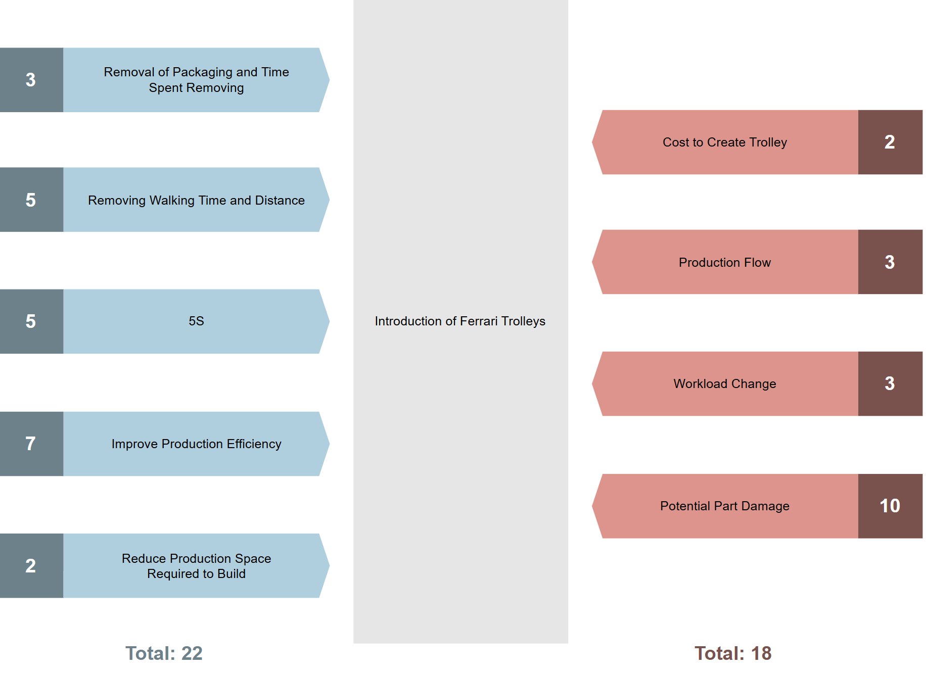
Figure 1 - Lewin's Forcefield Analysis, Ferrari Style Trolleys
Analysing Fig. 1, the main resistive force is the risk of damaging parts due to most parts being classified as “A” surface parts, meaning they would be visible to the customer and damage to these parts would increase the Defects Per Vehicle (DPV) of the area, with a score of 10. However, it shows that the introduction of the trolleys still had a benefit, with the driving force having a total of 22 compared to the resistive forces, 18. Schein stated, “that the equilibrium could more easily be moved if one could remove restraining forces”. This aligns with Kotter’s fifth step: “removing obstacles to change, changing structures or systems that undermine the vision, and encouraging innovative ideas” (Pollack and Pollack, 2014). Through communicating with the Parts Quality and involving the technicians, it was agreed that if the trolley incorporated foam inserts designed for each part, it would protect the parts whilst the trolleys are being moved, acting as a replacement for the packaging. This resulted in the technicians becoming more receptive to the “Ferrari Style Trolleys”, enabling concerns on the sequencing of the assembly to be clarified and resolved, and the technicians becoming “unfrozen”.

Changing/Moving
It is noted that Lewin's second stage is “changing” or “moving” this stage “entails putting in place the appropriate processes and training to carry out the desired change” (Ahmed, Kassem and Sleem, 2022). Lewin’s moving stage corresponds with Kotter’s sixth step: “Short-term wins help demonstrate the viability of change and to build momentum.” (Pollack and Pollack, 2014), The viability of the change can be shown through trialling two different “Ferrari Style Trolleys” with varying mechanisms for locking the shelves, operating the shelves and the integration to the delivery system. During the trials, the technicians provided feedback, making them more receptive to the changes as they had increased input on the design and helped them realise some of the benefits of the “Ferrari Style Trolleys” compared to the previous method of building. The technicians noted the reduction in packaging made it easier to keep the area clean, aligning with 5S which is used across the production sites 5S is a lean manufacturing tool that “helps to reduce non-value adding time, increase productivity and improve quality” (Omogbai and Salonitis, 2017) furthered with the parts being “kitted” on the trolley, removing the possibility of forgetting a part. Moving into Kotter’s seventh step, this “is about maintaining and increasing the momentum of the change initiative after initial short-term wins have been achieved.” (Majka, 2024) As part of this stage after conducting the trial, a review of the mechanisms the trolley required based on the technician feedback and consideration to integrate the “Ferrari Style Trolleys” with other aspects of the production site, a refined version of the “Ferrari Style Trolleys” was fabricated ensuring, where possible the technician’s preference was incorporated to further momentum to implement the change successfully. Moreover, this sparked further suggestions for change with tooling racking to house the tooling out of the assembly area but in reach of the technicians to improve station tidiness and efficiency alongside, a sub assembly trolley for the end cap jig which would remain on station to simplify the sub assembly and create additional space on the workbenches and station.
An additional trial was then carried out using the modified “Ferrari Style Trolleys” with the technician's preferences to capture the potential improvements to the assembly of the centre console stations against the current build method. After studying the trial, it was noted that the “Ferrari Style Trolleys” would save a total time of 3.08 minutes, with a reduction of 3.01 minutes for obtaining parts alone, which equated to roughly a £5 saving per car in terms of hours per car (HPC). Moreover, there was a theoretical cost saving with the “Ferrari Style Trolleys” as they resulted in the racking previously used to become obsolete, which took up a total of 21.17 square meters of space, with the operational cost per square meter being calculated to be £594, resulting in a theoretical cost saving of £12,587 of space. However, this space saving could enable the centre console stations to be moved closer to the point of fit, reducing the time taken for inter ops to deliver the parts from the centre console to the main production line, furthering the cost saving, provided this reduced the inter ops headcount.

Refreeze
The final stage of Lewin’s three-step model is referred to as refreezing. “This phase usually takes place immediately after change has been executed” (Deborah, 2018). Deborah warns, “If this step is not correctly taken, there is a high likelihood that the change will be short-lived and workers will quickly go back to their long-standing balance.” This once again corresponds to Kotter’s eight-step model, with the final step being to institute change. This step “is about making sure that the new behaviours, processes, and ways of thinking introduced during the change initiative become embedded within the organisation's culture.” (Majka, 2024). Majka reiterates the importance of this step and the risk with poor execution, stating, “This phase is critical because, without it, the risk of reverting to old habits remains high, potentially undoing the progress made. Instituting change ensures that the transformation is seen not as a temporary phase but as a new way of operating that defines the organisation”. Deborah and Majka both highlight that failure to correctly implement could result in the efforts to implement the change becoming redundant and reverting to previous methods.
As it stands, the implementation of the “Ferrari Style Trolleys” has been delayed due to the introduction of the new CEO, Adrian Hallmark and the change in priorities with a greater focus on the current cost to operate as a business. An aspect of this is the pause in expenses for introducing production techniques and technology, which the “Ferrari Style Trolleys” are classified within. The result of this has caused efforts to improve the production of the centre console stations to be hindered by the previous engagement and excitement the technicians and the cross-functional team previously displayed during the unfreeze and change stages, having been lost, with the efforts being viewed by some as wasted which could harm future changes and projects with greater resistance to change being established because of the current ineffective implementation and the uncertainty surrounding if the “Ferrari Style Trolleys” will become a part of the production line.
Despite this, the “Ferrari Style Trolleys” are still a change which some senior figures within the business would like to implement eventually, with the Senior Manager of Trim and Final production remaining keen on the change for its improvements in Lean manufacturing and its eventual cost saving. However, although the trolleys could improve a variety of factors across the site and provide a saving of over 3 minutes per vehicle, equating to £5 in terms of HPC. The implementation cost of £17,500 for 7 “Ferrari Style Trolleys” is a cost that cannot currently be sanctioned under the situation the business finds itself with the CEO's ambition to generate further cost and focus on minimising the cost with the resources currently in place.

Conclusion

In conclusion, the introduction of the “Ferrari Style Trolleys” can be viewed as both a success and a failure. This is because by following both Lewin’s and Kotter’s models for change, it can be seen the importance of removing resistive forces that are opposing change and how, through communicating and collaborating with those who will be impacted by the change the most and understanding where their resistance stems from. By understanding the concerns, actions to ease the concerns can be taken through communication, addressing the resistance or involving those who are resisting change to display the purpose of the change and how the concept or solution has been reached. Generating engagement in the change’s introduction and potentially excitement with those who were initially resistant to the change, feeling involved and opinions valued. The success of the “Ferrari Style Trolleys” is furthered with the trollies generating a saving of just over 3 minutes per vehicle and £5 in terms of HPC based on the gathered trial data, with possible further savings through interops and space saving. However, the implementation of the “Ferrari Style Trolleys” could become categorised as a failure, due to its poor implementation, with the new CEO halting spending on the introduction of new production techniques and technology. With a greater focus on reducing operational costs with the current resources available, this has impacted the previous excitement to introduce change with the technicians who were involved in the process, becoming demoralised and viewing their efforts as wasted, this could impact future changes embedding a mentality and culture that the process to introduce change is lengthy and pointless with the failure to properly implement changes and sticking or reverting to previous methods.

Bibliography
Ahmed, A., Kassem, A. and Sleem, W. (2022). Applying Lewin’s Change Management Theory To Improve Patient’s Discharge Plan. Mansoura Nursing Journal (MNJ), [online] 9(2), p.2022. Available at: https://journals.ekb.eg/article_295591_2e01c440a7769101b9fd53066f06f65c.pdf [Accessed 15 Apr. 2025].
Deborah, O.K. (2018). Lewin’s Theory of Change: Applicability of its Principles in a Contemporary Organization. Journal of Strategic Management, [online] 2(5), pp.1–11. Available at: https://www.stratfordjournals.com/journals/index.php/journal-of-strategic-management/article/view/229 [Accessed 21 Apr. 2025].
Loveys, R. (2015). Aston Martin. [online] Google Books. Available at: https://books.google.co.uk/books?hl=en&lr=&id=dlHDCwAAQBAJ&oi=fnd&pg=PA5&dq=aston+martin&ots=8iBCn1TRi2&sig=6Fig7z96TCVTSpSVi3S61ywPNf4&redir_esc=y#v=onepage&q=aston%20martin&f=false [Accessed 14 Apr. 2025].
Majka, M. (2024). Leading Change Successfully: A Guide to Kotter’s 8-Step Process. [online] ResearchGate. Available at: https://www.researchgate.net/profile/Marcin-Majka-2/publication/381280928_Leading_Change_Successfully_A_Guide_to_Kotter [Accessed 15 Apr. 2025].
Omogbai, O. and Salonitis, K. (2017). The Implementation of 5S Lean Tool Using System Dynamics Approach. Procedia CIRP, [online] 60((2017)), pp.380–385. doi:https://doi.org/10.1016/j.procir.2017.01.057.
Pollack, J. and Pollack, R. (2014). Using Kotter’s Eight Stage Process to Manage an Organisational Change Program: Presentation and Practice. Systemic Practice and Action Research, [online] 28(1), pp.51–66. doi:https://doi.org/10.1007/s11213-014-9317-0.
Salah, S., Rahim, A. and Carretero, J.A. (2010). An Integrated Company-Wide Management System: Combining Lean Six Sigma with Process Improvement. [online] Research Gate, Emerald Group Publishing Limited, pp.249–274. Available at: https://www.researchgate.net/profile/Souraj-Salah/publication/330045301_An_Integrated_Company-Wide_Management_System_Combining_Lean_Six_Sigma_with_Process_Improvement/links/5c42ef7592851c22a3800339/An-Integrated-Company-Wide-Management-System-Combining-Lean-Six-Sigma-with-Process-Improvement.pdf [Accessed 14 Apr. 2025].
Schein, E. (1996). From Systems Practice. Kurt Lewin’s Change Theory in the Field and in the Classroom: Notes Toward a Model of Managed Learning, [online] 9(1), pp.27–47. Available at: https://citeseerx.ist.psu.edu/document?repid=rep1&type=pdf&doi=f9f987dbf70fa5bd3c3e81ed75ba7b438078cd08 [Accessed 14 Apr. 2025].
Ventura, C.A.B. (2021). Aston Martin Lagonda Case Study - ProQuest. [online] Proquest.com. Available at: https://www.proquest.com/openview/69042a8133e8f8f7f9895bfda99ca32f/1?cbl=2026366&diss=y&pq-origsite=gscholar [Accessed 14 Apr. 2025].

