
Paul Gormlie (P149642)
Lecturer | Mr. M. mcdonald
Advanced Engine Design
Calculation on piston, rod and crankshaft

Contents
Introduction: 2
Methodology: 3
Gudgeon pin: 3
Gudgeon pin and related geometry: 3
6
Connecting rod: 7
Section A: 8
Section B: 9
Section C: 10
Con-rod Bolts: 12
(a): Bolt stiffness to cap-rod stiffness ratio. 12
(b): Standard bolt stiffness @ stretch region. 12
(c): Max alternating load on bolt. 12
(d): Calculate bolt tightening torque. 13
(e): Mean stress and range of stress in rod-bolt. 14
(f): Determine fatigue safety factor of bolts. 14
(g): Re-design bolt for uprated engine. 15
(h): Sketch standard and uprated bolt designs. 15
Crankshaft: 17
Conclusion: 20
Bibliography 21
Appendix: 22

Introduction:

For Advanced engine design (A.E.D) part (b), candidates have been tasked with carrying out calculations on the reciprocating engine parts of a Ford sigma, 1.6l, 4-stroke GDI engine. The study will analyse each component in the reciprocating assembly, such as, the gudgeon pin, connecting rod, connecting rod bolts and the crankshaft. For each component a number of studies will be carried out in order to determine the stresses and strains encountered by each part under normal engine operating conditions. Suitable applications of design features will have to be applied in order to achieve desired results with regard to structural suitability in the first instance, stress concentration factors and component fatigue life.
For selected components, a design study will be carried out to also determine these considerations when the engine has been modified, thus requiring an effective re-design of necessary components and subsequent effects on their suitability and fatigue lives.
From this, discussion can be raised on design theory and techniques applied to achieve a sufficiently robust component for use in the modified engine.
To conclude, the report will determine whether or not design criteria has been met and also the if the application of necessary design theory and practice fulfils the task in question.

Methodology:

Gudgeon pin:

Following from assignment part (a) of A.E.D whereby candidates have calculated the maximum tensile and compressive forces encountered by the reciprocating assembly, it is now possible to calculate the stresses encountered by the gudgeon pin during engine operation. In order to calculate these stresses and also calculate the fatigue safety factor, various methods will be employed to calculate the bending and shear stress encountered by the pin thus providing results from which a Goodman diagram can be plotted allowing for completion of the task.

Gudgeon pin and related geometry:

To begin, the geometry of the gudgeon pin and its relative geometry to the piston assembly must be measured. This was achieved by compiling a model of the assembly within 3D CAD software (Solidworks 2019) and obtaining required measurements such as:
- Pin protrusion
- Length to upper con-rod taper (L1)
- Length to lower con-rod taper (L4)
- Centre of gravity of Protruding gudgeon pin (L3)
- Mass of protruding pin section
- Inner and outer diameters of pin (d2 and d1 respectively)
Using the data obtained, it is now possible to calculate the bending and shear stresses encountered by the pin in compression (firing) and tension (TDC at exhaust stroke). These calculations utilise the following formulae:

Firing (compressive):

Bending stress at gudgeon pin:

$$\frac{M.Y}{I}$$

Where M = Bending moment at B, = $\frac{F_{NET}}{2}.L4-Finertia Pin.L3$
Y = Outer diameter of gudgeon pin divided by 2 or $\frac{d1}{2}$
And I = 2nd moment of area of pin, = $\frac{π}{64}({d1}^{4}-{d2}^{4})$
In this case, calculations have been performed on standard engine components at 5700 RPM as this is where maximum gas forces were found to occur in the previous assignment, thus:
F_{NET} = 38,001.32N
L4 = 11.91mm
F_{inertia pin} = 497.22N = Mass x Acceleration
L3 = 7.88mm
D1 = 21mm
D2 = 13mm
Y = 10.5mm
Therefore, $\frac{19000.7.\left(11.91\right)-497.22.\left(7.88\right)x10.5}{\frac{π}{64}.\left({21}^{4}-{13}^{4}\right)}=$ 286.69N/mm² = Bending stress

Shear stress at pin:

In order to calculate the shear stress in the pin during firing, the following calculations have been utilised:
$$τ=\frac{\frac{F_{NET}}{2}- F_{inertia pin}}{\frac{π}{4}.({d1}^{2}-{d2}^{2})}$$
Therefore, $τ=\frac{19000.7-497.22}{\frac{π}{4}.\left({21}^{2}-{13}^{2}\right)}$ = 86.61N/mm²

From these calculations it is now possible to calculate the combined compressive stress encountered using the following formula:
Compressive combined stress = $\sqrt{σ^{2}}+{\left(2.τ\right)}^{2}$
Therefore = $\sqrt{{286.69}^{2}}+({2x86.61)}^{2}$ = 334.96N/mm²

TDC on exhaust stroke (Tensile):

To calculate the stresses under tensile load, the same formulae are employed as compressive stress, the only alteration being the use of F_{Inertia} rather than F_{NET}, this F_{Inertia} is a product of the reciprocating mass of the piston assembly incl. gudgeon pin and one third of the con-rod mass by the acceleration at 5700 RPM. This is shown as follows:
$$F_{INERTIA}=\left(0.38752+0.13571\right)x18905.56=9891.96N$$
This figure is again inserted in the formula to calculate σ as shown below:

Bending stress:

Therefore, $σ=\frac{\left(\left(\frac{9891.96}{2}x9.3\right)+\left(497.22x7.88\right)\right)x10.5}{8144.56}$ = 64.35N/mm²

Shear stress:

Again, as for compressive force the same formula is utilised to calculate τ this time using F_{INERTIA} rather than F_{NET,} the resulting value can be calculated as:

$τ=\frac{\frac{9891.96}{2}+497.22}{\frac{π}{4}x\left({21}^{2}-{13}^{2}\right)}$ = 25.48N/mm²
Again, the combined stress must be calculated for tensile by utilising the same formula as compressive, in this case the combined stress is calculated to be:
$τ=-82.08N$/mm²

From this point, the range of stress can be calculated,
334.96 – (-82.08) = 417.04N/mm²
The mean stress can now also be calculated as,
$\frac{334.96+\left(-82.02\right)}{2}$ = 126.47N/mm²

From the tensile stress of the pin material (AISI 4340 steel, Normalised) which is 1110N/mm², it is possible to calculate the endurance limit of the material. This is defined as 48% of the tensile strength of the material in question (Engineering Toolbox, 2011). Therefore, endurance limit in this case:
E.L = 1110 x 0.48 = 532.8N/mm²
At this endurance limit, it is possible to calculate the allowable range when mean = 0, the allowable range at calculated mean can be calculated also, this is shown as follows:
Allowable range at mean = 0, = 2 x E.L = 2 x 532.8 = 1065.6 N/mm²
Allowable range at calculated mean = 2 x E.L $(1-\frac{Mean}{UTS})$ = 1065.6 $(1-\left(\frac{126.47}{1110}\right))$ = 943.66 N/mm²
This allows calculation of the fatigue safety factor (F.S.F) by: $\frac{Allowable range}{Actual Range}$
Therefore, $\frac{943.66}{417.04}=F.S.F of 2.26$

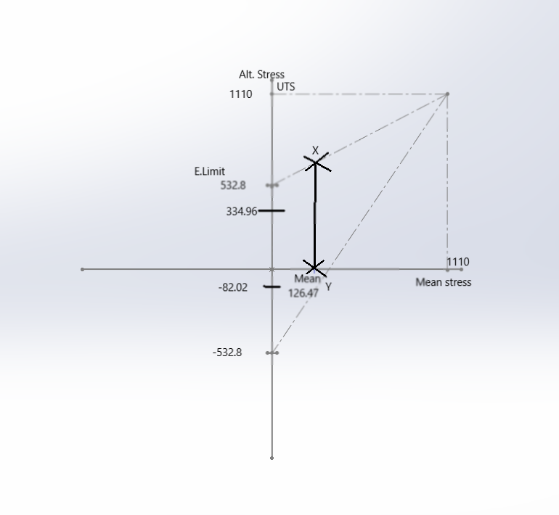
Figure 1: Goodman diagram with combined stresses shown
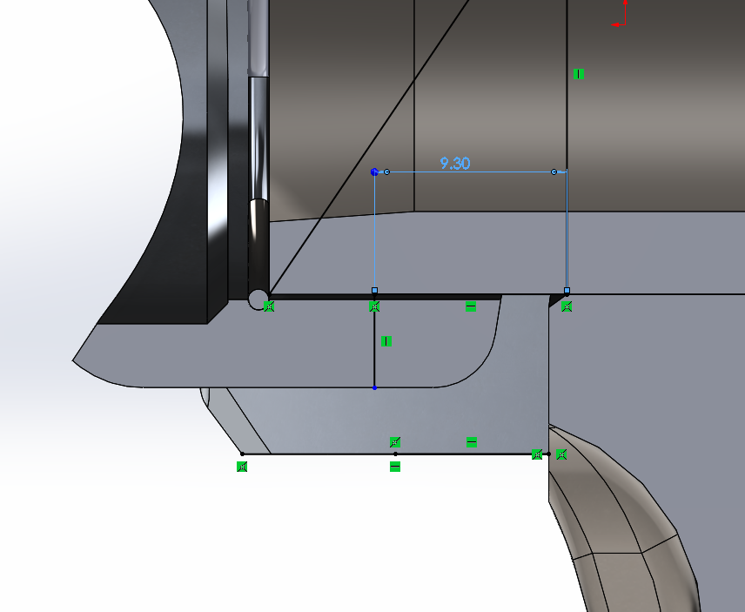
Figure 2: Obtaining piston and gudgeon pin geometry via Solidworks

Connecting rod:

For section 2 analysis will be carried out on three separate areas of the connecting rod in order to obtain fatigue safety factors for the area in question. Forces will be applied to each area to simulate tensile and compressive loads as in a real-world engine cycle. The loads will be applied numerically from a previous calculation and will simulate the engine running at the 5700RPM range as this is where maximum compressive force occurs. Further analysis will be carried out at the 6000RPM range to produce maximum tensile loading on the upper rod section and rod cap.
Goodman diagrams will then be plotted to ensure fatigue safety factors can be met with stress concentration factors applied to critical rod sections.

Section A:

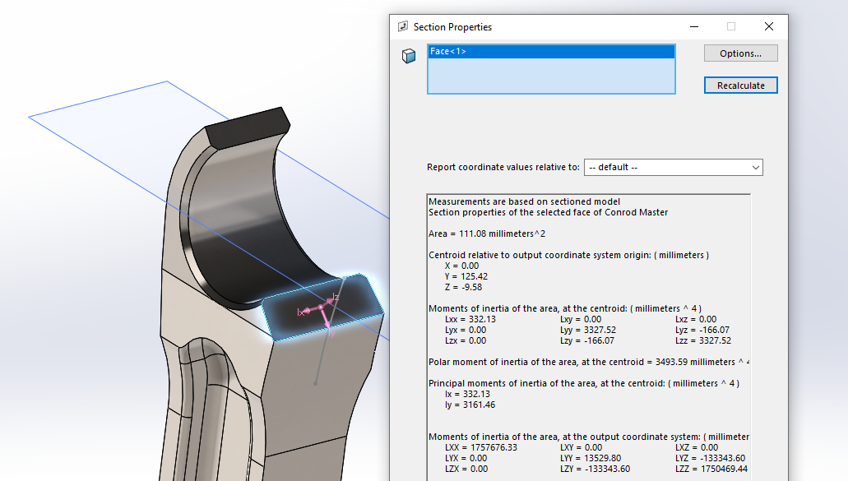
To analyse section of the rod, it is first necessary to measure the rod cross-sectional area at this point. In order to measure accurately, a scale model has been drafted using 3D CAD software, thus allowing a higher degree of tolerance than traditional methods.
Figure 3: Cross sectional area of small end
At this section it appears that the rod will encounter a compressive force as the engine fires, therefore it must be assumed that this area will receive 38,001N of force from the power stroke of the 4-stroke cycle. This information allows a calculation of nominal stress to be performed at the area in question:
$σminNOM=\frac{P}{A}$, therefore, $\frac{38001}{111.08}$
when calculated a value for σ of -342.1N/mm² is found. This force can be considered negative as compressive.
At this point a hoop stress is also encountered and can be calculated as:
$σmaxNOM=\frac{\frac{38001}{4}}{111.08}$ = 85.53N/mm²
Now a range of stress can be calculated and suitable concentration factors applied in order to calculate a final fatigue safety factor, this is shown as follows:
$Range=85.53-\left(-342.1\right)=427.63$N/mm²
It is now also possible to calculate the mean stress encountered at this area by using the following formula:

$Mean=\frac{85.53+\left(-342.1\right)}{2}$ = -128.29N/mm²
As the ultimate tensile strength of the con-rod material is 750N/mm², it is also possible to calculate the polished endurance limit of the material
$Polished endurance limit=0.45\left(U.T.S\right)=337.5$N/mm²
Applying a stress concentration factor of 1.034, which is almost negligible due to the large radius present at this area (100mm). The value for final endurance limit can be found:
$Final endurance limit=\frac{337.5}{1.034}$ = 326.4N/mm²
This value can then be used to produce a Goodman diagram and will allow calculation of the final fatigue safety factor.
This can also be calculated as follows:
$2 x Endurance limit x \left(1-\left(\frac{mean}{uts}\right)\right)=652.8 x (1-\left(-\frac{128.29}{750}\right)=764.5$N/mm²

This value is known as the allowable range, to calculate safety factor the calculation is as follows:
Fatigue safety factor = $\frac{Allowable range}{Actual range}=\frac{764.5}{427.63}$ = 1.79

Section B:

To calculate section B, it is again necessary to find the cross-sectional area of the required area, again this can be carried out in the Solidworks software and is shown as follows:
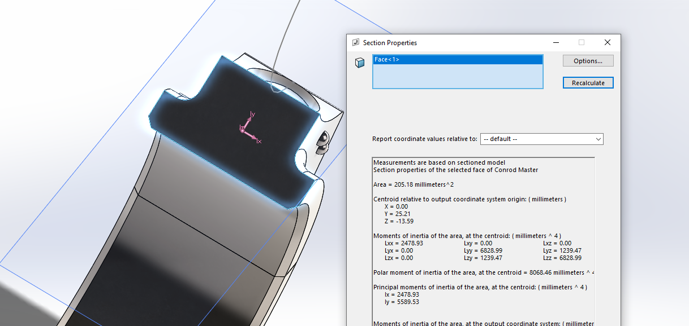
Figure 4: Big end upper cross-sectional area.
As can be seen, this area has a cross-sectional area of 205.18mm² which will be again input to the nominal stress formula with the correct load applied to give a value for min. nominal stress in this area.
As the crankshaft rotates through this area a compressive load is encountered at this point. This load can be considered to be half of the Net force on firing as the rod compresses itself:
Min nominal stress = $\frac{-36000.1}{205.18}$ = -175.46N/mm²

The maximum nominal stress can also be calculated as the maximum tensile force above point B, in this case:
Max nominal stress = $\frac{9891.87}{205.18}$ = 48.21N/mm²
Again, the stress range and mean can be calculated at this stage, from calculating, it is found that:
Range = -175.46 + (48.21) = -127.25 and Mean = $\frac{-175.46-48.21}{2}$ = -111.84N/mm²

Now it is possible to calculate the Final endurance limit, by applying a stress concentration factor of 1.096, which is again almost negligible due to the large radius present at the area in question (34.95mm).
Applying this factor, the Final endurance limit becomes: $\frac{337.5}{1.096}=307.94$N/mm²
Again, it is possible to calculate the allowable range of stress at the desired area by calculation, this is shown as follows:
$615.88 x \left(1-\left(-\frac{111.84}{750}\right)\right)=616.03$N/mm²
Now the F.S.F can be again calculated as: $\frac{616.03}{127.25}$ = 4.84

Section C:

Using a cross-sectional area of 163mm² and a tensile force of 12,118.72N the Min. Nominal stress is calculated as $\frac{\frac{12118.72}{2}}{163}$ = 37.17N/mm²
The Max nominal stress can also be calculated as $\frac{Rotational inertia force}{2}$ = $\frac{6913.84}{163}$ = -42.42N/mm²
The range of stress can be calculated as $37.17 – \left(-42.42\right)=79.58$N/mm²
And also, the mean can be calculated as $\frac{37.17 + \left(-42.42\right)}{2}$ = -2.625
Applying a stress concentration factor of 3.16 due to the small radius fillet, the final endurance limit becomes:
$\frac{78.58}{3.16}$ = 24.86N/mm² now the allowable range can be calculated from:
$49.73 x\left(1-\left(-\frac{2.625}{750}\right)\right)=49.74N$/mm²
Thus, giving a final fatigue safety factor of $\frac{49.74}{79.58}=0.625$.

Con-rod Bolts:

(a): Bolt stiffness to cap-rod stiffness ratio.

In order to calculate the bolt to cap stiffness ratio, it is first necessary to measure the components to obtain necessary geometry. In this case, the geometry required consisted of the surface area of the bolt and con-rod cap, the modulus of elasticity was obtained also at this time in order to satisfy the equation:
$\frac{E_{CAP x}A_{CAP}}{E_{BOLT} x A_{BOLT}}$

Using Youngs modulus of 205,000 N/mm² for the cap and determining the cap surface area from an accurate 3D CAD model of 154.18mm², also using a material with a Youngs modulus of 210000 N/mm² and calculating a surface area of 62.83mm² for the bolt, the cap to bolt stiffness ratio was found to be 3.84. (INSERT FIGURE)

(b): Standard bolt stiffness @ stretch region.

To calculate the bolt stiffness at the stretch region, a 3D CAD model was created and the length from the contact area between the rod bolt and the con-rod cap to the 2nd engaged thread was measured within the software. This allowed for the calculation of stiffness using the formula:
$\frac{E x A}{L}$ and thus, $\frac{210000 x 62.83}{23.04}$ = 392000N/mm²
(INSERT FIGURE)

(c): Max alternating load on bolt.

In order to calculate the maximum alternating stress encountered by the bolt it is necessary to firstly calculate the maximum inertia force encountered by the con-rod cap when the piston is at TDC on exhaust stroke. This inertial force can be calculated by using the formula;
$M_{Recip}.Rω^{2}.(1+\frac{R}{L})$ + ($\frac{2}{3}Rod-M_{Cap).}Rω^{2}$ = 18276.93N @ 7000RPM for standard bolts.
From here the nominal stress encountered by the bolt at highest inertia force can be found by first calculating the extra force on the bolt encountered at max inertia.
This is calculated using the formula:
$\frac{kB}{kB+kCap} x\frac{Finertia}{2}$ therefore, $\frac{392000}{392000+1371827.3} x\frac{18276.93}{2}$ = 2030.97N

It is now possible to calculate σ_{NOMINAL} by applying the standard stress formula $σ=\frac{F}{A}$
Where F = Extra force in bolt and A = Cross-sectional area of bolt.
This is calculated as: $σ_{NOM}=\frac{2030.97}{\begin{aligned}π x\frac{{6.917}^{2}}{4} \\ \end{aligned}}$ = 50.25N/mm²
Maximum stress in the bolt can also be calculated when tightened to 90% of yield strength, this is calculated as follows, utilising a bolt with ultimate tensile strength of 1110N/mm².
$σ_{MAX =}50.25+1110\left(0.9\right)x(0.9)$ = 949.35N/mm²

(d): Calculate bolt tightening torque.

To calculate the tightening torque of the bolt it is necessary to calculate the amount of friction the bolt has to overcome as a result of its geometrical properties. These properties will determine the amount of torque required to achieve sufficient tightness to 90% of yield when using Ford specified torque specifications.
At 90% of yield standard bolt has a value of $0.9 x 1110=999$N/mm²
From here the axial stress can calculated as $0.6 x 999=599.4$N/mm²
This allows calculation of the clamping force of the bolt by: Avg. c.s Area bolt x Axial stress = 39.2 x 599.4 = 23496.5N.
Now it is possible to consider the frictional forces to be overcome in order to determine the tightening torque.

Thread Friction:

In order to overcome thread friction, a suitable co-efficient of friction must be determined, this is denoted as μ, and in this case has been found to fall between 0.13 and 0.19 for the bolt and female thread material (Robert Bosch GmbH, 2008), for the purpose of this calculation a value of 0.175 will be assumed as an average of these two figures.
Circumferential friction force (C.C.F) is calculated as: 0.175 x 23496.5 = 4111.9N
Then resisting torque of the threads is found by: $\frac{dthread}{2} x Circ. fric. force= \frac{6.917}{2} x 4111.9=14221Nmm or 14.22Nm$

Bolt head Friction:

To find bolt head friction a similar method is employed, although in this instance, new values for μ are found and also the average area of the bolt head must be considered to total tightening torque.
In this case, μ = 0.13,
avg. bolt head area = 10mm,
Therefore, C.C.F = 0.13 x 23496.5 = 3054.55N
And total torque to overcome head friction is found by: 3054.5 x 5 = 15272.73Nmm or 15.27Nm

Total tightening torque:

Total tightening torque is = T_{HF +} T_{TF} = 14.22 + 15.27 = 29.49Nm

(e): Mean stress and range of stress in rod-bolt.

In order to calculate the mean stress and range of stress in the bolt it is necessary to obtain the values for σ_{MAX} and σ_{MIN}. These values are input to the following formulae and the relevant stress concentration factors applied giving a true estimation of the stresses encountered at the critical thread root.
These stress concentration factors have been decided by using Petersen’s method for thread root stress concentration factors, also using data obtained from the Roark’s book of formulae for stress and strain.
To determine the range of stresses in the bolt, the formula below is used:
$$Extra stress in bolt=(1/(1+\left(\frac{Kcap}{Kbolt}\right)x \left(\frac{Finertia}{2}\right)=1888.3 N/{mm}^{2}$$
From this extra force the nominal stress in the bolt can be calculated also, this is also the range of stress in the bolt at this inertia force, this is calculated as follows:
$σ_{Nom = }1888.3/(π x \frac{{6.917}^{2}}{4})$ = 50.25N/mm²
The mean stress can also now be calculated as:
$\frac{σ_{Max}+ σ_{min}}{2}$ = $\frac{949.35+899.1}{2}$ = 922.23N/mm²

This is for a stress concentration (K_{it}) = 2 as assumed from lecture notes, if concentration factors are applied such as the value calculated of (K_{T}) = 2.0313 at the thread root (Warren C. Young, 2002) there is no discernible difference to the endurance limit of the material in question.

(f): Determine fatigue safety factor of bolts.

To calculate the Fatigue safety factor, it is first necessary to find the allowable range of the material with stress concentration factors applied. The actual range has already been found using the Goodman diagram and can now be implemented. Allowable range is calculated as follows;
$$Allowable range=\frac{2 x Endurance limit}{(Kt)}x \left(1-\frac{Mean}{UTS}\right)$$

$$Allowable range=2 x\frac{\left(1110.\left(0.45\right)\right)}{2.0313}x \left(1-\frac{922.23}{1110}\right)$$
= 83.19N/mm²
Therefore, $\frac{Allowable range}{actual range}= \frac{83.19}{50.25 }=$F.S.F of 1.66

(g): Re-design bolt for uprated engine.

To re-design the bolts for an uprated engine, several design theories and applications were researched in order to achieve a reasonable design for the rod-bolts, taking into consideration the desire to maintain the original con-rod design and geometry.
Following this research, the waisting of the shank of the bolt appeared to provide a suitable solution (Automotive Racing Products ltd, 2020), this coupled with an increased tensile strength should present favourable results by increasing the elasticity of the bolt shank under similar clamping force as the original bolt.
The application of fillets on the bolt shank have been included to reduce high point stress loads under tensile loading also. (ASM International Ltd., 1990) These modifications should, in theory yield similar fatigue life to the standard bolts, whilst also allowing an increase in the engine speed ceiling. For the purposes of this study the engine speed has been increased to 9000 RPM in a numerical simulation.
To re-design the bolt, a high tensile steel alloy has been utilised, (90MnCrV8) which is a high magnesium content chrome-vanadium bolt with suitable properties for use in engine components, such as U.T.S of 1930N/mm² and high elasticity modulus of 210000N/mm². The bolt shank diameter has been reduced to 5.5mm to reduce the cross-sectional area and reduces the stiffness of the bolt by approx. 60%, this reduction should allow a high cap to bolt stiffness ratio with little variation in clamping force, <1%. Use of this design also delivers a F.S.F of 2.76, which deems the design fit for purpose at the 9000RPM range without modification to the piston assembly, although consideration may be applied to the connecting rod design, which from previous studies was shown to have a static safety factor of 1.4 at the 9000 RPM range.

(h): Sketch standard and uprated bolt designs.

A number of sketches were subsequently carried out using Solidworks 2019 to illustrate the design changes, a selection of which will be shown below:

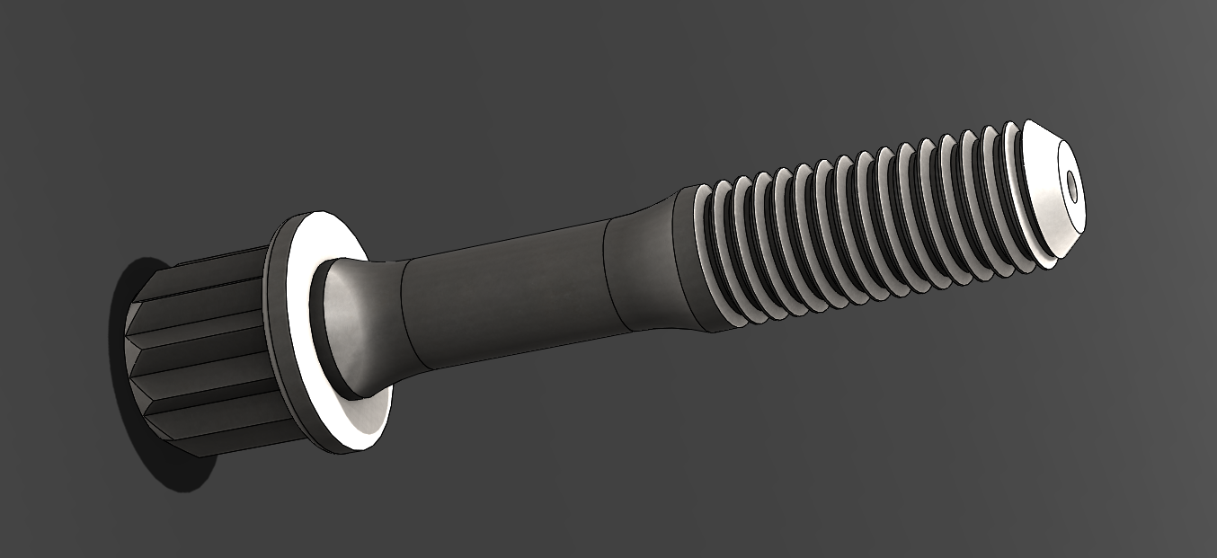
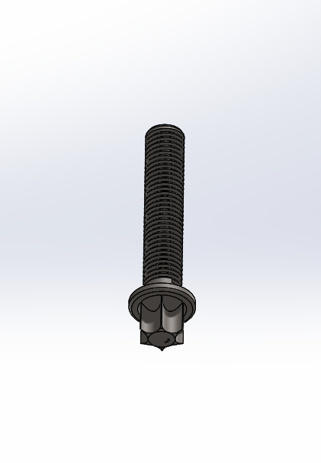
Figure 5:Comparison of re-designed rod bolt and standard Ford design
As can be seen, the removal of thread section and addition of a waist on the bolt provide the necessary reduction in cross-sectional area as previously mentioned. Also added to the design are 10mm radii on the waisted section, in an attempt to reduce stress concentration on the bolt shank. In addition, dimples have been added to each end of the bolt to provide a locating point for the fitment of a stretch gauge during initial engine building.
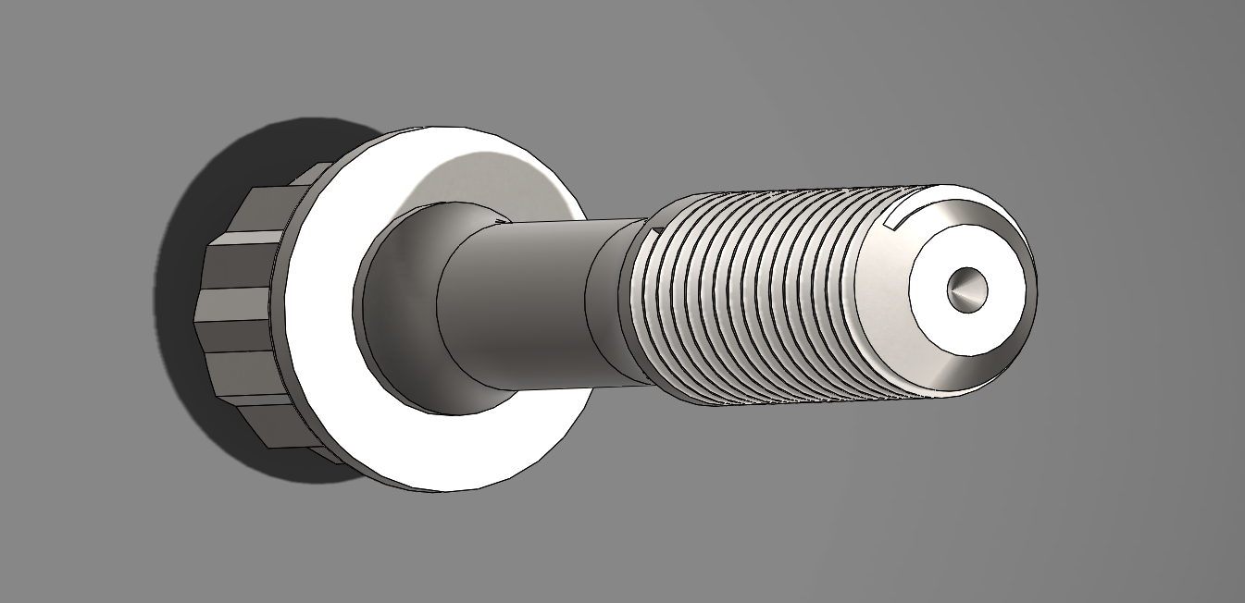
Figure 6:Rod bolt, stretch gauge dimples

Crankshaft:

In order to calculate the fatigue safety factor of the original crankshaft, various calculations have been performed to determine the critical stress characteristics of the crankshaft in a dynamic situation.
In this instance, the crankshaft geometry was measured by hand in order to achieve reasonable results when calculating, there is a small margin of error to be expected due to possible calibration errors with measuring equipment and user error, but results should fall within 5% of specification.
Below is a list of all measurements taken from the Ford crankshaft:
- Main Bearing journal, diameter and length.
- Big end journal, diameter and length.
- Distance from Point A to centre of big end journal.
- Distance from point B to centre of big end journal.
- Big end web width.
- Radii at interface of journals and webs.
- Undercut
From these measurements, it is now possible to carry out various calculations in order to find the stresses encountered at these critical areas on the crankshaft during compressive and tensile loading. These calculations will be outlined below:

Bending stress at point A:

To calculate bending stress at point A, the net gas force and inertia loads must be imported from a previous spreadsheet, these loads have been calculated for an engine running at 7700RPM to suggest a lightly modified engine.
Bending stress at point A = $σ=\frac{MxY}{I}$
Where M =bending moment at A, Calculated from $\frac{Fnet}{2}x length to point A$ = 214774.8Nmm
Y = beam measurement $\frac{'D^{'}}{2}$
And I = Second moment of area of crank section subject to stress = $\frac{b x d^{3}}{12}$

When calculated, the bending stress at A was found to be 58.85N/mm²

Bending stress at point B:

Bending stress at B is calculated the same way as A, only this instance takes the increased length from point B into consideration.
Final value for bending stress at point B = 166.61N/mm²

Shear stress at point A:

To calculate shear stress at point A the following calculation was employed:
$τ=\frac{\frac{Fnet}{2}}{\begin{aligned}π x\frac{l.A^{2}}{4} \\ \end{aligned}}$ This was calculated to be 160.25N/mm²

Shear stress at point B:

Employing the same method, the shear stress at point A was calculated to be 19.99N/mm²

Resultant stresses:

From these values the combined stresses at points A and B were calculated respectively employing the formula:
$$σ\max{= \sqrt{σ^{2}}+(2τ)^{2}}$$
In the case of point A, $σMax=65.29$N/mm²
And in the case of point B, $σMax=168.99$N/mm²

At this point a value for $σminB$is calculated also in order to determine a stress range and mean stress encountered at the critical sections of the crankshaft using the formula:
$$\frac{Finertia}{Fnet} x σB$$
This gives a value of: -83.63N/mm²

It is now possible to calculate the stress range and mean stress at B, these are the values;
Stress range = 168.99- (-83.63) = 252.62N/mm²
Mean stress = $\frac{168.99+\left(-83.63\right)}{2}=42.68$N/mm²

These values allow for a Goodman diagram to be plotted, whereby a stress concentration factor of 2 will be employed, in order to account for the filleted sections of the crankshaft journals, this is an accepted figure for a fillet of radius 1.5mm in this type of loading situation. (Shashank Hebbal, 2015)
Using a spheroidal steel crankshaft, the UTS of the material is assumed to be 750N/mm² this will allow for calculation of a polished endurance limit of 0.45(U.T. S) giving a value of: 337.5N/mm²
As a value for K_{t} is assumed as 2, the endurance limit with stress concentration is found to be 337.5/2N/mm² this gives a value of 168.75N/mm² which can be used to draw the final Goodman diagram which is required to calculate the final fatigue safety factor.
From the diagram, it is found that the crankshaft exhibits good fatigue life properties at 7700RPM where at an allowable range, at mean stress of 318.29N/mm² a fatigue safety factor of 1.26 is achieved.
Further analysis reveals that the standard for crankshaft appears to perform safely at the 9000RPM range also, in this instance, achieving a F.S.F of 1.18.

Conclusion:

Upon completion of all tasks, it is clear to see that certain critical engine components can be affected by even minor design flaws at early stages of the design process. The importance of hand calculations and the correct interpretation of geometry are also critical in a useable analysis being completed. Application of stress concentration factors has also been highlighted and the need to assess any possible problem areas and the methods of mitigation required to produce components that will fulfil their projected fatigue lives has been demonstrated.
For the re-design aspect, the modifications to the con-rod bolt proved to be successful with a reduction in mass of the bolt, an acceptable fatigue safety factor in a modified engine and the ability to retain the original con-rod geometry would consider the exercise overall beneficial.
The importance of the Goodman diagram was also illustrated as a tool for determining the fatigue life of components also and will be implemented in the future.

Bibliography
ASM International Ltd. (1990). Fatigue resistance of steels. ASM handbook Vol. 1, 673-688.
Automotive Racing Products ltd. (2020, 02 09). arp-bolts Metallurgy. Retrieved from Arp-bolts: https://arp-bolts.com/p/technical.php#p7TPMc1_4
Engineering Toolbox. (2011, 02 08). Steels, Endurance limits and fatigue strength. Retrieved from Engineering Toolbox: https://www.engineeringtoolbox.com/steel-endurance-limit-d_1781.html
Robert Bosch GmbH. (2008). Bosch automotive handbook. Berlin: Robert Bosch GmbH.
Shashank Hebbal, S. K. (2015). Study of stress concentration factor in crankshaft by FEM. Karnataka, India: International journal on emerging technologies.
Walter D. Pilkey, D. F. (1997). Peterson's stress concentrations. New York: Wiley.
Warren C. Young, R. D. (2002). Roark's formulas for stress and strain. New York: McGraw Hill.

Appendix:



