

Programme: Certificate of Higher Education in Employability Skills
MODULE: Digital Skills for Personal and Professional Growth
Module code: BMSW4008
ASSESSMENT COMPONENT: PORTFOLIO
STUDENT NAME: Cristina Abraham
STUDENT NUMBER:2523199
Module Lead: Philippa Fitzgerald
Table of Contents
Task 1 - Assessment of Digital Skills and the digital skills badges 3
Task 2 - LinkedIn Learning Certificates for Office365 (Outlook, Word, Excel, PowerPoint) 3
Task 3 - Essay on relevance of Excel + Embedded Excel 3
Introduction 3
Discussion 3
Conclusion 5
Task 4 - 5 Minute Reflective Presentation 7
Slide 1: Cover page 7
Slide 2: Introduction to development of digital skills, its uses and application in academic studies and future career 8
Slide 3: JISC Digital Capability assessment and action plan 9
Slide 4: LinkedIn Learning Office 365 certificates 10
Slide 5: Excel essay and spreadsheet 11
Slide 6: Conclusion 12
Slide 7: Reference List 13
Reference List 14
Declaration 16

Task 1 - Assessment of Digital Skills and the digital skills badges

1. Introduction and importance of digital skills
In contemporary learning and professional areas, digital skills are highly crucial. Internet technologies are popular in the world of business, education, and life in general. They promote productiveness and innovativeness in industries. Digital skills also enable individuals to practice digital entrepreneurship and to be responsive to the fast-evolving digital market (Soltanifar et al., 2021). Digital literacy helps in research, collaboration, and knowledge creation in the academic areas. Learners need to be skilful for assessing online content and applying digital technologies in learning. Technological skills and academic performance of the students are enhanced by digital literacy training (Erwin and Mohammed, 2022). Thus, I need to acquire good digital skills in my studies and career.

2. Overall summary of JISC Results
Following the JISC Digital Capability self-assessment tool, I have looked at my profile of digital capabilities. According to the results, I possess moderate to excellent capabilities in certain areas of digital capabilities. These are digital literacy and information and data literacy. These strengths indicate that I can utilise digital tools and reach out to internet-based information.
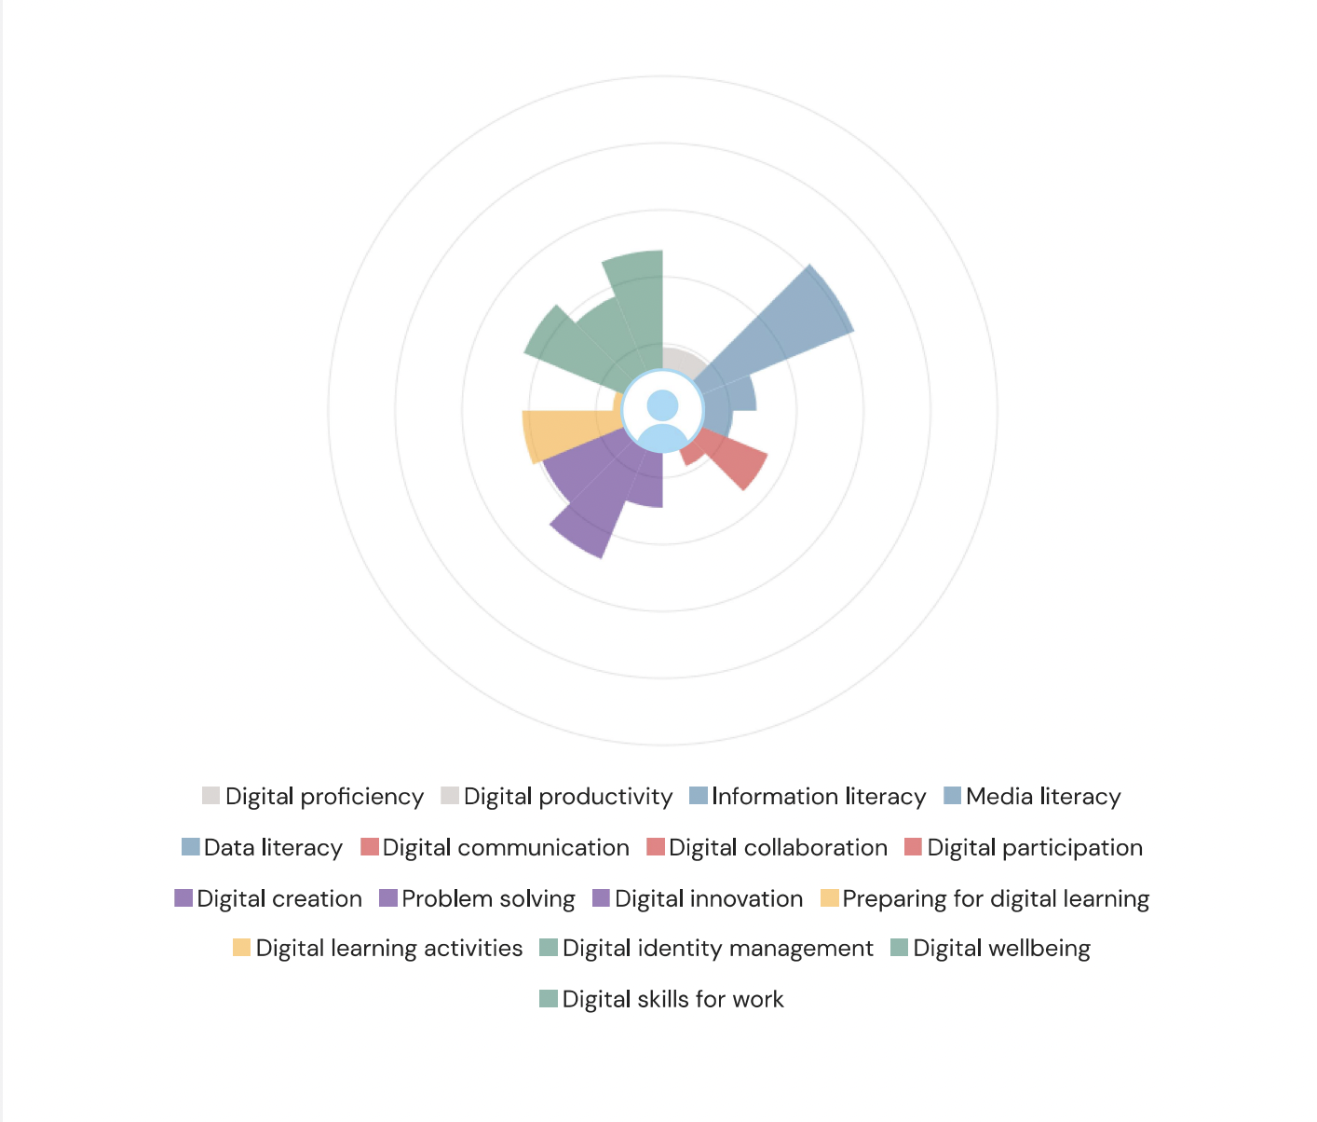
Figure 1: Digital skills badge
My less powerful strengths are digital collaboration and digital creation. These are the skills related to collaboration with people using the digital platform and creating digital content. Online communities are based on cooperation and invention within the aspects of digitality (Aksoy, 2023). Thus, it will be significant to enhance these skills to further enhance my academic and professional growth.

3. Strengths
Digital Proficiency
Digital proficiency is one of my greatest digital abilities. I am very comfortable with the common digital tools including word processing software programs and presentation platforms and online learning systems. These applications make my academic activities easier to accomplish, and they help me in doing my assignments effectively. Digital literacy is significant as it enables people to work in an environment that is based on technology. Digital marketing enhances productivity and communication and information management at the workplace (Pinto and Guarda, 2020). I am also able to engage in online learning activities because of my capacity to utilise the digital platforms.
Information and Data Literacy
Information and data literacy is another strength that was found in my results. I can research and locate scholarly articles, assess web resources and manage digital data to use in research. This ability is valuable in academic performance as it helps to critically analyse reliable information. Digital literacy skills enhance the effectiveness that students can process and make meaning of the digital information (Erwin and Mohammed, 2022). My capacity to locate valid sources can be used to support my coursework and research activities.

4. Weaknesses
Digital Collaboration
The JISC results also showed that I have to improve digital collaboration, which is one of my weaknesses. I also find it to be a challenge when cooperating with other people by using online sources like group documents or project management systems. Collaboration in digital environments is dependent on effective communication, coordination and participation. Collaborative creativity can be enhanced by using digital technologies (Selfa-Sastre et al., 2022). My digital collaborative skills are weak, which makes me less able to contribute to work in an online group.
Digital Creation
I also face the weakness of digital creation as per my JISC results. This skill includes the creation of digital media including videos, digital presentation and multimedia media. Currently, I apply simple tools to complete assignments and I am under-experienced with sophisticated tools of content creation. Digital creation is significant as organisations are relying more on digital content to convey ideas and bring value to digital ecosystems (Aksoy, 2023). Thus, the enhancement of more efficient digital creation skills will help me express ideas and deliver information in a more creative manner.

5. Action Plan Using SMART Goals to improve your weaker areas
The SMART goal is to enhance my collaboration in the digital field that involves the development of my skills to effectively use collaborative digital tools.
SMART Elements | Action Plan
Specific | I will enhance my digital working ability by becoming skillful in using collaboration tools like Google Docs and Microsoft teams in collaborative work.
Measurable | Using these tools, I will accomplish at least three online tutorials and two team academic projects.
Achievable | To practice the use of collaborative digital platforms, I will spend two hours a week.
Relevant | This objective will help me to become more productive in academic group work and professional teamwork areas.
Time-bound | Three months
Table 1: Action Plan

6. Conclusion
As per my digitally capable outcomes at JISC, I was able to figure out my weaknesses and strengths. I already knew that I have a good digital skill with an excellent information literacy level. I also understand that I need to work more to enhance my digital collaboration and digital creation. These skills will help me feel more confidently working with people on the internet and creating digital content. Developing my digital skills will help me to achieve academic success.

Task 2 - LinkedIn Learning Certificates for Office365 (Outlook, Word, Excel, PowerPoint)
Outlook
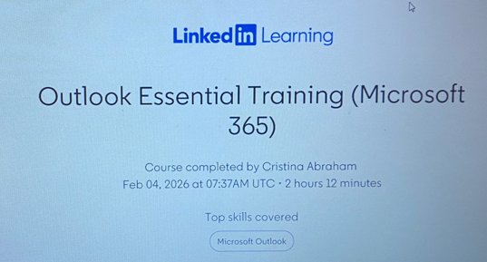
Figure 2: Outlook Essential Training
Word
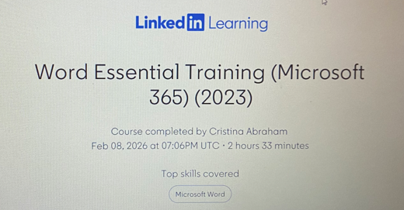
Figure 3: Word Essential Training
Excel
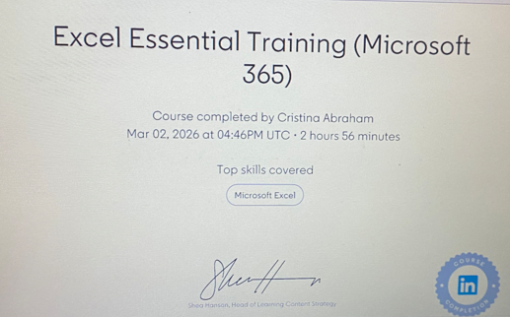
Figure 4: Excel Essential Training
PowerPoint
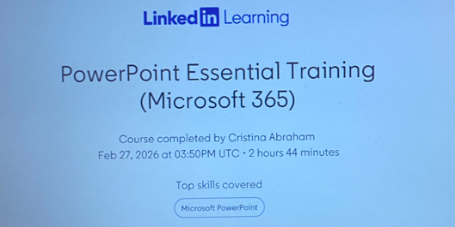
Figure 5: PowerPoint Essential Training

Task 3 - Essay on relevance of Excel + Embedded Excel

Introduction
Digital technology is one of the most important tools in the development of professional skills and the strengthening of personal brand (Reedy and Parker, 2018). One of the most used digital tools in the field of business, education, and research is Microsoft Excel (Kumar, 2023). It is one of the most recognised tools in the field of digital technology due to its capacity to efficiently analyse, visualise data and deal with data. Research in technology is crucial for the consumers (Dadwal, 2020). Microsoft Excel is used by individuals to process large amounts of information and transform them into meaningful knowledge. Digital transformation is highly crucial for business as well as learning (Sandhu, 2020). This is essential in the development of productivity and professional skills in different sectors. Studies indicate that the use of Microsoft Excel is common in the field of academics and professionalism in analysing numerical data which enhances the analytical and decision-making capacity of the individual.

Discussion
Relevance and importance of Microsoft Excel
Microsoft Excel is a digital tool that is used in data management, data analysis, and reporting in different professional sectors. Excel is used by individuals to organise numerical data in a structured manner . Such a capacity is essential in the management of large amounts of data and the accuracy of calculations. Microsoft Excel is also used in the field of digital technology due to its capacity to support different mathematical and statistical tools, which are essential in simplifying complex calculations in the field of research and business (Thiagarajan, 2023). Microsoft Excel is the most used digital tool in the field of digital technology due to its capacity to enhance the data analysis capacity. Excel software has the capacity to support different tools used in the field of statistics, sorting, filtering, and data visualisation that are essential in transforming raw data into meaningful information. The statistical tools in Microsoft Excel help the individual in the interpretation of trends and patterns in the field of research and analytical activities (Kumar, 2023). Excel is also highly necessary as it is connected with data-driven decisions in the business field. Data is used in the business field to inform decisions, and Excel is used in this process. Professionals are able to analyse financial data, track performance, and forecast using historical data. Excel and other data management tools are vital in the development of analytical thinking and business intelligence among aspiring analysts (Al Maruf et al., 2022). Excel is also vital in the development of a better understanding of statistics and other numerical tools. Excel is a data management application that allows users to execute different operations, including the creation of charts and the application of numerical calculations (Simaremare and Siregar, 2024). Excel plays an important role in the development of a professional skill like the strengthening of analytical and other technical skills (Rahman, Mansor and Rahman, 2025). The functions of Excel are vital in the adoption of financial analysis and other data management operations.
Uses of Excel for data analysis, budgeting, reporting and decision-making
Microsoft Excel is used to perform various business and personal activities like data analysis, budgeting, reporting, and making decisions (Thiagarajan, 2023). Data analysis is one of the most important uses of Excel. Excel offers many tools for data analysis which are used for easily performing data analysis. The tools available for data analysis include functions such as SUM, AVERAGE, COUNT, and IF, which make it easier for the user to perform data analysis and understand the relationship between variables. Excel also offers tools for statistical analysis, such as correlation, regression, and forecasting (Kumar, 2023). This helps to improve the results of research and make it easier for the user to derive accurate conclusions.
Another important use of Excel is for forecasting and prediction. Many organisations require forecasting and prediction tools for effective decision-making and strategic planning. Excel offers many tools for forecasting and prediction which can be used easily to perform forecasting and prediction. The forecasting tools available in Excel help managers and organisations to predict future sales and expenses (Grech, 2025). Such tools improve decision-making as well as strategic planning. The other important use of Excel is budgeting and financial planning. Many individuals and organisations require tools for budgeting and financial planning so that they can easily perform budgeting and financial planning. Budgeting tools available in Excel help the user create tables and easily perform budgeting and financial planning (Grobler-Dębska et al., 2024). For example, an income-expenditure table for a household can be created in Excel to show budgeting abilities. The table can have columns to record income sources such as trust funds, wages, universal stocks payouts. There can also be a section to record expenditure such as rent, council tax, electric, food and other aspects. Formulas such as the “SUM” function can be used to automatically calculate the total income and total expenditure. Along with this, formulas such as “=Total Income - Total Expenses” can be used to calculate the remaining amount to spend for the month. This type of calculation tables in Excel can be helpful for better understanding of finances and budget.

Conclusion
Microsoft Excel is a digital skill that helps in handling data and analysing information in different academic and professional areas. The application of Excel helps the user to effectively organise information, perform complex mathematical computations, and create visual reports. Excel is useful for data analysis, budgeting, predictions, as well as making decisions. Excel also helps to interpret the information accurately. The adoption of Excel helps to contribute to the development of digital skills as well as professional reputation. Excel will remain useful in the future due to the increased adoption of data-based strategies in various organisations.

Task 4 - 5 Minute Reflective Presentation

Slide 1: Cover page
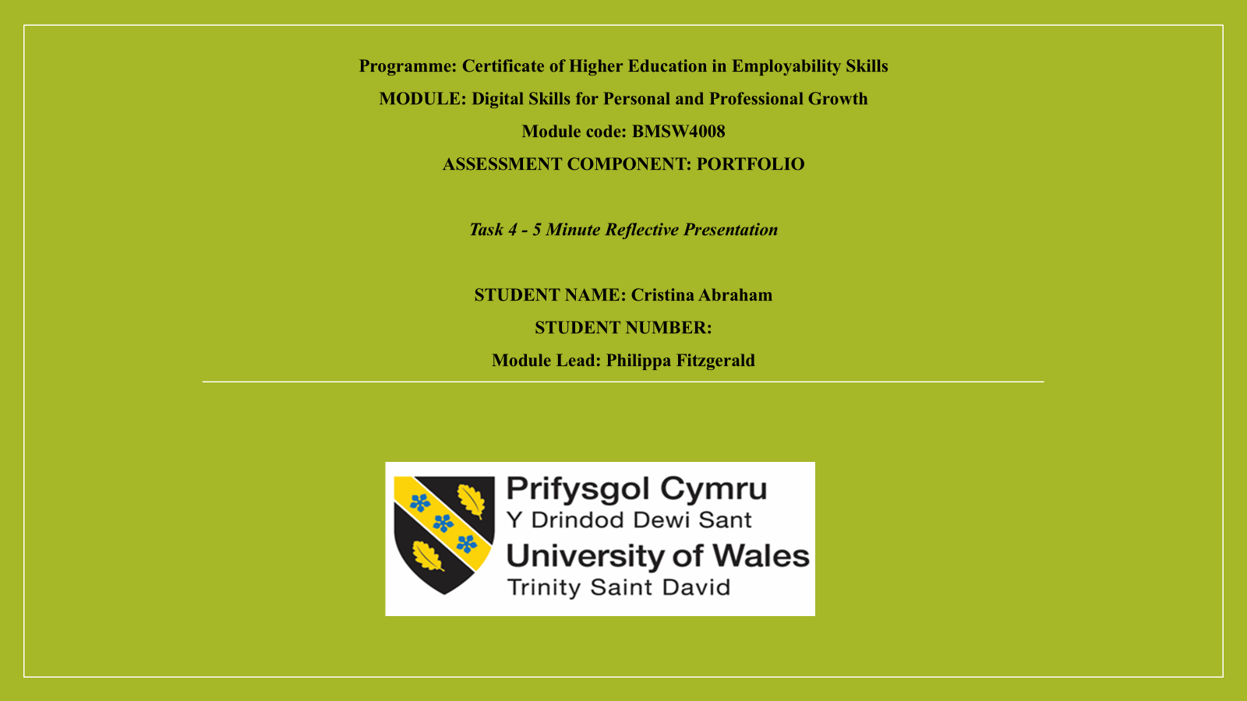

Slide 2: Introduction to development of digital skills, its uses and application in academic studies and future career
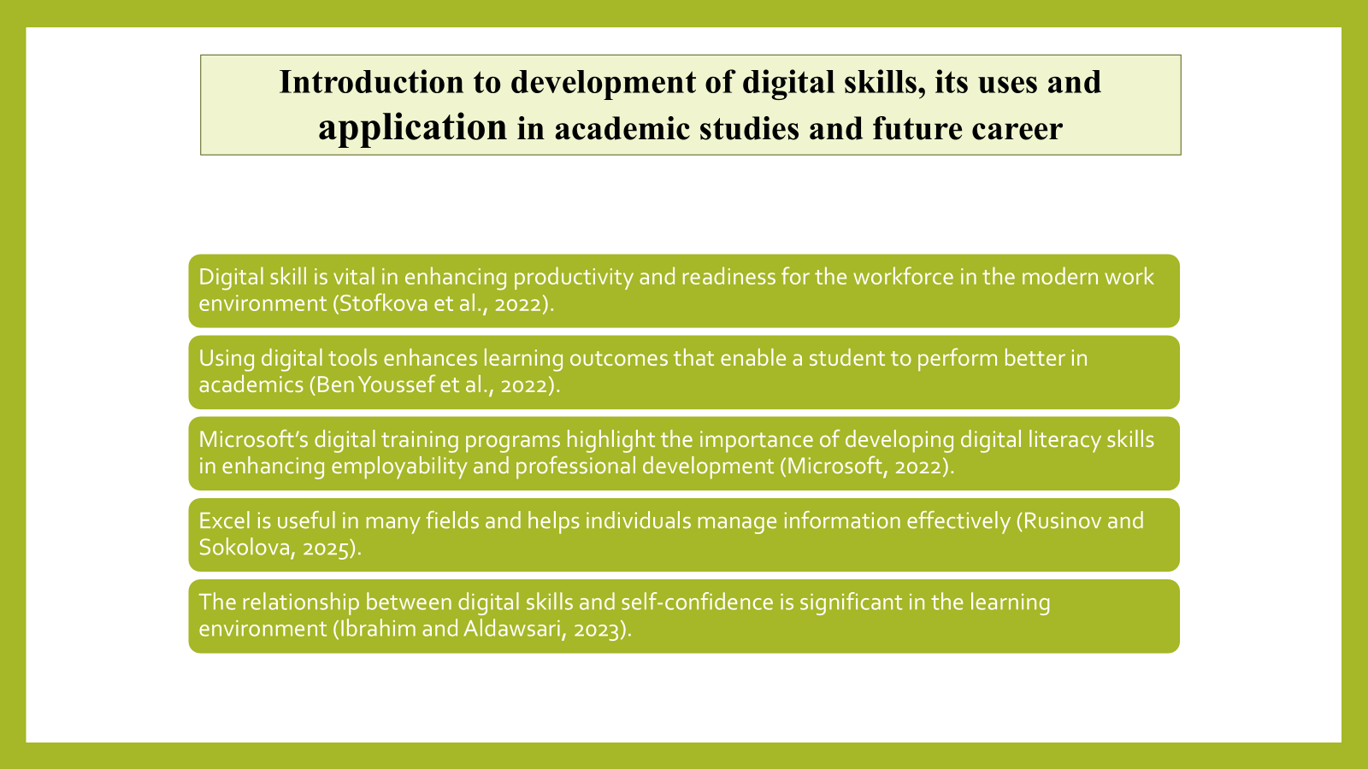

My understanding of digital technology has changed a lot throughout this module. I learned that it is a technical skill that enhances learning, communication, and professional development. From the tasks carried out in this module, I learned how to use different digital tools. In Task 1, I used the JISC Digital Capability tool to analyse my skills. In Task 2, I completed the LinkedIn Learning certificates on Office 365 that helped me to develop my skills of using different tools like Microsoft Word, Microsoft PowerPoint, and Microsoft Excel. This also helped me to develop my confidence in using these tools to create professional documents and presentations. Task 3 also helped me to enhance my digital skills through the Excel and spreadsheet task.

Slide 3: JISC Digital Capability assessment and action plan
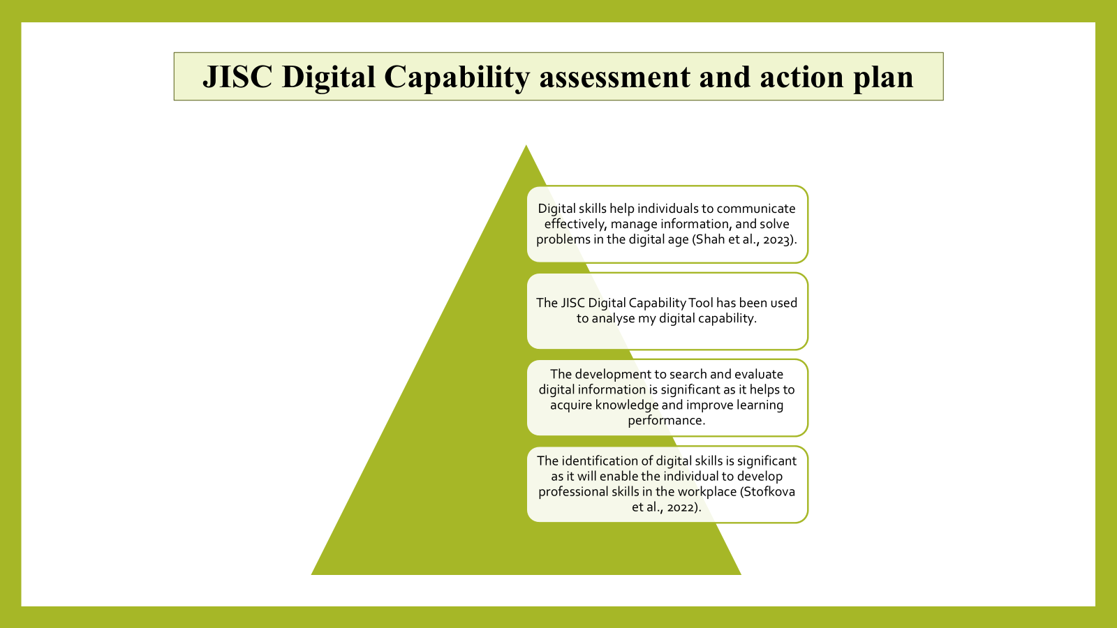

Understanding the digital skills of an individual is essential in helping various individuals to understand their strengths and weaknesses in relation to their personal and professional development. I have used the JISC Digital Capability Tool to assess my digital capability. This tool has helped me understand my level of confidence regarding my digital capabilities. I have created a SMART plan to improve the weaknesses that were revealed in the assessment. This is significant for me as it is specific, measurable, achievable, relevant, and time bound. This will be achieved by practicing the use of Excel functions every week while completing coursework assignments and projects.

Slide 4: LinkedIn Learning Office 365 certificates
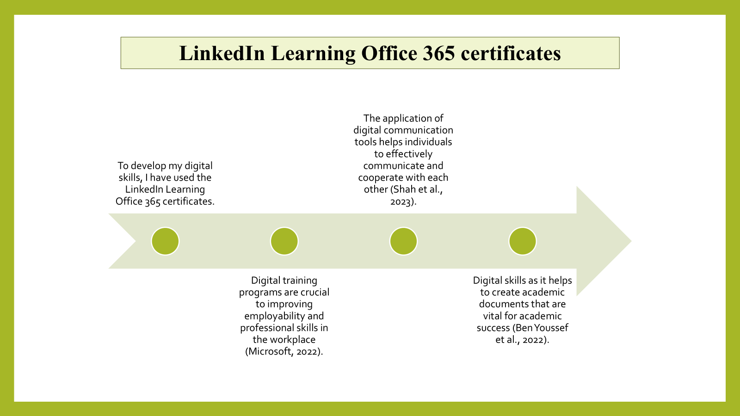

Throughout the module, I have been able to complete several courses offered on LinkedIn Learning Office 365 certificates. I have been able to learn the basics of using Microsoft Outlook, Word, Excel, and PowerPoint. I have accessed the courses through my university email account. I have performed several activities that were available in each of the courses offered on the platform. I have compiled the downloaded certificates, which have been included in my portfolio as evidence of my learning of the Office 365 digital skills. The completion of the Outlook course helped me enhance my communication and organisational skills. I was able to learn how to effectively manage my emails through the creation of email folders and the utilisation of scheduling tools.

Slide 5: Excel essay and spreadsheet
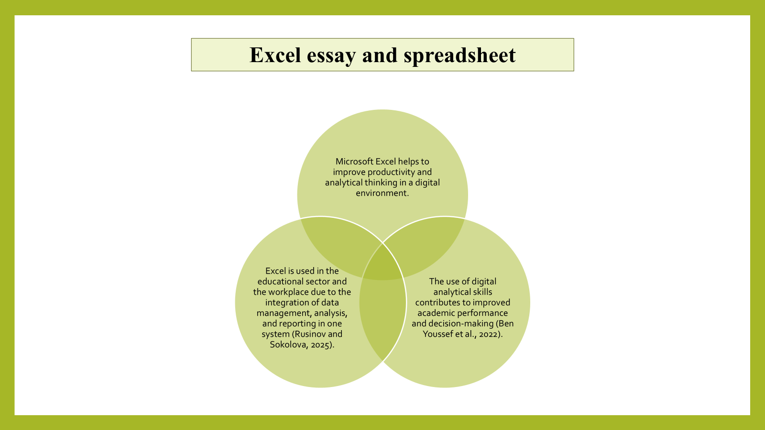

Microsoft Excel is a widely used digital tool in managing and analysing data. This tool is used in various fields, including academic studies, businesses, and organisations. With this tool, it is possible to store large amounts of numerical data, perform calculations, and use various formulas and functions. Data analysis is one of the primary uses of Microsoft Excel. During my Excel activity, I created a spreadsheet that presented household income and expenses. I have also presented the data in different categories that include salary, rent, food, transport, and savings. I also used formulas like “SUM” that helped me to calculate the total income and total expenses in the household. This type of budgeting spreadsheet helped me to manage the finances effectively and make the best decisions.

Slide 6: Conclusion
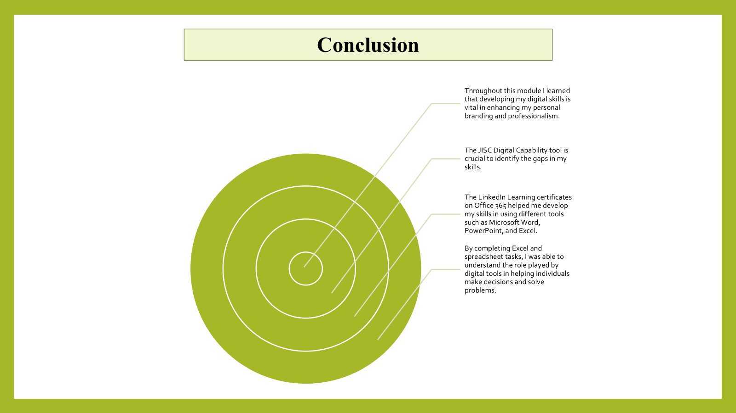

The JISC Digital Capability tool helped me understand my strengths and weaknesses in information literacy, communication, and content creation using digital tools. The LinkedIn Learning certificates on Office 365 helped me communicate information using digital tools. By completing Excel and spreadsheet tasks, I was able to learn how to effectively design a presentation through the utilisation of various tools such as templates, animations, charts, and images. I was able to learn how to effectively create academic documents through the utilisation of various tools such as headings, page layout, tables, and referencing tools. I will continue to enhance my digital skills to ensure that I make the best use of technology in my studies and future career.

Slide 7: Reference List
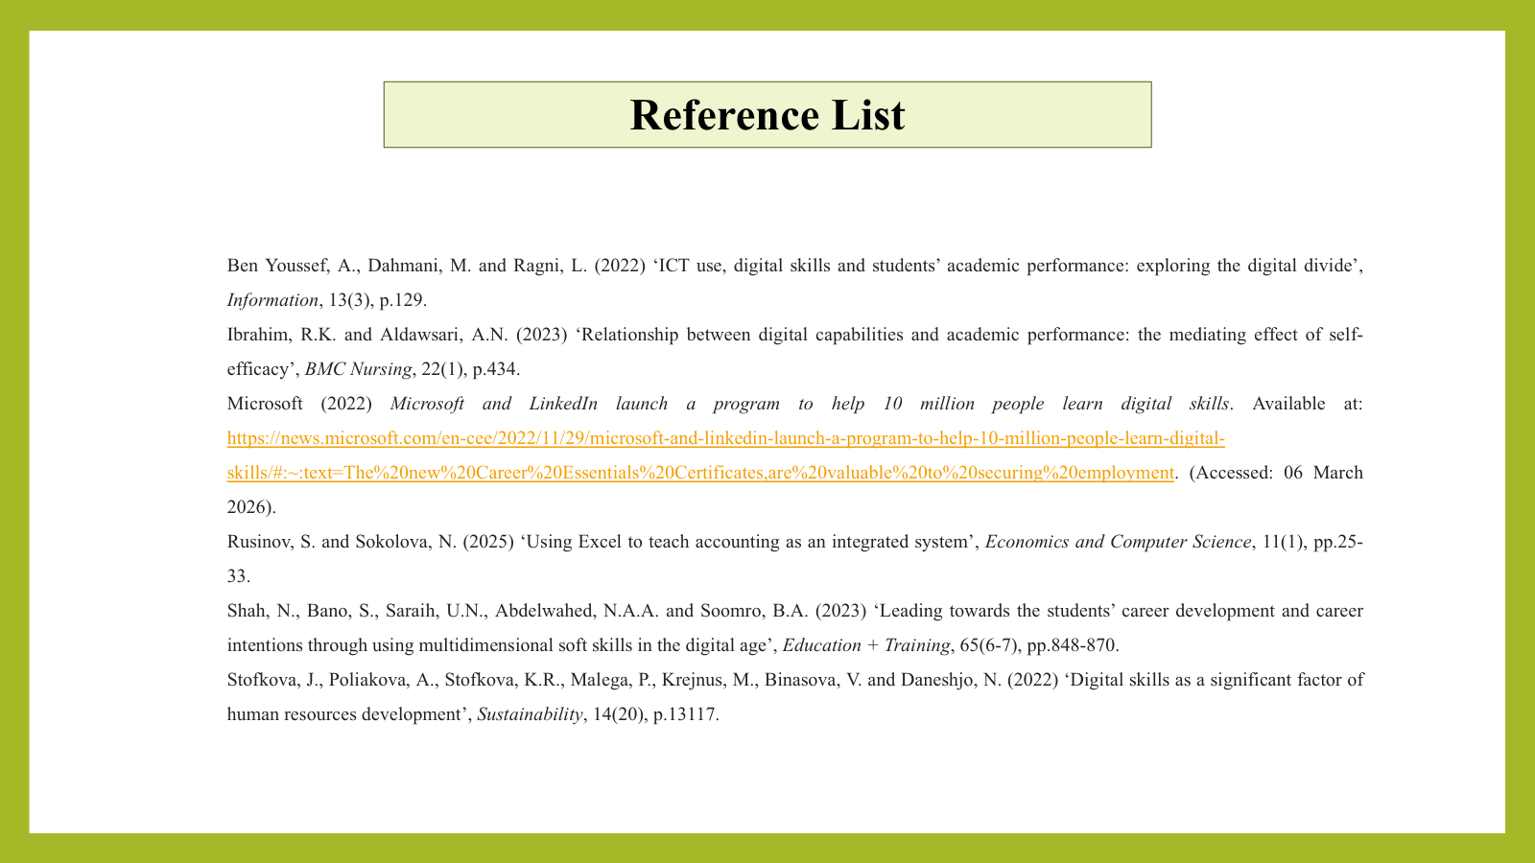

Reference List
Aksoy, C. (2023) ‘Digital business ecosystems: an environment of collaboration, innovation, and value creation in the digital age’, Journal of Business and Trade, 4(2), pp.156-180.
Al Maruf, A., Paul, R., Imam, M.H. and Babar, Z. (2022) ‘A systematic review of the role of SQL and Excel in data-driven business decision-making for aspiring analysts’, American Journal of Scholarly Research and Innovation, 1(01), pp.249-269.
Ben Youssef, A., Dahmani, M. and Ragni, L. (2022) ‘ICT use, digital skills and students’ academic performance: exploring the digital divide’, Information, 13(3), p.129.
Dadwal, S. S. (Ed.). (2020). Handbook of Research on Innovations in Technology and Marketing for the Connected Consumer. IGI Global.
Digital Literacy Unpacked, edited by Katharine Reedy, and Jo Parker, Facet Publishing, 2017. ProQuest Ebook Central
Erwin, K. and Mohammed, S. (2022) ‘Digital literacy skills instruction and increased skills proficiency’, International Journal of Technology in Education and Science, 6(2), pp.323-332.
Grech, V. (2025) ‘Forecasting with Excel’, Acta Medica, 67(3), pp.87-90.
Grobler-Dębska, K., Mularczyk, R., Gawęda, B. and Kucharska, E. (2024) ‘Time series methods and business intelligent tools for budget planning—case study’, Applied Sciences, 15(1), p.287.
Ibrahim, R.K. and Aldawsari, A.N. (2023) ‘Relationship between digital capabilities and academic performance: the mediating effect of self-efficacy’, BMC Nursing, 22(1), p.434.
Kumar, M.D. (2023) ‘A study on importance of Microsoft Excel data analysis statistical tools in research works’, Journal of Management & Educational Research Innovation, 1(3), pp.25-33.
Microsoft (2022) Microsoft and LinkedIn launch a program to help 10 million people learn digital skills. Available at: https://news.microsoft.com/en-cee/2022/11/29/microsoft-and-linkedin-launch-a-program-to-help-10-million-people-learn-digital-skills/#:~:text=The%20new%20Career%20Essentials%20Certificates,are%20valuable%20to%20securing%20employment. (Accessed: 06 March 2026).
Pinto, F. M., and Guarda, T. (Eds.). (2020). Digital Marketing Strategies and Models for Competitive Business. IGI Global.
Rahman, N.A., Mansor, R.Y. and Rahman, F.A. (2025) ‘The relationship between Microsoft Excel usage and perceived importance of functions among accounting internship students’, Technology and Innovation, p.95.
Rusinov, S. and Sokolova, N. (2025) ‘Using Excel to teach accounting as an integrated system’, Economics and Computer Science, 11(1), pp.25-33.
Sandhu, K. (Ed.). (2020). Digital Transformation and Innovative Services for Business and Learning. IGI Global.
Selfa-Sastre, M., Pifarré, M., Cujba, A., Cutillas, L. and Falguera, E. (2022) ‘The role of digital technologies to promote collaborative creativity in language education’, Frontiers in Psychology, 13, p.828981.
Shah, N., Bano, S., Saraih, U.N., Abdelwahed, N.A.A. and Soomro, B.A. (2023) ‘Leading towards the students’ career development and career intentions through using multidimensional soft skills in the digital age’, Education + Training, 65(6-7), pp.848-870.
Simaremare, S. and Siregar, R. (2024) ‘Effectivity of the Microsoft Excel application on student understanding in statistics courses’, Indonesian Journal of Education and Social Humanities, 1(2), pp.9-19.
Soltanifar, M., Hughes, M., Gocke, L., (2021), Digital Entrepreneurship, Springer group.
Stofkova, J., Poliakova, A., Stofkova, K.R., Malega, P., Krejnus, M., Binasova, V. and Daneshjo, N. (2022) ‘Digital skills as a significant factor of human resources development’, Sustainability, 14(20), p.13117.
Thiagarajan, B. (2023) ‘Mastering statistical analysis with Excel’, Otolaryngology Online.

Appendix:

Declaration
I confirm that I have not presented any AI generated materials as my own work.
I confirm that I have copies of my drafts, notes, and other resources I used, which I may be asked to provide in evidence.

