

Student Name: Ramona Moreanu
Student ID: 2213248
Module: Service Integration and Partnership Working
Module code: LCHS7005
Lecturer: Diola Bijlhout
Component 2 Reflective Report

A Reflective Report on Service Integration and Partnership Working in Health and Social Care

Contents
Introduction 3
Context 4
Understanding Target Population Needs 4
Identifying Opportunities to Address Needs 4
Developing Aims and Objectives 5
Input 6
Appropriate Partners and Integration Strategies 6
Principles, Concepts, and Frameworks 6
Human and Material Resources 7
Barriers to Integration 7
Recommendations and Solutions 8
Process 9
Group Work to Implement Activities 9
Roles and Responsibilities Within the Group. 10
Group Dynamics and Participation 10
Challenges Encountered and Problem-Solving 11
Product 11
Evaluation of the Overall Outcome 11
Achievement of Aims and Objectives 12
Skills and Competencies Developed 12
Steps for Professional Growth 13
Application to Real-Life Practice 13
Conclusion 15
References 16

Introduction
This reflective report is a critical reflection of my learning, knowledge and understanding of service integration and partnership working within the health and social care (HSC). During this module, I have learnt more about the intricacies of integrated care systems and the significance of partnership in working between professionals and organisations to deliver effective and person-centred care.
Service integration is a concept where health care and social care services are incorporated together to offer coordinated and continuous care and support to individuals. Partnership working, however, entails various stakeholders collaborating to attain shared goals and improved service user outcomes. This reflection aims to demonstrate how my theoretical knowledge and experience of working in groups have enhanced my critical thinking about these notions and the way they are put into practice.

Context

Understanding Target Population Needs
An important element of service integration is to be aware of what the target population needs. I have also come to learn in my learning process that health and social care services must be offered to meet the needs of individuals but not in a one size that fits all manner.
Within our group assignment, we analyzed a community that faced several problems, including the inability to access health care, language barriers and social isolation (Wilson, Brickman and Brame, 2018). Upon reflection of this, I understood that this is a widespread issue in most heterogeneous societies wherein individuals may struggle to find their way around the health system. This highlighted the importance of comprehensive needs assessment to reveal both overt and covert needs.
I learned that there are various ways of identifying needs which include surveys, interviews, community consultations and demographic analysis. These ways help service providers to determine not only physical needs but also social, emotional as well as cultural needs. As an example, individuals with various backgrounds might require culturally safe care and translation services to receive services.
Importantly, I realized that when we fail to identify needs properly, it may result in ineffective care and increased inequalities. The experience has helped me to strengthen my belief in the significance of evidence-based practice in health and social care.

Identifying Opportunities to Address Needs
After identifying needs, we should consider opportunities to address the needs using integrated services. When I looked back at what I had learned, I realized that the gaps in services could be availed to enhance the provision of services.
As an illustration, our group assignment realized that due to inadequate communication between health and social services, there was inadequate coordination. This was a chance to put in place coordinated systems, like care plans and information technology platforms, to enhance collaboration.
I also learned that multidisciplinary teams are important in addressing complex needs. With a combination of various professionals, such as doctors, nurses, social workers and community support workers, one can provide comprehensive care that considers all the aspects of health and well-being of a person (Singh, Klarner and Hess, 2020).
Importantly, I understand that critical thinking and being aware of the system are both critical in identifying opportunities. They must not merely be aware of the problems; they must also be proactive in creating new solutions.

Developing Aims and Objectives
It is important to set goals and objectives in service integration. This was not something I initially found easy, and it entailed relating theory and practice (Piercy et al., 2018). However, with group discussion and response, I was able to hone my abilities in creating SMART (Specific, Measurable, Achievable, Relevant, and Time-bound) goals.
An example is that we aim to improve access to health care among the disadvantaged populations. We achieve this by establishing goals to enhance communication between service providers, sensitize on services and engage the community.
In this process, I discovered that objectives do not only aid in guiding us but also give a way in which we can evaluate our progress. It is difficult to measure the success of integration without these.

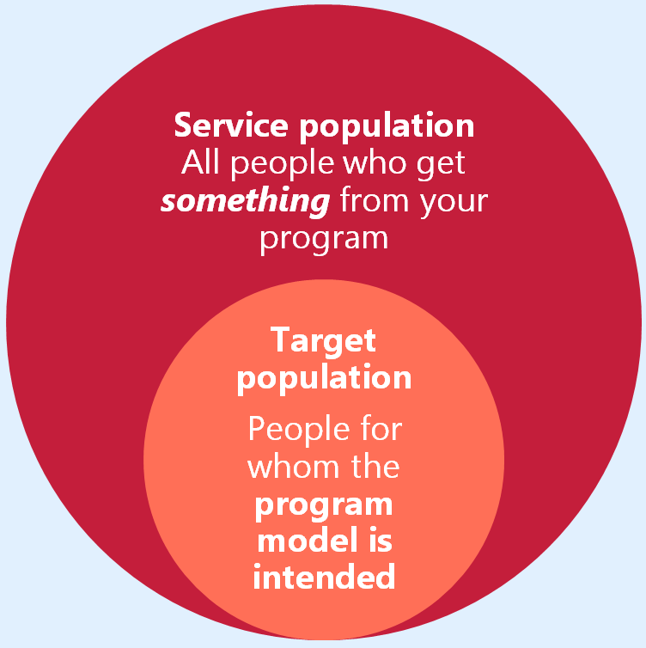

Figure and Source: Target Population (Chen, Tan and Pi, 2021).

Input

Appropriate Partners and Integration Strategies
The integration of services depends on the participation of several partners. This module has helped me better understand the contribution of various partners in health and social care.
Health-care professionals, social workers, local government, non-government organizations, and community organizations are among the partners. These partners bring different skills and resources to the table. Healthcare professionals concentrate on medical diagnosis and treatment, for instance, while social workers focus on social and environmental factors.
Through my group work, I have learnt that partnership involves effective communication, trust and shared objectives. Multidisciplinary working, co-planning and meetings are vital for collaboration (Marcus and Pekmezi, 2024).
Importantly, I recognize that partnership working can be complex. Variations in culture, priorities and communication can be problematic. So, strong leadership and coordination are required for successful integration.

Principles, Concepts, and Frameworks
During this module, I have considered several principles and approaches to service integration. A fundamental principle is person-centered care, which focuses on the need to personalize services to meet individual needs.
Other principles include collaboration, transparency, accountability and continuity of care. These principles ensure services are provided in an efficient way (Chen, Tan and Pi, 2021).
I also took away an understanding of frameworks for integration, such as coordinated care and partnerships. These frameworks offer a set of guidelines for integration.
From this, I realized that while frameworks are important for guiding practice, they need to be tailored to the context. This has improved my capacity to critically assess approaches to service integration.

Human and Material Resources
Human and material resources are important for service integration. Human resources refer to professionals with the ability to collaborate, and material resources refer to funding, facilities and technology.
In my reflection, I came to realize that resource constraints are a significant barrier to integration. For instance, limited funding can limit the number of services available, and a lack of training can impact the ability of professionals to collaborate with others.
During our group discussion, we reflected on the need to invest in electronic systems to support communication and information exchange. This emphasised the importance of technology for integration.

Barriers to Integration
Another learning outcome of the module was the barriers to service integration. These include:
- Lack of information and communication
- Lack of trust between organisations
- Limited funding and resources
- Differences in organisational culture
- Resistance to change
When I was thinking about these barriers, I realised that they are all coupled and can influence the success of integration. An example is misinterpretation and mistrust due to lack of communication. I also realised that the barriers are caused by other factors (Nagy et al., 2018). As an example, the differences in data systems may render organisations not easily share data even where they may have the intention to share. The power differences in organisations may also be a source of conflict, particularly where one of the organisations dominates in the decision making process.

Recommendations and Solutions
There are several ways to overcome these challenges, including:
- Creating common information systems
- Providing training and professional development
- Providing policies and guidelines
- Promoting leadership and accountability (Hoekstra et al., 2020)
Policies and laws are important in supporting integration. They help to guide collaboration and to make sure services are delivered effectively. Finally, I learnt that the implementation of these solutions should be ongoing and evaluative. It's not sufficient to implement strategies; organisations need to continually evaluate their success and adjust as needed. Fostering a collaborative culture is also important, in which professionals are empowered and incentivised to collaborate. I also discovered that the participation of users of services can improve the relevance and effectiveness of integrated services. Leadership is critical to facilitate change and accountability within and between organisations. In summary, integrated services require strategic planning and commitment by individuals and organisations to change and learn.

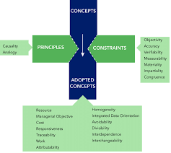

Figure and Source: Principles, Concepts, and Frameworks (He et al., 2020).

Process

Group Work to Implement Activities
Group work in the context of collaboration was also an important feature of this module, and it has contributed to expanding my understanding of the integration of services and collaboration between agencies (He et al., 2020). We began our project with a plan and this involved the goals, activities and schedules. This planning played a very important role in providing us with a guideline to operate.
I believe that communication was the most important aspect, personally. We exchanged ideas and monitored our progress both online and in real life discussions. I observed that there was a lack of communication at other times. In some cases, there were delays in the responses and clarity leading to confusion in who was doing what. This has helped me realize that not only does communication involve passing information but also ensuring that everyone in the group is sharing an understanding of the goals and expectations.
This activity made me understand the importance of collaboration in health and social care. Similar to health care professionals, students should be able to work in a team in order to accomplish their goals (Graham, Kothari and McCutcheon, 2018). I now realize that teamwork does not just entail the technical aspect of the team, but also the interpersonal aspect of empathy, patience and listening.

Roles and Responsibilities Within the Group.
The roles in our group were distributed based on our interests and capabilities. My responsibilities were research, content and assistance in the organisation of the assignment. I made sure that I was able to finish my work on time and present relevant and well organised work.
The experience has brought to focus the role of leadership in the process of group work. Leadership does not necessarily entail guiding the group, but facilitating the communication process, conflict management, and participation of group members. In the upcoming projects I would like to become a better leader because I would be more confident to take the lead and I would be more supportive of other people.

Group Dynamics and Participation
Acceptance and fulfilment of roles in the group were at varying levels. There were participants that were highly active and participated in discussions and tasks. Others were not so much involved, leading to allocation of work.
In my case, this scenario presented a challenge and a chance. On the one hand, it put additional pressure on the active members to work harder. However, it also highlighted the importance of responsibility and accountability within a team (Hughes, Shaw and Greenhalgh, 2020).
To overcome this, we attempted to encourage others to do so by setting time limits and checking on each other. It partially resolved the issue, although not entirely. Considering this, I believe that participation could have been improved with better leadership and communication.
This has also enabled me to be in a better position to comprehend more about the practical issues in partnership working. Healthcare also has various degrees of involvement and dedication among professionals that can influence the provision of services. Therefore, it is necessary to define responsibilities, make sure that there is an effective communication and promote accountability.

Challenges Encountered and Problem-Solving
There were a few problems in time management, style of communication and working during the group work experience. As an example, it was difficult to organize meetings because individuals had varying schedules, thus causing delays (Willie, 2024).
This has helped me develop my problem-solving and flexibility skills. I have come to realize that there are setbacks that are involved in the teamwork process, yet with support and determination, they can be overcome. This plays a critical role in health and social care where practitioners must be able to deal with uncertainty and stress.
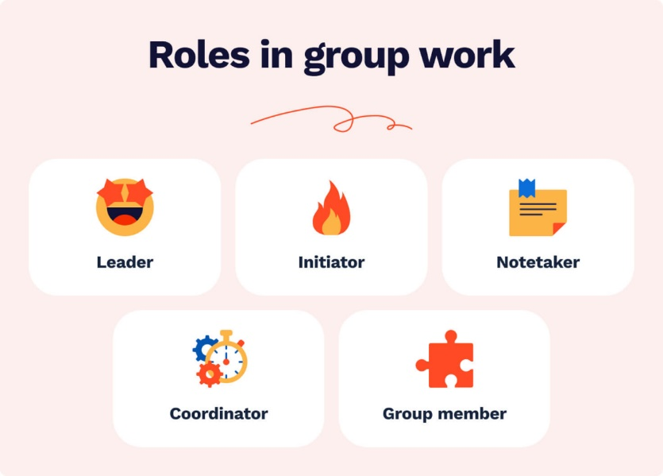

Figure and Source: Roles in Group Work (Willie, 2024).

Product

Evaluation of the Overall Outcome
Discussing the result of our group work, I believe that we managed to achieve rather well our purpose. We identified and resolved service integration-related issues, made relevant recommendations and clearly and coherently presented our work.
In regard to the analysis and recommendations we made we succeeded. We demonstrated a comprehension of the importance of partnership working and provided practical ways in which to enhance integration.
And yet there were other things we might have done better. As an example, the critical analysis of some of the parts could have been done more thoroughly, and the work in general could have been integrated better (Kitunen et al., 2019). When considering this, I understand that more cooperation and strict scrutiny might have enhanced the quality of the work.

Achievement of Aims and Objectives
Looking back we were able to accomplish most of what we wanted to accomplish, so I feel we were successful. We established goals that addressed the needs of the targeted population and provided answers to their needs.
I know, however, that it is one thing to achieve goals in a university setting and another in practice. Practically, service integration strategies consume time and resources and continuous monitoring and evaluation. This has been a learning exercise on how difficult it is to put knowledge into practice.

Skills and Competencies Developed
The module and group work have assisted me to acquire some skills and competencies that are essential to health and social care professionals. These include:
Communication Skills: I also acquired skills of effective communication and being a good listener. To work with other people, it is also required to have good communication skills and guarantee the information is properly interpreted (Seys et al., 2021).
Teamwork and Collaboration: Teamwork with others helped me to learn about the importance of collaboration and working together. I was able to acquire skills to work with individuals with different backgrounds and perspectives.
Critical Thinking: I also got to know how to evaluate some critical matters, how to analyze the problems and make effective decisions. This is critical in resolving health and social care problems.
Time Management: I was organizing time and deadlines, which helped me manage my time. I recognized how important planning and prioritization of tasks are.
Problem-Solving: The ability to overcome barriers in the process of collaboration with other people allowed me to seek viable solutions and manage change.

Steps for Professional Growth
As I reflect on my learning journey, I know that ongoing learning is vital to becoming a successful health and social care practitioner. To continue to develop my skills, I will:
- Develop my leadership skills by being more involved in group activities
- Practice and seek feedback on my communication skills
- Committing ongoing education to remain up to date
- Apply knowledge in practical health and social care settings (Wilson, Brickman and Brame, 2018)
I also plan to take a more critical practice approach to my work by questioning my assumptions and considering other viewpoints. This will make me a better practitioner.

Application to Real-Life Practice
A key learning outcome of this module is my capacity to apply learning to practice. I now understand the importance of service integration and partnership working in health and social care.
For instance, I know that working together with professionals can lead to better outcomes for service users, minimize service duplication and increase efficiency (Singh, Klarner and Hess, 2020). I also understand the value of putting the person at the center of care and involving service users in decision-making.
This reflection has boosted my confidence in transferring my knowledge to practice and has equipped me for future health and social care roles.

Conclusion
Overall, this reflective report has allowed me to reflect on my learning and understanding of service integration and partnership working in health and social care practice. I have gained a greater understanding of the value of working together, communication and person-centeredness.
Reflecting on context, input, process and product has provided me with a better understanding of the challenges of integrated care. This has equipped me to apply my learning to real-world practice and make a positive impact on health and social care.

References
Baxter, S., Johnson, M., Chambers, D., Sutton, A., Goyder, E. and Booth, A., 2018. Understanding new models of integrated care in developed countries: a systematic review. Health Services and Delivery Research, 6(29), pp.1–224.
Chen, W., Tan, J.S.H. and Pi, Z., 2021. The spiral model of collaborative knowledge improvement: an exploratory study of a networked collaborative classroom. International Journal of Computer-Supported Collaborative Learning. Available at: https://doi.org/10.1007/s11412-021-09338-6
Graham, I.D., Kothari, A. and McCutcheon, C., 2018. Moving knowledge into action for more effective practice, programmes and policy: protocol for a research programme on integrated knowledge translation. Implementation Science, 13(1), p.22.
Glasby, J. and Dickinson, H., 2021. Partnership working in health and social care: what is integrated care and how can we deliver it? 3rd ed. Bristol: Policy Press.
He, Q., Meadows, M., Angwin, D., Gomes, E. and Child, J., 2020. Strategic alliance research in the era of digital transformation: perspectives on future research. British Journal of8 Management, 31(3), pp.589–617. Available at: https://doi.org/10.1111/1467-8551.12406[tgffffffffff
Hoekstra, F., Mrklas, K.J., Khan, M., McKay, R.C., Vis-Dunbar, M., Sibley, K.M., Nguyen, T., Graham, I.D., SCI Guiding Principles Consensus Panel, Anderson, K., Anton, H., Athanasopoulos, P., Chernesky, J., Forwell, S., Maffin, J., Martin Ginis, K., McBride, C.B., Mortenson, W.B., Willms, R. and Gainforth, H.L., 2020. A review of reviews on principles, strategies, outcomes and impacts of research partnership approaches: a first step in synthesising the research partnership literature. Health Research Policy and Systems, 18(1), p.51.
Hughes, G., Shaw, S.E. and Greenhalgh, T., 2020. Rethinking integrated care: a systematic hermeneutic review of the literature on integrated care strategies and concepts. The Milbank Quarterly, 98(2), pp.446–492.
Kitunen, A., Rundle-Thiele, S., Kadir, M., Badejo, A., Zdanowicz, G. and Price, M., 2019. Learning what our target audiences think and do: extending segmentation to all four bases. BMC Public Health, 19(1), p.382.
Kolb, D.A., 1984. Experiential learning: experience as the source of learning and development. Englewood Cliffs, NJ: Prentice Hall.
Marcus, B.H. and Pekmezi, D., 2024. Motivating people to be physically active. Champaign, IL: Human Kinetics.
Nagy, J., Oláh, J., Erdei, E., Máté, D. and Popp, J., 2018. The role and impact of Industry 4.0 and the internet of things on the business strategy of the value chain—the case of Hungary. Sustainability, 10(10), p.3491.
Piercy, K.L., Troiano, R.P., Ballard, R.M., Carlson, S.A., Fulton, J.E., Galuska, D.A., George, S.M. and Olson, R.D., 2018. The physical activity guidelines for Americans. JAMA, 320(19), pp.2020–2028.
Reeves, S., Lewin, S., Espin, S. and Zwarenstein, M., 2017. Interprofessional teamwork for health and social care. 2nd ed. Oxford: Wiley-Blackwell.
Seys, D., Coeckelberghs, E., Sermeus, W., Van Zelm, R., Panella, M., Babu Payedimarri, A. and Vanhaecht, K., 2021. Overview on the target population and methods used in care pathway projects: a narrative review. International Journal of Clinical Practice, 75(10), p.e14565. Available at: https://doi.org/10.1111/ijcp.14565
Singh, A., Klarner, P. and Hess, T., 2020. How do chief digital officers pursue digital transformation activities? The role of organization design parameters. Long Range Planning, 53(3), p.101890.
Willie, M.M., 2023. Distinguishing between population and target population: a mini review. Surgery Journal, 7.
Willie, M.M., 2024. Population and target population in research methodology. Golden Ratio of Social Science and Education, 4(1), pp.75–79.
Wilson, K.J., Brickman, P. and Brame, C.J., 2018. Group work. CBE—Life Sciences Education, 17(1), p.fe1.
World Health Organization, 2016. Framework on integrated, people-centred health services. Geneva: World Health Organization.
Zapiain, S.R.A., 2025. Target population. In: Conceptual variable design for scorecards: a standardized methodology for the model-building process. Berkeley, CA: Apress, pp.141–163.

