Cloud Computing Administration

Name: Crucianu Mircea Alexandru
Student ID 2025870

Lecturer: Dr. Khadija Hanga

Table of Contents
Introduction 3
1. Aspire Cloud Solutions 4
Load Balancing 6
2. Comparing services of the Cloud Providers 9
Amazon Web Services (AWS) 9
Microsoft Azure 9
Google Cloud Platform (GCP) 11
Cloud Cost for Aspire 12
TCO (Total Cost of Ownership) 18
Azure Active Directory 21
Governance Strategy 22
Cloud Governance 28
Disaster Recovery for Aspire Retailers 30
Bibliography 32

_{A}^{bstract}
In the contemporary dynamic business landscape, the significance of a streamlined and adaptable information technology infrastructure cannot be overstated, as it plays a pivotal role in the prompt delivery of applications to end-users. Aspire Retailers, a well-established home improvement retailer, presently depends entirely on an on-premises datacentre for the purpose of hosting its retail website and storing diverse data and streaming videos to support its applications. The IT department of the company is responsible for overseeing the complete lifecycle of computing hardware and software, encompassing activities such as procurement, deployment, and monitoring. Nevertheless, this particular methodology presents certain difficulties in relation to its adaptability and capacity for expansion.
In my capacity as the IT administrator tasked with supervising these operations, it has become apparent that the existing configuration hampers the expeditious deployment of applications, impeding the company's agility in responding promptly to evolving market demands. To surmount these challenges and leverage emerging prospects, the management committee of Aspire Retailers has made the strategic decision to undertake a transformative endeavour by transitioning its infrastructure to systems hosted in the cloud.
This study examines the potential advantages and strategic implications of implementing cloud technology within the context of Aspire Retailers. The company's objective is to achieve immediate availability of storage devices, servers, databases, and a range of other services by utilising cloud services. The elasticity and on-demand characteristics of cloud computing will provide the IT team with the ability to rapidly create, implement, and expand applications, thereby improving the user experience in general and facilitating the company's expansion into new markets.

Introduction

In the current era characterised by the prevalence of digitalization and the significance of online presence for business prosperity, Aspire Retailers, a prominent retailer specialising in home improvement, acknowledges the criticality of optimising its information technology infrastructure to sustain competitiveness within the continuously evolving market. In my role as the IT administrator overseeing the management of the company's on-premises datacentre, we have determined the difficulties presented by the conventional methods employed in hardware and software administration. The primary challenges are centred on the time-intensive procedures of acquiring hardware, installing software, and monitoring, which ultimately lead to the delayed delivery of applications to end-users. [1]
To effectively tackle these challenges and enhance the organization's capacity for innovation and expansion, the management committee of Aspire Retailers has made a strategic determination to adopt cloud computing technology. The company's objective is to leverage the flexibility and scalability offered by cloud technology to migrate its infrastructure. This transition will grant the IT team immediate access to servers, storage, databases, and other critical services. [2]
This study explores the benefits and potentialities associated with the adoption of cloud technology in the context of Aspire Retailers. Through the utilisation of cloud services, the organisation aims to augment the flexibility of its information technology operations, facilitating the expedited creation and implementation of software applications. Moreover, the cloud's inherent ability to scale will offer the necessary flexibility to accommodate varying levels of demand, guaranteeing a smooth user experience and enabling businesses to venture into unexplored markets. [3] [4] [5]
In the following sections, an examination will be conducted to assess the potential advantages and obstacles related to the migration to cloud computing. Additionally, a detailed plan will be presented to guide Aspire Retailers through their transition process. The adoption of cloud technology not only has the potential to revolutionise the company's IT infrastructure but also has the capacity to stimulate innovation, enhance operational effectiveness, and improve customer satisfaction, thereby positioning the company favourably for continuous expansion in the ever-changing realm of home improvement retail. [6]
In the initial phase, it is pertinent to outline the various advantages associated with the adoption of cloud technology:

- Aspire Cloud Solutions
Cloud computing provides a wide range of advantages that are well-suited to meet the immediate computing requirements of Aspire Retailers. The adoption of cloud computing allows the company to address the constraints of its existing on-premises datacentre and gain various benefits that enhance flexibility, scalability, and expedited application deployment. [7]
- On-Demand Provisioning
The lengthy processes of purchasing and installing hardware are avoided when the IT team quickly deploys new servers, storage, databases, and other essential services. [8]
- Elasticity and Scalability
Increased website and application usage can be handled by Aspire Retailers without any hiccups. In contrast, the business might reduce its resources during slower times to maximise cost-efficiency. [9]
- Global Availability
To reduce latency and enhance the overall user experience, Aspire Retailers can make use of this worldwide presence to deploy applications closer to their end users. This capability is especially useful when entering new markets with a wide range of geographic regions. [10]
- High Availability and Redundancy
These characteristics enable Aspire Retailers to maintain constant service availability, fostering client loyalty and satisfaction. [11]
- Managed Services
Aspire Retailers can delegate routine management tasks to a cloud provider, thereby allowing the IT team to allocate their efforts towards more strategic initiatives and the development of applications. [12]
- Pay-As-you-Go Model
Cloud computing operates on a pay-as-you-go pricing structure, wherein Aspire Retailers are solely responsible for remunerating the resources they utilise. This approach obviates the necessity for substantial initial capital expenditures in hardware and affords the company the opportunity to optimise costs in accordance with real-time utilisation.
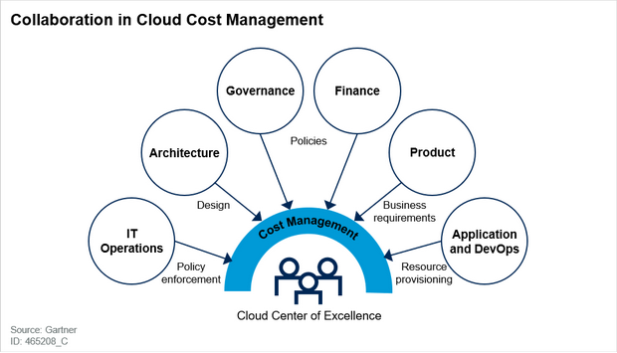
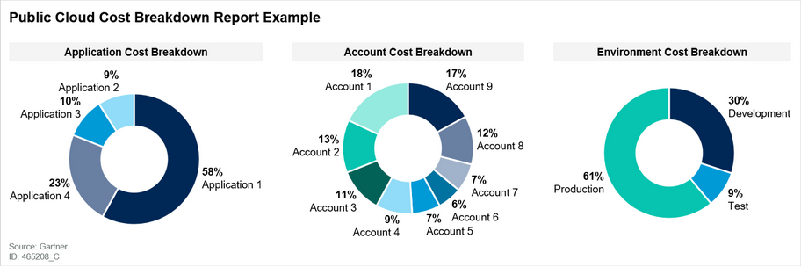

- Security and Compliance
Reputable cloud service providers allocate significant resources towards implementing robust security measures and obtaining compliance certifications, thereby safeguarding data integrity, and adhering to regulatory requirements. By adopting a reputable cloud platform, Aspire Retailers can improve its security stance and address concerns regarding data breaches and non-compliance. [13]
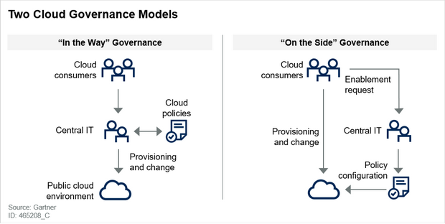

Load Balancing
Load balancing is an essential aspect of cloud computing that plays a crucial role in achieving efficient resource allocation and optimal performance across various applications and services. The primary function of this technology is to evenly distribute incoming traffic among a network of servers, thereby mitigating the risk of any individual server becoming overloaded. As a result, the overall dependability and responsiveness of applications are significantly improved. [14]
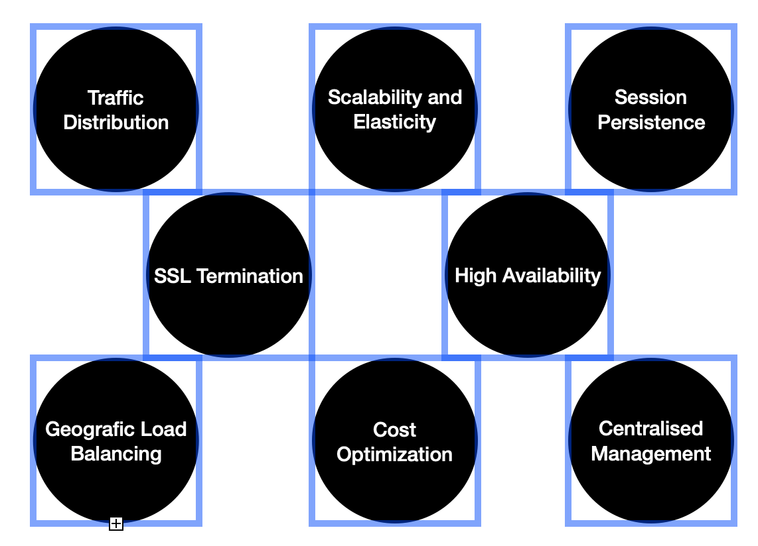
- Traffic Distribution - Load balancers are responsible for the allocation of incoming network traffic among multiple backend servers. Through the strategic allocation of requests, they ensure that no individual server becomes overwhelmed, resulting in enhanced response times and decreased likelihood of server failures. [15] 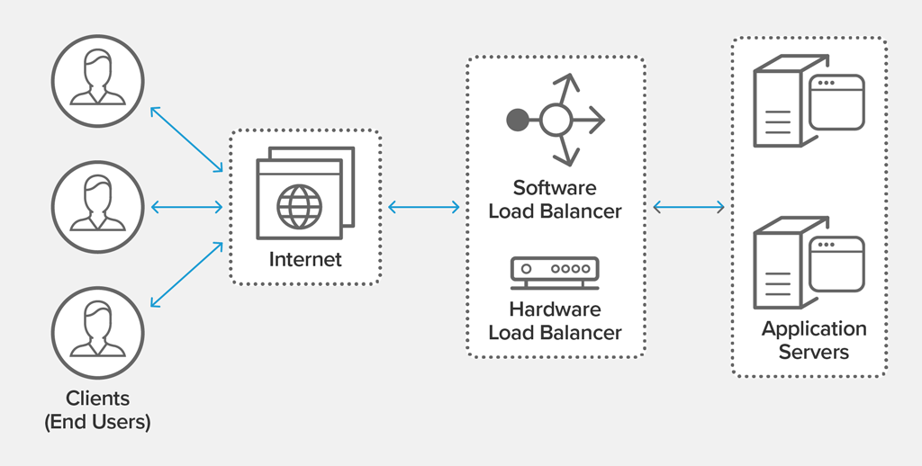
- High Availability - Continuous monitoring of the health of backend servers can be achieved through the configuration of load balancers. In the event of a server becoming unresponsive or experiencing failure, the load balancer will autonomously redirect traffic to operational servers, thereby guaranteeing continuous availability of services.
- Scalability and Elasticity - Load balancers are of utmost importance in cloud environments as they facilitate the horizontal scaling of applications. With the increase in demand, it becomes possible to incorporate supplementary servers into the backend pool. Consequently, the load balancer effectively allocates traffic among these servers. The implementation of dynamic scaling enables applications to effectively manage and adapt to fluctuating workloads. 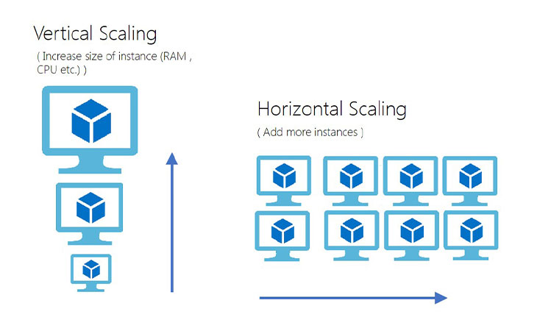
- Session Persistence - Certain applications necessitate the preservation of user sessions on a singular server to ensure consistency. Load balancers have the capability to provide session persistence by ensuring that subsequent requests from a particular user are directed to the same backend server, thus enabling the maintenance of session state.
- SSL Termination - Load balancers have the capability to alleviate the computational load on backend servers by handling the encryption and decryption of SSL/TLS. This feature significantly improves overall performance, especially for applications that have stringent security requirements.
- 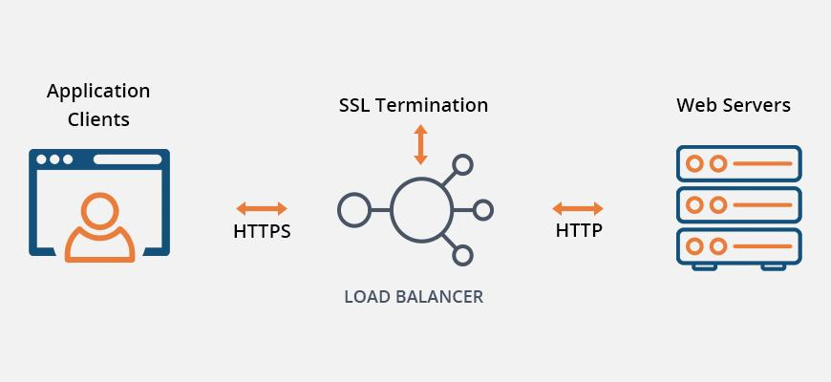
- Geographical Load Balancing - Cloud-based load balancers have the capability to utilise geolocation data to direct network traffic to the nearest data centre, considering the geographical location of the user. This enhancement enhances the responsiveness of applications and decreases latency for users located in different geographical locations.
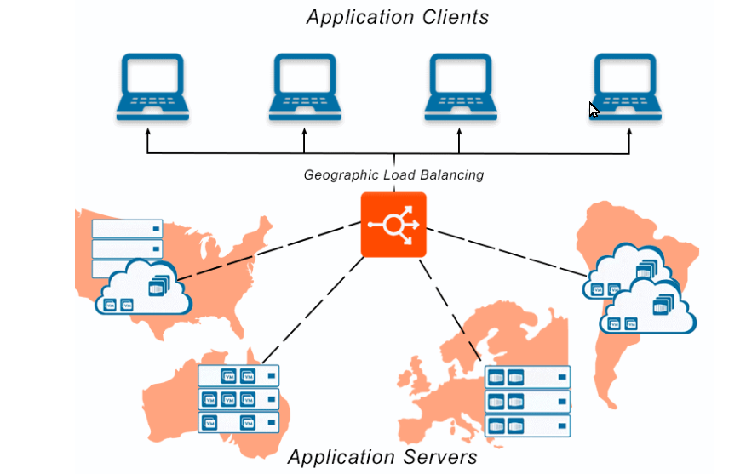
- Centralized Management - Cloud load balancers frequently provide centralised management interfaces that enable IT administrators to easily configure and monitor load balancing settings across multiple regions and availability zones.
- Cost Optimization - Load balancers play a crucial role in enhancing resource utilisation by effectively distributing workloads, thereby minimising the presence of idle or underutilised servers. This cost-effective strategy is in accordance with the pay-as-you-go cloud pricing model.
In conclusion the integration of load balancing mechanisms will be crucial for Aspire Retailers as they transition their infrastructure to the cloud, ensuring the preservation of a responsive and dependable user experience for their clientele.

2. Comparing services of the Cloud Providers

Amazon Web Services (AWS)
Amazon Web Services (AWS) is a prominent industry frontrunner and a highly prevalent cloud computing platform on a global scale. The platform offers a wide array of services that involve various domains such as storage, computing, databases, networking, analytics, machine learning, IoT, and other related areas. Several essential services provided by the organisation include:
- a) Amazon Elastic Compute Cloud (EC2) - Cloud-based virtual servers provide customers with a straightforward means of constructing scalable computing resources.
- b) Amazon Simple Storage Service (S3) - An object storage service has the capability to store and retrieve any amount of data.
- c) Amazon Relational Database Service (RDS) - The individual was responsible for overseeing relational databases that provided support for multiple engines, including MySQL, PostgreSQL, Oracle, and SQL Server.
- d) AWS Lambda - The serverless computing service provides users with the capability to execute code without the need for server provisioning or management.
- e) Amazon Virtual Private Cloud (VPC) - The implementation of isolated virtual networks is crucial in ensuring the security and scalability of cloud deployments.
- f) Amazon SageMaker - The provided service offers comprehensive management of machine learning processes, encompassing the construction, training, and deployment of machine learning models.
- g) Amazon CloudFront - A Content Delivery Network (CDN) is a system designed to facilitate the rapid and secure delivery of web content and videos.
- h) AWS IoT Core - The provision of cloud-based services for the management of Internet of Things (IoT) devices and applications.

Microsoft Azure
Microsoft Azure is a prominent contender within the realm of cloud computing, providing an extensive array of services that facilitate the construction, implementation, and administration of applications. The range of services provided by the company encompasses diverse domains such as compute, storage, databases, AI, analytics, DevOps, and others. Several essential services include:
- a) Azure Virtual Machines - The cloud offers scalable compute instances that are compatible with both Windows and Linux operating systems.
- b) Azure Blob Storage - The object storage service provided is designed to cater to unstructured data, offering exceptional levels of durability and availability.
II. c) Azure SQL Database - The provided service is a comprehensive and fully managed relational database system that operates on the SQL Server platform.
II. d) Azure Functions - The serverless compute service provides users with the ability to execute event-driven code without the need for infrastructure management.
II. e) Azure Virtual Network - The provision of a segregated networking environment for Azure resources, facilitating the establishment of secure connectivity.
II. f) Azure Machine Learning - The platform provided offers a comprehensive solution for the development, training, and implementation of machine learning models.
II. g) Azure Content Delivery Network - A globally distributed content delivery network (CDN) designed to ensure efficient and dependable delivery of content.
II. h) Azure IoT Hub - The proposed service aims to establish a comprehensive framework for the connection, monitoring, and management of Internet of Things (IoT) devices.
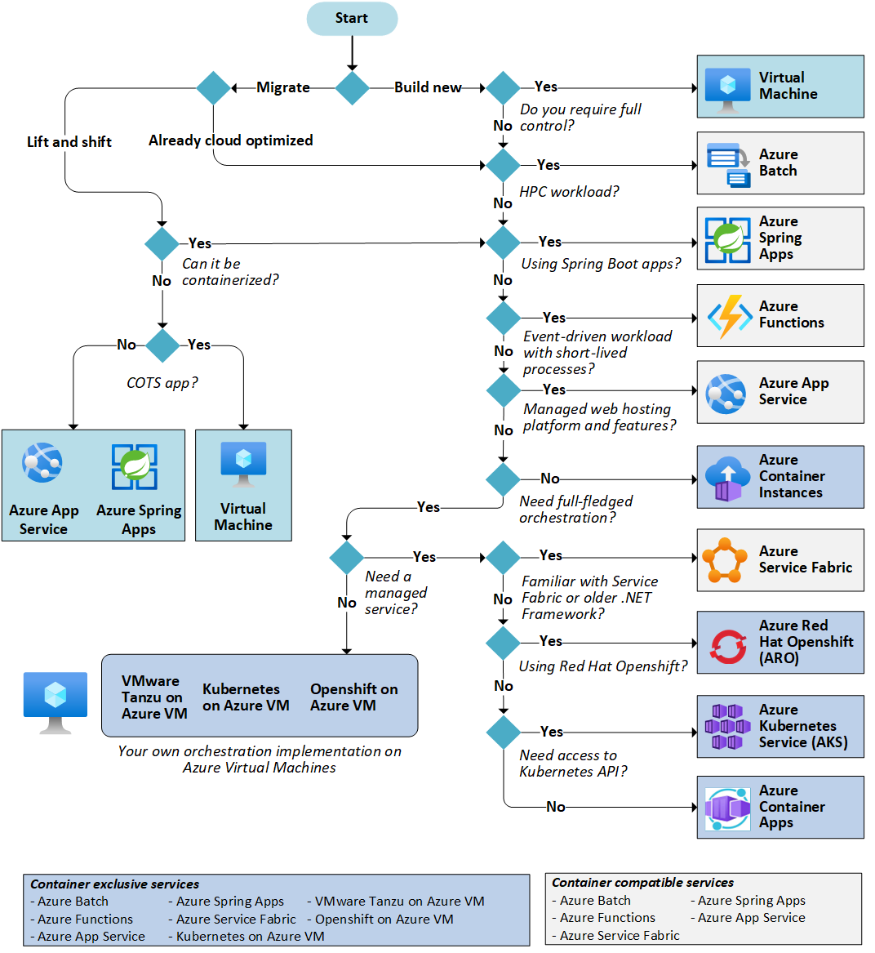

Google Cloud Platform (GCP)
Google Cloud Platform (GCP) is a comprehensive cloud computing solution developed by Google. It encompasses a wide range of services that facilitate cloud computing, storage, databases, machine learning, and various other functionalities. Several notable services offered by the organisation include:
- Google Compute Engine - The utilisation of scalable virtual machines for the execution of applications in cloud computing environments.
- Google Cloud Storage - The object storage service provided offers global data distribution capabilities and ensures strong data consistency.
- Google Cloud SQL - The administration of MySQL and PostgreSQL databases was conducted, encompassing the implementation of automated backup and replication mechanisms.
- Google Cloud Functions - The serverless compute service is designed to execute event-driven functions.
- Google Virtual Private Cloud (VPC) - A cloud networking environment that is characterised by its privacy and isolation.
- Google AI Platform - The proposed platform offers a comprehensive solution for the development, evaluation, and implementation of machine learning models.
- Google Cloud CDN - The global content delivery network (CDN) facilitates efficient and rapid distribution of content.
- Google Cloud IoT Core - The provision of a managed service that facilitates the connection and administration of Internet of Things (IoT) devices.

Each of the cloud providers possesses distinct strengths and features that are tailored to various use cases and industries. To make a well-informed decision, it is necessary to assess the specific requirements and compare the offerings of the providers. Factors such as service availability, performance, pricing, and integration capabilities should be taken into consideration during the evaluation process.

Cloud Cost for Aspire

- For the first step we will go to azure pricing calculator in here we will need to select for every VM.

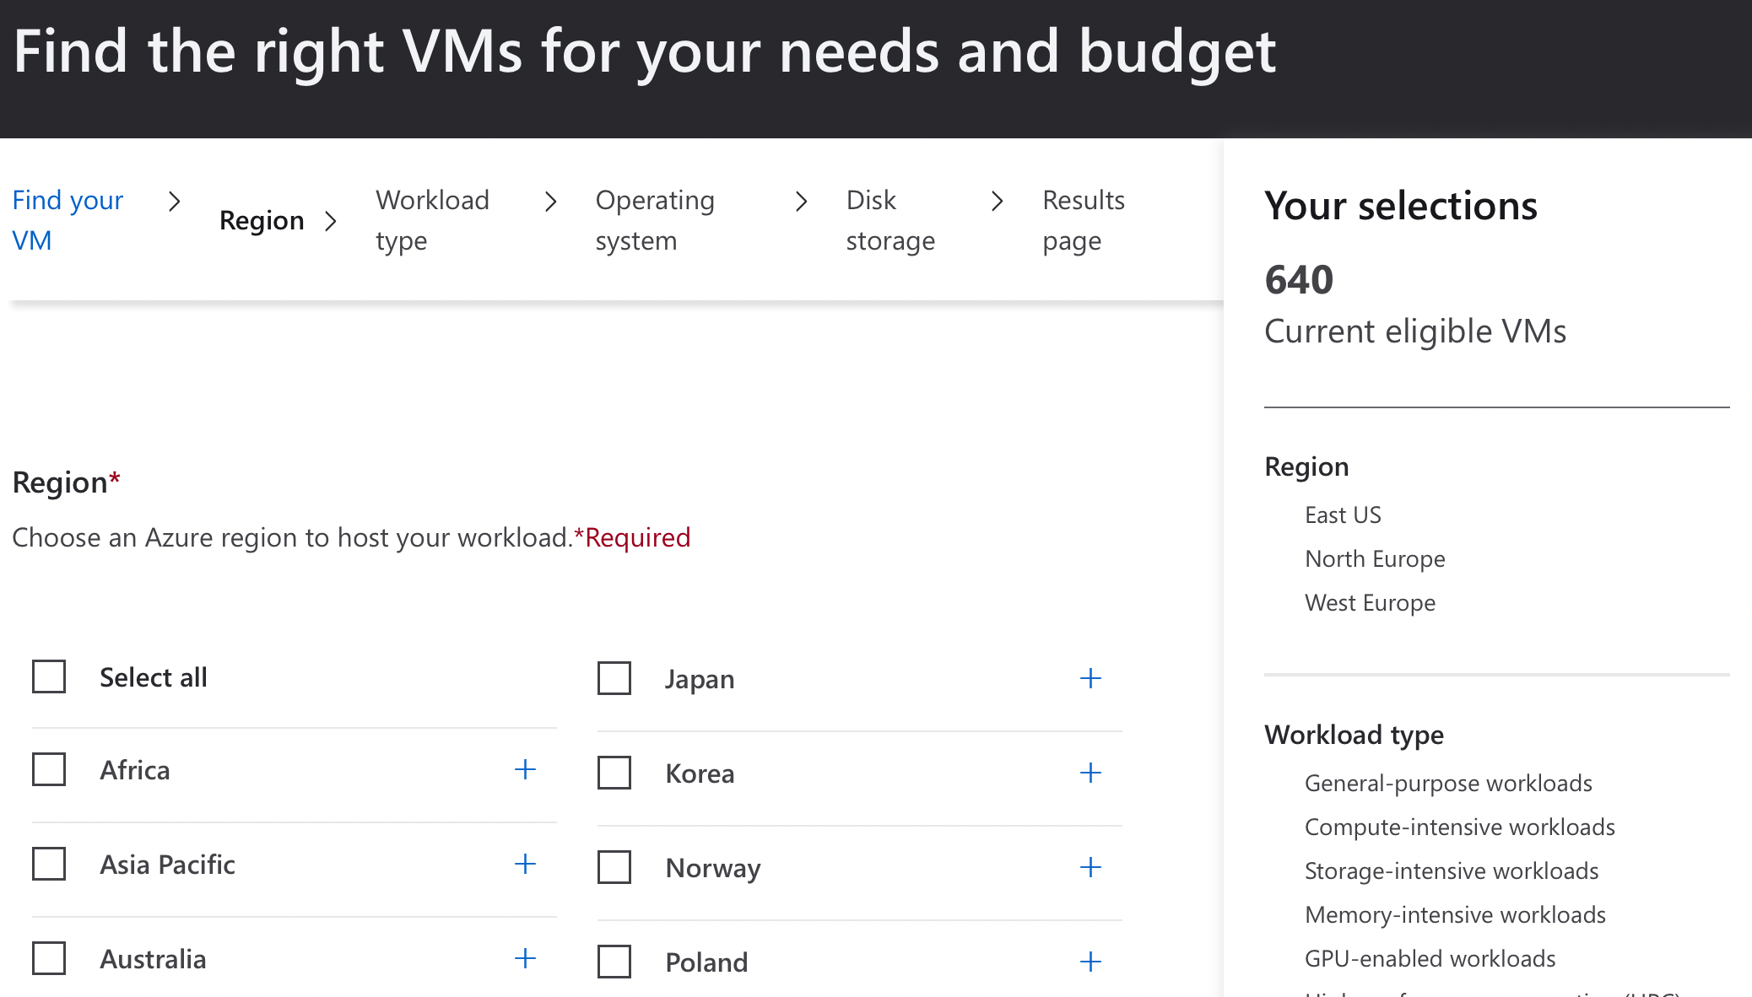

We know allready that the zone that we want to operate is North Europe

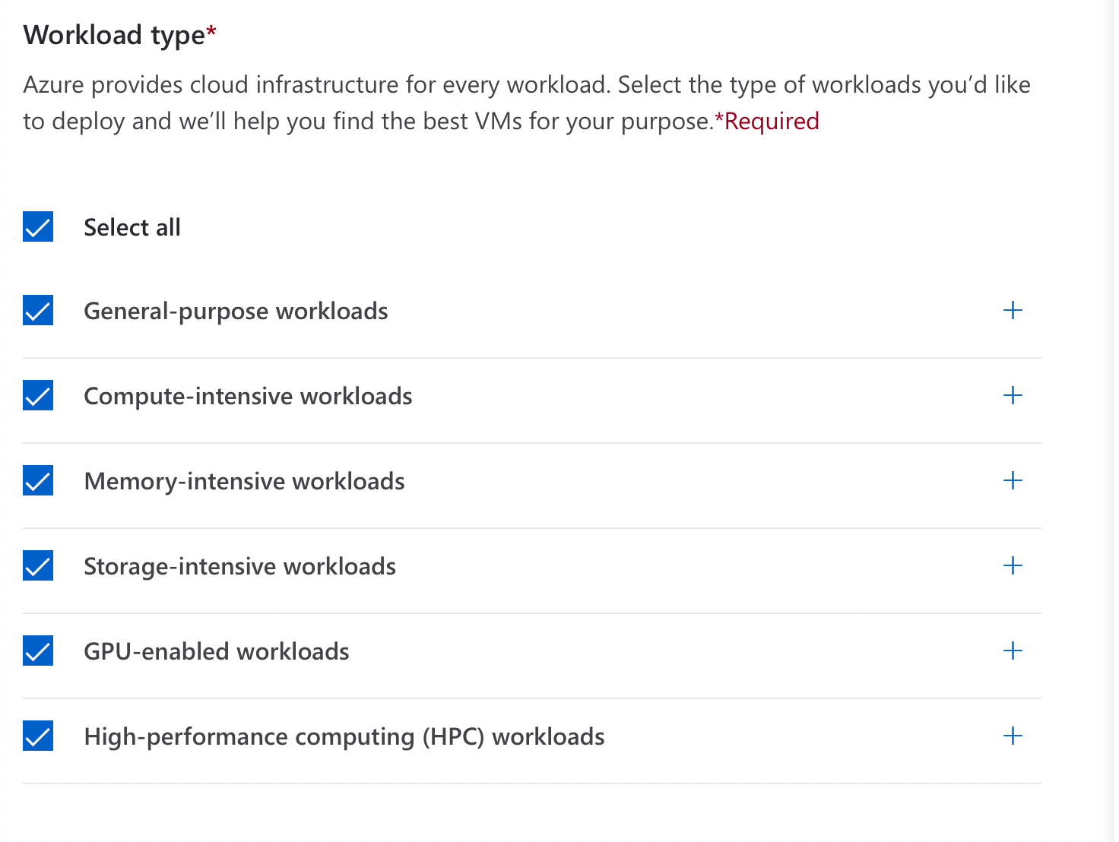
- In the picture above we can see that we are selecting all of the instances of the workload.

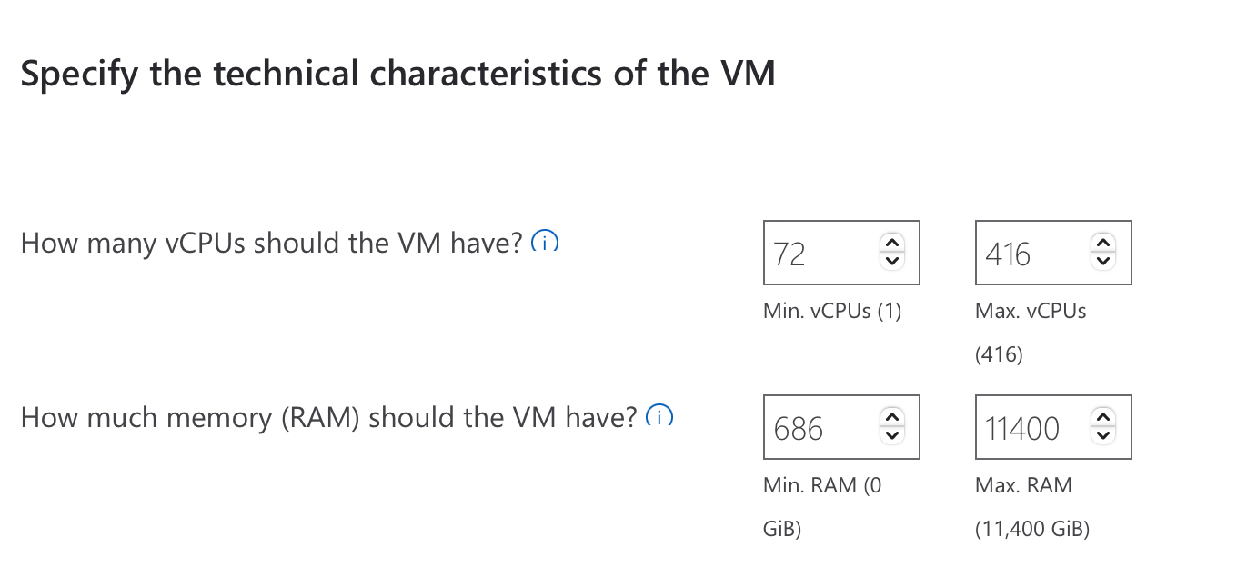

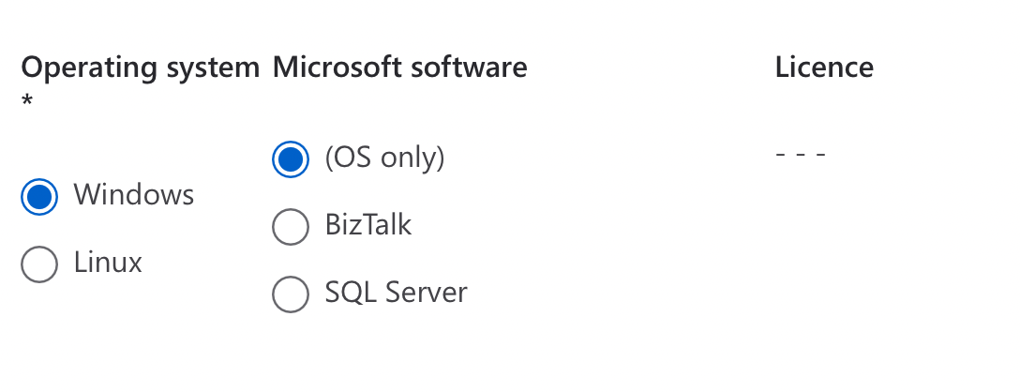
- For the Licence we will need to select the Windows and Linux Operating System.
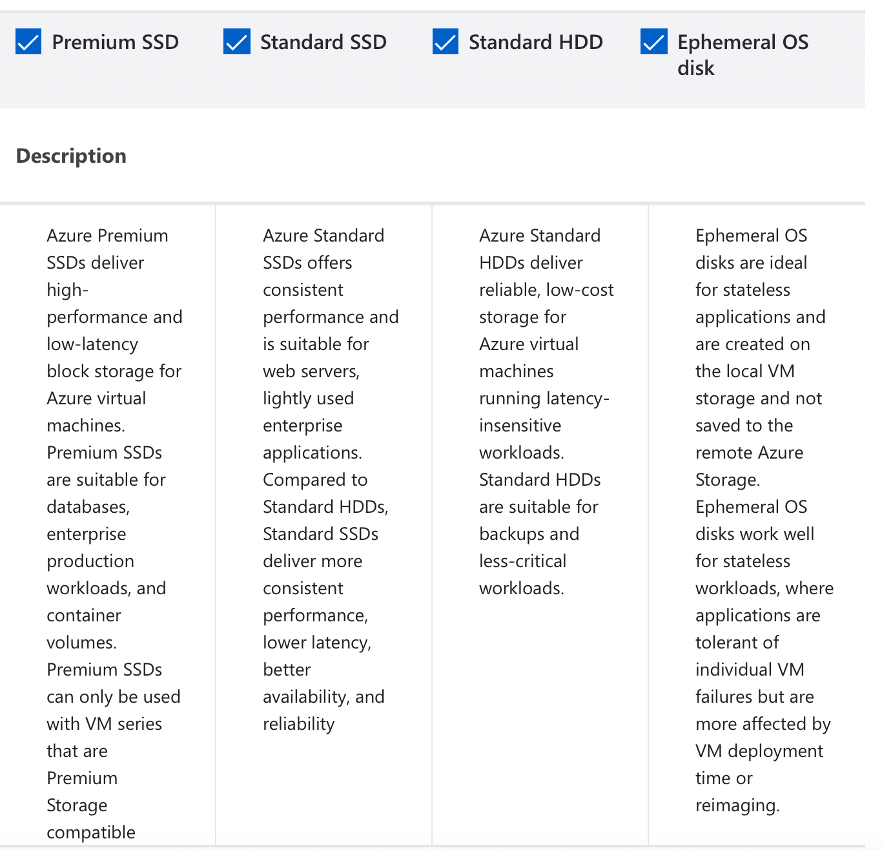

- In this step we will need to select the type of storage.
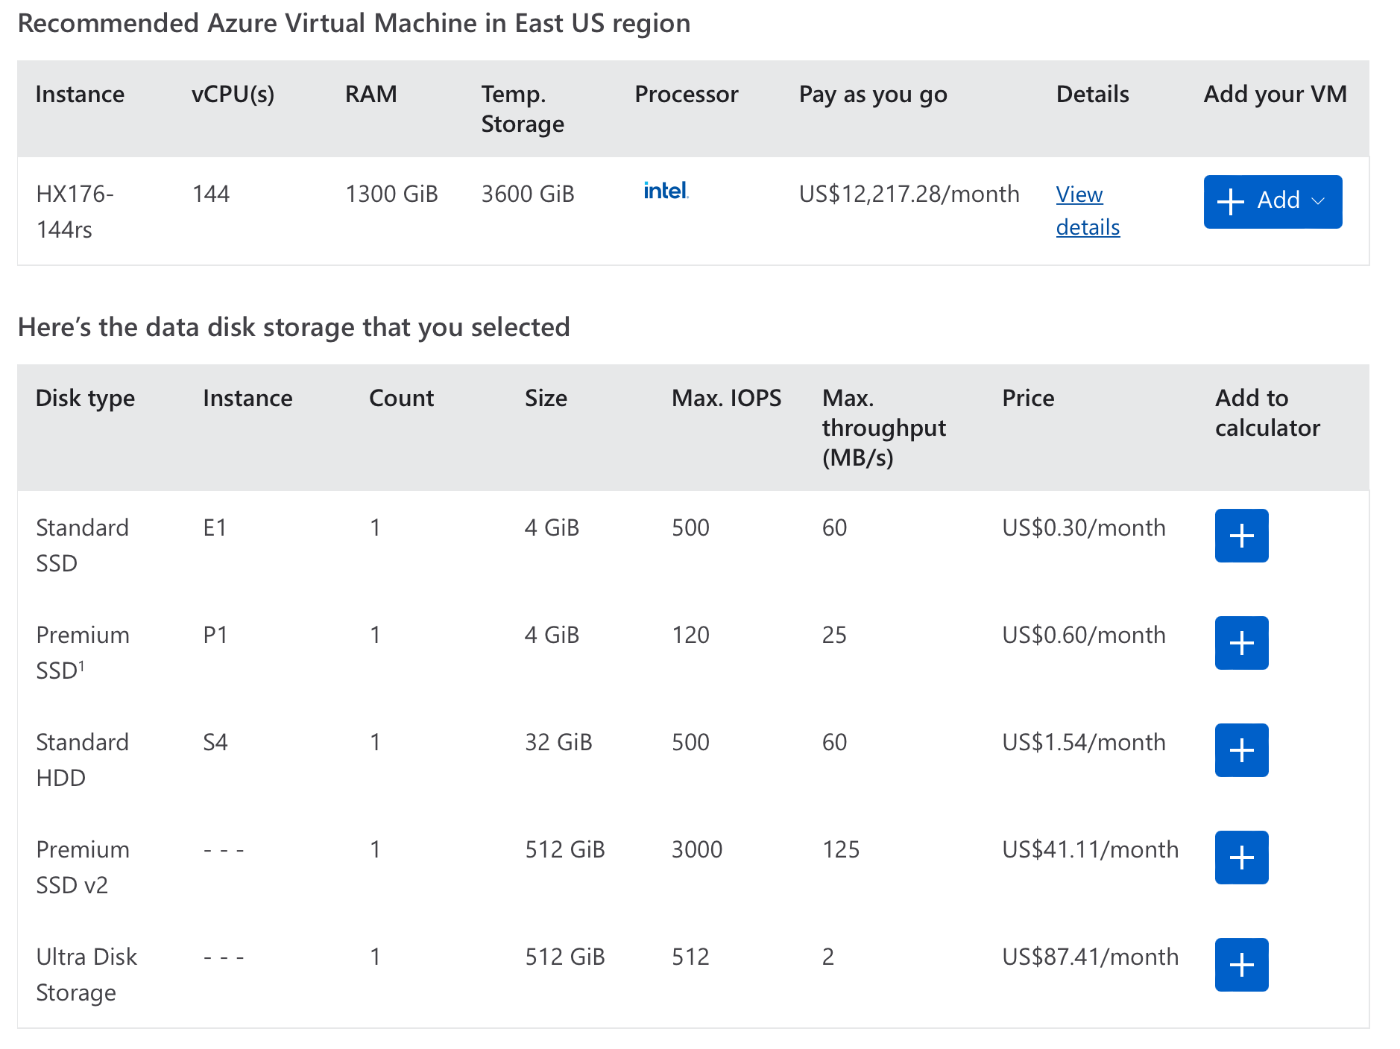
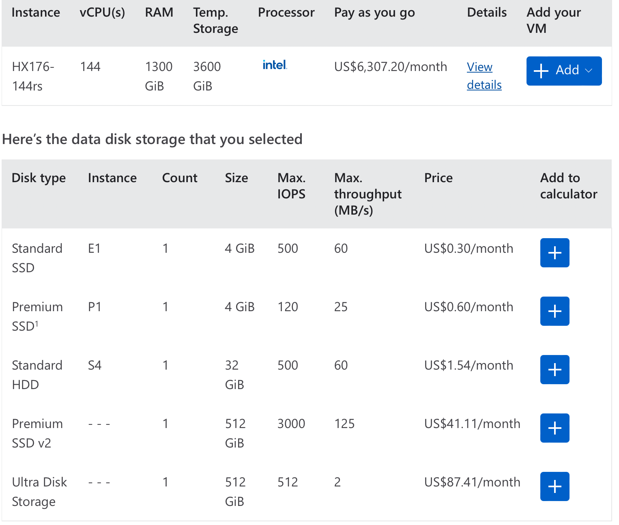

TCO (Total Cost of Ownership)
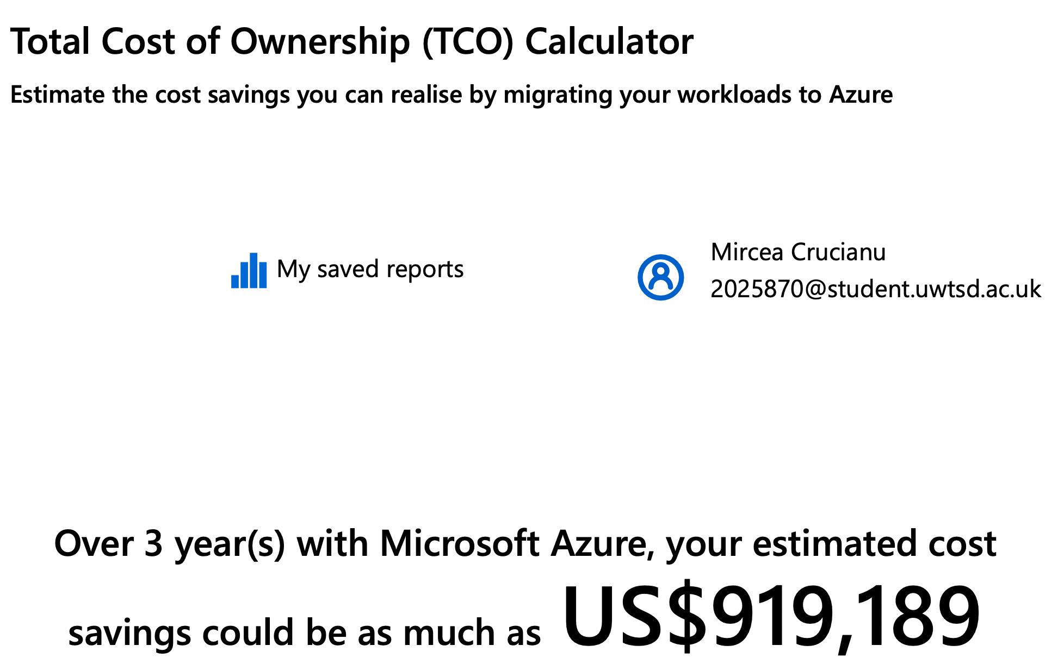

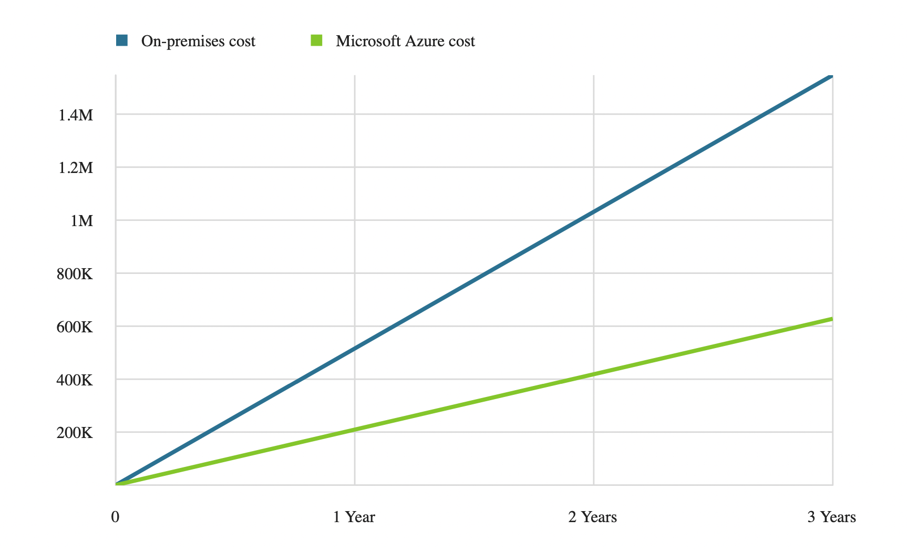

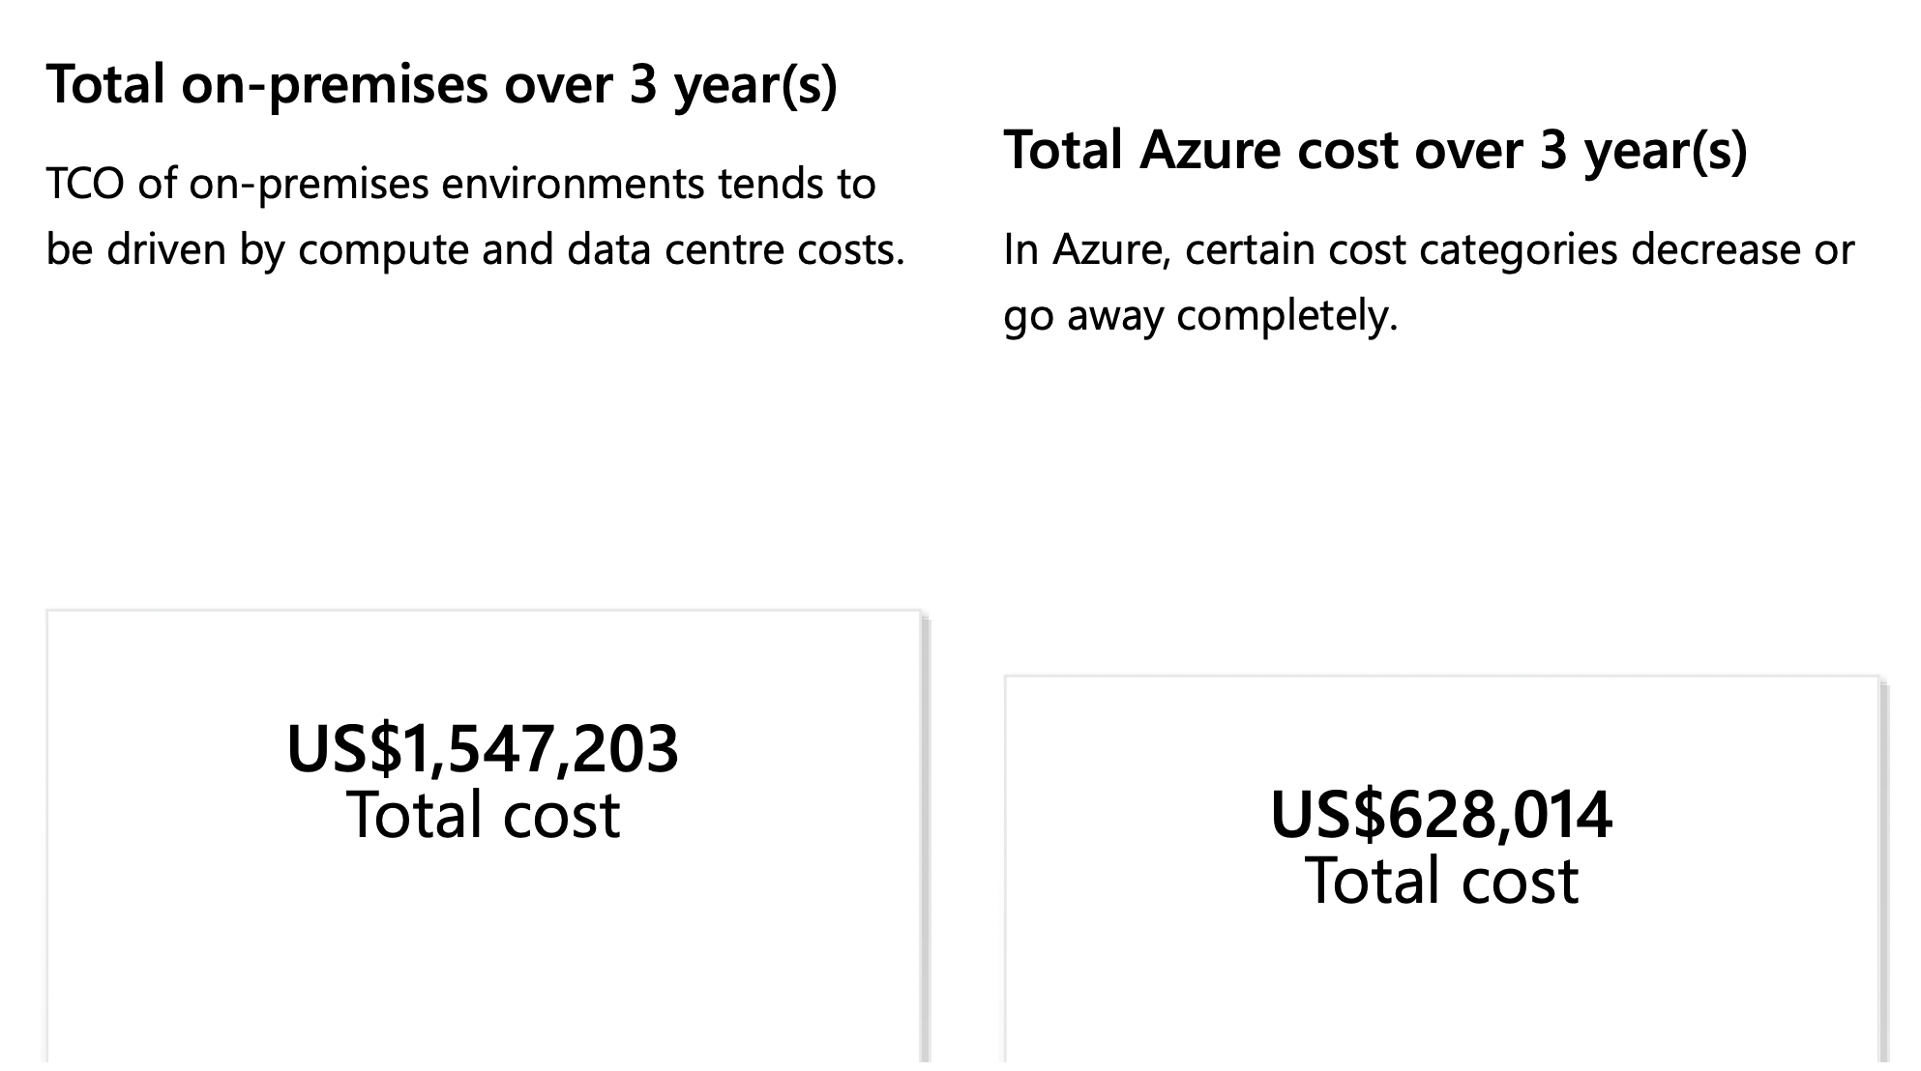

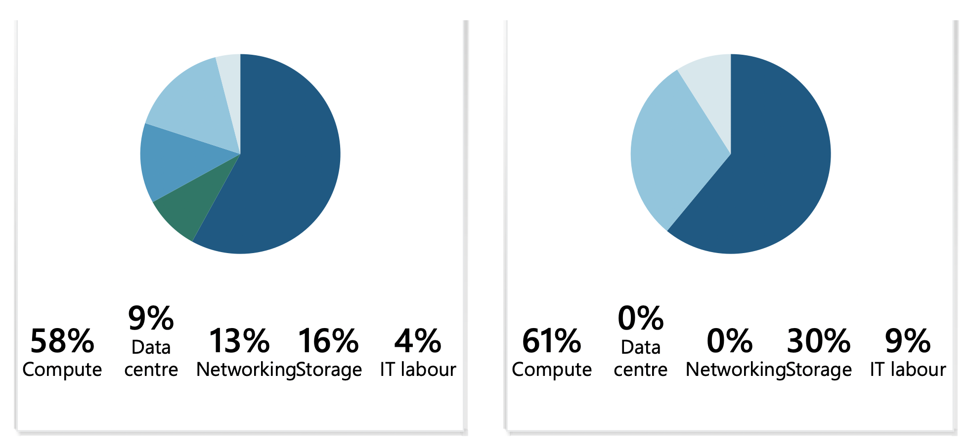
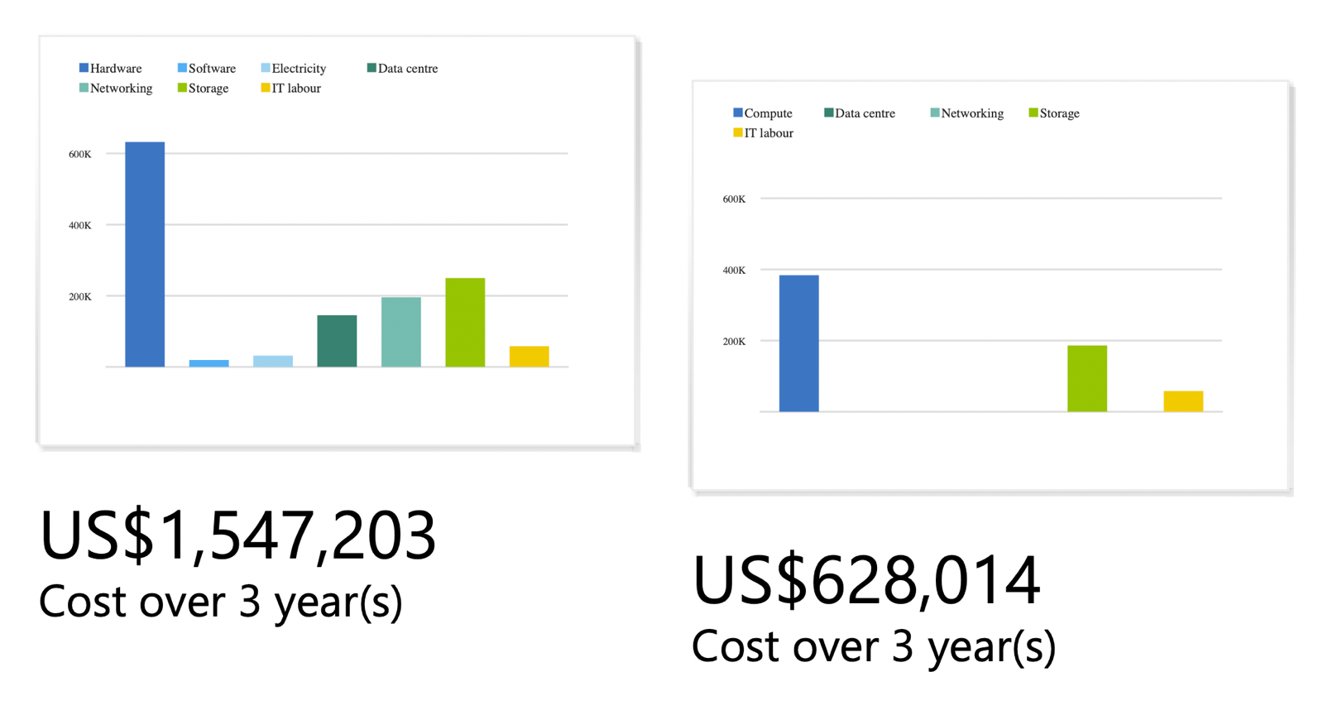
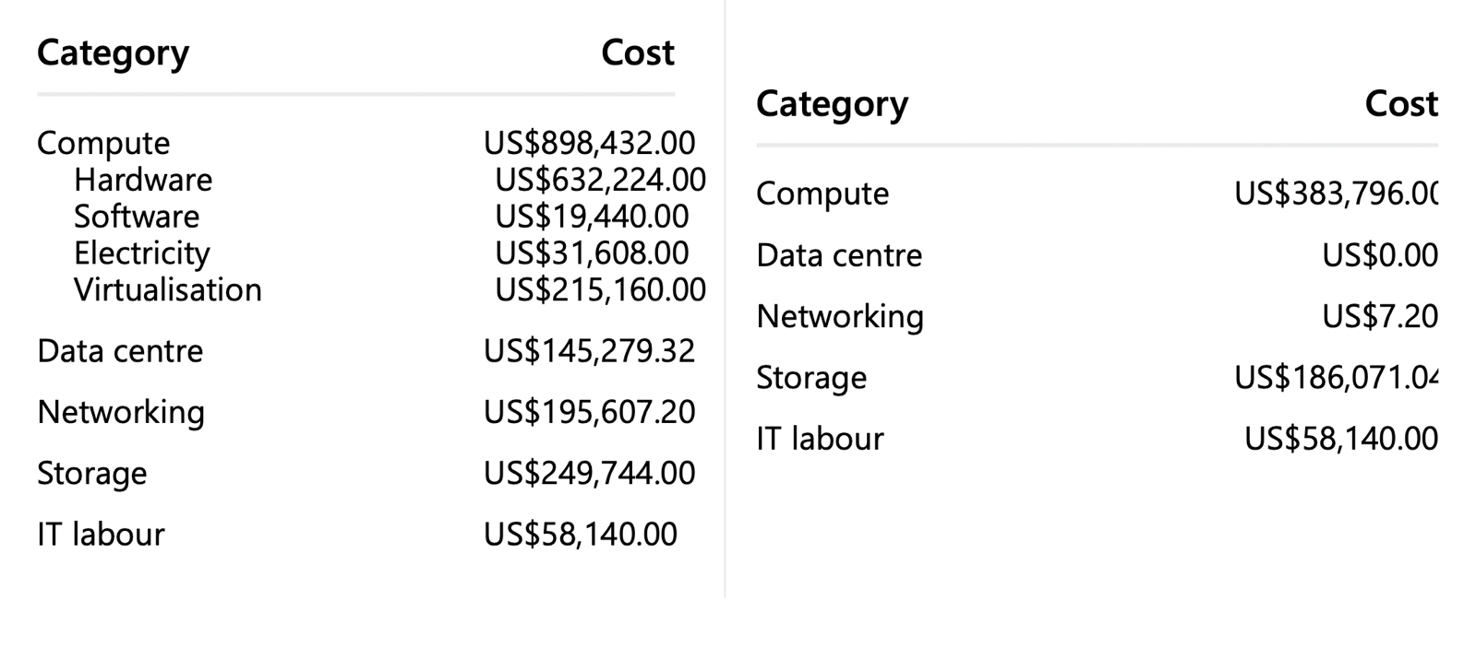

Retailers have the potential to achieve cost savings by strategically utilising cloud workloads and optimising their cloud resources. Herein lie several pivotal cost-saving strategies that can be adopted. [16]
Cloud providers offer a diverse range of instance types and configurations, allowing users to effectively allocate resources based on their specific needs. It is advisable for Aspire Retailers to conduct an analysis of their workloads and carefully select instance sizes that align with the specific requirements of their applications. The act of avoiding overprovisioning has the potential to result in substantial financial savings. [17]
Auto Scaling enables Aspire Retailers to dynamically modify the quantity of instances in response to varying levels of demand. The practise of expanding operations during periods of high demand and reducing them during periods of low demand is essential for achieving efficient allocation of resources and cost-effectiveness. [18]
Certain cloud service providers provide reduced pricing for unutilized or surplus capacity, commonly referred to as "Spot Instances." Additionally, these providers also offer "Reserved Instances," which entail pre-purchasing capacity at a discounted rate. Moreover, the strategic acquisition of "Reserved Instances" in advance for extended periods of utilisation has the potential to yield cost savings in contrast to the pricing structure of on-demand services. [19]
Serverless Architecture: By using serverless services like AWS Lambda or Azure Functions, Aspire Retailers can only be charged for the computing power used when executing a function. This reduces the expense of unused resources and improves cost effectiveness. [20]
Aspire Retailers may optimise their cloud workload and cut costs significantly while still enjoying the benefits of the cloud's flexibility, scalability, and performance by implementing these cost-saving measures and routinely monitoring cloud utilisation.

Azure Active Directory
Azure Active Directory (Azure AD) is a cloud-based identity and access management service developed by Microsoft. It offers a comprehensive suite of features for the administration of user accounts, as well as authentication and authorization processes, across Azure and various other Microsoft services. This document outlines several primary applications of Azure Active Directory (Azure AD) and provides instructions on configuring diverse user accounts and assigning roles to both Global users and regular users. [21]

- User Management
Azure Active Directory (Azure AD) provides administrators with the capability to create, manage, and synchronise user accounts across a wide range of applications and services. The system offers a centralised repository for users, facilitating the management of identities and access permissions.
- Single Sign-On
Azure Active Directory (Azure AD) facilitates the implementation of Single Sign-On (SSO) functionality, which permits users to authenticate themselves once and subsequently access various applications and resources without the requirement of repeated authentication for each individual service.
- Multi Factor Authentication
To bolster security measures, Azure AD offers support for Multi-Factor Authentication. This feature mandates that users furnish supplementary verification, such as a unique code transmitted to their mobile device, in conjunction with their password when attempting to access resources.
- Application Access Management
Azure Active Directory (Azure AD) enables administrators to manage the allocation and withdrawal of privileges for different applications and resources, contingent upon the roles and permissions assigned to individual users. This measure guarantees that users are granted access solely to the resources that are essential for their needs.
- Group Management
Azure Active Directory (Azure AD) facilitates the establishment of user groups for the purpose of effectively managing users who share similar access requirements. Group-based access control streamlines the process of managing permissions by allocating permissions to users based on their membership in specific groups, rather than on an individual account basis.
- Role Based Access Control
Role-Based Access Control (RBAC) in Azure Active Directory (AD) facilitates the ability for administrators to establish personalised roles and allocate precise permissions to these roles. The implementation of granular control mechanisms guarantees that users are granted access solely to the tasks that are pertinent to their designated roles.

Governance Strategy


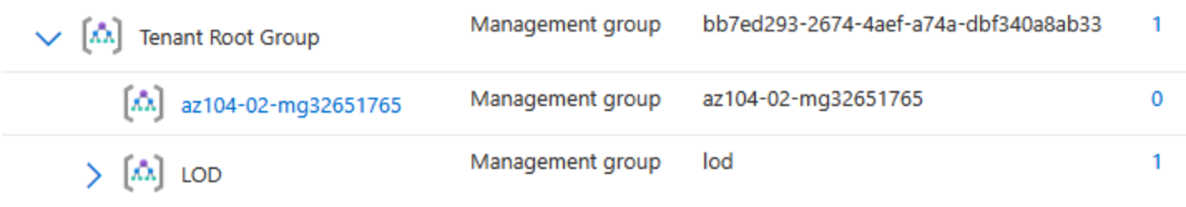

In the step above we will create a Management Group, where we will assign the Custom Support Request Contributor role.
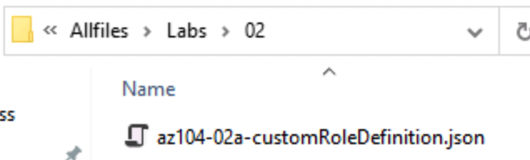

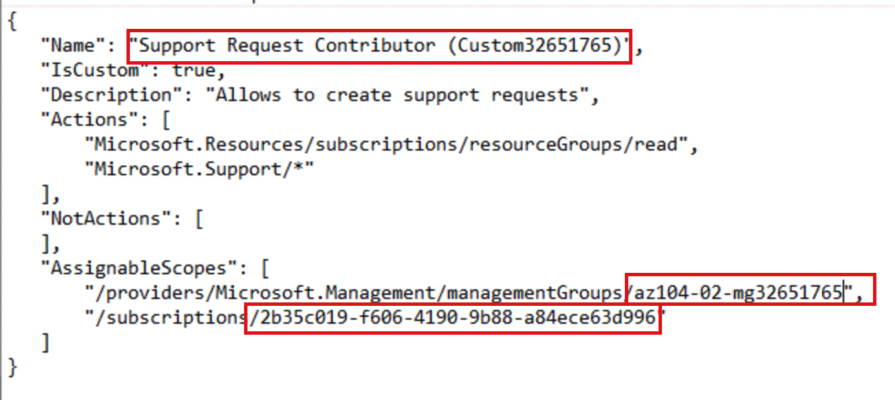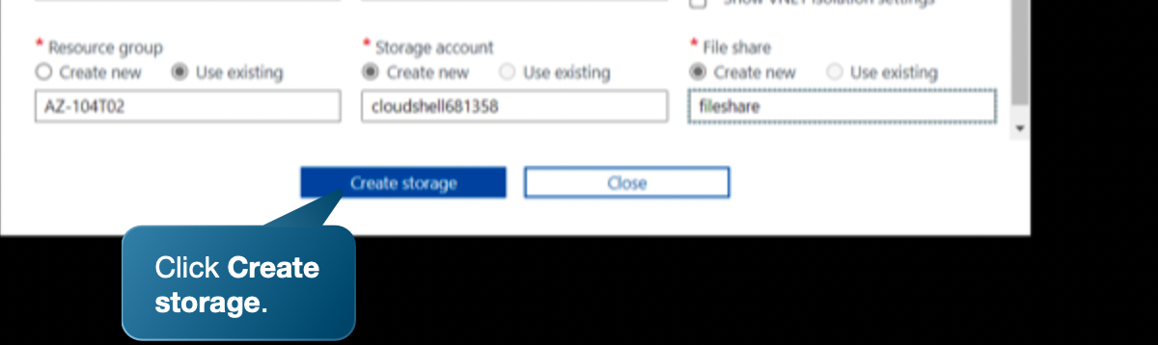
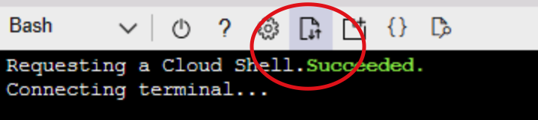

We will need to upload the file on the Storage that we create on the cloud for fileshare.

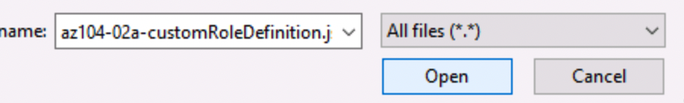
Before uploading to the cloud, we will need to double check if the Subscription id, custom and the name of the management group is the same with the one that we want to share.

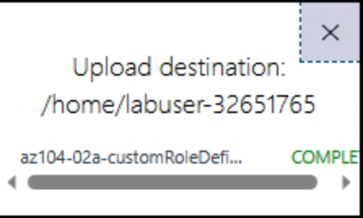

After uploading we will have the following message that will confirm that the file is installed in the storage.
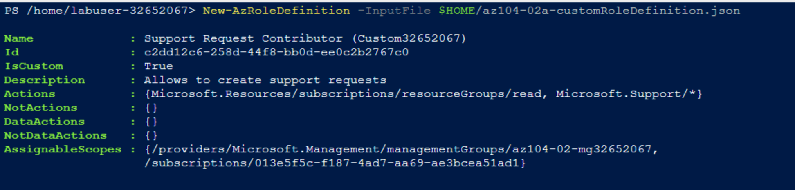

The next command in Shell is going to take from the file the custom role and it will automatically create a role for us.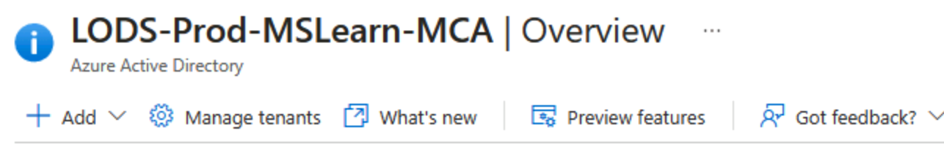



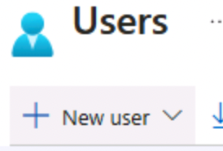

In this example we added the role to the following user.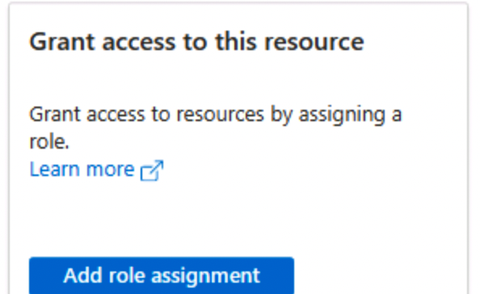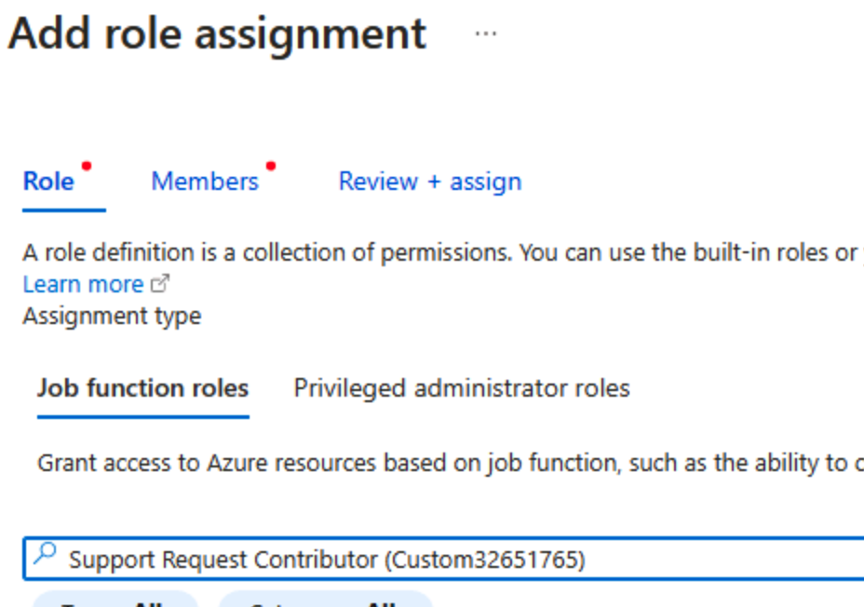
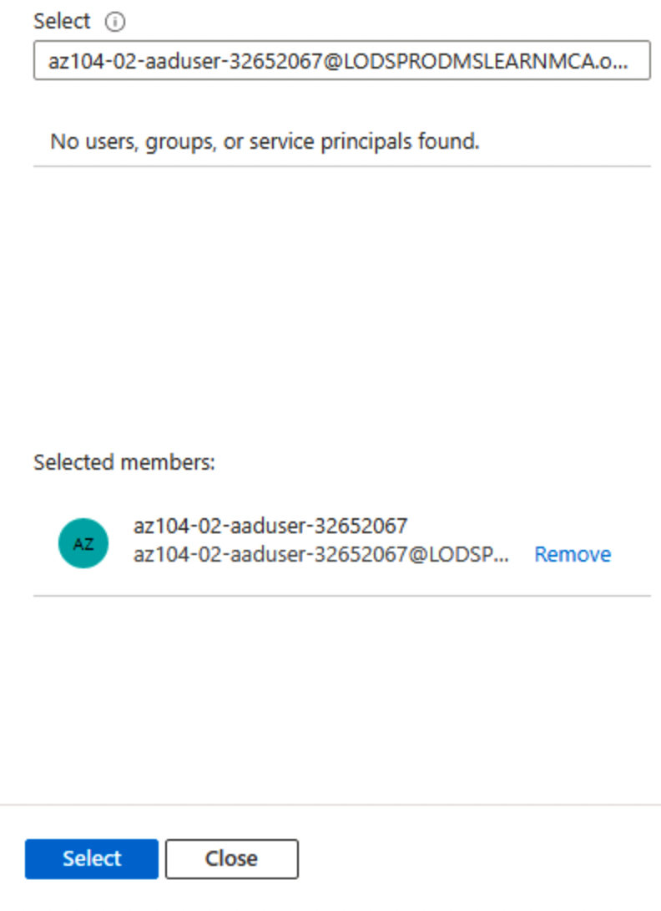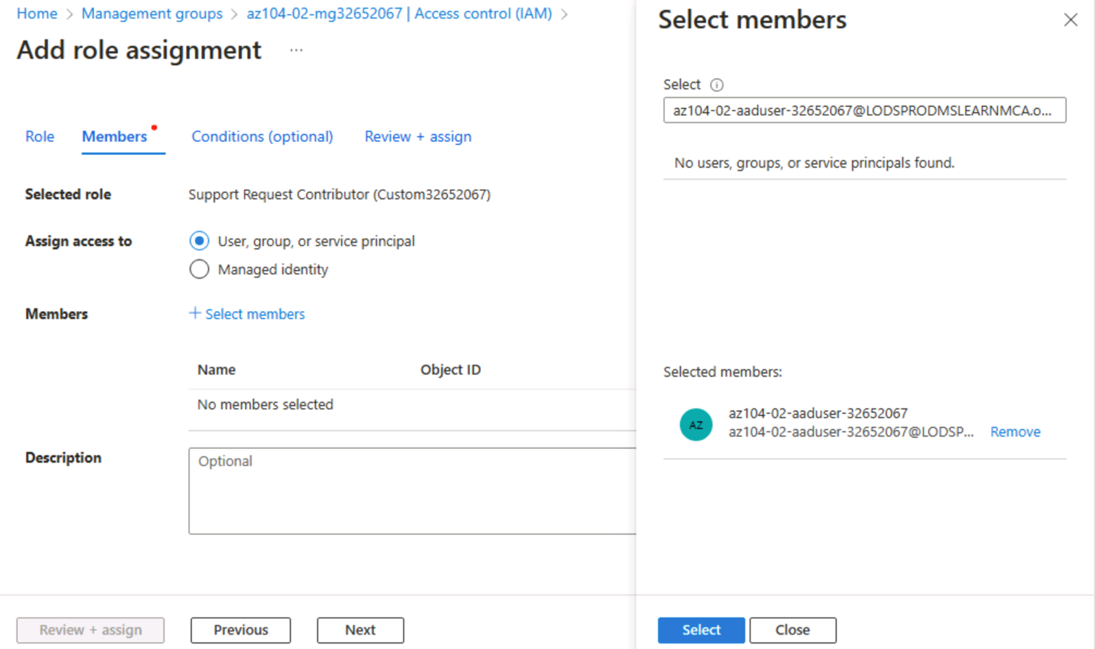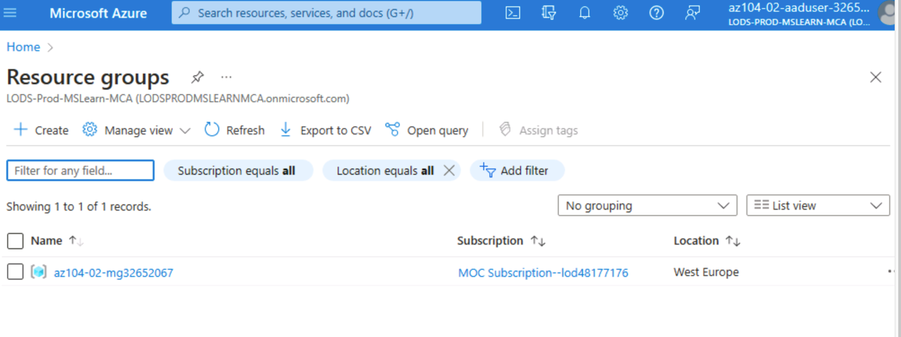
As you can see now, we have access in the management group from another account after we give them permission to have a role for the Management Group.

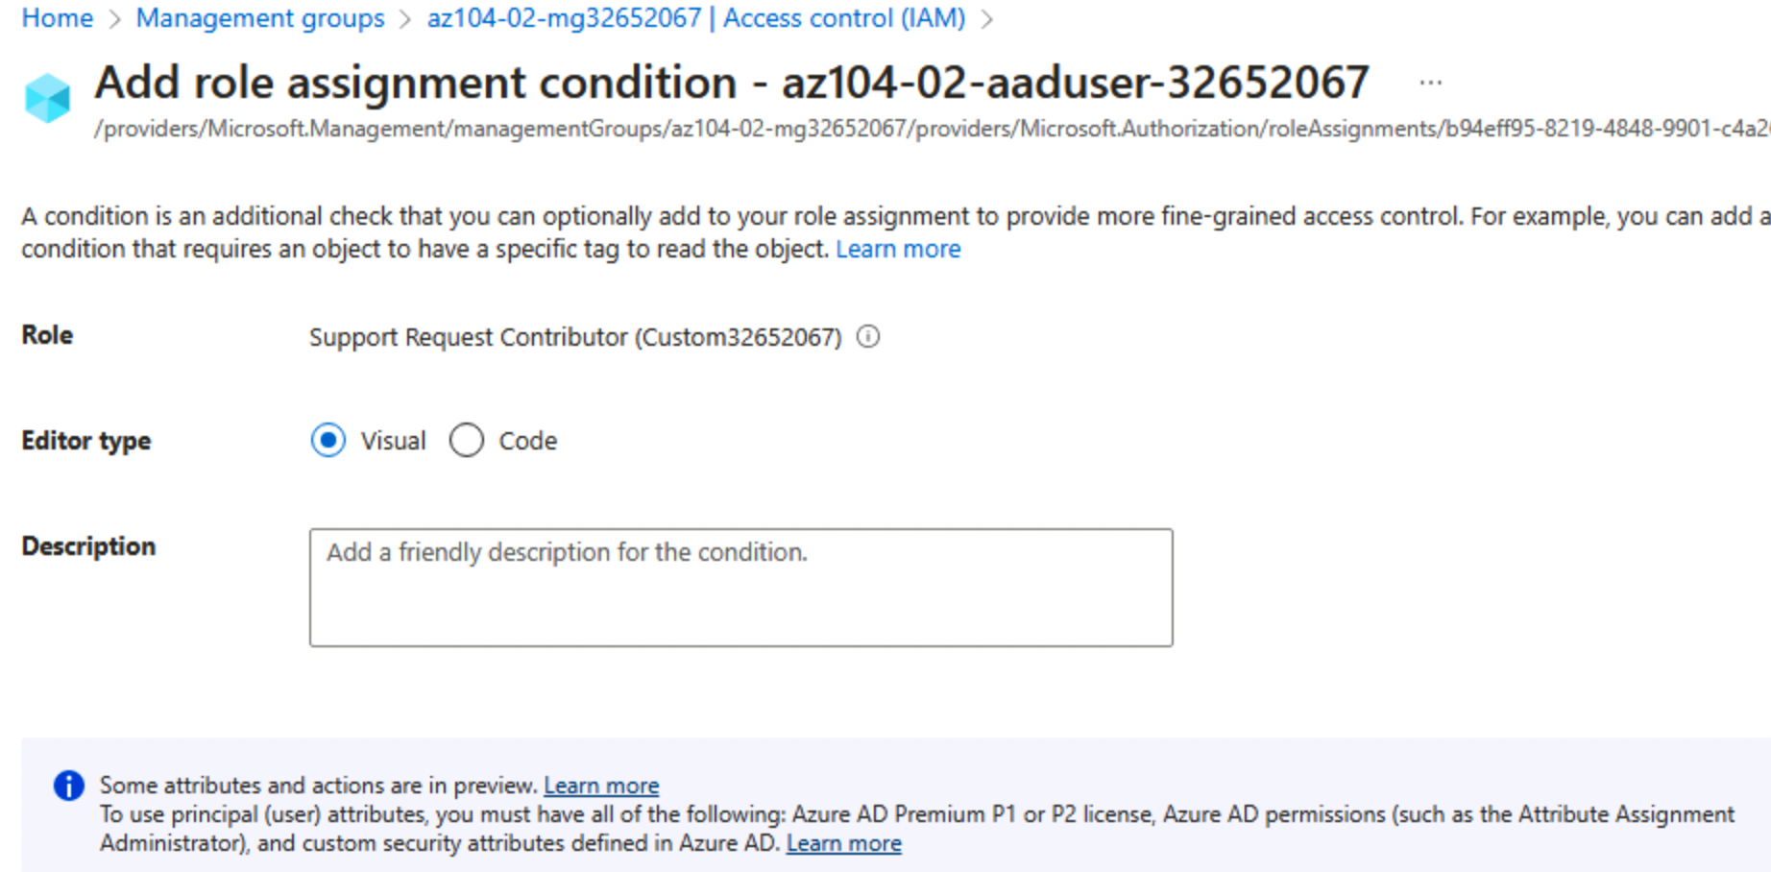

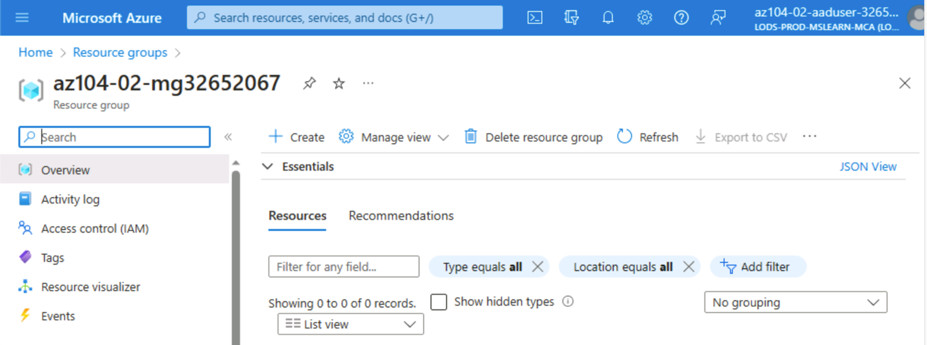

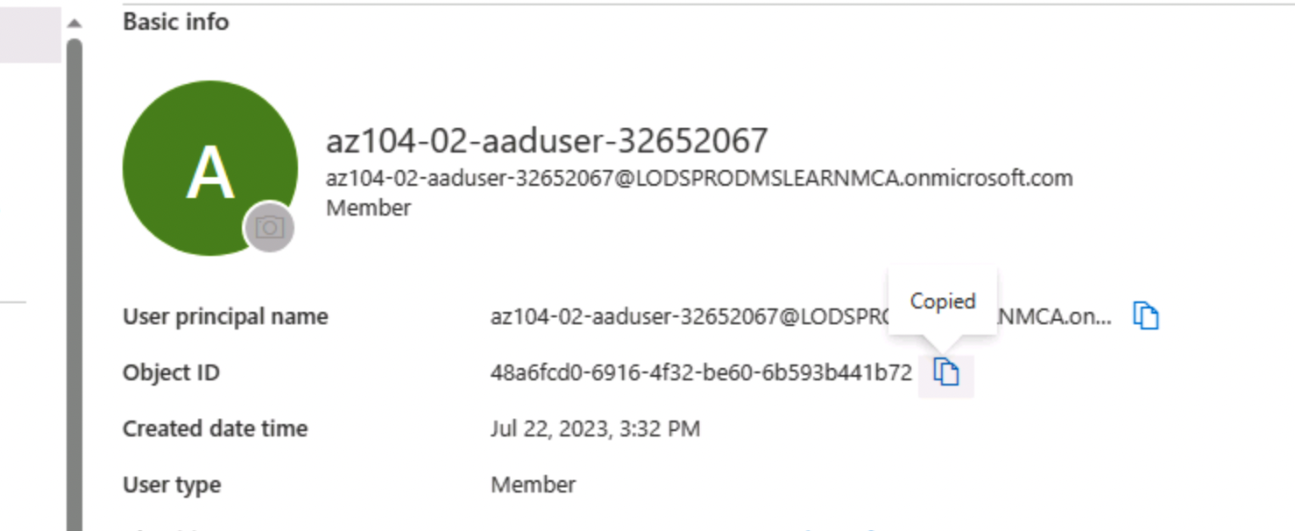

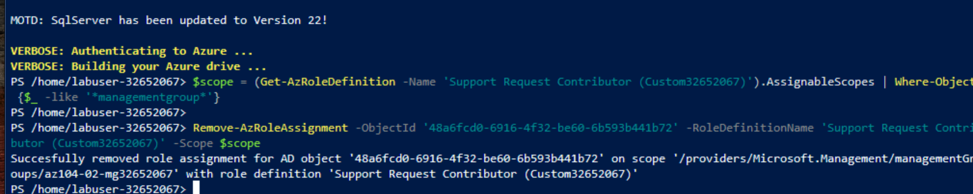

The command from above will allow us to remove the assigned role.

And, to remove the role from the Assigned Roles we need to use the above command.

Cloud Governance

Cloud governance encompasses the collection of policies, protocols, and optimal methodologies implemented by an organisation to guarantee efficient and secure administration of its cloud assets. An effectively formulated cloud governance strategy facilitates organisational control, ensures adherence to regulatory requirements, and enhances resource utilisation within the cloud infrastructure. The scope of this concept includes various elements, such as security, cost management, compliance, identity, and access management (IAM), resource provisioning, and monitoring. [22]
Microsoft Azure Roles that will secure access to cloud resources for Aspire Retailers are:

- Identity and Access Management
Azure Active Directory (Azure AD) serves as the fundamental component of Azure's identity and access management functionalities. Azure AD can be utilised by retailers to effectively manage user identities, enforce the implementation of Multi-Factor Authentication (MFA), establish role definitions, and exercise control over access to Azure resources. By employing the Identity and Access Management (IAM) framework, organisations can effectively enforce the principle of least privilege, thereby guaranteeing that users are granted only the essential authorizations required for their designated responsibilities. [23]
- RBAC or Role Based Access Control
Azure offers Role-Based Access Control (RBAC) functionality, enabling Aspire Retailers to establish personalised roles and allocate precise authorizations to individual users and groups. The implementation of fine-grained control mechanisms serves to effectively restrict access to crucial resources, thereby mitigating the potential threats associated with unauthorised access or inadvertent modifications. [24]

- Network Security
The Azure Virtual Network (VNet) facilitates the establishment of secluded network environments. Aspire Retailers have the capability to establish Network Security Groups (NSGs) to regulate the flow of inbound and outbound traffic between resources located within the Virtual Network (VNet). Furthermore, Azure Firewall and Azure DDoS Protection offer supplementary levels of network security. [25]

- Encryption and Key Management
Azure provides encryption capabilities to protect data both when it is stored and when it is being transmitted. Azure Key Vault can be utilised by retailers to handle encryption keys, certificates, and secrets effectively and securely. This ensures the preservation of data confidentiality and integrity. [26]

- Azure Policy and Azure Blueprints
Azure Policy enables organisations to ensure compliance and adhere to best practises by establishing rules and policies for resources. Azure Blueprints facilitate the generation of reusable templates for Azure environments, guaranteeing uniform governance and resource configurations across subscriptions. [27]

- Azure Security Center
The Azure Security Centre serves as a centralised platform for the monitoring and management of security measures across various Azure resources. The provided solution encompasses threat detection, vulnerability assessment, and security recommendations, thereby enabling Aspire Retailers to take proactive measures in mitigating potential security risks. [28]

- Azure Directory Privileged Identity Management
Privileged Identity Management (PIM) facilitates the management and surveillance of privileged access within Azure Active Directory (AD). Retailers can utilise Product Information Management (PIM) systems to provide time-limited and on-demand authorization to privileged roles, thereby mitigating the potential threat of unauthorised access.
- Monitoring and Auditing
Azure Monitor offers a wide range of monitoring and logging functionalities, ensuring comprehensive coverage. Azure Monitor can be utilised by retailers to enhance their visibility into the activities of their resources, identify any potentially suspicious behaviour, and ensure compliance with relevant regulations. [29]

- Azure Sentinel
Azure Sentinel is a cloud-based Security Information and Event Management (SIEM) solution that is designed to operate within a native cloud environment. The Aspire Retailers platform aids in the proactive identification and mitigation of security threats by providing advanced security analytics and automated response capabilities. [30]

Through the utilisation of the security features and services offered by Microsoft Azure, Aspire Retailers can effectively implement a comprehensive cloud governance strategy that places emphasis on security, compliance, and operational efficiency. The utilisation of these tools and services facilitates the establishment of a robust security framework for the company, allowing for the safeguarding of access to cloud resources, preservation of sensitive data, and efficient identification and mitigation of security threats. Consequently, this ensures the creation of a secure and reliable cloud environment.

Disaster Recovery for Aspire Retailers
The development of a resilient disaster recovery plan is imperative to guarantee the uninterrupted operation of a business and the continued accessibility of its data and applications in the face of unforeseen disruptions or calamities. Aspire Retailers, in the process of migrating their data and applications to the cloud, should develop a comprehensive disaster recovery plan that is specifically designed to address the unique requirements and risks inherent in their cloud environment. Outlined below are the fundamental steps and crucial factors to be considered when developing a suitable disaster recovery plan:

- Business Impact Analysis (BIA)
Perform a comprehensive Business Impact Analysis to ascertain the essential applications, data, and services that necessitate prompt restoration. To ascertain the maximum acceptable downtime and data loss, it is crucial to comprehend the Recovery Time Objectives (RTOs) and Recovery Point Objectives (RPOs) associated with each service. [31]
- Data Backup and Replication
Develop and execute a comprehensive and resilient data backup and replication plan. Utilise cloud-native backup services offered by the cloud provider in order to establish a consistent and automated backup system for essential data. One potential approach to enhance redundancy is the implementation of geo-replication, which involves the creation and maintenance of data copies across multiple geographic regions. [32]
- Disaster Recovery Site Selection
Select suitable disaster recovery regions or data centres that are geographically remote from the primary cloud deployment. This practise guarantees that in the occurrence of a regional disruption, data and applications can be promptly restored from an unimpacted site.
- Failover and Failback Procedures
The objective is to establish well-defined failover and failback procedures for critical applications. Implement automated failover mechanisms to facilitate the seamless transition of traffic and operational activities to the disaster recovery site in the event of unavailability of the primary site. It is imperative to establish comprehensive documentation and conduct thorough testing of the failback process in order to guarantee a seamless transition back to the primary environment following its restoration. [33]
- Cloud Provider’s Disaster Recovery Services
Utilise the disaster recovery services provided by the cloud service provider. Cloud service providers such as Azure, AWS, and GCP present a range of services, including Azure Site Recovery, AWS Disaster Recovery, and Google Cloud Disaster Recovery, which effectively optimise and mechanise the process of disaster recovery.
- Network Redundancy and Connectivity
It is imperative to establish network redundancy and connectivity between the primary and disaster recovery environments. To ensure continuous communication during failover, it is recommended to deploy redundant network connections and employ Virtual Private Networks (VPNs) or dedicated connections. [34]
- Periodic Testing and Drills
It is imperative to consistently administer assessments and execute disaster recovery exercises in order to verify the efficacy of the plan. These tests serve the purpose of identifying and mitigating potential issues prior to the occurrence of an actual disaster, thereby ensuring the efficacy of the subsequent recovery process.
- Disaster Recovery Team and Communication Plan
It is recommended to establish a specialised disaster recovery team that will be responsible for the execution of the recovery plan. Develop a comprehensive communication strategy to facilitate efficient coordination and effective communication throughout the duration and aftermath of a disaster occurrence. [35]
- Continuous Monitoring and Alerting
The implementation of continuous monitoring and alerting systems is crucial in detecting potential issues or anomalies that have the potential to result in a disaster. The utilisation of prompt alerts can facilitate the implementation of proactive measures aimed at preventing or mitigating the consequences of a disaster.
- Documentation and Updates
It is imperative to consistently update the documentation pertaining to the disaster recovery plan, encompassing the various procedures, contacts, and recovery steps. It is imperative to consistently evaluate and revise the plan in order to accommodate any alterations in the cloud environment and business demands.

By adhering to these procedures and considering the distinct requirements of their cloud infrastructure, Aspire Retailers can formulate an all-encompassing strategy for disaster recovery. This strategy will guarantee the availability of data and applications, mitigate the risk of downtime, and facilitate the continuity of business operations in the event of unforeseen disasters or disruptions.

Bibliography

[1] | R. H. Community, “What is digital transformation,” The Enterprisers Project, [Online]. Available: https://enterprisersproject.com/what-is-digital-transformation. [Accessed 18 July 2023].
[2] | J. Giemzo, M. Gu, J. Kaplan and L. Vinter, “How CIO's and CTO's can accelerate digital transformations through cloud platforms,” McKinsey Digital, [Online]. Available: https://www.mckinsey.com/capabilities/mckinsey-digital/our-insights/how-cios-and-ctos-can-accelerate-digital-transformations-through-cloud-platforms. [Accessed 18 July 2023].
[3] | Y. Chen, “A Strategic Choice: Cloud Smart vs Cloud First,” Medium, 18 June 2023. [Online]. Available: https://medium.com/@dynotes/a-strategic-choice-cloud-smart-vs-cloud-first-39cc4f590a45. [Accessed 18 July 2023].
[4] | A. Porter, “2023 Cloud Migration Trends: Data Takes Flight,” BigID, 9 June 2023. [Online]. Available: https://bigid.com/blog/cloud-migration-trends-and-statistics-2023/. [Accessed 18 July 2023].
[5] | A. Shirtliff, “Cloud Strategy for Organisations in 2023,” ONE BEYOND, 26 June 2023. [Online]. Available: https://www.one-beyond.com/cloud-strategy-for-organisations-in-2023/. [Accessed 18 July 2023].
[6] | Gauravkamble, “https://medium.com/@gauravkamble9112/empowering-innovation-and-efficiency-a-case-study-on-microsofts-cloud-migration-journey-f41e5ebf3fe4,” 1 July 2023. [Online]. Available: Empowering Innovation and Efficiency: A Case Study on Microsoft’s Cloud Migration Journey. [Accessed 18 July 2023].
[7] | Axrail, “6 Predictions for Cloud Migration in 2023: A Paradigm Shift in Business Agility and Growth,” 12 June 2023. [Online]. Available: https://medium.com/@axrail/6-predictions-for-cloud-migration-in-2023-a-paradigm-shift-in-business-agility-and-growth-e05f7d01262c. [Accessed 18 July 2023].
[8] | M. Azure, “What is cloud computing?,” [Online]. Available: https://azure.microsoft.com/en-gb/resources/cloud-computing-dictionary/what-is-cloud-computing. [Accessed 18 July 2023].
[9] | Hotjar, “Hotjar for the holidays: how to predict and prepare for a traffic spike,” 26 October 2022. [Online]. Available: https://www.hotjar.com/holiday-readiness/. [Accessed 18 July 2023].
[10] | V. K. a. C. Y. Keith Gilson, “Driving impact at scale from automation and AI,” February 2019. [Online]. Available: https://www.mckinsey.com/~/media/McKinsey/Business%20Functions/McKinsey%20Digital/Our%20Insights/Driving%20impact%20at%20scale%20from%20automation%20and%20AI/Driving-impact-at-scale-from-automation-and-AI.ashx. [Accessed 18 July 2023].
[11] | T. H. P. G. Roland Kassemeier, “Whether, when, and why functional company characteristics engender customer satisfaction and customer-company identification: The role of self-definitional needs,” International Journal of Research in Marketing, vol. 39, no. 3, pp. 699-723, 2022.
[12] | T. C. Marco Meinard, “How to Manage and Optimize Costs of Public Cloud IaaS and PaaS,” Gartner Research, 23 March 2020. [Online]. Available: https://www.gartner.com/en/documents/3982411. [Accessed 18 July 2023].
[13] | IBM, “IBM Integration software and solutions,” IBM, [Online]. Available: https://www.ibm.com/cloud/integration?utm_content=SRCWW&p1=Search&p4=43700068018467359&p5=p&gclid=Cj0KCQjw8NilBhDOARIsAHzpbLDz0jDOoPRhOldUEStpq3E_9stDoe5q49CVzlr8Znps5_DvsRzEtJUaAmP4EALw_wcB&gclsrc=aw.ds. [Accessed 18 July 2023].
[14] | N. R. Robert Sheldon, “Cloud Load Balancing,” TechTarget, [Online]. Available: https://www.techtarget.com/searchcloudcomputing/definition/cloud-load-balancing. [Accessed 18 July 2023].
[15] | Nginx, “What is Load Balancing,” NGINX, [Online]. Available: https://www.nginx.com/resources/glossary/load-balancing/. [Accessed 18 July 2023].
[16] | Gartner, “How to Manage and Optimize Costs of Public Cloud IaaS and PaaS,” Gartner, 23 March 2020. [Online]. Available: https://www.gartner.com/en/documents/3982411. [Accessed 21 July 2023].
[17] | “Create your hybrid cloud,” Hewlett Packard, [Online]. Available: https://www.hpe.com/uk/en/solutions/cloud.html?jumpid=ps_xwwmnac1u_aid-520074564&ef_id=Cj0KCQjw2eilBhCCARIsAG0Pf8tvwBWsyTjoJgLf_E4jkIJSCV5KUGhZFsyHUWR-PVlQBbDp4bnnvF0aAi26EALw_wcB:G:s&s_kwcid=AL!13472!3!631506184964!p!!g!!cloud%20solutions!18734790717!141. [Accessed 21 July 2023].
[18] | Sri, “Introduction to EC2 Auto Scaling,” 19 March 2022. [Online]. Available: https://dev.to/kasukur/introduction-to-ec2-auto-scaling-1mp4. [Accessed 21 July 2023].
[19] | Spot, “What are AWS spot instances?,” NetApp, [Online]. Available: https://spot.io/resources/aws-ec2-pricing/what-are-ec2-spot-instances/?utm_campaign=Ocean%20search&utm_term=aws%20hpc&utm_source=adwords&utm_medium=ppc&hsa_ver=3&hsa_kw=aws%20hpc&hsa_cam=12797893166&hsa_tgt=kwd-303877177438&hsa_acc=8916801654&hsa_mt=b&hsa. [Accessed 21 July 2023].
[20] | DATADOG , “Discover how adopting a serverless architecture can help you scale your applications in a cost-efficient way.,” DATADOG , [Online]. Available: https://www.datadoghq.com/knowledge-center/serverless-architecture/. [Accessed 21 July 2023].
[21] | Microsoft, “What is Azure Active Directory?,” Microsoft, 02 February 2023. [Online]. Available: https://learn.microsoft.com/en-us/azure/active-directory/fundamentals/active-directory-whatis. [Accessed 22 July 2023].
[22] | Red Hat, “What is cloud governance?,” Red Hat, 13 January 2023. [Online]. Available: https://www.redhat.com/en/topics/automation/what-is-cloud-governance. [Accessed 23 July 2023].
[23] | Microsoft, “Azure Identity Management and access control security best practices,” Microsoft, 19 December 2022. [Online]. Available: https://learn.microsoft.com/en-us/azure/security/fundamentals/identity-management-best-practices. [Accessed 23 July 2023].
[24] | Microsoft, “What is Azure role-based access control (Azure RBAC)?,” Microsoft, 21 August 2022. [Online]. Available: https://learn.microsoft.com/en-us/azure/role-based-access-control/overview. [Accessed 23 July 2023].
[25] | Microsoft, “Network security groups,” Microsoft, 16 March 2023. [Online]. Available: https://learn.microsoft.com/en-us/azure/virtual-network/network-security-groups-overview. [Accessed 23 July 2023].
[26] | Microsoft, “Azure encryption overview,” Microsoft, 23 February 2023. [Online]. Available: https://learn.microsoft.com/en-us/azure/security/fundamentals/encryption-overview. [Accessed 23 July 2023].
[27] | Microsoft, “What is Azure Policy?,” Microsoft, 15 June 2023. [Online]. Available: https://learn.microsoft.com/en-us/azure/governance/policy/overview. [Accessed 23 July 2023].
[28] | G. Elyashar, “New Azure Security Center and Azure platform security capabilities,” Azure, 7 November 2019. [Online]. Available: https://azure.microsoft.com/en-us/blog/new-azure-security-center-and-azure-platform-security-capabilities-2/. [Accessed 23 July 2023].
[29] | Microsoft, “Azure Monitor overview,” Microsoft, 7 December 2023. [Online]. Available: https://learn.microsoft.com/en-us/azure/azure-monitor/overview. [Accessed 23 July 2023].
[30] | Microsoft , “Microsoft Sentinel,” Azure, [Online]. Available: https://azure.microsoft.com/en-gb/products/microsoft-sentinel. [Accessed 23 July 2023].
[31] | W. Kazim, “How To Conduct Business Impact Analysis in 8 Easy Steps,” G2, 20 April 2023. [Online]. Available: https://www.g2.com/articles/business-impact-analysis. [Accessed 23 July 2023].
[32] | Cove Data Protection, “Cove does what other backups pretend to do,” N-Able, [Online]. Available: https://www.n-able.com/lp/backup-trial?utm_medium=cpc&utm_source=google-nonbrand&utm_campaign=bu-glbl-lt-dgd-google_nonbrand-2021-01-01&utm_term=backup%20software%20cloud_aud-1946019029017:kwd-297933077716_p_508680882173&utm_content=g_12602055012_12345852. [Accessed 23 July 2023].
[33] | Microsoft, “About on-premises disaster recovery failover/failback - Classic,” Microsoft, 31 January 2023. [Online]. Available: https://learn.microsoft.com/en-us/azure/site-recovery/failover-failback-overview. [Accessed 23 July 2023].
[34] | Google Cloud, “Architecting disaster recovery for cloud infrastructure outages,” [Online]. Available: https://cloud.google.com/architecture/disaster-recovery. [Accessed 23 July 2023].
[35] | Tulane University, “Developing a Disaster Communication Plan: 8 Steps,” Tulane University, 18 January 2023. [Online]. Available: https://publichealth.tulane.edu/blog/developing-disaster-communication-plan/. [Accessed 23 July 2023].

