
Applied Leadership and Management in the Workplace
Module Assignment Submission
Student Name: | Rosemarie Bennett
Student Number: | 2310781
Module No: | BMSK4012
Module Title: | Entrepreneurship & Intrapreneurship
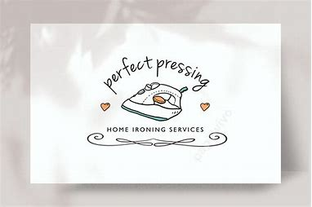
Contents
Executive Summary 2
Introduction 3
Operations 4
Marketing 5
Revenue and Pricing Strategy 6
Financial Information 7
Reference Section 9
Appendices 10

Executive Summary

My business, Perfect Pressing will operate as a sole trader. The business will provide a washing, drying and ironing service. Perfect Pressing will provide high- quality convenient and affordable ironing services to busy professionals, or families who can’t do it for themselves, i.e. elderly people and disabled people who live in the Pont Yates and surrounding area. The business will collect and deliver because not everybody has transport and allows them to focus on other important aspects of their lives. It’s a good communication strategy and will allow me to meet my customers as a lot of the elderly don’t see many people and they like a chat while I visit them even if it’s only for a few minutes which will be rewarding .

Introduction
My business plan is to provide an ironing service for the community and develop a good relationship with customers which will enable me to build my business up to its fullest capacity.
The business will be set up on a sole trader basis, which means I work alone, and ‘I am running the business as an individual’ (Gov.uk, 2024) A sole trader business is inexpensive, easy to set up and to run. Being my own boss means I can make decisions by myself and make my own financial decisions. I will have freedom to act independently and can choose my own hours of work, and my own income so being my own boss gives me the satisfaction of my success. Disadvantages of being a sole trader is that I take on all the risks of starting my own business and “have the disadvantage of unlimited liability” (BBC, 2024). Unlimited liability means that I will be responsible for any debts the business has incurred.
The business name is Perfect pressing and it is an ironing service. The business location will be Pont Yates Llanelli Carmarthenshire.
The Owner will be myself, Rosie Bennett.
The Product will be a pristine press ironing service, which will provide convenient and affordable ironing for professional families and individuals, helping them to maintain a polished appearance. Services offered include: standard ironing, express ironing packaging, in home ironing and specializing fabric care.

Operations
  - Locations, premises, equipment - My location will be from my home I have allocated one room which only I use which consists of my equipment i.e. steam press, ironing board, clothes rail, packaging and labels.
  - Production and distribution processes - I work solo so my production is as I iron per customer and distributes the items myself.
  - People, staff, suppliers – At the moment I work alone, there are no other people involved in the business. My suppliers are identified on the internet which is where I purchase my products from.
  - Systems and processes – I receive orders via mobile phone messaging service, phone calls, meeting people face to face, word of mouth, and friends of friends.
  - Health & safety, legal compliance, risk- Workplace safety set up especially from home I have to make sure that I have plenty of room around my working station as I have to have plenty of space so that can be done properly so that accidents don’t happen, I always put my ironing board and stream press away after iv used them because they remain very hot,
  - Licences required – as far as I am aware I do not require a licence. Although I do have music playing this is not a public place and therefore I do not need a licence.

Marketing
Target marketing is a strategy that involves identifying and selecting most economic and profitable segments and sectors (Khandelwal et al, 2020). There are 1475 people identified in the census living in my target market area and some of these will make up my market. It is recognised that Special services: which include add-on services like laundry are being added to cleaning service businesses as they strive to meet clients’ needs (Jobber, 2024). It has also been noted that revenue in the cleaning industry is growing by 11% each year (Jobber, 2024), and Spherical Insights (2024) reported that the UK Online Laundry Services Market Size was valued at USD 1.94 Billion in 2023. This would suggest that there is a growing market for an ironing/laundry business, especially one that aligns itself with a cleaning business. Furthermore companies offering value-added services such as doorstep delivery further boost demand (Spherical Insights, 2024) The target market I will aim my business towards comprises of:
- Elderly people
- Working couples who have dual incomes
- Small businesses in the hospitality industry
- Large families
I am targeting all ages of the community with my services as there isn’t anyone in my area providing this service, as I also deliver and collect. Times to suit the client due to work commitments.
Ages between 20 years and up with children with various income levels also ages over 50 and upwards as the elderly have a fixed income which they always can’t afford this service , family status occupation, my location climate, is a hit and miss we don’t get very good summers moderate temperatures during summer , spring autumn and winter which doesn’t really affect my business because there isn’t much of a change with my customers clothing .
Market Segmentation
Market segmentation is the process of splitting a business’ target market into different groups (BBC Bitesize. 2024). The market could be quite big as I’m the only person in my area providing this ironing service therefore, I would need to segment the market to make the market more achievable for my business.
The business will segment the market geographically. Geographic segmentation is based on the belief that consumers who live in the same region share some related wants and needs (Martin, 2011), this means that I will be aiming to provide the service to people in the village of Pont Yates and within a 5-mile radius
There is also an element of behavioural segmentation, as this type of segmentation is related to the purchase behaviour exhibited by the individuals (Khandelwal et al, 2020) with elements of needs and benefits associated with some of the buyers, especially those professionals who will be using the service. Artin (2011) suggests that behaviour-based strategies work well for most organizations, therefore it is hoped that the identified behaviour of professionals using an ironing service will result in my business being profitable and attracting my target market.
The marketing objectives are:
- To provide a professional, efficient and reliable service where the rate of complaints are below 5%
- To increase the number of customers by 10% within the first 6 months of setting the business up formally
- To increase profits by 10% within the first 6 months of formal trading.
Adopting a planned approach to marketing helps set clear objectives for the business based on the current situation, which in this instance is a fairly new start up business. The marketing mix is a tool used to identify the right marketing strategy and ‘is primarily tactical in nature’ (Kotler & Amstrong 2018). The marketing mix comprises of the initial 4 Ps product, price, place and promotion identified by McCarthy, (1960) and a further 3 p’s which are people, process and physical evidence (Booms & Bitner, 1981), which were included to meet the service markets.
Product
The product being offered is a pristine press ironing service, which will include convenient and affordable ironing for professional families and individuals, helping them to maintain a polished appearance, and completing a service that they may not have the time or capability to do themselves. Services offered will include standard ironing express ironing packaging in home ironing and specializing fabric care.
My unique selling point is all in my finishing item I press an item to perfection which shows after finishing each item I also pack every item with a plastic covering to protect the item. My other USP is the personal service I offer. As I work alone, I pride myself on the rapport and relationship I build up with every customer.
Place
The business will operate from the owner’s home which is located in the village of Pont Yates Llanelli Carmarthenshire.
Promotion
I will market my business by social media as Jobber (2024) found that many businesses are continuing to invest in cleaning-ads on social media. My other main form of marketing will be word of mouth marketing, Word of Mouth Marketing (WOMM) is a form of promotional campaign which operates through an individual’s personal recommendations of specific brands, products or services (Chittipaka, 2010). I will also deliver leaflets around my area which is a village with the population of around 1,475, people according to census in (2021). Leaflet distribution has been chosen because it is a very effective method of getting the message to people as 79% of recipients either keep, pass along, read, or glance at the contents of a leaflet that comes through their door, therefore the message has a much higher chance of being seen (Flow Fulfilment, 2024).
Price
Pricing is a critical component of marketing strategy since it generates revenue and, ultimately, profit for the organization (Abid, 2022). I plan to adopt a cost-plus pricing strategy and have found that this remains the most widespread pricing method (Dholakia, 2018). Cost-plus pricing, sometimes called markup pricing, ‘is the technique through which a business determines the product's cost to the business and then adds a percentage to that price to establish the product's selling price to the consumer’ (Abid, 2022) . Therefore I need to calculate all costs that are incurred in providing the laundry service, and then I add ‘a markup percentage to estimate the asking price’ (Dholakia, 2018). In my business I currently calculate the cost of ironing a garment (depending on size, material, complexity) and then add the mark-up percentage, this means that the prices for different garments will vary because the time taken to iron will vary, as will the technique for getting the professional finish.
  - PESTLE and SWOT analysis.
Strengths  - Skilled  - Range of services | Weaknesses  - Time  - Family Demands  - Competitive industry  - Lack of process for recording orders
Opportunities  - Adopting online booking system  - Growing demand for ironing service due to longer working hours and dual incomes  - Different geographic locations | Threats  - Pricing competition/price war  - Threat of another pandemic like COVID  - Change in consumer demands  - Shift to clothing & linens that don’t need ironing or are disposable

Political  - Change in Health and Safety regulation  - Change in legislation around businesses operating from home  - Changes to business tax  - Changes to NI contributions  - Consumer Protection Law changes which may affect the business | Economic  - Tax changes – personal and business  - Recession – people lose their jobs and will not need ironing done for them  - Less disposable income – cannot afford to employ someone to do their ironing
Social  - Trends – currently the trend to use external support for jobs in the home  - Changing consumer lifestyles and preferences  - Better work life balance – spend quality time on things they want to do | Technological  - E-commerce and using this to improve business process e.g. booking system  - Cybersecurity and threats for personal data  - GDPR Regulations must be met  - Emerging technologies that I could adopt in the business

Competitor analysis is the process of comparing your competitors against your brand to understand their core differentiators, strengths, and weaknesses (White, 2024). My competitors are local dry cleaning ironing services, also home-based ironing. Competitive advantages are being able to pick up at customers convenience and delivery services tailored to customers’ needs high-quality professional ironing service ensuring clothes are perfectly pressed.

 | Competitor A | Competitor B | Competitor C
What do they offer | Pont Yates laundrette | Brite wash laundrette Burry port | Coin wash laundrette
Price, they charge | £5.95per kilo | £4.95 per kilo | Wash only and dry self-service only
Location | Pont Yates | Burry port | Carmarthen
USP | Offer a washing and drying service and ironing. And they offer a self-service option. | Offer a self-service operation. Which suites some people because of work commitments. | Only do washing service and drying.
Ease of Accessibility/contact | 07980822281 | 07971756721 | 01267236521
Marketing – what do they do stalk Facebook/Instagram | Advertise on Facebook. | Advertise on the internet and Thomson local | Advertise on google.

Revenue and Pricing Strategy
I price my items individually, because that’s how my customers like it. There are many different fabrics which do differ in the ironing process i.e. silk, cotton, wool, linen, nylon and mixed fabrics. I will use a version of cost-plus pricing as I know what profit margin I want to make for each item. Therefore, I will add the cost of ironing the garment to the percentage profit I want to make and this will give me the price I charge.
Charges are made per item of clothing i.e. bedding, shirts, t shirts, and all items are differently priced based on the time taken, fabrics, attention required etc.
I have a number of potential income streams which include a standard ironing service, revenue from pay -per -use ironing services, and commercial ironing service.
Depending on my customers and the pricing of each service, if I was to charge a standard ironing service £2.50 an estimated 1000 items would be £2.500 per month, however if it was a commercial business then I would charge £3.00 because of the items requiring ironing which would then incur a revenue £3,000.

Financial Information
Cashflow forecast
 | Jan | Feb | Mar | Apr | May | Jun | Jul | Aug | Sep | Oct | Nov | Dec
Income | 1000 | 1000 | 1100 | 1000 | 1100 | 1250 | 1100 | 1250 | 1000 | 1000 | 1000 | 1000
X
X
X
X
Total Income | 1000 | 1000 | 1100 |  | 1100 | 1250 | 1100 | 1250 | 1000 | 1000 | 1000 | 1000
Expenses
Wages | 187,50 | 187,50 | 250 | 187 | 250 | 312,50 | 275 | 312,50 | 250 | 225 | 250 | 250
Phone | 4.00 | 4 | 4 | 4 | 4 | 4 | 4 | 4 | 4 | 4 | 4 | 4
Utilities | 40.00 | 40.00 | 40.0 | 40 | 40 | 40 | 40 | 40 | 40 | 40 | 40 | 40
Rent | 60.00 | 60 | 60 | 60 | 60 | 60 | 60 | 60 | 60 | 60 | 60 | 60
Bags and Hangers | 50.00 | 0 | 0 | 0 | 0 | 50 | 0 | 0 | 0 | 0 | 0 | 0
Total Expenses | 341,50 | 291,50 | 354 | 291 | 354 | 466,50 | 379 | 416.50 | 354 | 329 | 354 | 354
Net inflow / outflow | 658.50 | 709.00 | 746 | 709 | 746 | 784 | 721 | 833.50 | 646 | 671 | 646 | 646
Opening balance | 0 | 658,50 | 13750 | 2,121 | 2930 | 3,676 | 4,460 | 5,181 | 6,014 | 6,660 | 7,331 | 8,017
Closing balance | 658,50 | 1,3750 | 2,121 | 2,930 | 3,676 | 4,460 | 5,181 | 6,014 | 6,660 | 7,331 | 8,017 | 8,681

Income is lower in January and February as it is post Xmas and people are looking for ways to cut costs to pay their Christmas bills. Income picks up between April and July but falls again in the summer as schools is out and people are going on holidays, but September tends to be higher as they come back from holidays with a load of washing and ironing which they can’t face doing themselves. Income is higher in December as I have a number of tablecloths from local hospitality businesses following their Christmas Dinners and I charge £7 per tablecloth.
Income is based on an average price per item of £2.50
The wage calculation is based on the number of hours worked on ironing for the month @ £12.50 per hour
Phone calculation is based on a percentage of the overall monthly bill
Utilities is a percentage of the total bill
Rent is approximately one sixth of the monthly rent (based on number of rooms in the house)
NI is not required at the moment because the business is not making enough money.

-Profit and Loss (monthly over a 12-month period is usual)
PROFIT AND LOSS ACCOUNT FOR
Income | 4,592.20
Sales
Total Income | 4,592.20
LESS COST OF GOODS SOLD
Materials / purchases – hangers and bags | 100
Total COGS | 100
Gross Profit | 8,681
Expenditure
Wages and salaries | 4,592.20
Rent | 720
Utilities (Gas/Electric) | 480
Phone | 48
Total Expenditure | 5,740.20
Net Profit (Gross Profit – Expenditure) | 2940.80

Break even
The calculation for break even is fixed costs/(price per unit - variable cost per unit)
Therefore my break even calculation is 74/(2.50-0.57)=38.34
Based on these figures from January I would need to iron 38.35 garments before I started to make a profit and once, I iron item number 39 I am making money. This is useful to know as I can become more motivated once I know I have covered all my costs and have started to make some money.
Conclusion for my first year I’ve only been doing it part time as I also have two other jobs which take up my daily hours. I’m have made a profit of £2,941.20 which is a good start to going forward.

Reference Section
Abid, H. (2022). A review on the most common pricing strategies. International Journal of Finance, Insurance and Risk Management.
BBC, 2024, Sole trader, https://www.bbc.co.uk/bitesize/guides/zpx7gdm/revision/3, accessed 11/7/24
BBC Bitesize (2024), Market Segmentation, https://www.bbc.co.uk/bitesize/guides/z7scbdm/revision/1, accessed 11/7/24
Booms, B. H. & Bitner, M. J. (1981). Marketing strategies and organization structures for service firms. In: Marketing of services, American Marketing Association, Chicago (pp. 47–51).
Chittipaka V, 2010, Word of Mouth Marketing WOMM: A conceptual Framework, International Journal for Research in Commerce and Management
Dholakia U M, 2018, When Cost-Plus Pricing Is a Good Idea, https://hbr.org/2018/07/when-cost-plus-pricing-is-a-good-idea, accessed 24/7/2024
Flow Fullfilment, 2024, Leaflet Distribution for SMEs: Why It's More Effective Than You Think, https://www.flowfulfilment.co.uk/blog/post/leaflet-distribution-smes#:~:text=The%20short%20answer%20is%2C%20very%20effective.%20According%20to,and%20absorbed%20compared%20to%20other%20forms%20of%20advertising, accessed 11/7/2024
Gov.uk, 2024,, Become a sole trader: What a sole trader is, (www.gov.uk), accessed 11/7/24
Jobber, 2024, Cleaning Industry Trends: 27 Market Trends Affecting Your Business, https://getjobber.com/academy/cleaning/cleaning-industry-trends/, accessed 11/7/2024
Kotler, P., & Armstrong, G. (2018). Principles of marketing (17th ed.). Amsterdam: Hoboken.
Khandelwal, K., Jakhar, T., & Khandelwal, T. (2020). Segmentation, Targeting and Positioning. International Research Journal of Engineering and Technology (IRJET) e-ISSN, 2395-0056.
Martin, G. (2011). The Importance Of Marketing Segmentation. American Journal of Business Education, 4(6), 15-18.
McCarthy, E. J. (1960). Basic marketing. A managerial approach. Homewood, IL: Richard D. Irwin.
Spherical Insights (2024), UK Online Laundry Services Market Size, Share, and COVID-19 Impact Analysis, By Service (Laundry Care, Dry Clean, Duvet), By Application (Residential, Commercial), and UK Online Laundry Services Market Insights, Industry Trend, Forecasts to 2033, https://www.sphericalinsights.com/reports/uk-online-laundry-services-market#:~:text=Driving%20Factors&text=Companies%20offering%20value%2Dadded%20services,market%20during%20the%20forecast%20period., accessed 24/7/24
White C, 2024, What is a Competitive Analysis — and How Do You Conduct One? , https://blog.hubspot.com/marketing/competitive-analysis-kit, accessed 24/7/24

Appendices
- Your CV as the Owner / Manager
- any other supporting documentation such as orders, quotes, premises…

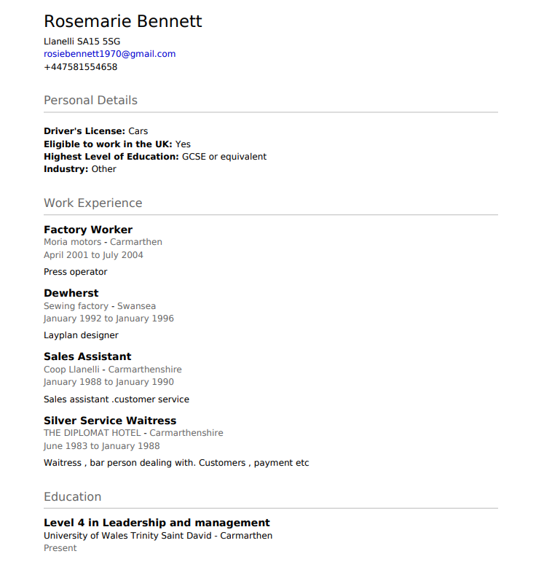
My cv.

Self-employed ironing service. Since 2023
Present employment

