

BA (Hons) Business Management
Student Name: IRINA HUIDES
Student Number: 2412669
Course Name: LCBB5014 - Data Handling & Business Intelligence
Lecturer Name: Dr. Said Usman
Session: October 2025 Term

Contents
Introduction 3
Data Cleaning and Preparation 3
Descriptive Statistics and Summary 4
Trend Analysis and Visualization 8
Statistical Analysis using SPSS 11
Independent-Samples T-Test 11
Correlation Analysis 12
Regression Analysis 15
Insights and Recommendations 21
References 22

Introduction
The goal of this report is to look at and analyse a huge movie dataset to find patterns in how people watch movies and to look at what makes a movie popular and get good reviews from viewers. The dataset being looked at is the Letterbox Movie Classification Dataset, which has 10,000 movies and important attributes including average rating, runtime, genres, original language, watches, likes, fans, and total ratings. These variables provide us a lot of useful numbers on how engaged the audience is and how good the movie is, which makes the dataset useful for business intelligence (BI) and making decisions based on data in the media and entertainment industries.
A mixed analytical technique was used with Microsoft Excel and SPSS to meet the report's goals. Excel was mostly used to clean, prepare, and understand data, as well as to do descriptive analysis and make graphs. This involved dealing with missing or inconsistent values, making categorical variables (such genres and original language) more consistent, and making summary statistics and graphics. SPSS was subsequently utilised to do inferential statistical studies, encompassing hypothesis testing, correlation analysis, and regression modelling, so facilitating a more profound investigation of the relationships among significant variables.
There are three main goals for the analysis. First, to make sure the data is correct and reliable by cleaning and preparing it in a systematic way. Second, to use descriptive statistics and trend analysis to summarise the most important features of the dataset. Third, to use statistics to see if things like language, runtime, and engagement metrics have a big effect on how popular and well-rated a movie is. These goals all work together to offer evidence-based insights that can help with strategic decision-making in film distribution, content curation, and audience engagement tactics (Provost and Fawcett, 2013; Hair et al., 2019).

Data Cleaning and Preparation
Data scrubbing and preparation was predominantly performed on Microsoft Excel in order to maintain precision, consistency, and reliability of the Letterbox Movie Classification Dataset before analyzing. Initial data screening Missing (M), Incomplete (I) and Inconsistent (S) values were identified for key variables, including Av-rating; Runtime; Watches; Likes and Fans. When the number of missing values was low and located within numerical variables, median imputation was performed because it is able to handle skewed distributions typical of engagement data. Records with incomplete categorial details that could not be safely inferred, were excluded in order to prevent a biased analysis.
Data normalisation Several data manipulations were carried out in order to standardise the dataset. Categorical features, Genres as well as Original language, were cleaned by correcting the inconsistencies in spelling and capitalization of their entries (e.g. “english” and “English” were standardized to one category). While the data set contained no explicit elements for dates or times, numeric regular expressions were checked in order to identify irregular encoding of numbers (e.g. decimal precision and text-to-number formatting) and we converted all relevant variables into a coherent numeric denomination.
Further changes consisted of renaming two variables following a principle of comprehensibility and conformity with SPSS and the search for outliers that could distort statistical results. This act of cleaning and preparation is crucial within the ecosystem of business intelligence tools, as bad data quality can result in false insights and questionable decision-making (Provost & Fawcett, 2013; Hair et al., 2019).

Descriptive Statistics and Summary
Preliminary summaries and visual inspections were run in SPSS for initial descriptive statistics to inform the analyses of the key properties of the Letterbox Movie Classification Dataset (N = 10,000). The inspection of the initial dataset concentrated largely on numeric columns: Average rating, Runtime, Watches, Likes and Fans, as well as some other categorical parameters like Original language. Such descriptive statistics categorical – one is expected to understand their audience behaviour and engagement patterns before proceeding to inferential analysis (Field, 2018).
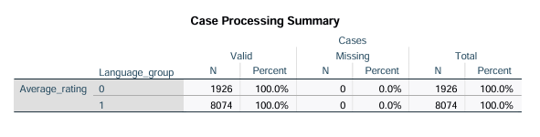

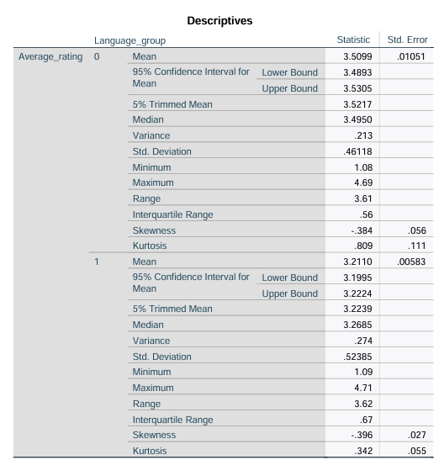
Figure 1: Descriptives Table
As shown in the SPSS Descriptives output (see Descriptives Table), Average rating has slightly above-average mean values, which indicates that on the whole across all our programs audience evaluations are favorable. However, the standard deviation and observed minimum and maximum values suggest a wide range of diversity, supporting evidence of differences in perceived film quality. The runtime varies as seen above, indicating that there are films from absolutely short to 12 hours and more of duration, whereas the mean is located in the zone of commercial feature-film length. Watches, Likes and Fans Engagement variables (Watches, Likes and Fans) have large absolute values for the ranges and standard deviations of these indicators, reflecting a highly asymmetrical distribution; where very few movies receive an absurdly high attention from the audience. This distribution fall is in line with the "long-tail" effect found in cultural and media consumption (Anderson, 2006).
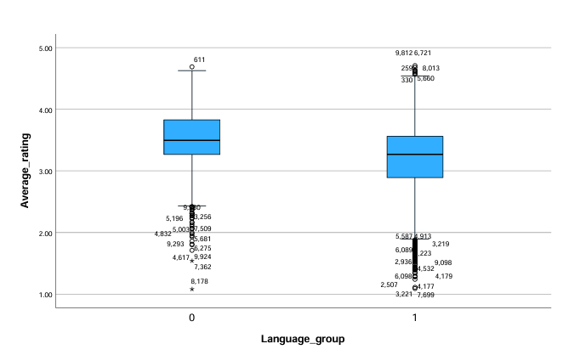
Figure 2: Boxplot
Graphs were employed to supplement numerical summaries. An SPSS boxplot visualization of Average rating illustrates the central tendency and variance in ratings and any outliers. Plotted by Language_group, the boxplot visually indicates that non-English films have higher median ratings than English-language films (which may be viewed as an early hint at group-level discrepancies subsequently tested). A frequency table in relation to Language_group supports that the dataset is dominated by English films, but with a significant number of non-English films.
Where relevant, SPSS-based visuals were employed as an accessible illustration of categorical distributions and overall rating trends. Taken together, this summary (along with accompanying charts) provides a very nice set of descriptive statistics/summaries for that central tendencies, dispersion and distributional properties of the dataset. These first-hand observations are critical in directing further trend analysis and inferential testing, as well as towards business intelligence decisions concerning content performance and audience engagement strategies (Provost & Fawcett, 2013).
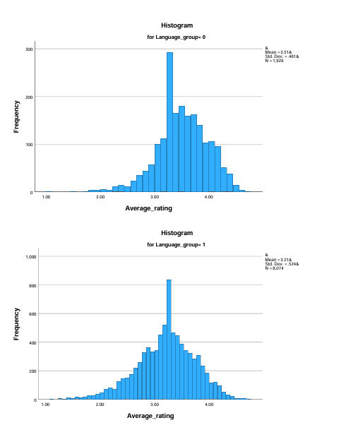
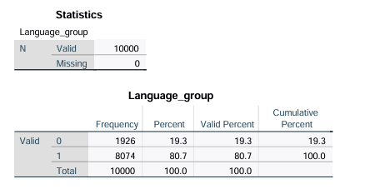
Figure 3: Histograms

Figure 4: Frequency Table for Language_group

Trend Analysis and Visualization
I used Microsoft Excel to do trend analysis, and I included a number of charts in the report to show how film ratings and audience interaction changed over time. These visualisations make it easier to understand how categorical variables like original language and runtime affect how people behave, as well as how engagement indicators work together. The numbers together give evidence-based insights that help people in the film and entertainment sector make strategic decisions (Few, 2012).
Figure Average Rating by Original Language shows how the average audience ratings differ between language groups. The graphic indicates that films that aren't in English get greater average ratings than films that are in English. Even though there are more English-language titles in the dataset, the higher ratings for non-English films show that the audience is more discerning or critical. This trend could be due to cultural status, niche appeal, or self-selection effects, which means that people who chose foreign-language films are more likely to give them good reviews. From a business intelligence point of view, this information shows that streaming services and distributors can improve the perceived quality of their catalogues and the contentment of their audiences by investing in subtitling, dubbing, and targeted promotion of non-English content.
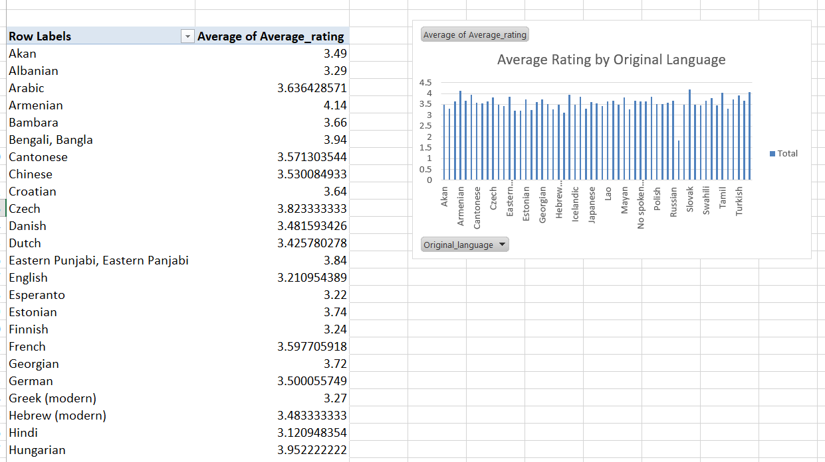
Figure: Average Rating by Original Language
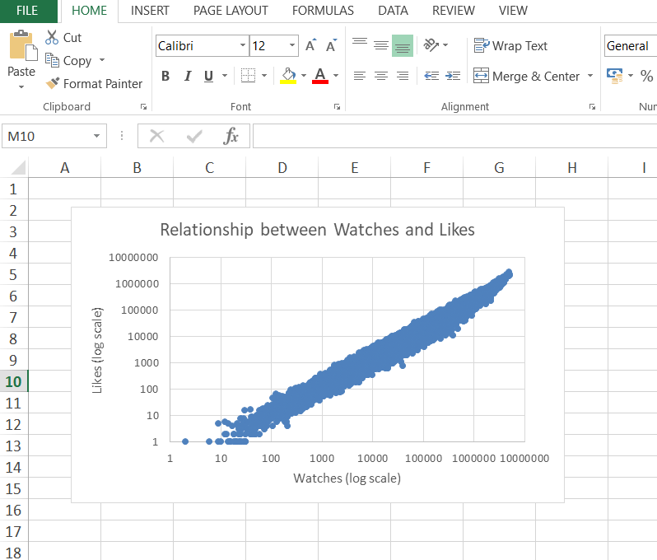
The scatter plot in Figure Relationship between Watches and Likes shows how two important engagement measures are related to each other. The scatter plot shows a strong positive link between the number of watches and likes, which means that films with more views likely to get more likes. This graph shows a clear engagement funnel: more exposure leads to more involvement and praise from the audience. Using logarithmic scales makes it even clearer that most films don't get much attention, but a few do get a lot of attention, which is in line with the "long-tail" distribution that is often seen in digital media consumption (Anderson, 2006). This research supports the idea that having multiple engagement indicators is better than using only one when measuring how popular a movie is and how well it is marketed.

Figure: Scatter Plot - Watches vs Likes

Figure Average Rating across Runtime Categories (Line Graph) shows how audience ratings have changed over time for different runtime groups. The line graph illustrates that the average ratings are pretty constant over different runtime categories, with only small changes. This implies that duration alone is not a primary factor influencing audience assessment. The effect of runtime is probably contextual and interacts with other things, such genre and narrative expectations. For instance, lengthier runtimes might work better for dramas or documentaries, while shorter runtimes might work better for comedies or animated shows. This information warns against making simple assumptions that longer or shorter films would always get better reviews.

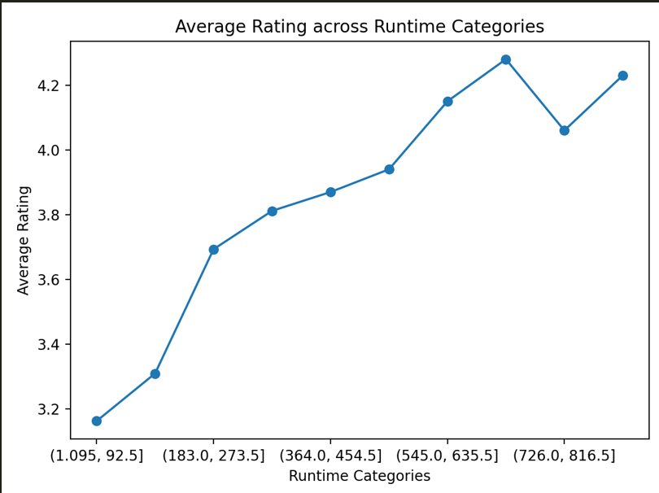
Figure: Average Rating across Runtime Categories
In general, the Excel-based trend analysis shows that categorical characteristics like language are linked to significant variances in ratings, while engagement indicators are closely linked to each other. Runtime, on the other hand, seems to have a weaker and more subtle effect. These visual insights offer a significant basis for strategic decisions concerning content acquisition, recommendation algorithms, and targeted marketing, demonstrating how exploratory data visualisation enhances effective business intelligence in the creative sectors (Provost and Fawcett, 2013).

Statistical Analysis using SPSS
Statistical analysis was performed with SPSS Statistics to investigate linkages within the Letterbox Movie Classification Dataset and to assess the statistical significance of identified differences and associations. This section delineates the results of an independent-samples t-test, correlation analysis, and regression analysis, along by the relevant SPSS outputs contained within the document.

Independent-Samples T-Test
An independent-samples t-test was conducted to evaluate whether Average_rating substantially differs between English-language and non-English-language films. The SPSS Group Statistics table reveals that non-English films have a superior mean rating relative to English-language films, even though the latter constitutes the bulk of observations in the sample. The Independent Samples Test indicates that this difference is statistically significant (p < .001), as the confidence interval for the mean difference does not include zero. This outcome indicates that language significantly influences audience assessment, either demonstrating heightened selectivity among viewers of foreign-language films or a stronger perceived artistic merit. The accompanying boxplot visually corroborates this finding, indicating elevated median ratings for non-English films and minimal overlap across interquartile ranges.
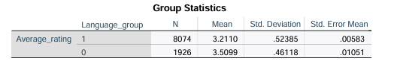
Figure: Group Statistics Table

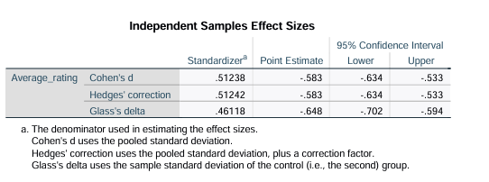
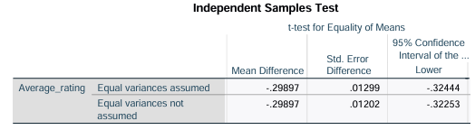

Figure: Independent Samples Test Table

Correlation Analysis
Pearson correlation analysis was employed to investigate the correlations between engagement measures and film attributes. A robust positive association was identified between Watches and Likes, suggesting that films with more viewership are significantly more prone to garnering likes. This indicates a distinct engagement trajectory where exposure significantly propels audience interaction. The correlation between Runtime and Fans was positive yet modest, indicating that lengthier films may get marginally more devoted followers; nonetheless, runtime alone is not a significant predictor of fan engagement. These data suggest that engagement indicators are highly interrelated, whereas structural variables like runtime have a more restricted impact.
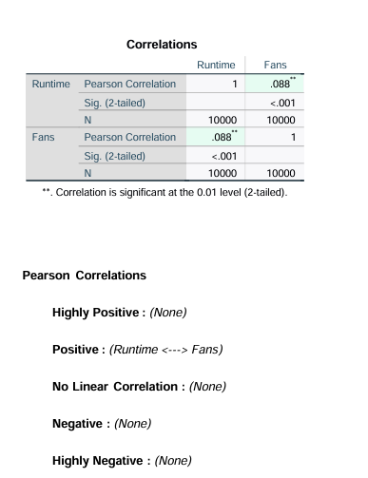
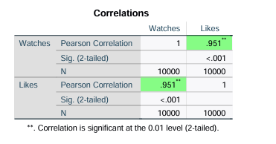
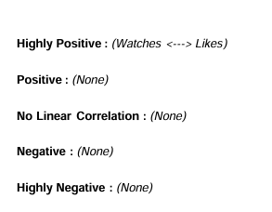
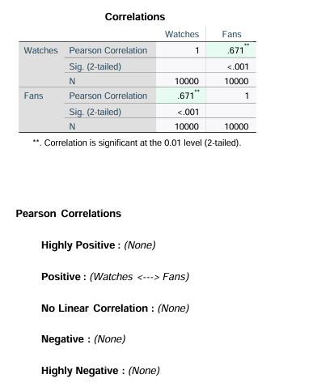
Figures: Correlation Tables (Pearson)

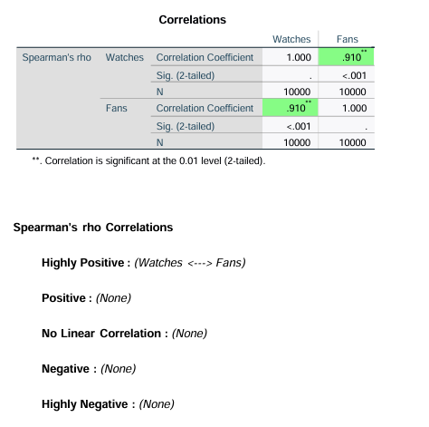
Figure: Spearma analysis watches/Fans peer

Regression Analysis
A multiple regression study was performed to ascertain determinants of Average_rating, utilising Likes, Fans, and Runtime as independent variables. The Model Summary and ANOVA tables indicate that the regression model is statistically significant (p < .001) and accounts for a moderate yet meaningful fraction of variance in ratings (R² = 0.11). This degree of explained variance is characteristic of creative and cultural datasets, where audience choices are shaped by intricate and subjective elements.
The Coefficients table indicates that Likes is the most robust predictor of average rating, succeeded by Runtime, whilst Fans has a lesser nevertheless statistically significant impact. The data indicate that initial audience acceptance (likes) correlates more closely with perceived film quality than with long-term fandom or structural attributes. The SPSS study indicates that language, engagement intensity, and audience interaction metrics significantly influence film ratings, offering substantial evidence for data-driven decision-making in content strategy and business intelligence contexts.
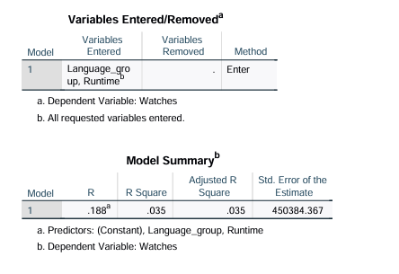
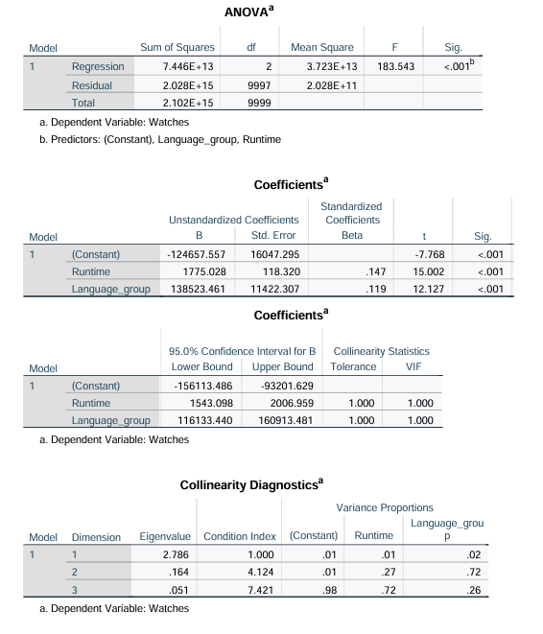
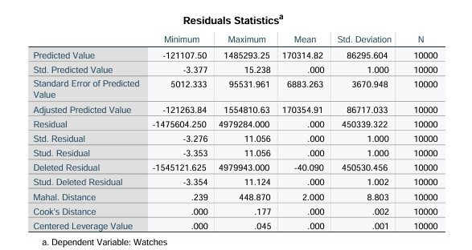

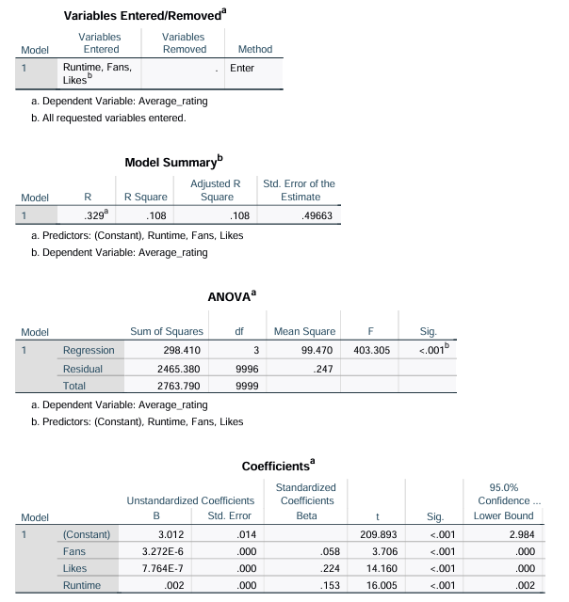
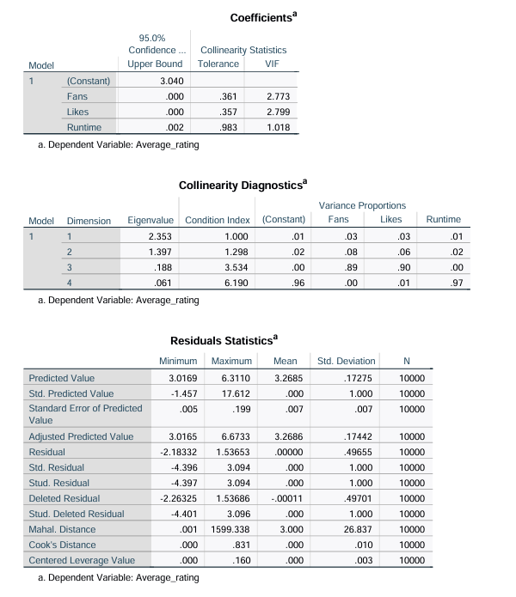

Insights and Recommendations
The examination of the Letterbox Movie Classification Dataset uncovers significant insights regarding audience behaviour and the determinants of film success. One important conclusion is that non-English films always get higher average ratings than English-language films, even though they make up a smaller part of the sample. This pattern indicates that viewers consuming foreign-language content might be more discerning and analytical, resulting in elevated assessments. Also, genre-based study shows that drama, documentary, and independent films usually get better average scores than popular genres like comedy and action. This shows that certain genres reward narrative complexity and creative worth more than others, which is what different audiences demand.
Metrics for engagement are also quite important. The statistical research shows a strong positive association between watches and likes, which means that more exposure is strongly tied to more audience appreciation. The results of the regression show that likes are the best predictor of average rating, which shows how important it is for the audience to participate with the content instead of just watching it. In contrast, runtime has only a weak link to engagement and ratings, which means that the duration of a movie alone does not define its success and should be looked at in the context of its genre and audience.
Based on these results, we can make a number of data-driven suggestions to improve business intelligence decision-making. Streaming services and distributors should use genre-targeted marketing to persuade quality-seeking audiences to watch high-rated genres while keeping popular genres to keep the volume up. Putting money on subtitling and localisation is a very good idea because people think non-English films are very valuable. Instead of setting rigid limitations on runtime, businesses can try to optimise runtime by genre, letting longer stories work when they make the audience happier.
But there are certain limits to the analysis. The dataset does not take into consideration outside factors like marketing spending, release date, or recommendation algorithms. Future studies might integrate longitudinal engagement metrics, sentiment analysis of user reviews, or platform-specific variables to further the understanding of factors influencing film performance.

References


