

Research on the influence of corporate social responsibility on consumers' purchase intention

Name: Yichao Deng
Student ID: 2006819
School: UWTSD Swansea
Degree: Human resource management
Due Date: 12th May 2021
Word Count:14,161

Abstract

With the development of economic globalization, a series of social problems are gradually increasing. When people enjoy the happy life brought about by the progress of science and technology, they also need to face a series of social contradictions between inadequate development, which makes the social public's awareness of rights protection constantly strengthened when facing these adverse social problems. As a basic industry closely related to people's vital interests, automobile service industry should realize the importance of fulfilling social responsibility for the development of enterprises. Therefore, in this macro context, it is of great practical significance to explore the impact of corporate social responsibility (CSR) on consumers' purchase intention.

Based on the research of foreign scholars, this paper combs and summarizes the basic theories of corporate social responsibility, corporate reputation and consumer purchase intention. Referring to the domestic and foreign literature on the correlation between CSR and consumer purchase intention, combined with the characteristics of the automotive industry, the automotive corporate social responsibility is divided into five dimensions as predictive variables. It includes community responsibility, consumer responsibility, employee responsibility, environmental responsibility and economic responsibility. Corporate reputation is divided into cognitive and emotional dimensions as variables. This paper studies the relationship between corporate social responsibility and consumers' purchase intention. The researchers use spss21.0 statistical analysis software for correlation analysis and regression analysis, as well as the effect test of corporate reputation. The results show that the five dimensions of corporate social responsibility have a positive impact on the two dimensions of corporate reputation. Secondly, the two dimensions of corporate reputation have a positive impact on consumers' purchase intention. The impact of emotional reputation on purchase intention is greater than that of cognitive reputation. Third, the five dimensions of corporate social responsibility have a positive impact on consumer purchase intention.
Finally, according to the research conclusions of this dissertation, which provides specific guidance and suggestions for automobile enterprises to fulfill their social responsibility. This dissertation also proposes that automobile enterprises should promote social responsibility from the strategic level, the government level and the public level, integrate social responsibility into the enterprise management system and corporate culture, and enhance consumers' purchase intention by shaping a good image of the enterprise. Finally, in view of the shortcomings of this paper, the researchers also provide relevant recommendations for future research.

Acknowledgments

I would like to thank professor Caroline Jawad and lecturer Gareth Hughes for their continuous support and explanation throughout the dissertation.

Finally, I would like to thank all my families for their support and help. In the last year of the whole university, their meaning to me was the whole world. I can't fully express my grateful to the people who helped me.

Content

1. Chapter One: Introduction 5
1.1 Introduction 5
1.2 Background and Rationale 7
1.3 Aim and Objectives 8
1.3.1 Aim: 8
1.3.2 Objectives: 8
1.4 Research Structure 9
1.5 Conclusion 10
2. Chapter Two: Literature Review 10
2.1 Introduction 10
2.1.1 History Development of Corporate Social Responsibility 11
2.1.2 Measurement dimensions of social responsibility of automobile enterprises 14
2.2 Enterprise reputation 15
2.2.1 Definition of corporate reputation 15
2.2.2 Corporate reputation and CSR 16
2.3 Consumer’s purchase intention 19
2.3.1 The concept of consumer’s purchase intention 19
2.3.2 Corporate reputation and consumer purchase intention 19
2.3.3 Corporate social responsibility and consumer’s purchase intention 20
2.4 Conclusion 21
3. Chapter Three: Research Method 23
3.1 Introduction 23
3.2 Research Onion 23
3.2.1 Philosophy 25
3.2.2 Approach 25
3.2.3 Strategy 26
3.2.4 Choice 26
3.2.5 Time Horizon 27
3.2.6 Data Collection and Processes 28
3.2.6.1 Data Collection 28
3.2.6.2 Questionnaire Design and Collection 28
3.2.6.3 Pilot Study 30
3.2.6.4 Analysis 30
3.3 Sample 31
3.4 Reliability and Validity 31
3.5 Limitations 31
3.6 Ethical Considerations 32
3.7 Conclusion 32
4. Chapter Four: Data Analysis 34
4.1 Introduction 34
4.2 Data Analysis 34
4.3 Methods 34
4.4 Demographics and Descriptive Statistics 34
4.5 Regression analysis of social responsibility of automobile enterprises on consumers' purchase intention 46
4.6 Conclusion 48
5. Chapter Five: Conclusion and Recommendation 49
5.1 Introduction 49
5.3 Recommendations 51
5.4 Limitations 55
5.5 Further Research 56
5.6 The Achievement of Objectives 56
5.7 Self Reflection 58
5.8 Conclusion 59
6. Reference 62
7. Appendix 70

1. Chapter One: Introduction

1.1 Introduction

This chapter introduces the background and expounds the theoretical basis. Besides, the purpose of this study, the description and structure will also be explained.
This study aims to explore the actual impact of corporate social responsibility on consumers' purchase intention. This study will include 10 well-known international vehicle companies for analysis.
Previous studies have shown that although some practice reports related to corporate social responsibility have been published, many consumers say that they are not obviously aware of it in the actual consumption experience.(Lee and Shin, 2010) Therefore, the corporate social responsibility (CSR) of automobile enterprises may have a certain impact on consumers' purchase intention.

In fact, the practice of these CSR policies is often poor (Csillag et al., 2018; Khan et al., 2018; Meacham et al., 2019; Miethlich, 2019; Miethlich & Oldenburg, 2019) The implementation of corporate social responsibility practices in the automobile industry is influenced by the public's or consumers' views on issues of social importance (Hernandez et al., 2008). Recently, some issues in corporate social responsibility of automobile enterprises have been paid great attention, for instance, environmental responsibility (Baughn et al., 2007; Carol, 2016; Crane et al., 2019; Diekmann; Franzen, 2019; HEO and muralidharan, 2019)

This research aims to explore whether the implementation of automobile corporate social responsibility will have an impact on consumers' purchase intention, and to identify which aspects of automobile corporate social responsibility will have a greater impact on consumers' purchase intention. This study hopes to help vehicle companies in the premise of limited resources to clarify the focus of corporate social responsibility, then combined with their own actual situation to further determine the corresponding measures in business activities and improve their corporate social responsibility policy. The ultimate objective is to improve the corporate reputation, promote the purchase intention of consumers, and enhance the competitiveness of enterprises in the automobile industry.

1.2 Background and Rationale
Research shows that more and more consumers encourage and appreciate the company's public welfare activities, because these activities will make a positive contribution to the society (Lee&Lee, 2015). According to a survey by McKinsey, 89% of consumers say they are more supportive of companies that effectively maintain their obligations to stakeholders and make great efforts for the broader common interests (Ramasamy & Yeung, 2009).
As a result, corporate voluntary economic responsibility, law, and philanthropy can be regarded as corporate social responsibility activities (Carroll, 1979). In other words, commercial companies should not only make profits, but also be responsible to the company, society, environment and other stakeholders (Fatma &amp; amp; gt; Rahman, 2016) Research shows that consumers will show a positive response to companies that participate in corporate social responsibility activities (Parsa, Lord, putrevu and kreeger, 2015). Therefore, corporate social responsibility activities have a significant role in promoting corporate image and consumer purchase behavior, and can effectively improve consumers' purchase intention and the long-term performance of the company.
Although the research report shows that enterprises' active participation in social responsibility activities has a positive impact on consumers' purchase intention
(Parsa et al., 2015; Lee and Lee, 2015), Fatma and Rahman (2016). Other studies suggest that consumers are less interested in corporate social responsibility. Because they are usually more concerned about their immediate interests. Therefore, corporate social responsibility activities, relatively speaking, are not related to the company's performance (Vaaland, Heide and gr ø Nhaug, 2008). In addition, most of the empirical studies have been confirmed in the UK, Europe and other countries.
However, there is little research on Chinese consumers' response to corporate social responsibility (Lee &amp; amp; Lee, 2015). Therefore, researchers are investigating and understanding in other countries and social backgrounds, especially in China, to explore whether corporate social responsibility initiatives have an impact on consumers' purchase intention (Lee&amp; Shin, 2010).

1.3 Aim and Objectives

1.3.1 Aim:

This dissertation will explore the impact of corporate social responsibility on consumers' purchase intention, and also to analyze it from two dimensions of corporate reputation.

1.3.2 Objectives:

- To make analysis of academic literature as part of CSR theory, practice and corporate reputation from two dimensions.

2. To select a suitable research approach to explore the influence of corporate social responsibility on the consumer’s purchase intention, so as to identified the importance of businesses’ responsibilities.

3. To analyze the data collected to identify corporate social responsibility on the importance of consumer purchase intention. And compare the impact of various types of corporate responsibility.

4. To understand practical situations of the dissertation, making recommendations for enterprise to enhance consumer purchase intention..

5. To investigate and propose other possible ways for future investigation, with reference to limitations of the present dissertation.

1.4 Research Structure

This dissertation consist of five chapters. Chapter one being the introduction, chapter two will provide information about literature review, chapter three include methods and methodology, data collection and analysis will be provided in chapter four, conclusion and recommendations will be proposed in chapter five.

The first chapter introduces the background of this study. According to the background of this study, the researchers then put forward the objectives and aim of this study. This study will use the first-hand and second-hand data to explore by means of questionnaire survey and literature review.

The chapter two is the literature review of the concept of corporate social responsibility, the measurement dimension model of corporate social responsibility and corporate reputation. Literature review will help researcher to understand this topic, the problems in this field and the gaps in other academic research, so as to provide auxiliary support for the research methods discussed in Chapter 3, therefore, to solve the deficiencies and difficulties in the above contents.
Chapter three is the methodology part, which is used to determine the most suitable research methods and approaches. This is to make up for the research gaps discussed above. Then researcher can draw more rigorous conclusions by analyzing the data.

Chapter four will analyze the original data collected by the methods identified in the third chapter. The researchers will make statistical analysis on these data and put forward the survey results. This information will be used for discussion and review in the next chapter.

Chapter five will discuss and review the aims and objectives of this study. Then the main findings, recommendations and limitations of the study will be identified and proposed by the researcher. In addition, some recommendations for future research will also be provided.

1.5 Conclusion

The chapter one introduces the research, then the researchers clearly and put forward the goal and purpose of this study, and a brief overview of the ways for enterprise to enhance consumers' purchase intention. The next chapter of literature review will be proposed to make the problems discussed in the first chapter more in-depth.

2. Chapter Two: Literature Review

2.1 Introduction

The aim of chapter two is to review the current academic literature on the fulfillment of corporate social responsibility in business, with more emphasis on the research on social responsibility of the automobile industry. And this chapter will accomplish the first objective in this dissertation:

“Making a critical and objective analysis of the academic literature on China’s automobile industry as a part of corporate social responsibility.”

The literature reviews mentioned below are from Google Scholar, the UWTSD online library and EBSCO. These sources of information include previous academic journals and research. Search terms are: “automobile industry”, “consumer’s purchase intention”, “corporate social responsibility”, “enterprise” and “government”.

2.1.1 History Development of Corporate Social Responsibility

In the past few decades, the debate about the appropriate relationship between business and society has been focused on the topic of corporate social responsibility (Klonoski, 1991). For many years, the specific concept of corporate social responsibility has been vague.

Bowen pointed out that businessmen have the obligation to formulate policies and take actions in accordance with social goals and value system, which is the social responsibility of businessmen. (Bahman, Kamran and Mostafa, 2014) This concept emphasizes that the main body of corporate social responsibility is a modern large company, responsible for the implementation of corporate managers, the principle of social responsibility is voluntary. (Bowen, 1953).

Frederick believes that businessmen should regard the operation of the economic system as meeting public expectations, which means that enterprises should increase the level of economic well-being of society as a whole in the process of production and circulation.
He pointed out that corporate social responsibility represents a kind of public behavior, which uses social economic resources and human resources to achieve a wide range of social goals, rather than being limited to the interests of individuals and enterprises.
In this conclusion, Frederick emphasizes that business goals and social goals should be coordinated and unified. (Frederick, 1960)

Manne and Wallich further extend the concept of corporate social responsibility, they believe that "responsibility to a certain extent means that the enterprise is a free actor." (Bahman, Kamran and Mostafa, 2014)
They pointed out that corporate social responsibility should involve the following three steps: the first is to set goals, the second is to decide whether to meet set goals, and the third is to provide funding for selected goals. Manne and Wallich tend to give instructions to the company so that the company can better meet the interests of shareholders. (Manne and Wallich, 1972)

Bowen (1953) believed that the definition of CSR is that enterprise should proceed from a long-term scientific point of view, which can to a large extent limit the bad behavior of a series of short-term results that may be caused by enterprises and individuals for short-term profits. Applying legislation to corporate social responsibility will make it mandatory (Toal&Broome,2020).
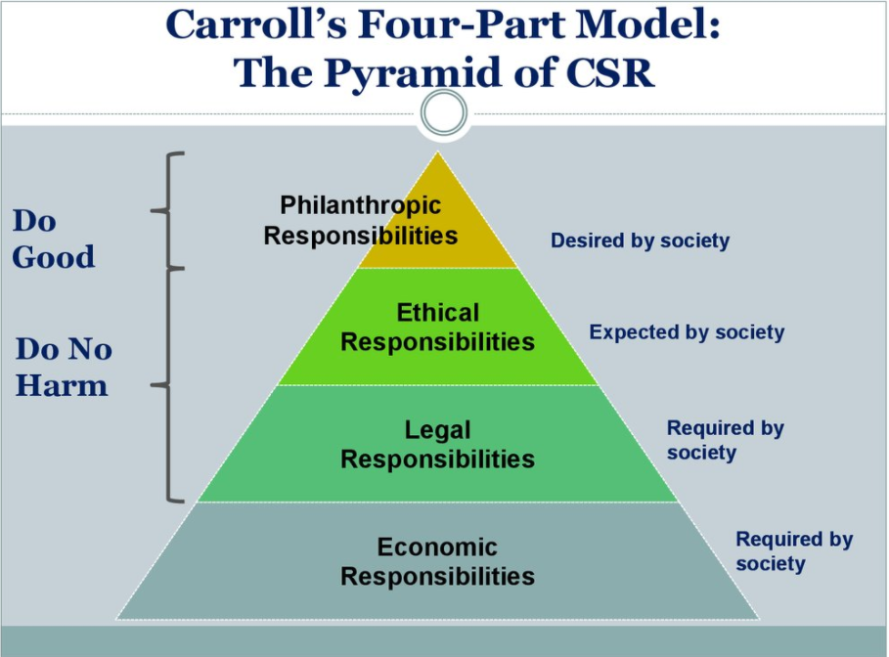
Figure 1: Carroll’s Four-Part Model: The Pyramid of CSR

According to Carroll, a professor at the university of Georgia in the United States, he believes that CSR is regarded as an obligation given to enterprises by society. Society not only requires enterprises to create economic interests, but also needs them to abide by the law, attach importance to morality and develop public welfare undertakings. (Carroll, 2014). Therefore, corporate social responsibility requires enterprises to take into account and fulfill economic responsibility, legal responsibility, ethical responsibility and charitable responsibility at the same time. (Miethlich, 2019). According to Tiezhu, Sang, he believes that corporate social responsibility means that enterprises must undertake a series of corresponding responsibilities to all stakeholders, resources, environment and society in their various activities. Meanwhile, enterprises are required to acquire the ability of sustainable development of society, economy, resources and environment while fulfilling their social responsibilities. (Sang, 2009) According to Yueming, Cui, the essence of corporate social responsibility is the enterprise’s restriction on business behavior, which requires enterprises to undertake a series of responsibilities to stakeholders, environment and society while pursuing profits, so as to promote social progress and development. (Cui, 2010)

Corporate social responsibility will bring some benefits to the enterprise. When there were many uncertainties exists a specific period, company that invested in corporate social responsibility performed better because it brought sustainability and competitive advantage. (Lins et al., 2019). Although it brings these advantages, there are still some shareholders who resist the implementation of corporate social responsibility strategy because it often conflicts with the goal of some shareholders, that is the interest of profit maximization (Wang, 2014).

2.1.2 Measurement dimensions of social responsibility of automobile enterprises

The division of corporate social responsibility by domestic and foreign scholars mainly includes Carroll's pyramid model, the concentric circle method of the U.S. Economic Development Commission, Streiner's internal and external social responsibility.

American scholar Carroll (1991) divides corporate social responsibility into economic responsibility, legal responsibility, ethical responsibility and charitable responsibility. The theory of corporate social responsibility adopted by most enterprises is based on the stakeholder theory put forward by Freeman. It is defined as that companies and managers should actually create value for customers, suppliers, employees, communities and financiers or shareholders. (Freeman,1984)
Freeman also pointed out that there are specific defects in corporate social responsibility, such as the contradiction between business and morality, because the development of business economy depends on profits, and moral constraints often consume and limit profits. (Freeman, 2009) Li Haiqin and Zhang Zigang (2010) divided corporate social responsibility into economic responsibility, legal responsibility, environmental responsibility, consumer responsibility, employee responsibility and charity responsibility according to stakeholder theory.

Automobile enterprises are constantly promoting the progress of society, while improving the convenience of people's life, they also cause a lot of consumption of resources and environmental pollution and other social problems. Therefore, while pursuing the maximization of economic benefits, automobile enterprises also need to stand in the height of automobile social industry ecological chain and strategic development to promote the realization of social responsibility.

However, there is still no clear definition for the measurement dimension of social responsibility of automobile industry. Bauner (2011), Cortez and cudia (2010) believe that policies and regulations have the greatest impact on the technological innovation of automobile enterprises, and they believe that environmental costs will affect economic profits, and automobile enterprises fulfill their social responsibilities to promote enterprise economic development. Ganescu (2012) believes that the implementation of appropriate corporate social responsibility strategy is crucial to achieve sustainable business development, and combined with the actual situation of the automotive industry, he believes that the automotive enterprises undertake the responsibility of economic, ethical and society.

2.2 Enterprise reputation

2.2.1 Definition of corporate reputation

Balmer (1998) believes that the concept of corporate reputation represents a relatively new perspective. The top management of the enterprise can solve the strategic problems of the company through this perspective. In order to guide the top management to manage the reputation and image of the organization, Balmer proposed a practical operation model. The model shows that in addition to understanding the reputation and image of the enterprise, managers also need to understand the corporate identity and Corporate Communication of the company, as well as the relationship between these factors. He believes that in the current economic environment, the ultimate survival of enterprises may depend on whether they can establish a good corporate image and reputation. Fombrun (2001) discusses the intrinsic economic value of "corporate reputation". He believes that corporate reputation is a good image for a company composed of four key resource Holders: employees, customers, investors and communities. Gotsi &amp; wlison (2001) believes that the corporate reputation of an organization will be affected by the behaviors of departments and employees of each company that contact with stakeholders.

Many scholars believe that corporate reputation can be divided into two dimensions. Liu Liang (2006) found that it is reasonable to divide corporate reputation into cognitive reputation and emotional reputation. Manfred (2004) summarized the definition of corporate reputation as that corporate reputation is mainly composed of cognitive and emotional elements. That is to say, corporate reputation is generated by stakeholders based on the comprehensive impression of emotional honor and cognitive reputation. Dividing corporate reputation into emotion and cognition can better reflect the overall situation of corporate reputation.
To sum up, researchers will cite Manfred's (2004) view of corporate reputation, that is, corporate reputation is a comprehensive evaluation of stakeholders' cognition and emotion on the past and future of an enterprise.

2.2.2 Corporate reputation and CSR

According to the definition of corporate social responsibility and corporate reputation, corporate social responsibility mainly reflects the expectations and needs of stakeholders in a particular aspect of the enterprise. Corporate reputation is a comprehensive reflection of consumers' cognition and emotion to the enterprise. There are many researches on the relationship between corporate social responsibility and corporate reputation in academic circles. Most scholars believe that the performance of corporate social responsibility will affect corporate reputation, and it is also one of the important methods to enhance corporate reputation. (Alzghoul et al., 2016)

There are many advantages in implementing CSR practices in enterprises. For example, in uncertain times companies that invest in CSR perform well as it not only brings sustainability but also to build its competitive advantage. (Lins et al., 2019) Wang (2014) emphasized the benefits of corporate social responsibility strategy for stakeholders and shareholders. Khan et al. (2018) believes that the significance of corporate social responsibility policy is to build image and improve reputation, rather than just making a commitment.

According to Fombrun & Shanley (1990), every social responsibility performed by an enterprise will have an impact on the reputation of the enterprise. Meanwhile, because different stakeholders have different expectations for the enterprise, the enterprise is required to engage in a series of different targeted social responsibility activities, such as public welfare, environmental protection and so on. Different corporate social responsibility behaviors are embodied and combined with their production process and resource status. Williams &amp; Barrett (2000) research confirmed that enterprises actively participate in charitable donation activities and environmental public welfare publicity and other social activities can enhance the reputation of enterprises. Based on the published data, Brammer &Pavelin (2004) studied the impact of corporate social responsibility on corporate reputation of 227 listed companies in various industries in the UK. The results show that corporate social responsibility of finance, resources and consumer goods industries has a significant positive impact on corporate reputation. This study confirms that different corporate social responsibilities have different impacts on corporate reputation. Yoon (2006) believes that when consumers can truly feel that the motivation of the enterprise is sincere, then the enterprise's behavior of actively fulfilling social responsibility will improve the corporate reputation. Castaldo (2008) believes that enterprises can enhance their reputation by fulfilling their social responsibilities, so as to gain competitive advantage.

The behavior of enterprises to participate in corporate social responsibility activities in a strategic way can be examined from the perspective of resource-based enterprise view (RBV). The RBV proposed by Wernerfelt (1984) and improved by Barney (1991) draws on the early research results of Penrose (1959). This theory assumes that enterprises are the aggregation of heterogeneous resources and capabilities, and the liquidity among enterprises is incomplete. Barney (1991) believes that if these resources and capabilities are valuable, rare, non imitative and irreplaceable, they can form the source of sustainable competitive advantage.

The first theoretical paper applying RBV framework to corporate social responsibility is Hart (1995), who focuses on environmental social responsibility. Hart believes that for some types of enterprises, environmental social responsibility can constitute a kind of resource or ability, which can bring sustainable competitive advantage.
Russo and Fouts (1997) empirically tested this theory by using the data of corporate social responsibility environment and accounting profitability, and found that those enterprises with higher environmental performance have better financial performance.

Based on RBV framework, McWilliams and Siegel (2001) put forward a more formal "profit maximization" model theory of corporate social responsibility. In this model, two companies produce the same product, but one company adds an additional "social" attribute or feature to the product, which is highly valued by some consumers or other potential stakeholders. In this model, managers perform cost / benefit analysis to determine the level of resources used for CSR activities / attributes. They assessed the specific needs of CSR and the specific costs of meeting them.

2.3 Consumer’s purchase intention

2.3.1 The concept of consumer’s purchase intention

Purchase intention belongs to the category of consumer behaviour theory. Philip Kotler (2016) believes that purchase intention refers to people's subjective tendency in the process of purchasing products or services to meet certain needs or desires. According to Schiffma (2000), purchase intention refers that that consumers are willing to purchase a certain goods or service. Spears Singh (2004) believes that consumers' purchase intention is a series of psychological activities in the process of purchasing products or services, including the role of external factors. Mullet (1985) believes that consumers' purchase intention can be identified as their own tendency to select the specific product, and it is also an essential symbol to predict consumer behaviour.
Zeithaml (1988) believes that perceived quality is consumers' overall value judgment of an entity, which is different from objective quality. It is an attitude towards expectation and performance. Šontaitė-Petkevičienė (2015) perceived quality and service quality will affect consumers' perceived value and purchase intention.

2.3.2 Corporate reputation and consumer purchase intention

Through the analysis of relevant literature, it can be found that corporate social responsibility can not only have a direct influence on consume purchase intention, but also have an indirect impact on it through corporate reputation, corporate image and so on. As the improvement of living standards, consumers will not only pay attention to the basic needs of product price and quality, but also pay attention to the enterprise behavior behind the product. For example: whether the enterprise actively fulfills its social responsibility and whether it has a good reputation and image. Grewal (1998) believes that corporate reputation is positively correlated with purchase intention. Kotler (2005) believes that enterprises actively donate to charity activities, carry out environmental protection and public welfare publicity activities can effectively enhance the image of enterprises in the public field of vision, and then promote the purchase intention of consumers. Asshidin (2016) research results show that perceived quality and emotional value have moderate positive relationship with purchase intention. According to Lu & Chang (2014), when an enterprise has a good reputation, consumers have a very positive attitude towards purchasing its products, and it can also improve consumers' purchase intention.

2.3.3 Corporate social responsibility and consumer’s purchase intention

Sen & Bhattacharya (2001) considered that corporate social responsibility has a direct impact on consumer evaluation, and divided consumers' social responsibility into different levels. Compared with enterprises which have well reputation, consumers are more vulnerable to negative social responsibility information. The results show that consumers' evaluation of products or services is significantly affected by corporate social responsibility, and this effect is also moderated by consumers' support for social responsibility activities. If consumers recognize the enterprise behavior, it will produce support behavior for the enterprise's products or services. According to Lee (2010), he believes that corporate social responsibility and community contribution have an impact on consumers' purchase intention, but environmental protection factors have no impact on consumers purchase intention. Lee believed that (2015), the two basic responsibilities of enterprise to economy and law have a direct impact on purchase intention. Among them, moral responsibility has little influence on purchase intention.

2.4 Conclusion

This chapter achieved the first objective:

“To analyse a series of academic literature on the impact of corporate social responsibility on consumers' purchase intention”

The literature review revealed that, CSR can be evaluated as a special asset because it invisibly helps the company improve its brand value and improve its overall reputation and image in terms of quality, basic functions or resource use. (McWilliams, 2010)
McWilliams also claims that many automobile companies are now committed to understanding and developing how to create and efficiently obtain value in the following ways, which is reflected in the strategic inclusion of corporate social responsibility (Baron, 2001) It is called strategic corporate social responsibility. (Werther and Chandler, 2006)

At present, vehicle manufacturers are actively identifying and recognizing the specific needs of strategic corporate social responsibility (CSR), as these requirements will trigger competitive advantage and help companies create long-term brand value in the future.
The eco-friendly automobile industry has entered the era of strategic corporate social responsibility competition. Hart claims that environmental social responsibility has gradually reached a consensus in the automobile industry, which will eventually lead to sustainable competitive advantage. (Hart, 1995) In recent years, the literature on corporate social responsibility related to innovation has gradually expanded its background and introduced the new term "corporate social innovation". (Kanter, 1999)

The appropriate research methods and methodology will be identified in the next chapter to address the issues discussed in this chapter.

3. Chapter Three: Research Method

3.1 Introduction

The first objective has been achieved in the previous chapter, which elaborates on the importance of corporate social responsibility in the automotive industry.
However, there is a lack of research on the relationship between the automobile industry and corporate social responsibility.

Then, the following chapter will introduce the research method which used in this paper and aims to achieve the second objective:

“Through the selection of appropriate research method, to identify the importance of automotive corporate social responsibility to society, as well as explore the point of view of the importance of environmental responsibility of relevant enterprise.”

The research onion developed by Saunders et al. (2016) can make this investigation process achieve the second objective logically. In addition, effectiveness, reliability, limitations and other issues will also be fully considered.

3.2 Research Onion

Research is usually regarded as a systematic process, and researchers strengthen cognition by studying the nature of phenomena. (Collis & Hussey, 2013; Saunders et al., 2009).

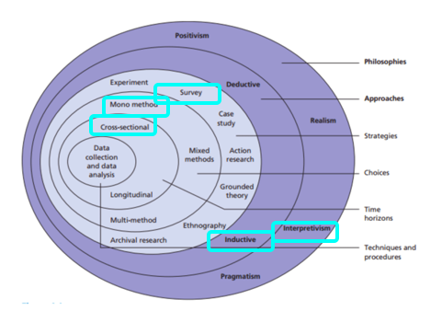
Figure 2: The Research Onion (Saunders et al., 2016)

Collis and Hussey (2013) and Saunders et al. (2009) pointed out that exploratory research can help researchers establish an understanding of the problems that need to be further explore due to the lack of previous research, and provide more valuable support for further investigation and analysis.

Descriptive research is a research method in basic research, which aims to accurately describe a topic or a phenomenon under study. (Collis & Hussey, 2013; Saunders et al., 2009).
Gliner and George state that the scientific research paradigm is a way of research or the process and implementation method of thinking. It is not a methodology, but a philosophy that provides a research process. (Gliner and George, 2016)

3.2.1 Philosophy

Research philosophy mainly explores the source, nature and development of knowledge. In short, it is an idea of how effectively the data of a phenomenon should be collected, analyzed and used in an appropriate way. (Bajpai, 2011)

In essence, this part can be seen as expounding in the paper that research philosophy involves awareness and elaboration of researchers' beliefs and hypotheses. （Saunders, Lewis & Thornhill, 2012)

The choice of specific research ideas will also be affected by some practical significance factors.
For example, there are important philosophical differences between research that pays attention to facts and figures and qualitative research. (Johnson & Clark, 2006) This research uses positivist because the objectives of this paper are to identify and analyze these objective elements and causes, and it based on a large amount of quantitative data support. Positivists prefer to collect objective data that can be observed and look for regularity and causality in the collected data to create systematic generalizations. (Saunders, Lewi, & Thornhill, 2009)

3.2.2 Approach

Deductive approach means that one or more hypotheses are put forward on the basis of existing theories, and then formulates the research approach to test it (Silverman, 2013). For research projects, the researchers focus on whether the observed phenomena are in line with expectations, and this method is the most suitable to guide this research. (Wiles et al., 2011).
Therefore, deductive methods may be considered particularly suitable for positivist approach, as the process is to make assumptions first and then statistically test the expected results to reach an acceptable level (Snieder&Larner, 2009)

3.2.3 Strategy

The method of data collection and analysis process depends on the specific situation (Brightman, 2012). This study will use the questionnaire survey method to investigate and analyze the actual situation of social responsibility of automobile enterprises, and provide a large number of relevant quantitative indicators to specify the impact of social responsibility of automobile enterprises on consumers' purchasing intention, which can greatly improve the authenticity of this study. The survey facilitates quantitative research by obtaining a large amount of data on attitudes and perceptions towards a phenomenon (Glasgow, 2005). At this stage, the overall reliability and validity of the mature survey project will make a significant contribution to the survey results (Sanders et al., 2007)

The survey conducted by the researchers in the form of questionnaire was created on the Internet. A link is created to participants direct access to it. It is then showed online on the social media platform which is called Wechat, as it is the most common and frequently used social platform in China, which can provide convenience for investigators and researchers.Then the survey were transmitted to voluntary participants via email. The questionnaire is confidential and anonymous. Participants were introduced to the study and asked to complete a questionnaire.

3.2.4 Choice

Due to mono-method research is often weak in providing comprehensive solutions to social problems, (Ojebode, and Oyedele, 2018) so this research adopts both of them. This approach which usually refers to the combination of qualitative and quantitative methods to make it more widely applicable. (Bryman, 2012). Positivist prefer quantitative indicators such as social surveys and official statistics because these methods are reliable and representative. (ReviseSociology, 2020) Quantitative method is through the collection of numerical data, used for statistical analysis, finally to explain the phenomenon or its nature. (Sukamolson, 2007). Qualitative research includes the collection and analysis of non-digital data, such as texts, to facilitate researchers to understand concepts and form opinions. (Pritha, 2020)

The positivist paradigm is regarded as a philosophical theory, and knowledge is analyzed and learned through real data, and these quantified results can be observed, measured and explained by logical analysis (positivist paradigm, 2018).

The researcher will use quantitative method in this research. Numerical data will be collected by quantitative method for statistical analysis to explore the phenomenon (Sukamolson, 2007). This makes it easier for researchers to analyze data with better reliability and accuracy.

3.2.5 Time Horizon

The time horizon refers to a time frame that contains an approximate time frame for the completion of a project plan. (Saunders et al., 2007). The cross-sectional time horizon refers to the time horizon that has been determined, and researchers must collect data at a particular point in time. (Flick, 2011). Which is the most suitable for this research. This method is suitable for the study of investigating specific phenomena. The longitudinal time for data collection refers to the repeated collection of data over a period of time, which is used to study an important factor (Goddard&Melville,2004) that changes over time.

3.2.6 Data Collection and Processes

3.2.6.1 Data Collection

Preliminary research includes direct collection of data on research issues (Hox &amp; amp; Boeije, 2005). The data will be obtained by questionnaire survey. Ghauri et al. (2020) pointed out that the drawbacks of using questionnaires, which are time cost and the way of accessing given resources. This study provides direct access to the surveyed public, and the questionnaire identifies consumers' attitudes towards corporate social responsibility of automobiles, allowing for comparison (Ghauri et al., 2020).

3.2.6.2 Questionnaire Design and Collection

According to Qingguo Ma(2002), researchers should design the questionnaire scientifically and reasonably, that is to say, to set up relevant questions in easy to understand language and avoid using professional terms, which will lead to the problem can not be understood by the respondents, thus leading to the decline of the authenticity of the questionnaire. Therefore, this questionnaire is based on the literature analysis of domestic and foreign scholars on corporate social responsibility, corporate reputation and consumer purchase intention, combined with the actual performance of corporate social responsibility of automobile enterprises, as well as the degree of familiarity and understanding of consumers.
The social responsibility of automobile enterprises is divided into five dimensions, including the responsibility of automobile enterprises to the community, the responsibility of consumers, the responsibility of employees, the responsibility of environment and the responsibility of economy. Through the above five dimensions set the corresponding questions. Corporate reputation is set from cognitive and emotional perspectives. Consumers' purchase intention is a specific issue based on their perception, understanding and familiarity with consumers. The questionnaire consists of the following four parts:

(1) Introduction. This part is mainly a brief summary of the questionnaire, and a brief description of the answering rules and confidentiality
(2) Basic information. This part mainly includes the four basic information of the respondents: gender, age, education background and monthly disposable income
(3) The Enterprises for evaluation
This research is a survey of automobile enterprises. The researchers selected ten automobile enterprises that consumers are familiar with as the evaluation objects, including: Chang'an, SAIC, GAC, Volkswagen, Dongfeng, Jiangling, FAW, JAC, great wall and BYD.
(4) The main content. This section includes 32 subjects. This questionnaire uses Likert's five scale method to score each item, 1 means "totally disagree", 5 means "totally agree". The maximum value should not be more than 5, and the minimum value should be more than 1.

This questionnaire is released through the questionnaire star survey network. The questionnaires were transfered through email and wechat. The data were collected from March 25, 2021 to April 25, 2021. A total of 460 questionnaires were distributed and 446 were returned, with a recovery rate of 96.7%.

3.2.6.3 Pilot Study

In order to help researcher better decide how best to conduct a large-scale research project, they will conduct preliminary small-scale study which is called a pilot study. (Ashley, 2019)
Researchers can identify or further refine research problems through pilot research, combine analysis to find out the best way to solve the problem, and make a comprehensive systematic assessment of the time cost and resources needed to complete a larger version of the survey.

3.2.6.4 Analysis

This paper mainly uses theoretical analysis and empirical analysis to study the impact of corporate social responsibility on consumers' purchase intention. There are three specific analysis methods:
- Literature analysis. Literature analysis is mainly to sort out and summarize the concept, relationship and measurement dimensions of corporate social responsibility, corporate reputation and consumer purchase intention, and to determine the dimensions in line with the actual situation of automobile enterprises.

- Questionnaire survey method. This paper takes the top ten auto companies that consumers know and are familiar with as the investigation background, and the existing car users and potential car buyers as the investigation subjects. Data acquisition is mainly through the investigation of consumers. The main purpose of this study is to clarify the relationship between the fulfillment of corporate social responsibility and consumers' purchase intention.

- Statistical analysis of data. The researchers used SPSS statistical analysis software for data quality analysis, exploratory factor analysis, correlation analysis and regression analysis. The values of coding and the way it is displayed can be easily identified by Likert scale questions. (Bowling, 2005).

3.3 Sample

The amount of consumers is too large, researchers used a smaller sample population (Ghauri et al., 2020). The sample can be widely representative of a part of the consumer population, in order to improve the reliability and validity of the research results (Collis &amp; amp; In order to be effective and reliable, a sample size of at least 150 respondents is required. Pearson and Mundfrom (2010) suggested that the minimum number of samples for statistical analysis should be 100, but 200 will be more suitable. The study included 440 respondents.

3.4 Reliability and Validity

Reliability is defined as the degree to which research results remain consistent over time. (Joppe, 2000) It can refer to the extent to which questionnaires, tests, observations, or other research procedures produce the same results in repeated trials.
Wainer and Braun (1998) described the validity in quantitative studies as "construct validity". It is the initial concept or assumption used to determine what data to collect and how to collect it.

3.5 Limitations

The identification of the influencing factors of the strategic transformation of automobile corporate social responsibility may not be comprehensive enough. (James and Judy, 2004) This study studies the driving factors and implementation basis of social responsibility in many automobile enterprises, but the identification of the driving factors is still based on the review of relevant theories, and combined with the analysis of relevant practice, it is concluded that due to the limitations of objective conditions such as COVID-19, the researchers did not carry out manager interviews or questionnaires, and the identification of driving factors may not be perfect. And there is no in-depth analysis of the importance of different drivers.

Another limitation comes from the social aspect. Because the information and content involved in the topic in this survey is very sensitive, participants will give moral answers through various trade-offs, rather than the real situation. (Andersen & Mayerl, 2019).
Therefore, researchers will select anonymous companies from multiple databases to reduce the extent to which the data is affected by other factors as much as possible.

3.6 Ethical Considerations

Ethical consideration is a major factor in the research. While ensuring that the purpose of the research is achieved, researchers transmit real information and knowledge, truth and prevent the emergence of erroneous ideas. (Priya, 2016)
The principles of ethical considerations can be concluded in the following aspects, promote authentic, original and true knowledge by avoiding error, to promote values of collaborative work and increase public accountability. (Resnik, 2011); (Smith, 2003)

This study was conducted in accordance with the ethical standards of UWTSD and approved by the research supervisor and coordinator through the ethical approval form (see Appendix 3).

3.7 Conclusion

This chapter successfully achieved the second goal of this study

"Researchers analyze the collected data through appropriate research methods to determine the impact of corporate social responsibility on consumers' purchase intention, and explore the importance of corporate reputation and image."

This chapter determines the research methods suitable for this study. Researchers choose the empirical quantitative method to collect first-hand data by issuing questionnaires, and then ensure the rationality of the research by random sampling. The next chapter will conduct in-depth analysis and Research on the collected data.

4. Chapter Four: Data Analysis

4.1 Introduction

The approaches and methodology of this research have been identified in the previous chapter. This chapter aims to achieve the third objective.

“Researchers will explore whether corporate social responsibility has an impact on consumers' purchase intention from multiple dimensions”

Firstly, this chapter will present the data collected, then the researcher will analyze the collected data by SPSS to explore the correlation between corporate social responsibility and consumer purchase intention. In addition, the relevant quantitative indicators are also displayed through tables to compare and analyze the specific content of automobile industry’s CSR, so as to further enhance the reliability of analysis result.

4.2 Data Analysis

Data analysis includes the process of collecting, modelling and analyzing data to provide support decision information. (Morton el al., 2014) The data was analyzed using the Excel software and SPSS. Descriptive statistics are provided by identification.

4.3 Methods

Participants were classified by gender and age, and any significant differences in their views were investigated.

4.4 Demographics and Descriptive Statistics

4.4.1 Descriptive statistical analysis of samples

According to the figure 3. There are 217 males and 223 females in the sample. The proportion of women is 50.7% and that of men is 49.3%. The difference between men and women is small, so the survey results will not affected by gender characteristics .

Secondly, among the respondents, 170 people aged 18-25, accounting for 38.6%, 177 people aged 26-30, accounting for 40.3%, and 93 people aged 31-50, accounting for 21.1%.College students are the main subjects of the survey. They belong to a large group of potential car buyers, and they have a certain understanding of the concept of corporate social responsibility reputation of automobile enterprises. They also have a better understanding of automobile brands and basic information. Taking this as the research object can effectively reduce the error.

Thirdly, according to educational background. The proportion of people with master's degree and doctor's degree is 46.6%, the proportion of people with bachelor's degree is 28.2%, and the proportion of people with college degree and below is only 25.2%. It can be seen from the distribution of educational background that 74.8% of the samples are undergraduates or above. Their logical thinking is clear and they can accurately express their views. They are representative of the research and are conducive to the researchers to draw scientific and reasonable conclusions.

Finally, it can be seen from the table that the group with income below 1500 yuan accounted for 15.21500 yuan to 2500 yuan, accounting for 21.1%, mainly college students. The proportion of 2500-5000 yuan was 34.5%, mainly for those who just started their work. The proportion of the revenue more than 5000 yuan, accounted for 21.9%. This part of the population is mainly middle-aged people with rich economic conditions.

Item | Constitution | Frequency | Percentage | Cumulative percentage
Gender | Male | 217 | 49.3 | 49.3
 | Female | 223 | 50.7 | 100
 | Total | 440 | 100
Age | 18-25 | 170 | 38.6 | 38.6
 | 26-30 | 177 | 40.3 | 78.9
 | 31-40 | 63 | 14.3 | 93.2
 | 41-50 | 30 | 6.8 | 100
 | Total | 440 | 100
Education | Senior High school | 10 | 2.2 | 2.2
 | Junior college | 101 | 23 | 25.2
 | Undergraduate | 124 | 28.2 | 53.4
 | Master | 151 | 34.3 | 87.7
 | Doctor | 54 | 12.3 | 100
 | Total | 440 | 100
Monthly disposable income | Under 1500 yuan | 67 | 15.2 | 15.2
Monthly disposable income | 1500-2500 yuan | 93 | 21.2 | 36.4
 | 2500-5000 yuan | 152 | 34.5 | 70.9
 | 5000-8000 yuan | 71 | 16.1 | 87
 | Over 8000yuan | 57 | 13 | 100
 | Total | 440 | 100
Figure 3: Sample statistical analystics

4.4.2 Reliability Analysis

Reliability refers to the stability or consistency of the test results. Devellis (1911) believes that the data accounted between 0.60 and 0.65 should be discarded; the value between 0.65 and 0.70 is the minimum acceptable value; The value between 0.70 and 0.80 indicates that the reliability of the data is quite good; If the value between 0.80 and 0.90 shows that the credibility of the data is very good.

Variation | Dimension | A value | Number Total
 | Community | 0.938 | 4
Corporate  Social Responsibility | Consumer | 0.900 | 5
 | Employee | 0.901 | 5 0.876
 | Environment | 0.846 | 4
 | Economic | 0.887 | 4
Coporate  Reputation | Cognition | 0.899 | 4 0.892
 | Emotion | 0.918 | 4
Consumer Purchase  Intention | Consumer Purchase  Intention | 0.934 | 5 0.934
Figure 4: Reliability analysis results of each variable

It is obvious that, the five dimensions of corporate social responsibility include 22 measurement indicators, the two dimensions of corporate reputation include 8 measurement indicators, and the a values of the five measurement indicators of consumer purchase intention are all greater than 0.8, which indicates that the scale of these three variables has high stability and good reliability.

4.4.3 Validity Analysis

Validity is the degree of trait that the scale can measure correctly. Kmo and Bartlett were used to test whether variables were suitable for factor analysis. Kaiser (1974) thought that when kmo index value was between 0 ~ 1 or kmo < 0.50, it was not suitable for factor analysis; By contrast, if kmo > 0.8, the variables are suitable for factor analysis; When kmo > 0.90, the relationship between these variables is excellent, which is very suitable for factor analysis.

- Validity analysis of corporate social responsibility scale

KMO measure |  |  |  | 0.863
Bartlett's sphericity test |  |  | Approximate chi square | 6131.662
 |  |  | df | 231
 |  | 197 | Sig. | .000
Figure 5: Kmo and Bartlett test of corporate social responsibility scale

It can be seen from figure 5, the results of exploratory factor analysis show that the test value is 6131.662, the degree of freedom is 231, the kmo index is 0.863, which is greater than 0.80, and the sig is 0.000, which is less than 0.001. Therefore, the possibility that the correlation number of the data is the unit matrix can be ruled out, thus, factor analysis can be carried out.

Composition Initial eigenvalue Extract sum of Rotation sum of squares
squares load

Total Variance% Accumulation Total Variance% Accumulation Total Variance Accumulation


Figure 6: The total variance of corporate social responsibility interpretation

The common factors are determined according to the principle of eigenvalue greater than 1. The results in figure 6 shows that there are five factors with eigenvalues greater than 1, which are 5.502, 3.001, 2.911, 2.707 and 2.232 respectively, and the sum of eigenvalues is 16.353; The variance explained by the five factors is 25.010%, 13.640%, 13.232%, 12.307, 10.147% respectively, and the cumulative explained variance is 74.336%, which has reached the standard of 60%. It shows that it is appropriate to retain the five factors, and it also shows that the scale of corporate social responsibility has good explanatory ability.

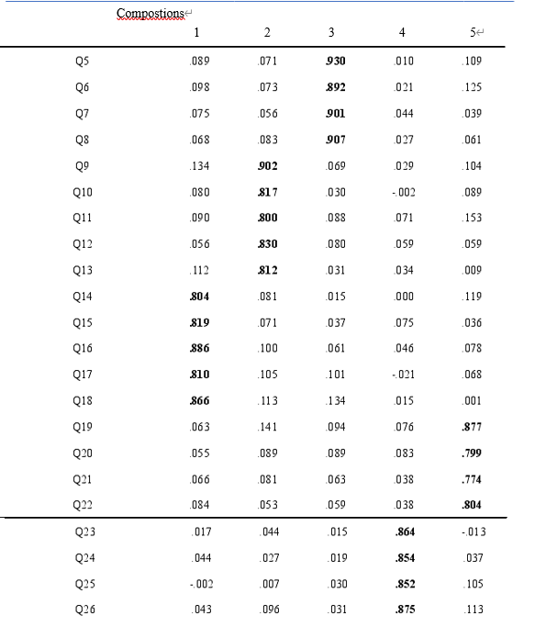Figure 7: Rotating component matrix

It can be seen from table 4.5 that the items with factor load value greater than 0.50 in the rotating component matrix are concentrated in the same latitude. Common factor one includes Q5, Q6, Q7 and Q8, common factor two includes Q9, Q10, Q11, Q12 and q13, common factor three includes q14, Q15, Q16, Q17 and Q18, common factor four includes Q19, Q20, q21 and q22, and common factor five includes q23, q24, q25 and q26. The questionnaire Q5 ~ Q5 corresponds to the topic of community responsibility, Q9 ~ q13 corresponds to the topic of consumer responsibility, q14 ~ Q18 corresponds to the topic of employee responsibility, Q19 ~ q22 corresponds to the topic of environmental responsibility, and q23 ~ q26 corresponds to the topic of economic responsibility. The five main components extracted correspond to community responsibility, consumer responsibility, employee responsibility, environmental responsibility and economic responsibility respectively, which are consistent with the theory of five dimension division of automobile corporate social responsibility in the questionnaire design mentioned above, indicating that the effect of the scale is reliable.

(2) Analysis on the validity of enterprise reputation scale

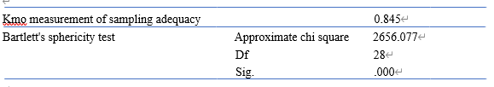Figure 8: Kmo and Bartlett test of corporate reputation scale

It can be seen from figure 8 that the approximate chi square value is 2656.077, the degree of freedom is 28, and the value of kmo is equal to 0.845, greater than 0.80. These data all show that the relationship between the item variables is good. In addition, SIG is equal to 0.000 and less than 0.01, which has passed the significance level test, so the data of enterprise reputation scale is suitable for factor analysis.

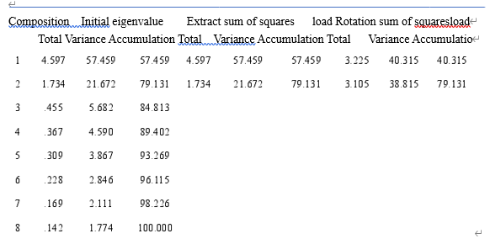
Figure 9: The explanatory total variance of corporate reputation

According to figure 9, there are two factors with eigenvalues greater than 1, which are 4.597 and 1.734 respectively, and the total eigenvalue is 6.331. The explained variance of these two factors is 57.459% and 21.672% respectively, and the combined explained variance is 79.131% and greater than 60%, which indicates that it is reasonable to retain these two factors.

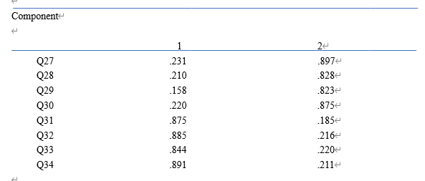
Figure 10: Rotating component matrix

From figure 10, it can be found that common factor 1 contains four topics q27, Q28, q29 and q30 respectively, and common factor 2 contains four topics Q31, q32, Q33 and q34 respectively. In the questionnaire, q27 ~ q30 correspond to cognitive reputation, Q31 ~ q34 correspond to emotional reputation. At the same time, the two factors extracted from the scale correspond to cognitive reputation and emotional reputation respectively, which is consistent with the two dimensions of corporate reputation mentioned in the previous questionnaire design, indicating that the scale is effective.

4.4 Correlation Analysis

Correlation analysis is a statistical analysis method to study the relationship between independent variables and dependent variables. The correlation coefficient is between - 1 and 1. If the correlation coefficient is greater than 0, then the two variables are positively correlated; On the contrary, if the correlation coefficient is less than 0, it means that there is a negative correlation between the two variables; The larger the absolute value of correlation coefficient, the stronger the correlation between the two variables.

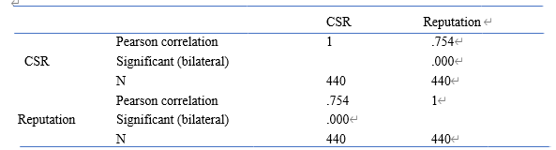
Figure 11: The correlation analysis of corporate social responsibility (CSR) and corporate reputation

It can be seen from figure 11 that the correlation coefficient between corporate social responsibility and corporate reputation is 0.754, which indicates that there is a significant positive correlation between corporate social responsibility and corporate reputation

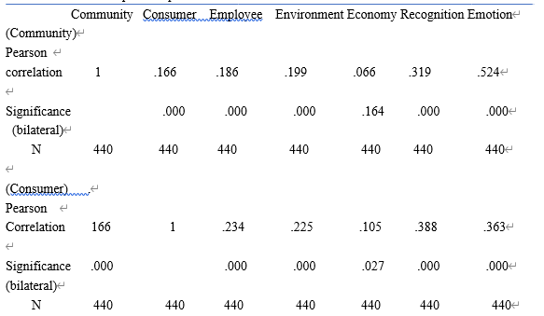

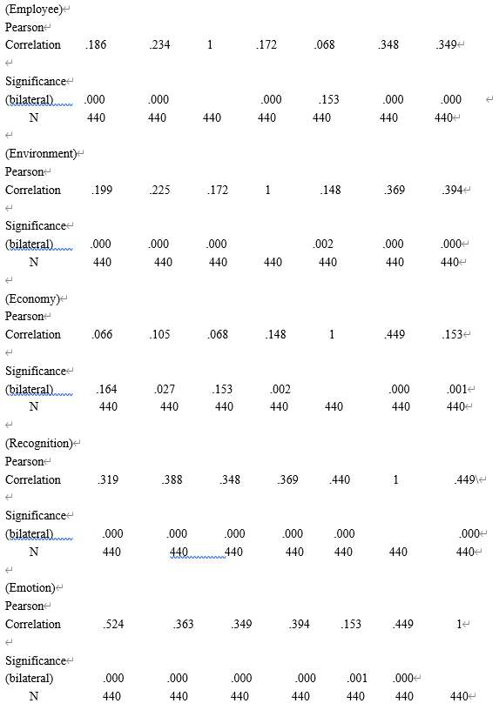
Figure 12: Correlation analysis between five dimensions of corporate social responsibility and two dimensions of corporate reputation.

According to figure 12, there is a significant positive correlation between the five dimensions of corporate social responsibility and cognitive reputation. The correlation coefficients of community responsibility, consumer responsibility, employee responsibility, environmental responsibility and economic responsibility with cognitive reputation are 0.319, 0.388, 0.348, 0.369 and 0.449 respectively. The order of the coefficients also corresponds to the correlation degree of the five dimensions of corporate social responsibility with cognitive reputation. From high to low, the order is economic responsibility, consumer responsibility and environmental responsibility, Employee responsibility and community responsibility.

There is also a positive correlation between the five factors of corporate social responsibility and emotional reputation. The correlation coefficients of community responsibility, consumer responsibility, employee responsibility, environmental responsibility and economic responsibility with emotional reputation are 0.524, 0.363, 0.349, 0.394 and 0.153 respectively. The correlation degree of social responsibility and emotional reputation of automobile enterprises is corresponding from high to low.
In addition, economic responsibility has the strongest correlation with cognitive reputation, and community responsibility has the strongest correlation with emotional reputation.
Based on the above data and analysis, the researchers believe that there is a significant correlation between the five dimensions of corporate social responsibility and the two dimensions of corporate reputation.

4.5 Regression analysis of social responsibility of automobile enterprises on consumers' purchase intention

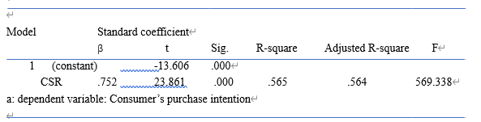
Figure 13: Regression analysis of social responsibility on consumers' purchase intention

According to figure 13 the influence of corporate social responsibility on consumers' purchase intention β coefficient is 0.752, the sig value is less than 0.001, and the revised r square is 0.564. It can be inferred that the independent variable of corporate social responsibility can explain 56.4% of the variation of consumer purchase intention variable, and the F value is 569.338.

From the above regression analysis data, the following standard regression equation is obtained: consumer purchase intention = 0.752 * corporate social responsibility. Thus, it can be concluded that corporate social responsibility has a significant positive impact on consumer purchase intention. That is to say, "corporate social responsibility has a positive effect on purchase intention."

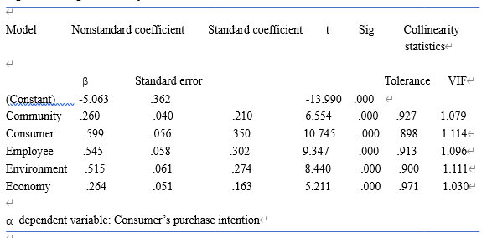
Figure 14: Regression analysis 2

It can be found that, the Vif values of the five variables are less than 10, indicating that there is no collinearity problem among the five predictive variables. Meanwhile, in terms of the non-standardized regression coefficient, the five predictive variables in the regression model are the β, the values are 0.260, 0.599, 0.545, 0.515 and 0.264 respectively. Which indicating that the five variables of community responsibility, consumer responsibility, employee responsibility, environmental responsibility and economic responsibility have positive effects on consumers' purchase intention.

Finally, the standardized regression model of automobile corporate social responsibility on consumers' purchase intention can be determined as follows:
Consumer’s purchase intention=0.210*Community responsibility+0.350*Consumer responsibility+0.302*Employee responsibility+0.274*Environment responsibility+0.163*Economy responsibility

It is obvious that, among these five factors, consumer responsibility and employee responsibility are the two independent variables that have a greater impact on the dependent variable of consumer purchase intention.

4.6 Conclusion

This chapter achieved the third objective:

“This paper analyzes the collected data. Through data analysis, researcher explore the impact of the five dimensions of corporate social responsibility on consumers' purchase intention. It can be concluded that there is a positive correlation between corporate social responsibility and consumer purchase intention”

The last chapter will achieve the final objectives of understanding implications and limitations of the research, then, recommendations will be provided by researcher, and further possibilities for future research will be analysed.

5. Chapter Five: Conclusion and Recommendation

5.1 Introduction

The previous chapter analyzes the data of this study, highlights the main findings, and achieves the third goal. This chapter will achieve the last two objectives:

“To explore the practical significance of the dissertation and put forward practical recommendations”

and,

“Referring to the limitations of current research, the possible research direction and approach in the future will also be explored and discussed.”

There will be an additional discussion section that focuses on self-reflection.

(1) Automobile enterprises' social responsibility can enhance their reputation. According to the data analysis in the fourth chapter, the social responsibility of automobile enterprises has a positive and significant effect on the corporate reputation, that is, the more responsibilities the enterprise undertakes in the five aspects of community, consumers, employees, and economy, the more favorable it will be to enhance the reputation of the enterprise and win the favor of consumers. Through the analysis of the regression coefficient, we can see that there are significant differences in the impact of the five dimensions of automobile corporate social responsibility on corporate reputation, and the impact of economic responsibility, consumer responsibility, employee responsibility, environmental responsibility and community responsibility on corporate cognitive reputation decreases in turn. The positive effects of corporate responsibility to community, environmental responsibility, consumer responsibility, employee responsibility and economic responsibility on corporate emotional reputation decrease in turn. This shows that corporate reputation, as an intangible asset of an enterprise, can create profits for the enterprise. Therefore, while pursuing the maximization of economic profits, automobile enterprises should also actively carry out activities that contribute to community public welfare and environmental protection. For example, philanthropy and providing jobs for social work. These activities will help enterprises improve their reputation and make consumers have a sense of identity with enterprises.

(2) Corporate reputation has a positive impact on consumers' purchase intention
Automobile corporate social responsibility indirectly affects consumers' purchase intention through corporate reputation. According to the regression analysis data in Chapter 4, the regression coefficient of corporate reputation on purchase intention is 0.858, that is, corporate reputation has a significant positive impact on purchase intention, and emotional reputation has a significant impact on purchase intention(β=0.595) is greater than the impact of cognitive reputation on purchase intention(β=0.565). Therefore, it also shows that good corporate reputation can enhance consumers' purchase intention of corporate products or services

(3) Automobile enterprises actively and effectively fulfill their social responsibility can enhance consumers' purchase intention
The five dimensions of automobile corporate social responsibility have a positive impact on consumers' purchase intention, but the degree of impact is different. The regression coefficient of automobile corporate social responsibility on purchase intention is 0.752, showing a positive significant impact. Among them, the standardized regression coefficients of consumer responsibility, employee responsibility, environmental responsibility, community responsibility and economic responsibility are 0.350, 0.302, 0.274, 0.210 and 0.163, respectively. Therefore, automobile enterprises' active social responsibility will transmit some information to consumers, and consumers will judge whether the enterprise is consistent with their own values according to these information. Usually, consumers will recognize the enterprises with high level of social responsibility, and choose the automobile enterprises that are consistent with their own social values, so as to enhance their sense of identity and purchase intention of the enterprise products.

5.3 Recommendations

Following the present study, a number of recommendations can be made.
Firstly, automobile enterprises can promote social responsibility from the strategic level.
The empirical study shows that corporate social responsibility has a positive direct impact on consumers' purchase intention. For automobile enterprises, they must actively respond to national policies and take responsibility for the community, consumers, employees, environment and economy to achieve sustainable development. Because the five dimensions of corporate social responsibility have an impact on consumer purchase intention, but the specific degree of impact is different. Although the direct effect of economic responsibility on purchase intention is weak, it does not mean that automobile enterprises can ignore the importance of economic responsibility, but should correctly deal with the relationship between social responsibility and financial performance and other economic indicators.

R. Edward Freeman (1984) put forward a more positive view on the support of enterprise development report based on Chester Barnard's "incentive contribution" framework (1938). According to Freeman's stakeholder theory, an enterprise must satisfy all kinds of stakeholders (such as employees, customers, suppliers, local community organizations) who can affect the company's performance. According to this view, it is not enough for managers to focus only on the needs of shareholders or company owners. This means that it is considered important and beneficial for a company to engage in some non-financial interest related activities, because without these activities, these groups may withdraw their support for the company. Donaldson and Preston (1995) further expanded the stakeholder theory by emphasizing the ethical and ethical aspects of business development reporting and the business reasons for engaging in such activities. Another view is that management theory (Donaldson and Davis, 1991) is based on the view that managers must "do the right thing" morally, regardless of how these decisions affect the financial performance of the company.

Consumers pay more attention to the social responsibility of automobile enterprises to consumers, employees, environment and community. Therefore, automobile enterprises need to reasonably plan resources to maximize the effect of fulfilling their social responsibility, and then promote the development of enterprise economy. Therefore, automobile enterprises can specify social responsibility behavior strategy, timely disclose complete automobile Corporate Social Responsibility Research Report, and actively fulfill corporate social responsibility in action.

On the other hand, automobile enterprises should integrate social responsibility into corporate culture and management system. According to the results of data analysis in Chapter 4, consumer responsibility has the greatest impact on purchase intention. Therefore, automobile enterprises should achieve the following goals in terms of consumer responsibility: put the needs of consumers first, and strive to provide consumers with safe, comfortable and reliable cars.

In terms of pre-sales experience and after-sales service, automobile enterprises should also actively respond to customers' needs and improve consumers' satisfaction; Secondly, the responsibility of employees. Automobile enterprises should always pay attention to the basic needs of employees, care for and respect the value of each employee. It is also necessary to customize career development planning and provide training opportunities for employees. This can enhance the sense of belonging of employees.

The third is environmental responsibility. With the increasing trend of global environmental pollution, automobile enterprises should abide by the national laws, regulations and policies on environmental protection, and actively formulate and carry out relevant strategies on environmental protection and energy saving. To ensure the sustainable development concept and green economy as the development direction of enterprises. The fourth is community responsibility. Automobile enterprises should widely carry out charity activities, such as actively donating funds to vulnerable groups and providing support.

Finally, in terms of economic responsibility, automobile enterprises should ensure that the rights and interests of investors and creditors are protected. By deeply standardizing and strengthening the management of automobile enterprises, and combining with the stable and orderly operation mechanism, it can bring good profit returns for shareholders and creditors.
Social responsibility should be regarded as an important part of enterprise operation system by automobile enterprises and integrated into actual production activities. Social responsibility, as the "soft power" of enterprises, should also be continuously promoted. So as to obtain more consumer recognition and support.

Even if it is not directly related to product characteristics or production process, corporate social responsibility can also be regarded as a form of establishing or maintaining reputation. The second strategic meaning of corporate perspective theory is that RBV logic can be applied to corporate social responsibility, that is, it can generate a set of predictions about corporate and inter industry corporate social responsibility investment model. For example, we expect to observe a positive correlation between corporate social responsibility and R &amp; D and advertising (McWilliams and Siegel, 2000). In the context of corporate social responsibility, when consumers clearly realize that products with corporate social responsibility characteristics are better than products without such characteristics, this special type of differentiation can strengthen or maintain the company's reputation, This not only enables the company to meet the specific market demand, but also increases its own brand value (Fombrun and Shanley, 1990).

5.4 Limitations

This report has some limitations in methodology. Price and murnan (2004) pointed out the importance of reporting limitations, which is a systematic bias that has a negative impact on the results. Due to the domestic research on corporate social responsibility of the automotive industry is still in the exploratory stage, there are few references, and limited by time and cost, there are still some deficiencies in this study. As the strong professional characteristics of the automotive industry, this study takes the automotive industry as the background for analysis, but the industry differences of corporate social responsibility are large, and the conclusions may only represent the influence relationship between corporate social responsibility and consumer purchase intention.

Secondly, the limitations of sample selection. Due to the limitation of time, human resources and other resources, the accuracy and preciseness of the research results are affected.

Since the study was conducted during the covid-19 pandemic, the researchers were unable to collect data using a comprehensive method as planned. The data collected are mainly from the first-hand data of the questionnaire survey. In essence, due to the lack of official data support from some auto companies, the depth of research results may be reduced. Sen Crowe et al. (2020) recently reviewed the impact of covid-19 and admitted that there is no normal life and face-to-face meeting

This study mainly selected a part of the people near the University parking lot as the survey object. Whether it will become the representative of the main consumer groups of automobile enterprises remains to be studied and confirmed.

Finally, in the analysis of automobile corporate social responsibility, if we can use the empirical research method for large sample test and obtain the data support of automobile corporate social responsibility report, the accuracy and preciseness of the analysis results will be improved.

5.5 Further Research

This will be helpful for future research to use hybrid analysis mechanism by combining qualitative data with interview form. This will provide a more diversified and detailed insight into why corporate social responsibility affects consumers' purchase intention and the importance of corporate social responsibility to corporate reputation. This may play a crucial role in helping managers formulate future recommendations to support the strategic priorities of corporate social responsibility.

On the other hand, corporate social responsibility in this study is divided into five dimensions: business to community, consumers, employees, environment, economy (shareholders), to explore the impact of corporate social responsibility on consumers' purchase intention. It is suggested that in the future research, we can choose the legal responsibility of corporate social responsibility or the responsibility of suppliers and other partners for further research.

5.6 The Achievement of Objectives

This research has completed the following objectives:

1. To critically analyse academic literature on the development of CSR theory, identify the measurement dimensions of CSR of automobile enterprises.

This was achieved through the in-depth understanding of the literature review, focusing on the previous research on the practice of corporate social responsibility. That is to understand the actual development of corporate social responsibility. The purpose of this study is to investigate the impact of corporate social responsibility on consumer purchase intention, which is often ignored in previous literature.

2 The researchers choose the appropriate research methods to explore whether corporate social responsibility will affect consumers' purchase intention, and determine which social responsibility factors have a greater impact
This was done using the onion study (Saunders et al., 2016). As an exploratory way of research, researchers also use the method of hermeneutics. Because of the impact of covid-19 on life, researchers used quantitative research methods to collect data. A questionnaire is compiled to explore whether corporate social responsibility has an impact on consumers' purchase intention, and it includes the analysis process of two dimensions of corporate reputation.

- The collected data were analyzed by researchers to explore the actual impact of corporate social responsibility on consumers' purchase intention, and determine which social responsibility factors account for the largest proportion.

This is accomplished by spss 26.0 software. The correlation test and chi square test are used to further analyze the relationship between corporate social responsibility and consumer purchase intention. According to the survey results, corporate social responsibility has a significant impact on consumers' purchase intention to a large extent, and its relationship is determined to be positive. In addition, there is a direct positive correlation between corporate reputation and consumers' purchase intention

4. To identify practical implications of the dissertation, recommendations will be provided for practice.

This is accomplished by considering the practical problems analyzed in this study. On the basis of previous studies, this study further illustrates that the performance of corporate social responsibility often has a positive correlation with consumers' purchase intention. It is also important that corporate reputation should be valued and emphasized by enterprises. This study further proves that those enterprises with good reputation tend to be better in performance.

5. To provide possible approaches for the following investigation in the future, with reference to limitations of this research.

Researchers not only analyze the limitations of current research, but also consider how to improve it to ensure that future research can be better completed. The limitations of this study are mainly reflected in the convenience of the use of samples and the limitations of covid-19. Researchers believe that more representative samples may be obtained for future research. In addition, qualitative research methods can also be used to obtain more in-depth and rigorous views on the impact of corporate social responsibility on consumers' purchase intention

5.7 Self Reflection

This study aims to explore the impact of corporate social responsibility on consumers' purchase intention, especially the fulfillment of corporate social responsibility and corporate reputation. Because of the lack of research in this area, this may affect the rigor of this study.
The researcher is interested in the social responsibility of automobile enterprises and has studied various courses of human resource management and finance.

The researchers developed and used new skills of Excel tabulation and SPSS data analysis, and demonstrated the ability to work and learn independently. This is especially true given the limitations of covid-19, as face-to-face communication with university lecturers has stopped. Considering the continuous changes and interruptions caused by covid-19, it is sometimes very challenging to complete some of the contents of this article, such as the limitation of working hours. Although these are overcome through creative thinking and flexibility. At the same time, it is also very challenging to collect data related to corporate social responsibility by questionnaire survey. With good time management skills and sense of responsibility, researchers have successfully achieved this goal.

It is also of great significance to understand and study the existing problems of automobile corporate social responsibility. Researchers hope that with the improvement of consumers' awareness and attention in this field, these suggestions and future suggestions can be implemented, so as to improve the awareness and behavior of automobile enterprises to fulfill their social responsibility. To create a better product and consumption environment for its stakeholders.

5.8 Conclusion

This chapter achieved the fourth and fifth objectives:

"Understand the practical significance of the research and put forward practical suggestions."
and,
"Referring to the limitations of current research, the possible research approaches in the future are explored."

This study also successfully achieved the original purpose. The first chapter introduces the purpose and purpose of this study, which provides a theoretical basis for this study. The second chapter realizes the first goal, reviews the relevant literature, points out the necessity of the research on the performance of the automobile enterprise social responsibility, and divides the CSR into five dimensions for discussion. The third chapter realizes the second goal and determines the corresponding research methods. This is an interpretative quantitative method. The researchers collect the first-hand data related to corporate social responsibility through questionnaire survey. Chapter four realizes the third goal, and analyzes the data collected successfully, and discusses and explores the direct relationship between corporate social responsibility and consumers' purchasing intention. Chapter five realizes the fourth and fifth goals, and successfully realizes the concrete manifestation of the influence of social responsibility of automobile enterprises on consumers' purchasing intention. The significance, suggestions, limitations and future research directions of this study are discussed. This study emphasizes the particularity of the evaluation system of social responsibility of automobile enterprises.

This study aims to explore the impact of social responsibility of automobile enterprises on consumers' purchasing intention, and to compare and analyze some samples of consumers. This research has successfully achieved this goal, and found that fulfilling the corporate social responsibility is necessary for the automobile enterprises to achieve the long-term sustainable development strategy and provide improvement suggestions.

Although the concept of corporate social responsibility (CSR) has been advocated for decades and is commonly employed by corporations globally, agreement on how CSR should be defined and implemented remains a contentious debate amongst academia, businesses and society. This gap is problematic for corporations because they are increasingly being required to align with societal norms while generating financial returns. In order to remedy this problem, the following definition is presented: corporate social responsibility is a business system that enables the production and distribution of wealth for the betterment of its stakeholders through the implementation and integration of ethical systems and sustainable management practices.
Many of the concepts in the proposed definition are commonplace amongst CSR practitioners and organizations, the validations for the key segments – production and distribution of wealth, stakeholder management, ethical systems, sustainable management practices – coupled with the application of a systems approach and other business practices make the definition unique and conclusive. An in depth review of the definition and supporting concepts will provide the needed vision and knowledge to enable corporations to successfully manage CSR strategies.

6. Reference

- M. Quazi, (2003) “Identifying the determinants of corporate managers perceived social obligations,” Management Decision, vol. 41, no. 9, pp. 822-831.

- McWilliams and D. Siegel, (2010) “Creating and capturing value: Strategic corporate social responsibility resource-based theory, and sustainable competitive advantage,” Journal of Management, Special Issue: Twenty Years of Resource-Based Theory.

Alzghoul, A., Elrehail, H., Saydam, P., Alnajdawi, S. and AlArarah, K., 2016. The impact of corporate social responsibility on corporate reputation using Marketing as Moderate variable. International Journal of Online Marketing Research, 2(1), p.1.

Andersen, H. and Mayerl, J. (2019) Responding to Socially Desirable and Undesirable Topics: Different Types of Response Behaviour?. Methods, data, analyses: a journal for quantitative methods and survey methodology (mda), 13(1), pp.7-35.

Ashley, C. (2019). Pilot Study In Research. [online] Available at: https://www.thoughtco.com/pilot-study-3026449 [Accessed 24 February 2021].

Bajpai, N. (2011) “Business Research Methods” Pearson Education India
Bond, J. T., Galinsky, E., Swinberg, J. (1998) National Study of the Changing Workforce. New York: Families and Work Institute.

Bowen, HR. (1953) Social responsibilities of the businessman, New York: Harper & Row.

Bryman, A. (2012) Social research methods (5th ed.). Oxford: Oxford University Press.

Carroll, A.B. (1979). “A Three-Dimensional Conceptual Model of Corporate Performance.” Academy of Management Review 4(4): 497-505.

Carroll, A.B. and Buchholtz, A.K. (2014) Business and society: Ethics, sustainability, and stakeholder management. Nelson Education.

Carroll, Archie B, Buchholtz. (2000) Business and Society: Ethics and Stakeholder Management, Cincinati, South-Western Collage Publishing:135-139.

Clarkson, M.A (1994). Risk-based model of stakeholder theory. Proeceding of the Toronto Conference on Stakeholder Theory. Center for Corporate Social Performance and Ethics, University of Toronto, Canada.

Collis, J. and Hussey, R. (2013) Business research: A practical guide for undergraduate and postgraduate students. England: Palgrave Macmillan Higher Education.

D. Baron, (2001) “Private politics, corporate social responsibility and integrated strategy,” Journal of Economics and Management Strategy, vol. 10, pp. 7-45.

D. L. Swanson, (2008) “Top managers as drivers for corporate social responsibility,” in The Oxford Handbook of Corporate Social Responsibility, A. Crane et al., Eds. Oxford University Press,Norfolk, pp. 227-248

Davis, K. (1967) "Understanding the Social Responsibility Puzzle: What Does the Businessman Owe to Society?" Business Horizons 10(4) (Winter): 45-50.

Dosi G. (1982) Technological paradigms and technological trajectories – a suggested interpretation of determinants and directions of technological change. Research Policy, Vol.11, pp. 147-162.

Dosi G. (1982) Technological paradigms and technological trajectories – a suggested interpretation of determinants and directions of technological change. Research Policy, Vol.11, pp. 147-162.

Fatma, M., & Rahman, Z. (2016). The CSR’s influence on customer responses in Indian banking sector. Journal of Retailing and Consumer Services, 29, 49-57.

Flick, U. (2011). Introducing research methodology: A beginner’s guide to doing a research project. London: Sage.

Forsyth, T. (1997) Environmental responsibility and business regulation: The case of sustainable tourism. Geographical Journal, pp.270-280.

Fournier, G. (2009) How To Cope With Distance In The Future? The Impact Of Globalisation And Ecological Requirements The Destiny Of The Automotive Industry And Its Suppliers. Economic and Business Review for Central and South - Eastern Europe. Vol.11,No. 1, pg. 75-102.

Frederick, W.C. (1960) The growing concern over business responsibility. California Management Review. 2(4): 54-61.

Free Essays - PhDessay.com. (2016). Corporate Social Responsibility in Automotive Industry. [Online]. Available at: https://phdessay.com/corporate-social-responsibility-in-automotive-industry/ [Accessed 28 Jan 2021]

Freeman, R.E. (1984) Strategic Management: A Stakeholder Approach. Pitman: Boston.

Friedman, A. (2002). Developing Stakeholder Theory. Journal of Management Studies, 39(1), pp.1-21.

Friedman, M. (1970). “The Social Responsibility of Business Is to Increase Its Profits” The New York Times, September 13, 1970, pp.32-33 & 122&126.

Glasgow, P, (2005) Fundamentals of Survey Research Methodology: MITRE. Washington C3 Centre, Virginia, USA.

GLINER, J., (2016) RESEARCH METHODS IN APPLIED SETTINGS: An Integrated Approach to Design and Analysis, 2nd. USA: ROUTLEDGE.

Goddard, W. & Melville, S. (2004) Research Methodology: An Introduction, (2nd ed.) Oxford: Blackwell Publishing.

Gonzalez, Sarkis, J., Adenso-Diaz, B. (2008) environmental management system certification,and its influence on corporate practices. International Journal of Operations & Production,Vol. 28, No. 11, pp. 1021-1041.

Gorgeu A., Mathieu R. (2005) Teamwork in factories within the French automobile industry. New Technology, Work, and Employment, Vol. 20, No. 2, pp. 88-101.

H. J. Khaledabadi and T. Magnusson. (2008) “Corporate social responsibility and knowledge management implications in sustainable vehicle innovation and development,” Communications of the IBIMA, vol. 6.

J. B. Barney. (1991) “Firm resources and sustained competitive advantage,” Journal of Management, vol. 17, no. 1, pp. 99-120.

James H. and Judy Murnan. (2004) “Research Limitations and the Necessity of Reporting Them.” American Journal of Health Education 35: 66-67.

Johnson, P. and Clark, M. (2006) Business and management research methodologies. London: SAGE.

Joppe, M. (2000) The Research Process. [online] Available at: http://www.ryerson.ca/~mjoppe/rp.htm [Accessed 24 February 2021].

Khan, N., Korac‐Kakabadse, N., Skouloudis, A. and Dimopoulos, A. (2018) Diversity in the workplace: An overview of disability employment disclosures among UK firms. Corporate Social Responsibility and Environmental Management, 26(1), pp.170-185.

Klonoski, R. (1991). “Foundational Considerations in the Corporate Social Responsibility Debate.” Business Horizons (Jyly/August): 9-18

Lee, J., & Lee, Y. (2015). The interactions of CSR, self-congruity and purchase intention among Chinese consumers. Australasian Marketing Journal, 23(1), 19-26. http://doi.org/10.1016/j.ausmj.2015.01.003

Lee, K. H., & Shin, D. (2010). Consumers’ responses to CSR activities: The linkage between increased awareness and purchase intention. Public Relations Review, 36(2), 193-195. http://doi.org/10.1016/j.pubrev.2009.10.014

Lins, K.V., Servaes, H. and Tamayo, A. (2019) Social capital, trust, and corporate performance: how CSR helped companies during the financial crisis (and why it can keep helping them). Journal of Applied Corporate Finance, 31(2), pp.59-71.

M. E. Porter and M. R. Kramer. (2006) “Strategy & society: The link between competitive advantage and corporate social responsibility,” Harvard Business Review, vol. 84, no. 12, pp. 56- 68.

Manne, H.G. (1972) The modern corporation and social responsibility. Washington, DC: American Enterprise Institute for Public Policy Research.
Miethlich, B. and Oldenburg, A.G. (2019) How Social Inclusion Promotes Sales: An Analysis of the Example of Employing People with Disabilities.

Morton, K., Balazinska, M., Grossman, D. and Mackinlay, J. (2014) Support the data enthusiast: Challenges for next-generation data-analysis systems. Proceedings of the VLDB Endowment, 7(6), pp.453-456.

Ojebode, A., Ojebuyi, B., Oladapo, O. and Oyedele, O. (2018) Mono-Method Research Approach and Scholar–Policy Disengagement in Nigerian Communication Research. The Palgrave Handbook of Media and Communication Research in Africa, pp.369-383.

Orsato, R.J., Wells., P. (2007) The Automobile Industry & Sustainability: Introduction. Journal of Cleaner Production, Vol. 15, No. 11-12, pp. 989-993.

Oxford Reference. (2021) secondary research. [online] Available at: https://www.oxfordreference.com/view/10.1093/oi/authority.20110803100451291 [Accessed 24 February 2021].

Parsa, H. G., Lord, K. R., Putrevu, S., & Kreeger, J. (2015). Corporate social and environmental responsibility in services: Will consumers pay for it? Journal of Retailing and Consumer Services, 22, 250-260.

Pil, F. K., Fujimoto, T. (2007). Lean and reflective production: the dynamic nature of production models. International Journal of Production Research, Vol. 45, No. 16, pp. 3741.

Pil, K., Frits, K., Rothenberg, S. (2003) Environmental performance as a driver of superior quality. Production and Operations Management, Vol. 12, No. 3, pp. 404-416.24 Martinuzzi / Kudlak / Faber / Wiman

Pritha, B. (2020) An Introduction To Qualitative Research. [online] Available at: https://www.scribbr.com/methodology/qualitative-research/ [Accessed 24 February 2021].

Priya, C. (2016) Importance Of Ethical Considerations In A Research. [online] Available at: https://www.projectguru.in/importance-ethical-considerations-research/ [Accessed 25 February 2021]

Ramasamy, B., & Yeung, M. (2009). Chinese consumers’ perception of corporate social responsibility (CSR). Journal of Business Ethics, 88(SUPPL. 1), 119-132. http://doi.org/10.1007/s10551-008-9825-x

R. Edward Freeman, (2009) "Managing for Stakeholders." In Ethical Theory and Business 8th Edition, edited by Tom L. Beauchamp, Norman E. Bowie, and Denis G. Arnold (New Jersey: Pearson), 56.

R. M. Kanter. (1999) “From spare change to real change: The social sector as a beta site for business innovation,” Harvard Business Review, vol. 77, pp. 123-132. Whitelegg, J. (1993) Transport for sustainable future: the case for Europe. London: Belhaven.

Resnik, D. (2011). What is Ethics in Research & Why is it Important? National Institute of Environmental health sciences.

ReviseSociology. (2021) Positivism and Interpretivism in Social Research. [online] Available at: <https://revisesociology.com/2015/05/18/positivism-interpretivism-sociology/> [Accessed 24 February 2021].

Roca, L. C., & Searcy, C. (2012) An Analysis of Indicators Disclosed in Corporate Sustainability Reports. Journal of Cleaner Production, 20, 103-118. http://dx.doi.org/10.1016/j.jclepro.2011.08.002

S. Hart. (1995) “A natural resource-based view of the firm,” Academy of Management Review, vol. 20, pp. 986-1014.

Sang, Tiezhu. (2009) Analysis of the current Social responsibility of Chinese Automobile Enterprises. Journal of automobile industry,

Saunders, M., Lewis, P. & Thornhill, A. (2012) “Research Methods for Business Students” 6th edition, Pearson Education Limited

Saunders, M., Lewis, P., & Thornhill, A (2007) Research Methods for Business Students. (6th ed.) London: Pearson.

Saunders, M., Lewis, P., & Thornhill, A. (2009) Research methods for business students (5th ed., pp. 1–617). England: Pearson.

Silverman, D. (2013) Doing Qualitative Research: A practical handbook. London: Sage.

Smith, D. (2003). Five principles for research ethics. Monitor on Psychology, 34(1), p.56. Available at: http://www.apa.org/monitor/jan03/principles.aspx [Accessed February 25, 2021].

Snieder R. & Larner, K. (2009) The Art of Being a Scientist: A Guide for Graduate Students and their Mentors, Cambridge: Cambridge University

Šontaitė-Petkevičienė, M., 2015. CSR Reasons, Practices and Impact to Corporate Reputation. Procedia - Social and Behavioral Sciences, 213, pp.503-508.
Steffani, C. (2018). The Advantages And Disadvantages Of Secondary Research. [online] Available at: https://bizfluent.com/info-8205583-advantages-disadvantages-secondary-research.html [Accessed 24 February 2021].

Steinweg, T. (2010) Driven by corporate social responsibility? Top ten car manufacturers: a CSR analysis. Report, Centre for Research on Multinational Corporations, Amsterdam.

Sukamolson, S. (2007) Fundamentals of quantitative research. Language Institute Chulalongkorn University, 1, pp.2-3.

Thun, J., Müller, A. (2010) An empirical analysis of green supply chain management in the German automotive industry. Business Strategy and the Environment, Vol. 19, No. 2, pp.119-132.

Tiezhu, Sang. (2009) Analysis of the current Social responsibility of Chinese Automobile Enterprises. Journal of Automotive Industry Research, 5.
Toal, B and Broomes, V. (2020) Corporate Social Responsibility: Legislation and regulations relevant to CSR. (online) Available at: https://www.alchemyassistant.com/topics/iLd3HjQDVDMwjZT3.html (Accessed 22nd May 2020).

Vaaland, T. I., Heide, M., & Grønhaug, K. (2008). Corporate social responsibility: investigating theory and research in the marketing context. European Journal of Marketing, 42(9/10), 927-953. http://doi.org/10.1108/03090560810891082

Van den Hoed, R. (2007) Sources of radical technological innovation: the emergence of fuel cell technology in the automotive industry. Journal of Cleaner Production, Vol. 15, pp. 1014

W. B. Werther and D. Chandler. (2006) The Strategic Context of CSR, Strategic Corporate Social Responsibility: Stakeholders in a Global Environment, Sage Publication, London.

Wainer, H., & Braun, H. I. (1988). Test validity. Hilldale, NJ: Lawrence Earlbaum Associates.

Wang, S. (2014) On the Relationship between CSR and Profit. Journal of International Business Ethics, 7(1).

Whitelegg, J. (1993) Transport for sustainable future: the case for Europe. London: Belhaven

Wiles, R., Crow, G., & Pain, H. (2011) Innovation in qualitative research methods: a narrative review. Qualitative Research, 11(5),

Winter, G., Schaub, K., Landau, K. (2006) Stress screening procedure for the automotive industry: Development and application of screening procedures in assembly and quality control. Occupational Ergonomics, Vol. 6, pp. 107–120.

Yueming, Cui. (2010) Research on Corporate Social responsibility from the Perspective of stakeholders. East China normal University

- Appendix

Appendix 1: Carroll’s Four-Part Model: The Pyramid of CSR

Appendix 2: The Research Onion (Saunders et al., 2016)

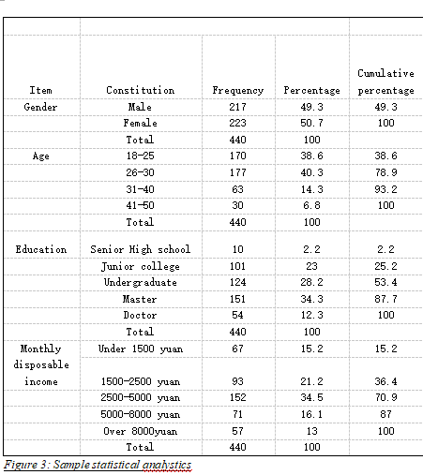
Appendix 3: Sample statistical analystics
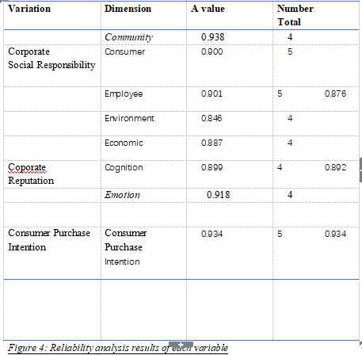
Appendix 4: Reliability analysis results of each variable
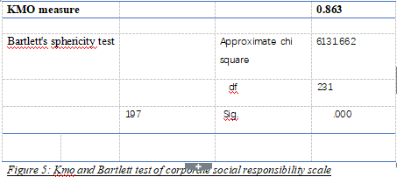
Appendix 5: Kmo and Barlett test of corporate social responsibility scale
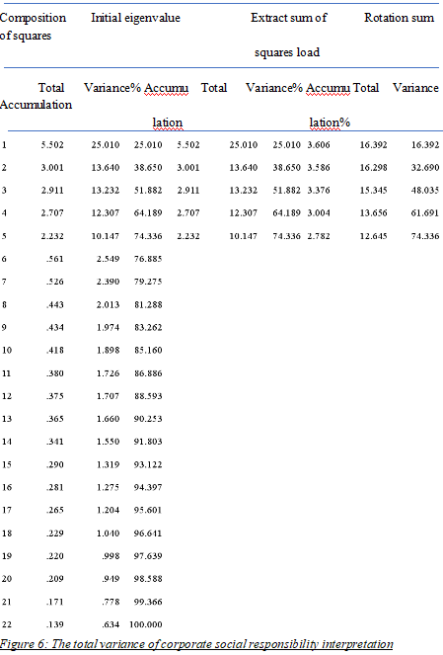Appendix 6: The total variance of csr interpretation

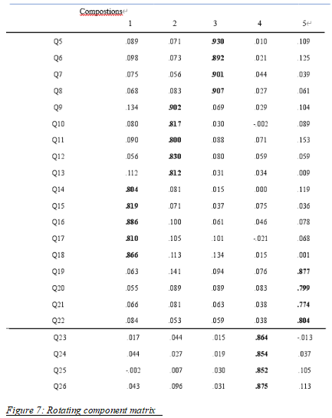
Appendix 7: Rotating component matrix
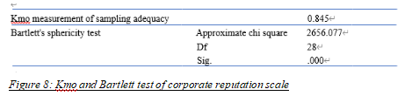
Appendix 8: Kmo and Barlett test of corporate reputation scale

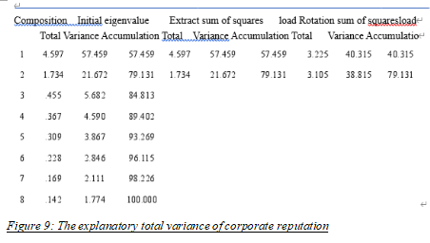
Appendix 9: The explanatory total variance of corporate reputation
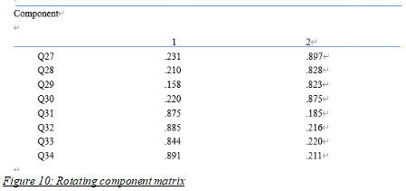
Appendix 10: Rotating component matrix
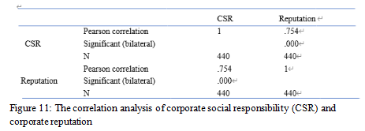
Appendix 11: The correlation analysis of CSR ad corporate reputation
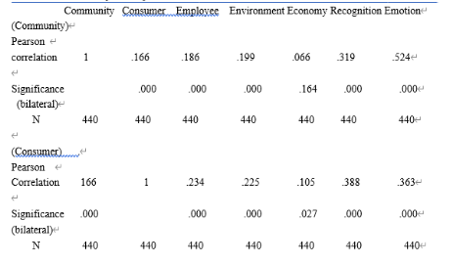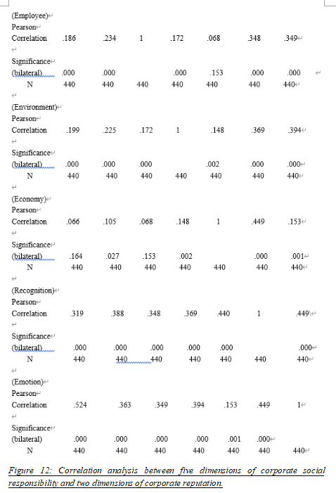
Appendix 12: Correlation analysis between five dimensions of csr and two dimensions of corporate reputation

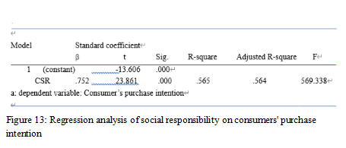
Appendix 13: Regression analysis of CSR on consumers’ purchase intention
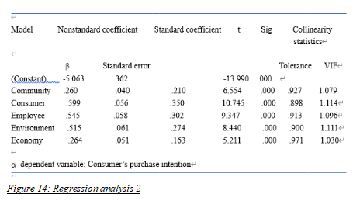
Appendix 14: Regression analysis 2

Appendix 15： Questionnaire
Questions
Q.1 What is your gender?  Q.2 What is your age range?  Q.3 What is your education background?  Q.4 What is your monthly disposable income?  Q.5 Which vehicle company is you familiar with? | Questions 1-4 are demographic questions to provide background information for analysis.
Q.6 What do you think the company should do ( ), which will affect purchase intention of the company's products

Q.7 Whether enterprises actively carry out and participate in community charity donation activities will have an impact on purchase intention

Q.8 Whether enterprises often help vulnerable groups will have an impact on purchase intention

Q.9 Whether enterprises actively and effectively carry out activities that contribute to society will have an impact on purchase intention

Q.10 Whether the enterprises actively respond to and support the public welfare undertakings held by the community will have an impact on the purchase intention

Q.11 The quality and safety of products and services provided by enterprises will affect the purchase intention

Q.12 Whether the products provided by enterprises can meet the needs of consumers will affect the purchase intention

Q.13 When consumers ask for compensation, whether enterprises can think about effective solutions will affect the purchase intention

Q.14 Whether enterprises should have good after-sales service

Q.15 Whether enterprises do not disclose or privately use consumers' personal information

Q.16 Whether enterprises can recruit employees in accordance with the law, and actively protect the legitimate rights and interests of employees
Q.17 Enterprises treat every employee fairly and provide broad development prospects for employees

Q.18 Whether enterprises can sign formal labor contracts with employees and pay social insurance for them

Q.19 Whether enterprises pay attention to the personal development of employees and provide them with vocational training opportunities

Q.20 Whether the enterprise pay employees' wages on time

Q. 21 Whether enterprises devote themselves to the production of environment-friendly vehicles and actively participate in the management and maintenance of the environment

Q.22 Does the enterprise actively participate in and sponsor various environmental protection activities

Q.23 Whether the enterprise can properly handle the waste in the process of production or service

Q.24 Do enterprises attach great importance to environmental protection

Q.25 Whether the enterprise can continuously create value for shareholders and protect their rights and interests

Q.26 Whether the enterprise has good performance and competitiveness in the industry
Q.27 Whether the financial mechanism of the enterprise is sound and how to improve the utilization rate of funds

Q.28 Is the business condition of the enterprise good enough to effectively drive the local economic development

Q.29
The automobile enterprise has a high reputation in the market

Q.30 The automobile enterprise has a strong strength and is the main competitor in the industry

Q.31 The operation ability of the automobile enterprise is very strong

Q.32 The automobile enterprise has broad development prospects

Q.33 Do you prefer the manufacturing technology of this enterprise

Q.34 Do you pay more attention to the relevant information and development of the enterprise

Q.35 Do you support and identify with the enterprise more emotionally

Q. 36 Are you very willing to buy the auto products of the company

Q.37 Are you very willing to accept the new cars invented by the company

Q.38 Would you recommend this enterprise to your friends

Q.39 Will you continue to purchase other cars in the enterprise

Q.40 Do you think buying a car from this company is the best choice

