Strategic Management & Sustainability

Module number: LCBB6004

Lecturer’s name: Dr. Hossein Shokri

Contents
Introduction 3
Company Background 3
Key Business and Corporate Strategies 4
Primary Resource of the company 5
Value chain and Value system analysis 6
VRIO analysis of the resource and capabilities 7
Evaluating strategy in action 8
SAF framework 9
Evaluating Sustainability Efforts 9
Conclusion 11
Recommendations 11
References 13
Appendix 14
SWOT analysis of the ASOS 14

Introduction
Businesses without strategic management are unable to achieve long-term success in the economy. To achieve the goals and business achievements of the company strategic management is an essential part of the company. This report contains the strategic actions and their implications for the British company named ASOS.
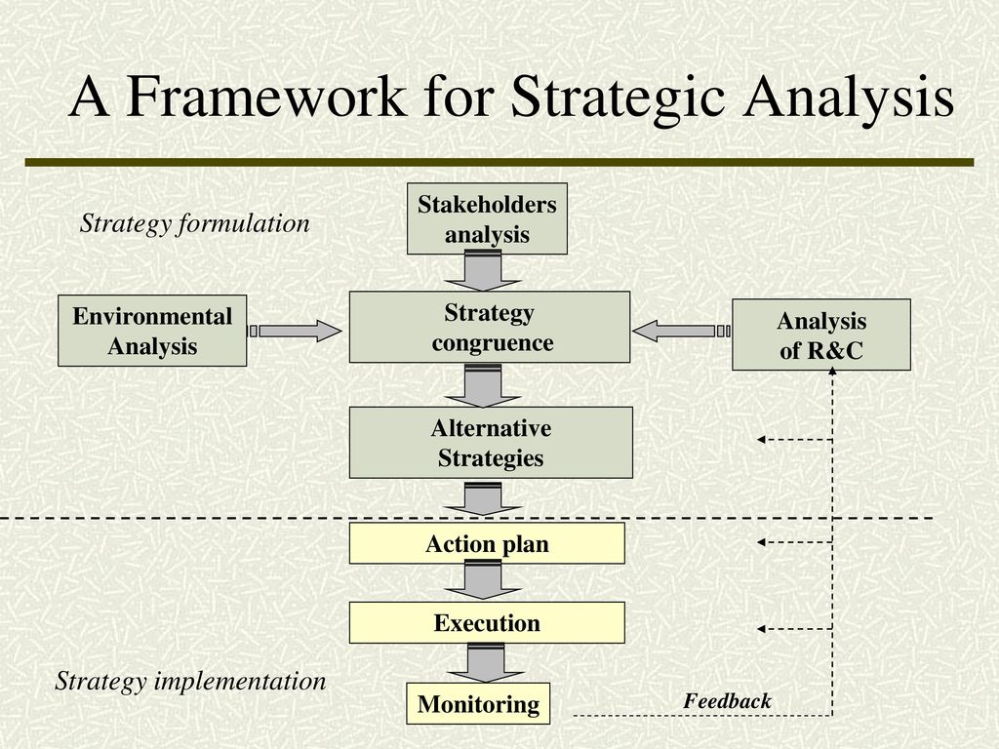
Figure 1: Framework for strategic analysis
Source: (Kay, 2020)

Company Background
ASOS is a cosmetic and fashion apparel retailer based in London. The company was founded in 2000 in London with a small presence in their business. Now the company has a net worth of almost 500 million on the London Stock Exchange (ASOS, 2022). Strategic management is its significant importance in the organization to identify the capabilities of the company and its resources for better consequences.
The above framework for strategic management shows the procedure where company management decides and makes the strategy for the company and makes sure of its proper implementation in the company environment.

Key Business and Corporate Strategies
The business environment has grown to become dynamic in nature and it has become crucial for business organisations to adapt and implement the most suitable business or corporate strategy with the aim to ensure success and stability in the long-run. There are various business and corporate strategies such as cost-leadership strategy, business level strategy, differentiation strategy, hybrid strategy and focus strategy. These strategies play a vital role in ensuring success of the business organization along with gaining competitive advantage in the market (Whittington et al., 2020). The nature of business for ASOS have major competition in the market such as Boohoo, HOF and ZARA. In accordance with the nature of the business, the differentiation strategy can be the most suitable business strategy for ASOS.
Porter’s generic strategies : Michael Porter defines four generic strategies depending on how companies position themselves in the market: cost- leadership (cheaper prices than the rivals), differentiation (differentiated products and services from competitors that are valued and charged more), focus (products and services tailored to a specific segment) and hybrid (combination of different generic strategies under specific circumstances). (Whittington et. al., 2019)
As mention by Johnson (Johnson et al., 2023). Asos should be doing cost-efficient marketing for themselves in the fashion apparel industry and make a difference between themselves and their competitors (Johnson et al., 2023). To run a business the company needs a strategy for making its business more attractive and attracting its consumer segment. In the case of ASOS company is working in the fashion apparel industry where trends are changing regularly and businesses need to be flexible with that demand to fulfil all the requirements of their consumers. In the following section business strategies are described which are related to the company:
Cost Leadership strategy: in this strategy company tries to manage its cost margins therefore the consumer benefits from that price and prefers the company’s products. This can be implemented by reducing the cost of the products or services (ASOS, 2022). The cost of the product is dependent on the input cost of the product, managing the process of manufacturing for the product, managing manufacturing scale on the economy level and experience in the industry.
Hybrid Strategy: The company’s main business revenue comes from its online sales. In a hybrid strategy, the company focuses on the other segments of the business technological advancement of the company, its innovative managerial upgradations and many more related things.

Primary Resource of the company

Resources are the assets of the company such as buildings, offices, functional equipment and many more. In the case of ASOS, the company has most of its resources in the form of intangible assets such as its e-commerce platform where people can buy clothes. The resources and capabilities of the company are described in the following section of the document.
Resource/Capability | Description
Financial Resources | ASOS has a significant financial base, driven by revenue from online retail operations.
Technology Infrastructure | Advanced e-commerce platform, mobile apps, and website for seamless customer experience.
Supply Chain | Efficient supply chain management for quick and reliable product delivery.
Distribution Network | Global distribution network to reach customers in various regions.
Brand Recognition | Strong brand recognition as a leading online fashion retailer.
Customer Base | Large and diverse customer base, including a significant presence among millennials.
Data Analytics | Utilizes data analytics for personalized marketing and understanding customer preferences.
Logistics and Fulfilment | Effective logistics and fulfilment capabilities for timely order processing.
Global Presence | Operates in multiple countries, allowing for a broad international market presence.
Product Variety | Wide range of fashion products and styles catering to different customer preferences.
Marketing Strategies | Utilizes digital marketing, social media, and influencer collaborations for promotion.

Value chain and Value system analysis: Value chain consists of all activities that create a product or service. It’s used to understand the strategic position of an organisation. Businesses could be also part of a wider value system- inter- organisational links and relationships necessary to create products or services. (Whittington et.al., 2019)

Online platform: The company has a strong e-commerce platform where people can see all the inventory of the company and buy items if they want. This is the first interaction point for the company to its consumers. In the case of ASOS, this online e-commerce platform is the main resource of the company because the major business comes from its e-commerce platform.
- Global distribution centres: To manage its supply chain management, the company has its global distribution centres from which the company manages all its shipping.
- Products range: The company has a diverse range of products such as fashion apparel, footwear, cosmetics and beauty products.
- Analytics and data: The company has data on its consumers and from that data company can customise its products as per their requirements therefore the company can gain more market share.
- Social media presence: For its marketing company uses social media marketing which gives an additional advantage to its online presence.
- Cash and cash equivalents: The company has cash received from its operations and uses that cash balance to manage its expenses and operating charges.
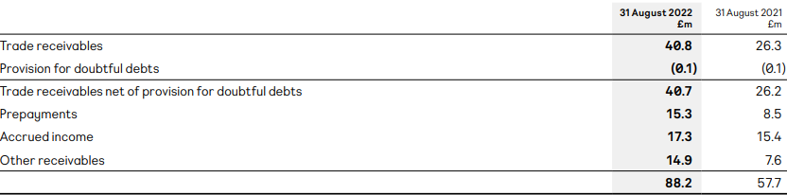
Figure 6: Trade receivables of the ASOS
Source: (ASOS, 2022)
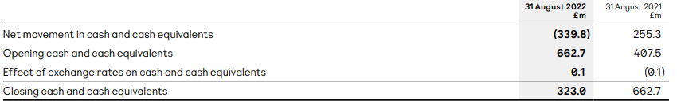
Figure 7: Cash and cash equivalents of the ASOS
Source: (ASOS, 2022)
- Tangible assets: As tangible assets, the company has warehouses across the world and its headquarters in London.
- Employees: As capabilities the company has above 4000 employees across the world to manage its operation and presence.

VRIO analysis of the resource and capabilities : VIRO analysis determines if a company has enough capabilities and resources to achieve and sustain competitive advantage. (Whittington et. al.,2019.)

Value, Rarity, Imitability, and Organisation are the acronyms for VRIO. It is a framework for a managerial strategy that assesses a company's internal resources and skills for competitiveness (Barney, 1991). From the analysis of this VRIO farmwork, ASOS can analyse its resources and capabilities from factors like value, rarity, imitation of the cost advantage and exploitation of the company. Also in this framework, competitive advantage is included as part of this VRIO where all the resources and capabilities are considered for this.

Resource and Capability | Valuable | Rare | Costly to Imitate | Exploited by organization | Competitive advantage
String brand appreciation | Yes | Yes | No | Yes | No
Wide online platform | Yes | Yes | Yes | Yes | No
Information-driven personalization | Yes | No | Yes | Yes | No
Efficient management of the supply chain | Yes | Yes | Yes | Yes | No
Strong financial resources | Yes | No | Yes | Yes | No

Evaluating strategies in action

Evaluating strategy in action
The strategic success of ASOS UK's differentiating business strategy has allowed the company to stand out in the highly competitive online apparel retail market. A primary advantage is ASOS's capacity to assemble a broad and distinctive range of products by combining its own house brands with exclusive partnerships with well-known designers. With this strategy, ASOS is able to satisfy a wide range of customer preferences and becomes the go-to place for unique and stylish products. The company's emphasis on ethical sourcing, manufacturing, and transparent communication about sustainability initiatives aligns with the values of modern shoppers. The establishment of a strong brand identity and customer loyalty through effective marketing, exclusive offerings, and personalized services is indicative of the success of ASOS's differentiation strategy (Parker and Alexander, 2022).
Overall, ASOS's differentiation approach has not only positioned the brand as a leader in the industry but has also contributed to its resilience and long-term success in the dynamic world of online fashion retail.

SAF framework
Sustainability
ASOS is working in the e-commerce sector where the company is completely dependent on its online interface where consumers come and buy the company’s products. But the main problem is that almost every company in this sector is using almost the same methods and applying online sales methods for their sales (Ali, 2021). In this kind of business environment, the company needs a complete advantage in this industry where they can focus on specific approaches but in that criteria company can adapt specific business strategies for its sales and revenues.
Acceptability
ASOS is working in the fashion retail sector and the company needs funds to manage its operations and growth projections for the upcoming years for that reason company is not giving any dividends to its shareholders. And this decision is also acceptable to the shareholders of the company. In 2022 company achieved a return on equity of 3 per cent and a return on capital employed of 0.5 per cent which shows that the company has big room for growth (Chevalier, 2022).
Feasibility
In 2022 company achieved approximately 4 billion worth of sales from its operations which was increased by 0.5% from 2021. In 2022 the company’s operating margins declined by 0.5% from 4.5% from the previous year which shows that the company has lost its pricing power in the market (Chevalier, 2022).

Evaluating Sustainability Efforts
To sustain in this kind of competitive environment ASOS should have an extra advantage for the consumers such as slow prices for their products, better quality of the services and other related benefits (Kay, 2020). To achieve long-term sustainability ASOS should focus on the profitability aspect because if the company is profitable for the long term in the e-commerce industry, then it will be able to invest in innovation and the future goals of ASOS (Ciampi, 2021). ASOS can manage their competitiveness from various sectors like the quality of their services, maintain their technological advancement, culture of that organization, and low cost for their products or services.
There are 7 main elements of sustainable competitive advantage in business which are described in the following:
- The company can require the resources of other companies to grow in the long term (Ali, 2021). That kind of acquisition contains the technology aspects of other companies or assets of the company that were not able to manage its operations and file for bankruptcy.
- Innovative capability contains the development of the existing operating procedures of the company where the company invest in research and development to achieve advancement in their existing technology and operations (Johnson et al., 2023).
- The company should be truly competitive with its competitors because in the corporate industry, businesses do all kinds of things which can open the way to becoming successful in that industry and the company should behave truly competitive approach to the competitors.
- Sustainability contains long-term growth projections of the company and the strength of the company can manage its existence in that industry for the long term.
- The company can offer extra or added services in the existing services which the consumer wants, this will help the company to gain the market share in the industry (Johnson et al., 2023). This kind of strategy can help the company to manage competition in the industry.
- The offered services or products of the company should have proper longevity and durability so that the consumer can prefer the company's services the next time they require those services or products.
- Imitability defines the quality of the product which should not be easily imitated and have sustainability in its quality for the consumers.

Conclusion
The focus strategy is the best business strategy for the company to achieve a competitive advantage in this industry. Also, the company has another competitive advantage of a large number of fashion apparel industries where the company addresses those people who are changing their fashion sense regularly. The E-commerce industry is itself very competitive and the businesses in this industry have struggled to achieve their profitability aspect which is necessary for the sustainability of the business.

Recommendations
For sustainable development, the company should maintain a healthy margin on its inventory so that if the company faces any economic losses, then the company can manage that situation with its existing cashflows. The company’s major revenue comes from its online presence and it is very important to maintain the traffic and other technical things for that online portal. In peak season the site should be capable of handling the volume and managing the demands of the people (Ali, 2021). This company should be inventing regularly in this area and make sure that the online interface is attractive to its consumers. In the fashion apparel industry, there is a huge competition and this company needs to adopt a single business strategy such as a focus strategy to cater for that competition and achieve sustainable growth in the fashion apparel sector.

References

References
Ahmad, Q. (2019). EXPLORING STRATEGY ELEVENTH EDITION. www.academia.edu. [online] Available at: https://www.academia.edu/44504531/EXPLORING_STRATEGY_ELEVENTH_EDITION.
Ali, B.J. and Anwar, G., (2021). Porter’s Generic Competitive Strategies and its influence on the Competitive Advantage. Ali, BJ, & Anwar, G.(2021). Porter’s Generic Competitive Strategies and its influence on the Competitive Advantage. International Journal of Advanced Engineering, Management and Science, 7(6), pp.42-51.
ASOS (2022). ASOS Announces Ambitious New 2030 ESG Goals. [online] ASOS plc. Available at: https://www.asosplc.com/news/asos-announces-ambitious-new-2030-esg-goals/.
ASOS (2022). Results centre. [online] ASOS plc. Available at: HTTPs://www.asosplc.com/investor-relations/results-centre/.
ASOS plc (2019). Home. [online] Asosplc.com. Available at: https://www.asosplc.com/.
Barney, J. B. (1991). Firm Resources and Sustained Competitive Advantage. Journal of Management, 17(1), 99–120.
Chevalier, S. (2022). Topic: ASOS. [online] Statista. Available at: https://www.statista.com/topics/6330/asos/.
Ciampi, F., Demi, S., Magrini, A., Marzi, G. and Papa, A. (2021). Exploring the impact of big data analytics capabilities on business model innovation: The mediating role of entrepreneurial orientation. Journal of Business Research, [online] 123, pp.1–13. doi https://doi.org/10.1016/j.jbusres.2020.09.023.
Johnson, G. (2019). Exploring Strategy, Text and Cases, 12th Edition. [online] Google Books. Pearson UK. Available at: https://books.google.com/books/about/Exploring_Strategy_Text_and_Cases_12th_E.html?id=GeksEAAAQBAJ.
Kay, W.D., Porter, John (2020). A Framework for Strategic Analysis - ppt download. [online] slideplayer.com. Available at: https://slideplayer.com/slide/12493152/ [Accessed 15 Nov. 2023].
Parker, G.-L. and Alexander, B. (2022). Bloomsbury Fashion Business Cases Accepted for publication version of case study, pre-production. Title: Digital Only Retail: Assessing the Necessity of an ASOS Physical Store within Omnichannel Retailing to Drive Brand Equity. [online] Available at: https://ualresearchonline.arts.ac.uk/id/eprint/17978/1/ASOS%20case%20study%20accepted%20version%2C%20BFBC.pdf.
Petrie, S. (2023). Redirect Notice. [online] Google.com. Available at: https://www.google.com/url?sa=i&url=https%3A%2F%2Fprezi.com%2F79i6qj1tzumq%2Fhybrid-strategy%2F&psig=AOvVaw1o8mj1BUGB4tdfxVSoSQhE&ust=1702625680084000&source=images&cd=vfe&opi=89978449&ved=0CBIQjRxqFwoTCKCMuY21joMDFQAAAAAdAAAAABAD [Accessed 14 Dec. 2023].
Rashid, A. and Barnes, L. (2020). Exploring the blurring of fashion retail and wholesale brands from industry perspectives. The Journal of The Textile Institute, pp.1–7. doi: https://doi.org/10.1080/00405000.2020.1757295.
Teoli, D., An, J. and Sanvictores, T. (2022). SWOT Analysis. [online] Nih.gov. Available at: https://www.ncbi.nlm.nih.gov/books/NBK537302/.
Whittington, R., Regnér, P. and Angwin, D. (2020). Exploring strategy: text and cases. [online] thuvienso.hoasen.edu.vn. Pearson. Available at: https://thuvienso.hoasen.edu.vn/handle/123456789/12693.
Whittington, R., Regnér, P., Angwin, D., Johnson, G. and Scholes, K. eds., (2020). 104-215. [online] Available at: https://books.google.co.in/books?id=GeksEAAAQBAJ&pg=PT27&source=gbs_toc_r&cad=2#v=onepage&q&f=false [Accessed 12 Dec. 2023].

‌Appendix

SWOT analysis of the ASOS
SWOT analysis provides a brief framework of strengths, weaknesses, opportunities and threads and for ASOS the SWOT is the framework which analyzes all the frameworks regarding this. Strengths, Weaknesses, Opportunities, and Threats, or SWOT analysis, is a corporate strategy technique used to evaluate an organisation's competitive position. Although it is still up for debate, Albert Humphrey is traditionally credited with developing the tactic in the 1960s. There isn't a creator who is acknowledged by everyone (Teoli, An and Sanvictores, 2022). Alternatively referred to as the SWOT matrix, it has become acknowledged as a valuable tool for distinguishing and carving out a niche in the wider market.

Strength | ASOS has a strong brand reputation among its consumers and that is the main strength of the company where the company has the pricing power to manage their margins in business.  The e-commerce approach of the company gives a cost-benefit advantage to the company where the company does not need to maintain physical stores in various parts of the world.  The company has data on its existing consumers where they can find the requirements of mass people and manage their inventory as per the requirements which drives less losses for the company.
Weaknesses | The company is completely dependent on third-party logistics partners for delivery and logistics. This creates a big difference between the consumer and the company because if a company wants to control the logistics and supply chain then it is very difficult for them.  In the fashion apparel industry consumer acquisition cost is very high and the company spends a lot of money to acquire new consumers in this sector.
Opportunities | Currently, the company is working in developed regions of the world and there are very big opportunities in Southeast Asian countries and South American countries which are developing regions and can provide very big demand for the company.  The company can use AI in their online portal where they can find the buying patterns of their consumers and offer better deals and requirements which were taken by previously.
Threads | The economic downtrend is the key factor for the company which can lead to lower sales which is the thread to the company.  Due to technological factors, the moat of the company in this industry is disrupted and there are equal opportunities for every business to enter this segment.

