
Skills for the Workplace
Module Assignment Submission
Student Name: | Siraje Sekawunde
Student Number: | 1706807
Module No: | BMSK4003
Module Title: | Digital skills and research

Statement of Confirmation of Authenticity
By the act of making this submission, the student declares that this is the work of the student named above. The work has not, in whole or in part, been knowingly presented elsewhere for assessment, or where assessment has been built on a previous assessment, this has been identified. Where materials have been used from other sources it has been properly acknowledged. If this statement is untrue, the student acknowledges that an assessment offence has been committed.
Attention is drawn to the plagiarism and unfair practice policies of both the University and of ILM.

Table of Contents
Introduction 3
Workplace technology & its importance in the workplace 4
Social media increases communication and how they are used in workplace 5
Appropriate use of technology and its applications 7
Safety and security of the social media and web-based applications 10
Conclusion 12
Bibliography 13
Bibliography 13
Appendix 1 14

Introduction

This report will be focused on the use of technology in the workplace, improve workplace efficiency through web-based email, web conferencing, file storage and also social networking. Also, in this report will focused in how social media increases communication, benefit in the marketing sector, appropriate use of technology, safety and security of the social media and so on. During the report all these things will be discussed. A consumer always wants something better and innovative product from the producers. Because day by day technology is advancing and it makes everything so faster than before. Digital is actually become so transformative. Using the technology in the workplace, it helps to make the workplace better, freer and also simpler. Easily lots of work can be completed in a short time. Now a day’s customers use social media in their every aspect of life. By following the strategy of digital marketing, it makes easier to build brand, create cost savings and also helps to make more revenue. That’s why if the staffs become skilful in the digital technology sector, it will help the company to achieve its goal easily and make the best benefit. But it is important to implement the technology in every sector in a proper way and also in the right direction. Because sometimes misuse of the technology can bring harm for the company.

Workplace technology & its importance in the workplace
(Poynter, 2010). Technology is the outlet of knowledge and machinery, devices are advanced from all kinds of scientific knowledge. Technology makes the workplace more better and more effective. Because using the computers and smartphones it becomes much easier to engender the information and also distribution.
- (Ramey, 2012). How the technology used in workplace to improve workplace efficiency and employability
- Supports innovation- Use technology in the workplace has a great advantage and the owner of the company always try to make the best use of it. It helps to innovate and come up with a new idea frequently so that they can change their flow of work. They can create new ideas. With internet they can research on it and can gain the competitive advantages.
- Speeds data processing- Using the technology data processing system has become so faster than before. Helps to create presentations and also helps to setting up website’s where customers can also order their desired products easily. It is important to process information very fast.
- Quick decision making- Technology is very important in the workplace. It helps to improve the workplace efficiency. After using the technology workers can easily access any data because of information are systematized through dispersed computing system.

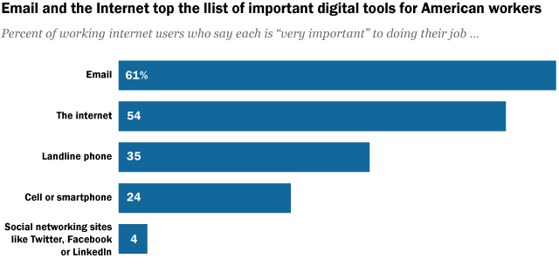
- Through the web-based email, web conferencing, file storage and social networking workplace efficiency and employability is improving. They can easily communicate easily through and e-mail. With the web conferencing they can easily done with a deal with the other company as well. Using social media such as Facebook, twitter and so on employees are making their flow of communication better than before. Now a day’s employees are distracting from work because of the use of technology in a higher amount. They are not focusing on their practical work field in their workplace.

Social media increases communication and how they are used in workplace
- (WILLIS, 2017). Social media increases communication are described in the below –
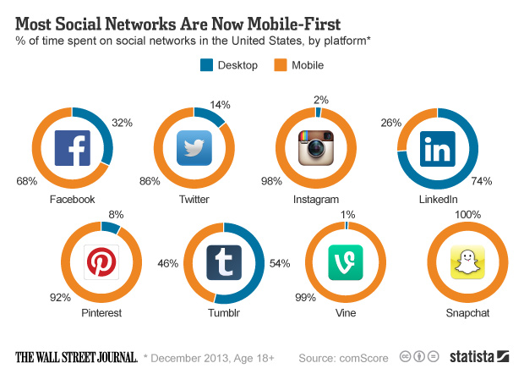
- Created when any need to share with anyone
- Can share full story
- Help to make any digital communications more individual
- Capability to broadcast any moments instantly anywhere
For example,
Twitter (fast strode network) (Help the user to share information in instant)
Snapchat (Allow the user to share their content which can be seen only for 24 hours at utmost)
Facebook (Largest social media and people can communicate effectively with anyone around the globe and important part of any kind of business operations)

- Social media helps in marketing and information gathering
- Helps to upsurge the website traffic
- Helps to raise brand awareness
- Create brand identity
- Optimistic brand association
- Improve communication
- Gather information what customers want easily
For example, using Facebook a businessman or any company can easily know which products are consumer wanting and what are their needs, where to improve. They can communicate also with their customers. They can create good image through communication and get in touch with their customers.
- (wordstream, 2017). Social media increase efficient without any doubt. Using social media everyone can get in touch and can quickly make any decisions and in the workplace, it is making more effective day by day.
- (employability , 2017). LinkedIn can be used for any kind of business and helps in an effective way to promote business. Using LinkedIn in the world of business there are also important element should which should focus on such as, creating a profile, alumni search, search company, make connection, join groups. (Duermyer, 2017).
- Helps to give the best exposure to people what products they are wanting
- Helps to introduced with potential clients
- Can display my recommendations from others on this social media
- Can advertise my business easily
- Helps to expand the network
- Can find clients easily
- Can create a professional image

Appropriate use of technology and its applications
- (Beckingham, 2014). Use the technology appropriately in the workplace is important. For example,

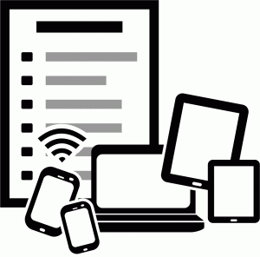
- It is important to keep phone in silent mode
- While receiving a call ask to the leader or excuse yourself
- Do not use music while in a meeting
- Do not use slang
- Do not use social media while working hour
- Always need to careful what you are posting on the social media
- Never post any negative comments about tour company
- Always check for the spelling error
- While making video call always sure that you are in a silent place
- Be professional while you are talking
(hackbarth, 2015). Mentioned above some of the appropriate use of technology through the creating of Facebook, twitter, LinkedIn accounts.
- Possibilities for communication and collaboration in the workplace that use of these social networks might provide-
As a powerful social media, it can help us to share information and build up relationships with individual persons other people as well. If people do not emphasis on responsibilities, but use social media to attend personal matter, it may invite significant interruption in the places people are working. So, we can see companies to think social media as a valuable work source in spite of responsibilities which are to be accomplished with great care.
Though the given statistics are eye opening still they are disturbing too. In is seen in the offices, many workers do not take interest in their employers. May be the prevailing culture in the company plays an important role. Too firm and split leadership often lead the employees to shut down. Now if the company leaders give importance to the employees’ satisfaction, then they will be active work force and feel them as active part of the company business.
These businesses are becoming models for how IT can work within the corporate intranet and have begun to spark interest in tools like IT ticketing systems. Here are some things to consider when deciding to implement an enterprise social network at your company:
It is true that social media has really changed many of ours way and helped us to run business from sales to IT. In telecommunication sector, Verizon and Optimum, have changed Twitter to assist desk support. Nowadays, these businesses are becoming models and that’s why IT can work within the corporate intranet. Moreover, the businesses have started to flash curiosity in tools. So, people prefer IT ticketing systems rather than buying tickets visiting concern offices thinking the process backdated. Companies are taking advantages to make roles both for internal community management and social media management and thus they are able to inspire communication, idea exchange and cooperation.

When enterprise social media can present itself as a wonderful thing, it really comes down as how the company supports it. Here some key points are furnished to take into consideration when deciding to implement an enterprise social network at any company:
- Company Policy: Internal and external communication policies in place should involve good leadership should have. If not, it is necessary to prepare one soon. Any company must supply with necessary guidelines information and interactions with their types to take place on the network and state what will be allowed and moderated. Apart, a policy should set structure such a way that there should not have any obstacle.
- Human Resources: To make enterprise social media work for any business, person concern will have to build a team for backing and managing it duly. The managers of community and social media should be given power so that they can encourage engagement and collaboration and for that they must set examples to moderate activity and support employee usage.
- IT Infrastructure: Gong to implement new technology, any present systems are to be assessed to support it. Also, you a knowledgeable team will be necessary to see the work of the networks. With a combined communication system in place, the enterprise social network should be a part and then a separate communication tool will not be needed. Moreover, it should be available and safe as well.
- Company Culture: Leadership together with employees will need to buy into the idea of an enterprise social network. So, it can be said that communication is key in any sort of change no matter big or small. So, interest and excitement representing the operations and the benefits to business. If once accepted, any company will begin to see a change in its culture so that a sharing environment can be upheld. (Team, 2014). In this era social network make communication more effective through using Facebook, twitter and so on.

Safety and security of the social media and web-based applications
(2016). It is important to be safe and cautious while using social media for any kind of purposes. Because now a day’s security level is advancing but also hacking others account are also increasing. Some of the steps have mentioned below to stay safe on social network-

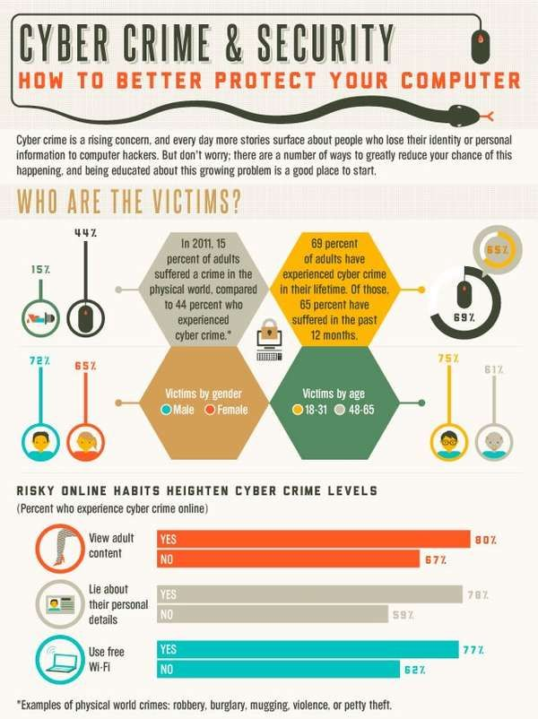
- Use solid password in every social media account. Password should be lengthier to secure the account more.
- Use different password for different social media accounts.
- Always use security answers. Now authentication method is available on every social media for the higher-level security.
- If you use social media apps on phone, always give security code on the device to unlock.
- Do not accept any unknown person request on the social media.
- Do not give any kind of information to any unknown person.
- Do not click or enter any kind of unknown link because social media accounts are getting hacked frequently.
- Always be careful what are you sharing and do not reveal your personal information to the public. Because providing personal info can help those hackers to hack your account more easily.
- Important to get familiar with privacy policies in every social media and customize the privacy settings of the account.
- Install antivirus in computer and ensure that all the browsers you are using are secured and operating system should be up to date.
- Always try to log off from account after the work has done.

Web-based applications for the workplace:
https://www.sciencedirect.com/science/book/9780124170018
By the name of web-based application it can be stated that it is kind of a program which is retrieved over a network connection (via HTTP). It runs inside any web browsers. They are also known as web apps. There are some web-based application benefits. Such as-
- Cost effective development
- Can access anywhere
- Can customize easily
- Can access in a range of devices
- Improve the level of interoperability
- Easy to install and maintain
- Adaptable to any increased workload
- Increase the level of security
- Flexible to all core technologies

Conclusion
World is progressing day by day through the improvement of technology and digital revolution. In the workplace without digital skills it is impossible to get the success in the workplace. Knowledge of technology is so important for all employees. For example, if any worker only knows how to operate a computer and Microsoft office skills. It can be enough only for today but not for the future. Digital skill importance is growing so fast because of the buyer’s perspective is changing every day. Because customers want to solve their problems more easily and for this company also has to change their system to more digitalization. Importance of social media in the workplace already captured a huge importance sector. Using this social media business communication has become so much effective than before. Use the technology appropriately is also an essential part. Because without proper using the technology it can bring negative effect for the organization. Using social media for the purpose of any business increasing day by day, but hacking social media site or accounts also increasing. So, it is also important to ensure the best safety and security for social media accounts you are using for your business or any other purposes. At the end it is stated that all the workers need to trained properly and should gained digital skills if they want to make a better carrier and also if the organization want to stay and win in this world large competitor market.

Bibliography

Bibliography
(2016, May 02). Retrieved from https://carleton.ca/its/2016/social-media-safety/
(2017). Retrieved from wordstream: https://www.wordstream.com/social-media-marketing
Beckingham, S. (2014, March 11). Retrieved from slideshare: https://www.slideshare.net/suebeckingham/using-social-media-to-develop-a-professional-online-presence
Duermyer, R. (2017, April 03). Retrieved from thebalance: https://www.thebalance.com/how-to-use-linkedin-to-promote-your-home-business-1794731
employability . (2017). Retrieved from https://sites.google.com/a/my.shu.ac.uk/shusome/employability
hackbarth, o. (2015, January 5). Retrieved from https://prezi.com/-nyqewuxkugw/appropriate-use-of-technology-in-the-workplace/
Poynter, R. R. (2010, October 11). Retrieved from bookdepository: https://www.bookdepository.com/Handbook-Online-Social-Media-Research-Ray-R-Poynter/9780470710401
Ramey, K. (2012, October 16). USE OF TECHNOLOGY IN THE WORKPLACE. Retrieved from useoftechnology: https://www.useoftechnology.com/technology-workplace/
Team, U. (2014, August 17). Retrieved from https://www.goubiq.com/should-you-use-social-media-for-work-collaboration/
WILLIS, A. (2017, August). Retrieved from http://circaedu.com/hemj/how-social-media-changed-the-way-we-communicate/
WILLIS, A. (2017, August 15). Retrieved from http://circaedu.com/hemj/how-social-media-changed-the-way-we-communicate/

Appendix 1


