Evaluation of blended learning and classroom learning on student attainment (report)

Induction
This report will be explaining the differences in both blended learning & traditional classroom learning, and the pros and cons they both have on the effects off how the high education learning today.
Blended learning is a structure that allows students to be freer when it comes to learning, having more control in the way they choose to learn and process the information they are learning, blended learning is not just education that’s been taught in the classroom but also gives students the opportunity to learn online & classroom courses and different activities with peers that are not also sitting in a classroom.

“Blended learning is an approach to education that combines online educational materials and opportunities for interaction online with traditional place-based classroom methods. It requires the physical presence of both teacher and student, with some elements of student control over time, place, path, or place.”
(Quigley,2019)

Classroom learning which is known as the traditional way off learning has always been the way a student would learn by having studies in the classroom, In front off a teacher or lecture being told loads of information and having face to face interaction with your peers.
“A traditional classroom refer to rooms consist of clean pastel-coloured walls and rows of desks and chairs facing a lectern were placed under the microscope.[6] For ages, education has been centred on attending classes day after day, and people found that school facilities could affect learning.”
(Li, Qi, Wang, 2014)

Both are something that will forever main a thing but how did blended learning become so common?
Blended learning is a learning technique that has been around for many years but recently become more common Due to the covid pandemic there was a lot off studies that took their education online this was a way for peers to still be able to continue their courses and get the grades they had been studying for, while this was in plan blended learning became a lot common as peers enjoyed having more variety on the way they learn.
“Blended learning emerged as one of the most popular pedagogical concepts at the beginning of 2000. With an increasing tendency, many researchers have reported on blended learning since it flourished.”
(Güzera,Canera,2013)

Main body
Blended learning was introduced as learning that could allow both students and lecturers to have more of a balanced work flow where the idea is to put both traditional classroom learning and internet learning into the same way of learning hoping that students would engage more and have a better understanding of their chosen course, allowing students to have a more accessible relationship with their peers and lectures, also being able to have the advantage of having everything they need on their internet devices allowing assignments and course work to be accessed more easily blended learning focuses on allowing the students to feel more comfortable with having more of a diverse way of study.
Many pros can be taken from blended learning, it is easier for students to access their course work and have one to one interaction with their lectures, also consistency will be more frequent as it is easy to always email and have answers for the direct question you may be asking.
Graham, stein, (2020. pg 15) said
“Individualized learning opportunities-. Because digital materials
may be accessed and reviewed on-demand, students have some
control over the pace of certain learning activities in a blended
course. Automated assessments often used in online learning
environments may also provide immediate, corrective feedback that
directs students to revisit materials.”

[Stein, Jared/Graham, Charles R. Essentials for Blended Learning, 2nd Edition]

In addition to blended learning having pros of why it can be a better way for a pupil to learn there is also cons that come with this with that being said

“Disadvantages for learners
- Access to resources. A blended learning model often requires students to utilise technology outside of the classroom. Not every learner will have equal access to the resources, which can make online learning difficult or even impossible.
- Supporting individual learners. There is no catch-all approach to education. Students with different needs and digital literacies may not find technology-based learning as accessible without the right level of support.
- A lack of direct contact. Although self-directed learning can be beneficial, learners that are struggling with online material may not be able to find solutions by themselves.”
(Learn,2021)

It is shown that with addition to the diverse way off learning there are still many disadvantages as future learn have stated in their blog that even though you have the support off your course work having the emotion connection and having other people's opinions and help is much harder to gain threw blended learning

Traditional classroom learning is the first ever learning that was in place when it came to study this is the classic way that everyone knows how to learn but with classroom learning also has its pros and cons off the better outcome off the way people wish to learn.
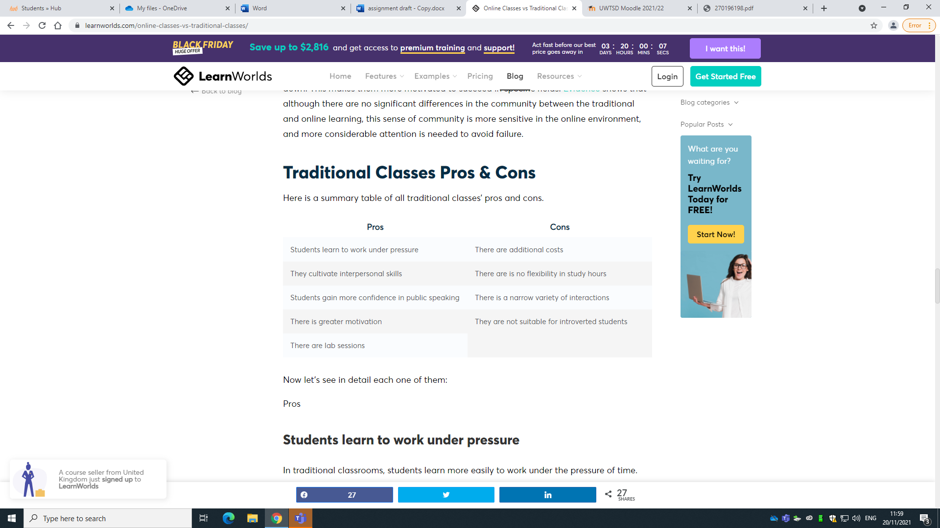
(Papadopoulou,2020)
With this table you can see the different effects that classroom learning has for students with pros it shows that it can teach a student to learn under pressure it can also motivate peers more having human interaction in class with others to see how they work and to find the style that suits you better.
There are also cons being the cost that it would take to come to uni and study in a classroom and all the extra things you will need for your class, you must work around your studies as you have set times and dates that you would be required to come to class and learn that can could be a problem for them peers who may have children or different work commitments.

Picking factors
What is the satisfaction & achievement from both blended and classroom?

What are my first-hand experiences of both blended & classroom learning?

My experience with classroom learning is that with it comes a huge responsibility to make sure your attending all your lessons and making sure you ain’t turning up on time and maintaining a good positive attitude thought out , with this being said it can be hard to always maintain a good classroom relationship and always have the right mindset to come in and learning this may effect how much work you get done after the class and also the ability to focus and stay on task during the lesson, where as blended learning you have the ability to always be on time as it’s there whenever you need your course work and study also there is a lot off things you can work round when it comes to staying on task and always being able to go back and check on a activity already taken place within your study , I agree that blended learning is the best learning as it’s very flexible and you have both the choice to come into class and sometimes having the online accessibility helps as well , I think a lot off people benefit differently from both classroom and blended learning and outcomes can be different where as my personal opinion I like the idea off having a mixture off learning techniques to help me apply my best ability to the course.

Summery
This assignment has been something fun to learn with finding out both the benefits off class room and blended learning and also being able to see the effects it has on different people and how others prefer to learn has helped me have a better understand on what both are , this assignment has shown the pros and the cons off blended learning which will give a more off and understand on how blended learning has became so much more effective and also the pros and cons off traditional class room learning , class room learning will be traditional way of learning for years and years but with the blended learning coming in to place a lot more students and lectures are learning the techniques.

Summaries blended learning classroom learning -

recommendations
I like both blended learning and traditional classroom learning but learning more about the pros and cons off both and the effects it has on the pupils when it comes to learning the different techniques I think my preference would be blended learning as this gives you a better understanding off the course at hand , there’s always information you can find hen it comes to your online work and there are different techniques to help you stay focused on the course , I find I loose focus so staying in a classroom for the whole duration of the year wouldn’t help me find the motivation to work without seeing and being taught other things.

Reference

https://www.learnupon.com/blog/what-is-blended-learning/
Eoghan Quigley
Published on January 17, 2019

https://core.ac.uk/download/pdf/270196198.pdf
Fei Li, Jingyao Qi, Guiwei Wang and Xiaofeng Wang Harbin Institute of Technology,
Harbin, China
2014

https://core.ac.uk/download/pdf/82476791.pdf
The past, present and future of blended learning: an in depth analysis of literature Bayram Güzera *, Hamit Canera ,2013

https://www.futurelearn.com/info/blog/everything-about-blended-learning
Published onApril 16th, 2021
by FutureLearn

Everything you need to know about blended learning

https://www.learnworlds.com/online-classes-vs-traditional-classes/

Online Classes vs Traditional Classes – Find the Best for You
JULY 15, 2020 • Anthea Papadopoulou

