University of Wales Trinity Saint David
School of Engineering
Technical Report
Engineering Applications and Study Skills
M4X00384

Student Name: Joseph Blackmore
Student Number: 1702858
Date: 24/04/18

Operation of a metal lathe

Introduction
The practical session that I am basing this report on involved me operating a metal lathe for the second time. In this technical report, I am going to show that I understand how to operate this equipment safely, along with producing evidence of my work in the specific practical session assigned to me. I will describe what was carried out in this practical session, highlighting what I had learned and how I can improve my operation of the equipment. I am further going to educate myself in how to operate such equipment by conducting research into legislation and guidelines for safe practise when operating a metal lathe in a workplace environment.

Background Research
Before conducting any practical work in the workshop, the relevant induction procedure had to be carried out. I needed to understand how to work safely in the dangerous workshop environment. I have conducted research into guidelines and legislation in order for me to better understand how and why I must adhere to certain health and safety rules when operating in the workshop.
When working in the workshop the following PPE (personal protection equipment) had to be worn; Lab coat, steel toe capped boots, safety glasses.
Studying the British government Health and Safety Executive (HSE) guidelines for safe practise in a milling and machining environment further developed my understanding of how to safely operate such equipment. The guidebook states that most accidents happen due to ‘Entanglement and contact with rotating cutters’ and ‘Not wearing eye protection when machining, cleaning and removing swarf.’ (Health and Safety Executive, 1999) This highlights the necessity for eye protection and the use of a lab coat to help prevent entanglement and eye injuries. This source was particularly useful as it gives government guidelines for key safety features that the machine also needs to include that I need to be aware of along with their functions; ‘Guards also help control metalwork fluid and swarf.’ ‘Exhaust ventilation fitted or capable of being connected.’ (Health and Safety Executive, 1999). A website that offers information on how to operate a lathe provided a useful source in the form of a diagram to help me understand the location and names of the different operating tools on a centre lathe;

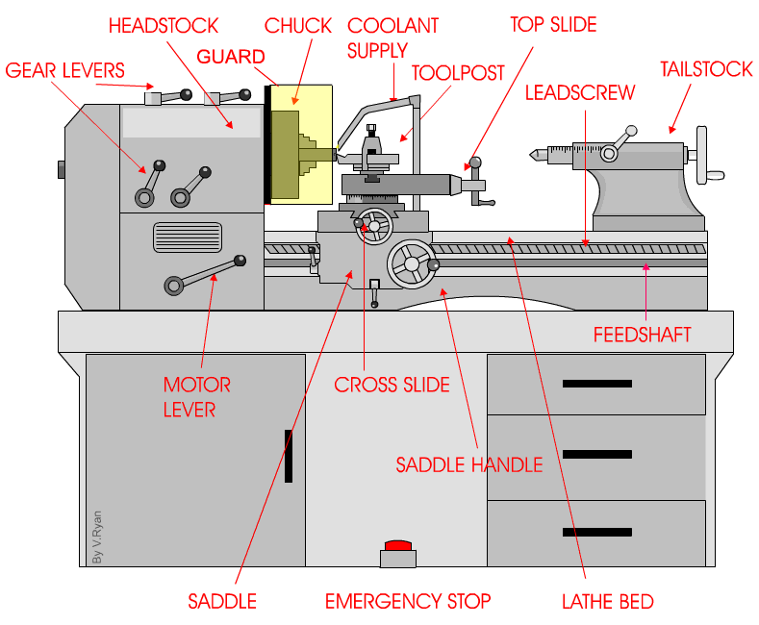 (V.Ryan, 2009)
This diagram will help me to use the metal lathe safely and more effectively.

Studying the Australian governments website for workplace safety guidelines offers information regarding how swarf, which is the ejected metal from the cutting tool, should be handled; ‘Ensure swarf handles and buckets are used when cleaning swarf, shaving and cuttings from lathe.’ (WorkSafe Victoria , 2017)

Methodology
The equipment used during this session was a centre drive metal lathe with a digital axis measurement display, a micrometer and a digital measuring gauge. The component was cylindrical in shape and composed of mild steel. In this session, I had to turn the metal component and remove material from the outer edge in order to cut ‘steps’ into the component at the required measurements. The first cut had already been made at this point on the other face of the component. The cut I made in this session was 60mm along the component from the face and had to be 4mm deep. This would leave a 40mm diameter step surrounded by a 36mm diameter step and the step cut in the previous session. All dimensions of the finished component need to be within a tolerance of +- 0.2mm. The process was carried out as follows;
- Firstly, I had to secure the component into the 3-jaw chuck. It is important to check that the component is tightly fastened into the chuck and that the guard is lowered before starting the lathe

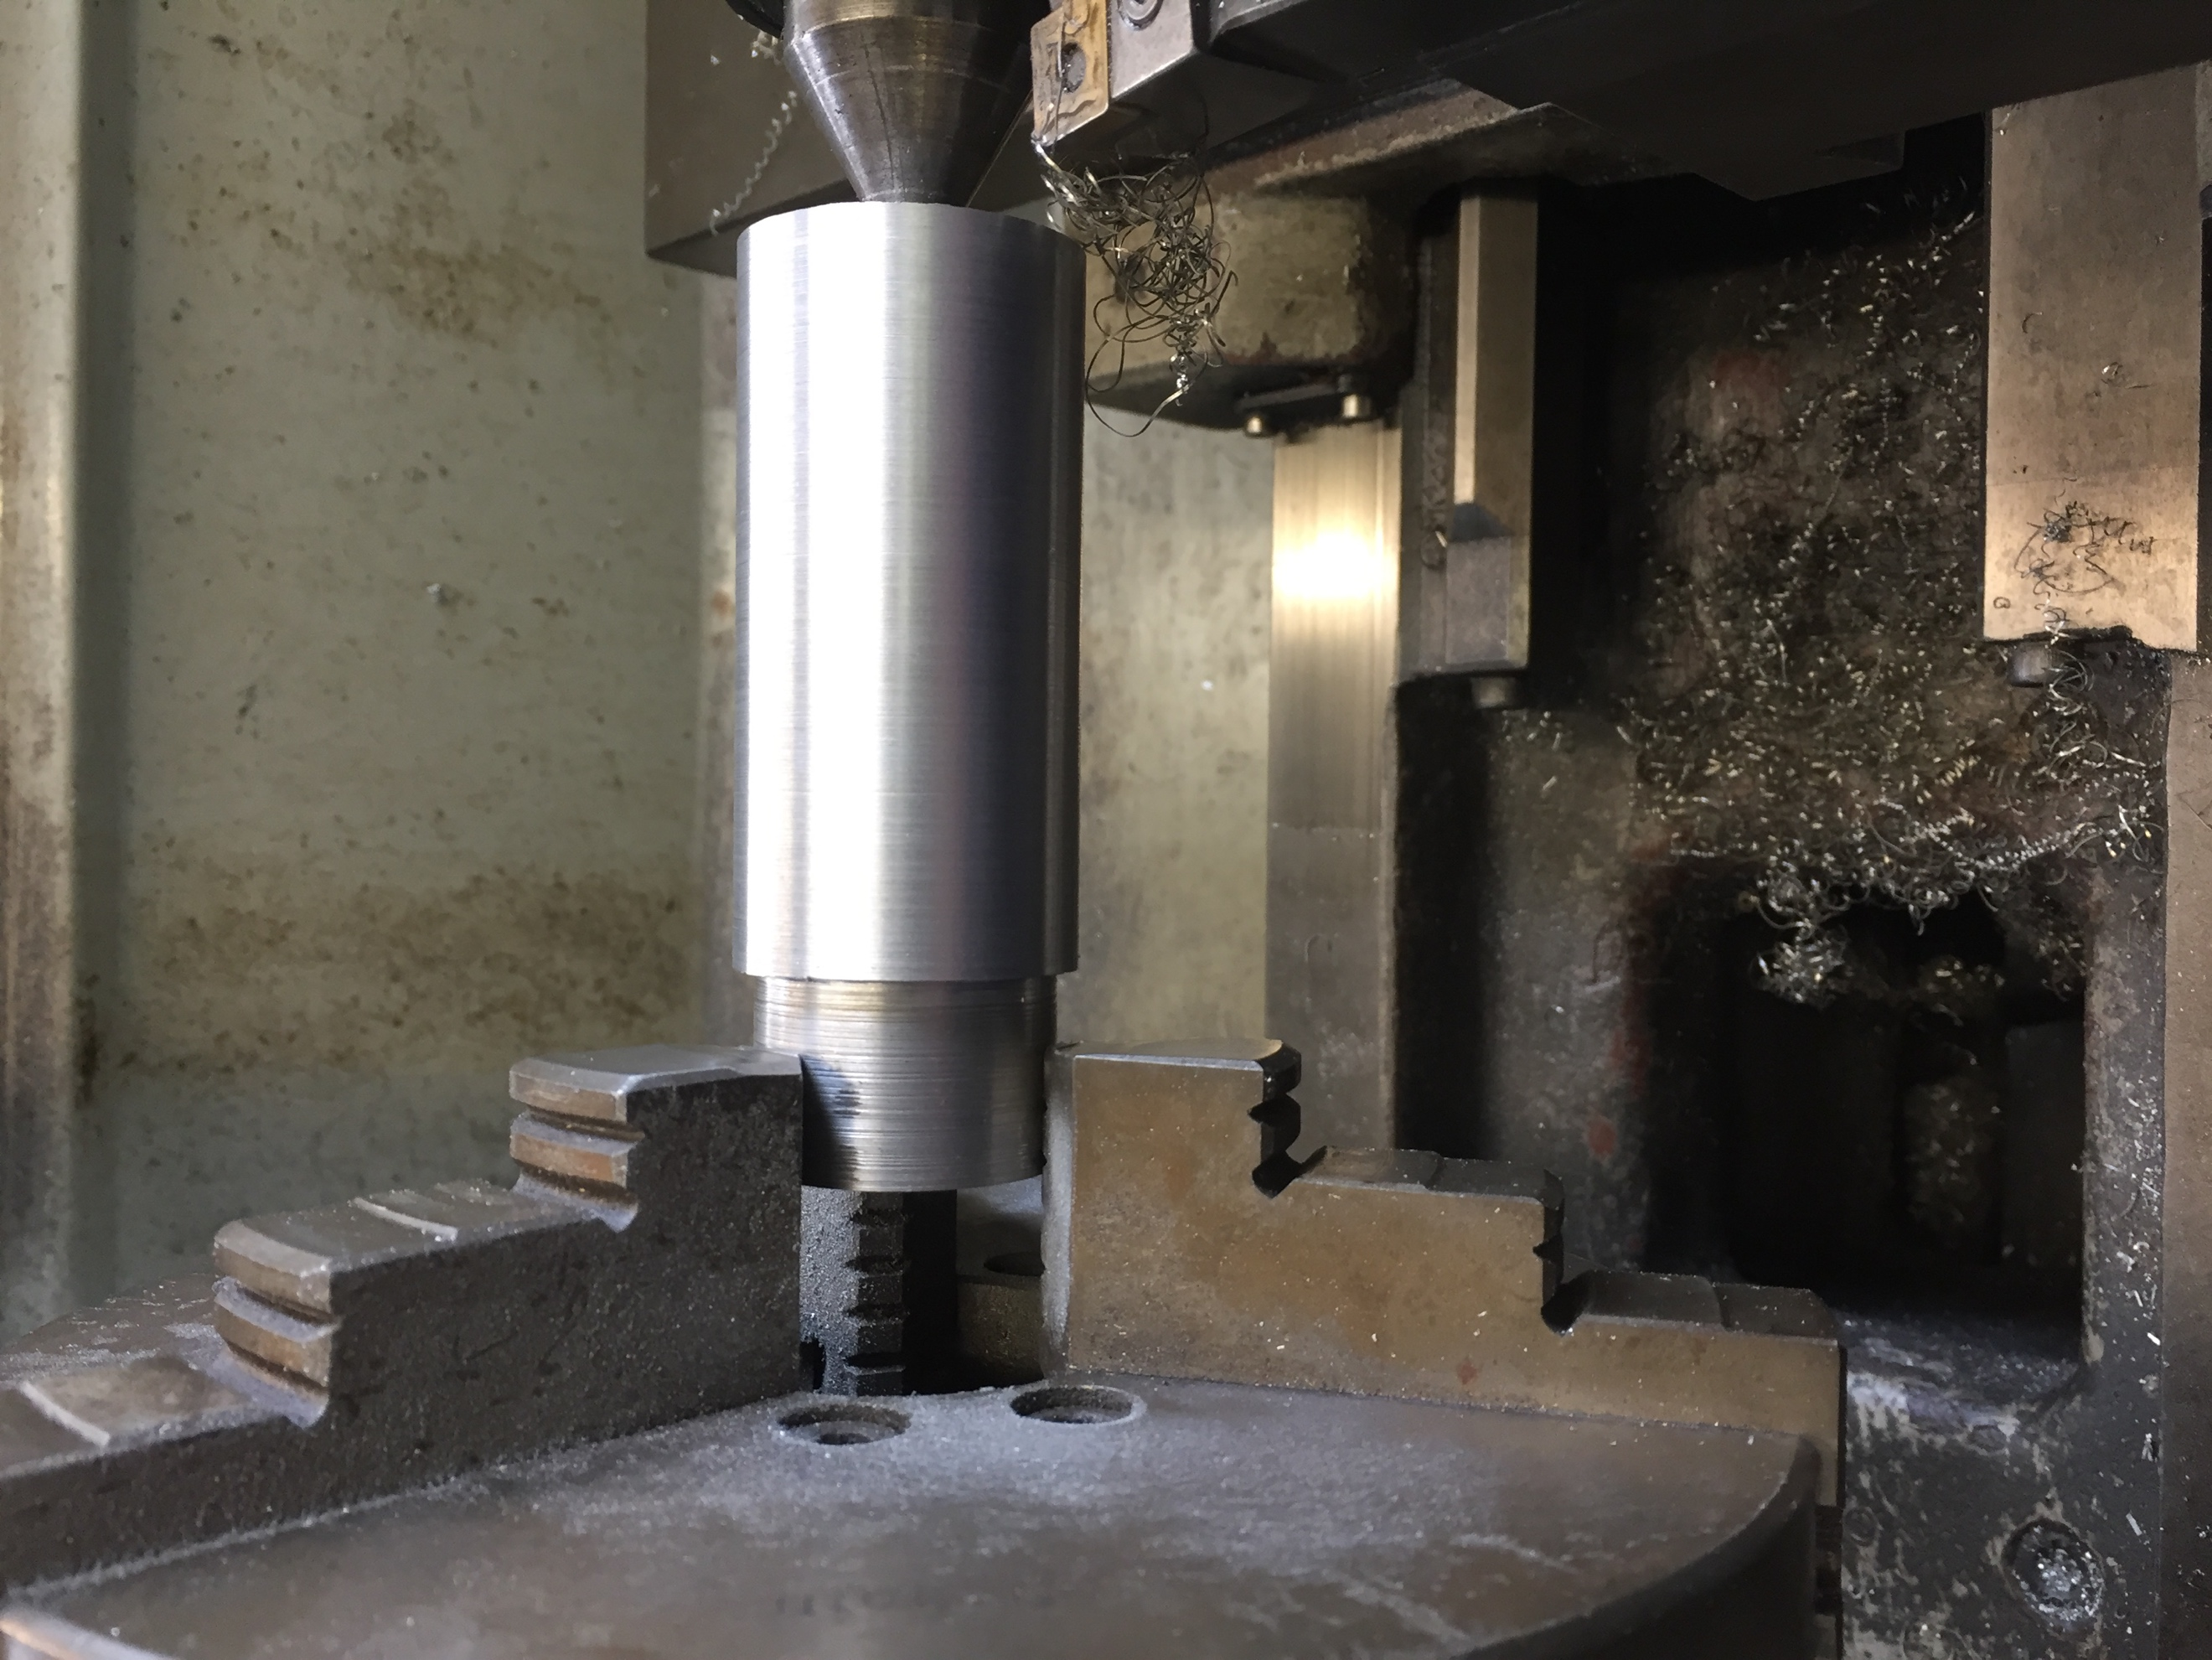 figure 1, the component fastened securely in the chuck

- The next step was to measure the component inside the chuck using a micrometer, once the width is known for certain measurements can be entered into the digital readout on the lathe. Below are photographs of the micrometer measurement and the component diagram;

Figure 2, the technical drawing Figure 3, micrometer screw gauge

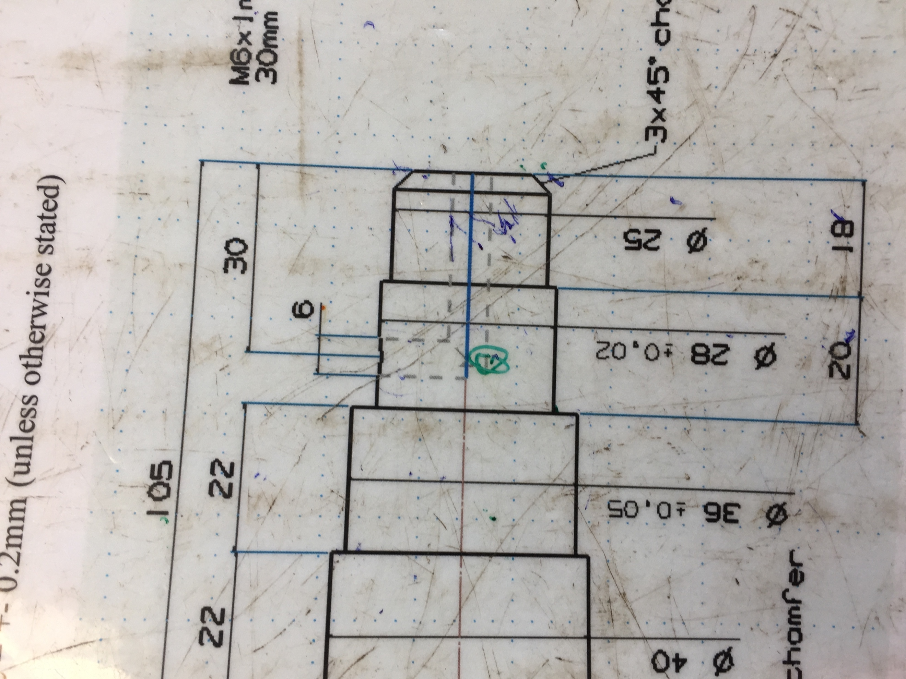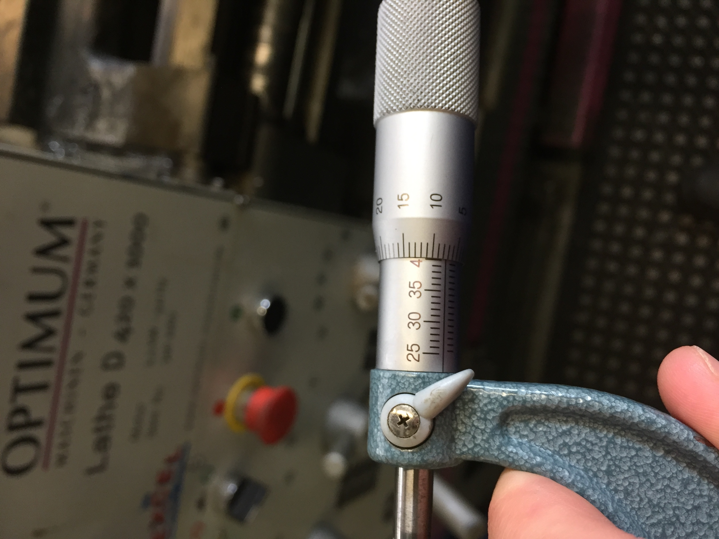

- the next step was to start cutting the component. I started the lathe using the motor lever before slowly edging the face of the component towards the cutting tool using the saddle handle. Once contact was made between the component and the cutting tool I zeroed the digital readout in the x axis.
- I then proceeded to cut along the component in 0.5 mm increments until I had reached within 0.2mm of 4mm from the first cut. I stopped the machine cutting before reaching 59.8mm from the face as excess material can be carefully removed if this does not end up within the tolerance.
- After cutting I removed the component from the machine after using the emergency stop in order to measure my cut. I checked that the cut was within the 0.2mm tolerance in terms of width and length

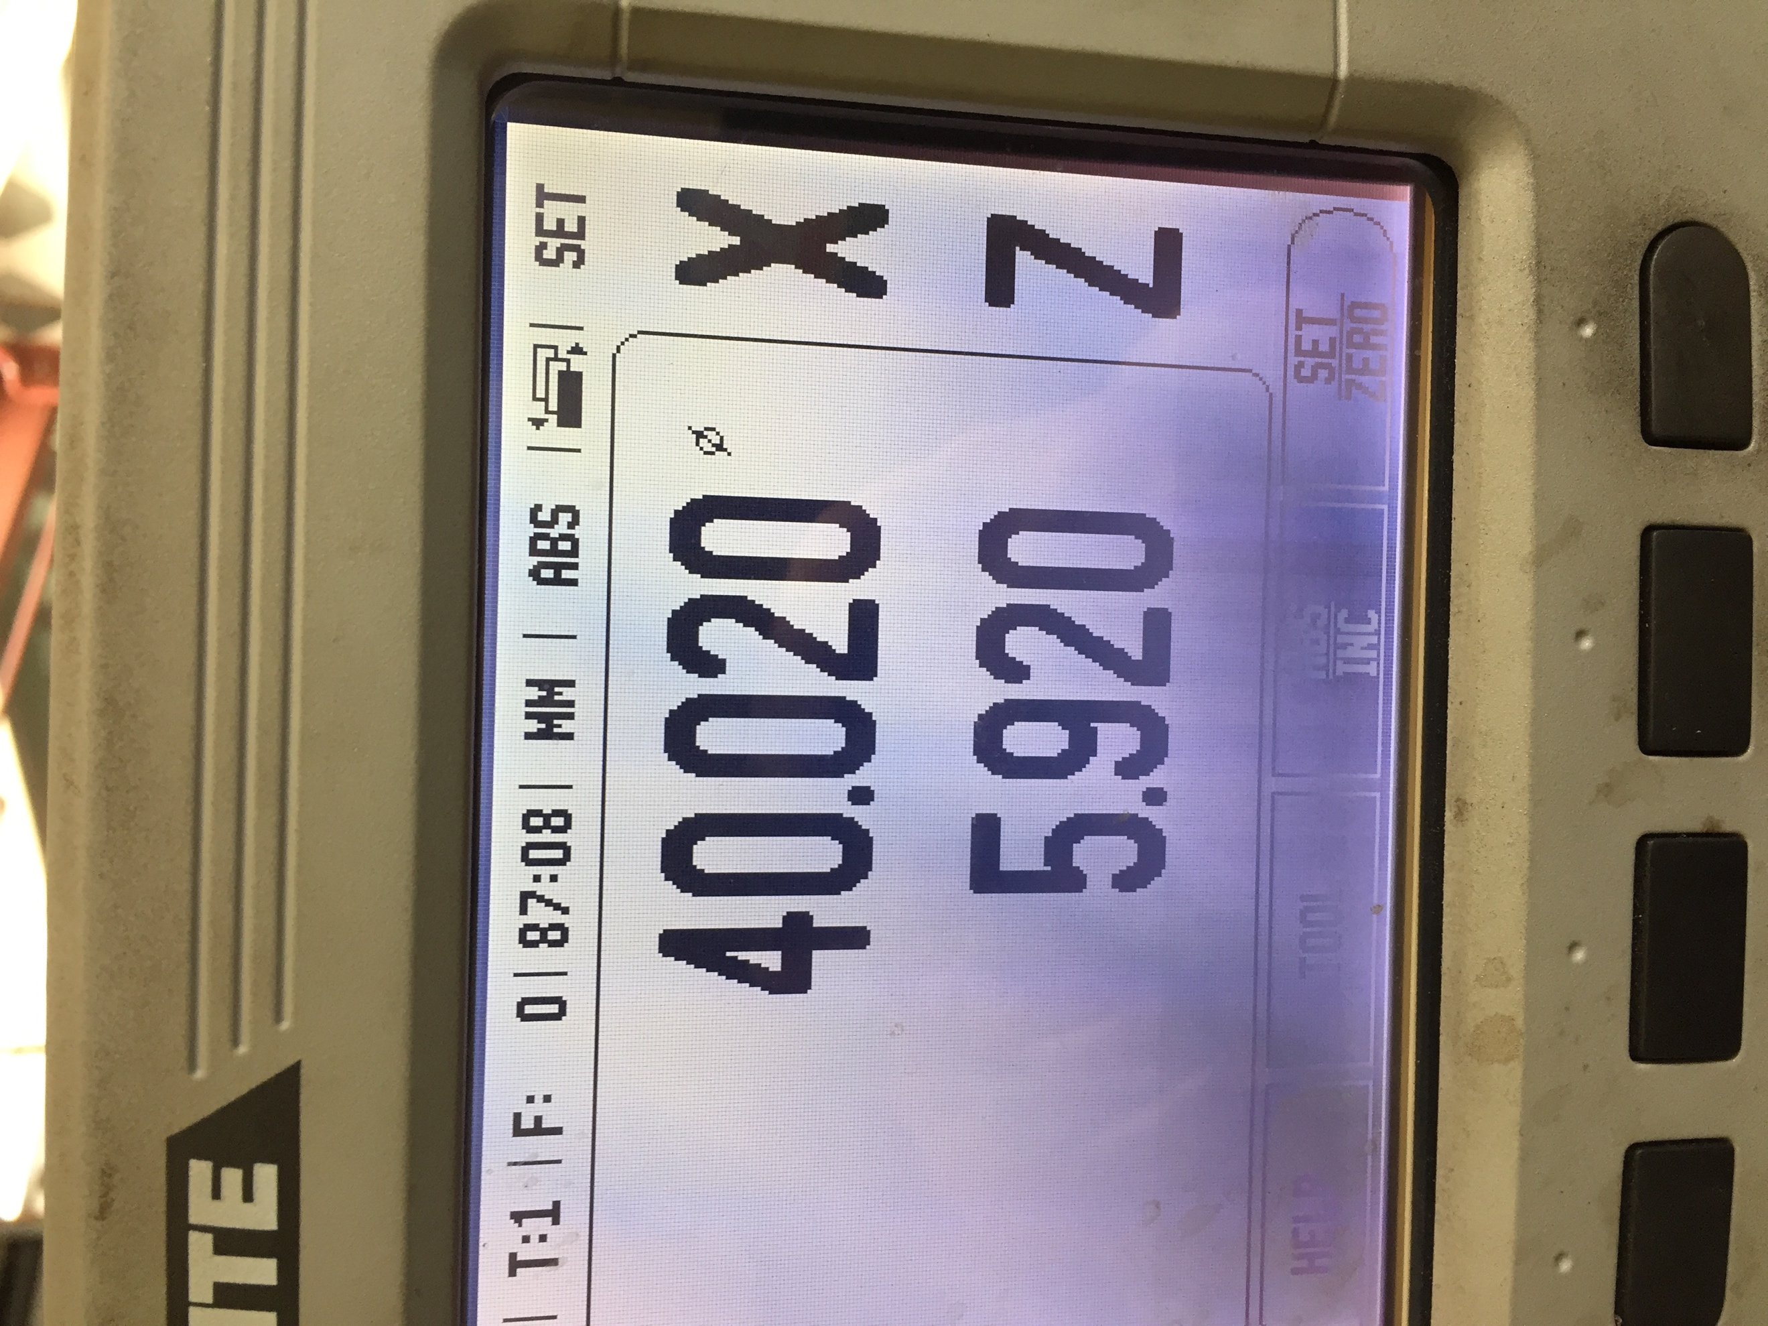Figure 4, digital readout of the lathe

Figure 6, the component being cut down for the next ‘step’

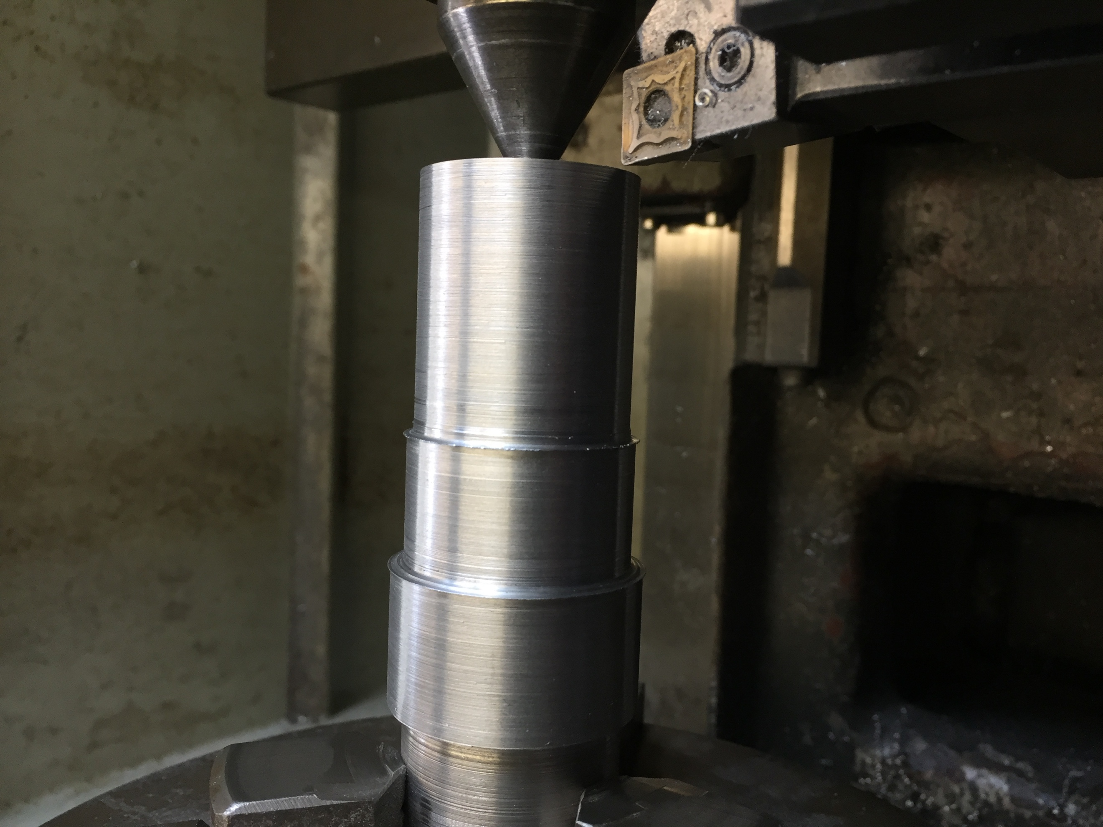

Discussion and Conclusions
In conclusion, the lathe is an incredibly useful but dangerous machine that needs to be operated carefully. Failure to follow health and safety legislation when operating such a machine can result in serious injury. In regard to my personal performance when operating the lathe, it was suggested that taking more time to slowly and smoothly release the cutting tool from the edge of the component would improve the surface finish of my component as the edges of my cuts were roughly finished.

References

Health and Safety Executive. (1999). Health and safety in engineering workshops.
V.Ryan. (2009). Retrieved 2018, from Technology Student : http://www.technologystudent.com/
WorkSafe Victoria . (2017, June ). Safe use of metal turning lathes . Retrieved from WorkSafe Victoria : https://www.worksafe.vic.gov.au

