
Applied Leadership and Management in the Workplace
Module Assignment Submission
Student Name: | Alexandra Williams
Student Number: | 2126654
Module No: | BMSK4011
Module Title: | Continuous Professional Development

Statement of Confirmation of Authenticity
By the act of making this submission, the student declares that this is the work of the student named above. The work has not, in whole or in part, been knowingly presented elsewhere for assessment, or where assessment has been built on a previous assessment, this has been identified. Where materials have been used from other sources it has been properly acknowledged. If this statement is untrue, the student acknowledges that an assessment offence has been committed.
Attention is drawn to the plagiarism and unfair practice policies of both the University and of ILM.

Table of Contents
Section 1: Know how to identify development needs 3
1.1 Identify learning styles for self and another 3
1.2 Use a simple technique for identifying development needs for self & another 4
1.3 Identify potential barriers to learning for self and another. 5
1.4 Explain how these barriers to learning can be overcome. 5
Section 2: Know how to develop self & others to achieve organisational objectives 5
2.1 Analyse learning/development options to meet needs of self & another. 5
2.2 Identify support mechanisms for the development of self & another 6
2.4 Method used to monitor the development of self & another. 8
Conclusion 8
Reflection on the Recruitment process 9
References 10
Appendix A Curriculum Vitae 11
Appendix B Continuous Professional Development Record 12

Section 1: Know how to identify development needs

I enrolled on to this course as a mature student to gain up-to-date knowledge in Leadership and Management and open up opportunities to progress outside my current role. I hope to gain a better understanding of the principles, policies and governance in relation to Leadership and Management and utilise this in my current and future role.

Time management, procrastination and confidence are where I lack. By identifying these behaviours and using the ‘Go Mad’ Model I have been able to implement an action plan and utilise ‘smart exercises’ in my daily and professional life.

1.1 Identify learning styles for self and another

This module has highlighted the importance of personal development and utilising one’s full potential by recognising and adopting different learning styles. By using the Kolb, 1984 Learning Cycle and with the use of self-reflection, I have been able to use initiative and think outside the box to complete tasks more efficiently (Kolb, 1984).
Based on my self-evaluation using the Honey and Mumford assessment, it was identified that I fell in the category of a theorist and a reflector. These categories appear to be correct upon reflection due to my traits of gathering information and analysing facts. My self-reflection structure consists of ‘what worked? what did not? and why?’ and identify areas for improvement. I consider myself cautious, empathetic, fair, and considerate of the implications that any shared data/information may cause. Whilst being mindful and cautious of sharing information, I can confidently speak up and explain my findings and opinions ensuring information is factual and accurate. I have also recognised during this assessment that my learning style is to make notes and then transcribe digitally.
My partner in this assignment was also assessed using the Honey and Mumford Assessment tool. Her results concluded that she is an Activist and Pragmatist. We collectively agree that this is a true categorization of her due to her ability to take risks, hands-on nature, and ability to proactively action ideas to complete tasks efficiently. Her learning style is hands-on, and she prefers to work alone.

CHARACTERISTICS OF THE FOUR LEARNING STYLES
(Sources: Learning Styles. FEDA, 1995; Honey & Mumford, The Manual of Learning Styles. 1992)

 | ACTIVISTS | REFLECTORS | PRAGMATISTS | THEORISTS
STRENGTHS | - Doing things  - Putting ideas into action  - Enjoy change and variety  - Flexibility  - Acting quickly | - Collection of data from variety of sources  - Looking at situations from various perspectives and grasping the big picture | - Practical application of ideas  - Integrating theory and practice  - Decision making in organisations  - Getting things done | - Creating theoretical models  - Thoroughness  - Industriousness  - Verbal skills  - Developing and working with systems
PREFERENCES | - New experiences  - Taking risks  - Getting involved in activities with people  - Getting things done | - More interested in people (how they behave and how they feel) than in structures  - To get involved directly and then reflect on the experience  - More concerned with processes than outcomes | - More interested in structural aspects of situations than in people.  - "Hands On" experience | - Dealing with ideas  - Solving problems  - To know the experts' views  - To work alone
CONCERNED ABOUT | - Personal relevance  - Doing what interests them | - Personal meaning  - The feelings of others  - Maintaining wide range of interests  - Harmony | - Testing things out to get correct solution  - Practical application of what they learn | - Details  - Quality of information  - Accuracy of facts  - Personal effectiveness  - Intellectual ability

1.2 Use a simple technique for identifying development needs for self & another

By utilising the SWOT analysis, we were able to identify personal strengths and weaknesses and discover own development needs. Using this tool enabled us to critically discuss personal attributes and behaviours and identify areas for improvement.
SWOT Person 1
STRENGTHS  - Positive Thinker  - Problem Solver  - Verbally Literate  - Friendly & Approachable  - Multitasker  - Always try new experiences | WEAKNESSES  - Personal Confidence  - Time Management  - Organisation
OPPORTUNITIES  - Further my qualifications  - Career Prospects  - Enhance my time management | THREATS  - Time Management due to work and family commitments  - Financial  - Other Colleagues
SWOT Person 2
STRENGTHS  - Leadership  - Confidence  - Lone working  - Literate  - Friendly & Approachable | WEAKNESSES  - Impatient  - Jumps to conclusions and makes assumptions  - Time Management  - Poor concentration  - Rush tasks
OPPORTUNITIES  - Leading a team confidently  - Able to work on own as well as a team  - Keeping morality up  - Good mentor | THREATS  - Loosing friends / family and support  - Loosing job or course placement  - Not able to complete assignments on time or giving full potential.
Having done a SWOT analysis, I then produced a personal GAP analysis for me and my partner.

Having completed the SWOT analysis, I was able to produce a GAP analysis for both myself and my partner. It has identified current skills and highlighted potential improvements that could be utilised to enhance learning and development needs in a personal and professional manner. This information will aid with my progression in consolidating past and new knowledge and skills learnt in current and past roles.

A Gap Analysis can be used in many ways whether personal or for business purposes. A personal gap analysis enables a person to gain a deeper understanding of one’s skills and set clear objectives and strategically develop competencies.

Gap Analysis – Person 1

Objective | Current Position | Deficiency | Action
What do I want to do? | What can I already do? | What am I lacking? | How do I fix this?
Graduate University Course | Attend classes | Time Management and concentration | Organise my time more effectively and doing smaller amounts that are more achievable
Confidence | Speak out and present in a professional or knowledgeable capacity | Self Confidence in personal and new learnings i.e around new people and new projects / university work - this takes me out of my comfort zone | Doing little by little and often to progress in assessments and going to every class and interacting more
Time Management | I just about fit everything in within my daily life but am always chasing my tail and late this making my days usually stressful | Time management and organisation | Organise my time better by preparing the night before i.e clothes / lunches and not book in so much in one day. Concentrate on work, university and school more
Start my own business whilst working part time until up and running | Life skills and supervisory skills | Experience and confidence | Gain more knowledge by completing university course, researching and time management.
Organisation | I am organised chaos; I know where everything is but often in an unorganised way. I usually mange to work proficiently but sometimes take longer than normal due to not always being as organised as I think I am | Time and organisation | Organise my time and daily plan rather than just go from one task to another and back again

Gap Analysis - Person 2
What do I want to do? | What can I already do? | What am I lacking? | How do I fix this?
Be more patient | Work in a care home and a student nurse and have professional patience as know how to control situations and show understanding and compassion to  others | Personal patience with friends and family | Work on self-control
Gain Nursing Degree | Continue to attend all classes, work placements and continue to submit assignments | Time Management | In addition to comments in the time management box - Organise time and prioritise other tasks that can wait rather than trying to fit all in in one day.
Time Management | Having a toddler, working, a student person 2 just about fits everything in within their daily life but is always chasing their tail and late thus making their days usually stressful and tiring | Time management and organisation | Person 2 needs to organise their time better by preparing the night before i.e clothes / lunches and not book in so much in one day. Concentrate on work and university more whilst maintain family balance

Completion of this analysis using the GAP and SWOT tool clearly identified strengths and weaknesses and revealed that improvements can be made by researching and utilising various methods found on google and journal articles.

1.3 Identify potential barriers to learning for self and another.

Concentration, time management and organisation are where I lack in personal and working life. My partner has a diagnosis of ADHD and lacks in these areas. It is important to note that these are all symptoms of her condition.
During this assignment I have learnt that researching external and internal barriers can aid in methods to overcome disadvantageous learnt behaviours.

My Partner | Barriers | Remedy | Myself | Barrier | Remedy
Family Time | Work, University course work and placement. | Finding a work / home balance by giving time frames and planning days that don’t overlap with family days. | Work time | Monitor Time commitment and shift patterns | Organising time in and out of work better to enable further learning and course assignments
Finance | Must work to earn living | Make cutbacks where possible. Complete university nursing course to enable graduation and potential to earn a comfortable wage and work way up over the years | Overthinking | Procrastinating and worrying | Find ways to focus more and identify and tackle worrying matters
Finance | Must work to earn living |  | Family | Constantly trying to source childcare as well as support others with childcare takes time | Pre organise dates ahead of time i.e. not the current week. This will prepare further organisation.
Finance | Must work to earn living |  | Finance | Limited finances mean I have to work extra job and this means I am tired more and loose interest in the things that really should have more attention | Complete my Management & Leadership course which will hopefully enable me to be more self-aware of managing my capabilities and enhance my career prospects.

1.4 Explain how these barriers to learning can be overcome.

It is clear from this analysis that myself my partner need to overcome similar barriers in relation to learning. We both lack in organisation, time management and struggle with procrastination.
By using Covey’s Eisenhower Time Management Matrix we could compartmentalise what was Important and Urgent and Not Important and Not Urgent for example using the format below which was taken from https://www.usemotion.com/blog/time-management-matrix
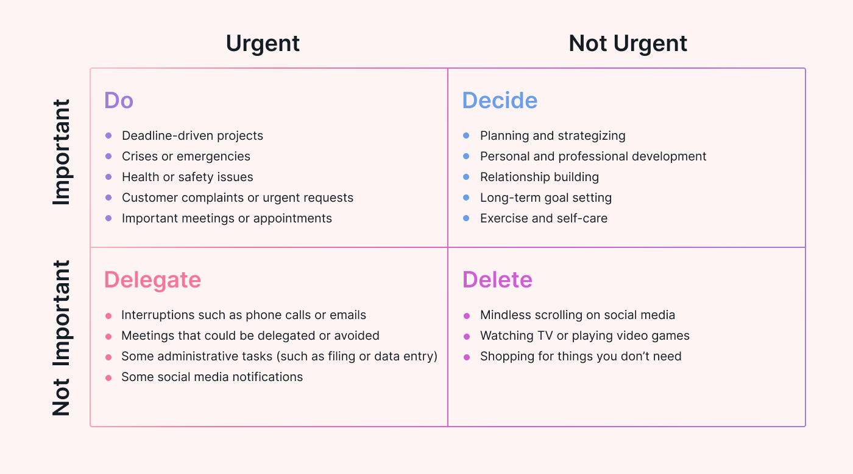

Section 2: Know how to develop self & others to achieve organisational objectives

It is important to know how to know to develop oneself and others to achieve organisational objectives. Investing in oneself and promoting other’s development can boost confidence, positively impact on self-esteem, and provide new knowledge and skills, focussing on personal development.
To enable us to develop self and others to achieve organisational objectives we must take the following into consideration:
- Learning Techniques i.e. analyse self-learning behaviours such as VARK
- Recognising current skills and knowledge
- Learning how to overcome any behaviours
- Evidencing any achievements
- Passing on new skills or knowledge to others
All the above can be researched and actioned using Google which I did and found a wide range of information and different theories that can be used.

2.1 Analyse learning/development options to meet needs of self & another.

Analysing my learning and development I would say from being a reflector I learn better by:
- Learning by listening and sharing ideas with others
- Researching and reviewing from computer to paper
- Thinking and planning in smaller sections before doing tasks
- Observing others and note taking for future reference

My negative attributes are that I lack concentration and try to fit to many things into one day. To manage and overcome this, I should prioritise and organise tasks in segments, by doing this I would complete tasks more efficiently.

I also used the Myers-Briggs Type Indicator to identify my learning styles which gave insight to how I like to learn – my result was ISTJ which I believe is quite true to my nature.

Due to my partner being an activist and pragmatist, her best learning and development would be to:

• Learning by doing
• Flexible approaches to learning
• Likes to get stuck in without wasting time
• Work on practical, relevant problems
• To use skills and tinker with things
• Clear goals and adequate rewards

My partners’ barriers for the above are she overloads herself and has a low attention span and needs to learn more patience.

2.2 Identify support mechanisms for the development of self & another

I used “Go Mad” Model / Framework using Principles 1, 2 and 3 considering internal and external factors to identify specific support mechanisms for the development of myself which I have identified above in section 1.
I also identified that support mechanisms for my development would be
- Small team working or work partner
- Online team meetings
- Study groups out of university time
- Time management
- One to one sessions
Support mechanisms for my partner would be
- One to one with her tutor
- Study groups
- Team working
- Online meetings i.e. teams

2.3 Prepare development plans for yourself and another person

A personal development plan as detailed below for myself and partner give a clear map of what we would like to do, how we can achieve, what resources we would need and how to measure the success within a time frame by setting a target date.
Personal Development Plans and Smart Objectives were used to analyse myself and my partner.

Person 1
What do I want to learn? | What do I have to do? | What support and resources will I need? | How will I measure success? | Target Date for Review
I would like to develop my skills further in team leading and management | I will need to continue to attend classes, complete modules, assignments and meet deadlines for submittal | I need to have access to a laptop to enable me to research and write assignments along with the support of my tutor and class friends. I will also need quiet time alone to reflect and work efficiently. | I will measure my success by gaining passes for completed assignments along with feedback from my tutor. | Review after each module and assignment.
Be able to write assignments including referencing | I will need to research and test myself more on my best learning approach to enable me to do this task in a professional manner. | I will need time and quiet to research a practice more hands on writing of assignments. I will also need to gain more support or reassurance from my tutor as I do not have much confidence. I will need access to a laptop and internet. | I will measure my success by requesting critical feedback from my tutor. | Review after each module.

Personal Objectives
Person 1 - myself
Short Term Goals (next 12 months)
My short-term goals, within the next 12 months would be to pass my University Course and gain further knowledge and skills that can be transferable.
Medium Term Goals (2-3 years)
Medium term Goals within the next 2 to 3 years would be to do another year on a university course to further gain higher qualifications and to have started my own side business. I have a few ideas what I would like to go towards and feel this is achievable. This is also where my training from this course will be beneficial and aid me in achieving this goal.
Long Term Goals (3-5 years)
To be in a higher management role or running my own business and be able to manage on less hours and enjoy my family and personal life a little more and be financially better off. Continue professional development for example always keeping up with training to ensure all competencies are being maintained

Person 2
What do I want to learn? | What do I have to do? | What support and resources will I need? | How will I measure success? | Target Date for Review
Graduate Nursing Course | They will need to continue to commit to study and attend work placements | The support and resources needed to enable studies, and graduation is a big barrier of childcare and balancing of another job in addition to the course work. | Success will be measured by being signed off by each placement mentor and course assignments being passed by tutors. | Targets would be each event. i.e. assignment results, placement report.
More Patient | Manage time better, sleep more | Support and resources needed would be sleeping more and keeping a realistic daily diary. | Feedback from friends and family. | Monthly review

Personal Objectives
Person 2 – my partner
Short Term Goals (next 12 months)
Graduate as a qualified nurse and gain employment in a field that is satisfying and looking for further advanced training that can be completed alongside work i.e cosmetic treatments and procedures.
Medium Term Goals (2-3 years)
Practiced nursing and attend other side courses continuously for the 2 to 3 years and gained a feel for what nursing pathway to take.
Long Term Goals (3-5 years)
Long term goals from 3 to 5 years would be to practice nursing, and have own business practicing aesthetics as well as continued professional development, seeking new procedure training to keep up with the growing cosmetic trends and maintaining a nursing registration. Have a calmer family life by only having to work part time.

2.4 Method used to monitor the development of self & another.

Methods used to monitor the development of my partner and myself were initially the Honey and Mumford Learning Style questionnaire, SWOT analyse which led onto analysing the results against our personalities and identified our individual learning styles. I also researched Brainstorming, Dantec and Kolb. I also read up on mind mapping and learnt that there are so many ways to process and different learning developments.
A good way to progress is to always monitor progression, this could be using PDP’s, Learning Logs, Performance/Personal Reviews. I would like to use a Personal Development Plan/Review to monitor my success.
An example from the internet using https://www.linkedin.com/advice/3/how-do-you-monitor-evaluate-effectiveness-3c is:
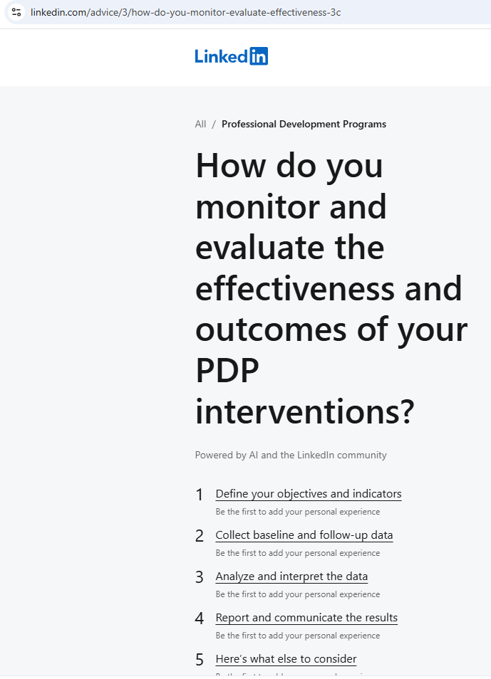

Reflection on the Recruitment process

Reflective model
I will reflect on this analysis exercise using Driscoll’s Model of Reflection (2007). With the use of subheadings “What? So what? What now?”, I will derive valuable insights from this experience with the aim of recognising what went well and where could be improved.
What?
I conducted an analysis using the SWOT, Honey and Mumford, Dantec, VARK and Myers-Briggs Type Indicator tools. The task was to identify what myself and my partner’s learning preferences and outcomes were.
So what?
By using these tools, we discovered what type of learners we are and our strengths and weakness, as well as a discussion on where we can improve.
What now?
This analysis has highlighted the importance of using a model to identify personal behaviours and strategies to overcome poor behaviours to complete tasks efficiently.

CV
A CV (Curriculum Vitae) is a description of your personal skills and knowledge, CPD, and personal attributes when applying for jobs – see Appendix A and B

Conclusion
Within this module I have self and other evaluated
- Learning Styles
- How we perform and how to manage or change to work more effectively
- What our specific goals and objectives are and how to achieve them
- How to track our achievements and goals using different resources to identify, monitor and help
- Identify were where and what we want to achieve on our progression / journey
We need to reflect because it is not sufficient to simply have life experiences, in order to learn and progress in life we need to reflect, assess or learning potential may not be reached. Using the Kolb cycle which identifies areas of needs, and therefore planning the next steps.

References

The references I used or refer to within my learning and assignment were:
Driscoll, J. (2007). Practicing Clinical Supervision: A Reflective Approach for Healthcare Professionals. Bailliere Tindall Elsevier.
Fleming, N.D. and Mills, C. (1992), Not Another Inventory, Rather a Catalyst for Reflection, To Improve the Academy, Vol. 11, 1992., page 137.
Honey, P., & Mumford, A. (1982). The Manual of Learning Styles. Maidenhead: Peter Honey.
Humphrey, A. (2005). SWOT Analysis for Management Consulting. SRI Alumni Newsletter. SRI International
Kolb, D.A. (2015) Experiential learning: experience as the source of learning and development. 2nd edn. New Jersey: Pearson Education.
Myers, I. (1962). The Myers Briggs type indicator: Manual. Palo Alto, CA: Consulting Psychologists Press.

Appendix A Curriculum Vitae

Appendix B Continuous Professional Development Record

Continuous Professional Development Plan – Alexandra Williams
Formal | Informal | Date | Duration | Status | Details
ILM Level 4 Diploma in Leadership and Management |  | 2024 | 1 Year | In Progress | ILM
L4 Certificate of HE Applied Leadership and Management |  | 2024 | 1 Year | In Progress | University of Wales Trinity Saint David
Attend Safeguarding Training |  | 2024/25 | Within 1 year | In progress | Will need to find dates out
 | Learning How to Reference using APA | 2024/25 | Within 18 weeks | In Progress | Will teach me how to research and reference
 | Time Management | 2024/25 | Ongoing | Ongoing | To be more organised and manage using various measurable modules and assessments

