

Module NaMe: Usability Engineering
Module Code: Acccb6017
Student NAME: Emriona Bushaj
Student ID: 2313944
Lecturer: Fahad Ahmed
Trinity saint david University of Wales (London Campus)

Introduction

This game is a team board game where players work together to overcome a series of global crises. Each participant takes on a specialist role with unique abilities, allowing the team to respond to emergencies, travel between locations, share resources and prevent outbreaks from spreading. Success depends on effective communication, careful planning and making strategic decisions as a group under increasing pressure .
For this project, the original concept has been transformed into a mobile game based on the University of Wales Trinity Saint David (UWTSD). Rather than fighting worldwide diseases, players cooperate to manage incidents that occur across university campuses. Working as different university specialists, they must respond to emergencies, complete shared objectives and prevent problems from escalating throughout the campus.[1]
Using a university setting makes the game more meaningful for its intended audience. Familiar locations such as the Library, Student Union, IT Centre and Lecture Hall replace the cities found in the original game, making it easier for students and staff to recognise the environment and connect the gameplay to everyday university life. Although the setting has changed, the redesigned game retains the original focus on cooperation, resource management and collective decision-making while encouraging teamwork and communication in an educational context [2].
This report outlines the early stages of the design process for the UWTSD version of Pandemic. It describes the user-centred research carried out to understand the needs of potential players, presents the developed personas, identifies and prioritises system requirements using the MoSCoW framework, and introduces the initial storyboard and low-fidelity wireframes. Together, these activities establish the basis for creating a more detailed, high-fidelity prototype in the next phase of development.

Game Story
UWTSD Outbreak: is a team-based strategy game created from the concept of the original Pandemic board game. The game takes place at the University of Wales Trinity Saint David (UWTSD) London Campus, where a fast-spreading virus has caused disruptions across multiple university facilities. Players assume the roles of different university personnel, each contributing unique skills to help manage the emergency.
The team's objective is to prevent the virus from spreading further by responding to incidents in affected buildings, supporting one another with resources and completing tasks that lead to the development of a cure. Success depends on cooperation, [2] planning and effective communication, as every player must work together to restore safety across the campus before the situation becomes uncontrollable.

Player Roles

 |  | Role | Special Ability
 |  | Cyber Security Specialist | Prevents cyber incidents from spreading and protects digital systems.
 |  | Student Wellbeing Officer | Reduces the impact of outbreaks by supporting affected students.
 |  | Campus Operations Manager | Restores damaged university facilities more efficiently.
 |  | Research Scientist | Collects research data and helps develop cures faster.
 |  | Emergency Response Coordinator | Can move another player to their location once per turn.
 |  | Library Manager | Provides additional knowledge resources, allowing teammates to complete research objectives more quickly.

Campus Buildings
The game replaces the cities from the original Pandemic board game with familiar UWTSD London Campus locations.

Storyboard
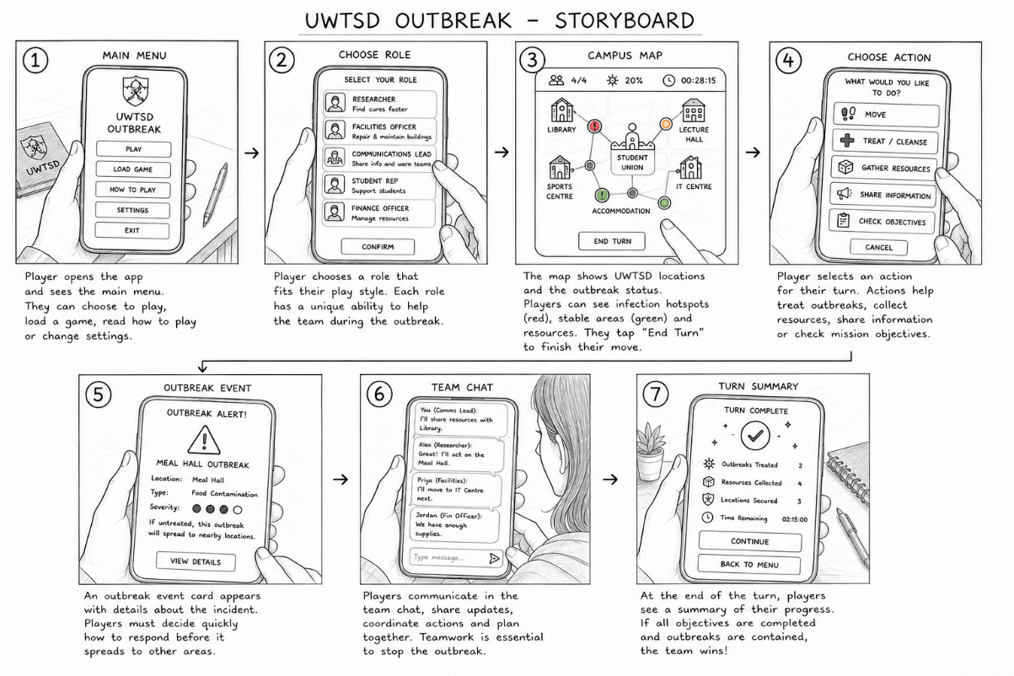

User Research
Before designing the game interface, user research was conducted to understand the needs, preferences and expectations of potential players. A user-centred design approach was followed to ensure that the interface was based on real user feedback rather than assumptions. The information gathered from the interviews was later used to develop personas, identify user requirements and influence the storyboard and wireframe designs.[3] [4]

Research Method
Four semi-structured interviews were conducted with participants aged between 23 and 33 years. The participants were asked a series of open-ended questions about their gaming experience, mobile game preferences, accessibility requirements and opinions on the proposed UWTSD Outbreak game. Semi-structured interviews were selected because they allowed participants to freely explain their experiences while ensuring that all key usability topics were discussed. [5]

Participant Information
Participant | Age | Gaming Experience
Marina | 33 | Mobile gamer
Mariana | 33 | Occasional player
Eftali | 23 | Rarely mobile gamer
Davion | 31 | Non-gamer

Interview Findings
Ease of Use
Many participants explained that they prefer games with straightforward controls and interfaces that are easy to understand. Complex menus or unclear navigation made the experience less enjoyable.
Design decision:
To address this, the game was designed with a clean home screen, clearly labelled buttons and a short tutorial to help new players get started quickly.

Collaboration
Participants consistently highlighted that working together with other players would make the game more engaging and enjoyable than playing alone.
Design decision:
The design focuses on cooperative gameplay by allowing players to choose different roles, communicate through an in-game chat and complete objectives as a team.

Accessibility
Feedback indicated that users valued interfaces with larger text, recognisable icons and layouts that are easy to read on a mobile device.[6]
Design decision:
The wireframes use simple wording, well-spaced controls and buttons that are large enough for comfortable interaction.

Preferred Session Length
Most users stated that they would be happy to play for around 20–45 minutes, as this fits around lectures and study breaks.
Design decision:
The game is structured so that a full mission can normally be completed within a single play session of approximately this duration.

Player Engagement
Participants appreciated games that clearly showed their progress and rewarded them for completing objectives.
Design decision:
Progress indicators, mission goals and an end-of-game results screen were included to provide players with regular feedback and a sense of achievement.

Summary of Findings
User Feedback | Design Solution
Users preferred straightforward controls. | A simple interface and step-by-step tutorial were created.
Readability was considered important. | Large buttons, clear text and uncluttered screens were used.
Cooperative play was highly valued. | Team-based gameplay with role selection and chat functionality was included.
Players wanted clear goals throughout the game. | Mission objectives and an outbreak progress tracker were added.
Shorter game sessions were preferred. | Missions were designed to last approximately 20–45 minutes.
Players enjoyed seeing their achievements. | Progress tracking and a mission summary screen were incorporated.

Influence of the Research on the Design
The information gathered during the user research played an important role in shaping the design of UWTSD Outbreak. The participants' responses helped identify the main expectations and usability needs of potential players, which were then used to create four representative personas. These findings also informed the prioritisation of system requirements using the MoSCoW method. Furthermore, the storyboard and wireframes were developed to reflect the preferences expressed during the research, such as clear navigation, accessible layouts and cooperative gameplay. Applying a user-centred design approach helped ensure that the proposed interface is both practical and enjoyable for its intended audience.[7]

The interview findings directly influenced the design of the UWTSD Outbreak game. Participants consistently emphasised the importance of simplicity, accessibility, teamwork and clear objectives. These findings guided the creation of the personas, the MoSCoW prioritisation, the storyboard and the low-fidelity wireframes. As a result, the proposed design follows a user-centred design approach by ensuring that key interface decisions are supported by evidence collected from potential users.

Personas

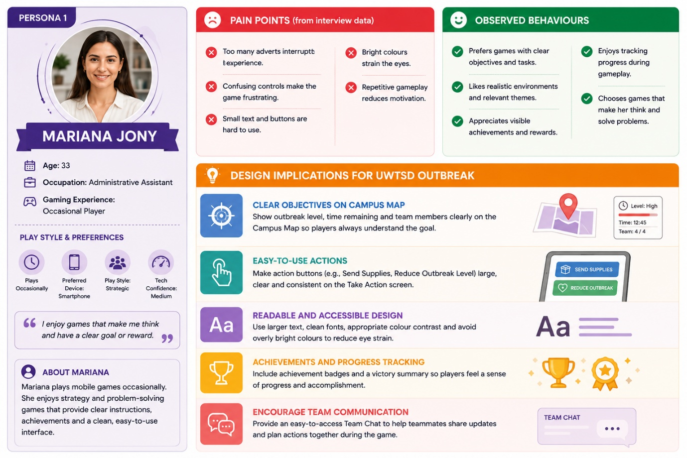

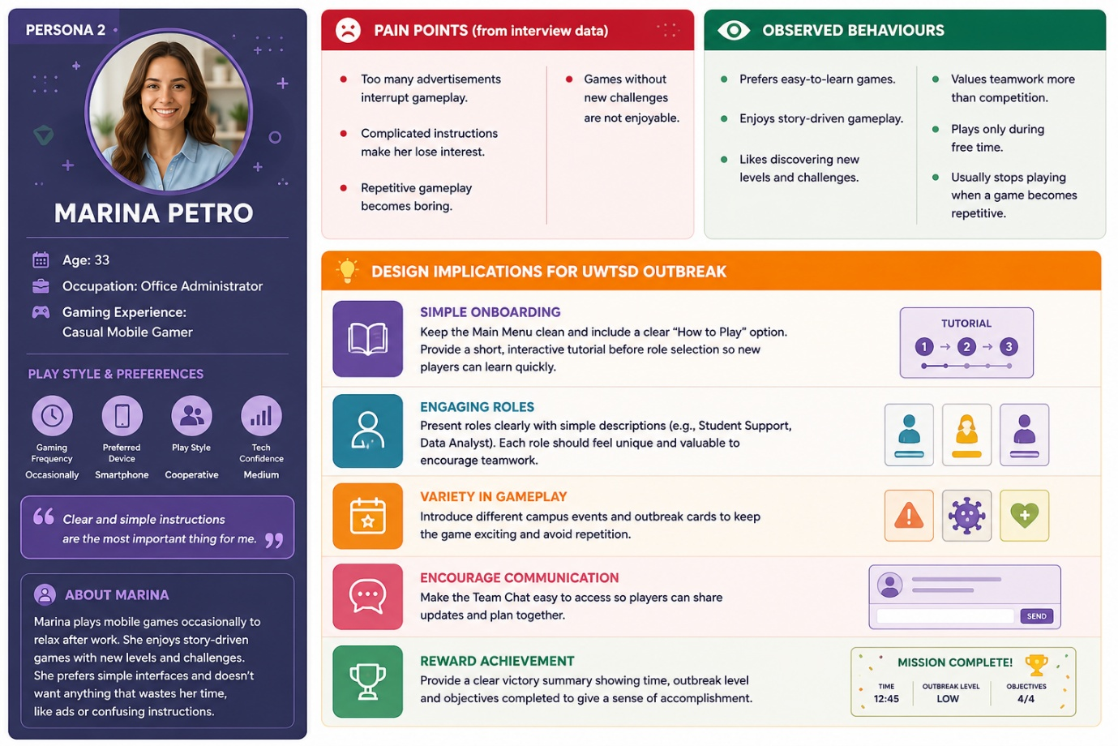

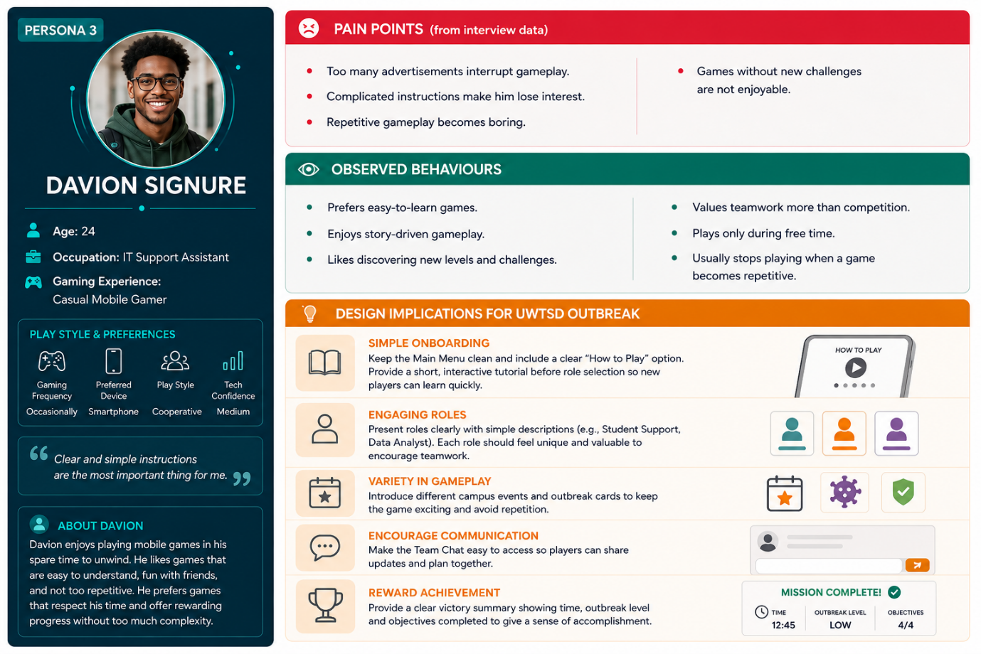

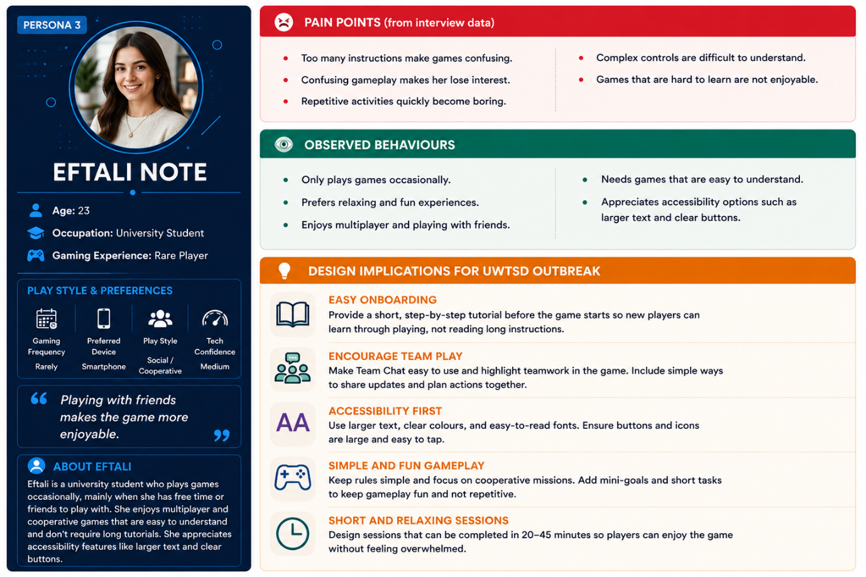

(MoSCoW)

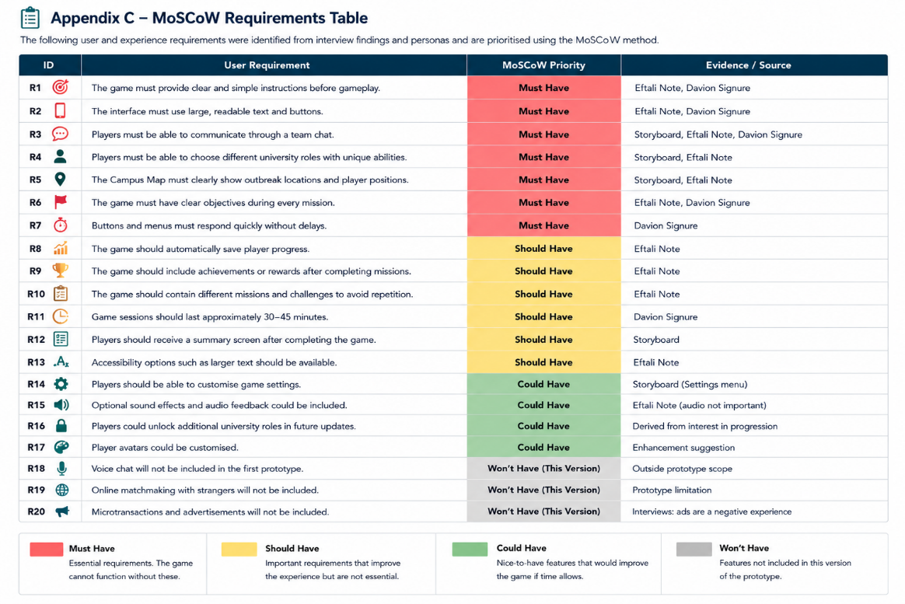

Low-Fidelity Wireframes

Wireframe Storyboards
The initial wireframes were produced to demonstrate the structure and key functions of the UWTSD Outbreak mobile game before creating a detailed visual prototype. Rather than focusing on colours or visual styling, these wireframes concentrate on screen layout, navigation, user interaction and the organisation of interface components. Their design was guided by the findings from the user interviews, the developed personas and the prioritised requirements identified through the MoSCoW analysis.

Home Screen
Home Screen Wireframe
Description
The Home Screen is displayed when the application is launched. It acts as the starting point of the game, allowing players to begin a new mission, continue a previous game, access the tutorial, modify settings or leave the application.
Design Justification
The layout uses a small number of clearly labelled buttons arranged in an easy-to-read format. This approach reduces confusion for new players and allows them to find important options quickly. Feedback collected during the research showed that users preferred interfaces that were straightforward and required very little effort to understand.

Character Selection
Character Selection Wireframe
Description
Before entering the game, players select one of the available university characters. Every character offers a different ability that contributes to solving campus incidents and supports cooperation within the team.
Design Justification
Each role includes a short explanation describing its purpose, enabling players to compare abilities before making a decision. This encourages players to build a balanced team and supports the collaborative gameplay that participants identified as an important feature.

Campus Map
Campus Map Wireframe
Description
The Campus Map provides an overview of the university buildings where incidents may occur. Players can monitor affected locations, move around the campus and decide which area requires attention first.
Design Justification
The screen was designed to present essential information without overwhelming the user. Recognisable campus buildings make navigation more intuitive, while the simplified map allows players to understand the current situation at a glance.

Action Menu
Action Menu Wireframe
Description
During a player's turn, the Action Menu displays the available activities, including moving to another location, resolving incidents, sharing resources with teammates and reviewing mission objectives.
Design Justification
Frequently used actions are grouped together to reduce unnecessary navigation and improve efficiency. Large interactive buttons and consistent positioning make the interface easier to use on mobile devices and improve accessibility.

Incident Card
Incident Card Wireframe
Description
The Incident Card appears whenever a new campus emergency occurs. It provides information about the location, severity and impact of the incident, helping players decide how to respond.
Design Justification
Important details are displayed using clear headings, simple wording and easily identifiable icons. This allows players to quickly understand the situation and react without interrupting the flow of the game.

Team Chat
Team Chat Wireframe
Description
The Team Chat allows players to exchange messages, coordinate their plans and update each other throughout the mission.
Design Justification
Research participants highlighted communication as one of the most enjoyable aspects of cooperative games. Including a dedicated chat feature encourages teamwork, supports collaborative decision-making and helps players organise their strategies more effectively.

Mission Complete Screen
Mission Complete Wireframe
Description
The Mission Complete screen is shown after the team successfully finishes the mission. It provides an overview of the team's performance, including completed objectives, remaining time and overall results. Players can then continue to another mission or return to the main menu.
Design Justification
Providing a summary at the end of each mission allows players to review their achievements and understand how well the team performed. This type of feedback gives players a stronger sense of accomplishment and motivates them to replay the game and improve their performance.

Storyboard Feedback
Positive Feedback
- The storyboard is easy to follow, with a clear sequence from the main menu to the mission completion screen.
- The wireframes are clean and uncluttered, making the interface simple to understand.
- The use of university buildings creates a realistic setting that relates well to UWTSD students.
- Different player roles encourage teamwork and make the game feel more collaborative.
- The action buttons are large and clearly labelled, making them easy to use on a mobile device.
- The Team Chat screen supports communication, which is important in a cooperative game.
- The Mission Complete screen provides useful feedback on player progress and achievements.
Constructive Feedback
- A tutorial could include more visual guidance for first-time players.
- The Campus Map could use clearer indicators to show which buildings are currently infected.
- Different icons could be used to distinguish between player locations and outbreak locations more easily.
- The Action screen could briefly explain what each action does before the player confirms it.
- Adding a progress bar showing how close the team is to finding a cure would improve awareness.
- The Incident Card could include colour or symbols to represent different severity levels.
- The Team Chat could allow players to send quick preset messages, such as "Need help" or "Heading to the Library."

Conclusion
This project has outlined the early stages of designing UWTSD Outbreak, a cooperative mobile game developed from the concept of Pandemic and reimagined for the University of Wales Trinity Saint David. Throughout the project, a user-centred design approach was adopted to ensure that the proposed interface reflected the expectations and preferences of its intended users instead of relying solely on design assumptions.
Information gathered during the user research provided valuable insight into the features that participants considered most important. Simplicity, accessibility, effective teamwork and clearly defined objectives emerged as the main priorities. These findings informed the development of the user personas, the prioritisation of functional requirements using the MoSCoW framework, and the production of the storyboard and low-fidelity wireframes. Consequently, the design decisions made throughout the project were supported by user feedback and recognised usability principles.
The resulting wireframes demonstrate a simple and accessible interface that promotes cooperation between players while incorporating recognisable university locations and campus-based roles. Although the prototype currently represents an early design concept, it provides a solid starting point for further development and refinement.
Future work will focus on transforming the wireframes into a fully interactive high-fidelity prototype. Additional usability testing involving a wider range of participants will also be carried out to evaluate the effectiveness of the interface, identify areas for improvement and enhance the overall user experience before implementation.
In conclusion, this project highlights the value of involving users throughout the design process. By applying established Human-Computer Interaction (HCI) principles alongside user feedback, it has been possible to design a game concept that is not only functional and accessible but also engaging and relevant to the UWTSD community.

References
[1] Z-Man Games, Pandemic. [Online]. Available: https://www.zmangames.com/en/games/pandemic/. [Accessed: Jul. 25, 2026].
[2] D. A. Norman, The Design of Everyday Things, Revised and Expanded ed. New York, NY, USA: Basic Books, 2013.
[3] J. Preece, Y. Rogers, and H. Sharp, Interaction Design: Beyond Human–Computer Interaction, 5th ed. Hoboken, NJ, USA: John Wiley & Sons, 2019.
[4] B. Shneiderman, C. Plaisant, M. Cohen, S. Jacobs, N. Elmqvist, and N. Diakopoulos, Designing the User Interface: Strategies for Effective Human-Computer Interaction, 6th ed. Harlow, UK: Pearson, 2018.
[5] S. Krug, Don't Make Me Think, Revisited: A Common Sense Approach to Web Usability, 3rd ed. Berkeley, CA, USA: New Riders, 2014.
[6] J. Brooke, "SUS: A 'Quick and Dirty' Usability Scale," in Usability Evaluation in Industry, P. W. Jordan, B. Thomas, B. Weerdmeester, and I. McClelland, Eds. London, UK: Taylor & Francis, 1996, pp. 189–194.
[7] International Organization for Standardization, ISO 9241-210:2019 Ergonomics of Human-System Interaction—Part 210: Human-centred Design for Interactive Systems. Geneva, Switzerland: ISO, 2019.

