MY REPORT ON UNDERSTANDING AND ENGAGING IN CUSTOMER EXPERIENCE

“How do internal and external factors including COVID-19 affect or influence organisation’s quality systems and controls for customers and how the organisation can deal with the new situation and achieve its business objectives by developing and maintaining good customer relationship

Teletha Duberry
Student I.D - 1917189
Understanding and Engaging in Customer Experience
Term 1 Assignment
Lecturer: ZeZook

TABLE OF CONTENTS

1. |  | Executive Summary | Pg.3
2. |  | Introduction | Pg.4,5
3. |  | Egg Free Cake Box | Pg.5
 | 3.1 | Business objectives | Pg.5
 | 3.2 | Operational Highlights | Pg.6
 | 3.3 | Franchisee Store Highlights | Pg.7
 | 3.4 | Current Trading and Outlook | Pg.7
4. |  | SWOT Analysis | Pg.7
 | 4.1 | PESTEL Analysis Information | Pg.8
 | 4.2 | Michael Porter’s Five Forces | Pg.12
 | 4.3 | QSM- Internal Audit | Pg.14
5. |  | Customer Relations and Digital Marketing | Pg.15
 | 5.1 | AIDA Model | Pg.16
6. |  | Conclusion and Recommendations | Pg.19
 |  | References | Pg.20
 |  | Appendices | Pg.21

Executive Summary

Besides many other internal and external factors, Covid-19 has certainly been a major factor for organisations over the last year. For some, product control took precedence over customer relations, but in this current climate, focusing more on customer relations and maintaining their position in the market.
Did Cake Box have to shift focus much?
This report will show how much customers have always been at the forefront of priority for this brand and how digital marketing strategies highlighted in the AIDA Model have helped them to maintain their customer relations.
With annual internal audits, they continue to improve and implement where required and this quality system management proves effective an efficient.
But have Cake Box prepared for the future impacts of external and internal factors including the Pandemic?
We did a SWOT and PESTEL analysis in this report to highlight the concerns, risks and mitigations when it comes to preparing for further external and internal factors, as some issues remain uncertain for many organisations. Regardless of the continuous growth in sales and revenue, ‘Porter’s Five Forces Model’ was used to identify the competition and threats in the industry, and foresee whether Cake Box are at risk or if their unique Franchisee method will keep them in the lead of the UK’s largest cake business.

Introduction

Egg Free Cake Box also known as Cake Box Holdings PLC for stakeholders, is the UK’s most favourite cake brand, and currently soaring in sales and popularity. Specialising in a unique egg free cake recipe, the brand aims to keep their customers happy by providing cakes for all types of occasions and daily consumptions. Early in 2020, the Pandemic surprisingly approached us and this organisation was forced to close all of their branches for business when they were considered ‘non-essential’ in the early stages of the Pandemic, leaving Franchisees uncertain about the unforeseeable.Eventually, they were allowed to re-open branches for ‘click & collect’ service, and later joined other food businesses on food delivery apps such as Uber Eats, Just Eat etc. allowing them to still produce cakes for everyday consumption as well as special occasions, ensuring that they maintained the foundation of their customer relations.
In a competitive market where dessert stores and celebratory cakes services are popular and in high demand, Cake Box was at risk of suffering a major impact if they didn’t expand their services.
Although they produced a unique recipe for their cakes, separating them from many high street cake franchises in the UK, customers’ needs heavily switched to convenience and high demand with online purchases being the main point of sales for many organisations.

The purpose of this report is to highlight how internal and external factors, including Covid-19 has affected or influenced, Egg Free Cake Boxes quality and control systems for their customers. We hope that this report cold be beneficial for other organisations or any one intending to start a business during this current climate.
In the first section, we will get some insight on Egg Free Cake Box’s history, operational, financial and current trading highlights, produced from their 2020-2021 annual report. This report will provide evidence of this organisations growth through Covid-19, and briefly identify what development strategies were put into action, in order to make these results attainable.
Information will be produced from both a SWOT and PESTEL analysis that was carried out on this organisation to identify external/internal factors that are possibly having an adverse/positive effect on the brands representation and customer relations.
In addition to these findings, we used the ‘Porter’s Five Forces’ framework to analyse Egg Free Cake Box’s competitors and what factors are currently influencing the brands profitability.

In the second section of this report we will look at what quality system is in place and the procedure or strategy they are currently using to operate business, finances and customer relations, and if it was deemed beneficial when it came to adapting to the ‘new normal.’ This will align with Egg Free Cake Box’s business objectives and briefly identify their main focuses that drive the success of the brand.

The final section of this report will further look into how this organisation engages with their customers via Internet marketing to maintain customer relations. This will be identified by the ‘AIDA Model’ which will show how Cake Box engages with existing and new customers through digital marketing as well as standard marketing. We aim to end this report by gaining a full perspective on this organisations business objectives, resilience towards the internal/external factors and procedures put in place to ensure the growing success of the brand.

Egg Free Cake Box

Egg Free Cake Box is a Franchise and PLC (Cake Box Holdings PLC) founded by Chief Executive SukhChamdal, who is also a Shareholder along with Chief Financial Officer and Executive Director Pardip Kumar Dass and Chief Operating Officer and Executive Director Jaswir Singh, with an addition of 7 other companies.
Egg Free Cake Box is the UK’s largestcake franchise, serving customers celebratory fresh cream cakes made from an egg free recipe. The idea for this brand initiated from the Founders’ daughter who requested an egg free cake as she followed a strict diet. Referring to themselves as the ‘Cake Box Family’ this organisation runs their business with a family orientated culture, as they place confidence in the success of the brand being a result of broadening their family circle, by including employees, franchises and customers, as well as staying committed and loyal to the brand.
This organisations’ growth patterns are a representation of the resilience they have the ability to maintain, regardless of any economic impacts in the market. Egg Free Cake Box opened their first store in East London in the midst of the 2008 recession and continued steady growth of expanding their franchises moving forward.

3.1 Business Objectives

Cake Box believes that our Environmental, Social, and Governance policy is about responsibly maintaining an obligation to consider the interests of our customers, employees, shareholders and communities. We must also consider our impact on the environment and the social consequences of our business activities. By continuing to adopt these values we believe that we have a significant contribution to our core business processes and stakeholder management.This will help us achieve our ultimate goal of creating a fully sustainable and ethical business that will also help the less fortunate and promote equality for all. (Egg Free Cake Box, 2021, p. 20)

Communities
This organisation takes great pride in putting back into the community, supporting investments for community purposes and education by sometimes volunteering cakes for charitable cause. Cake Box recently donated £10,000 to its local authorities’ Business Hardship Fund to give support to small businesses who did not meet the requirements for Government support throughout the pandemic.
In addition to their generous hands, this organisation also operates a ‘Hot Kitchen’ every Wednesday from October – April on a yearly basis, to feed the homeless and those in need.
Back in India, the Directors sponsor a free dispensary where they provide tests, medicines and check-ups free of charge for the whole village, as well as annual eye and cancer camps. Cake Box franchisees introduced a Charity Matched Giving Policy for staff at Head Office, which is a scheme that means any funds raised by staff members will be matched by the organisation. (Egg Free Cake Box, 2021, p. 21)

Environmental
Cake Box believe in being considerate in their supplies and ingredients when it comes to protecting the environment, and will not make any transactions for supplies from company’s who do not have a sustainability programme in place. They are constantly reviewing product ingredients to ensure that they meet their criteria. (Egg Free Cake Box, 2021, p. 21)

Plastics
By 2022, his organisation aims for over 90% of their plastic packaging to be recyclable and biodegradable. (Egg Free Cake Box, 2021, p. 21)

Carbon Footprint
To reduce carbon footprint, Cake Box strategically opened their distribution centres with 90 minutesdistance of their stores in both Coventry and Bradford. This also helps to reduce the maintenance of vehicles and diesel mileage.
They have also implemented bulk waste collection to rid of unwanted waste, which includes industrial containers to dispose of general waste and cardboard on site, at the new distribution centres.
To reduce energy consumption, Cake Box have also installed LED lights in offices and the distribution centres. Electric ovens were also replaced with gas ovens to make baking more efficient as well as reducing emissions.
In addition to the previous mentioned, they have a printer cartridge recycling facility to contribute to consumable items waste. (Egg Free Cake Box, 2021, p. 21)

3.2 Operational Highlights 2020 - 2021
- £21.9m revenue (+16.9%)
- Gross Profit of £10.9m (+23.8%)
- Earnings per Share – 8.4p (+7.7%)
- Online Sales Growth – 84%
- Launch of Delivery Platform complementing third party delivery and Click and Collect Service
- 24 New Franchises as of 31/3/21
- 21 Kiosks
- New Product Launches – Eggfree custard & more gluten free options
- Provision of £486k made for fines and related expenses as a consequence of a website data breach in 2020. (Egg Free Cake Box, 2021, pp. 2,3)

3.3 Franchisee Store Highlights 2020-2021
- Total turnover - £42.7m (+17%)
- Online Sales - £9.4m (+71%) (Egg Free Cake Box, 2021, pp. 2,3)

3.4 Current Trading and Outlook
- 9 Franchise stores opened in the first quarter
- 18-24 Franchise Store openings predicated on a recorded number of deposits from impending franchisees. (Egg Free Cake Box, 2021, pp. 2,3)

Based on these highlights, Egg Free Cake box has continued to grow throughout the Pandemic, proving their resilience, with delivery sales increasing to and estimation of 500,000 per month by March 2021. This brand has continued to maintain high standards when it comes to their products, ensuring that their delicious recipe and ethically sourced ingredients remain the same to control the quality and value.

Appendix A

4. SWOT Analysis

The SWOT analysis undertaken in this report for Cake Box, helped us to get a practical insight on the organisations future in the market. Based on the results produced, Cake Box have a great opportunity for success and further growth as this analysis highlights more strengths and room for opportunities in the industry.

Strengths
- ‌Consistent growth in Revenue
- ‌Unique Cake Recipe
- ‌Social Media Engagement
- ‌Own online delivery services
- ‌Third party delivery services
- ‌Economical Resilience
- ‌Growth in online sales
- ‌Franchisees Increasing all over the UK
- ‌Product development - Consumer Trends
Weaknesses
- ‌Online Live website Assistance
- ‌Novelty Cakes
Threats
- ‌Similar Brands
- ‌Cyber Attacks
- ‌Covid-19 Restrictions
- Brexit Economical Change
Opportunities
- ‌International stores and operational branches
- ‌Increased shares
- ‌Growth in the stock market

4.1 PESTEL Analysis Information

The PESTEL analysis was used to identify external and internal factors currently and potentially impacting on this organisations success. Some information was gathered and analysed from CAKE BOX’s strategic report (Egg Free Cake Box, 2021, pp. 24,25) where they produced organisational strategy to mitigate various levels of risks and concerns that they are currently facing or could potentially face, based on external factors and managing of internal factors.

Political

- Covid-19 (External)
Cake Box has analysed the potential impact of the Government announcing and inciting another lockdown, which could yet again impact on business by causing temporary closure. Although this is a medium/low risk of concern, this organisation has a firm balance sheet to forecast any further lockdown that could possibly occur. The current government regulation across the UK, is ensuring that businesses are operating under very firm guidelines.
Based on earlier highlights and information in this report, it is evident that Cake Box have managed to safely operate as a good business throughout the lockdown, through the recent implementation of their own delivery service.

- Brexit (External)
Brexit has caused and uncertainty in Sterling, which can impact on the prices in purchases being incalculable, and this could possibly cause a reduce in customer spending. Fortunately, the Cake market has not been heavily impacted as much as others, so Cake Box additionally increased their stock levels and additionally searched for alternative suppliers in the UK who’s supply chains are dissimilar. They also extended international orders by building a three week median time due to delays in importation.

Economical

- Increase in Disposable Income (External)
Fortunately for Cake Box, the Food Industry’s overall revenue has been rapidly growing, due to individuals saving and generating more income during the Pandemic due to not being able to partake in many recreational activities. This meant that there was more disposable income for food, out of boredom, comfort and the heavy impact that many suffered as a result of Covid-19. Furthermore, the most anyone was able to celebrate was at home, making brands like Cake Box’s products and services very much needed in this time.

- Employment (Internal)
Stability in employment is uncertain during this current climate, as the impacts of Covid-19 are vastly having an effect on employee’s physical, mental, emotional and physical health. Cake Box have ensured employees by complying with Government and NHS guidelines and regulations, that they will be safe at work and practice excellent health and hygiene.

- Fuel Price Increases (External)
Cake Box’s services cannot operate without the transportation of their products. Products are delivered to franchisees via their branded cake vans/cars from the operational sites, and additionally their delivery services. As fuel prices start to increase, this could mean increased prices on products for this organisation in order for franchises to maintain a healthy profit margin.

Social Impact

- The aptitude to recruit and sustain proficient franchises (Internal)
It may be challenging for Cake Box to captivate and maintain new franchisees that are appropriate for the brand in vacant and suited locations.
Due to this, their recruitment and vetting process is very meticulous and they have greatly become experienced in scoping out a suitable franchisee.

Cake Box implemented an exclusive franchise concept to the UK’s high street, with a 154 franchise branches successfully open and currently in operation, they are further working towards a total of 250. Egg Free Cake Box is looking for business partners with a similar work ethic, to be a part of their success.
They are accepting applications all across the UK, but especially from Scotland, South Wales and the South of West of England.
Cake Box looks for like-minded individuals to join and be a part of the brands’ success and growth. By adhering to the brands established business model and being flexible towards new developments, these individuals will be considered suitable for the ‘Cake Box Family.’ Along with the standard business acumen, this brand is looking for:
- A genuine commitment to providing the highest quality Eggfree cakes to a diverse range of customers and communities
- Individual Franchisees, not partnerships
- Dedicated and motivated to providing the highest levels of customer service in a retail environment
- Leaders – You will have to manage your employees
- Team players – franchising is all about the wider network and you will become part of a supportive ‘family’ of Franchise Owners
- Well organised and disciplined
- People who will follow systems and set procedures
- Previous food or cake knowledge is not required as full training will be provided. (Egg Free Cake Box, 2021)
Appendix B

- Trends in Consumers (External)
Material change in consumer habits within the UK can materially have an effect on financial results.
According to Cake Box, their products are classified as 'treats' and consumers pay no mind to health, sugar and fat concerns when indulging. They have focused on developing new products to attract a wider market, such as vegan and gluten-free.

Technological

- Failure of Significant Sites (Internal and External)
Potential internal and external factors can include unexpected events such as a fire, flooding, explosions on site, failure of IT systems, cyber-attacks or other factors such as geopolitical instability. This can possibly impact Cake Box's manufacturing ability and satisfying customer demands.
This is currently a very low risk to the organisation as Cake Box started operating from an additional two sites in Bradford and Coventry back in 2019, which can provide back-up facilities for the main site in Enfield (London.)

- Maintaining Product Quality (Internal)
If quality reduces, so does franchisee sales which impacts on Cake Box's supplies, causing them to reduce also.
Sponge, being the essential recipe is centrally produced and tested for quality regularly.
Their recruitment and vetting process is very meticulous and they have greatly become experienced in scoping out a suitable franchisee.

- Cyber Security (internal and External)
With Cake Box experiencing the Malware attack recently, they have analysed that the widespread cyber threats are maturing and becoming very common, with cyber attacks and data breaching. Third party hosting is important for transactional websites to ensure a high level of security, and most businesses rely on this, to maintain customer trust.
Although no business has the power to protect their website 100% from cyber attacks, controls have been implemented to protect the platforms availability.
They are using physical servers as well as the clouds to store multiple backups of data files. Additionally, Cake Box uses an external company to regular testing on their website security and PCI Data Security Standards.
Investments are being increased for IT capabilities along with reviewing of the IT support and security controls to ensure the platform is better protected from potential external cyber threats.

Malware Attack 2020
Unfortunately Egg Free Cake Box suffered the impact of a malware attack back in April 2020, causing an impingement on their website payment system resulting in a website data breach. The organisation got in contact with those customers whose personal information was possibly made public as a result of this malware attack, and provided as much support possible. Relevant authorities were also informed to ensure that customers were assured that the security of their personal information was taken as a serious issue, and acted accordingly to prevent any further issues by securing the website. The organisation formed a team that dedicated their customer service to those customers who were affected, by being available via mail to assist them, which also included offering a fraud protection service at their discretion, along with sincere apologies and reassurance of future use of the website.

4.2 Michael Porter’s Five Forces

Throughout the 1970’s, Michael E. Porter wrote and published a series of articles dedicated to the strategy that led to the publication of the book Competitive Strategy: Techniques for analyizing Industries and Competitors, a strategy bible that has since been translated into 19 different languages. In the book, he developed a powerful model that revolutionised the theory, practice, and also the teaching of the strategy throughout the world: the five forces model.
This approach focuses on the different forces that shape and influence the competitive environment of an industry. From a strategic point of view, this analysis technique is crucial to determine the positioning of a company in a market, but also to fight against the competition. It is necessary to clearly identify:
- The company’s relationship with the other industry players, including:
- Customers
- Suppliers
- Producers of substitute products
- Potential new entrants
- Competitors
- And, thereby, the five forces:
- Bargaining power of customers
- Bargaining power of suppliers
- Threat of substitute products
- Threat of new entrants
- Intra-industry rivalry. (Stephanie Michaux, 2015)

Rivalry Among Existing Competitors

- ‌Lola's Cupcakes - High Customer Loyalty
- ‌Cake Shop - Similar brand look in colours
- ‌Only Eggless, Cakes Delight + More
- ‌Competitive Prices
- ‌Eat-In Services
- ‌Online Services
- ‌Stores and Kiosks

Threat of Substitute Products - Low Risks

- ‌Outsourcing Cakes for Supermarkets
- ‌Cake brands selling vegan cakes 100% organic ingredients
- ‌Competitors - Competing in Price/Branding/Customer Engagement

Threat of New Entrants
- Accreditation for Food Standards - Cake Box has no Accreditation for Food Standards
- Many Cake Brands have entered the UK market with competitive recipes and prices

Power of Customers

- Growing Franchises – 157 stores in operation with 21 kiosks to date and current planning for more – Allowing further interests in buying a franchise.
- Convenience and Availability in Services – Due to the number of franchises, kiosks, Cake Box is becoming widespread across the UK, along with online delivery, click and collect and third party delivery services, making them more available and convenient for existing and new customers.
- Catering to the growing vegan market – approved by The Vegetarian Society who consistently inspect their product ingredients to ensure that they are suitable for vegetarian customers.

Power of Suppliers

- China – Supplies Packaging and Equipment for Cake Box

With Brexit negotiations underway, and the stalling process meaning trade negotiations are consistently being pushed back, many businesses and individuals are questioning whether or not Brexit is going to have a major impact on importing goods. (EUbusiness, 2021)

According to (EUbusiness, 2021) at the moment, it is uncertain on whether Brexit will be having an effect on UK trading. However, importation of goods may increase from China, Japan, India and the US (who is in agreement with supporting UK trading,) which will minimise how much the UK relies on goods from the EU.
Depending on whether Brexit has further impact on additional countries leaving the EU, this could consequently have positive effect on the UK’s trade- with numerous deal propositions.

- UK – Most cake ingredients are supplied from the UK and Cake Box have many suppliers to provide the same exact ingredients, ensuring that they always have resources should any unforeseen circumstances occur.

4.3. Quality System Management - Internal Audit

RSM undertake Internal Audits for Cake Box by assisting them in pinpointing major risks that could impact on the business's operations, strategic planning and finances.
According to RSM (RSM, 2021), organisations have suffered major impact when failing to meet the standards of governance, risk management and not quite meeting regulations. In contrary, they have also seen new opportunities arise and increase in support, when productively engaging with internal audit and risk management.
Internal audit must be positioned at the core of all organisations, whether for regulatory requirements or not. This ensures that Board members and Senior management are convinced that Cake Box can continue to operate efficiently.

According to the independent auditor’s report – Financial Statement for CAKE BOX this annual period (Egg Free Cake Box, 2021, p. 51), one of the key audit matters was the website data breach that occurred in 2020.
The audit report claims that management did not inform them of the website data breach immediately, but in the final stages of the audit when the provision of £486k was recognised as a result from the fine from the payment platform, as well as anticipated fines issued from the Information Commissioners Office (ICO) as a result of non-compliance in GDPR and additional related costs.

Our audit approach included:
- Holding detailed discussions with management and the Board in respect of the breach and disclosure of
- information to the auditors
- Reviewing signed confirmations from all department heads to assess that we had been informed of all material
- matters including any legal claims or disputes during the year or outstanding subsequent to the year-end
- Holding detailed discussions with the Group’s legal advisors to ensure completeness oflegal claims or disputes.
- Engaging internal IT experts to assist with addressing the IT risks
- Holding detailed discussions with the independent 3rd party company responsible for investigation into the
- data breach and subsequent PCI compliance assessment
- Holding detailed discussions with the website hosting company to confirm remediations have been
- implemented
- Confirmation that website is independent and there is no automatic link to the Group’s other IT systems and
- networks, including the financial accounting system
- Obtaining, reviewing and challenging management’s consideration of the quantum of the provision for fines
- and relevant associated costs
- Holding detailed discussions with management’s legal advisor in respect of the GDPR breach and associated
- fines
- Reviewing disclosures in the financial statements for their completeness, accuracy and appropriateness
- Obtained representations from management in respect to the completeness and quantum of the provision
- recognise (Egg Free Cake Box, 2021, p. 51)

5. Customer Relations and Digital Marketing

As a franchise, Cake Box are not only attracting customers to purchase products, they are also getting interests from individuals whether existing or previous customers, looking to become a franchisee. Therefore, it is important that this organisation have the ability to maintain excellent customer service and high quality of products. By using marketing theorist Adrian Payne’s ‘Loyalty Ladder’ model, Cake Box will be able to create a breakdown of the various types of customers their brand may attract and identify ways to keep each type engaged and loyal. Along with this model, the AIDA Model in addition to Ladder of Loyalty can help them to identify any room for improvement in their digital marketing, ensuing they have all areas covered.
Appendix C

5.1 AIDA Model

In 1898 the AIDA Model was a hierarchy created by St Elmo Lewis to support organisations in digital marketing as well and sales strategies, with identifying the process in which customers purchase products/services.

Attention
Although this organisation already has strong customer attention and favouritism due to their vibrant brand colours that help their stores and kiosks to stand out on high streets and in shopping centres, unique products and on demand services available online and in store, there is still much room for improvement to attract the attention and awareness of new customers.
One of the most beneficial approaches is breaking existing behavioral patterns by becoming uniquely innovative in their marketing.
Cake Box can do this by:
- ‌Bus Advertising Campaigns for New Products/Services
- ‌Social Media Advertising - Paid Instagram Promotions, YouTube Ads etc.
- ‌Occasional Product Advertising - Birthdays, Christmas, Graduation for students etc.

Interests
Although many competitive cake and dessert business growing in online services, ECB's products and services maintains interest for customers, due then stores and kiosks placed across the UK as well as an online website and delivery service. Some of the features that make this brand stand out from the rest are:
‌Simple but effective logo with celebratory colours and readable font

- ‌Short and sweet company slogan - "... Making celebrations a piece of cake" That intrigues customers' wants and needs, implying that their services are on to the public demand and ready for any occasion.
- ‌Informative tabs on the website - that contain relevant and detailed information of a suitable length for the public including dietary and allergen ingredient information
- ‌The brand name itself identifies the unique recipe, immediately letting customers now what the main recipe is.

Desire
Along with Interests, customers' desires also need to be fulfilled when it comes to them choosing ECB's products/services. Their current website, ensures that main page advertisement is kept fresh and updates with relevant information, such as:

- ‌New and developed Products - Vegan Loaf Cakes, Gluten Free Cakes, 'Naked' look Cakes
- ‌Third Party Delivery Services Available - Uber Eats, Just Eat etc.
- ‌Seasonal and miscellaneous occasions - Cakes for Exam results, graduation, religious events etc.
- ‌Clear and witty health, safety and hygiene messages that reassure customers they are taking the impact if Covid-19 seriously whilst still providing product and service
These features assist customers by encouraging a conscious 'need' for their convenience. Attached links, pictures of products and reality type pictures used to describe the Suitability for the product/service, enlightens great value for money, and allows easy access and on demand purchases to be fulfilled.

Action
Once the core part of the process is complete, ECB now has customers whether new or existing, ready to use a service to purchase a product... It is important that they get the customer to now 'action' their interests and desires, they can ensure that this is done by using ‘Product Anatomy’ to structure their customers’ wants and needs around the desired product or service.

Appendix D
With Cake Box’s click and collect service via their website, once products are selected and added to the basket, they show a list of suitable suggestions that align with the products. From example if a birthday cake is purchased, their 'add a few extras' section will suggest birthday candles of various colours, balloons etc. To add to the order, helping the customer to get everything required for their special occasion altogether, or even hint to the customer that they need these additional. Products in case they didn't think about it. This also helps ECB in increasing the sale.
Although the aim is to ensure a compete sale, ECB remains true to their brand and level of care for customers' needs are still important. So when ready to make a payment, there is a prompt page that intervenes which gives information AGAIN on:

- ‌Allergen Warnings
- ‌Photo Cake Requirements
- ‌Collection Instructions
- ‌Transportation Advice
- ‌Storage Advice
- ‌Ingredient Awareness
Which customers must read along with terms and conditions, and a tick box to acknowledge and accept before continuing with payment. Additionally customers are still allowed to change their mind on whether they would like to use the click and collect service or if they would perhaps now like delivery to desired address instead. All Arrangements can be made in accordance to customer schedule, making it convenient for their schedule.
The Delivery options has a prompt page that intervenes with a disclaimer on how the cake will be transported and the protocol drivers are instructed to follow. With additional information on:
- ‌Delivery attempt solutions - cake will be dropped back to local store to be picked up by customer
- ‌Unavailable drivers - collection from store to have delivery fee refunded
- ‌Full Refund offered along with apologies for inconvenience. Along with a FAQ link.

Cake Box’s website is easy to navigate around, clear and doesn't miss out any relevant information. Customers even haven the privilege of following them on social media sites, where they are also accessible and the brand is attentive to complaints, gratification and any relevant information.

- Cake Box adds features to maintain then interests of customers by:
- ‌Prompting new registration (subscription for promotions, new products etc. Via email)
- ‌Guest Checkout - For customers who don't want to feel pressured or don't have time to register
- ‌Log in - for existing customers to keep a history of their orders and payments, ensuring they continue to receive ECB information.

Conclusion and Recommendations

Internal and External factors including Covid-19 barely had an impact on this organisation as shown in the operational highlights, which can only mean continuous growth in sales, revenue and popularity, as they continue to make their employees and customers the core of their brand.
Based on the information gathered in this report, it’s clear that Cake Box has scoped the market and found an exclusive position that they are able to maintain. QSM Internal Audits, are proven to be an advantage for both this organisation as well as their stakeholders, ensuring that issues are carefully identified and resolved with efficient prevention put into action. I therefore, wouldn’t recommend any CRM be implemented, as their aims and values staying consistent throughout the organisation (including franchisees) help them to maintain their customer relations, as well as attracting new customers, franchise interests and stakeholders.

References
CELSolicitors, 2021. Financial Woe for Cake Box Customers After Serious Data Breach Exposes Payment Information. [Online]
Available at: Financial Woe for Cake Box Customers After Serious Data Breach Exposes Payment Information
[Accessed 1 September 2021].
Consuunt, 2021. Loyalty Ladder. [Online]
Available at: https://www.consuunt.com/loyalty-ladder/
[Accessed 04 September 2021].
Egg Free Cake Box, 2021. 2021 Annual Report and Accounts. [Online]
Available at: https://www.fundslibrary.co.uk/FundsLibrary.DataRetrieval/Documents.aspx/?type=sl.ra.full&id=33e71b26-aef4-4e71-b946-c3aeebdab303&user=150DimY6CZt6pzqu7JRuHK2g9tTYmD1ElEWtiT%2bZd484WmQDTeEgU%2bYeGOKzyIbT&r=1
[Accessed 1 September 2021].
Egg Free Cake Box, 2021. Franchise - What We Look For. [Online]
Available at: https://www.eggfreecake.co.uk/what-we-look-for
[Accessed 30 August 2021].
EUbusiness, 2021. Will Brexit have an effect on importing goods?. [Online]
Available at: https://www.eubusiness.com/focus/17-09-292
[Accessed 2 September 2021].
RSM, 2021. Internal Audit. [Online]
Available at: https://www.rsmuk.com/what-we-offer/by-service/risk-advisory/internal-audit
[Accessed 1 September 2021].
Stephanie Michaux, A.-C. C., 2015. Porter's Five Forces. In: Understand competitive forces and stay ahead of the competition. s.l.:50Minutes.com, pp. 4-5.

Appendices

Appendix A

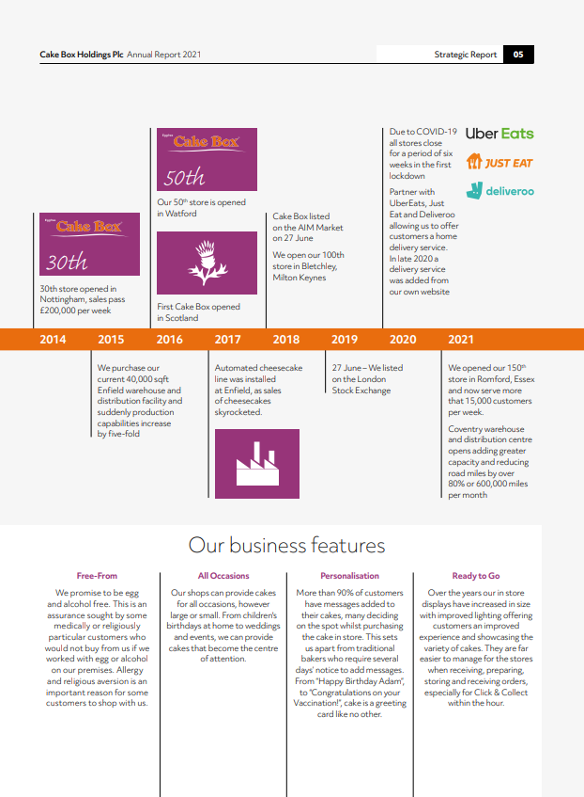
(Egg Free Cake Box, 2021, p. 7)

Appendix B
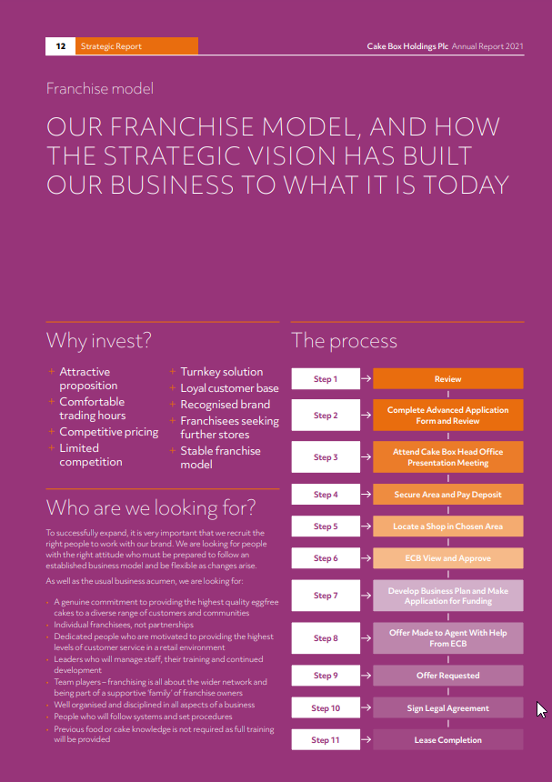
(Egg Free Cake Box, 2021, p. 14)

Appendix C

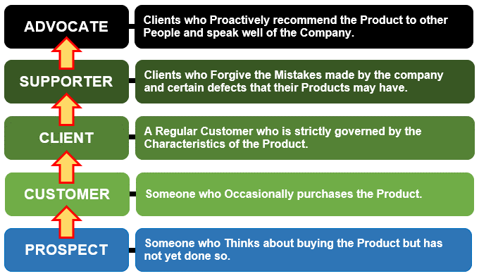
(Consuunt, 2021)

Appendix C
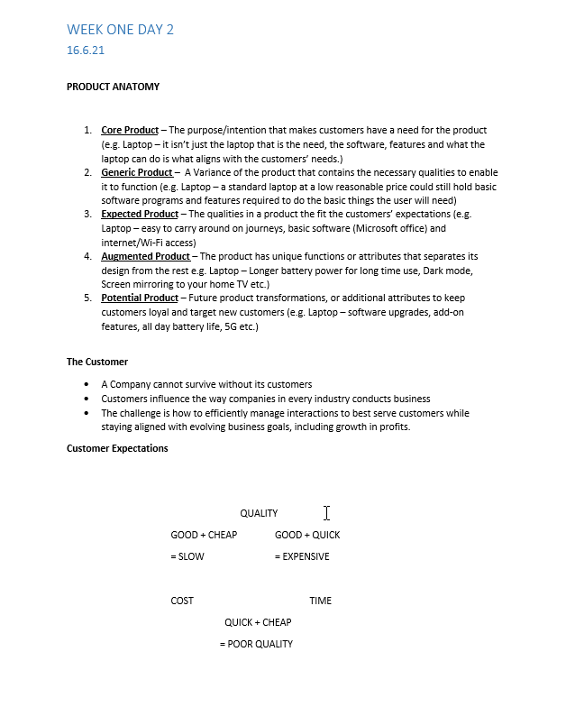
(Notes from Lecture Week 1 16.6.21)

