Network Operating Systems and Services (NOSS) ACCA5023
Managing and Maintaining Network Resources using Network Policy and Security Practices

Worksheet Three

Network Operating Systems and Services – ACCA5023
Sarah Rule - 1810755

Worksheet Three

Task One: Understanding NTFS and Share Permissions

NTFS – New Technology File Systems

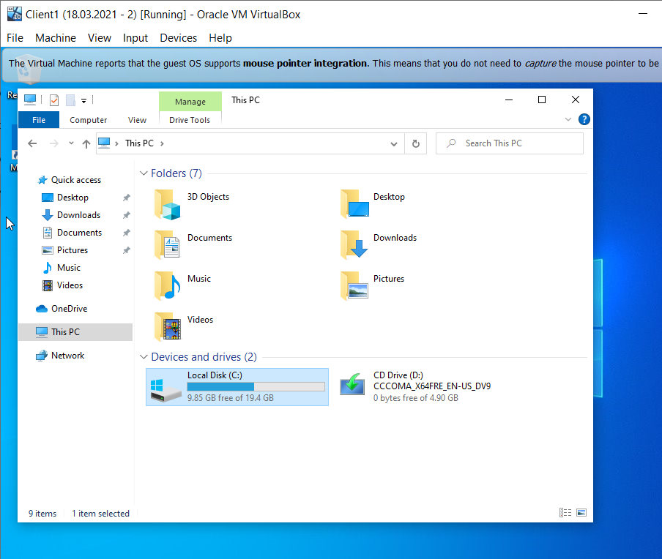
Figure 1
Client 1 machine above is a Windows 10 machine, and is logged in with an administrative account on the nwtraders.msft domain. The C: Drive on This PC has been selected.

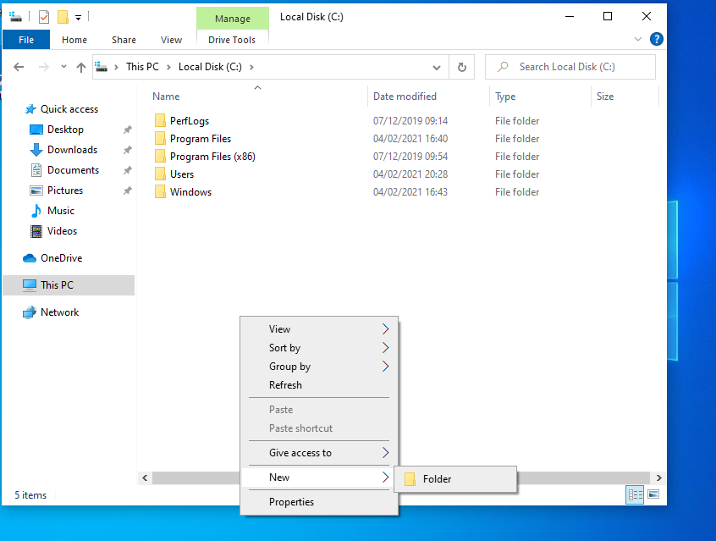
Figure 2
A new folder is being created on the C: Drive of this PC. The new folder has been renamed as Dept_Important_Docs.

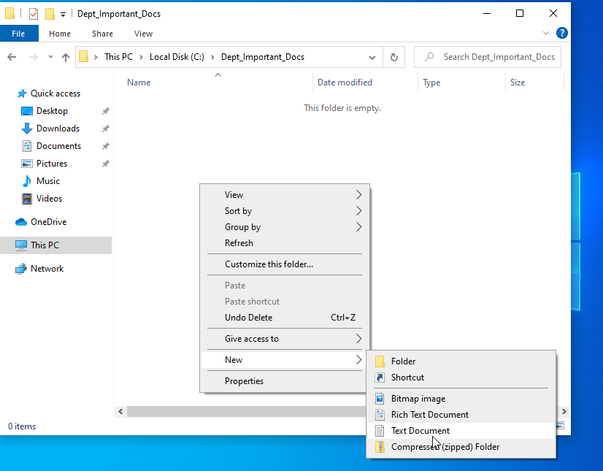
Figure 3
As shown in Figure 3, the folder has been created and renamed as explained in Figure 2. Within the Dept_Important_Docs Folder, a text document named Important_File has been created.

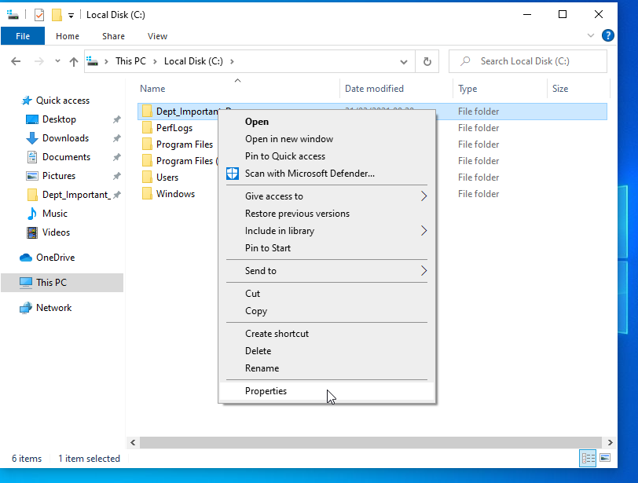
Figure 4
NTFS Permissions now need to be set on the Dept_Important_Docs Folder. To achieve this, the user has right clicked on the folder, and then clicked properties.

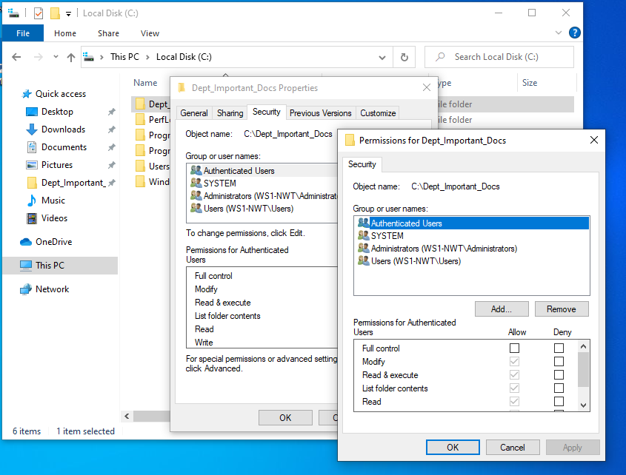
Figure 5

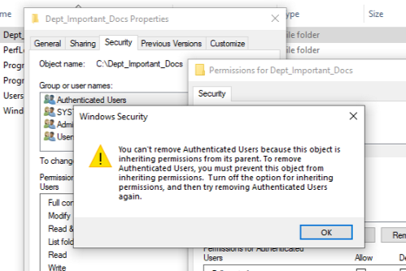
Figure 6
The Security Tab within properties contains a Group or User Names section. The Authenticated Users Group is where the permissions will need to be removed. As shown in Figure 6, an error message has occurred to say this is not possible until the Inherited Permissions are disabled.

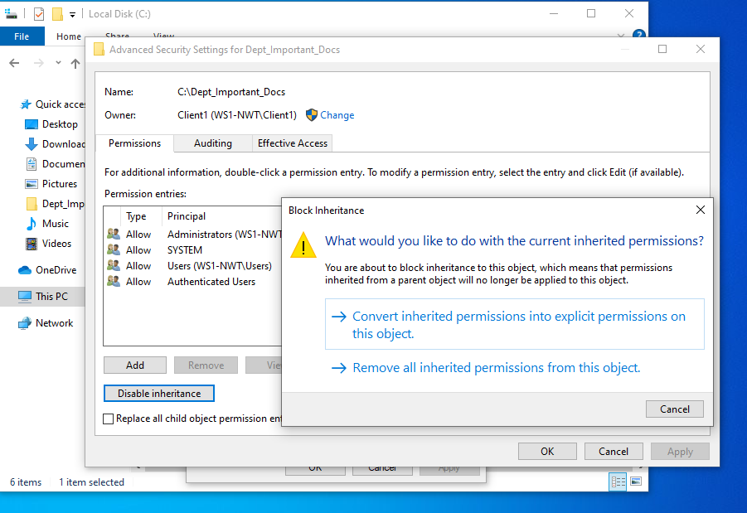
Figure 7
The Advanced button allows the user to disable the permissions. As shown in Figure 7, the ‘Remove all inherited permissions from this object’ button has been applied to the Authenticated Users Group. The user will now be able to add the permissions on the folder.

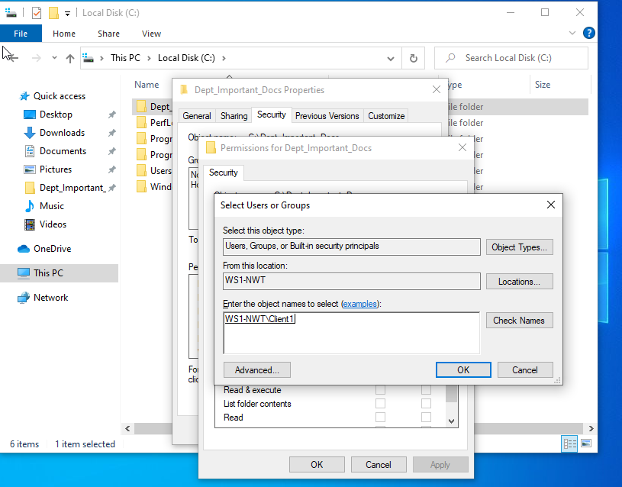
Figure 8
The user has given WS1-NWT\Client1 the permissions. This is the account that the machine is currently logged in as.

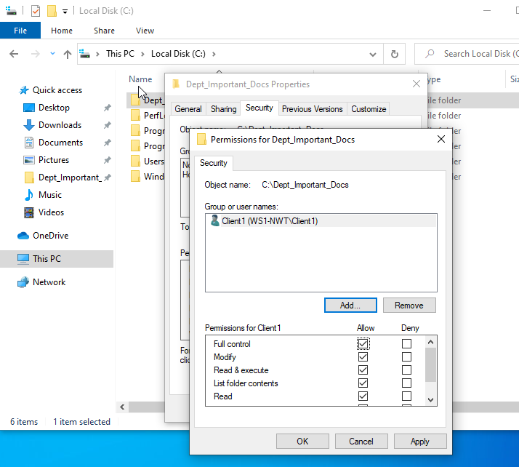
Figure 9
Once selected, the user has given ‘Full control’ permissions to the account as shown in Figure 9.

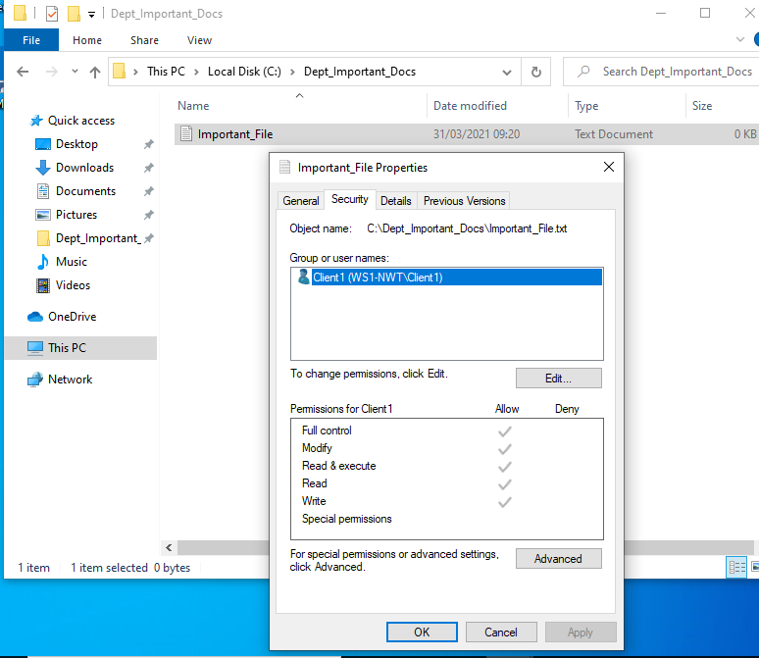
Figure 10
The permissions have been applied and the account has been given Administrative Level Access. Another account granting Read & Execute permissions and below was also created. The Admin account is able to add and amend data to the Text File that was created earlier, however, the second account was created, was not able to make any modifications to the Text Document.

Share Permissions

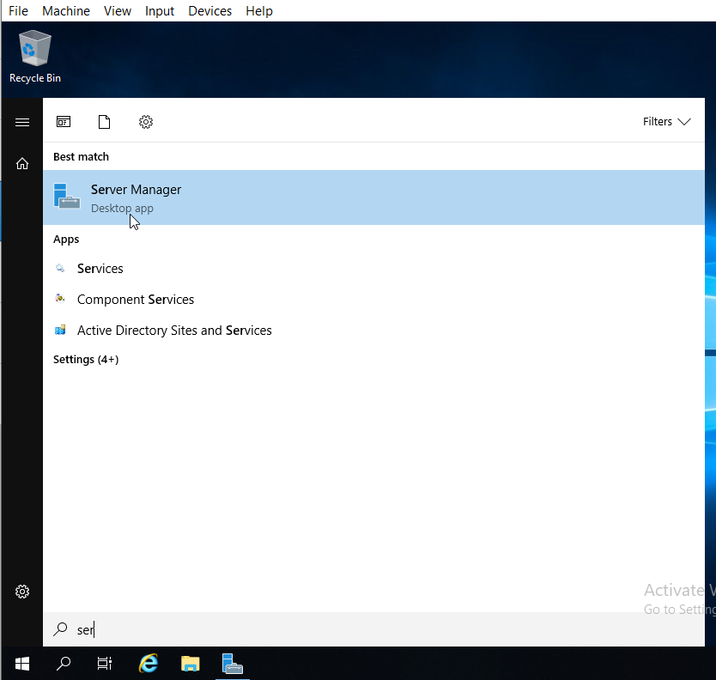
Figure 11
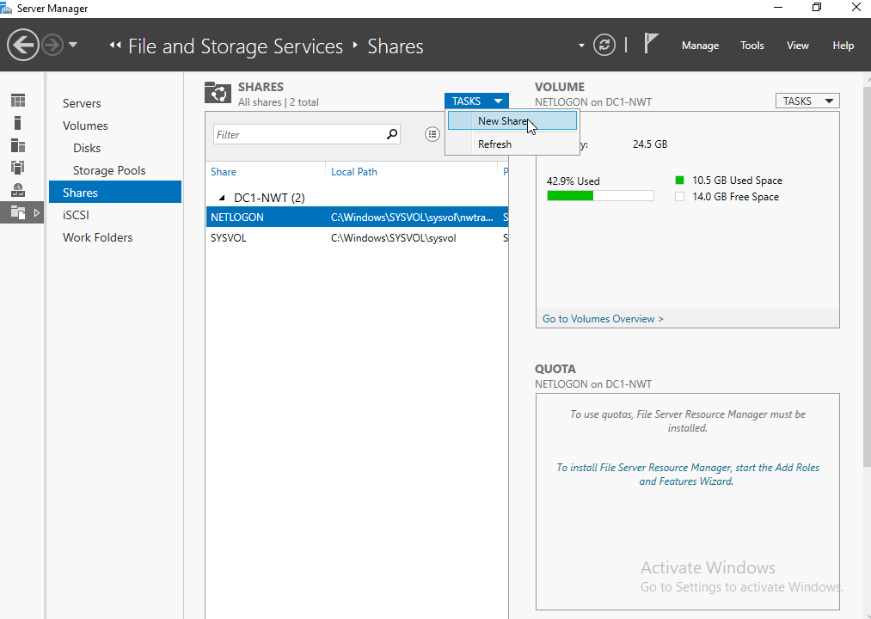
Figure 12
On the Server Manager, the user is going to create a new share as shown in Figures 11 and 12.

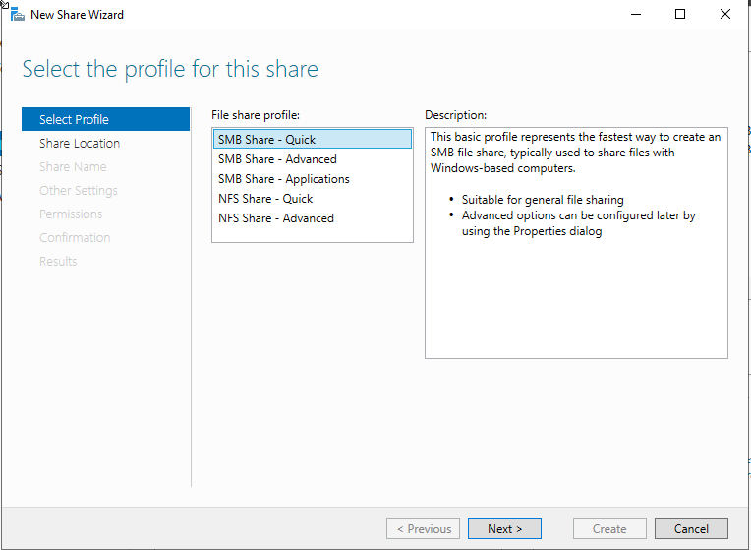
Figure 13
The profile chosen for this share will be SMB Share – Quick.

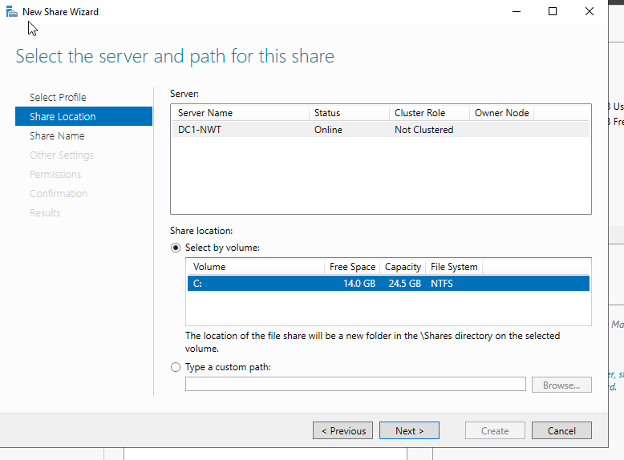
Figure 14
The Location chosen is the C: Drive.

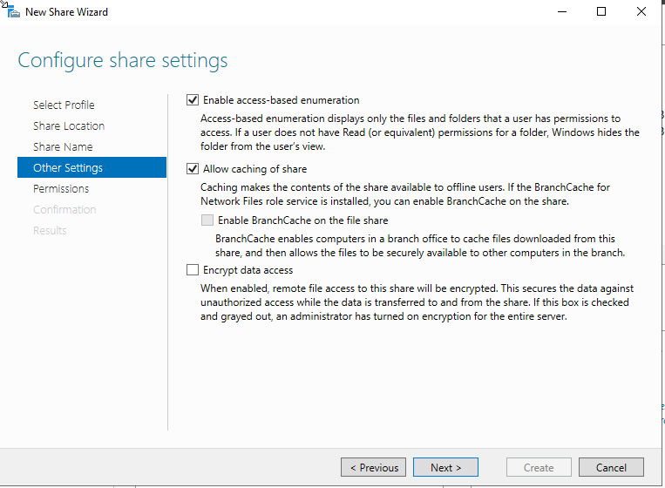
Figure 15
The user has enabled ‘access-based enumeration’ and ‘allow caching of share’ within other settings.

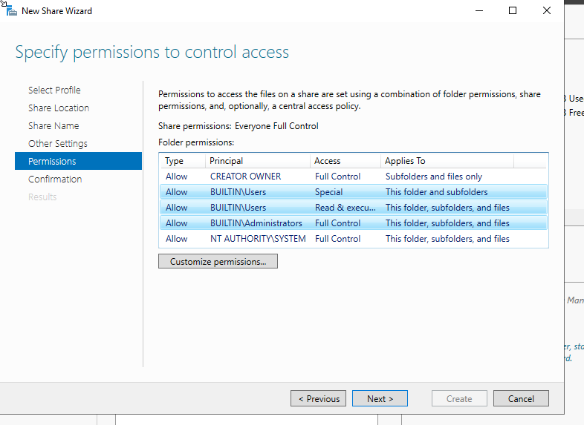
Figure 16
Here the account with administrative access. Two members with read and execute access have been granted permissions for this share.
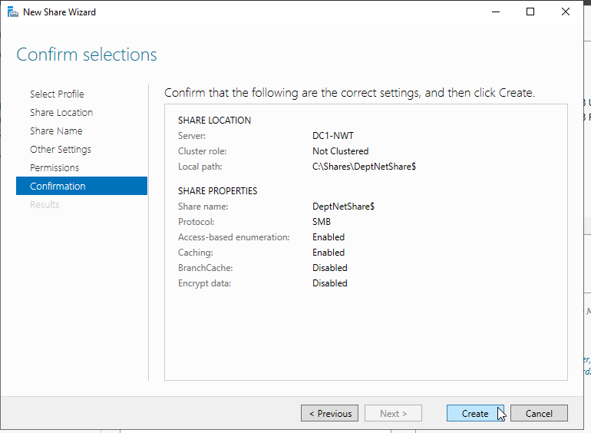
Figure 17
Figure 17 shows the details of the share the user has just created to check that all information is correct before clicking create. As shown, the share location is for the DC1-NWT Server and the local path is C:\Shares\DeptNetShare$.
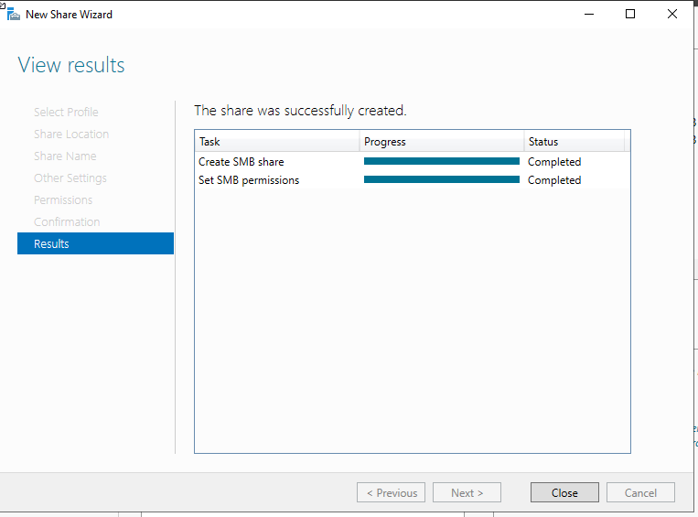
Figure 18
Once applied the share was successfully created.

Accessing the File Share/Server over the Network
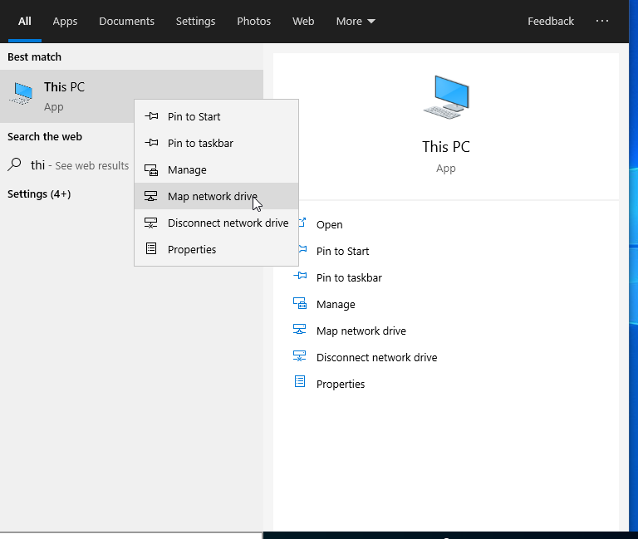
Figure 19
The user is allowing access to the share through the network, this is done through ‘My PC’ and ‘Map Network Drive’.

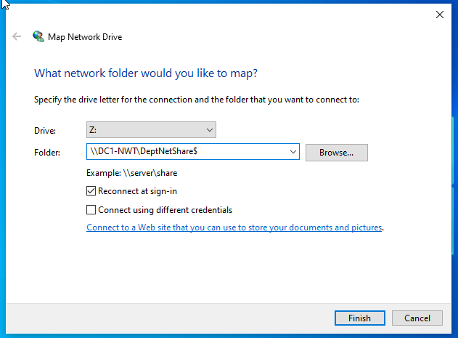
Figure 20
The default drive letter is showing as Z: which the user has accepted, and then entered the folder name location.

Task Two: Utilising Group Policy Management Console to better facilitate Network Object Management

Group Policy Management Console
Configuring User Environment and Computer Environment, ‘Network Group Policy Objects’.
GPO 1: Moderating Access to the Control Panel
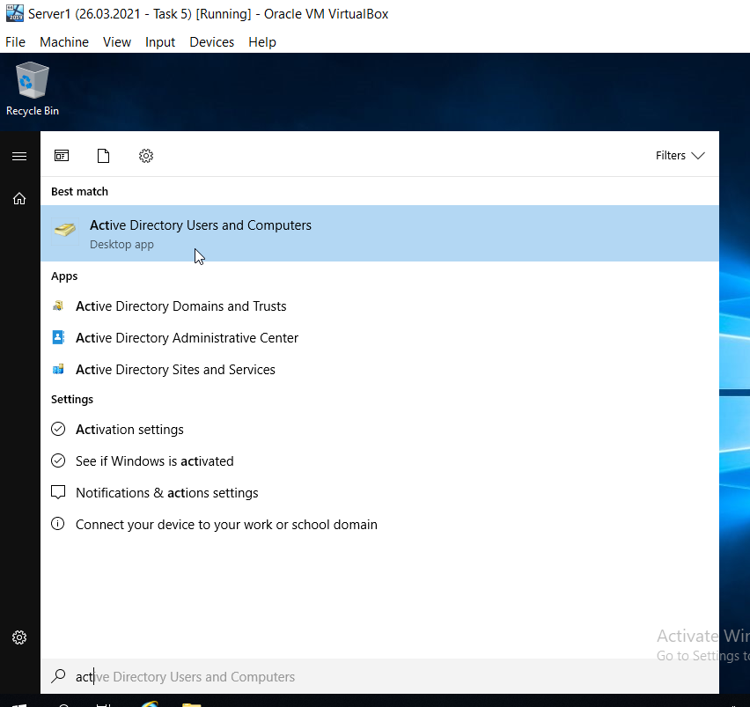
Figure 21
Accessing the Active Directory Users and Computers on Server 1.
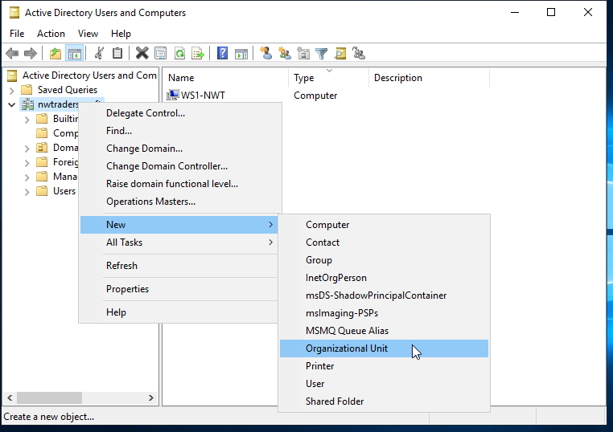
Figure 22
On Server 1, the user is going to create a new Organisational Unit.

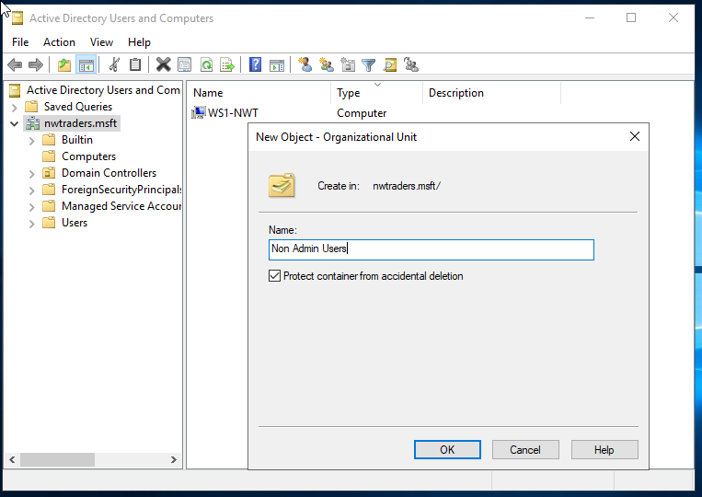
Figure 23
The new Organisational Unit Folder is called ‘Non Admin Users’.

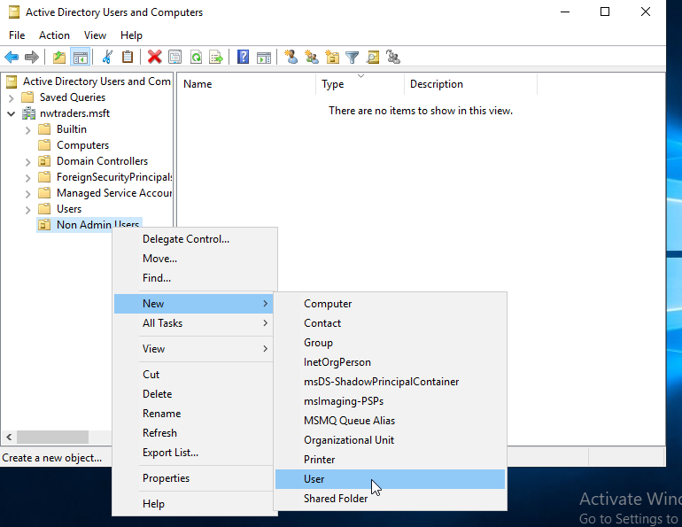
Figure 24
A new user is created within the Non Admin Users folder that was previously created in Figure 23.

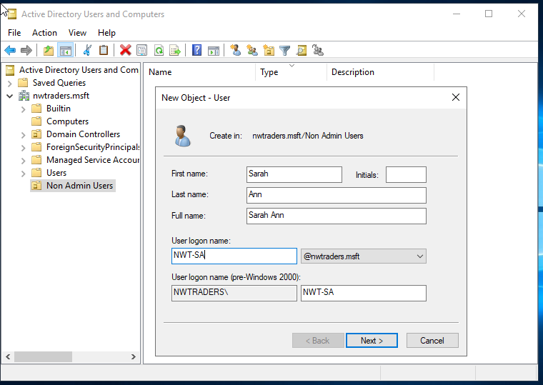
Figure 25

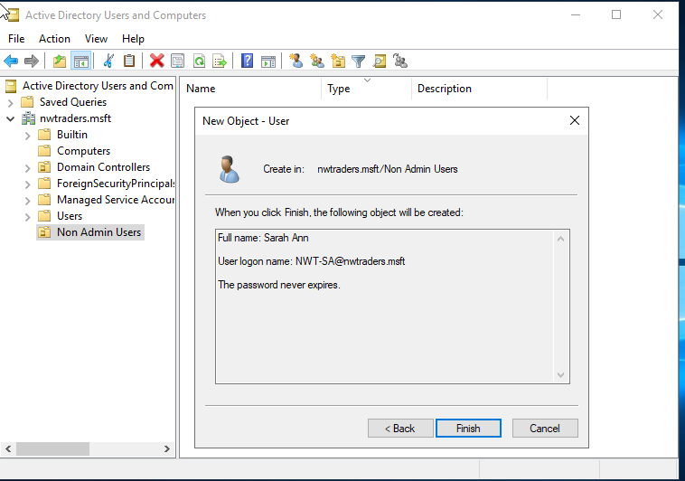
Figure 26
The new user has been created within the folder for nwtraders.msft/Non Admin Users, and the password has been set to never expire for the account as shown above, in Figures 25 and 26.

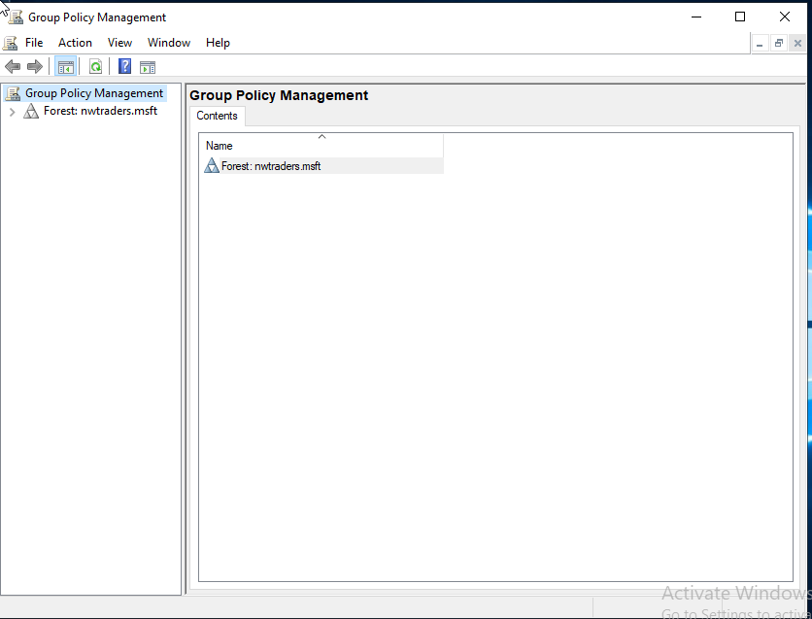
Figure 27
Managing nwtraders.msft within the Group Policy Management Option.

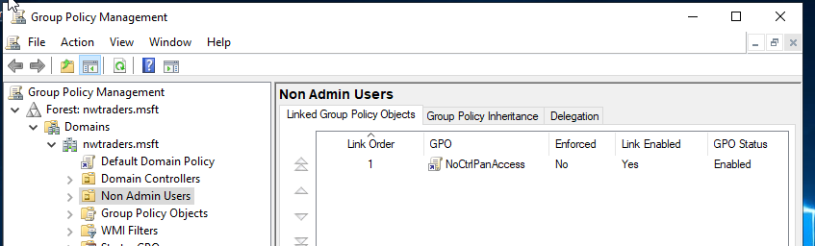
Figure 28
Applying ‘No Control Panel Access’ to Non Admin Users.

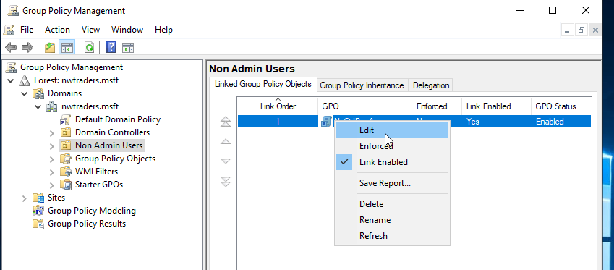
Figure 29
Control Panel access needs to be restricted for the Non Admin User. To do this, right click the Non Admin User Folder on the left and ‘Edit’ from the options.

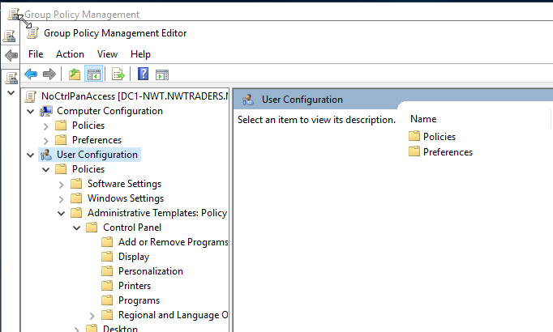
Figure 30
Group Policy Management then User Configuration is selected.

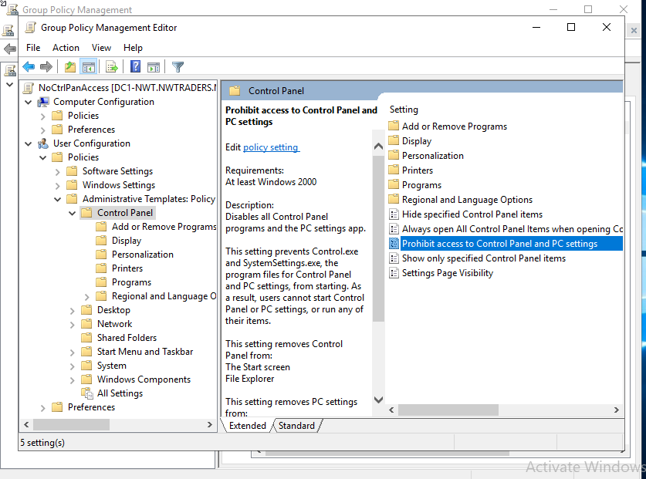
Figure 31
Control Panel access needs to be enabled, this is done through Administrative Template Policy > Control Panel > Prohibit access to Control Panel and PC Settings.

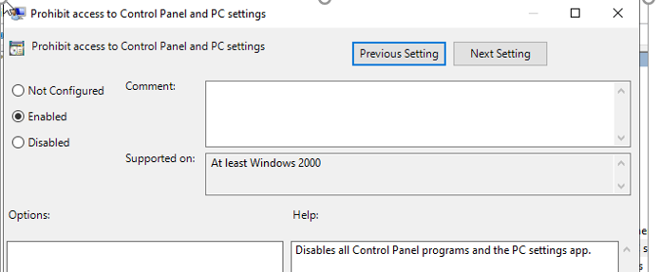
Figure 32
The enabled button has been turned on to enable ‘Prohibit access to Control Panel and PC Settings’.
`
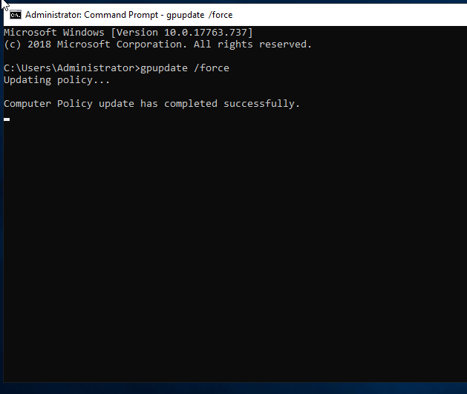
Figure 33
The command prompt has been used to force the gpupdate. Figure 33 above, shows that the Computer Policy has been updated successfully.

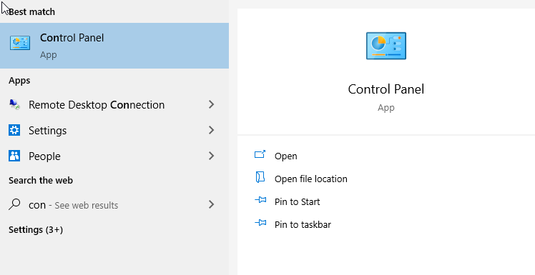
Figure 34
The user has attempted to open Control Panel on the PC.

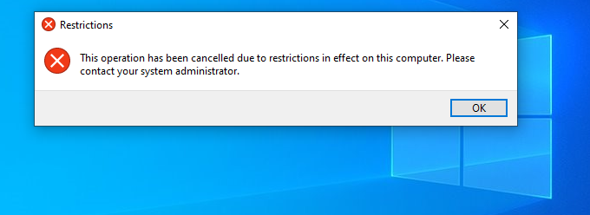
Figure 35
Here shows the restrictions pop up. This is because the account has had the Control Panel restrictions placed on it, again confirming that the policy has taken effect.

GPO 2: Removing Access to the Command Prompt
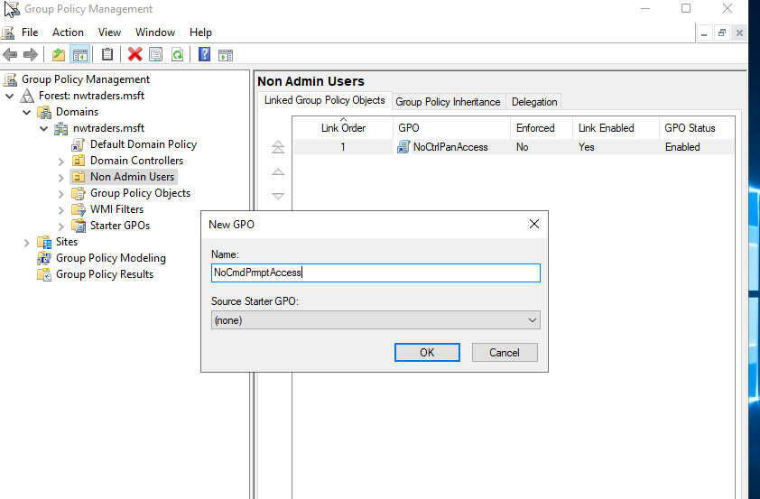
Figure 36
Creating a New Group Policy Object (GPO) to restrict Command Prompt Access for Non Admin Users.
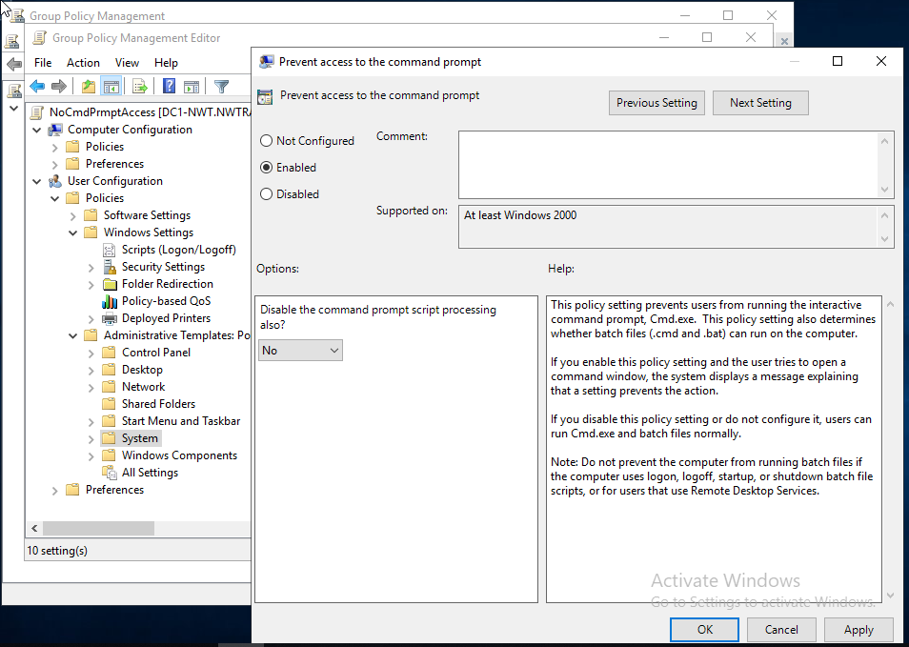
Figure 37
The Policy has now been enabled to prevent access to the command prompt.

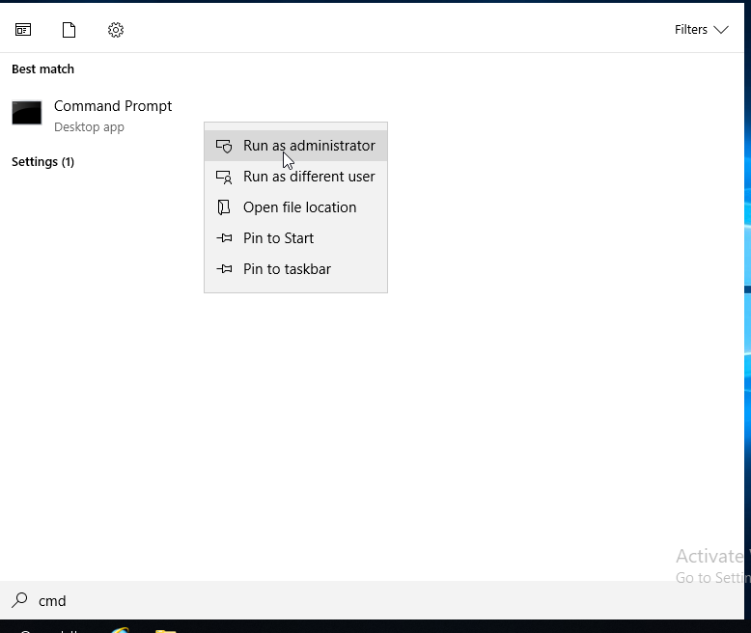
Figure 38
To enforce the policy changes, the user has run the command prompt as the ‘administrator’ to force the update.

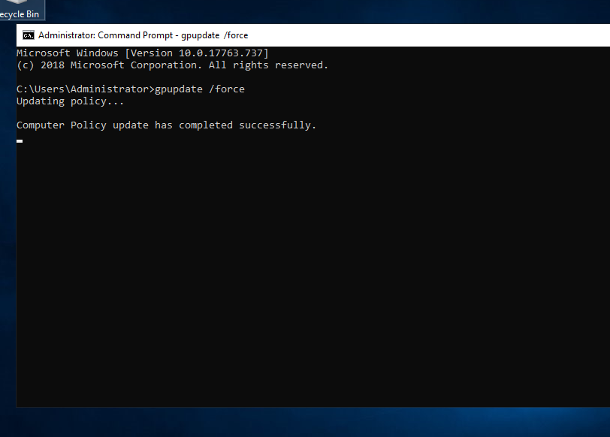
Figure 39
Figure 39 shows that the computer policy has completed successfully.

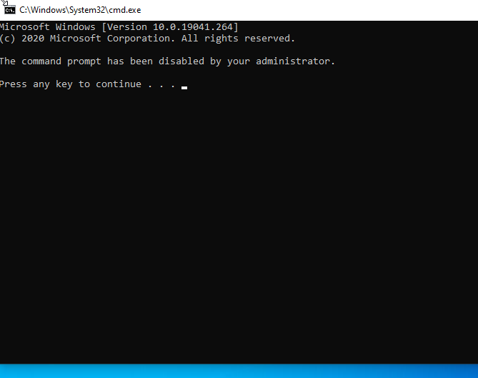
Figure 40
The command prompt has been attempted to be used, but has been disabled correctly as shown in Figure 40.

GPO 3: Restricting Access to Removable Media Drives
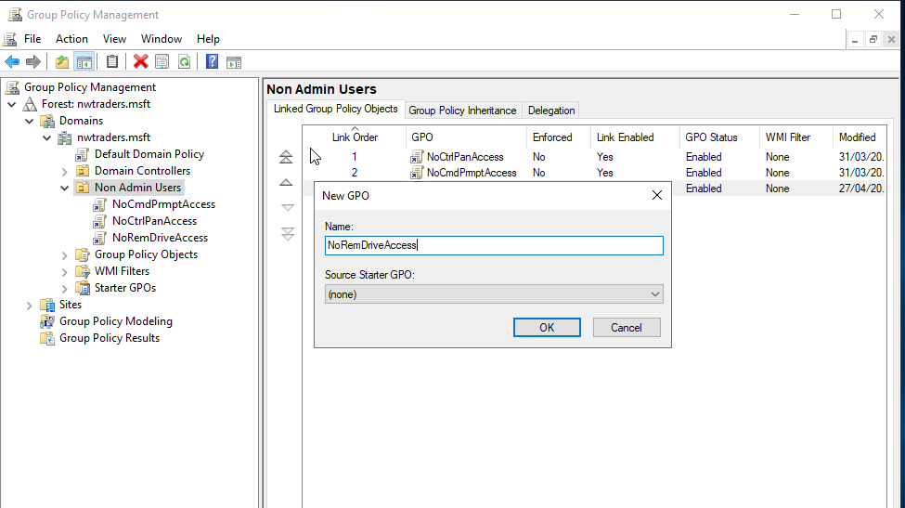
Figure 41
Creating a new GPO for removing drive access.

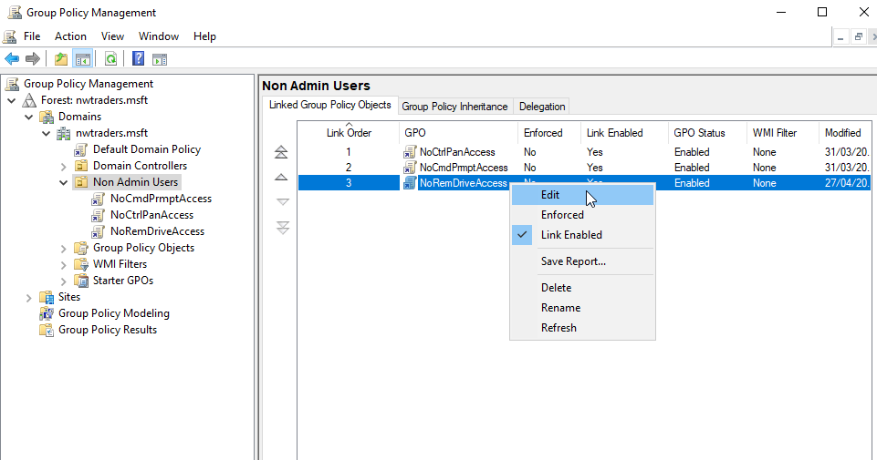
Figure 42
Once the GPO has been created, the user makes any edits required.

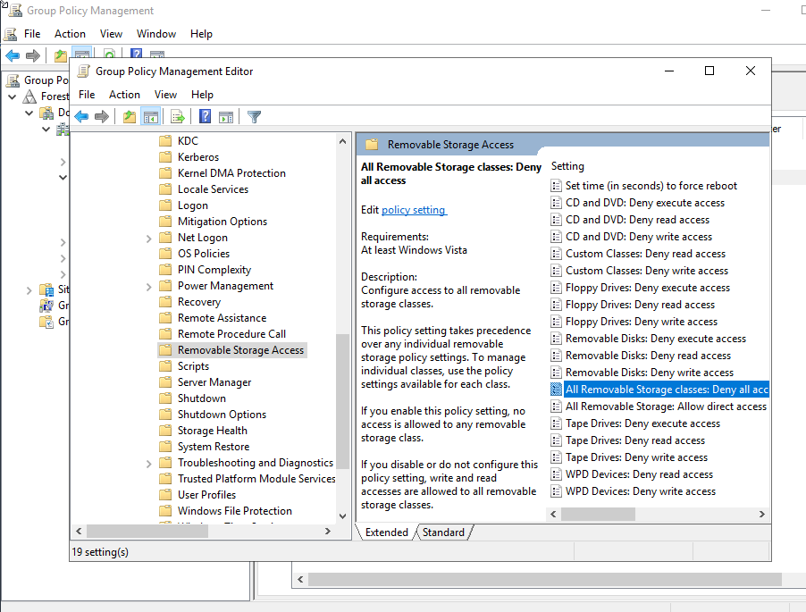
Figure 43
The setting the user has chose to enable is highlighted above.
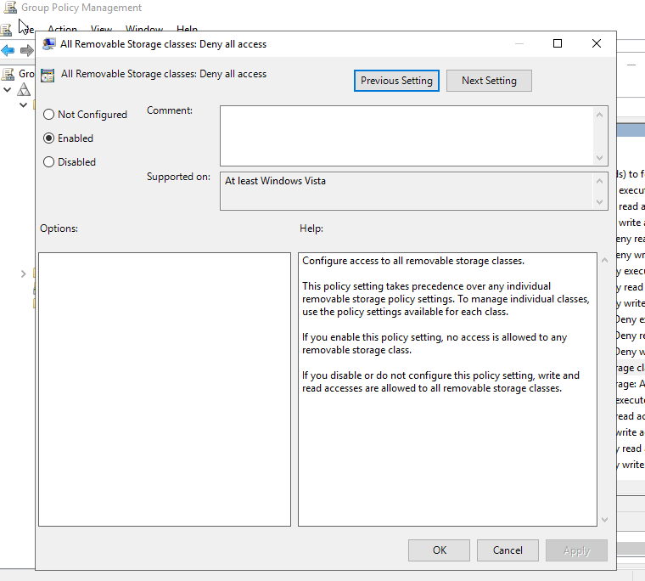
Figure 44
The user has enabled ‘Deny all access’ to this setting.

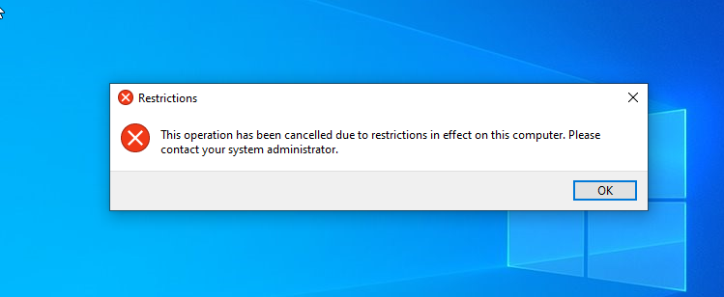
Figure 45
The change has been successful.

GPO 4: Restricting Software Installs
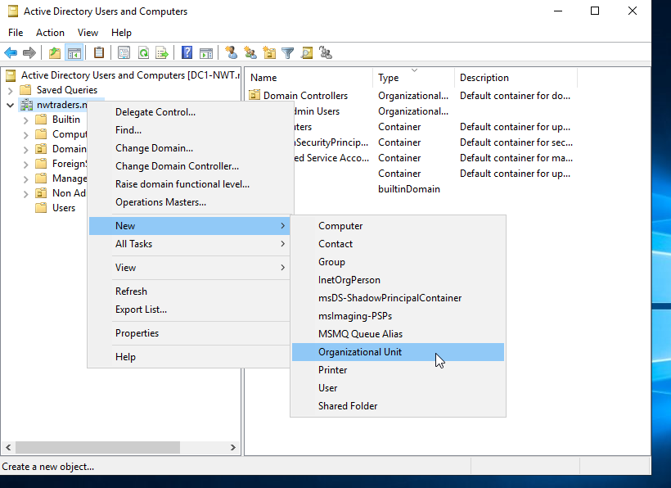
Figure 46
Creating a new Organisational Unit.

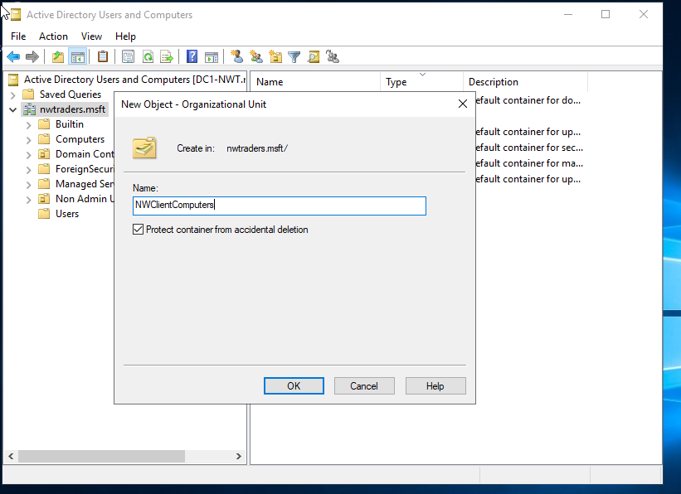
Figure 47
Renaming the Organisational Unit to NWClientComputers.

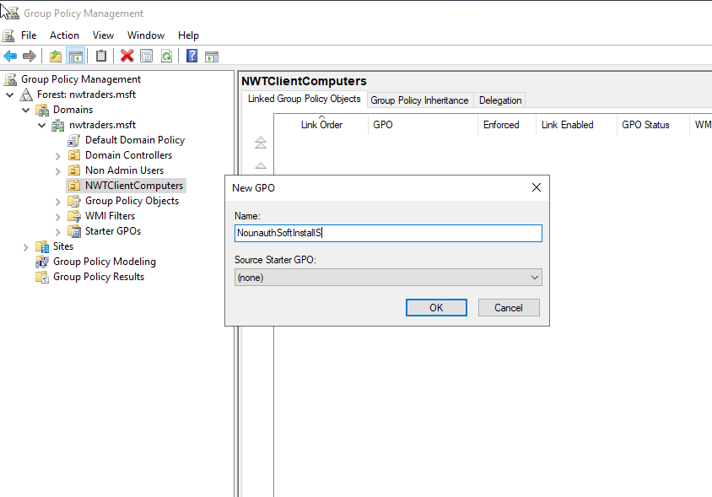
Figure 48
Creating a new GPO, and naming it as NounauthSoftInstallS. A good naming convention will help the user to identify the GPO easily in the future.

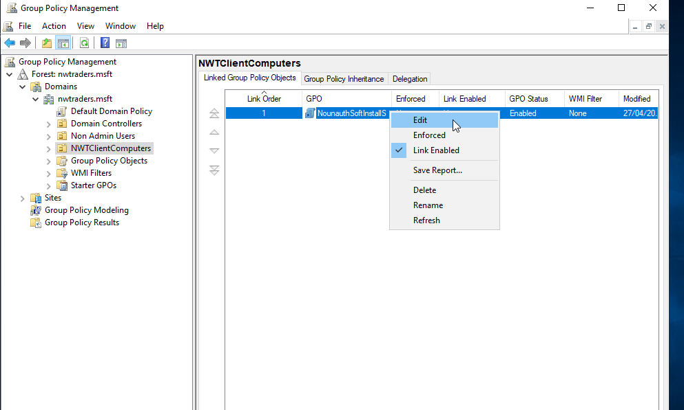
Figure 49
Editing the GPO that was previously created in Figure 48.

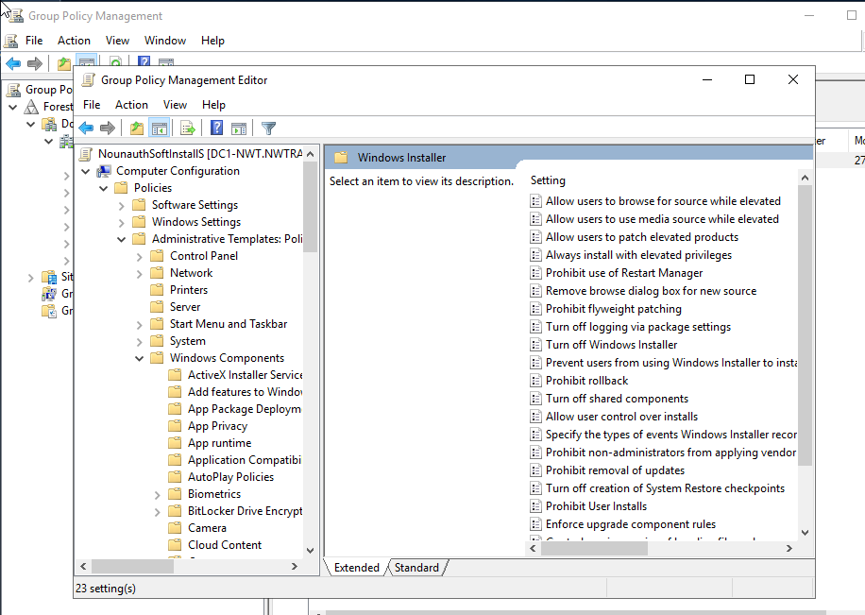
Figure 50
Prohibit User Installs is the setting required here.

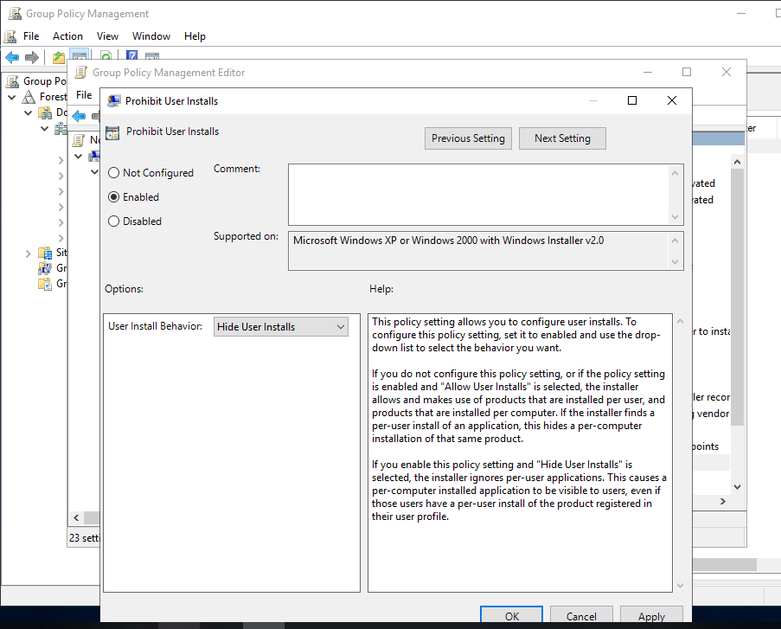
Figure 51
The user has enabled the ‘Prohibit User Installs’ from the settings page within the GPO.

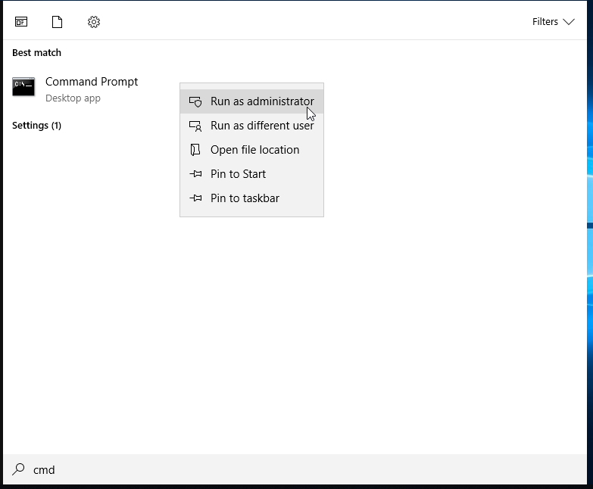
Figure 52
Running the command prompt as an administrator to push the recently created GPO out.

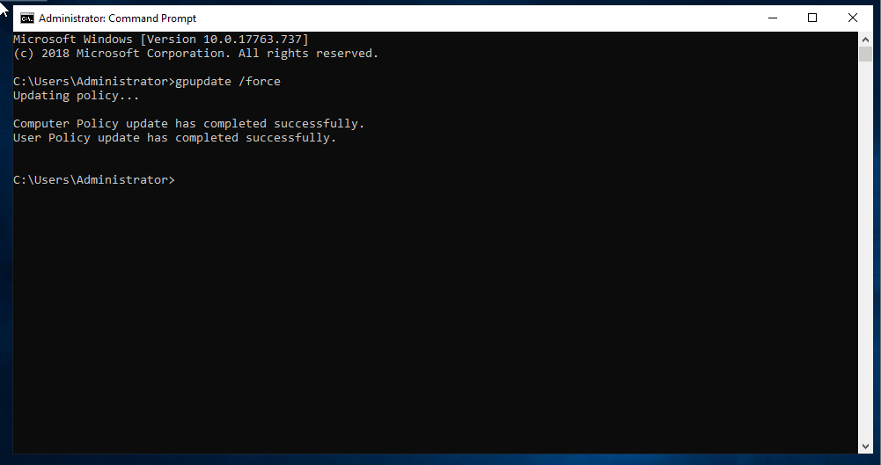
Figure 53
The policy has been updated successfully as shown in Figure 53.

GPO 5: Enforcing Password Policy in the ‘nwtraders.msft’ domain
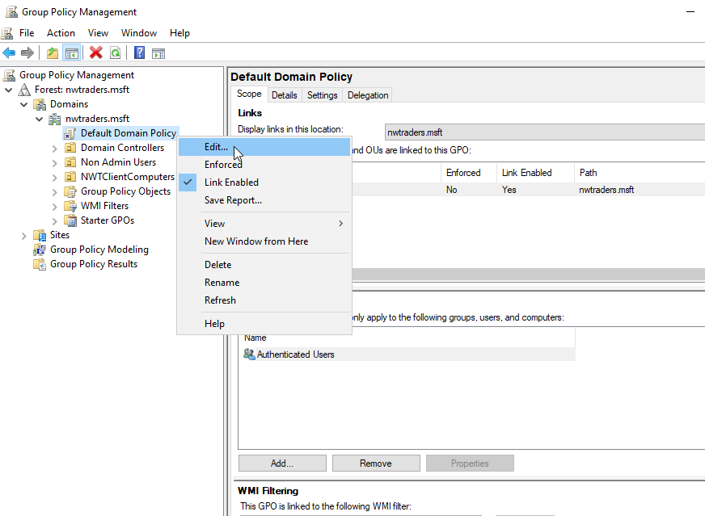
Figure 54
The user is editing the Default Domain Policy to enforce a Password Policy within the nwtraders.nsft domain.

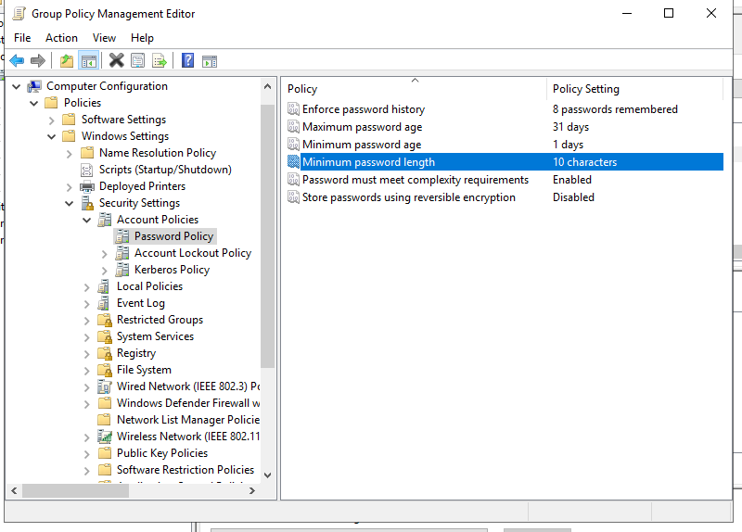
Figure 55
Amending the Password Policy to ensure that any passwords used are secure. The minimum password length is required to be at lest 10 characters.

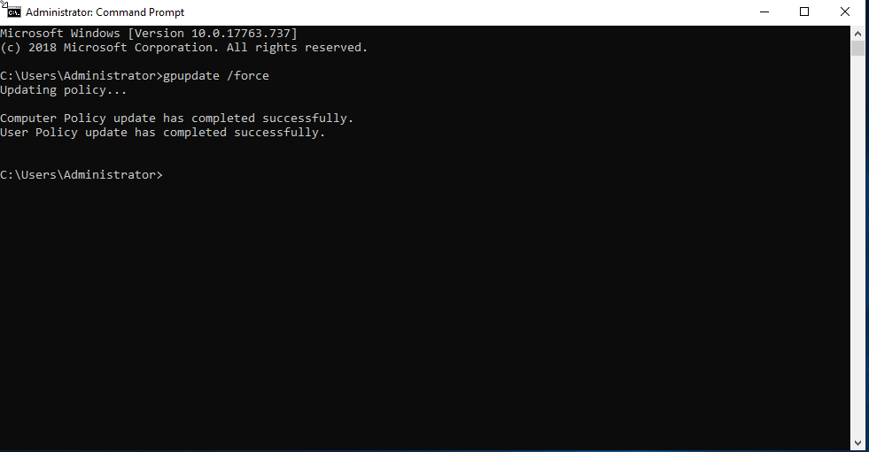
Figure 56
The Password policy has been updated successfully.

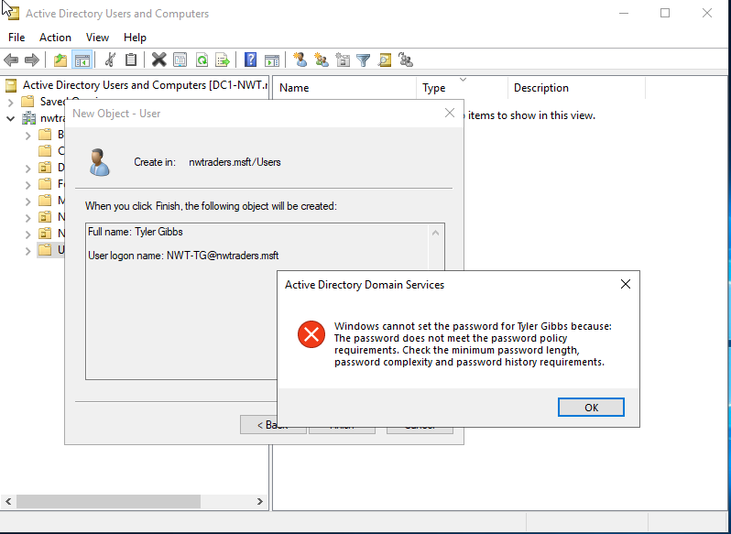
Figure 57
The password policy has been implemented correctly as one of the users is unable to apply their selected password due to the password not meeting the requirements of the new Policy, for example, it was not a minimum of 10 characters long.

Task Three: Observational Tasks

3 a) Explain the main differences between local permissions and file shares.

What are Local Permissions?

What are File Shares?

3 b) Describe the role of Group Policy Management in the Network Environment, you can use example policies in your answer.

3 c) Give some examples of sound ‘password’ principles in modern network environments.

Task Four: Only allow specific hosts in PrivateNet1 to access the FTPService running on Server2

4 a) Construct your own ‘rule’ to restrict FTP access to everyone except 192.168.100.1 (Client 1).

Task Five: Failover Clustering for high availability systems/services

5 a) Give a detailed explanation of the concepts that need careful consideration when considering the usage of such a system. Also, show one possible role within the Window Server OS environment that could provision these requirements. You should breakdown the aspects that need consideration when attempting to deploy this role/service. (Hint: Give screenshots of the role being configured and discuss these steps)

Task 6: Observational Tasks

6 a) Assume that you are the Head – Network Administrator of an Enterprise Network which operates in multiple locations nationwide. Draft a network policy, critical business applications high availability practices and security practices for your network. State all assumptions made. (Hint: In your draft, address (not limited to) the architecture, topology, design, layout of the network, network access, security team, enforcement of security policies, analysis of security risks, scope of security changes (if needed), monitoring the security operations, mitigations in the event of violations, etc)

