Computer Forensics (Activity 1)

Task 1
To begin with, I opened the folder which contained documents which will be used in an investigation. I started by opening the random folder and I began reading from the start. The first key thing to note was that a person has abducted a cat by the name of “Gato”. Then from the next part of the letter I can see that the person who abducted Gato wants to receive a ransom payment to be able to retrieve him back.
Once I understood the situation of the document, I carried on reading and the person would like to receive a payment of 3.14159 XMR in cryptocurrency. From this I can see that the person wants to receive their money through cryptocurrency which there is no way to track where the money is going to as its extremely secure. They also mentioned that if you cannot use the cryptocurrency which they have named then instead you can transfer over 0.0165 worth of Bitcoin.
The next message then states that we have 3 days to comply with the rules otherwise Gato will be sent to a very far away animal shelter. They also stated that currently Gato is warm, and they also attached an image of Gato.
To make the analysis of the documentation, I followed the “ransom letter” in a step-by-step manor as you should when carrying out a forensic investigation.
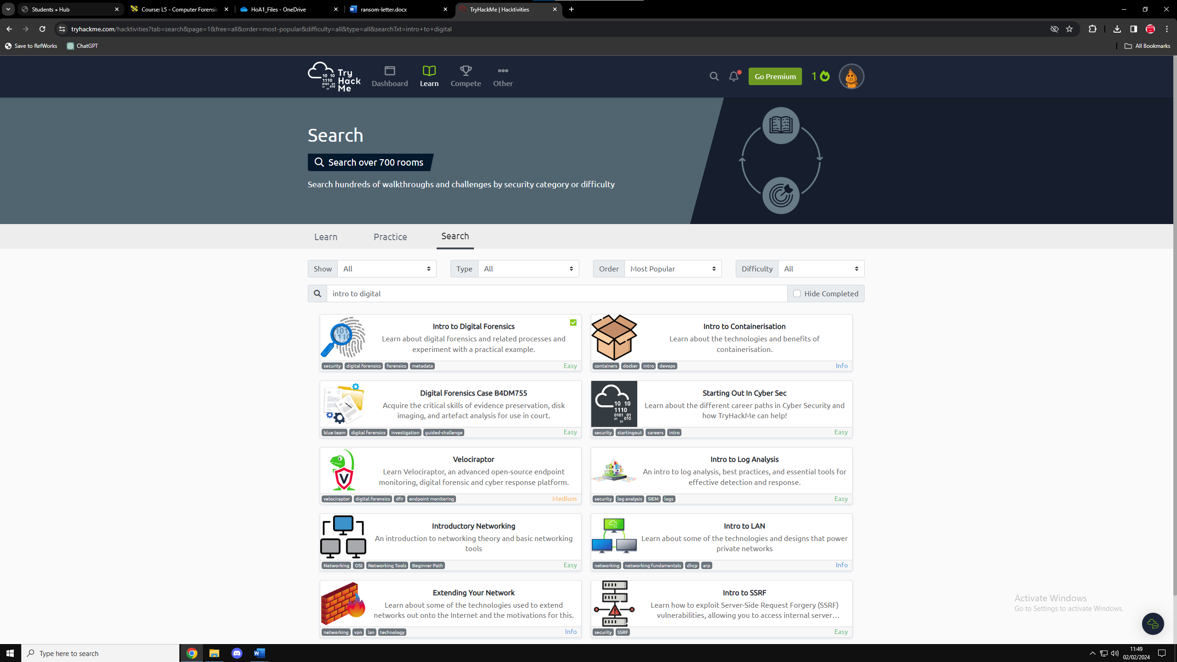
The screenshot above is to show that I’ve completed “intro to digital forensics”.

Task 2
After conducting some research, I found that there are many different websites and tools which can be used to enhance my digital forensics skills. To start off with, I found a website called “CFReDS” which gives you the ability to download files and conduct your own investigation from the downloaded files. This can be very beneficial to learn. Another website which I found is called “Cybrary” and on this website your once again able to practise your skills to further improve your computer forensics skills. I have done some research on “Cybrary” and I believe that it’s a extremely good website to use
After finding out what websites can be used to further improve my skills, I also found a few tools which can be used. To begin with, I previously used a tool called “Wireshark” and this is used to analyse anything which is flowing through a network. In addition, I found another tool called “forensic tool kit” (FTK) which is a tool used for analysing digital evidence. The last tool which I found is “autopsy” which is used to analyse disk images and smartphones.

