

Cover Page

Name: Sherelle Mclean
Student Number: 2407059
Module: Changemakers: Creativity and Value Creation
Module Code: BMHP5014
Lecturer: Raheela Shaikh
Assignment Title: Component 1: Online Portfolio of Set Exercise

Task 1 – Concept Map
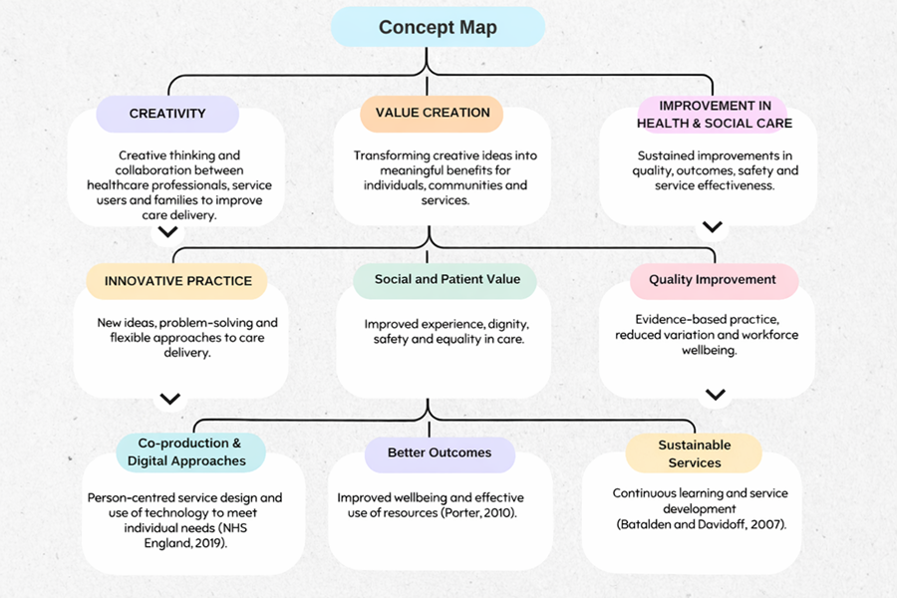
This concept map looks at how creativity, value creation, and improvement connect in health and social care. Creativity is the starting point because it helps professionals rethink how care is planned and provided. By working together and involving service users and families, creative ideas help meet complex and changing needs in new ways. Using digital tools and designing services for individuals also makes care more flexible and responsive (NHS England, 2019).
Creativity leads to value creation because new ideas need to bring real benefits. In health and social care, value is not just about saving money. It also means supporting dignity, safety, well-being, and a good experience. Porter (2010) says value is created when services improve outcomes that matter to people. By focusing on what matters to patients and society, services can improve both experience and results.
Creating value helps improve quality and make services more sustainable. Improvement means making care safer, more effective, and based on evidence over time. Ongoing learning and developing services help make sure that new ideas lead to better results and use resources well. Batalden and Davidoff (2007) point out that improvement comes from continuous efforts to make care processes and outcomes better.
In summary, the concept map shows that creativity leads to value creation, which then supports ongoing improvement and better results in health and social care.
Task 2 - Self-Reflection of Group Activity

Introduction
Reflection is important for learning and improving in health and social care. Gibbs’ Reflective Cycle helps with this by guiding people through six steps: description, feelings, evaluation, analysis, conclusion, and action plan (Gibbs, 1988). These steps help individuals look back on experiences, understand their reactions, and think about how to use what they learned in the future. Reflective practice is especially valuable in health and social care because it supports ongoing learning, critical thinking, and professional growth (Bulman and Schutz, 2013). In this reflection, I will use Gibbs’ Reflective Cycle to look at my experience with the paperclip thinking activity and how it helped me develop creative thinking in a group. The activity required both divergent and convergent thinking.

Description
In the activity, our group used both divergent and convergent thinking to turn a paperclip into creative items. Divergent thinking helped us come up with many ideas, like bracelets, earrings, keyrings, and zip fasteners. One group member Precious suggested making jewellery from the paperclip, which became our main focus. We then used convergent thinking to review the ideas and choose the most practical ones (Runco and Acar, 2012).

Feelings
At first, I was unsure about sharing my ideas because I worried, they might not be creative enough. But as the discussion went on and others shared their ideas, I felt more comfortable joining in.

Evaluation
The activity worked well because it encouraged teamwork and open discussion. Hearing different viewpoints helped us come up with many ideas, even if some were not practical.

Analysis
This activity showed me that creative thinking grows through working together and open discussion. Divergent thinking let us explore many ideas without judging them right away, which encouraged creativity. Convergent thinking then helped us narrow down the choices and pick the most practical ones (Runco and Acar, 2012). In health and social care, professionals often need to be creative while also thinking about safety, practicality, and what service users need. This experience taught me that mixing creativity with teamwork can lead to good solutions.

Conclusion
Overall, this activity helped me recognise how collaboration and creative thinking can support problem-solving in group situations. It also highlighted the importance of listening to different perspectives when developing practical solutions.

Action Plan
In future group activities, I plan to share my ideas with more confidence and stay open to others’ perspectives to help the team work well together.
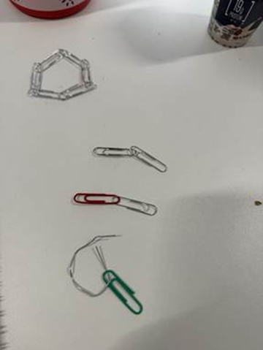


Task 3 - Case Study of a UK innovation
Case Study - NHS at Home – Remote Monitoring to Reduce Hospital Admissions

Introduction
The NHS at Home initiative is an important innovation in UK healthcare. It aims to reduce hospital admissions for people with long term conditions like heart disease, diabetes, and chronic breathing problems (Health Data Research UK, 2024). In the past, care for these conditions was mostly given in hospitals and was reactive, with problems often found only when symptoms got worse (NHS England, n.d.). This put extra pressure on emergency services and made early help harder. NHS at Home tackles these issues by moving monitoring into people’s homes, which fits with NHS goals for prevention, digital change, and joined up care (NHS England, 2025).

Main body
NHS at Home uses digital technology and remote monitoring devices. Patients check things like blood pressure, oxygen levels, and glucose, then send this information securely to clinical teams (NHS England, n.d.). The model is creative because it turns the home into a place where people can get clinical support and encourages patients to manage their own care (NHS England, 2025). Wearable devices and virtual wards mean patients are watched over all the time, not just during appointments. Evidence shows fewer hospital admissions and bed days, proving the system works (Mid Yorkshire Teaching NHS Trust, 2025). Digital monitoring has also led to a 25% drop in emergency admissions, showing how remote technology can help prevent problems (Health Data Research UK, 2024).
Even with its benefits, there are challenges to consider. Relying on digital systems brings up worries about data security, leaving some people out, and depending too much on automated alerts (NHS England, n.d.). People who do not have digital skills or access may find it hard to take part, which could make health inequalities worse (Health Data Research UK, 2024). Also, constant data monitoring can add to clinicians workload and needs ongoing investment in training and equipment (NHS England, 2025).

Conclusion
Overall, NHS at Home shows that technology can change care from being reactive in hospitals to being proactive in the community (NHS England, 2021). By helping with early intervention and letting patients manage their own care, the program supports person centred care and makes the system more sustainable (Mid Yorkshire Teaching NHS Trust, 2025). Although there are still issues like digital exclusion and staff pressures, the program marks a cultural and structural change in the NHS. It shows how creativity, backed by evidence and good management, can bring value and set an example for future innovations in managing long-term conditions (NHS England, n.d.; Health Data Research UK, 2024).

Task 4 - Research Task
Current Issue in Health and Social Care: NHS Workforce Shortages and Staff Burnout

Recent research and articles in the BMJ give insight into the challenges facing the NHS workforce. Deakin (2022) looks at how staff shortages affect workload and wellbeing right now, while Rimmer (2020) reviews long-term planning and recruitment. Together, these sources give a full picture of both short-term pressures and bigger issues that lead to staff burnout.
The NHS is facing a serious staff shortage, which affects both staff wellbeing and patient care. There are still over 110,000 unfilled jobs across NHS trusts, with many gaps in primary care (Deakin, 2022). This means current staff have to take on too much work, leading to stress, tiredness, and emotional strain. Managers say staff are under a lot of emotional pressure, and patients may have to wait several days for important care (Deakin, 2022). Not having enough staff also makes it harder for healthcare workers to do their jobs safely, which increases burnout and puts patient safety at risk.
Another problem is poor long-term planning and not enough investment in the workforce. Rimmer (2020) criticises the NHS People Plan for not having strong recruitment and retention strategies. Temporary fixes, like better rest areas and psychological support during COVID-19, helped for a while but do not solve the ongoing problem of not having enough staff. Healthcare leaders say that without steady funding, clear hiring goals, and good planning, high turnover and staff burnout will keep happening, which hurts both care quality and staff wellbeing (Rimmer, 2020).
These studies show that NHS staff shortages are a complex problem caused by both immediate pressures, like heavy workloads and the pandemic, and bigger issues like underinvestment and poor planning. Fixing the shortage needs a full approach, including hiring, keeping staff, planning, and investing in staff wellbeing. Making sure healthcare workers have enough support and resources is key to reducing burnout and keeping care high quality and compassionate (Deakin, 2022; Rimmer, 2020).

Task 5 - Podcast

Task 6 - NHS Leadership Framework Analysis
The NHS Leadership Framework sets out six main areas that define good leadership in the health service (NHS England, 2024). The first is delivering high quality, sustainable care, which keeps patient safety and ongoing improvement at the centre of decisions. Setting direction and leading change encourages leaders to plan ahead and make real improvements. Promoting equality, diversity, and inclusion shows the NHS’s commitment to fairness and reducing health inequalities. Leading with governance and assurance means making ethical decisions, being accountable, and managing risks. Creating a compassionate and positive culture supports staff wellbeing, safety, and teamwork. Finally, building strong relationships and partnerships focuses on working together with colleagues, patients, and communities for joined up care. These areas give leaders a clear guide to follow NHS values, improve services, and help staff grow.
Creating a compassionate, fair, and positive culture is important for encouraging creativity in the NHS. Leaders who are empathetic, fair, and open help staff feel safe to share ideas and speak up without worrying about criticism (West et al., 2017). For example, regular discussions that focus on learning instead of blame let teams try new ways to care for patients. Compassionate leadership builds trust, helps people work together, and supports creative problem solving, even when things are busy. Research shows that leaders who show compassion boost staff engagement, morale, and creativity (West et al., 2017). When leaders value and use staff ideas, they can improve patient outcomes, build stronger teams, and keep care safe and person centred (NHS England, 2024).

Task 7 - Self-Reflection Journal Entry
Introduction
In this reflection, I use the Gibbs Reflective Cycle to look at how my understanding of creativity and value creation in health and social care has grown and how it will influence my future work (Gibbs, 1988).

Description
During the module, I learned how creative thinking can make care better for service users. The activities and discussions pushed me to go beyond usual methods and look for more person centred solutions.
Feelings
At first, I thought creativity was separate from daily care and mostly about abstract or impractical ideas. Over time, I became more confident in seeing creativity as a useful skill that can improve everyday practice.
Evaluation
The module showed me that even small, thoughtful changes can help service users become more independent and improve their wellbeing. It also pointed out challenges like limited resources, time pressures, and having to follow organisational rules.

Analysis
This helped me see that creativity means balancing new ideas with responsibility, making sure care is safe, ethical, and focused on the person (Runco and Acar, 2012). This matches professional standards like the NHS values of dignity, respect, and high-quality care.

Conclusion
Overall, I now have a more practical view of creativity. I see it as essential for improving care quality, making service user experiences better, and dealing with challenges in health and social care.

Action plan
In the future, I will use creative problem solving with confidence, while making sure my approaches stay safe, ethical, and focused on helping service users.
Reference List
Batalden, P.B. and Davidoff, F. (2007) ‘What is “quality improvement” and how can it transform healthcare?’, Quality and Safety in Health Care, 16(1), pp. 2–3.
Bulman, C. and Schutz, S. (2013) Reflective Practice in Nursing. Oxford: Wiley-Blackwell.
Deakin, M. (2022) NHS workforce shortages and staff burnout are taking a toll, BMJ: British Medical Journal (Online),377, p.945. DOI:10.1136/bmj. o945
Department for Education (2025) Keeping children safe in education. London: DfE. Available at:https://assets.publishing.service.gov.uk/media/68add931969253904d155860/Keeping_children_safe_in_education_from_1_September_2025.pdf( Accessed 17 February 2026).
Gibbs, G. (1988) Learning by Doing: A Guide to Teaching and Learning Methods. Oxford: Further Education Unit, Oxford Polytechnic.
Health Data Research UK (2024) Remote health monitoring smartphone app reduces emergency hospital admissions from care homes by 25%. Available at: https://www.england.nhs.uk/nhs-at-home/covid-virtual-wards/ ( Accessed : 27th January 2026).
Mid Yorkshire Teaching NHS Trust (2025) Stats on virtual wards: 1,422 hospital admissions avoided and 987 bed days saved. Available at: https://htn.co.uk/2025/11/24/stats-on-virtual-wards-from-mid-yorkshire-teaching-highlight-1422-hospital-admissions-avoided-and-987-bed-days-saved/ (Accessed : 27th January 2026).

NHS England (2025) A guide to setting up technology-enabled virtual wards. Available at: https://www.england.nhs.uk/long-read/a-guide-to-setting-up-technology-enabled-virtual-wards/ (Accessed: 27th January 2026).
NHS England (n.d.) COVID virtual wards. Available at: https://www.england.nhs.uk/nhs-at-home/covid-virtual-wards/ (Accessed: 27 January 2026).
NHS England (2023) Mental health of children and young people in England, 2023. NHS England. Available at: https://digital.nhs.uk/data-and-information/publications/statistical/mental-health-of-children-and-young-people-in-england/2023-wave-4-follow-up# ( Accessed 17 February 2026 ).

NHS England (2019) The NHS Long Term Plan. Available at: https://webarchive.nationalarchives.gov.uk/ukgwa/20230418155402/https:/www.longtermplan.nhs.uk/publication/nhs-long-term-plan/ (Accessed:18 February 2026).
NHS England (2024) The NHS Leadership Framework. London: NHS England. Available at: https://www.england.nhs.uk/long-read/nhs-leadership-competency-framework-for-board-members/ (Accessed : 18 February 2026).
Porter, M.E. (2010) ‘What is value in health care?’, New England Journal of Medicine, 363(26), pp. 2477–2481. Available at: https://www.nejm.org/doi/full/10.1056/Nejmp1011024 (Accessed 27 January 2026).
Public Health England (2021) Promoting children and young people’s emotional health and wellbeing. London: PHE. Available at: https://assets.publishing.service.gov.uk/media/614cc965d3bf7f718518029c/Promoting_children_and_young_people_s_mental_health_and_wellbeing.pdf promoting children and young people’s mental health and wellbeing(Accessed 18 February 2026).
The King’s Fund (2025) Mental health 360. Available at: https://www.kingsfund.org.uk/insight-and-analysis/long-reads/mental-health-360 (Accessed 17 February 2026).
Rimmer, A.(2020) NHS England workforce plan fails to tackle staff shortages, say health leaders. BMJ : British Medical Journal (Online), 370,p.m3057.DOI:10.1136/bmj.m3057
Runco, M. A. and Acar, S. (2012) ‘Divergent Thinking as an Indicator of Creative Potential’, Creativity Research Journal, 24(1), pp. 66–75.
West, M., Eckert, R., Collins, B. and Chowla, R. (2017) Caring to change: How compassionate leadership can stimulate innovation in health care. London: The King’s Fund. Available at: https://www.england.nhs.uk/nhs-at-home/covid-virtual-wards/2017.pdf ( Accessed: 18 February 2026).

