Level 6 Contemporary Themes
- Conference Learning Log -

Student Name:  Emoke Gego - 1815061 | ‘SERKD BESTEVENTPLANNING’ LTD

Week 1 | Monday July 6th, 2020
Planning:

- The aim of the event is to present a new alcohol product, called ‘Limoncello’
- Half-day, closed, on-site event
- Type of event: conference
- Customer: ‘Limoncello Capri Spa” Ltd
- Organizer: ‘SERKD BESTEVENTPLANNING’ LTD
- Event location: UWTSD London Campus
- Official language of the event: English
- Purpose: knowledge transfer, profit making
- Weekly meetings to be held over a six weeks period
- Date of the Event: 21st of September 2020

Organising:

- Assigning individual roles
- Event manager: Emoke Gego
- Marketing manager: Sandra Seneko
- Public relation manager: Kissary Valdez
- Quality control: Domenico Conte
- Operations manager: Ricardo Russo

Managing:

- Assingning individual tasks
- Keeping in touch regurarly during the weeks

Marketing:
- Organizing participation in social media platforms
- Start creating promotional material

Technical:

- Submission of material requirements - what will be needed: making a list

Problems/Resolution Action Plan:

- Finding a guest speaker, consultation, invitation

Focus for the Week:

- Individual work during the first week, compiling materials and gathering information for the next week's meeting

Student Signature:

Emoke Gego

Date:

13/07/2020

Week 2 | Monday July 13th , 2020
Planning:

- Review and expansion of the previous week's tasks
- Conciliation meeting, review of tasks, division of labor
- Venue / room, equipment, ordering of hostesses.
- Requesting and evaluating offers related to catering. Order after consultation.

- Request for quotation related to venue rental, equipment rental, souvenirs,hostesses, evaluation of offers. Exploit sponsorship opportunities
Organising:

- Myself: -to create the event plan for the day
-preparation of an implementation scenario
-make a budget plan
-create a safety plan
-obtain licences from the government
-monitoring and coordinating financial processes

- Kissary: -to create invitations
-send invitations (round 1)
-compile a list of guests invited to the event
-send out e-mails to attendees
-thank you’ e-mails for post-event

- Domenico: -create event logo
-compose survey for post-event
-contractual arrangements

- Ricardo: -data protection policy- up to date
-preparation of protocol
-legal issues, contracting
-agreement between the organizer and the commissioner

- Sandra: -monitoring and coordinating of social media platforms

Managing:

- Team members are doing well in completing the assigned work
- All members took part in the discussions so far
- Update budget

Marketing:

- Sandra and Emoke are continuosly monitoring social media platform and they are reacting to customer reviews on a regular basis
- Printing and compiling documents
started for the event (badge, attendance form, project information, data collection form, etc.)

Technical:

- Provision of technology - agreement with an external company and finalization of the contract must be done by the end of the week

Problems/Resolution Action Plan :

- Developing an accurate idea of possible room decoration

Focus for the Week:

- Technical needs - projectors, computers, microphones to be delivered by the end of the week

Student Signature:

Emoke Gego
__________________________________

Date:

13/07/2020
_________________________________

Week 3 | Monday July 20th , 2020
Planning:

- Date negotiations and finalization
- Finalization of the program plan
- Consultation with the guest speaker
- Ordering refreshments, sandwiches, pre-packed goods
- Summarize the list of invitees
- Ordering and designing on-site decoration

Organising:

- Licences obtained
- Still to be worked on flyers
- Deposit to be collected
- Providing logistics of techical equipment, organizing on-site reception, providing security

Managing:

- Develop a plan for the design of the event venue in terms of hospitality - go out to the venue this week
- Event plan created by myself:

EVENT PLAN & BUDGET PLAN

- Event overview

Event Organizer: SERKD Ltd
Presenter: Limoncello Capri Spa Ltd
Guest Speaker: Gennaro Contaldo – Italian Chef and Restaurateur
Event name: ‘A morning of Limoncello di Capri’
Event Date: 11:00am – 13:30pm on the 21st of September, 2020
Location: Winchester House, 11 Cranmer Road, Vassal, London, SW9 6EJ, UK
Purpose: Product Launch
Need: “Our customers/partners need to learn about our latest product.

- Event Audience and USP

Audience: Fast growing retailers and hospitality businesses with annual revenues between £1m-5m.

“We have the best italian entrepreneurs and guest speakers who provide an engaging and informative presentation, where the online audience will gain insight into the world of fine alcoholic beverage and into the world of successful businesses.”

- Event Marketing Timeline

Marketing Channels Used: E-Mail, Facebook, Instagram,Twitter, LinkedIn
Invitations: Via E-Mail

- Our Budget

Expenses | Cost
Venue ( + projector, microphones etc) | £ 150
Furniture | £ 120
Power/lightning | £ 50
*Refreshments | £ 150
 | £ 160
Printing | £ 20
Guest speaker fee | £ 500
 | Total cost: £ 1.150
 | VAT: £ 230

*Prepackeged sandwiches/snacks due to health and safety purposes.

- Event Safety Plan

Professionally trained staff will implement the procedures onsite if there is an incident or emergency:

- Raising the alarm
- Use of the fire extingushiers
- Crowd management, including evacuationwhere necessary
- Incident control
- First aid and medical assistance

*Toilets and wash facilities available onsite.
*Free parking.

AGREEMENT between “SERKD Ltd” and “LIMONCELLO CAPRI SPA”:

AGREEMENT BETWEEN “SKERD Ltd” and “LIMONCELLO CAPRI Spa”

SERKD Ltd was commissioned by Limoncello Capri Spa to organize the launch of: “LIMONCELLO DI CAPRI, THE TRUE ESSENCE OF CAPRI ISLAND” in London
.
At 11am on the 21st September 2020, SERKD Ltd will host Limoncello Capri Spa at its offices located in: Winchester House, 11 Cranmer Rd, Vassal, London SW9 6EJ, United Kingdom for a conference presentation where Limoncello di Capri will be promoted to about 200 possible buyers.

• Limoncello Capri Spa undertakes to send 250 test samples to SERKD Ltd offices no later than 1st September 2020; the event organizing agency will have then to deliver the 250 test samples to the buyers participating in the conference presentation;

• The conference will begin at 11am on 21st September 2020, using "ZOOM" platform; access link will be communicated to all participants no later than 15th September 2020. A reminder will be sent on 18th and 20th September 2020.

• Limoncello Spa has requested a room meeting for this event with the following accessories:
1. 1 rectangular table
2. 5 chairs
3. 5 microphones
4. 1 projector
5. 5 Notebook
6. 5 Pens
7. Water service always available throughout the conference presentation
8. Wifi connection available throughout the conference presentation
9. Air conditioning available throughout the conference presentation

Two hostesses available throughout the conference presentation
Any accessories can be added no later than September 18, 2020

• The event will begin at 11am and end at 1.30pm, more information about the program is provided in the next chapter.

• The event will have a total cost of £ 1150.00, advance payment of 50% of the amount no later than 1st of September 2020 to SERKD Ltd at the following coordinates:
Bank: Boombank
Account Number: 2435678734
Sort Code: 24-57-64

Clauses on recessions, cancellations and any changes are available on request.

Marketing:

- E-mails all been set up
- Social media content updates – ongoing
- Logo has been created
- Flyers still to be designed by the end of the week at the latest by Domenico.

Technical:

- Testing of technical devices (round 1)

Problems/Resolution Action Plan:

- The work goes smoothly among the team members.
- The tasks planned so far have been completed on time

Focus for the Week:

- Preparation of SWOT analysis for each team member, also every one to create an introductory video of themselves.

Student Signature:

Emoke Gego
__________________________________

Date:

20/07/2020
_________________________________

Week 4 | Monday July 27th , 2020
Planning:

- Sending out invitations as reminder (round 2)
- Contracts with rental companies to be finalised by the end of the week

Organising:

- SWOT and presentations done
- Data protection policy up to date
- Completion of the remaining tasks by deadline
Managing:

- Visit to the site by Dom and Ricardo to check compliance with fire protection systems and Covid19 safety measures.
- Editing of the event booklet - Emoke

Marketing:

- Social media presence/content update going strong.

Technical:

- Lighting, sound and design of the presentation desk
- Checking of presentation technique

Problems/Resolution Action Plan:

- No issues, project is going strong according to the plan

Focus for the Week:
Finalising contracts.

Student Signature:

Emoke Gego
____________________________

Date:

27/072020
_________________________________

Week 5 | Monday Aug 3rd , 2020
Planning:

- Fliyers and posters still in completion – to be finalised and shared with the team

Organising:

- Final testing of the sound speakers and wi-fi connection has been organised for the day before the event
- Food and beverage menus finalised, delivery arranged
- Sample packages to be sent out to the 250 online attendees – Emoke to follow up
Managing:

- Meeting with the team to go throught the action plan once more.

Marketing:

- Intro video in progress – will be finalised by the end of the week
- Lots of positive feedback received regards the previous events

Technical:

- Recording the event - Photographer hired for the event – details discussed

Problems/Resolution Action Plan:

- Budget plan to be updated.

Focus for the Week:

- Financial settlement - payments, preparation of post-calculation

Student Signature:

Emoke Gego
__________________________________

Date:

03/08/2020
_________________________________

Week 6 – Final Week | Monday Aug 10th , 2020
Planning / Organising

- Preparing for unforeseen situations -The invited speaker does not arrive, the technical equipment terminates the service, a bomb alert / fire disrupts the program, etc. Reserve location

One the day before the event

- Venue furnishing
- Decoration
- Buffet preparation
- Sound system, wi-fi connection, AC control

On the day of the event

- Quick orientation meeting with the presenters on site pre-event
- The organizer and the customer jointly review the site
- Welcoming guests
- Quick breefing of the hostesses
- Handing over the program booklet
- Coordinating programmes – running and recording the event

AGENDA

“LIMONCELLO DI CAPRI, THE TRUE ESSENCE OF CAPRI ISLAND”

- 9.00am: arrival of Limoncello Capri Spa members at our office;
- 9.30am: technical tests of the equipment and possibility of any logistical changes;
- 10.30am: break;
- 10.45am: access to the platform and welcome;
- 11.00am: conference start, 30 minutes of company presentation;
- 11.30am: 30 minutes of Limoncello presentation and the island which it comes from;
- 12.00pm: 15 minute break;
- 12.15pm: resumption of the conference and start of the tasting;
- 1.00pm: end of the tasting and release of contacts for possible and future collaboration;
- 1.15pm: thanks to all people who attended;
- 1.30pm: end of the conference presentation.

After the event – Closing, finishing works

- Tidying up the site, packing, restoring the original site
- Logistics tasks for the return of materials and equipment
- Financial Accounting
- Payments required by agreement
- Send thank you letters and surveys to the participants
- Gathering press releases for documentation and evaluation - continuous monitoring of feedback
- Creating a reference dossier - notes, documents, leaflets, list of participants, videos, photos from the event
- Making a summary - an evaluative, analytical summary of the event, including any errors and positives
- Articles about the event, writing and sending press material

Student Signature:
Emoke Gego

Date:

10/08/2020_____________________________

Conference Review | Evaluation of the event

The set goals were met, the budget was maintained. Everyone showed up for the event. the on-line presence was 99%. There were no interruptions. Being an online conference, the choice of venue proved to be appropriate, and the time allotted for organization was ample. The online participants enjoyed the conference.

Appendix

SERKD Ltd – Company structure, Roles and Record of Meetings
Week 1- Meeting Minutes Dom – Company structure – Assessment of Skills –
Meeting Date 21st September 2020 / Final confirmation and full details of participant to be provided one week prior. 11:00 am to 13:30 pm
Organising/Managing
Everyone to prepare a SWOT
Company Name agreed as per our initials SERKD
Following assessment of the Swot, Roles assigned based on the company scope, and tasks assigned (some tasks may not completely reflect the role, thus, voluntarily agreed to ensure a successful event):
Emoke Gego – Event Manager
- Tasks:
  - Overview of the Event/Purpose
  - Audience engagement
  - Timeline – Budget
  - Safety Plan
  - Licences
Sandra Senenko – Marketing Manager
  - Create Social Media Pages
  - Promotions
  - Email set-up
  - Logo/Posts
  - Company Outline/Heading
Kissairy Valdez – Public Relation Manager
- Attendees
- Invitation
- Letter Template
- Thank you Email
Domenico Conte – Senior Project Manager – Quality Control
- Logo
- Flyers
- Survey
- Contract
Riccardo Russo – Operation Managers
- Contract – TBR
- Premises
- H&S – Confirm the current plan/make amendments or addendums

Action Plan
Planning
- Assign tasks to the Team (Decide Roles)
- Date/Type of meeting
- Define the purpose of the Meeting (team decided launch of a new product)
- Contracts, letters, invites
- Marketing (Social Media Pages)

Week 2
Tasks assigned almost completed, some adjustments are necessary
Company description developed as below, consistent throughout the platforms:
This group Project aims to deliver a virtual conference at the University Campus in London.
SERKD is an event planning agency based in London, able to organize your events with tailor-made creative solutions.
We start with an elegant and suitable set-up for the occasion, passing by a qualified staff that includes: multilingual hostesses, conference translators and one of the best technical services on the market.
Finally, to delight your guests, we offer the best catering, with an excellent quality / price ratio that will make each event unique.

We communicate your event online and offline!
Let's not forget the communication side of your event: our communication agency is in fact able to create invitations and campaigns for your guests and to advertise your event both online and offline with the support of our marketing unit and communication team.

The choice is SERKD if….
you need to rely on an event organization agency that, thanks to its decades of experience, knows how to move and provide the best to each customer. We have coordinated and organized events for large companies and we are ready to listen to your idea and to start organizing the event you want!
• We create your event, physical, digital or virtual, involving you in every phase of your project!
• We simplify the organization by taking care of all complex aspects of your event!
• Focus on your goals and your customers, we'll take care of the rest!

Meeting Minutes Kissairy
Planning
- Youtube video about each role introducing ourselves.
- More Reviews
- Flyers
- Business Cards
- SWOT to be sent
- Security Measures
- Temporary License
- Budget (GBP1,150 all included+ Vat)
- 150-200 attendees approx. packages
Organizing
- Survey
- Contract with rental companies
- Thank you email
- Data protection policy
- Twitter to be included on the invitation

Issues
- Rental company, we haven’t received a confirmation so far
- Raising prices
- Invites have been refined
- Contracts to be adjusted (Operational Manager to work on that)

THE TEAM:

• Emoke Gego (Event Manager)
• Sandra Senenko (Marketing Manager)
• Kissary Valdez (Public Relation Manager)
• Domenico Conte (Senior Project Manager -Quality controller)
• Riccardo Russo (Operations Manager)
Emoke Gego SWOT
STRENGHTS | WEAKNESSES | OPPORTUNITIES | THREATS
Punctuality | Not creative enough | Online course learning course | Lack of job opportunities in my field due to COVID-19
Team – worker | Bad with public speaking | Practice public speaking – do more | Competition
Quick - learner | Impatient | Apprenticeship programmes | Change of consumer trends/spending habits
Good interpersonal skills | Perfectionist | Skill – based training | Work – life balance
 |  | Continuing education
Sandra SWOT
Strength- punctuality, good team-work, very reliable, organized, disciplined, patient, dedicated, detailed focus
Weakness- overthinking, intensely private, perfectionist, does not like public speech
Opportunity – virtual learning, lots of time
Threat- lack of job due to covid

Riccardo’s SWOT
STRENGTH | WEAKNESS | OPPORTUNITY | THREATS
HARD WORKER | STRESS MANAGEMENT | WORK ON MYSELF AND PERSONALITY | TOO MANY HOURS WORKING, NOT A PROPER LIFESTYLE
SOCIABLE | SHYNESS | KEEP TRYING FIGHTING SHYNESS | STOPPING MY CAREER PROGRESS
VERY GOOD EXPERIENCE IN HOSPITALITY FIELD | IMPATIENT | BE SURRONDED BY THE RIGHT PEOPLE | HIGHER COMPETITION TO FIND A JOB DUE LACK OF BUSINESS IN HOSPITALITY INDUSTRY
CURIOUS | INVADENCE | UNDERSTAND THE RIGHT MOMENT WHERE TO ASK THINGS | CAN BE SEEN AS AN INVADENT PERSON

Dom SWOT
STRENGTHS | OPPORTUNITIES
- Strong Leadership and Organizational Skills  - Problem prevention and Solving attitude  - Important network background | - Built network based on Hospitality Background  - Launch and Deliver a millennial Version of the Event scene  - Global Streamline Leading Events Company
WEAKNESSES | THREATHS
- Being too hands on  - Defining goals too hard to reach  - Optimistic | - Coronavirus limiting Events (adapted with virtual broadcasting)  - Flexibility unaccepted  - Supplement of Motivation to the team whilst facing hard times

Kissairy SWOT
STRENGHTS
Specialist on creating the best marketing experience
Capable of create a new and innovative product
Self-motivated with a positive and professional approach to management
Capable of create quality processes and procedures
WEAKNESSES
Lack of marketing expertise
Not great with work under high stress environments
OPPORTUNITIES
A new type of marketing procedures due to Covid-19
A developing market such as internet
Excellent organizational and planning skills
A market vacated by ineffective competitors
Moving into new markets that offer improved profits
THREATS
New competitors in the market
A competitor implements innovative tools or product
Competitors with superior access to channels of promotion or marketing

Further Discussions:
Review of the Company description
Event date Finalized
Licenses in process for the type of event described
Social Media Launched
Contracts to be refined
Invites and flyers not ready

Action Plan
Planning
- Design Structure (posters hangers)
- Event Preparation
  - Location for Guest Speakers and Presenters
  - Projectors, speakers, Wi-Fi, Streaming Techs
  - Flipcharts, Cameras with live broadcasting
  - Pre- Packaged food, Drinks, Consumables, Coffee, Tea
  - Display tables for samples
- Licences (Temporary)
- Budget
- Flyers
- Packages
  - Draw three offers
- Finance (Deposit, final payment, tickets)

serkd_besteventplanning


Serkd Besteventplanning
https://www.facebook.com/serkd.besteventplanning.7

Serkd Besteventplanning @SerkdB
https://twitter.com/SerkdB

Serkd.besteventplanner@gmail.com

Company Intro:
https://youtu.be/CqHNopLNMiI

Week 3
Update of the prior Meeting
Confirmed points on previous meetings – Adjustments – New Points Discussed:
- YouTube – Company Intro/ Everyone to present their role
- Reviews social media – 4/5 stars reviews – Articulated – Standard reply to be signed by Emoke as Event Manager - Standard (to be done by next meeting) –
  - 3 Reviews to be made and posted on a steady pattern / Emoke to focus on a standard Reply
- 2-3 posts by Monday with different Pictures – One post Tomorrow / one Friday – Couple of post per week for the Month
- Event to be advertised on a steady pattern once a week –
- Referral Promotion 10% off – August offer (Flier to Post – Dom)
- -Rental companies and costs / Audited – Rent appliances (find out pricing)
- -Update Riccardo on Job Roles/Email

Description for attendees provided/communication will be refined: (see appendix)

ATTENDEES
As per the situation we are currently living, we thought that the best way to gather all possible attendees to hear our Conference about Capri Spa Limoncello, is an online type of meeting; where the attendees will buy a ticket that brings all the information with all the details needed to log in via Zoom, on the date and timing agreed. We are looking to host approximately 150 attendees.
Communication
The communication will be something that our company will try to do as smooth as we can, so that the attendees don’t find frustrating the process of log in and payment for the ticket.
We have created two social media pages; the ones we think they are the most crowded with hospitality companies and regular public.
Through Instagram and Facebook, there will be the possibility for the attendees to see all the information regarding the Conference, where and when will be delivered. There will be the possibility for them to ask questions through this platform as there will be a person responsible of responding all the concerns and also updating the information on the page.
Event Description Final for Communications
EVENT PLAN

- Event overview

Event Organizer: SERKD Ltd
Presenter: Limoncello Capri Spa Ltd
Guest Speaker: Gennaro Contaldo – Italian Chef and Restaurateur
Event name: ‘A morning of Limoncello di Capri’
Event Date: 11:00am – 13:30pm on the 21st of September, 2020
Location: Winchester House, 11 Cranmer Road, Vassal, London, SW9 6EJ, UK
Purpose: Product Launch
Need: “Our customers/partners need to learn about our latest product.

- Event Audience and USP
Audience: Fast growing retailers and hospitality businesses with annual revenues between £1m-5m.
“We have the best Italian entrepreneurs and guest speakers who provide an engaging and informative presentation, where the online audience will gain insight into the world of fine alcoholic beverage and into the world of successful businesses.”
- Event Marketing Timeline
Marketing Channels Used: E-Mail, Facebook, Instagram, Twitter
Invitations: Via E-Mail

- Our Budget

Expenses | Cost
Venue ( + projector, microphones etc) | £ 150
Furniture | £ 120
Power/lightning | £ 50
Refreshments | £ 150
Hostesses | £ 160
Printing | £ 20
Guest speaker fee | £ 500
 | Total cost: £ 1.150
 | VAT: £ 230

Further Additional costs will be added based on Requests
- Event Safety Plan

Professionally trained staff will implement the procedures onsite if there is an incident or emergency:

- Raising the alarm
- Use of the fire extingushiers
- Crowd management, including evacuationwhere necessary
- Incident control
- First aid and medical assistance

*Toilets and wash facilities available onsite.
*Free parking.

Areas to consider appropriately:
Evaluation of further general policies to ensure the success of the project:
General:
- Data Protection Policy
- Credit card Information Handling
- Hire Company for Broadcasting instruments – to set up the room as well

Week 4
Promotion Launched/Flyer Below
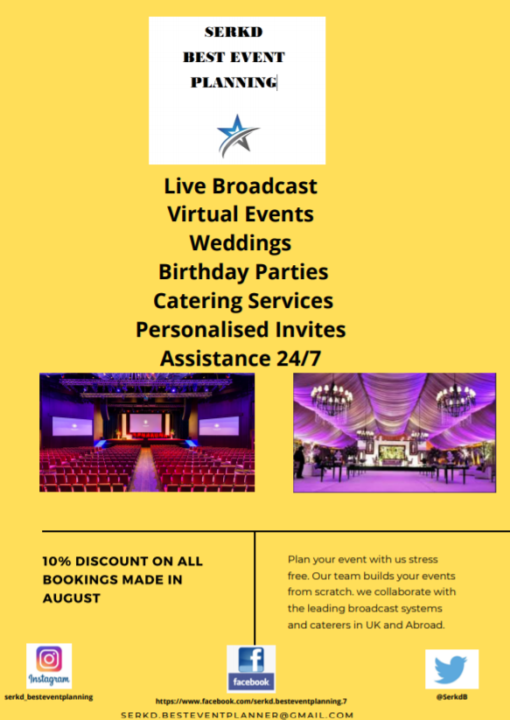
Offer 2 – Only applicable to people involved in current meetings
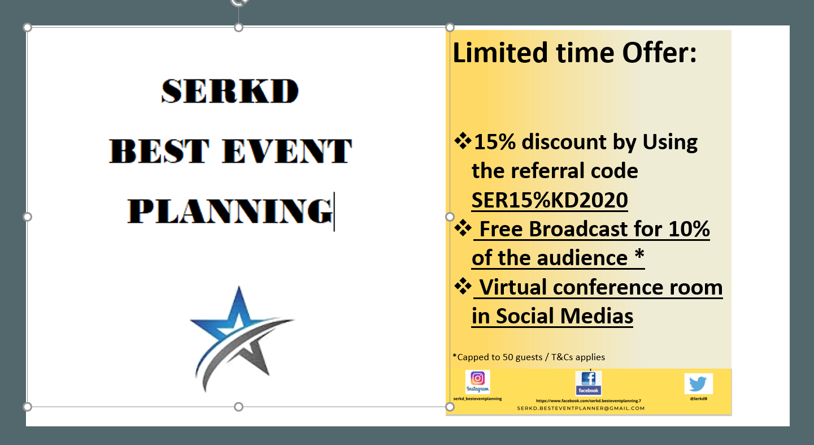
Wedding Promotion Flyer

Contract reviews and sent to “Limoncello Capri S.p.a.” (trading company launching the product to the Market)

Private and Confidential
International Agreement Department
Limoncello Capri SPA

30th July 2020

AGREEMENT BETWEEN “SERKD Ltd” and “LIMONCELLO CAPRI Spa”
SERKD Ltd was commissioned by Limoncello Capri Spa to organize the launch of: “LIMONCELLO DI CAPRI, THE TRUE ESSENCE OF CAPRI ISLAND” in London

At 11am on the 21st September 2020, SERKD Ltd will host Limoncello Capri Spa at its offices located in: Winchester House, 11 Cranmer Rd, Vassal, London SW9 6EJ, United Kingdom for a conference presentation where Limoncello di Capri will be promoted to about 200 possible buyers.

• Limoncello Capri Spa undertakes to send 250 test samples to SERKD Ltd offices no later than 1st September 2020; the event organizing agency will have then to deliver the 250 test samples to the buyers participating in the conference presentation;

• The conference will begin at 11am on 21st September 2020, using "ZOOM" platform; access link will be communicated to all participants no later than 15th September 2020. A reminder will be sent on 18th and 20th September 2020.

• Limoncello Spa has requested a room meeting for this event with the following accessories:
1. 1 rectangular table
2. 5 chairs
3. 5 microphones
4. 1 projector
5. 5 Flipcharts with Pens
6. Coffee/Tea
7. Water service always available throughout the conference presentation
8. Wi-Fi connection available throughout the conference presentation
9. Air conditioning available throughout the conference presentation
10. Catering services

Two hostesses available throughout the conference presentation
Any accessories can be added no later than September 18, 2020

The event will begin at 11am and end at 1.30pm, more information about the program is provided in the next chapter.

The event will have a total cost of £ 1150.00, advance payment of 50% of the amount no later than 7th of September 2020 to SERKD Ltd at the following coordinates:

Bank: Boombank
Account Number: 2435678734
Sort Code: 24-57-64

Clauses on recessions, cancellations and any changes are available on request.

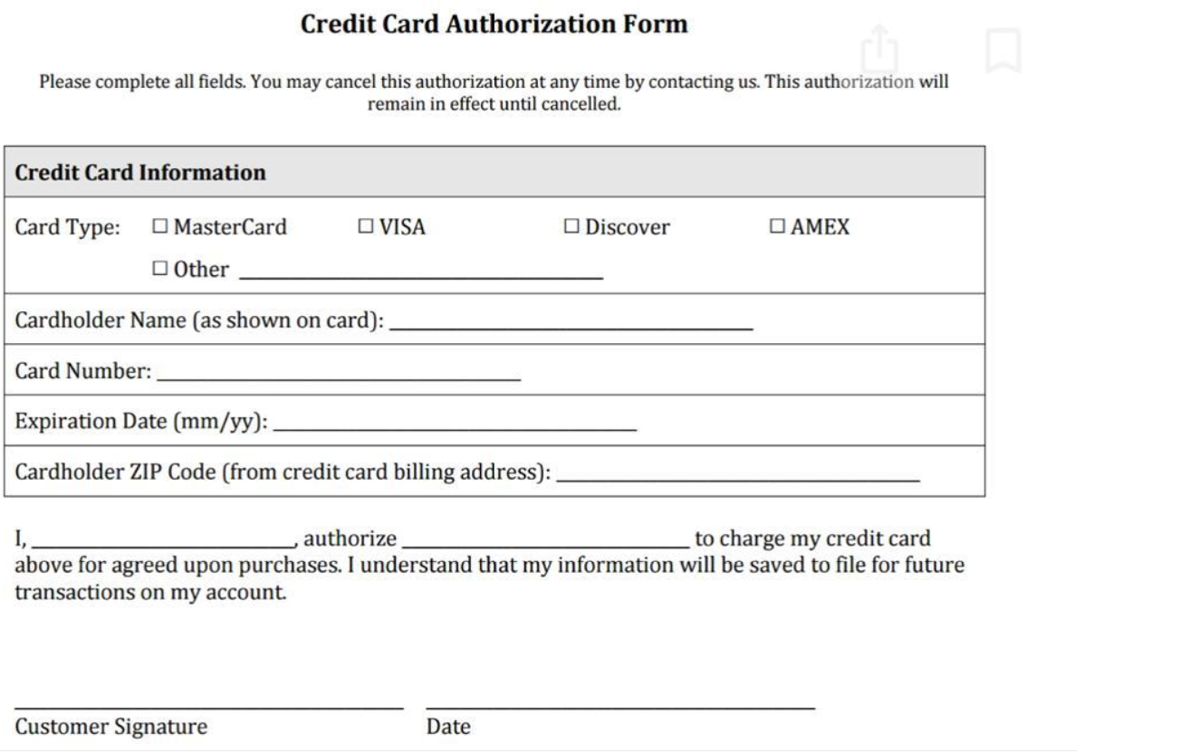

Week 5
Invitation Letter ready to be sent to attendees


Limoncello Capri Spa Ltd
Winchester House, 11 Cranmer Road, Vassal,
London, SW9 6EJ, UK
To: Miss Woo
Dear Miss Woo,
REF: Invite to Product Launch
It is our great pleasure to invite you to our “Morning of Limoncello di Capri” conference. This conference is scheduled on September 21st, 2020 from 11:00 am to 13:30 p.m. at Winchester House. We are hosting this event to allow our high-profile clients and our business partners the opportunity to share in our latest Food & Beverage ideas and to deepen relationships while building new ones.
The conference will be delivered via Zoom platform, due to current restriction as a result of Covid19 implications. Speeches from our leading expert Gennaro Contaldo will build momentum to an extraordinary talk about our new product, a launch of Limoncello Capri Spa. We hope to provide insight into our exciting new ideas at the conference.
This conference will also give our guests the opportunity to network with colleagues in the hospitality field. Your presence will bring depth to interactions and encourage colleagues who can benefit from the example of hospitality entrepreneurship your experience offers.
Please confirm your attendance with Kissairy at serkd.besteventplanner@gmail.com by 15th September 2020.
Login Details will be shared Friday, 18th September 2020. A recording of the session will be shared with attendees for future refence.
We sincerely look forward to seeing you at the conference.
Best regards,
Kissairy Valdez Public Relations Manager
Invitation:
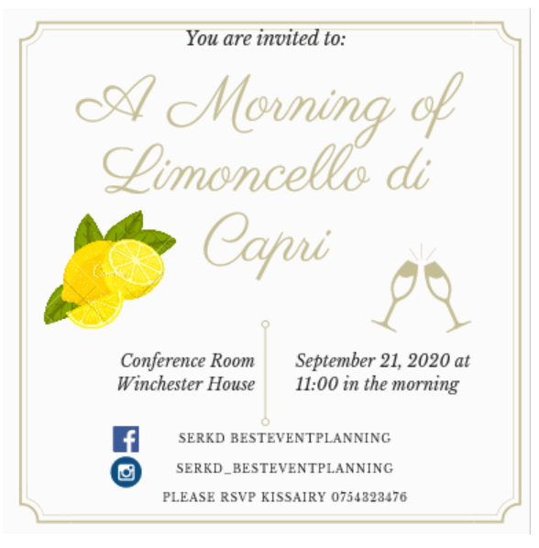
Business Card:

Minutes Dom
Problem resolution
- Quote not available yet, therefore, price tag still needs to be updated in accordance with their latest requests (Photographer and Catering cost TBC)
- Company intro TBR
- Fliers and Posters to be completed and shared with the team
Management of the event
- Sound speakers and connection test to be organised for the day before to ensure that everything goes smooth
- Arrange set-up of the premises with the Tech and Engineers from Site (communications to be sent)
- Contracts for food and beverage deliveries to be defined and choose company (Arrange menu with Catering Company)
- arrange delivery time for food and beverages (beverages and appetisers to be on site for a 10 mins break at 12:00 – INCLUDED-) rest of the food on site at termination of event (13:30/45 PM) (excluded menu to be arranged – company wants to dine on site for practicality and avoiding any extra travel)
- Hire freelancer photographer for the day (Extra cost as per request)
Marketing
Social media going strong, positive feedback received from previous events –
Intro video to be refined
Finance
Follow up on the deposit and Credit Card Forms
Deposit to be received by the 7th September (at present not received yet, contract signed)

PR
Relationship built with the new group
Proactively looking to get new events alongside Emoke
Logo and other work assigned completed

Week 6
Video to be uploaded on YouTube and link shared / Fliers and posters to be shared by sat DOM
-Sound speaker test arranged for Saturday 19th September 2020 (room setup will be done the same day)

- Food and beverages arranged with Di Lieto Italian Restaurant https://m.facebook.com/dilietobakery/ food and drinks will be delivered via uber eats (pre-paid)
Delivery at 12:00 (included)/ Full lunch at 13:30 paid individually (food ordered) Tot Cost £200 (£40 first delivery paid by the company)
Freelancer PH cost 500£ to cover Pictures Vid and Brochure
Follow up on the deposit and Credit Card Forms - Kissairy
Social Media promotion going well (attracted 25 more events through referral code)
PR
- engaging further with potential customers following referrals and new sales
- Email reminder set to be sent the 9th of September following check of event deposit paid
- Send referral code for future meetings
Agenda to be shared:
AGENDA
“LIMONCELLO DI CAPRI, THE TRUE ESSENCE OF CAPRI ISLAND”
- 9.00am: arrival of Limoncello Capri Spa members at our office;
- 9.30am: technical tests of the equipment and possibility of any logistical changes;
- 10.30am: break;
- 10.45am: access to the platform and welcome;
- 11.00am: conference start, 30 minutes of company presentation;
- 11.30am: 30 minutes of Limoncello presentation and the island which it comes from;
- 12.00pm: 15-minute break;
- 12.15pm: resumption of the conference and start of the tasting;
- 1.00pm: end of the tasting and release of contacts for possible and future collaboration;
- 1.15pm: thanks to all people who attended;
- 1.30pm: end of the conference presentation.
Additional services to be added to the cost 500+160=660 Total including VAT 1150+230+660= 2040
1020£ due the 7th September 2020
1020£ due at 30 days following the meeting
Communication to be sent and meeting held as described
Focus of the Week:
Attract more customers that will be in the conference for future events

Temporary Event Notice

I, the proposed premises user, hereby give notice under section 100 of the Licensing Act 2003 of my proposal to carry on a temporary activity at the premises described below.

1. The personal details of premises user
1. Your name Emoke Gego
Title | Mr Mrs x Miss Ms Other (please state)
Surname
Forenames
2. Previous names (Please enter details of any previous names or maiden names, if applicable. Please continue on a separate sheet if necessary)
Title | Mr Mrs x. Miss Ms Other (please state)
Surname
Forenames
3. Your date of birth |  |  |  | Day 21 | Month 10 | Year1984
4. Your place of birth |  |  |  | Hungary
5. National Insurance Number |  |  |  | AB123456C
6. Your current address
Flat 1, Tree House, 2 Rainbow Road, London, UK

Post town London |  |  | Postcode A12 3BC
7. Other contact details
Telephone numbers  Daytime  Evening (optional)  Mobile (optional) |  | 09876543212
Fax number (optional)
E-Mail address  (if available) |  | serkd@mybusiness.com
8. Alternative address for correspondence (If you complete the details below, we will use this address to correspond with you)
serkd@besteventplanner.co.uk

Post town London |  |  | Postcode D4 5EF
9. Alternative contact details (if applicable)
Telephone numbers:  Daytime  Evening (optional)  Mobile (optional) |  | 01234567898
Fax number (optional)
E-Mail address
(if available)

2. The premises
Please give the address of the premises where you intend to carry on the licensable activities or, if it has no address, give a detailed description (including the Ordnance Survey references)
(Please read note 2)
11 Cranmer Road, Vassal,
London
SW9 6EJ
United Kingdom

Does a premises licence or club premises certificate have effect in relation to the premises (or any part of the premises)? If so, please enter the licence or certificate number below.
Premises licence number
Club premises certificate number
If you intend to use only part of the premises at this address or intend to restrict the area to which this notice applies, please give a description and details below. (Please read note 3)
One office will be in use to promote the alcoholic beverage.
Please describe the nature of the premises below. (Please read note 4)
Public house.

Please describe the nature of the event below. (Please read note 5)
Conference

3. The licensable activities Lauch of an alcoholic beverage/tasting
Please state the licensable activities that you intend to carry on at the premises (please tick all licensable activities you intend to carry on). (Please read note 6)
The sale by retail of alcohol
The supply of alcohol by or on behalf of a club to, or to the order of, a member of the club
The provision of regulated entertainment
The provision of late night refreshment
Are you giving a late temporary event notice? (Please read note 7)
Please state the dates on which you intend to use these premises for licensable activities. (Please read note 8)
21/09/2020
Please state the times during the event period that you propose to carry on licensable activities (please give times in 24 hour clock). (Please read note 9)
11:00am – 13:30pm

Please state the maximum number of people at any one time that you intend to allow to be present at the premises during the times when you intend to carry on licensable activities, including any staff, organisers or performers. (Please read note 10) |  |  | 7
If the licensable activities will include the supply of alcohol, please state whether the supplies will be for consumption on or off the premises, or both (please tick as appropriate). (Please read note 11) | On the premises only |  | x
 | Off the premises only
 | Both

4. Personal licence holders (Please read note 12) Emoke Gego
Do you currently hold a valid personal licence?  (Please tick) |  | Yes | No  x
If “Yes” please provide the details of your personal licence below.
Issuing licensing authority
Licence number

Date of issue

Date of expiry

Any further relevant details

5. Previous temporary event notices you have given (Please read note 13 and tick the boxes that apply to you)
Have you previously given a temporary event notice in respect of any premises for events falling in the same calendar year as the event for which you are now giving this temporary event notice? | Yes  x | No
If answering yes, please state the number of temporary event notices (including the number of late temporary event notices, if any) you have given for events in that same calendar year | 26
Have you already given a temporary event notice for the same premises in which the event period:  a) ends 24 hours or less before; or  b) begins 24 hours or less after  the event period proposed in this notice? | Yes  x | No

6. Associates and business colleagues (Please read note 14 and tick the boxes that apply to you)
Has any associate of yours given a temporary event notice for an event in the same calendar year as the event for which you are now giving a temporary event notice? | Yes |  | No  x
If answering yes, please state the total number of temporary event notices (including the number of late temporary event notices, if any) your associate(s) have given for events in the same calendar year.

Has any associate of yours already given a temporary event notice for the same premises in which the event period:  a) ends 24 hours or less before; or  b) begins 24 hours or less after  the event period proposed in this notice? | Yes |  | No  x
Has any person with whom you are in business carrying on licensable activities given a temporary event notice for an event in the same calendar year as the event for which you are now giving a temporary event notice? | Yes |  | No  x
If answering yes, please state the total number of temporary event notices (including the number of late temporary event notices, if any) your business colleague(s) have given for events in the same calendar year.
Has any person with whom you are in business carrying on licensable activities already given a temporary event notice for the same premises in which the event period:  a) ends 24 hours or less before; or  b) begins 24 hours or less after  the event period proposed in this notice? | Yes |  | No  x

7. Checklist (Please read note 15)
I have: (Please tick the appropriate boxes)
Sent at least one copy of this notice to the licensing authority for the area in which the premises are situated | x
Sent a copy of this notice to the chief officer of police for the area in which the premises are situated | x
Sent a copy of this notice to the local authority exercising environmental health functions for the area in which the premises are situated | x
If the premises are situated in one or more licensing authority areas, sent at least one copy of this notice to each additional licensing authority | x
If the premises are situated in one or more police areas, sent a copy of this notice to each additional chief officer of police | x
If the premises are situated in one or more local authority areas, sent a copy of this notice to each additional local authority exercising environmental health functions | x
Made or enclosed payment of the fee for the application | x
Signed the declaration in Section 9 below | x

8. Condition (Please read note 16)
It is a condition of this temporary event notice that where the relevant licensable activities described in Section 3 above include the supply of alcohol that all such supplies are made by or under the authority of the premises user.

9. Declarations (Please read note 17)
The information contained in this form is correct to the best of my knowledge and belief.

I understand that it is an offence:
(i) to knowingly or recklessly make a false statement in or in connection with this temporary event notice and that a person is liable on summary conviction for such an offence to a fine not exceeding level 5 on the standard scale; and
(ii) to permit an unauthorised licensable activity to be carried on at any place and that a person is liable on summary conviction for any such offence to a fine not exceeding £20,000, or to imprisonment for a term not exceeding six months, or to both.

Signature | Emoke
Date | 03/07/2020
Name of Person signing | Emoke Gego

For completion by the licensing authority

10. Acknowledgement (Please read note 18)
I acknowledge receipt of this temporary event notice.

Signature | Apple  On behalf of the licensing authority
Date | 10/07/2020
Name of Officer signing | Apple Pear
NOTES

General

In these notes, a person who gives a temporary event notice is called a “premises user”.
The police and local authority exercising environmental health functions may intervene on the grounds of any of the four licensing objectives (the prevention of crime and disorder, public safety, the prevention of public nuisance, and the protection of children from harm) to prevent the occurrence of an event at which permitted temporary activities are to take place or to agree a modification of the arrangements for such an event. However, the licensing authority will intervene of its own volition in the cases described below.

First, it will issue a counter notice if there is an objection to a late temporary event notice (see note 7 below).

Secondly, it may issue a notice in relation to its decision to impose conditions on a temporary event notice (see note 2 below).

Thirdly, it will issue a counter notice if the first, second, third and fifth of the limits set out below would be exceeded. If any of the limits below are breached or if a counter notice has been issued, any licensable activities taking place would be unauthorised and the premises user would be liable to prosecution. The limitations apply to:

- the number of times a person may give a temporary event notice (50 times per year for a personal licence holder and 5 times per year for other people);

- the number of times a person may give a late temporary event notice (10 times per year for a personal licence holder and 2 times per year for other people);

- the number of times a temporary event notice may be given in respect of any particular premises (12 times in a calendar year);

- the length of time a temporary event may last for these purposes (168 hours or 7 days);

- the maximum aggregate duration of the periods covered by temporary event notices at any individual premises (21 days per calendar year); and

- the scale of the event in terms of the maximum number of people attending at any one time (a maximum of 499).

For the purposes of determining the overall limits of 50 temporary event notices per personal licence holder (in a calendar year) and of 5 for a non-personal licence holder (in a calendar year), temporary event notices given by an associate or a person who is in business with a premises user (and that business involves carrying on licensable activities) count towards those totals. The limits applying to late temporary event notices are included within the overall limits applying to the total number of temporary event notices. Note 14 below sets out the definition of an “associate”.

When permitted temporary activities take place, a premises user must ensure that either:

- a copy of the temporary event notice is prominently displayed at the premises; or

- the temporary event notice is kept at the premises either in his own custody or in the custody of a person present and working at the premises and whom he has nominated for that purpose.

Where the temporary event notice is in the custody of a nominated person, a notice specifying that fact and the position held by that person must be displayed prominently at the premises.

Where the temporary event notice or a notice specifying the nominated person is not displayed, a constable or an authorised person (for example, a licensing officer, fire officer or environmental health officer) may require the premises user to produce the temporary event notice for examination. Similarly, where the nominated person has the temporary event notice in his custody, a constable or authorised person may require that person to produce it for examination. Failure to produce the temporary event notice without reasonable excuse would be an offence.

It should also be noted that the following, among other things, are offences under the Licensing Act 2003:

- the sale or supply of alcohol to children under 18 years of age (maximum fine on conviction is a fine not exceeding level 5 on the standard scale, currently £5,000);

- allowing the sale of alcohol to children under 18 (maximum fine on conviction is a fine not exceeding level 5 on the standard scale, currently £5,000);

- knowingly allowing the consumption of alcohol on the premises by a person aged under 18 (maximum fine on conviction is a fine not exceeding level 5 on the standard scale, currently £5,000);

- allowing disorderly behaviour on the premises (maximum fine on conviction is a fine not exceeding level 3 on the standard scale, currently £1,000);

- the sale of alcohol to a person who is drunk (maximum fine on conviction is a fine not exceeding level 3 on the standard scale, currently £1,000);

- obtaining alcohol for a person who is drunk (maximum fine on conviction is a fine not exceeding level 3 on the standard scale, currently £1,000);

- knowingly allowing a person aged under 18 to make any sale or supply of alcohol unless the sale or supply has been specifically approved by the premises user or any individual aged 18 or over who has been authorised for this purpose by the premises user (maximum fine on conviction is a fine not exceeding level 1 on the standard scale, currently £200); and

- knowingly keeping or allowing to be kept on the premises any smuggled goods which have been imported without payment of duty or which have otherwise been unlawfully imported (maximum fine on conviction is a fine not exceeding level 3 on the standard scale, currently £1,000).

In addition, where the premises are to be used primarily or exclusively for the sale or supply of alcohol for consumption on the premises, it is an offence to allow children under 16 to be present when the premises are open for that purpose unless they are accompanied by an adult. In the case of any premises at which sales or supplies of alcohol are taking place at all, it is an offence for a child under 16 to be present there between the hours of midnight and 5am unless accompanied by an adult. In both instances, the penalty on conviction is a fine not exceeding level 3 on the standard scale, currently £1,000.

Note 1
A temporary event notice may only be given by an individual and not, for example, by an organisation or club or business. The individual giving the notice is the proposed “premises user”. Within businesses, clubs or organisations, one individual will therefore need to be identified as the proposed premises user.

If you include an e-mail address in section 1(7) or 1(9), the licensing authority may send to this the acknowledgement of receipt of your notice or any notice or counter notice it is required to give under sections 104A, 106A or 107 of the Licensing Act 2003.

Note 2
For the purposes of the Licensing Act 2003, “premises” means any place. Premises will therefore not always be a building with a formal address and postcode. Premises can include, for example, public parks, recreation grounds and private land.

If a premises licence or club premises certificate has effect in relation to the premises (or any part of the premises) which you want to use to carry on licensable activities, it is possible that any conditions which apply to the licence or certificate may be imposed on the temporary event notice if certain pre-conditions are met. These pre-conditions are that the police or the local authority exercising environmental health functions object to the notice and the licensing authority decides:

- not to give a counter notice under section 105 of the Licensing Act 2003;
- the conditions apply to the licence or certificate; and
- the imposition of the conditions on the notice would not be inconsistent with the carrying on of the licensable activities under the notice.

Note 3
A temporary event notice can be given for part of a building, such as a single room or a plot within a larger area of land. You should provide a clear description of the area in which you propose to carry on licensable activities. This is important as any licensable activities conducted outside the area of the premises protected by the authority of this temporary event notice would be unlawful and could lead to prosecution.

In addition, when holding the proposed event, the premises user would need to be able to restrict the number of people on the premises at any one time when licensable activities are taking place to less than 500. If more than 499 are on the premises when licensable activities are being carried on, the licensable activities would be unlawful and the premises user would be liable to prosecution. The maximum figure of 499 includes, for example, staff, organisers, stewards and performers.
Note 4
A description of the nature of the premises assists the chief officer of police and local authority exercising environmental health functions in deciding if any issues relating to the licensing objectives are likely to arise. You should state clearly that the premises to be used are, for example, a public house, a restaurant, an open field, a village hall or a beer tent.

Note 5
A description of the nature of the event similarly assists the chief officer of police and local authority exercising environmental health functions in making a decision as to whether or not to make an objection. You should state clearly that the event taking place at the premises would be, for example, a wedding with a pay bar, the supply of beer at a particular farmers’ market, a discotheque, the performance of a string quartet, a folk group or a rock band.

Note 6
The licensable activities are:

- the sale by retail of alcohol;
- the supply of alcohol by or on behalf of a club to, or to the order of, a member of a club;
- the provision of regulated entertainment; and
- the provision of late night refreshment.

Please refer to Schedules 1 and 2 to the Licensing Act 2003 for fuller details of the definitions and exemptions relating to regulated entertainment and late night refreshment.

Regulated entertainment, subject to specified conditions and exemptions, includes:

(a) a performance of a play;
(b) an exhibition of a film;
(c) an indoor sporting event;
(d) a boxing or wrestling entertainment;
(e) a performance of live music;
(f) any playing of recorded music;
(g) a performance of dance; and
(h) entertainment of a similar description to that falling within (e), (f) or (g).

If you are uncertain whether or not the activities that you propose are licensable, you should contact your licensing authority for further advice.

Note 7
Late notices can be given no later than 5 working days but no earlier than 9 working days before the event in relation to which the notice is given. A late notice given later than 5 working days before the event to which it relates will be returned as void and the activities described in it will not be authorised.

The number of late notices that can be given in any one calendar year is limited to 10 for personal licence holders and 2 for non-personal licence holders. These count towards the total number of temporary event notices (i.e. 50 temporary event notices per year for personal licence holders and 5 temporary event notices for non-personal licence holders).

If there is an objection from either the police or local authority exercising environmental health functions, the event will not go ahead and a counter notice will be issued.

Note 8
The maximum period for using premises for licensable activities under the authority of a temporary event notice is 168 hours or seven days.

Note 9
You should state here the times during the event period, for example 48 hours, when you intend to carry on licensable activities. For example, you may not intend to carry on licensable activities throughout the entire 48 hour event period, and may intend to sell alcohol between 8.00 hrs and 23.00 hrs on each of the two days.

Note 10
No more than 499 may be on the premises for a temporary event at any one time when licensable activities are being carried on. If you intend to have more than 499 attending the event, you should obtain a premises licence for the event. Your licensing authority should be able to advise you. The maximum figure of 499 includes not only the audience, spectators or consumers but also, for example, staff, organisers, stewards and performers who will be present on the premises.

Note 11
If you indicate that alcohol will be supplied only for consumption on the premises, you would be required to ensure that no person leaves the premises with alcohol supplied there. If such a supply takes place, the premises user may be liable to prosecution for carrying on an unauthorised licensable activity. Similarly, if the premises user gives notice that only supplies of alcohol for consumption off the premises will take place, he/she must ensure that alcohol supplied is not consumed on the premises. The premises user is free to give notice that he/she intends to carry on both types of supplies. For this purpose, the supply of alcohol includes both of the first two licensable activities listed in note 6 above.

Note 12
The holder of a valid personal licence issued under the Licensing Act 2003 may give up to 50 temporary event notices in any calendar year subject to the other limitations in the 2003 Act. A proposed premises user who holds such a licence should give the details requested.

Note 13
As stated under Note 12, a personal licence holder (issued under the Licensing Act 2003) may give up to 50 temporary event notices (including 10 late notices) in any calendar year. An individual who does not hold a personal licence may only give 5 temporary event notices (including 2 late notices) in England and Wales in any calendar year. A calendar year is the period between 1st January to 31st December inclusive in any year.

If an event straddles two calendar years, it will count against the limits on temporary event notices (12 for each premises, 21 days for each premises, 50 per personal licence holder and 5 for non-holders) for each year. However, only one notice needs to be given.

For the purposes of determining the overall limits of 50 temporary event notices per personal licence holder (in a calendar year) and of 5 for a non-personal licence holder (in a calendar year), temporary event notices given by an associate or a person who is in business with a premises user (and that business involves carrying on licensable activities) count towards those totals. Note 14 below sets out the definition of an “associate”.

If a temporary event notice has been given for the same premises, by the same premises user, and would have effect within 24 hours before the start of the event period under the current proposal or within 24 hours after the end of that period, the temporary event notice given would be void and any licensable activities carried on under it would therefore be unlicensed.

For the purposes of determining whether or not the required gap of 24 hours is upheld, temporary event notices given by an associate or a person who is in business with a premises user (and that business involves carrying on licensable activities) count as if they had been given by the premises user. Note 14 below sets out the definition of an “associate”.

Note 14
An “associate” of the proposed premises user is:

a. the spouse or civil partner of that person;
b. a child, parent, grandchild, grandparent, brother or sister of that person;
c. an agent or employee of that person; or
d. the spouse or civil partner of a person within (b) or (c).

For these purposes, a person living with another as that person’s husband or wife is to be treated as that person’s spouse.

Note 15
It is a requirement that you send at least one copy of this notice to the licensing authority at least ten working days (or five working days for a late notice) before the commencement of the proposed licensable activities. The authority will give you written acknowledgement of the receipt of the notice. This will be important proof that you gave the notice and when you gave it for the purposes of the Act. Some premises may be situated in two licensing authority areas, for example, where a building or field straddles the local authority boundary. Where this is the case, at least one copy of the notice must be sent to each of the licensing authorities identified, together with the appropriate fee in each case. In such circumstances, you will receive acknowledgements from all the relevant licensing authorities.

One copy must be sent to each of the chief officer of police and the local authority exercising environmental health functions for the area in which the premises is situated at least ten working days for a standard notice (or five working days for a late notice) before the commencement of the proposed licensable activities. Where the premises are situated in two police areas or environmental health areas, a further copy will need to be sent to the further police force and local authority exercising environmental health functions.

Note 16
Under the Licensing Act 2003, all temporary event notices are given subject to a mandatory condition requiring that where the licensable activities involve the supply of alcohol, all such supplies must be made by or under the authority of the named premises user. If there is a breach of this condition, the premises user and the individual making the supply in question would be liable to prosecution. For this purpose, the supply of alcohol includes both of the first two licensable activities listed in note 6 above.

Note 17
It is an offence knowingly or recklessly to make a false statement in, or in connection with, a temporary event notice. (A person is to be treated as making a false statement if he produces, furnishes, signs or otherwise makes use of a document that contains a false statement.) To do so could result in prosecution and a fine not exceeding level 5 on the standard scale.

Note 18
You should not complete section 10 of the notice, which is for use by the licensing authority. It may complete this section as one means of giving you written acknowledgement of its receipt of the notice.

