

Postgraduate/Distance Learning
Assignment coversheet & feedback form

THIS SHEET MUST BE THE FIRST PAGE OF THE ASSIGNMENT YOU ARE SUBMITTING (DO NOT SEND AS A SEPARATE FILE)

For completion by the student:
Student Name:Ffranses Dawn

Student University Email: 2518607@student.uwtsd.ac.uk
Module code:  HPCA7015  Module title:  Foundations in Cultural Astonomy & Astrology | Student ID number:  2518607 |  |  | Educational support needs:  No
Assignment title:
Essay 2 based on Sky Journal word count 2100

Assignment due date:27.11.2025
This assignment is for the 1^{st X} 2nd 3rd 4th 5th 6th module of the degree
I confirm that this is my original work and that I have adhered to the University policy on plagiarism.
Signed …Ffranses Dawn……………………
Email submission:if you are submitting this form via email, please tick this box □X
(as a substitute for your signature) to confirm that you agree to the above declaration.
Assignment Mark
1st Marker’s Provisional mark
2nd Marker’s/Moderator’s provisional mark
External Examiner’s mark (if relevant)
Final Mark

NB. All marks are provisional until confirmed by the Final Examination Board.

For completion by Marker 1 :
Comments:

Marker’s signature: |  |  | Date:
For completion by Marker 2/Moderator:

Comments:

Marker’s Signature: |  | Date:
External Examiner’s comments (if relevant)

External Examiner’s Signature: |  | Date:

The primary source for this essay was my observation of the skies, the dates were 4.10.25 to 8.11.25, predominantly from where I live in North Wales, during this time it was also my 60th birthday. Initially writing for myself but with the distant idea of critiquing the journal afterwards I have to declare a double bias, this essay is self indulgently subjective but I also want to highlight the inadequacy of writing in English about such a personal and spiritual content.
The main themes that emerged were ones of the mundane routine interwoven with an embodied sense and spiritual connection to the Sun. This awareness ran as a warp thread through the journal and an inspirational backdrop to the story of myself; my personal r/evolution and identity and the unfolding and revisiting of personal past.
In light of this Sun theme I read the letters of Vincent Van Gogh to his brother Theo, they too are also are mundane yet spiritual, detailing starving poverty, his joy at delivering a sermon in the UK as well as sky enchantment. His sunflowers picture has been a feature of my life since I was 11 years old. (Fig.1)
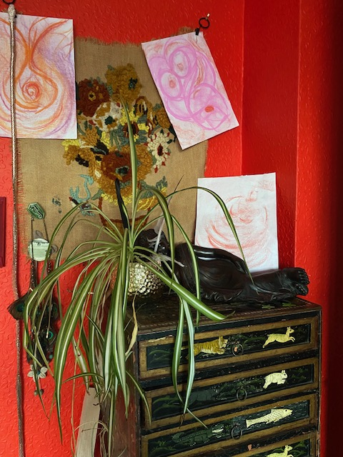
his ‘Starry Night’ graces the top of my stairs as I ascend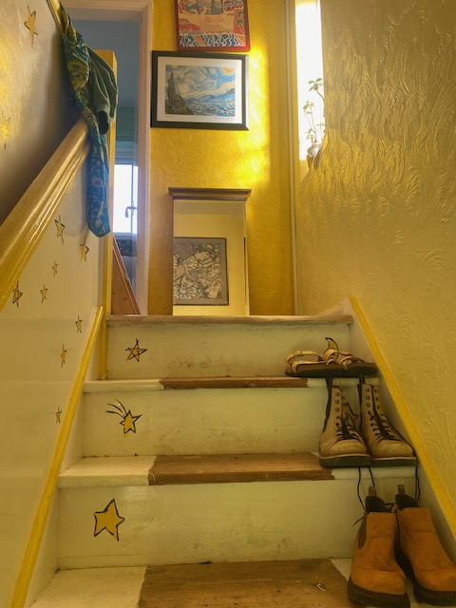
Fig.2 My staircase ascending to Van Gogh’s painting La nuit étoilée à Saint-Rémy
Swedenborg talks about there being two worlds and two Suns, ‘The only possible source of warmth and light is the Sun, it stands to reason there is a different Sun in the spiritual world than there is in the physical world, it also stands to reason that because of the essential nature of the spiritual world Sun, spiritual warmth and light can come forth from it’
Having art work, divination and words like Sanskrit, Hindu, French, Welsh in this essay help me to relieve the relentless Cartesian paradigm of the English language, and with my declared subjectivity I am trying to explore outside of my mechanistic default as it does not reflect my life experience or personal paradigm. Henri Corbin calls it ‘the agnostic reflex in Western man, because he has consented to the divorce between thought and being.’ I can only use words like ‘embodied’ in an attempt to encompass and convey a totality of experience, as we in the West have lost our resonance with what Corbin calls ‘the mundus imaginalis and what theosophers in Islam designate as the “eighth climate”’ and the ‘organ of perception that perceives this reality’ (of the eighth climate) ‘ is the imaginative consciousness, the cognitive imagination’.
The first Sky Journal entry was initiated on ‘Nos Sadwrn 4^{eg} Hydref
An old friend visited me and in her presence I pulled a divination card from the deck by Rima Staines and Sylvia Linsteadt ‘Sooth’ that we both share.
I choose one from the section called ‘Houses’ one of only 9 cards meant as ‘still points’. ‘Sanctuaries for the seeker after miles in the forest’
The card was ‘Our Lady of the Lyre Star’
‘She holds the constellation Lyra in her lap, whose brightest star is Vega, the blue pole star of the Palaeolithic. She is the one playing the song of the spheres.’ And in the meditation you ‘smell the sky’
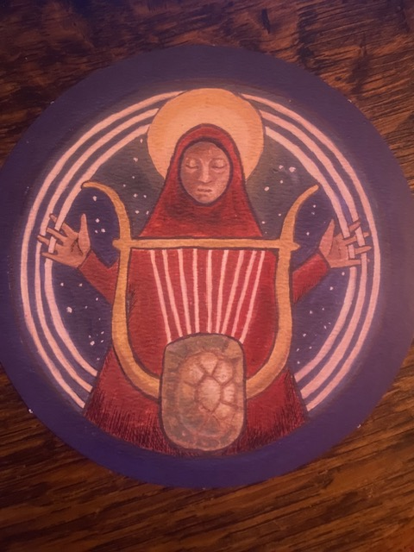

This felt perfectly propitious! For my 60th year, the course with UWTSD and my sky journal with the guidance of ‘smelling the sky’. The next morning we both shared the dawn sky together’
‘Dydd Sul 5^{eg} Hydref
The morning air is almost balmy after the storm, we sit out in the garden in my ‘morning room’. It is an outside space in the shelter of the extension and protects from any wind and faces east. It is my sunrise place. I’m happy to share my morning ritual with her. I light the incense, brew the coffee and we bathe in the new pinky yellow splendorous light wrapped up in housecoats listening to the Hanuman Chalisa.’
संकट मोचन हनुमानाष्टक
(हनुमान चालीसा के पाठ के बाद अवश्य ही एक पाठ तो करें ही करें।)
‘Having polished the mirror of my heart with the pollen like dust from the Guru’s lotus feet I sing the pure splendour of Sri Ram …..……as mighty as a thunder bolt, golden hued and splendidly adorned…’
Fig. 3 View of the sunrise/dawn from my seating area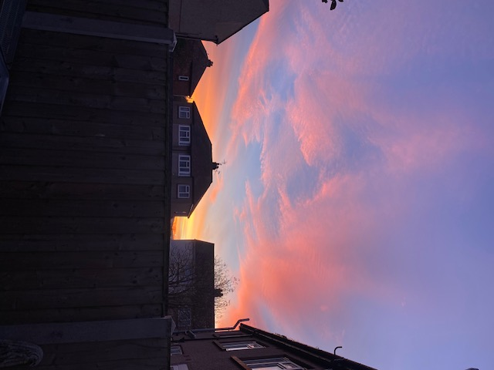t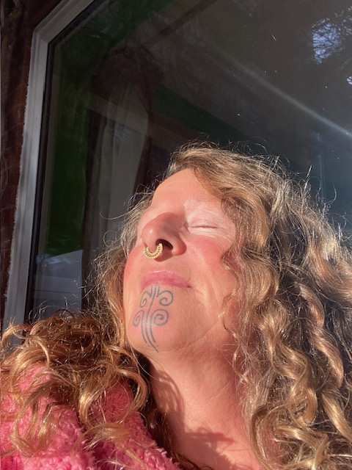Fig. 4 Sunbathing at Dawn

This theme of my spiritual practice being part of my connection to the Cosmos has been deeply aligned within me in what seems like forever, most especially my sensitivity to the Sun.
‘Dydd Mawrth 7^{eg} Hydref 2025
I awake just as the sun rises, in my loft bedroom with blackout blinds. I can feel in my body when the sun comes up over the horizon, I have checked with weather apps in the past and it’s true, I’m usually a few minutes before the official time, but I definitely feel the sun rise. It’s like a blind is lifted from my auric body, a subtle etheric activation, there, just, sudden, a ‘feeling’, an embodied alertness, a jump from unconscious to consciousness…. part of me is wide awake and alert, a primitive sheath, activated, ready, on’
Levy-Bruhl’s words in ‘How Native’s Think’ made a connection with me when he said, ‘Rather let us consider these connections in themselves, and see whether they do not depend upon a general law, a common foundation for those mystic relations which primitive mentality so frequently senses in beings and objects. Now there is one element which is never lacking in such relations. In varying forms and degrees they all involve “participation” between persons or objects which form part of a collective representation.’ The Sun has been one such object in my life, whether physical, metaphysical, mundane or mystical.
‘Dydd Mecher 15^{eg} Hydref 2025
I walk the dogs in a stupor, I’m straight out in my wellies and dog walking coat over my housecoat, the light is adorable, the wind is calm, again its soo delicious, I’m enchanted by the air and pinky light. I mentally feel a chant rising in the back of my mind until it surfaces in my consciousness as I walk into the dawn light with my face, moisturised by the light, nourished.’
ॐ भूर्भुवः स्वः  तत्सवितुर्वरेण्यं  भर्गो देवस्य धीमहि  धियो यो नः प्रचोदयात् | Om Bhuur Bhuvah Svah  Tat Savitur Varennyam  Bhargo Devasya Dhiimahi  Dhiyo Yo Nah Pracodayaat

The mantra to the Sun was ‘physically’ transmitted to me by Swami Neel Kamal at the Mandala Yoga Ashram 30 years ago, I had no idea what it was, she sang it and my heart just ‘popped’ like a bubble bursting and tears flowed out of my eyes down my cheeks. I had no idea what had happened, awestruck by the visceral sensations. I cannot explain this powerful life changing event; I only know what I felt and its endurance in my life.

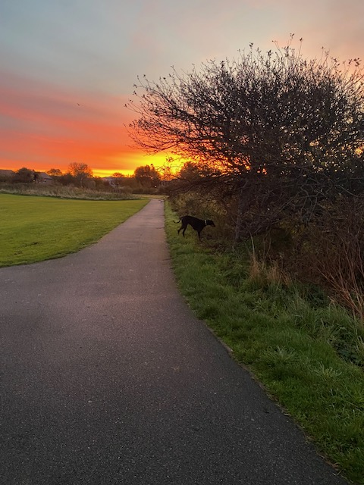 Fig 5 Dog walking at dawn
‘Dydd Mawrth 14^{ed} Hydref
As a child my mum sent me and my sister to elocution lessons to control our voice, as she was severely hard of hearing and we were, by default very loud. I was about 9 years old, we had to learn poetry. My first experience of hearing a poem was magical; it spoke to me of Soul, of vastness, romance, adventure and awe. Still to this day I can capture in my body a kernel of excitement at the dawn as the words drift into my consciousness from my childhood initiation into poetry.
I’ll tell you how how the Sun rose by Emily Dickenson
I’ll tell you how the sun rose,
A ribbon at a time.
The steeples swam in amethyst,
The news like squirrels ran.
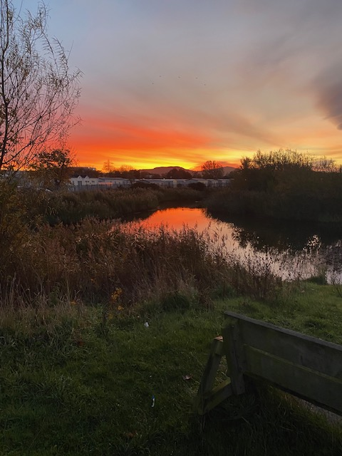
Fig 6 Morning dawn dog walk
‘Dydd Mercher 8^{eg} Hydref my birth month of October is the time I have decided in my 60th year to change my name, to lose the surnames that came from a man’s lineage and just go by the names that were given to me at birth, my own, no one else’s, linked to my identity, my destiny and my resonance. I was given the name Dawn due to being born at six minutes past six in 1965. To reclaim a lost part of self feels very centring, grounding, to come back to myself, to be 60 and not to be ‘defined by men’
Fig. 7 My birth chart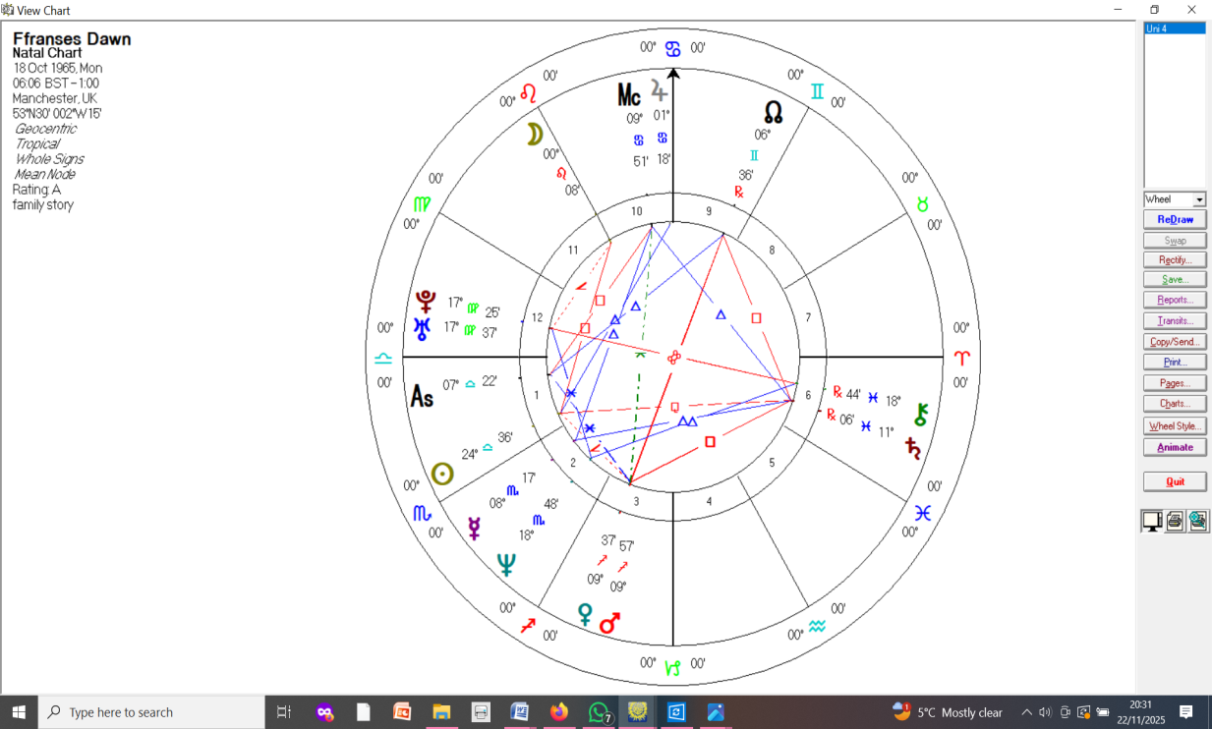

‘Dydd Iau 23^{ed} Hydref
At the Ashram, woken for yoga practice at 5.45am by the sounding of a hand rung bell calling everyone out of their beds in the dark, after yoga we sit to chant and the light is slowly beginning to illuminate the garden. I always get to the Sadhana hall early so as to sit facing the long floor to ceiling window where I perceive the shadows retreat in the face of the sunrise, the day has truly dawned as we finish our mediation.
Dydd Sul 26^{ed} Hydref
For yoga this morning the clocks have gone back one hour and the sudden jump and jolt of the day, the dawn, the light in the wrong place is stunning in its shift. My circadian rhythms are shocked.’
Again the embodied theme of the Sun, my sensitivity to it, my ‘participation’ with it.
To return to Van Gogh and his life juxtaposing the mundane with enchantment from the skies; ‘Alors la vie est tout de même presqu’enchantée. Ah ceux qui ne croient pas au soleil d’ici sont bien impies. Then life is almost magical, after all. Ah, those who don’t believe in the sun down here are truly blasphemous.
He too portrays the Sun as sublime and those who don’t believe as ‘impious’ or ‘blasphemous’
Fig.7 long boring drive home on the Cat and Fiddle, sunset magnifique above the clouds in an upside down phenomenon where the sky is on the earth.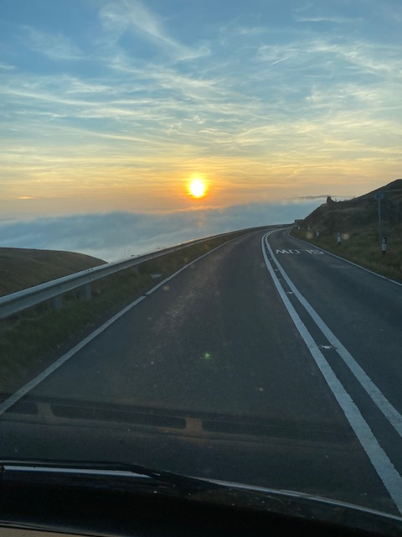
In Welsh/Cymraig the time is inherent in the word for the days of the week. If it’s the daytime the prefix word is Dydd meaning day. If it’s after the sun goes down its Nos meaning night. In English we have no such delineation, a connection to the heavens and her luminaries lost linguistically in translation. A cultural shift away from the movement of the Earth reflected in the vernacular.
Finally to mirror Van Gogh’s mundane life here is my final journal example for the daily routine of my life as a dog owner
Cerdded yn y nos/yn y bore Nos Llun/Dydd Mawrth 27/28^{ed} Mis Hydref
Rhigol dywyll  Llwybr gwlyb  Dyrnod y gwynt  Gwacter yn arbed o'r nos  Nos da  Dark routine  Wet path  Buffeting wind  Emptiness save from the night  Nos da | Rhigol ysgafn  Llwybr sych  Gwyntoedd uchel  Wedi'i achub gan y golau  Bore da  Light routine  Dry path  High winds  Saved by the light  Bore da

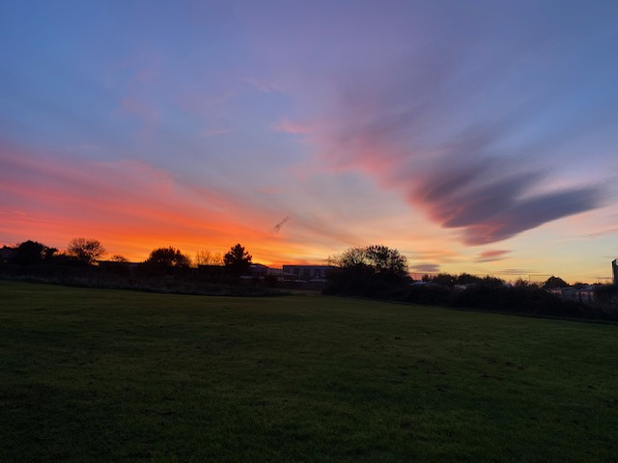
Fig. 8 walking the dogs at dawn after the storm
To conclude, I have only focussed on my personal spiritual, mundane and historical relationship with the Sun and yet the daily habit of looking up to skyscapes has a wider context for October 2025 with all the current affairs occurring globally such as storms, the AI Atlas and other comets in the news and media everywhere. This has influenced and broadened my perspective and judgement of things in the sky so much so, that now I am looking up at strange phenomena from storms and unusual electromagnetic energy and wondering if the two huge twin lights I saw dancing over the M56 are UFO’s or if the strange pink hue over Manchester is an alien Venusian ‘hello’ rather than the Northern Lights, which I’ve seen before and this time didn’t look anything like them to me!

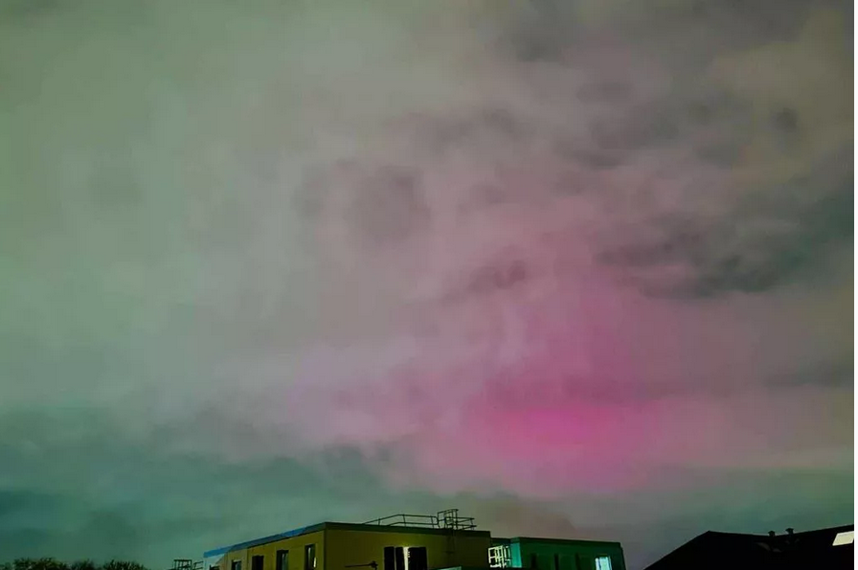 The Northern Lights pierced through cloud in Greater Manchester last night(Ayush Verma/MEN)
Bibliography
Beauvoir. Simone, de The Second Sex, H.M Parshley (ed.and trans.), New York: Vintage Books, 1952/1974:intro
Corbin. Henri, Mundus Imaginalis, or the Imaginary and the Imaginal https://hermetic.com/moorish/mundus-imaginalis :4
Dickenson. Emily, I’ll tell you how the Sun rose (1890), pub The Complete Poems of Emily Dickinson (1924)
Tulsidas. Goswami, Hanuman Chalisa
https://vangoghletters.org/vg/letters/let663/print.html
Levy-Bruhl, L. How Natives Think pub George Allen & Unwin Ltd:76
Manchester Evening News Newspaper online 12th November https://www.manchestereveningnews.co.uk/news/greater-manchester-news/stunning-northern-lights-spotted-above-32857299
Oxford-Hatchette French Dictionary
Rig Veda, Gayatri Mantra,
Staines and Lundsted, Sooth, Our Lady of the Stars (self published Devon 2024)
Swedenbourg. Emmanuel, Divine Love and Wisdom, trans Dole. E. George

Swedenbourg. Emmanuel, Divine Love and Wisdom, trans Dole. E. George:section 84
Corbin. Henri, Mundus Imaginalis, or the Imaginary and the Imaginal https://hermetic.com/moorish/mundus-imaginalis :4
ibid:1
ibid:1
Staines and Lundsted, Sooth, Our Lady of the Stars
ibid:12
ibid:62-63
Hanuman Chalisa translation in Hindi By Abhilash Rajendran
Das. Krishna translation
Levy-Bruhl, L. How Natives Think pub George Allen & Unwin Ltd:76
Gayatri Mantra in Hindi
Gayatri Mantra in Sankrit
Mandala Yoga Ashram Pantypistyll, Llansadwrn, Carmarthenshire SA19 8NR
The Gayatri mantra is for Savitur, the Sun God.
Dickenson. Emily, I’ll tell you how the Sun rose (1890), pub The Complete Poems of Emily Dickinson (1924)
Beauvoir. Simone de, The Second Sex, H.M Parshley (ed.and trans.), New York: Vintage Books, 1952/1974:intro
Levy-Bruhl, L. How Natives Think pub George Allen & Unwin Ltd:76
https://vangoghletters.org/vg/letters/let663/print.html
Oxford French Dictionary
Walk in the night and morning, Monday/Tuesday 27th/28th October
https://www.manchestereveningnews.co.uk/news/greater-manchester-news/stunning-northern-lights-spotted-above-32857299
Manchester Evening News Newspaper online 12th November https://www.manchestereveningnews.co.uk/news/greater-manchester-news/stunning-northern-lights-spotted-above-32857299

