An Early Years Practitioners Handbook:
A guide to Transitions

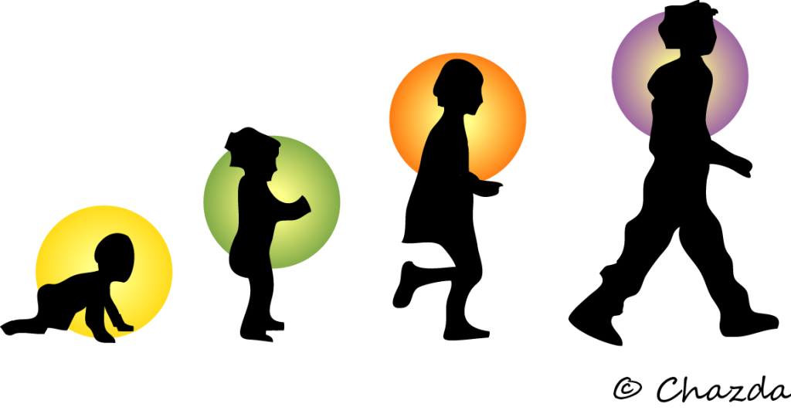
(PYP Counselor, 2017)

Contents

Introduction

The role of the adult

The needs of the child

Environments

Partnerships

Proposed outcomes

INTRODUCTION

What is a Transition?
In theory according to New York State Multiple Systems Navigator (2022) the word transitions derive from the Latin word transire meaning to go through or across which links a form for growth and development without a result. Transitions are made up of multiple stages that are both predictable and unpredictable circumstances.
In general transitions can be a change from school life to work and can vary from each person’s life stage.
Children and transitions?
Research suggests that transitions are central to young children’s development and emotional wellbeing. According to Early Years Matter (2022) as years go by children’s life’s grow more frantic as children are constantly changing their setting such as, starting a new school and changing classrooms. These are too adults seen a normal stages changes children go through as they once went through.
Early Years Matter (2022) states transitions are milestone events in a child’s life which at times they may experience positive opportunities which alter their growth. However, children often experience a change in surroundings, procedures and even prospects.
In contrast, according to Lago, L. and Elvstrand, H. (2019) transitions is not only about moving from surroundings such as from indoors to outdoors but changing the daily routine which is more structured and fuller in their day-to-day life. For instance, nursery to home, then childminder to lunch… such as lunchtime, or going from home to childminder, nursery, and back again in the same day.
“Transition has been described as an ongoing journey rather than a destination” (Early Years Matter 2022)
Doing transition correctly is critical for each child as change should be described as a positive process instead of an event in which children, practitioners, and parents all participate.
In these stages from nursery on wards it’s important that children are encouraged through transitions as, Cosaro, W.A. (2021) believes when changes in childhood are handled delicately, it creates the groundwork for positive feelings toward the many subsequent transitions children will encounter throughout their lives.

THE ROLE OF THE ADULT = 1185

The beginning of a child early life, it is important that children create familiar bonds with the child-minder, parents, and Practitioners. It’s the adult’s role to help create these bonds with early year.
It was argued by Ackesjö according to Bath spa university (2019) that when children go through a transition, they are interacting and understanding both their familiar environment and their new unfamiliar environment. This negotiation is part of the process of assembling their identity within a new environment.
This process Ackesjö states according to Bath spa university (2019) mentioned is linked to the theory by Schlossberg as he believes transition is defined as an incident or non-event that ultimately resulted in altered connections, routines, presumptions, and responsibilities. Schlossberg identified four major sets of factors that influence a person's ability to cope with a transition: situation, self, support, and strategies, which are also known as the 4 S's.

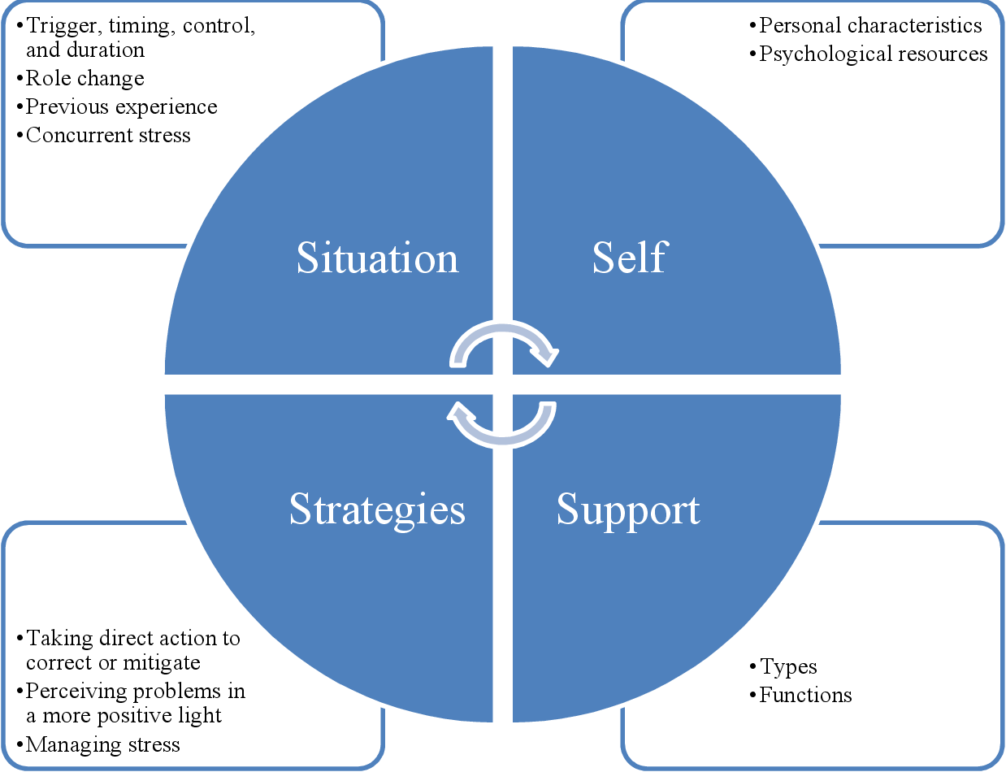
(K. Derrick, 2019)
The Mentor - Division of Undergraduate Studies (2019) explains this first stage is the triggers for change where you describe the situation through answering questions about timing, control, role change, duration, current stress and assessment of the situation.
The second stage is Self: factors considered important in relation to the self are classified into two categories. You consider the personal factors like socioeconomic status, gender, age, stage of life, level of health, and ethnicity have an impact on how a person views life. Then the emotional and intellectual development, outlook, commitment, and values are all examples of psychological resources.
The third stage is the social support when, you begin to consider familiar and deep relationships, a household unit, a broad unit of friends and Institutions and communities.
The final stage is Strategies, or coping responses, are divided into three categories It’s when you modify the situation, take control the meaning of the problem and aid in managing the stress in the aftermath.
Schlossberg's model appears to be comprehensive, enabling for various types of transition that other models do not. This is similar to Kübler-Ross model according to The Editors of Psycom (2022) which is mainly focused on the grieving process. Schlossberg proposes a process, going through various stages of the alter or transition process In contrast to these models, Schlossberg appears to allow for a lot more fluidity in how the model is interpreted and used, as well as a lot more spontaneity in the types of transitions it trying to describe.
“Any event or non-event that results in changed, relationships, routines, assumptions, and roles” (Goodman, Schlossberg and Anderson, 2006)
Evans (1970) explains Bronfenbrenner’s ecological systems theory as more focused on child development a complex system relationship which are affected from different types of environments. Bronfenbrenner’s model (1976) theory focuses on beyond individual development, considering wider influencing and the context (or ecology) of development.
In contrast to Schlossberg (1984) theory mentioned earlier both have 4 stages;
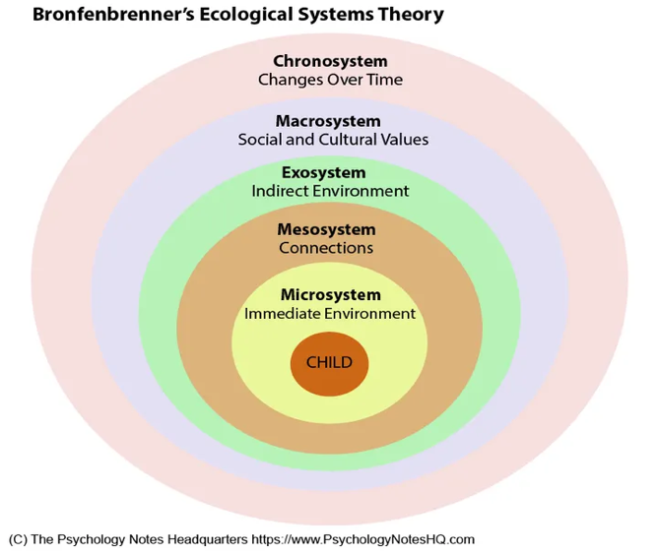
(AUTHOR PSYCHOLOGY NOTES HQ, 2021)

The microsystem- This is the child's physical environment during which children invest the vast majority of their time; they are active and comfortable in this surroundings. Long-term relationships inside this microsystem had a consistent and long-term impact on a child's development.
The Mesosystem- this refers to the lengthened environments, such as entire family, school, nursery, community, and so on.
The Exosystem- These are typically settings that don't involve children but can have an impact on their growth. This includes the media, politics, community members, and related industries.
The Macrosystem - Consists of a significantly broader range of ideologies, laws, regulations, and cultural influences.
Bronfenbrenner believed that a more holistic approach to a child’s development would be more beneficial. However, Drew (2022) states it is sometimes vague with the categorise as, the list of the mesosystem such as the family, school, friends, etc. the ways in which these factors interact to influence a child's development are not well understood. Where as, MRCR (2022) Schlossberg seems to allow a lot more fluidity in how the model is interpreted and used and she allows for a lot more fluidity in the kinds of transitions it attempts to describe. Also, Schlossberg theory can be used in many kinds of transitions in a personal’s life not just children.

Parents
The primary role of a parent in their child's development is to engage as much as possible with schools and teachers. Also, taking any views they may have as everyone has the same goal of aiding the development of the children. Hetherington, el at (1998) states that parents should be participating with schools and communicating with your children as it can make the transition easier for everyone. Children can express concerns about losing contact with former friends, whether they have teacher who they think is too strict or even being bullied by peers. Also, Bath spa university (2019) suggest that Ackesjö argues that with children aged 2-6years they do change educational setting a few times and it’s important that the parents to achieve a smother transaction for the child is to do their own research. As, seeking advice from practitioners or qualified teachers is important with visits done prior and research done their room for more questions to be answered. Such as weather there are staff that can identify any learning difficulties or a broad range of activates which include any/every child as well as getting use to and understanding of the school’s culture and set up.

Teacher/ care-minder
PACEY (2021) identifies a teacher or child-miner is a named person in a setting who is accountable for collaborating with your parents while, also achieving your child's personal needs. Childcare policy in England and Wales emphasises the importance of the Teacher or child-miner as being a member of the childcare staff you would be assigned as your child's key figure. If you use a childminder, they are the child's primary caregiver. A theory by Mario Mikulincer according to Simpson (2017) as a model that record the sequence of events that could identify people with various attachment histories' emotional coping and regulation strategies
When anxiety or a possible threat is perceived, for example, highly secure individuals are confident that their attachment figures would be alert, responsive, and accessible to fulfil their needs and assist them in reducing their anxiety and distress.
These belief systems, in turn, should significantly raise their sense of security, enabling them to disable their attachment mechanisms and use cogent, problem-focused coping mechanisms that are highly probable to resolve their issues over time.

THE NEED OF THE CHILD

“We can teach and nurture children holistically to thrive” (Carly 2020)
According to In Early Years, Parents (2021) All children form attachments to parents and teachers to thrive in relationships that are dependable, respectful, warm, and loving. When children's physical and emotional needs are met and their feelings are accepted, they experience happiness and contentment. The key person strategy, which reflects relationships within families, contributes to meeting these conditions. Early experiences with love and attachment have long-term impacts.
Early years begin nursery and can be make the transition stressful when they leave their parents. As a result, it can be beneficial to establish a "goodbye routine," perhaps using a favourite toy. Make sure the child knows where everything is - the toilets, their preferred activities, and toys. Learning about their new surroundings will help to alleviate any anxiety and make going to the nursery more pleasurable.
According to Kenrick, D.T. et al. (2010) Maslow's hierarchy of human needs, introduced in 1943, has become one of the greatest cognitively infectious concepts in behavioural psychology. Maslow anticipated later human evolution perspective on human desire and cognition by viewing human motivations as inherent and global preconceptions.
McLeod (2007) Maslow’s hierarchy of needs is a psychological motivational theory that consists of a five-tier theory of human needs, that is often represented as pyramid as hierarchical levels.

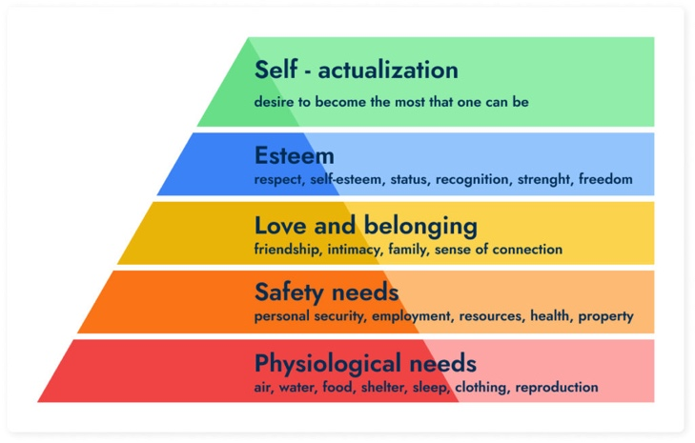
(Jade ALM ,2022)
The first stage is Physiological needs, Maslow states this as the biological requirement to function normally. This in tales’ food, water, shelter, and clothing, etc. The second stage is Safety need which are needs that cater to an individual such as having a predictable routine and control their own lives. This need could be filled by society and family. Such as financial security, freedom from fear healthy livelihood etc.
The third stage is Love and belongingness needs and feeling emotionally fulfilled. As human we have strong needs emotionally and these needs can be filled through intermate relationships, family, and friends. The fourth stage is Esteems needs, this is the need of self-achievement and the desire to gain respect from others through status and prestige.
Maslow indicated that the need for respect or reputation is most important for children and adolescents and have real self-esteem or dignity. The last stage is Self-actualization needs, this is the highest need on Maslow’s hierarchy, and this achieved by recognising the personal growth and personal potential to continue the growth. Maslow (1943) describes this level as the desire to accomplish everything that one can, to become the most that one can be.
University of Reading (2020) states Maslow’s theory give people structure and when a child doesn’t feel as though the foundation of the hierocracy isn’t met children can’t be expected to reach their full potential. Children can withdraw from relationships that were built and stunt their self-esteem.

ENVIRONMENTS

Having an enabling environment can impact of child’s surroundings and their overall development. It is essentials that all practitioners understand children’s need for independence and values.
Froebel (1912) created kindergarten where children play as he believed this to be the highest expression of human development. As his theory focuses on child-led play which is based on social, emotional, spiritual, intellectual, and physical development. It inspires children’s imagination and behaviour as children can express themselves freely. This daily environment created by practitioners encourages children to build new friendships and developing security which aids transitions.

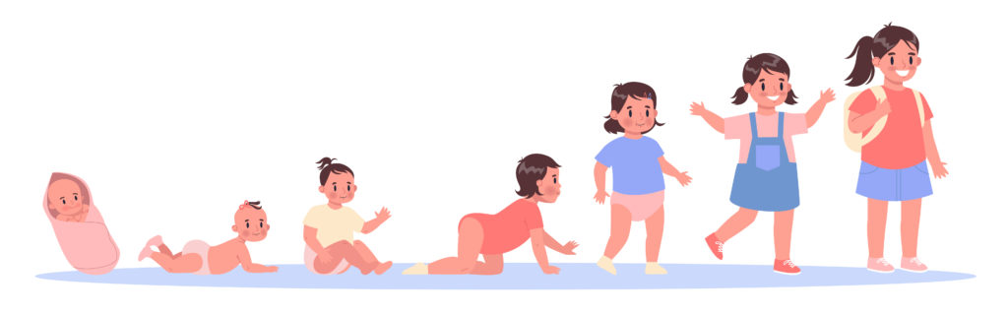
(Onlinepsychologydegree, 2021)
Early years’ experience curriculum requires relevant material as well as practitioners who can implement the curriculum requirements. Kagan SL, elt (1995) believes practitioners should be able to build on what the child already knows and should capture their interests. Practitioners should already be aware that children do rapidly develop during these stages and encouraging a positive attitude to enhance and expand a child’s development.
Like Froebel, Piaget (1962) suggest who was among the very first A psychologist will conduct a comprehensive study of children's cognitive development. Who is regarded as having one of the most influential theories in human development. Piaget argues that as children mature in their development their environment and play should develop to further their cognitive and language development. Children who explore the settings around them and are constantly using their senses learn more effectively. It’s interesting to see the development of Frobel (early1800) who first began to explore the element of play and the in-depth development of children.
Teach Early Years Magazine, A.P. (2022) believes children are constantly changing their settings, from school, to day care and home. It’s crucial for the children to feel safe as they continue to develop.) encourages environments that have routines, small groups and building new friendships to aid transitions. As children progress in their school settings activities, joining other settings it is important children are provided with familiar resources and experiences. Both identify the need for children to feel safe to continue to develop, so when minor adjustments occur the children are less likely to feel overwhelmed and can continue the importance of their development. Children will be more open to new ideas and challenges if they have successfully adjusted to their surroundings,
Children should be able to freely talk about their feelings and what might be happening to them. Val (2020) believes they should be allowed to express themselves and be encouraged children to ask questions when they feel unsure to help ease any worries that may arise. Spending quality time with children can foster a sense of familiarity which can help reduce any anxieties and worries children have during transitions. Philosophy’s such as Montessori who worked in young, disadvantaged children and began to focus on child-led play supported by age-appropriate activities and provisions.

Partnerships

The ability to communicate effectively is a key skill, and the better we are at it, the better our quality of life will be. Kumon (2021) states communication beings from the time a child is born as they first cry to let the mother they have arrived.
Winter, L. (2020) refers to the Early Years Foundation Stage (EYFS) framework, a partnership consists of parents, families, and practitioners working along-side of each other to benefit children. A effective partnership is based on trust, clarity, and accountability from all parties involved.
Partnerships are important as According to Cohen et al. (2011), Using a mixed approach allows the researcher to gather more comprehensive data, resulting in results that provide a more comprehensive view of the overall issue. According to Teach Early Years Magazine, A.P. (2022) Strong, mutually respectful relationships with both parents and practitioners pave the way for a smooth transition. Importantly, relationships with those who care for their child provide solace to parents, while simple, visible conversations between significant adults are deeply reassuring to children.

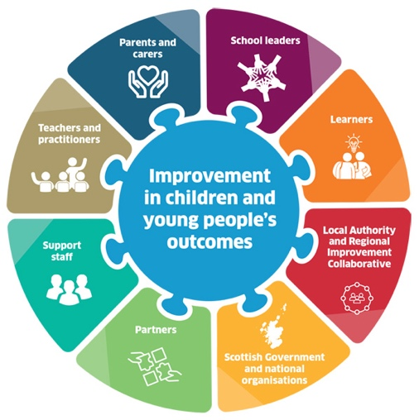

(National improvement Hub, 2022)
A strengthened and more confident system collaborates to lead education and learning that achieves brilliance and equity for all learners. At all levels of the system, empowerment and collaborative effort for improvement occur.
As claimed by, Zimmerman (1995) In order to participate in the partnership, both parents and practitioners must feel empowered. The potential to be assertive while having self-efficacy and self-assurance in attempting to control resources and making decisions is referred to as empowerment in this context. (Zimmerman, 1995).
When discussing family empowerment, as stated by, Thompson et al. (1997) Individuals being able to choose their own prospect, and parents having the relevant information and problem-solving skills to deal with difficult situations, are examples of empowerment. In the context of establishing parent-practitioner partnerships within early years, empowered individuals must be able to confidently to engage one another and establish healthy relationships, which necessitates a level of transparency.
Teach Early Years Magazine, A.P. (2022) in accordance with Thompson et al. (1997) agrees respectful connections between parents and professionals build the groundwork for a successful transition. A true discussion with parents gives information to the practitioner, as well as possibilities to enhance ideas and academic experience inside the environment. Crucially, interactions with individuals who care for their kid provide solace to parents, while simple, visible talks between major adults are immensely soothing to youngsters.

Proposed outcomes

The possible outcomes that can come from a successful transition can allow children to control their development and have a positive coping method to deal with different strategies. In relations to WJEC Digital Educational Resources (2021) they explore the study by John Bowlby and attachment theory that states that a baby’s need to form an attachment would suffer psychological harm if separated in the first year. This alone effected the need for attachments and why it’s hard for children to cope with transitions.
Its important that practitioners and parents understand the need for independent play for a child as when a child is able to dispatch, they can become less relent on others and be independent. A child will show they are settling when as they are responsive when called, happy, feel safe to do as they will and ask for help and many other positive responses.

REFERNECE
Bath spa univeristy (2019) Transitions in early childhood - transition why do children experience difficulties when, StuDocu. Available at: https://www.studocu.com/en-gb/document/bath-spa-university/introduction-to-early-childhood-studies/transitions-in-early-childhood/12608515 (Accessed: November 20, 2022).
Cohen, L., Manion, L., & Morrison, K. (2011). Research methods in education. (7th ed.). Routledge.
Cosaro, W.A. (2021) Reflections on longitudinal ethnographies of children’s interactions, friendships and early life transitions in Italy and the United States, in A-W Dunlop, S. Peters and S.I Kagan, The Bloomsbury Handbook of Early Childhood Transitions Research: London and New York: Bloomsbury Academic Press
Derrick, K elt (2019). Assessing and responding to anxiety and panic in the Emergency Department. Australasian emergency care, 22(4), pp.216-220.Schlossberg, N.K. and Goodman, J., 2005. Counseling adults in transition. Springer Publishing Company.
drew, C. (2022) Bronfenbrenner's Ecological Systems Theory (Pros & Cons), Helpful Professor. Available at: https://helpfulprofessor.com/ecological-systems-theory-pros-cons/ (Accessed: November 20, 2022).
Early Years Matters (2022) Transitions, Early Years Matters. Available at: https://www.earlyyearsmatters.co.uk/eyfs/positive-relationships/transitions/ (Accessed: November 20, 2022).
Goodman, J., Schlossberg, N. K., & Anderson, M. L. (2006). Counseling adults in transition: Linking practice with theory. (3rd ed.). New York: Springer Publishing Company.
Guy-Evans], [O. (1970) [Bronfenbrenner's ecological systems theory], https://www.simplypsychology.org/Bronfenbrenner.html. Available at: https://www.simplypsychology.org/Bronfenbrenner.html (Accessed: November 20, 2022).
Hetherington, el at (1998). What matters? What does not? Five perspectives on the association between marital transitions and children's adjustment. American Psychologist, 53(2), 167–184. https://doi.org/10.1037/0003-066X.53.2.167
Kumon(2021) The importance of children developing good communication skills, Kumon UK. Available at: https://www.kumon.co.uk/blog/the-importance-of-children-developing-good-communication-skills/ (Accessed: December 5, 2022).
Lago, L. and Elvstrand, H. (2019) Pupils’ everyday transitions in school as a condition for social relations and activities in leisure time centres, Early Years, Vol.39, No.2, 169-174.
McLeod. Saul (2020) Sociocultural Theory of Cognitive Development, simple psycology. Available at :https://www.simplypsychology.org/vygotsky.htm l(Accessed: November 20, 2022).
MRCR (2022) Transition theory - Nancy K. Schlossberg, Marcr. Available at: https://marcr.net/marcr-for-career-professionals/career-theory/career-theories-and-theorists/transition-theory-nancy-k-schlossberg/ (Accessed: November 20, 2022).
New York State Multiple Systems Navigator (2022) What does "transition" mean?, What does "Transition" Mean? in relation to Transition to Adulthood. New York State Multiple Systems Navigator. Available at: https://www.msnavigator.org/transition-to-adulthood/transitions-big-picture/what-does-transition-mean (Accessed: December 1, 2022).
PACEY (2021) Your child's key person . Available at: https://www.pacey.org.uk/parents/resources-for-parents/tips,-factsheets-and-downloads/your-child-s-key-person/ (Accessed: December 3, 2022).
Simpson, , J.A. (2017) Attachment theory, Encyclopædia Britannica. Encyclopædia Britannica, inc. Available at: https://www.britannica.com/science/attachment-theory (Accessed: November 20, 2022).
Teach Early Years Magazine, A.P. (2022) Transitions in early years – ideas for supporting children and families: A unique child, Teach Early Years. Teach Early Years Magazine. Available at: https://www.teachearlyyears.com/a-unique-child/view/supporting-transitions-in-the-early-years (Accessed: November 20, 2022).
The Editors of Psycom (2022) Five stages of grief - understanding the Kubler-ross model - psycom, The Five Stages of Grief. Available at: https://www.psycom.net/stages-of-grief (Accessed: November 20, 2022).
The Mentor - Division of Undergraduate Studies - The Pennsylvania State University (2019) The mentor - an academic advising journal., The Mentor - An Academic Advising Journal. Available at: https://journals.psu.edu/mentor/article/view/61512/61164 (Accessed: November 20, 2022).
Thompson, L., Lobb, C., Elling, R., Herman, S., Jurkiewicz, T., & Hulleza, C. (1997). Pathways to family empowerment: Effects of family-centered delivery of early intervention services”
Transition theory - Nancy K. Schlossberg (2022) Marcr. Available at: https://marcr.net/marcr-for-career-professionals/career-theory/career-theories-and-theorists/transition-theory-nancy-k-schlossberg/ (Accessed: November 20, 2022).
Walker, E. (2022) Managing transitions in early years provisions, Croner. Available at: https://app.croneri.co.uk/feature-articles/managing-transitions-early-years-provisions (Accessed: November 19, 2022).
Winter, L. (2020) 4 reasons every nursery should have a partnership with parents, Stars Childcare Group. Available at: https://www.starschildcaregroup.co.uk/blog/4-reasons-every-nursery-should-have-a-partnership-with-parents (Accessed: November 22, 2022).
Zimmerman, M. A. (1995). Psychological empowerment: Issues and illustrations. American Journal of Community Psychology, 23(5), 581–599. https://doi.org/10.1007/BF02506983.

Kenrick, D.T. et al. (2010) Renovating the pyramid of needs: Contemporary extensions built upon ancient foundations, Perspectives on psychological science : a journal of the Association for Psychological Science. U.S. National Library of Medicine. Available at: https://www.ncbi.nlm.nih.gov/pmc/articles/PMC3161123/ (Accessed: November 20, 2022).

Carly , J. (2020) How early years transitions set children up for life: Famly, RSS. Available at: https://www.famly.co/blog/early-years-transitions (Accessed: November 20, 2022).

Mcleod, S. (2020) Maslow's hierarchy of needs, Simply Psychology. Available at: https://www.simplypsychology.org/maslow.html (Accessed: November 20, 2022).

R.A. Walker, (2010) International Encyclopedia of Education (Third Edition),
University of Reading (2020) Maslow's hierarchy of needs, FutureLearn. Available at: https://www.futurelearn.com/info/courses/supporting-learning-primary/0/steps/58666 (Accessed: November 20, 2022).

Nursery Story (2021) Supporting children and parents with transitions, Nursery Story. Nursery Story https://nurserystory.co.uk/cupboard/uploads/2021/08/Transitions-01.png. Available at: https://nurserystory.co.uk/resource-centre/supporting-children-and-parents-with-transitions/ (Accessed: November 20, 2022).

WJEC Digital Educational Resources (2021) Home Page WJEC Educational Resources Website. Available at: https://resources.wjec.co.uk/ (Accessed: November 20, 2022).
Teach Early Years Magazine, A.P. (2022) Transitions in early years – ideas for supporting children and families: A unique child, Teach Early Years. Teach Early Years Magazine. Available at: https://www.teachearlyyears.com/a-unique-child/view/supporting-transitions-in-the-early-years (Accessed: November 20, 2022).
Fröbel, F. and Rönsch, G., 1912. Friedrich Froebel.

Piaget, J. (1962). The relation of affectivity to intelligence in the mental development of the child. Bulletin of the Menninger clinic, 26(3), 129.

Clarke, val (2020) different types of transistions in child development , Twinkl.co.uk. Available at: https://www.twinkl.co.uk/blog/different-types-of-transitions-in-child-development (Accessed: December 20, 2022).

Kagan SL, elt (1995) Reconsidering children’s early development and learning: Toward shared beliefs and vocabulary. Washington, DC: National Education Goals Panel

Cherry, K. (2020) Influential theories about how children grow and develop, Verywell Mind. Verywell Mind. Available at: https://www.verywellmind.com/child-development-theories-2795068 (Accessed: November 20, 2022).

