UWTSD
Name - Judith Churcher
Course – Business and Management (BA)
Module – Changemakers: Creativity and Value Creation (BMSP5013/C)
Assignment 1 – Create a: Mind map, written summary, elevator style pitch with a supporting flyer and a conference poster.

Changemakers: Creativity and Value Creation.

What makes an entrepreneur?

Contents
- Mind Map
- Written Summary
- Elevator Pitch
- ^ Supporting Flyer
- Conference Poster
NEED FOR ACHIEVEMENT
Theorist McClelland, 1967, says in his ‘Achievement Motivation Theory’ that entrepreneurs look at problems differently. They will find new ways to improve and drive the idea which will challenge them and help them grow. Although some think that you have the skills naturally – he believed that entrepreneurship could be learned and should be encouraged. They usually:
- Achieve their next target easily
- Plan well and set goals
- Always look for more information to learn and improve.
Social Skills.
Baron. 2000, says that social skills including making favourable first impressions adapting to different social situations, being persuasive and reading people well, play a big role in their success. These attributes will help them build a reputation to build their clients and personal contacts
and push their confidence to a new level.
Communication is a key social skill and is
crucial quality of an entrepreneur as it
helps them share, demonstrate and
present ideas to others.

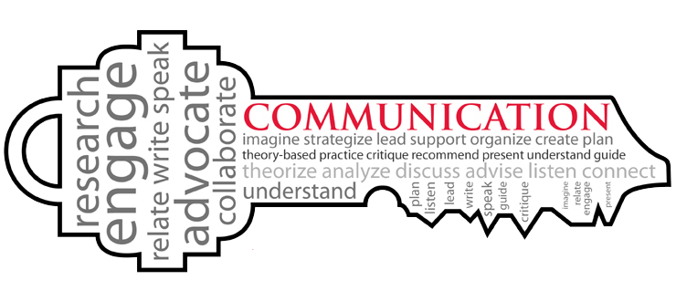

WHAT MAKES AN ENTREPRENEUR?
BASIC QUALITIES
Being a successful entrepreneur is all about your mind works and your individual personality. Its been shown that they have specific traits in common, these include (Cohen, 2017):
- Passion
- Adaptability
- Finding opportunities
- Bold
- Vision
- Decisiveness

RISK TAKER.
Risk taking is an important attribute that entrepreneurs have. It helps show that they are not afraid to take a chance and that they have passion and a vision that their idea has potential. A study shows that individuals who take fewer or no risks are less likely to be entrepreneurs. (Ekelund et al. 2005) Whether the risk they take fails – as long as they don’t give up, there is no negative to this attribute.

PERSISTENCE
Moving on from risk taking, when you take a risk, you need to expect failure. Miller, 2020, tells us that they see this as not a failure but as an opportunity to learn and change. This is what makes them successful as they are persistent and learn from their mistakes. Just having the possibility gives them hope but they can prepare themselves and be comfortable if things do not go their way.


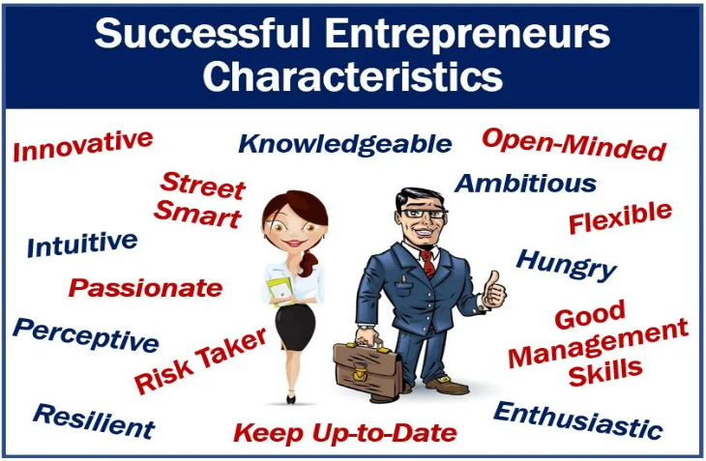


Why developing Entrepreneurial skills benefit both the individual and society at large?

There are many benefits to entrepreneurship, but it will always have its risks, which is one of the biggest attributes to an entrepreneur. In fact 20% of small businesses fail in the first year, 50% fail within five years, and 70% fail within 10 years of opening. (G, McIntyre 2020). Entrepreneurs not only benefit from the business that they create or idea that they pursue, they help improve individuals, communities and the economy. Maryville, 2022, says that their determination to succeed helps create a better standard of living by making more jobs and producing better ideas. They benefit themselves as they get to create their own program and plan how they think best, they are rewarded when taking the risk that turns into a business which is generating earnings. As they are driven with a vison and a passion, when they take a risk and the outcome is a business that is flourishing they will gain a satisfaction from knowing they made that happen with their determination and skill set. After successes, they only want to pursue the dream further which will lead to expansion. Communities will reap the benefits from this as they will create jobs, and invest in community projects.
Entrepreneurial skills are definitely ones that we should encourage people to learn as it is key to innovation. Although some innovations can be trial and error, they play an important role in the contribution to the economy. It is fair to say that they do not cover all sectors as studies have shown that innovation can affect industries differently (National Bureau of Economic Research, 2020) Others will argue that it created wealth and benefits the national income. The contribute to the economic development of a county through increases in tax revenue which will then inevitably be given to the services that need it the most. Kirzner does argue that it is important to have entrepreneurs and their skills as they are what we need to lead the market economy and we will see that the resources will put to the right uses, Mamyrbaeva, 2012. We can say that they play a big role in many ways as they act as the wheels for the growth. The help the development by as mentioned creating jobs but also encouraging social change. It helps increase productivity and as they are known to be philanthropists, they are always looking for way to give back and make a change. It is not only about creating a business, but the determination of an entrepreneur helps people how to think creatively and work up from failure. They will not be held back on opportunities are they are risk takers which makes them they key to growth and new ideas. With the evidence its clear to see that they play a huge role in every economy. They make economic history and drive innovation and prosperity all around the world.

Elevator pitch link:
https://youtu.be/y68qhZ7VGPg


We are Level 5 Business and Management students here at UWTSD in Carmarthen, and we would like to invite you along to enter our enterprise challenge 😊
Get yourself ready and group up! You will need to be in a group with no more than 4 people. Come up with a group name – as out there as you like!


Is there something that you and your team are passionate about? An idea that could make a change? Create a presentation that will WOW the judges with a chance to win some great prizes!
We have trophies for gold, silver and bronze to the presentation that shows the best innovative business idea with a element of sustainability.

Join us on Friday the 18^{th of} November 2022 in the Student Union at UWTSD.
12.00pm – 3.00pm
RISE, CHALLENGE, CHANGE!
It’s Competition time!
DID SOMEONE SAY PIZZA?
Dominoes pizza and refreshments will be served at 12.00pm so make sure you arrive on time.

(Please make us aware before the 11th of November if you have any allergy information that we would need to catered for.) 

You can present your idea to us using PowerPoint and brought along on a USB or email to your class lecturer! Please respond if you would like to take part by the 11th of November 2022.
We look forward to seeing you!

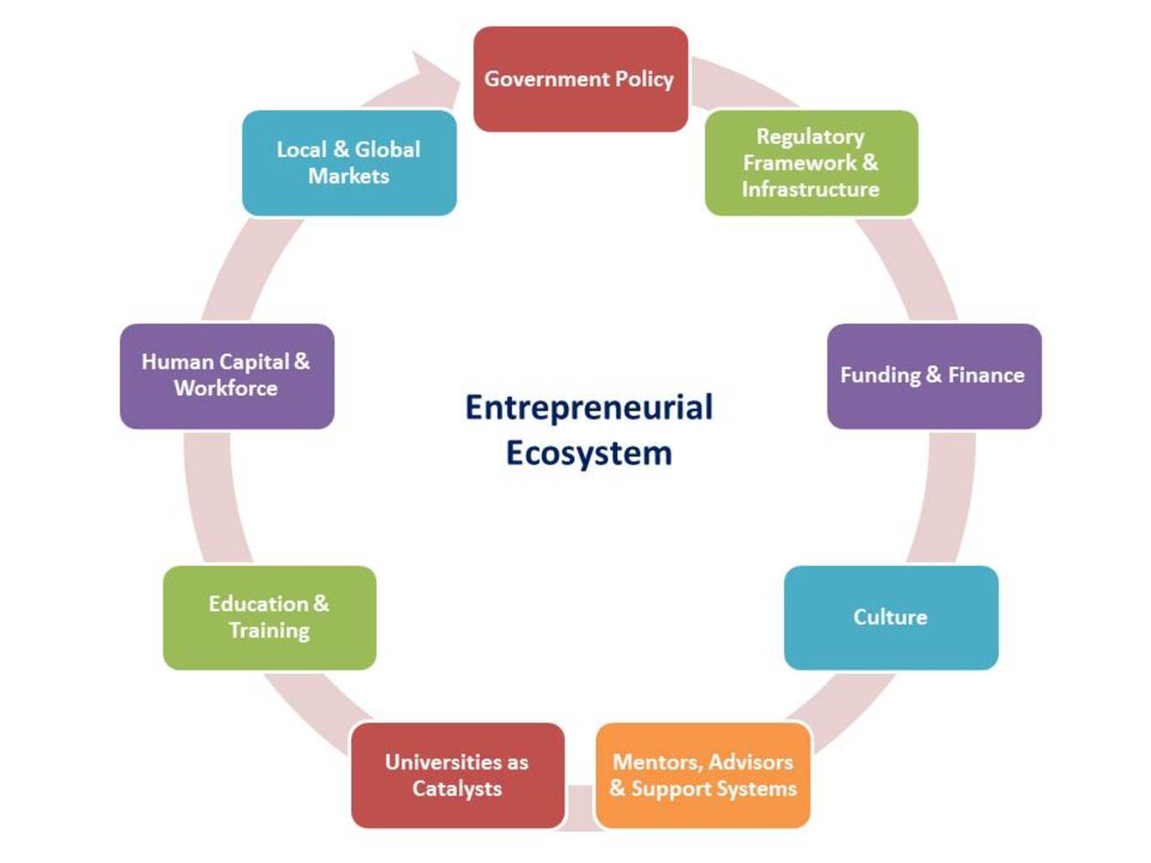
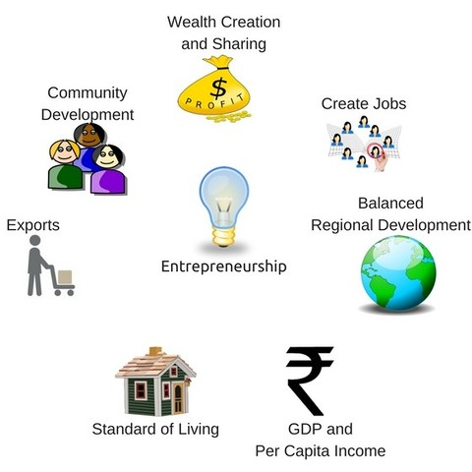
For society:
- Economic advancement – by finding new ways to improve on products/services.
- When successful – they contribute to society by paying taxes – they earn more and the contribute to the society needs.
- Creates employment for those places that may need it.
- They help stable the economy by channelling capital into productive processes.
- Economy grows further with new businesses ideas.

For the individual:
- What do we all want? Money? It’s not why all people are entrepreneurial, but the level of earning will increase if successful.
- They are responsible for all their actions – whether the result be good or bad. But they can take pride in both as there is no such thing as failure – you try until you succeed.
- Freedom to be innovative – they like being creative.
- You are your own boss. They are always looking for new opportunities or looking at way to improve.
- Always involved as they have great passion in what they do.

Benefits of developing Entrepreneurial activity to both individuals and society.

REFERANCE PAGE FOR:

MIND MAP.
Baron, & Markman, G. D. (2000). Beyond social capital: How social skills can enhance entrepreneurs’ success. Academy of Management Perspectives., 14(1), 106–116. https://doi.org/10.5465/ame.2000.2909843
Caliendo, Fossen, F. M., & Kritikos, A. S. (2009). Risk attitudes of nascent entrepreneurs–new evidence from an experimentally validated survey. Small Business Economics., 32(2), 153–167. https://doi.org/10.1007/s11187-007-9078-6
C, Carosa. (2022) Forbes. Why Is ‘Need For Achievement’ Important To Entrepreneurship? Why Is ‘Need For Achievement’ Important To Entrepreneurship? (forbes.com) Accessed: 20/11/2022
D, McClelland. (1967) Entrepreneurship Theories. Achievement Motivation Theory of Entrepreneurship. Achievement Motivation Theory of Entrepreneurship (entrepreneurshiptheories.blogspot.com) Accessed: 20/11/2022
G, Cohen. (2017) CO2 Partners. The 5 most important attributes of a successful entrepreneur. The 5 Most Important Attributes of a Successful Entrepreneur l CO2 (co2partners.com) Accessed: 10/11/2022
K, Miller. (2020) Business Insights. 10 Characteristics of successful entrepreneurs. 10 Characteristics of Successful Entrepreneurs | HBS Online Accessed: 10/11/2022
M, Singer. (2018) MBN Market Business News. Most common traits of an entrepreneur. Most common traits of successful entrepreneurs - Market Business News [image] Accessed:10/11/2022
R, Sharma. (2016) The Practice, public relations. Communication as a key function. Communication as a Key Function - The PRactice (the-practice.net) [Image] Accessed: 20/11/2022

WRITTEN SUMMARY.
E, Mamyrbaeva. (2012) Business and industrial. Entrepreneurship in Israel Kirzner’s Theory. Entrepreneurship in Israel Kirzner S Theory - Docest Accessed: 12/11/2022
G, McIntyre. (2020) Fundera – Data and reports. What Percentage of Small Businesses Fail? (And Other Need-to-Know Stats) https://www.fundera.com/blog/what-percentage-of-small-businesses-fail Accessed: 11/11/2022
Help Tap. (2022) Academy. Entrepreneurship has a key role to play in Economy - Importance & Characteristics. Entrepreneurship has a key role to play in Economy (helptap.com) Accessed: 12/11/2011
Maryville University. (2022) Masters in management and leadership. Importance of Entrepreneurship: Types, Benefits, and Styles. Importance of Entrepreneurship: Types, Benefits, and Styles (maryville.edu) Accessed: 12/11/2022
Michael J. Andrews. (2022) National Bureau of Economic Research. The Role of Innovation and Entrepreneurship in Economic Growth. https://www.nber.org/books-and-chapters/role-innovation-and-entrepreneurship-economic-growth Accessed: 12/11/22
S, Seth. (2021) Investopedia. How Entrepreneurship Affects the Economy. Why Is Entrepreneurship Important to the Economy? (investopedia.com) Accessed: 12/11/2022
Van Praag, & Versloot, P. H. (2007). What is the value of entrepreneurship? A review of recent research. Small Business Economics., 29(4), 351–382. https://doi.org/10.1007/s11187-007-9074-x Accessed: 12/11/2022

FLYER IMAGES
Dominoes. (2021) Dominoes. 5 EPIC WAYS TO CUSTOMISE YOUR PIZZA AT DOMINO’S. 5 Epic Ways to Customise Your Pizza at Domino’s - Domino's Pizza Blog (dominos.co.uk) [Image] Accessed: 24/11/22
Make a Change. (2022) Make a Change. Make a Change [Image] Accessed: 24/11/2022
UWTSD. (2020) University of Wales Trinity Saint David. University of Wales Trinity Saint David to Open Office in New Delhi. Press Releases 2020 | University of Wales Trinity Saint David (uwtsd.ac.uk) [Image] Accessed: 24/11/2022

POSTER
Featherlite. (2017) 7 ROLES OF ENTREPRENEURSHIP IN ECONOMIC DEVELOPMENT OF A COUNTRY. Business Development Support in Bangalore? Contact Evoma Now. [Image] Accessed: 25/11/2022
Hitt, Ireland, R. D., Sirmon, D. G., & Trahms, C. A. (2011). Strategic Entrepreneurship: Creating Value for Individuals, Organizations, and Society. Academy of Management Perspectives., 25(2), 57–75. https://doi.org/10.5465/amp.25.2.57 Accessed: 25/11/2022
V, Kumar. (2018) Business and Finance. Advantages of Entrepreneurship for Individual and Society. Advantages of Entrepreneurship Make it a Great Choice in spite of the Risks Involved. Advantages of Entrepreneurship for Individual and Society - Businessandfinance Blog (expertscolumn.com) Accessed: 25/11/2022
World Economic Forum. (2014) Entrepreneurship. 6 ways governments can encourage entrepreneurship. 6 ways governments can encourage entrepreneurship | World Economic Forum (weforum.org) [Image] Accessed: 25/11/2022

