Employability Skills
Marin Zhelev (4010)
Student number 2210834

Academic writing
Academic writing can be defined as writing that communicates information, research and ideas to the wider range of the academic community. It can be categorised into two different types: expert academic writing and student academic writing. Expert academic writing is intended for academic book and journal publication and student academic writing is used for the assessment at the university (Knight et al., 2020). Academic writing or which is also known as scholarly writing helps scholars or students present their ideas, analyse various types of research, and develop an effective argument. Though the main purpose of academic writing may vary among different disciplines, the style and standard of writing have several common features. It involves a formal writing style that educators and researchers utilise in their scholarly publications that focus on logical reasoning and evidence-based arguments. Academics usually write reports, journal articles and books for publications and for students the common categories of scholarly writing assignments are essays, dissertations, research papers, research proposals, literature reviews, annotated bibliographies and lab reports. Writers utilise these academic formats in order to analyse and identify a concept and develop a theory or conclusion. Professional writers utilise scholarly writing in a different manner that depends on their field. For instance; Scientists utilise scholarly writing to explain their research work and support their analysis and findings, while critics utilise scholarly writing to develop an argument based on fact-based research.

Characteristics of academic writing
Structured- Academic writing must have a clear structure which is often derived from the genre of writing. For instance, a report contains an introduction, a discussion and a method section, while an essay includes an introduction, a body paragraph and a conclusion. The writing needs to be coherent with logical and clear progression throughout the writing with different parts clearly connecting with each other (Silvia, 2018). It is essential to make careful planning before writing in order to ensure that the overall writing will be well-maintained and structured with a logical progression and clear focus on ideas. The logical and clear structure of the writing helps the readers to better understand the text and make proper connections between different related topics.
Evidenced- The arguments and opinions in scholarly writing must be supported by proper evidence and the writing needs to be based on the information and data provided by the experts. It is also important to provide references appropriately for the information in writing, with the use of reference sections and in-text citations. The writers need to support their opinions or statements using various facts and evidence. They use analysis and data to present their arguments and statements objectively, without providing their own assumptions and beliefs.
Use of resources- Writers support their statements and arguments with evidence and provide a citation to those resources by including a bibliography with their writing. A bibliography contains all the scholarly journals, books, articles or other various sources that the writer references throughout their writings. It is very important to cite different sources in academic writing in order to give credit to other writers for their research and also help to support the main contents of the topic.
Free of errors- It is essential for scholarly writing to be free of errors and consistent so the readers view the statements as a credible source of information. Scholarly writing utilises specific language to convey arguments and key points. It also needs to follow grammatical rules in order to remain consistent with punctuation, verb tense and spelling.

Importance of Academic Writing
Analytical thinking- When the writer engages in academic writing then they become a critical thinker. They analyse the information and communicate it in such a way that it makes sense to the reader. The research helps to provide the information that will be needed while writing the paper. The writer needs to analyze the information and provide their opinions and arguments based on their findings.
Facilitates students to communicate their understanding- When the students learn and gain knowledge about various complex contents and topics, it can be a challenging process to provide an explanation of what they have understood and learnt if they struggle with the process of academic writing (Fowler, 2020). Essays provide an opportunity for the students to explain what they have understood and learnt using the right styles and terminology in order to make the information easier to understand if they are addressing the reader.
Focuses on technique and style- Academic writing focuses on various types of techniques and styles as compared to formal writing. If a student gains knowledge and learns about different styles and understands how to write an essay, then it will be easier to write down academic content through university. Some lecturers prefer formatting and style guidelines that force students to address these requirements and use them in their papers. Students can ask for guidance with academic writing if they face problems with different writing techniques and methods.
Enhances research skills- With the help of academic writing, students can improve their research skills. Researching involves an internet search for academic writing and it takes more time to research a particular topic, gather important data and information and analyse information or data that has been accumulated. The writer develops their critical thinking and research skills, though the research skills are not only essential for the students, the professional researcher also requires these skills.
Enhances objectivity and critical thinking- Academic papers force students to research from different sources and analyse all ideas in order to receive good grades. It is important for the students to properly analyse all the theories from various different perspectives and make arguments and statements based on their understanding (Ahmed, 2021). It can be defined as the ability to view things objectively and it can also be helpful in career development.
Develops work ethics- Academic writing helps to enhance and develop higher standards of work ethics. Learning work ethics is not essential for students but it can help when they are doing a topic that they have never heard of before, then they can deal with the topic ethically by following all the rules and standards of academic writing. It consists of several steps which require more time and effort.

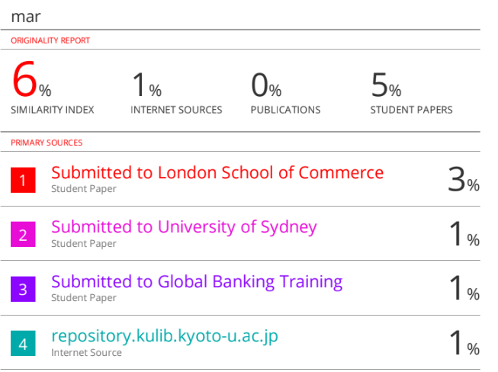

From the above figure, it can be analysed that there is a 6% similarity in my academic report. I would like to improve my academic writing skills by focusing on my critical thinking skills so that there will be less similarity in my future work. I would like to develop my paraphrasing skills and use different alternative words so that there will be less similarity in my academic work. I would like to use different scholarly sources like blogs, articles, and journals in my future academic work.
Critical Analysis
Critical Analysis can be defined as a detailed evaluation and examination of another individual’s work and ideas. It can be said that it is subjective writing as it helps to express the writer's analysis and interpretation of their work (Rahma et al., 2020). A writer can do critical analysis to critique another individual’s academic report or business process, for instance; critical analysis that draws upon their critical thinking skills, is presented as a written paper or essay, but it may also be presented as a report. An effective critical analysis evaluates the work or ideas in a balanced manner that portrays its both negative and positive qualities. The writers must have a better understanding of the work that they are analysing before writing their critical analysis (Samanhudi and Linse, 2019). The following steps need to be followed for writing a critical analysis;
Creating an outline- It is important to create an outline of the bullet points regarding the main ideas about the topic that the writer will make. The writer needs to think critically regarding the work that they are analysing and it is the most essential part while creating the outline. The writer will refer to their outline throughout the process of their writing in order to stay focused. It is also important to consider the length and structure requirements for critical analysis while creating an outline. Most critical analyses consist of an introduction, body, paragraphs and at last a conclusion.
Writing an introduction- After creating an outline, the next step is to write an introduction that will provide knowledge to the reader about the work that the writer is going to analyse and their opinions about the analysis (O'Flaherty and Costabile, 2020). It should discuss the original creator's thesis statement or aim and main ideas, and it needs to end with the writer's thesis statement. Three to four, sentences are considered a good length for the introduction part of the critical analysis, however, it may also consist of multiple paragraphs for the complex critical analyses. It is important for the writer to focus on making their introduction part more engaging in order to attract the reader's attention and encourage them to continue reading their critical analysis.
Writing body paragraph- The body paragraph needs to address the main points that are argued in the introduction part. There must be two to four body paragraphs, but the writer may add more or a few paragraphs depending on the guidelines of writing that they have received. The writer needs to keep in mind that each body paragraph must focus on a single idea. The idea needs to be addressed in the first sentence, then the idea needs to be supported with various examples from the work that the writer is analysing. The writer may add quotes from various sources in order to support their claims and it is also important to add formatted citations to any quotes they include.
Concluding critical analysis- The conclusion part includes the perspective of the writer about the analysis in the main body. It should be developed on the statements or arguments based on the body paragraphs in order to bring the critical analysis to an ending point. It contains similar information or content to the introduction but it needs to be expressed in a different way. Two or four sentences are enough for most of the conclusion part, but some complex critical analyses may have multiple concluding paragraphs.
Proofreading the work- It is very important to proofread the critical analysis in order to ensure that it looks as professional as it should be (Ebadi and Rahimi, 2018). The writer needs to correct any grammatical or spelling errors and refine their work properly until they are satisfied with their critical analysis.

How Critical Analysis enhances the quality of work
Improves presentation and language skills- Thinking systematically and critically can enhance the way individuals express their ideas and knowledge. Critical thinking also helps in enhancing the comprehension abilities of the students.
Promotes Creativity- Critical thinking plays a vital role in evaluating new and innovative ideas, selecting the best ideas and modifying them if it is necessary. Developing a creative solution for a problem does not just involve having a new idea, it must be the case that the new idea that has been generated is relevant and useful for the particular task.
Critical analysis is important for self-reflection- Critical thinking is one of the most essential tools for the self-evaluation process and in order to structure the individual’s life accordingly it is very important to reflect and justify their decisions and values.
Critical thinking skilling- Developing critical thinking skills improves the individual's academic performance and the students who better understand how to critique and analyse their ideas can be able to make connections among various disciplines.


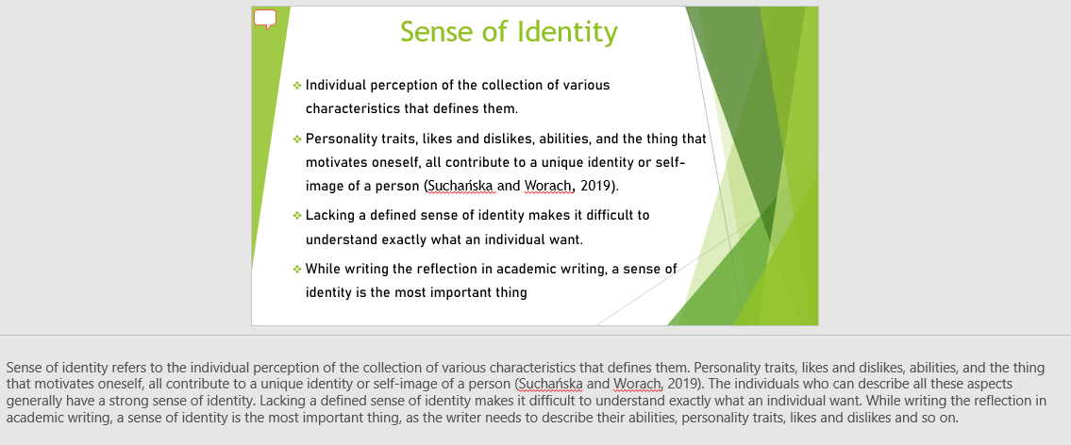Sense of Place
An effective sense of place helps the readers to develop the imaginative world, whether it is a present, past or future. Before an individual creates a sense of place, they are required to immerse themselves in the world that they are writing about, which includes research, reading, observation, imagination and recollection (Silberbauer, 2020). It is important to select the specific details of the place rather than a general description. The use of dialogue in a specific place helps to enhance a sense of that place. In scholarly writing, a sense of place plays a crucial role for the writers, as they want their readers to visualize the place described in the paper.
Sense of identity
Sense of identity refers to the individual perception of the collection of various characteristics that defines them. Personality traits, likes and dislikes, abilities, and the thing that motivates oneself, all contribute to a unique identity or self-image of a person (Suchańska and Worach, 2019). The individuals who can describe all these aspects generally have a strong sense of identity. Lacking a defined sense of identity makes it difficult to understand exactly what an individual want. While writing the reflection in academic writing, a sense of identity is the most important thing, as the writer needs to describe their abilities, personality traits, likes and dislikes and so on.

References
Ahmed, R., 2021. Peer review in academic writing: Different perspectives from instructors and students. Tesol Journal, 12(1), p.e00537.
Ebadi, S. and Rahimi, M., 2018. An exploration into the impact of WebQuest-based classroom on EFL learners’ critical thinking and academic writing skills: A mixed-methods study. Computer Assisted Language Learning, 31(5-6), pp.617-651.
Fowler, J., 2020. Academic essays part 1: the importance of academic writing. British Journal of Nursing, 29(12), pp.718-718.
Knight, S., Shibani, A., Abel, S., Gibson, A. and Ryan, P., 2020. AcaWriter: A learning analytics tool for formative feedback on academic writing. Journal of Writing Research.
O'Flaherty, J. and Costabile, M., 2020. Using a science simulation-based learning tool to develop students' active learning, self-confidence and critical thinking in academic writing. Nurse Education in Practice, 47, p.102839.
Rahmat, N.H., Aripin, N., Lin, N.M., Whanchit, W. and Khairuddin, Z., 2020. Exploring the connection between critical thinking skills and academic writing. International Journal of Asian Social Science, 10(2), pp.118-128.
Samanhudi, U. and Linse, C., 2019. Critical Thinking-Related Challenges to Academic Writing: A Case of Indonesian Postgraduate Students at a UK University. Lingua Cultura, 13(2), pp.107-114.
Silberbauer, G.B., 2020. A sense of place. In Key issues in Hunter-Gatherer research (pp. 119-143). Routledge.
Silvia, P.J., 2018. How to write a lot: A practical guide to productive academic writing. American Psychological Association.
Suchańska, A. and Worach, A., 2019. Self-complexity and the sense of identity. Roczniki Psychologiczne, 16(2), pp.217-233.

