

Usability study on privacy controls in social networks

by
Sammy Phoenix

Supervisor: Mike Dacey
Second Marker: Kemi Ademoye

Project submitted as part of the requirements for the award of BSc(Hons) Web Development

April 2018

Declaration FORM AND FORM OF CONSENT
DECLARATION

I, ...Sammy Phoenix……………………………… declare that I am the sole author of this Project; that all references cited have been consulted; that I have conducted all work of which this is a record, and that the finished work lies within the prescribed word limits.

This work has not previously been accepted as part of any other degree submission.

Signed: .............................................

Date: ...............................................

FORM OF CONSENT

I ...Sammy Phoenix……………………………… hereby consent that my Project, submitted in candidature for the B.Sc. (Hons) Web Development degree, if successful, may be made available for inter-library loan or photocopying (subject to the law of copyright), and that the title and abstract may be made available to outside organisations.

Signed: .............................................

Date: ...............................................

ABSTRACT
Privacy controls within a social media account are often taken for granted, and Facebook in particular seem determined to make it as difficult as possible for users to modify them.
This report considers the problem of privacy controls and how they could be improved from a user interface perspective. It explores the underlying issues of privacy concerns for users and why they are important. It considers some reasons companies like Facebook may wish to make it hard for users to change them, and what they gain from more open privacy controls. It also contains design ideas for an improved user interface, with suggestions on how it could be used.
A usability study was conducted by way of an observation, and a pre-designed User Experience Questionnaire (UEQ) which is designed to aid in usability testing. Adobe Xd was used for creating the initial design, including a working prototype, with a supporting interface written in HTML5 using Bootstrap 4 to demonstrate other working features.
The major findings happened at an unusually late stage in the project with the Cambridge Analytica revelations. Within the conclusions section, space is dedicated to the new discoveries that occurred at this point in the project, which gives more depth to the problem at hand and re-emphasises the need to research this topic in more detail than this project can provide. It is suggested that the redesigned interface is one part of a multi-faceted solution; one possibility is using it in the scope of browser extensions to assist the user in regaining control over the sharing of their information.

Contents
Declaration FORM AND FORM OF CONSENT ii
ABSTRACT iii
Contents iv
Table of figures vi
Table of Tables vii
1 Introduction 8
1.1 Aim 8
1.2 Objectives 8
1.3 Structure of the Report 8
2 Research and Review of Literature 9
2.1 What is meant by security and privacy in social networks? 9
2.2 Why is it important to the general public? 9
2.2.1 Information a user shares 9
2.2.2 Information gathered through tracking 10
2.3 Why is it important to certain groups of people? 12
2.4 What privacy features are expected? 13
2.5 What features are available? 15
2.6 What extra features would be required by certain groups? 19
2.7 Why don't some features get used, even if they're expected or required? 21
2.8 What is usability engineering? 24
2.9 What are usability tests? 25
2.10 What kind of tests are available, and when would they be used? 26
2.10.1 User surveys 26
2.10.2 Interviews and focus groups 27
2.10.3 Contextual design 27
2.10.4 Wizard of Oz 28
2.10.5 Evaluating existing systems 28
2.11 Conclusion 29
3 Research and Development Methodology 30
3.1 Research philosophy and approach 30
3.2 Research strategy 31
3.2.1 Experiment and software development 31
3.2.2 Document review 31
3.2.3 Case study 31
3.2.4 Survey 31
3.3 Generalisability, reliability and validity 32
3.4 Development methods 32
3.4.1 SCRUM 32
3.4.2 Extreme Programming (XP) 33
3.4.3 Feature Driven Development (FDD) 33
3.4.4 Joint Application Development (JAD) 34
3.5 Chosen approach 34
3.5.1 How the observation will work 35
3.5.2 Focus groups 35
3.6 Conclusion 35
4 Design and implementation 36
4.1 Problem formulation 36
4.2 Design 36
4.3 Implementation 37
4.4 Conclusion 38
5 Evaluation 39
5.1 Results 39
5.2 Outcome vs aim and objectives 40
5.3 What would be done differently 40
6 Conclusions and recommendations 42
6.1 Summary 42
6.1.1 Unexpected events 42
6.2 Conclusion 45
6.2.1 Methodology and implementation 46
6.3 Recommendations for further research 46
7 Reflection 48
8 References 50
9 Appendix 1: Task list 54
10 Appendix 2: UEQ reconstructed in Google Forms 55
11 Appendix 3: UEQ results 58
12 Appendix 4: Designs 59
13 Appendix 5: Code 62

Table of figures
Figure 1: The website Facecrooks.com[7] provides information on Facebook scams, and advice on securing a user's account 11
Figure 2: Post on a support group for a minority community[11], that highlights “bleed” between closed groups and the larger Facebook user base. Names and avatar have been censored. 13
Figure 3: Custom filter set for topic-related posts 14
Figure 4: Asking who might be added to topic-related filters 15
Figure 5: Managing friends on Facebook 16
Figure 6: Choosing who to show posts in Facebook 17
Figure 7: Full list of post filters on Facebook, including a custom option 18
Figure 8: Facebook allows a user to exclude a friend from posts 19
Figure 9: Choosing alternative names on Facebook 20
Figure 10: Privacy settings in Facebook. These are not the default settings. 21
Figure 11: Accessing privacy controls on Facebook 22
Figure 12: PrivacyBird.org explains their goal in layman's terms[24] 24
Figure 13: A diagram illustrating the many areas of usability engineering[26] 25
Figure 14: Table showing available methods, that can be refined using the conditions above[27] 26
Figure 155: FDD lifecycle[35] 33
Figure 16: Elgg edit profile screen 37
Figure 17: Privacy wizard as shown in HTML form 37
Figure 18: The manage friends screen 38
Figure 16: Google's new privacy controls[41] 39
Figure 20: "off record" chat reveals Mark's disregard for privacy 43
Figure 21: Default privacy settings in 2005[44] 44
Figure 22: Default privacy settings in 2010[44] 45
Figure 17: Intro section 55
Figure 18: Section 1 55
Figure 19: Section 2 56
Figure 20: Section 3 56
Figure 21: Section 5 57
Figure 22: Section 6 57
Figure 23: Screenshot of additional questions asked 58
Figure 24: Privacy wizard design 59
Figure 25: Personal details – design 60
Figure 26: Manage friends – design 61

Table of Tables
Table 1: Comparison of positivism and phenomenology 30
Table 2: Comparison of deductive and inductive approaches 30
Table 3: Comparing initial aims of project with outcome 40

Introduction
This project will look at the usability issues surrounding privacy controls in social networks. It will include a proposed design to find the best way to offer sufficient privacy settings for users within the context of an existing social network application.

Aim
The aim of this project is to find a user-friendly approach to setting privacy controls, including how widely content is shared, and the possibility of setting expiry dates on posts (like Telegram).

Objectives
The objectives are:
- Investigate and analyse existing approaches
- Develop improvements to security by building a prototype using interfaces
- Evaluate usability of approaches to security settings by conducting usability tests

Structure of the Report
The project is essentially in three parts. Firstly, the studies already conducted on the complex issue of privacy in social media, what has been tried before to improve the situation, and why it is necessary. The second part details the research methodology and approaches that can be applied to this project, and how the research will be conducted. Finally, the third part detailing the findings and designs for a better approach to privacy controls, and recommendations for further research, designs or implementation in future projects.
Chapter one illustrates an overview of the report. It details the aims and objectives that once achieved will bring success to this research.
Chapter two focuses on the research of literature pertaining to existing studies on privacy in social media and discusses the subjects of privacy and usability.
Chapter three details the research approach and design that will be applied to this project, and how the research will be conducted.
Chapter four covers the design and implementation of improved privacy controls.
Chapter five discusses the success of the project compared to the objectives explained above.
Chapter six concludes the report and explores recommendations for further research.
Chapter seven reflects on the project and experience gained while working on it.

Research and Review of Literature
This chapter explores the existing research conducted on this topic, and how it relates to the aim of this project.

What is meant by security and privacy in social networks?
The broadest definition of privacy is the “right to be let alone”[1], to be free from intrusion. It is regarded as one of the basic human rights within all parts of life, including family, friendships and other relationships.
Laws relating to privacy breaches focus on unlawful intrusion or observation within certain contexts, such as stalking or harassment, or publishing private information such as home addresses, known as "doxxing" within online communities.
The definition of privacy can be narrowed down further, where it is known as "information privacy". James H. Moor[2] defines this as "the right to control access to personal information." This definition of privacy is relevant to social networks, as it refers to the information shared by people online regarding their personal habits, likes, dislikes, etc., that is accessible by others.

Why is it important to the general public?
According to PrivacyRights.Org[2], privacy concerns are two-fold:
- Information a user shares - this is what users choose to post about themselves, such as photos, location (e.g. by “checking in”), events etc.
- Information gathered by tracking - this uses means such as cookies and analytical data (i.e. Google Analytics) to collect information about a user's activities
The combination of these two share large quantities of information about a person, and the implications of this are vastly underestimated by most users. These will be discussed below.

Information a user shares
The very nature of social networking sites is to encourage people to share information with each other. It functions as an online extension of the friendships built by interacting with other people. However, while people are conscious of the information they share with people face to face, the same cannot be said of online contact.
Rick Delgado[3] refers to the "TMI temptation” - TMI is an acronym for Too Much Information. In this context, TMI refers to the amount of over-sharing that happens between users. He specifically refers to two separate problems:
- There is a mistaken belief that their identity is protected online; they therefore tend to share information they would not usually
- Privacy settings are often taken for granted; posts meant for friends only may be shared publicly without their knowledge.
  - Even "friends-only" posts can be read by people not on their friends list, as these posts are also readable by friends of the user's friends.
The consequences of sharing too much information to too many people can have a lasting impact. The website GetSafeOnline[4] provides a list of concerns that can result from over-sharing, including harassment, cyber-stalking, and the risk to children as there is no reliable way to provide proof of age. It can also become the target of physical as well as cyber-criminals, as stated below:
“You or a family member posting that you're away or going away on holiday and therefore advertising that your home is empty, leaving the way open for burglars. If you do so and you make an insurance claim for a burglary while you are away, your insurance company may well reject it for this reason."[4]
Another problem caused by over-sharing involves the reputation of the user, and not just in a social sense. When applying for jobs, it is becoming increasingly common for prospective employers to check the applicant's social networking accounts to build a profile of the person wishing to work for them - according to Time Money[5], 93% of employers now do this. In fact, listed on the article are ten cases of not just prospective, but also current, employees who have lost their jobs due to posts on their social network feeds. One former hiring manager states:
“To people who don’t lock down their accounts because ‘it’s never been a problem,’ I say, you don’t know whether that’s true.”[5]
There are many articles and tutorials online that explain how to adjust privacy settings to prevent, or at least reduce, the likelihood of over-sharing, yet this remains an ongoing issue. A paper titled "The failure of online social network privacy settings[6]" conducted a study on the sharing intentions of different user groups, and compared them to the sharing reality based on their privacy settings. The network used was in this study was Facebook, and the findings on sharing can be summarised as follows:
“Our results show that there is serious potential for privacy problems. 93.8% of participants revealed some information that they did not want disclosed. Given our sample, it is virtually certain that most other Facebook users have similar problems. On the other hand, we also note that 84.6% of participants are hiding information that they wish to share. In other words, the user interface design is working against the very purpose of online social networking. Between these two figures, every single participant had at least one sharing violation. Either result alone would justify changes; taken together, the case is quite compelling.”[6]

Information gathered through tracking
Even if a user adopts all the best practices for sharing safely, their privacy cannot be guaranteed. This is because information can also be gathered electronically, using cookies stored on their hard drive. The main purpose of cookies is to make browsing and logging onto sites more convenient, but they also have other uses, as explained below:
“A study... Found that the unique identifying code assigned to users by social networks can be matched with behaviour tracked by cookies. This means that advertisers and others are able to use information gleaned from social networks to build a profile of a user's life, including linking browsing habits to one's true identity.”[2]
The most common use of this information is for companies to tailor advertisements to the user. Social networks that are free for users make their money by selling advertising space, and such adverts (known as behavioural advertising) are more valuable, as they are seen to be more likely to result in a sale.
Another common use of electronic tracking is by third-party developers who make apps for the social network. (E.g. Facebook games.) The purpose of this is to personalise the application to make it more appealing to the user, and to offer another way to interact with friends.
While intentions may be genuine on the companies' part, this presents another, more concerning problem: if this data can be accessed in this way by reputable developers, it can also be accessed by cyber-criminals.
In fact, rogue applications and links shared on social media is so widespread, particularly on Facebook, there is a website - called Facecrooks.com[7] (Figure 1)- dedicated to warning of scams and other related issues. It notes a common trend with apps that steal sensitive information via "clickbait" links (given headlines that pique a user's interest to lure them into clicking a link) or promising to add features that do not exist (such as seeing who viewed your profile - a feature of LinkedIn, but not Facebook). Fake pages offering “freebies” and "articles" that take advantage of tragedy (e.g. a video by Robin Williams shortly before his death, which is fake) are commonly shared by unsuspecting users.
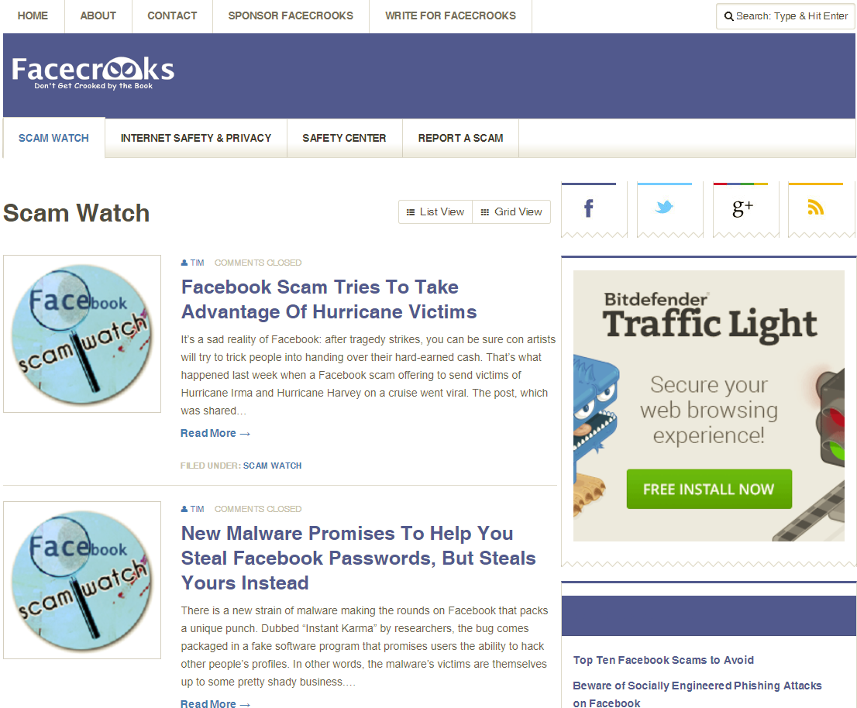
Figure 1: The website Facecrooks.com[7] provides information on Facebook scams, and advice on securing a user's account

The use of cookies is explained in a social network's privacy policy. However, there are two problems:
- They are often so long that users will skim read without processing the information and tick the box to say they "have read and understood", when they have not. Also, the most important information is often found at the bottom, where most users will not see it[8].
- They can change without notice, often without alerting the user to any changes.
Also, changing features, or bugs, with the network service itself can create their own privacy issues. Facebook encountered this in May 2010, as NY Times[9] explains:
“On Wednesday, users discovered a glitch that gave them access to supposedly private information in the accounts of their Facebook friends, like chat conversations.
Not long before, Facebook had introduced changes that essentially forced users to choose between making information about their interests available to anyone or removing it altogether.
Although Facebook quickly moved to close the security hole on Wednesday, the breach heightened a feeling among many users that it was becoming hard to trust the service to protect their personal information.”[9]
Ad blockers have tried to address the potential problems of behavioural advertising by blocking social media adverts. Other developers have built apps or browser extensions to block tracking from "Like" and other sharing buttons on websites. However, because social networking sites heavily rely on advertising as a source of revenue, they actively resist such efforts. As stated below:
“In 2014, ad blockers reduced the income that online advertising generates by some $22 billion, a number that was almost double the losses from the year before.”[10]
This has resulted in “an increasingly sophisticated online battle[10]”, as a growing number of online publishers implement ad-blocking detectors, and other ways to circumvent these tools. Some companies, such as Google and Microsoft, instead pay to have their adverts whitelisted.

Why is it important to certain groups of people?
If over-sharing could cause problems for the public, it is especially troublesome for more vulnerable communities. Facebook began as an academic social network but is now open to people from all walks of life - including people who wish harm on others. This may mean anything from hate groups to people with a grudge against others, who take their offline bullying online.
There is also the problem, especially with Facebook, where communities have access to closed groups, but changes on their profile may cause trouble with others on their friends list, including family members, as in the real life example[11] shown in Figure 2:

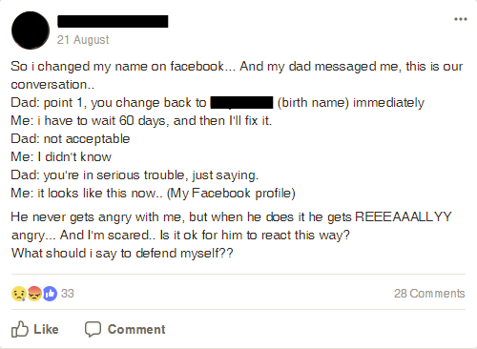
Figure 2: Post on a support group for a minority community[11], that highlights “bleed” between closed groups and the larger Facebook user base. Names and avatar have been censored.
Anonymity online is a grey area. On the one hand, it protects vulnerable users from bullying, cyber-stalking, etc. On the other, it grants hateful individuals the means to attack others without being identified by their victims[12]. Facebook's way of combating this is to insist that users give their real names on their profile, but this has been argued to cause problems for people with particularly unusual names, as well as transgender people. It also goes against common safety advice to not provide your real name online, for reasons mentioned above.
Also, the concern about electronically gathering information to build a profile of a user's life can be especially problematic for prominent political figures, notably activists who face jail in countries such as China for political dissent. In fact, Facebook has been blocked in China[13], partly to prevent the circulation of news stories and partly to hamper communication between like-minded people who may plan revolts.

What privacy features are expected?
The paper “Mapping User Preferences to Privacy Default Settings”[14] conducted a study into user’s preferred privacy settings for various profile information, using Facebook as the platform of choice since it is the most popular. It was found that:
“… most participants were more inclined to share profile information with their friends only, with the ratio between friends only and other audiences increasing with the more sensitive profile items. Of those willing to disclose the more sensitive information (phone numbers and addresses) on Facebook, only in rare cases—such as religion and political preference—was the preferred audience more permissive than friends. However, for less sensitive profile items such as gender, personal preferences and posted photos, participants reported varying audience preferences.”[14]
It also gauged reactions to under and over-sharing of information based on privacy settings and found a “stronger negative reaction” to oversharing.
Its findings suggest that the preferred default settings should be geared more towards sharing with friends only, with more sensitive information such as contact details restricted to “only me”. This contrasts with Facebook’s default settings, which leans more towards sharing with everyone, or friends of friends.
There are two privacy-related features that have been suggested via a question on Quora.com: “What features are missing from social networks?”[15] One answer mentioned being able to divide friends into smaller groups – (covered in section 2.6 below) – while another responded that “Who-viewed-your-profile feature on FB & TW would be nice”[15]. Personal experience can attest to the latter; not only could it suggest new friends or other interested parties, but if one is trying to avoid contact with certain people, this could alert them to any attempts made at such. This feature is available on LinkedIn, although since the idea is to be found by professionals, there is less privacy control, and is therefore more open to abuse.
The study “Exploring topic-based sharing mechanisms” raises an additional suggestion; using topic-based controls to “avoid oversharing or offending others and allow them to target improved audiences or share improved content”[16].
A good example of how this could apply on a platform like Facebook is shown in Figure 3 and Figure 4; these screenshots provide real-life examples of how this would be useful:
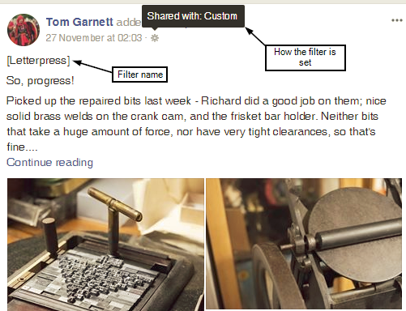
Figure 3: Custom filter set for topic-related posts
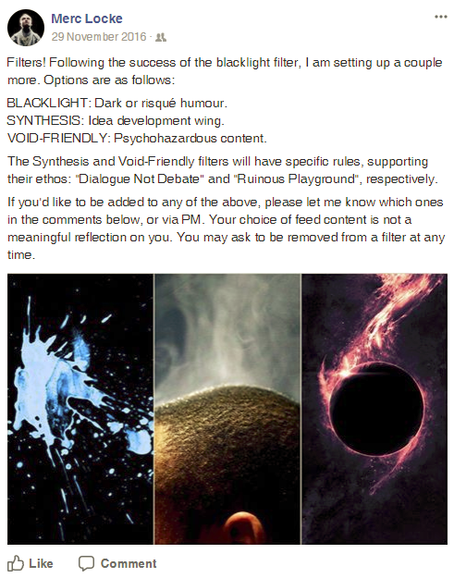
Figure 4: Asking who might be added to topic-related filters
Currently, the only way these topic-based privacy filters can be set up is by asking people if they would like to be included in these posts, then adding those people to a custom filter (discussed in section 2.5 below).

What features are available?
Contrary to belief, Facebook does provide a way to break down a user’s friends list into smaller groups, although as with its other settings, this is not clear.
To manage the friends list, one must first find the friends tab in their home page. From there, clicking on the button by a friend offers several options, as shown in Figure 5:
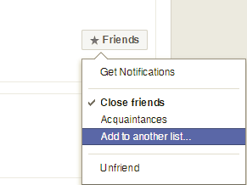
Figure 5: Managing friends on Facebook
Some of these lists are created automatically, known as “smart lists”, based on information provided in the user profile. For instance, people who live in the same area, or work at the same company. Others are predefined (e.g. acquaintances, shown above), and there is also the option for custom lists.
These lists become relevant when making posts, especially the custom filters discussed in section 2.5 above. Facebook offers the ability to filter posts in various ways, as shown in Figure 6 and Figure 7:

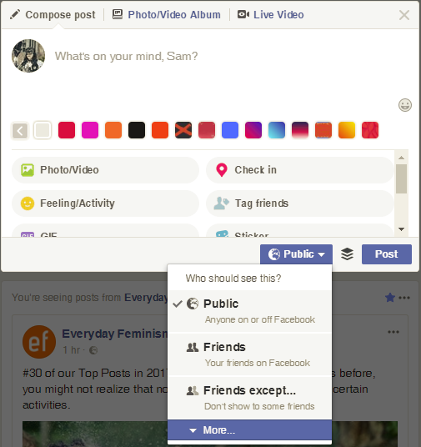
Figure 6: Choosing who to show posts in Facebook
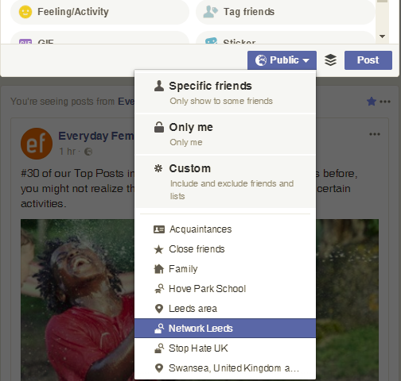
Figure 7: Full list of post filters on Facebook, including a custom option
Among these filters is the ability to exclude specific people from posts, as Figure 8 shows:
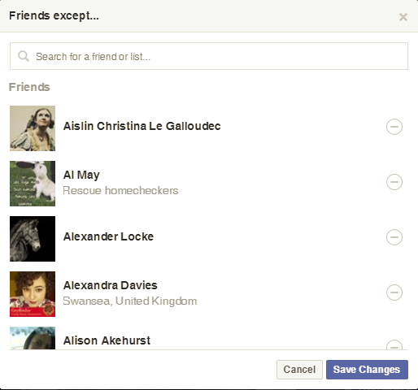
Figure 8: Facebook allows a user to exclude a friend from posts

What extra features would be required by certain groups?
Depending on the group of people, some settings referenced above[14] would not be suitable for these individuals. For instance, sharing gender with everyone may be acceptable for the wider public, but for transgender people who are not “out”[11], they would need this to be available only to friends, or even “only me”. The same could be applied to the activist example referenced in section 2.3 above; these people would not want their political or religious views disclosed to anyone but a small number of people.
This refers to the answer given to the question[15] in section 2.4 above, which suggested that friends be divisible into smaller groups. For vulnerable communities, not everyone on their friends list can be trusted with such knowledge. It would therefore benefit these people to not only break down their friends list in such a way, but to be able to keep those sub-lists hidden from public view by default.
Another possibility is based on this quote from the book Security and Usability[17]:
“…people present a “face” to others. Goffman, fascinated by spies and scam artists, proposed that everyone presents bits and pieces of themselves as socially appropriate to the other and, in fact, may wish to present themselves differently depending on the circumstances.”[17]
This problem with names, especially on Facebook, has been discussed in section 2.3 above, particularly regarding Figure 2. It would be useful for people to be able to choose who views the name they use on social media, possibly offering other names that different people know them by.
Facebook does offer a choice to add “other names”, but as Figure 9 shows, there is a problem:
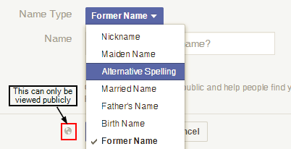
Figure 9: Choosing alternative names on Facebook
There are several alternative names a user could enter, but as highlighted, they can be viewed by everyone, with no option to change this setting.
Twitter does not use real names as a display name but does show them on a user’s profile. It does, however, make it a lot easier to change the name shown there.
Facebook have often argued that anonymity allows users to abuse others with no way of finding out who they are – a point that has been raised in section 2.3 above – yet Twitter, which allows the possibility to be anonymous, handle abuse much better, as explained below:
“Now, perhaps it’s because Twitter has made a lot of headlines lately for failing to address abuse and harassment that I’m able to say that Twitter has actually done a pretty good job of handling this abuse. Just about everything that I reported for slurs and threats was removed and quite a few of the offending accounts were locked. With the addition of the quality filter that blocks out the majority of hate from reaching my updates — it’s almost as if I don’t have hundreds of angry white people calling me a fat gorilla on there.
But facebook has been another story. … They suspended me for three days for posting screenshots of the abuse they have refused to do anything about..”[18]
The author of the quoted article is a person of colour, who posted a tweet about her unease in one particular setting and was met with scores of abusive messages. The comments on her article only serve to echo her feelings, including one which notes their reporting system is also open to abuse. It leaves people questioning the real reason Facebook is so strict with its naming policy, if it cares so little about the groups most prone to receiving abuse.

Why don't some features get used, even if they're expected or required?
According to Steve Krug[19], the golden rule of usability is “Don’t make me think”. This theme is common in studies involving user experience and privacy settings; two of these suggest that users are influenced by the default privacy settings, with the view that users should be “nudged” more towards beneficial privacy settings[20][21]. Another study[22] states that:
“As individuals spend more time online, they are becoming increasingly concerned about Internet privacy. Most individuals have little knowledge about the real risks to their privacy in an online environment and they find learning about privacy and reading website privacy policies to be difficult and time consuming.”[22]
To add to the confusion, sites like Facebook have notoriously convoluted privacy settings, as shown in Figure 10:
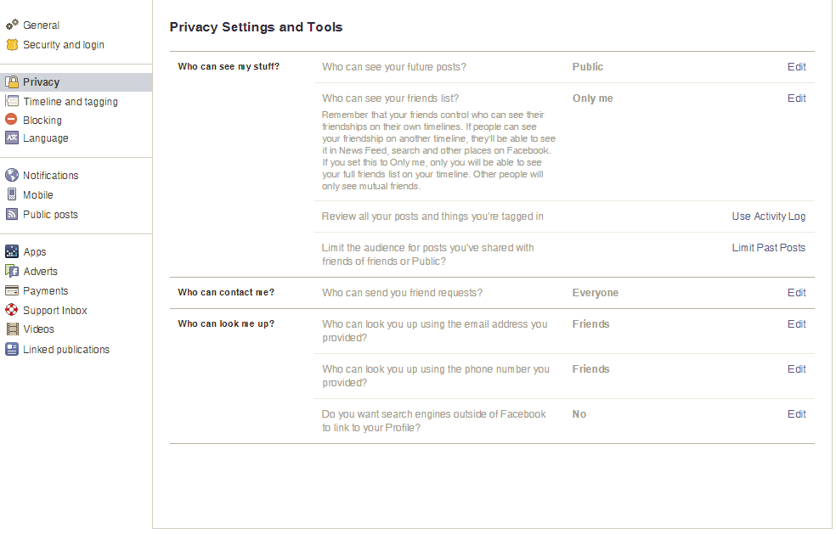
Figure 10: Privacy settings in Facebook. These are not the default settings.
To access these settings, the user must know where to find them; as Figure 11 shows, this is not at all clear:
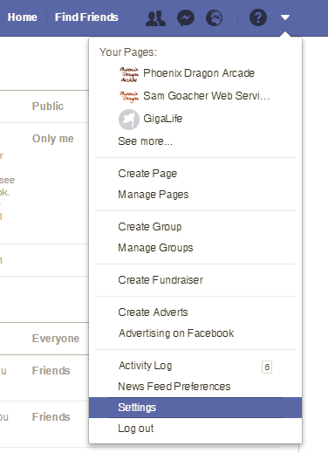
Figure 11: Accessing privacy controls on Facebook
If the user has never used Facebook before, they would not know how to access their settings without spending time looking for it or asking for help. The down arrow only indicates that there are more options alongside the main icons; the settings item itself is right at the bottom above “Log out” – both of which may be easy to miss, depending on the user.
Facebook may or may not be easy to use in other ways, but regarding privacy controls, this runs contrary to the guideline “Don’t make me think” stated above. Also, the default settings are geared mainly towards sharing, with profile information defaulting to “public” unless changed. Depending on the information shared (including mandatory information like name, date of birth, gender etc.), this could lead to inadvertent oversharing before the user has started posting. According to one study[14]:
“Any set of controls has a starting point—the default configuration that the user then modifies as desired. Customizing these settings takes user effort, and users often accept the defaults rather than perform the work of modifying them to meet their needs. Thus, the default settings can have a large impact on the resulting privacy for users. Organizations and developers that create applications must make a decision on a default privacy configuration that may or may not account for user privacy needs and desires.”[14]
This also applies to the filters discussed in section 2.4 above; if these were more easily accessible, it is possible there would not be so many instances of over-sharing.
Another problem is that many social networking sites tend to change their privacy settings whenever they change their policy. The resulting sentiment shared by many users is “I don’t have the time to keep on top of constantly changing privacy settings” or “the settings are too confusing”[23].
The below quote offers another reason:
“…calling attention to privacy and making it an explicit task at any level can be problematic. For example, Cranor discusses users’ difficulties in explicitly articulating their privacy preferences. The goal with privacy, then, is often not so much to measure and refine task performance as it is to refine task invisibility or light-weightness.”[17]
So, the challenge is to make privacy settings more usable by making them less visible to the user, while also considering a user’s concern about oversharing.
AT&T attempted to address this issue by developing a tool called Privacy Bird. According to their paper:
“Privacy Bird is a P3P user agent that can compare P3P policies against a user’s privacy preferences and assist the user in deciding whether to exchange data with a website. Privacy Bird is designed as an add-on for the Internet Explorer (IE) 5.01, 5.5, and 6.0 web browsers on Microsoft Windows 98/2000/ME/NT/XP operating systems.”[22]
Figure 12 shows a captioned image from their website, explaining how this software works to the public.

Figure 12: PrivacyBird.org explains their goal in layman's terms[24]
The website hosts their public beta of this software, but it has never progressed beyond this point. It is unusable for current technology and has the additional downside that it relies on websites being P3P-enabled – i.e. providing a privacy policy in a format readable by the software.
However, they raise some interesting points for future designers:
“Designers have an opportunity to build interfaces that will reinforce the status quo or attempt to push generally accepted business practices in a direction that is more privacy friendly. …balancing the desires of keeping interfaces simple with providing flexibility and educating users about privacy is a complicated problem.[22]”

What is usability engineering?
Usability engineering can be summarised as “designing for general usability and the evaluation of usability”[17]. It utilities a collection of tools and methods for establishing requirements, evaluating the usability of a product and testing it with a sample of users.
Usability engineering has evolved since the 1980s, beginning with Human-Computer Interaction (HCI) which focuses on making the user interface as accessible as possible. It began as a research field when computers were starting to be made available for the public but were run mainly by command prompt. To ensure people other than programmers could use computers, a rethink of the user interface was needed.
HCI began as a comparatively simple concept, summarised by the phrase “easy to learn, easy to use”. Since then, it has continually evolved and expanded to include “qualities like fun, wellbeing, collective efficacy, aesthetic tension, enhanced creativity, flow, support for human development, and others.”[25]
Since its conception, HCI has expanded beyond computer science, considering also how it can be used to help the disabled, elderly and any other kind of user (e.g. those whose first language is not English) who may not otherwise be able to use a computer effectively. Today, it encompasses a broad range of technologies and applications, and covers a variety of fields, as Figure 13 shows:
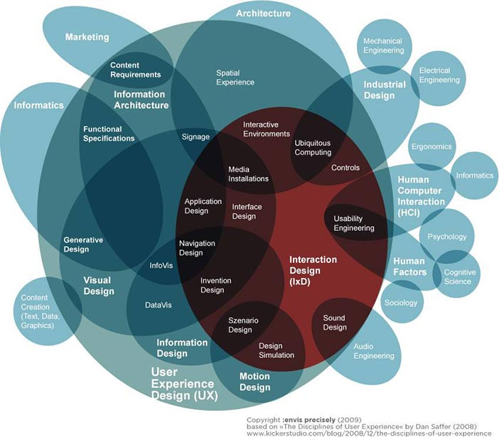
Figure 13: A diagram illustrating the many areas of usability engineering[26]
When the internet emerged, users began using computers as “communication channels”; as applications such as blogging, instant messaging and social networking appeared, HCI expanded to include an area now known as “social computing”[26].

What are usability tests?
Usability tests are a range of methods used to test the usability of a device or software, and run from the planning stage (like contextual design, which “considers how users will use the privacy mechanisms in their tasks”[17]) to prototyping using “think-aloud” techniques (requiring the user to talk through their thoughts and feelings as they use the application, while being recorded) and evaluation (using surveys to gather user feedback on the software).
There are many tests available, some in recent development, while others have been in use for a long time. These are discussed in section 2.10 below.

What kind of tests are available, and when would they be used?
There are many tests available for use, depending on the situation. Figure 14 below shows an interactive menu that displays a list of a number tests available:

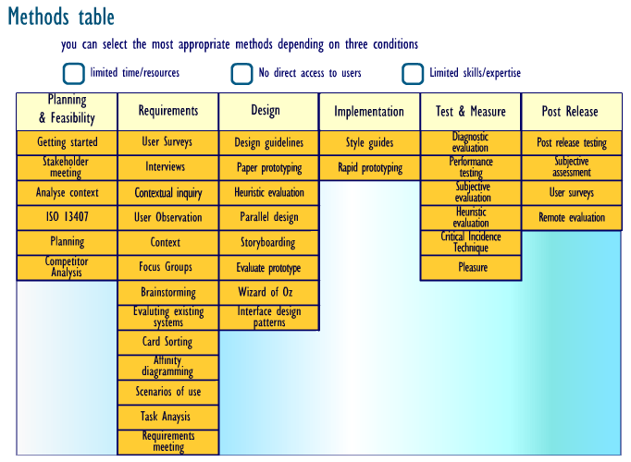
Figure 14: Table showing available methods, that can be refined using the conditions above[27]
Those relevant to evaluating user privacy include:
- User surveys
- Interviews and focus groups
- Contextual design
- Wizard of Oz
- Evaluating existing systems
These are discussed in more detail below.

User surveys
User surveys are often used as a way of reaching a large amount of people quickly. They are typically conducted online, whether it be via email or social media, although they can also be sent via post.
They consist of a series of questions, with closed (yes/no or multiple choice) questions being preferred as they are more useful for statistical analysis. In the same manner, scaling such as the Likart scale is often used for recording opinions[28] – it is common practice to find ratings of 1 – 5, Poor – Excellent, etc. used to note answers, with any open questions used either in conjunction with “other” options, or as an extra opportunity for feedback towards the end. Questions must be thought through carefully and pre-tested to ensure the most accurate responses, by avoiding misinterpretation of the questions and a non-response. They must also be kept as brief as possible to encourage respondents to answer; too long a questionnaire will result in a lower response rate.
Questionnaires sent in this fashion are useful in the event of time or money constraints, although these are best sent to as large a sample base as possible, because response rate tends to be lower.

Interviews and focus groups
Interviews, and their group equivalent focus groups, are a type of survey used when a more personal, more structured form of questioning is needed.
Interviews can be conducted via the telephone or in person, while focus groups can take place in person or via conference call, or more recently, via video call such as Skype. While the telephone or virtual group meeting can be used for shorter interviews, there is a danger of “respondent fatigue”[29]. There is also a concern that respondents may react more positively to visual cues presented by the interviewer, which is not possible over the telephone. However, this may be beneficial, depending on the nature of the questions.
These are like the surveys noted above, where the questions must be carefully considered, as they provide the script for the interviewer to work with. However, the interviewer also needs to be able to engage the respondent while talking to them, to keep their interest and prevent early termination of interview[29].
Focus groups tend to be more open than an interview situation; the questions are still scripted, but the arrangement is more like a group discussion, where the people present discuss their views. This is more likely to be useful for collecting qualitative data, as there is more freedom to discuss opinion, with the additional possibility that people can “bounce off” each other – which may serve to influence the response.

Contextual design
Contextual design, according to the Interaction Design Foundation[30], can be summarised as follows:
“Contextual Design is a structured, well-defined user-centered design process that provides methods to collect data about users in the field, interpret and consolidate that data in a structured way, use the data to create and prototype product and service concepts, and iteratively test and refine those concepts with users. This is the core of the Contextual Design philosophy - understand users in order to find out their fundamental intents, desires, and drivers. But these are invisible to the users - so the only way to glean them is to go out in the field and talk with people”
This is a process including a specific kind of interview, where users are asked within the workplace or other natural environment, how they go about using the software. However, because users are often unable to articulate the work process they go through when using the product, observation is also highly encouraged. This could be in person, or virtual using recording software that the user installs onto their computer.

Wizard of Oz
The Wizard of Oz technique is named after the movie, where the imposing “wizard” is controlled by a man behind the curtain. In this context, it involves a “wizard” sitting in a room away from the user, who simulates the functionality of systems before it is implemented.
It works by using cameras focussed on the user’s hand movements, feeding the stream back to the “wizard”, who uses this feedback to anticipate what to emulate on the system.
UsabilityNet[27] states:
“The Wizard of Oz technique can provide valuable information on which to base future designs. It can:
- gather information about the nature of the interaction
- test which input techniques and sensing mechanisms best represent the interaction (so that subsequent effort developing or adapting sensing technologies is appropriately directed)
- test the interaction of a device before building a functional model
- find out the kinds of problems people will have with the devices and techniques
- investigate aspects of the products form such as visual affordance (whether the product shows how it can be used)”
This requires prior organising and the ability to simulate the systems being tested. It would therefore not be a viable option for this project.

Evaluating existing systems
This involves the testing of software, either a prototype or an existing competitor system, to identify potential problems that can be avoided while building the system in question[31]. This is a “what can we do better” approach that produces a list of usability problems with existing software, and possible solutions to these problems. This can be done using interviews, questionnaires or other methods, including “piloting” – where the new system is rolled out to a sample user base for testing, along with feedback questionnaires to monitor its use. If the system proves successful in this area, it is then released to the public in stages, with each stage offering an opportunity to revise the requirements of the new system.
This would be a good tool to use for this project, as it is inspired by the failings of existing social networks (mainly Facebook, which is most often used).

Conclusion
This chapter explored the existing studies on privacy in social media, the usability tests that are often used when considering design of interfaces, and the impact poor privacy controls have on users’ lives.
Privacy in social media is an ongoing problem. Extensive research has been conducted on the subject, with differing ideas on how best to solve this problem, but mostly points towards considering better default settings for the users. The problem exists mainly because businesses tend to favour profit from collected data over the considerations of their user base, who in turn assume the default privacy settings are adequate when in fact they are not. This has considerable impact on users’ lives outside social media; this can range from losing their jobs or even fearing for their lives.
The next chapter discusses research and development methods, and how it will be applied to this project.

Research and Development Methodology
This chapter explores the different ways of conducting research, and which of these would be best for this topic.

Research philosophy and approach
This refers to the basis for which research is carried out. It decides which kind of results the researcher is aiming towards, and the kind of data collected during this research.
There are two research philosophies that can be used when conducting research. These are compared below:
Table 1: Comparison of positivism and phenomenology
Positivism | Phenomenology
Positivism is the study of facts, with the view that all data is trustworthy, tangible and observable. It is an objective view that detaches the researcher from the study, leaving no room for human experience[31]. This is most useful when conducting experimental research involving, for example, software development. | According to D.W. Smith, phenomenology can be described as:  Phenomenology is the study of structures of consciousness as experienced from the first-person point of view[32].  Unlike positivism, which studies scientific facts, phenomenology is the study of human experience and is therefore subjective. This is a more personal study involving experiences of different people, or groups of people, usually involving different opinions of a subject, and is therefore harder to analyse statistically.

Research approaches refer to the reasoning that drives the research, as discussed below:
Table 2: Comparison of deductive and inductive approaches
Deductive | Inductive
Deductive reasoning is based on defining hypotheses. The research is then conducted with the aim of disproving or confirming this theory. Quantitative data is most often used with this approach; this provides data that can be statistically analysed and used to prove or disprove a theory. | Whereas the deductive approach starts with a hypothesis, inductive reasoning starts with an idea that reaches a conclusion based on observed patterns and behaviours. The researcher starts off not entirely sure of the nature of the study, instead building a picture as research progresses, eventually developing a theory based on that research. In this approach, there is nothing to prove or disprove.

Research strategy
This refers to the ways in which research is carried out. Three strategies are typically applied during research, and always includes a document review.
These are discussed below:

Experiment and software development
These are used in line with a deductive approach, as they involve testing a hypothesis. Two or more scenarios are created with slightly different variables to test the hypothesis in question.
Software development is typically used as part of the experiment; in the case of information technology, it is usually the way in which the experiments are built. The different means of testing described in the previous chapter are applied in this instance as a form of debugging the code, making sure that the final product functions with minimum errors.
The two together are often used to compare different methods of building a system, different languages and tools available, or testing the effectiveness of building a system using a particular means (e.g. how effective is ASP.NET in building [x] web application, as opposed to PHP).

Document review
This is the background literature study that forms the basis of the research. It involves a range of media, typically books, journals and reliable websites (i.e. not Wikipedia or any other editable resource). The idea of the document review is to research any previous studies that have been carried out in the area of interest, and if so, how to avoid the mistakes made before.
This involves strong use of secondary resources; second-hand research that other people have done before. It can be used either to provide ideas, recommended actions etc. for future researchers wishing to continue their study; alternatively, finding a lack of material indicates that very little study has been conducted in this area, which can provide a good reason to investigate a particular topic.

Case study
This means of data gathering involves speaking to the participants, usually via interview, recording their stories and referring to them in research. This is used more in inductive studies, where the research involves looking for patterns and gathering opinions.
This is most often used when exploring a user or societal problem regarding technology; for instance, investigating the impact of social media on the political landscape, or how it is open to abuse. There is a risk here of gathering highly sensitive information, which must be used carefully.

Survey
Surveys include methods such as questionnaires, observations and video-casting, which are generally used in usability testing. Questionnaires can be used for statistical analysis to a point, although they are notoriously unreliable: if a hundred questionnaires are sent out, the researcher cannot expect that a hundred will be sent back.
Mostly, these are used for gathering qualitative data, which consists of opinion. This can be used when developing designs for software which will be built later, using tools like personas to use as guidelines for designing an interface that users can use effectively.

Generalisability, reliability and validity
This refers to the quality of the data collected, and falls into three categories:
- Generalisability: This refers to the external influences regarding data measurement. Using the below example of software debugging, if one user complains that the software does not work as expected, and it is found that their computer is not configured correctly, that user’s input is therefore invalid as it does not produce the expected results.
- Reliability: This questions whether the research could be carried out a number of times and achieve similar results. In software debugging, the developer often refers to this as “reproducing the problem” and is essential in making sure the end product is fit for purpose.
- Validity: While reliability refers to the data measurements producing the same results, validity refers to the means of data capture recording the results accurately. If the developer’s configuration is wrong to start with, the results produced will be invalid and therefore unusable.

Development methods
Development methodology refers to the system used for developing software and are often referred to as life cycles. The classic lifecycle is the Waterfall, so named as it works to a set methodology; progression moves from one stage to the next, until the project is complete. The main disadvantage of this is that it does not allow for revisions that become necessary during development.[33]
One alternative to this is the Spiral lifecycle. It is an extension of the waterfall that uses prototyping, with each iteration of the spiral incorporating a series of identifying requirements, developing a prototype, then evaluating that prototyping in the next stage of the spiral and altering where necessary, developing a new prototype incorporating those changes. It is often favoured over the waterfall method for large-scale, complex projects.
A more recent set of methodologies were developed in the late 1990’s, and are known as the Agile Software Development lifecycle (known as ASD). According to the quote below:
“Agile Software Development is an umbrella term for a set of methods and practices based on the values and principles expressed in the Agile Manifesto.
Solutions evolve through collaboration between self-organizing, cross-functional teams utilizing the appropriate practices for their context.”[33]
There are several Agile methods used in software development; some of these are covered below.

SCRUM
The idea behind Scrum is:
“… to dramatically improve productivity in teams previously paralyzed by heavier, process-laden methodologies.”[34]
It focuses on getting teams of people to work efficiently together on a project, and consists of a daily meeting (known as a scrum), where progress reports are given and the work for the day is defined. It involves a “scrum master”, who acts as a bridge between the teams and ensures good communication between them.

Extreme Programming (XP)
Another form of team-focused methodology, XP allows for flexible working within an unpredictable working environment. It is aimed more at lowering the costs of changing requirements, and includes test-driven development and pair programming which aid in the debugging process to catch problems early on.
While the above two are more centred around teamwork, the below two are more likely to be of use in usability testing.

Feature Driven Development (FDD)
FDD, as the name implies, is focussed on the features of a project, and can be broken down into five stages, as Figure 15 shows:
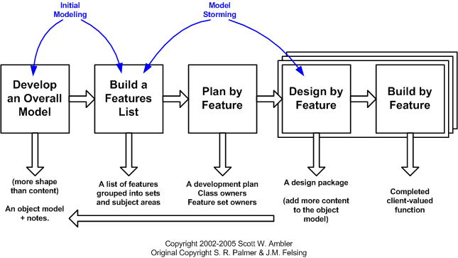
Figure 155: FDD lifecycle[35]
FDD begins by developing an “object model”; this is the design of the system being developed, that will be further built upon as the project is constructed. The features list contains the set of required features that the project will have, with the next stage being to plan development based on these features. This then moves onto design by feature, which is when the initial object model is expanded to reflect how the finished project will function.

Joint Application Development (JAD)
JAD refers to the continued involvement of the client in the design process, as quoted below:
“JAD is a requirements-definition and user-interface design methodology in which end-users, executives, and developers attend intense off-site meetings to work out a system's details. So the Joint Application Development (JAD) methodology aims to involve the client in the design and development of an application.”[33]
It is not so much a development lifecycle in itself, as it is a means of gathering requirements to be used during the development process. According to Joy Matthews:
“An important aspect of the iterative development approach is the Joint Application Development (JAD) process. JAD is used as a technique for developing business system requirements. The purpose of JAD is to bring together IT and the business community in a structured workshop setting to extract consensus based system requirements. … Experience has shown that the JAD process substantially reduces development time, costs and errors.”[36]
JAD is used as part of an iterative lifecycle such as prototyping, feature-driven development and the spiral lifecycle. It is typically used early on in the project to gather requirements, and to keep the clients involved during the design process.
A study[37] has been conducted which explores the growing interest in usability, and how it relates to the Agile development process. It explores the use of personas, a usability technique that constructs a hypothetical user based on research (interviews, observations etc.) This technique is used while building a list of requirements and is a means for the designer to consider the people who will use the software, as opposed to what often tends to happen in design, where systems get designed for the people already familiar with it (i.e. software developers). This is a common usability design mistake that techniques such as those discussed hope to avoid, or at least minimise.

Chosen approach
The best approach for this project would involve inductive phenomenology, since usability involves the human experience, which is subjective and cannot be proven or disproven with facts or hypotheses. A degree of quantitative research may be possible when breaking down usability factors, although the majority of the study will be based upon qualitative research using observation and focus group discussions, forming a persona (or personas) based on this research.
There is a tool called the User Experience Questionnaire (UEQ)[38], which will be of great use when conducting research, particularly for the observation.
The development method used will be JAD and feature-driven development; this will be a process that involves the users, be it through initial brainstorming or gathering feedback on the initial prototypes. Focus groups, and other interaction with potential users relating to this, will be the “JAD meetings”, or off-site meetings, discussed above. Designs will be centred around the features considered during the meetings.

How the observation will work
There will be two observations; one to evaluate an existing system and locate problems, one to test the suggested solution via a prototype. The system of choice is Facebook, partly because it is the most popular system, but mainly because it is the most problematic, and inspired this project in the first place.
The user will run through a set of tasks that will be written prior to the observation, based on research noted in the literature review and further research. They will use a laptop which will have screen recording software installed; this is to capture mouse movements and keyboard entry.
There are different options for screen recorders, many of which offer picture-in-picture recording, where the webcam is also used to record the user. This would be the ideal approach, but in case of problems with this feature, a second recording device – a phone, or other video recorder – will be trained on the user as they run through the tasks. The user will be asked to think aloud as they work, talking through their actions, what they think while performing them, why they do a task a certain way, etc. If the user stops speaking as they work, they will be prompted to continue their train of thought, or be asked questions about what they are thinking, why something might be a problem, etc.

Focus groups
The focus group will be held after the first observation. It will involve discussing the problems found during the evaluation and brainstorming possible solutions. It will be recorded with a smartphone, and there will be the possibility for a card sorting exercise or drawing mind maps during the meeting. It will not be scripted, although results from the observation will be brought into the meeting for discussion.
The group selected to take part in this project will number about four or five – a fairly small number that will reduce the possibility of some people present not getting to voice their opinion, as tends to happen in larger group meetings. Using four or five people allows for the experience of quickly talking about user experiences and gauge reactions to suggested improvements.[19] It will include people with varying privacy concerns and abilities; one who has volunteered to assist is autistic, dyspraxic, dyslexic and transgender. They have already notified this author of a change made by Facebook, who now request identification when signing up for a new account. They have also had to use a different account because of unsupportive family, which factors into why this study is taking place, so would be an ideal candidate for both the focus group and the observation.

Conclusion
This chapter detailed the research process and how it can be best applied to this project.
Usability studies rely more on user experience, which is qualitative data, although the ready-made User Experience Questionnaire can provide a degree of quantitative data that can be analysed. It would be useful to consider applying joint application development to involve the users in the design process as much as possible. This will include an initial observation to analyse an existing system and its flaws.
The following chapter explores the design and implementation of this project.

Design and implementation
This chapter explains the process of evaluating the existing tools and using the results to design an alternative interface.

Problem formulation
While privacy controls vary across platforms, the main focus of this project is Facebook, since it is the most popular with the worst controls. With that in mind, the challenge is to design a more user-friendly interface with default settings geared more towards user preferences as noted in the literature review.
This will be done in two ways; Adobe Xd to suggest the visual layout, and HTML to demonstrate working menus (it has been found that Xd does not have this functionality out of the box).

Design
An observation was conducted to evaluate problems with Facebook’s existing system, with new designs from Google (see conclusions) added as a comparison. It was found that the wizard feature offered by Google’s new dashboard is much more user-friendly; it offers a more intuitive interface that guides the user through the steps needed to check their privacy settings against various information.
Considering that Facebook offers more options than Google, the challenge was to present this in a layout that is easier to navigate while still in the context of a “privacy wizard”.
It was decided to follow the convention of a grid layout, with an option to return to the main account settings, with a combination of visual and textual information to offer the user (see Figure 24 in Appendix 4: Designs). The use of icons was also employed as another means of catching the user’s attention and illustrating the setting to be changed.
Figure 25 and Figure 26 give an idea of the screens that follow when the “change” button is clicked. Again, the use of a grid layout is used, along with icons and short descriptions, to give the user less information to process as they scan the options (in line with the mantra “don’t make me think”[19]).
The settings here also portray the proposed default settings, which are more secure and in line with findings in a study highlighted in the literature review. The preferred defaults for most personal information is friends-only, and it is a matter of security (as noted with the problem of scams in the review) to keep the friends lists private.
The navigation, while not officially part of the project, proposes a way to make the settings more obvious and accessible, as shown in an existing framework called Elgg (shown below) - rather than the inconspicuous down arrow in Facebook, settings here are shown with a familiar gear icon.
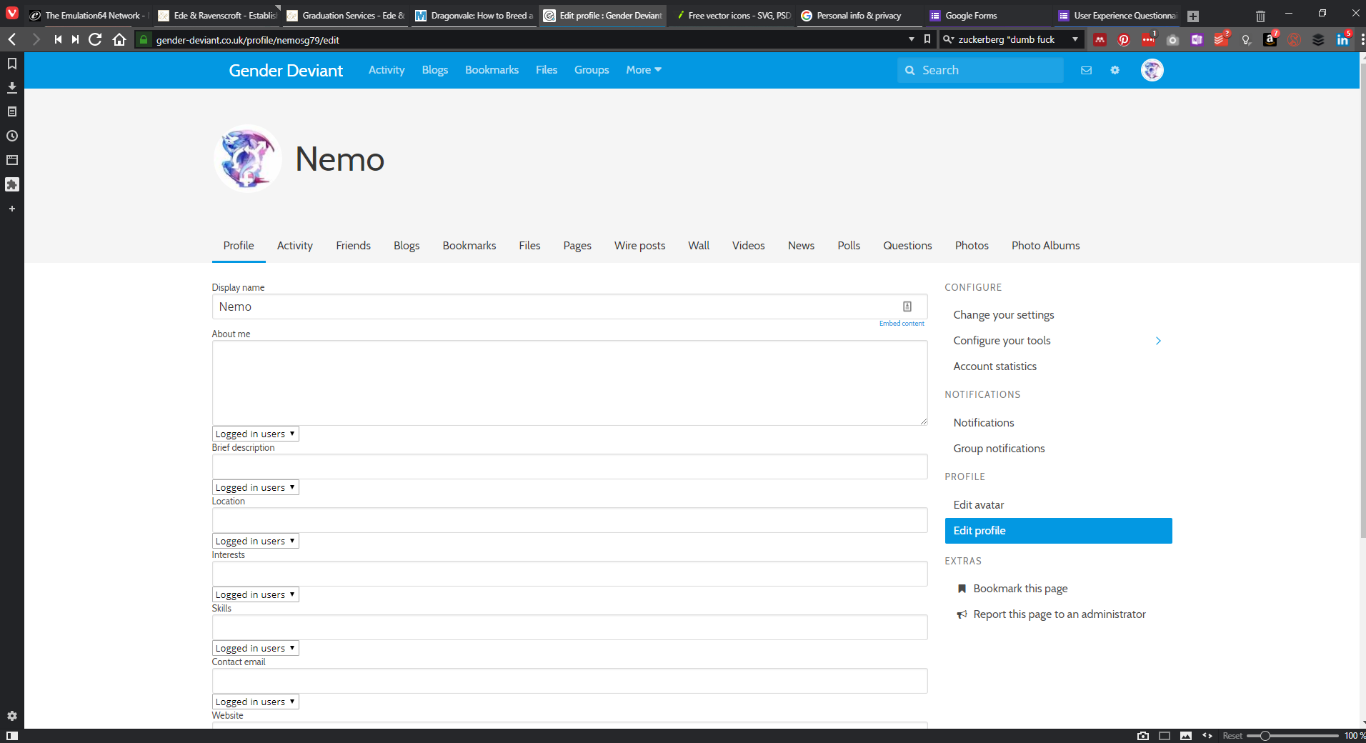
Figure 16: Elgg edit profile screen
The choice to partially redesign this feature came from the response to the UEQ which said that “some controls are hard to find”.
The framework itself is simpler than Facebook, so whether the layout shown here would be workable in practice is questionable and outside the scope of this project.

Implementation
The “implementation” here refers to the HTML code (shown in Appendix 5: Code), which was built when it transpired that Xd could not illustrate properly the dropdown menus that are part of the design. An example of this is shown below in illustrating the settings menu:
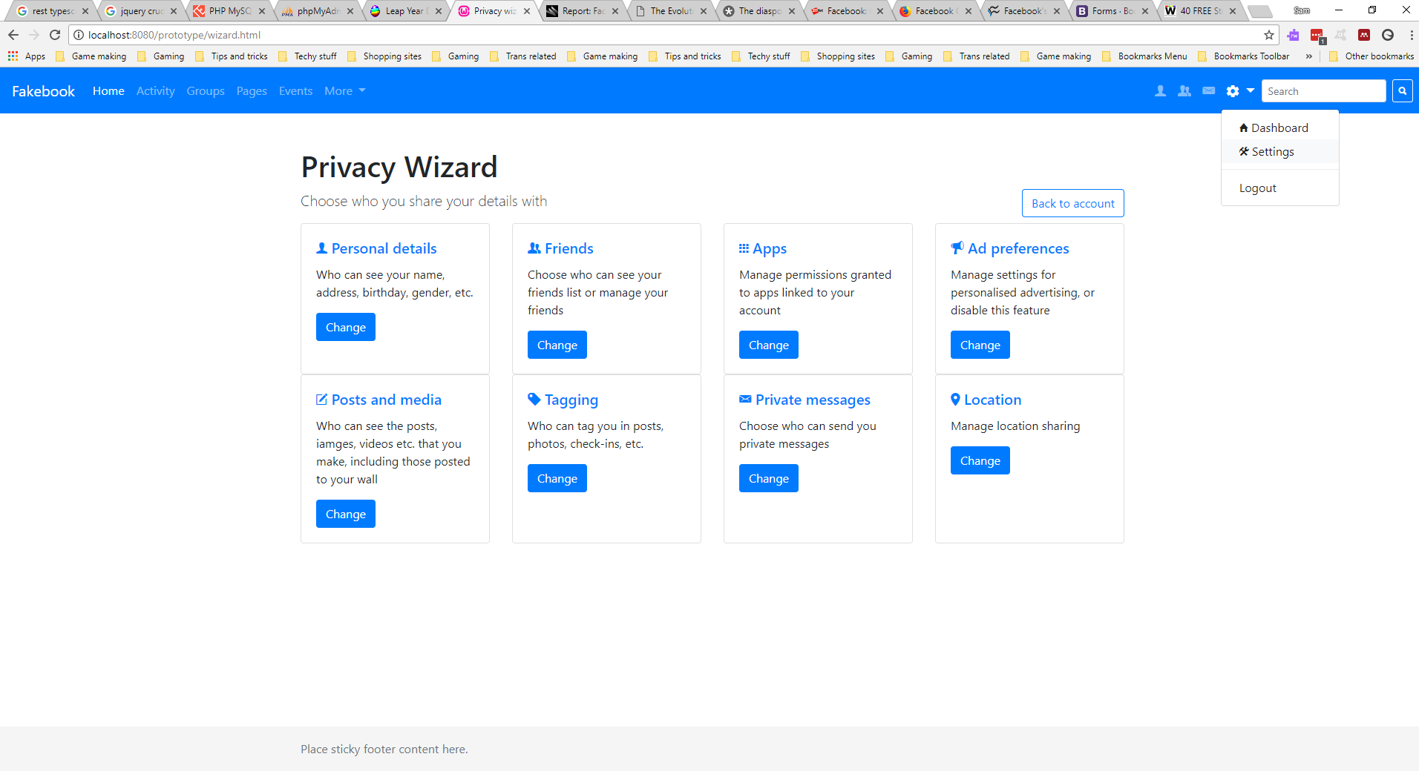
Figure 17: Privacy wizard as shown in HTML form
Bootstrap 4 was used to aid development of the code form, which does affect the appearance in a few ways. The most obvious example of this is shown below with friends management:
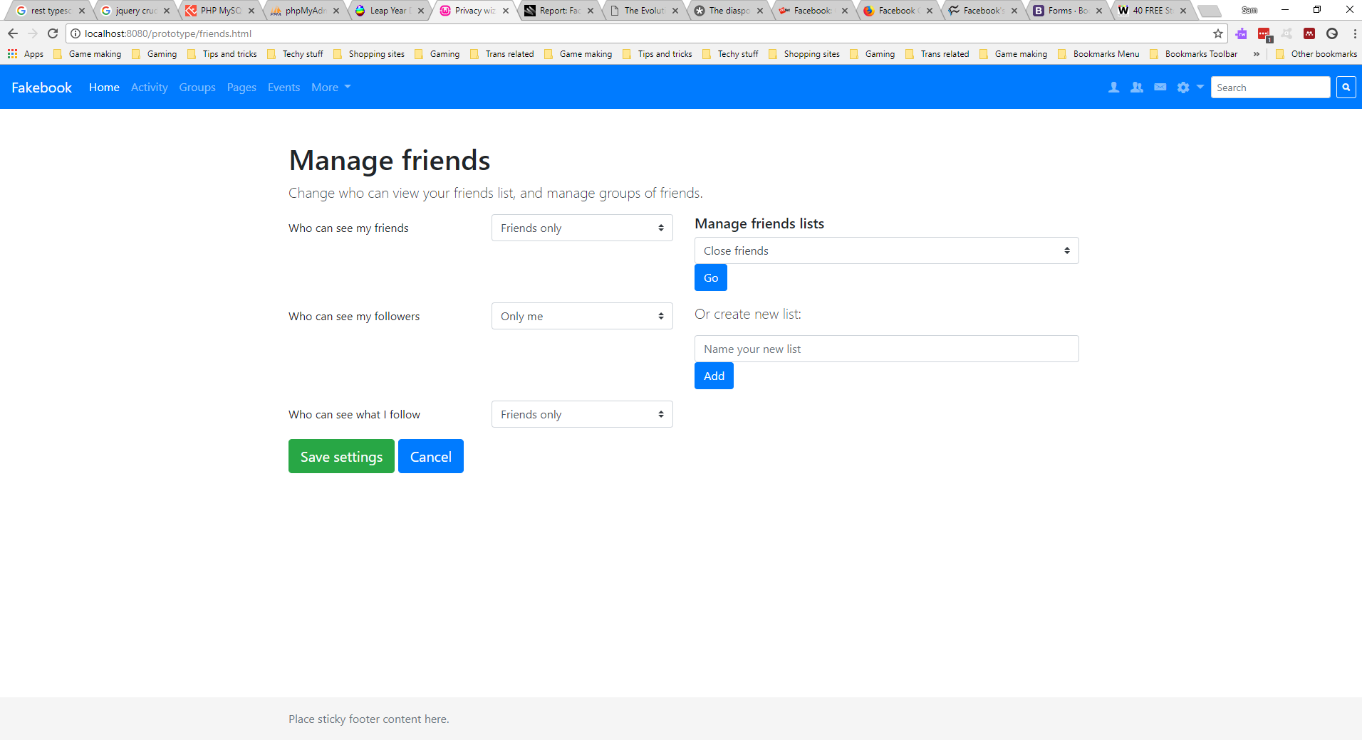
Figure 18: The manage friends screen
It was preferred to show icons alongside the options and may be possible using the button dropdowns instead of form select, but this was the easiest way to show how the menu would work.
As noted in the evaluation and conclusion sections, designs were severely delayed due to the usability tests being pushed back, so while design and implementation are incomplete, they do give an idea of the proposed improvement to the UI, although due to above reasons, a second usability test could not be arranged in time.

Conclusion
It is known that design and implementation is not as well formed as it could have been. With more time and less delays, there would be more substance to this section, as well as detail on the second usability test in regard to the prototype. It does, however, explain the ideas behind the design and give a foundation to the proposed alternative; other screens would follow a similar layout to those described above.
The next chapter will evaluate this process in more detail.

Evaluation
This chapter discusses the results of the project and compares them with the objectives covered in the introduction.

Results
The one result obtained from the UEQ (shown in Appendix 3: UEQ results) confirms what was found in a study mentioned in the literature review; additional, optional questions were added, one of which asked, “How could the UI be improved?”
The answer given was “Default settings should be more private”, which confirms the study mentioned in 2.4 above.
It was also remarked that “Some controls are difficult to find!”, which points to the main inspiration for this project.
This alone was not enough to inspire designs from the project; however, recent developments regarding the Cambridge Analytica scandal*[40] have been. Google have already redesigned their privacy dashboard, as shown below:
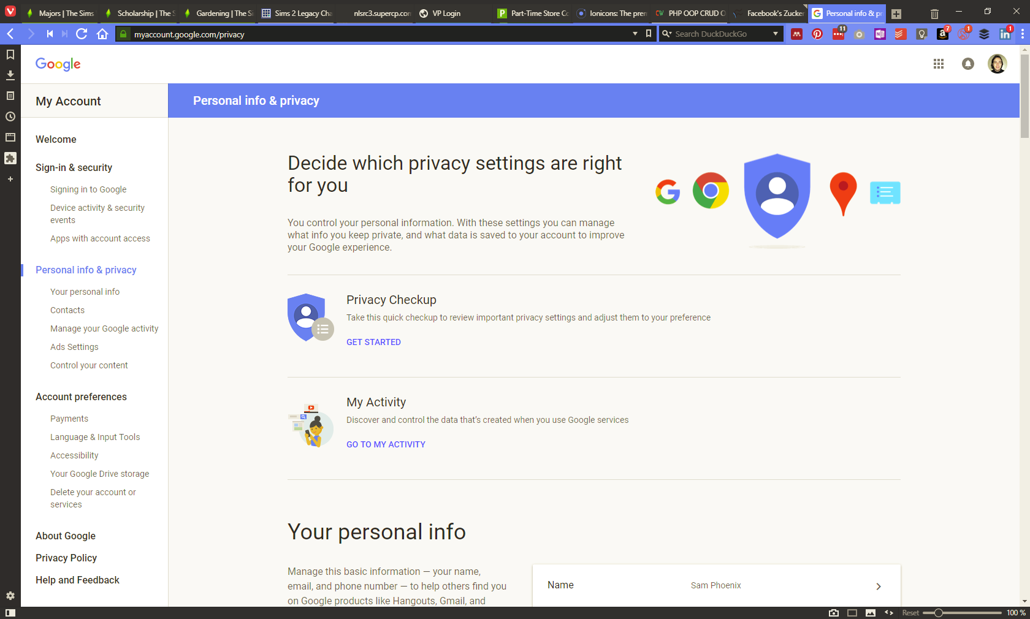
Figure 16: Google's new privacy controls[41]
By the time the observation happened, after the task list was complete, it was decided to show them the above privacy dashboard and ask their opinion on this layout in comparison to Facebook. The response can be summarised as “much better, more user-friendly”.
Results from the observation also confirmed findings discussed in the literature review. The user remarked that they had no idea that it was possible to do most of the things listed in the task list (see Appendix 1: Task list). They also struggled to find the controls needed to perform these tasks.
While the user did not represent the minority groups originally aimed for, they did represent the average user who is not knowledgeable enough to know about the filters discussed in the literature review.
Overall, the conducted usability tests confirm what was found in existing studies, confirms expectations regarding privacy controls, and reinforces the need to continue studying this topic.
*Facebook and Cambridge Analytica will be discussed in more detail in the “conclusions and further recommendations” section since it affects proposals for further study.

Outcome vs aim and objectives
The project did not go entirely as planned. The user who had originally offered to assist became unavailable due to personal reasons. A backup plan was implemented, which involved sending a mass email to a group of usability engineering students with the task list to be completed, and an online re-creation of the UEQ; however, as noted above, only one response was received. When an observation candidate was found, the meeting for this got delayed considerably.
There was, therefore, no time to involve any focus group discussion on the initial findings, let alone conduct a second usability test. Designs were taken straight to Adobe Xd, and it was found that it is more limited than expected. The only way to prototype menus such as dropdowns is to duplicate artboards, and with the delay in observation, there was no time left to put in the required extra work. Also because of the delay, designs are incomplete, although it gives a good idea of the intentions behind the design.
The table below summarises the initial aim and objectives and compares them against the outcome of the project.
Table 3: Comparing initial aims of project with outcome
Aim / objective of project | Outcome of project
Find a user-friendly approach to setting privacy controls, including possibility of expiry dates | Exploring expiry dates proved to be beyond scope of project.
Investigate and analyse existing approaches | Successful not only in existing approaches, but in continuing to discover new information on the topic.
Develop improvements to security by building a prototype using interfaces | Some interactive designs produced. Successfully created more visual privacy dashboard, have also indicated more locked down default settings.
Evaluate usability of approaches to security settings by conducting usability tests | Partially successful; initial testing delayed as described above, which in turn delayed progress on designs and rendered further tests impractical.

What would be done differently
One of the main delays of this project was the fact that this is the third incarnation of it. The first, completely unrelated topic never passed the project proposal; the second project idea began as a case study into developing a privacy-conscious social network for a minority group and morphed into this current project. This therefore delayed the initial literature review, which in turn set back the rest of the project.
The main thing that would be done differently, is to seek additional support in deciding on a topic early on and proceed to conduct the literature review in good time. Additionally, more consideration would be taken in contingency planning to account for inevitable setbacks, as this posed another long delay in completing the project.
Further considerations and evaluating in this area will be discussed in the Reflection.

Conclusions and recommendations
This chapter will summarise the project, discuss any unexpected occurrences during the project, and pose suggestions for continuing research into this topic.

Summary
This project was an attempt to address the ongoing problem of users oversharing their information due to poor privacy controls, with the emphasis being on how to improve the interface design. It included a more visual UI with short descriptions explaining what the control would change, as well as more secure default settings as shown to be preferred by users (this is discussed in the literature review).
Usability tests were carried out as a means of evaluating existing systems, conducted via observation and a pre-constructed User Experience Questionnaire (UEQ), although responses to the latter were considerably low; the choice to add additional questions proved to be helpful in providing comments that confirmed study findings discussed in the literature review.
The most significant findings regarding this issue occurred late into the project, after the initial review was conducted; these are discussed below.

Unexpected events
During the later stages of the project, specifically at the time of the design stage, the Facebook and Cambridge Analytica scandal happened. ZDNet summarises it as follows:
“A data analytics company that helped propel Donald Trump to election victory harvested private information from 50 million Facebook profiles without their permission.”[40]
It was found that a “benign-looking personality prediction “research” app” was used to harvest the data of over 270,000 Facebook users. That number rose to over 50 million when it was discovered that the Facebook Messenger app on smart phones gathered data on not only the users themselves, but also the contacts stored in their phones, so the users clicking on this app inadvertently shared details of their contacts as well as their own.
This raised serious questions about the security of users’ data, and how it can be so easily collected without their knowledge. As noted in the literature review, this has been the subject of many studies for several years, and there have been several tutorials published with the hope of educating users on how to better protect the information they share, but this is the first time users have seen for themselves the implications of placing too much trust in social media.
The sad truth is, as much as it would be expected that users can trust companies with the data they share, there have since been some disturbing findings to the contrary. These are discussed below.

Facebook’s CEO and his attitude to privacy
The revelations regarding Cambridge Analytica have prompted fresh interest in Facebook and Mark Zuckerberg, and the results are problematic at best.
It begins with an early series of IMs discovered by Business Insider[42] in 2010, between a then 19 year old Mark and a friend:
Zuck: Yeah so if you ever need info about anyone at Harvard
Zuck: Just ask.
Zuck: I have over 4,000 emails, pictures, addresses, SNS
[Redacted Friend's Name]: What? How'd you manage that one?
Zuck: People just submitted it.
Zuck: I don't know why.
Zuck: They "trust me"
Zuck: Dumb f**ks.
While it has been suggested that he was joking at the time, Business Insider notes the following:
But the company's attitude toward privacy, as reflected in Mark's early emails and IMs, features like Beacon and Instant Personalization, and the frequent changes to the privacy policy, has been consistently aggressive: Do something first, then see how people react.
And this does appear to reflect Mark's own views of privacy, which seem to be that people shouldn't care about it as much as they do -- an attitude that very much reflects the attitude of his generation.[42]
Mark’s attitude to privacy is best summarised by the below screenshot, as reported on Wired[43]:
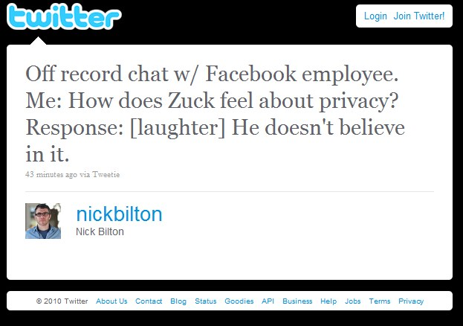
Figure 20: "off record" chat reveals Mark's disregard for privacy
This attitude to privacy has shown itself in the way Facebook’s privacy policy has changed over the years. The below images show the difference in default privacy settings between when it started in 2005, and in 2010:
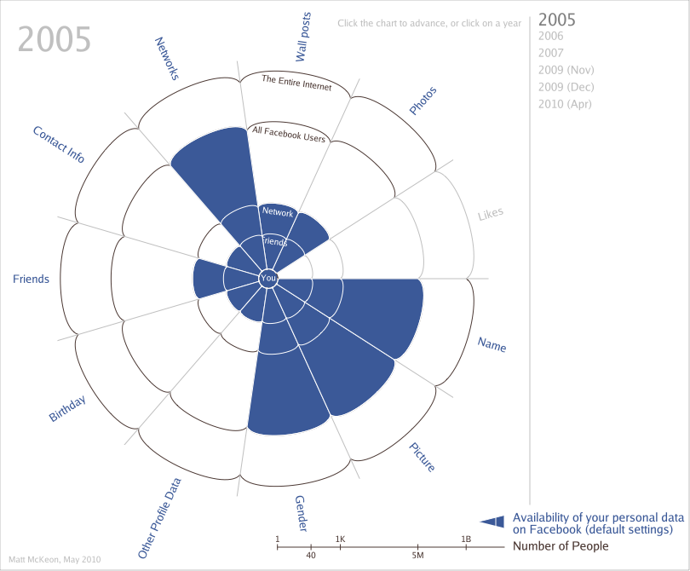
Figure 21: Default privacy settings in 2005[44]
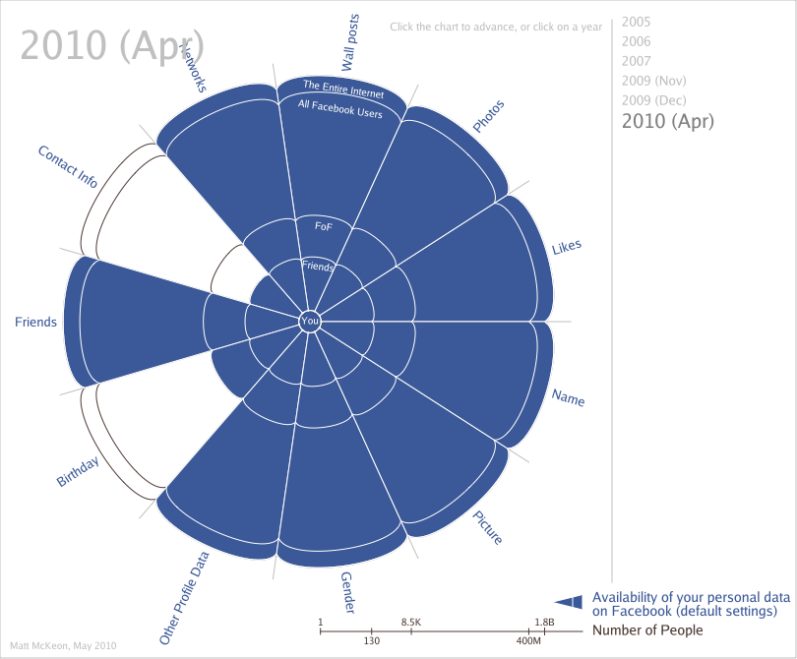
Figure 22: Default privacy settings in 2010[44]
A point to note here, is that the default privacy settings are changed with each revision to their privacy policy; with each change, no matter how much a user has locked down their account, these changes reset them to the new default settings.
A quote in the literature review is worth repeating here to highlight the problem with this approach:
“Any set of controls has a starting point—the default configuration that the user then modifies as desired. Customizing these settings takes user effort, and users often accept the defaults rather than perform the work of modifying them to meet their needs.” [14]
With this in mind, designing new interfaces for privacy controls is a start, but more consideration is needed on how and where to use them.

Conclusion
Facebook may be the most extreme example of a disregard for users’ privacy, but there is a precedent of businesses placing profits at a higher priority than the welfare and privacy of its users.
Another quote from the literature review is worth repeating:
“Designers have an opportunity to build interfaces that will reinforce the status quo or attempt to push generally accepted business practices in a direction that is more privacy friendly. …balancing the desires of keeping interfaces simple with providing flexibility and educating users about privacy is a complicated problem.[22]”
The scope of this project was to address this challenge by producing more privacy-friendly, user-friendly designs with better default settings. Google have taken on this challenge in the face of the Cambridge Analytica backlash by redesigning its privacy controls, while Facebook have explained that they will be changing the functionality of their APIs[45] to address the misuse of data – however, Mark Zuckerberg maintains that “you chose to share it.”[46]
Another point raised that ties in with the literature review is the method by which this scandal happened in the first place: a “benign-looking app”. As discussed in that chapter, one of the means companies can gather information is with enticing looking apps that claim to “find out who you’ll marry”, “what are your most used words in posts”, etc. This raises another, separate issue of educating users on the potential dangers of clicking on these links or the permissions they grant to third party apps.

Methodology and implementation
An observation and the UEQ were used with partial success, as detailed in the evaluation and reflection chapters. Because of the delays discussed previously, the proposed JAD development method became impractical, with no time to arrange or hold focus groups.
The resulting designs and implementation are admittedly lacking. Had the observation gone as initially planned, more time would have been available to produce a more complete set of prototypes. As it stands, the choice to not construct a fully functional implementation (as opposed to using Bootstrap as another prototyping tool) was a wise one, as explained in the section below.

Recommendations for further research
The best approach to improving privacy controls is to consider how to make controls more user-friendly despite existing companies’ disregard for user privacy. The backlash has sparked new interest in this area, with the Mozilla Foundation developing a new extension, called Facebook Container, which promises the following:
Installing the extension is easy and, once activated, will open Facebook in a blue tab each time you use it. Use and enjoy Facebook normally. Facebook will still be able to send you advertising and recommendations on their site, but it will be much harder for Facebook to use your activity collected off Facebook to send you ads and other targeted messages.[47]
With Facebook being so popular, and with the CEO having such blatant disregard for privacy in general, browser extensions seem to be the best way of controlling privacy for users. Firefox offers an approach which contains Facebook to a separate tab; another way might be to use the interface designs in this project as a wizard that opens when an extension is installed and set a user’s Facebook controls that way. Possibilities could include alerting a user to a change in privacy policy and prompting them to check their settings, providing them with a “privacy check up” similar to that now used by Google.
Other options include setting up something different, as some companies have started to do. One such company is the Diaspora foundation, which hosts their service in a decentralised fashion, with the following privacy statement:
In diaspora* you own your data. You don’t sign over rights to a corporation or other interest who could use it. In addition, you choose who sees what you share, using Aspects. With diaspora*, your friends, your habits, and your content is your business ... not ours![48]
Another development is the EU’s General Data Protection Regulation (GDPR)[49], a replacement for the Data Protection Directive that comes into force 25th May 2018. With this in mind, and with users now being more aware of how their data can be misused, it is more important than ever that this problem is looked into more thoroughly.

Reflection
This chapter reflects on the process of conducting this research and completing the project. It explores what has been learnt during the course of this task and what could be improved if it were to be attempted again.
The key takeaway from this project is, while learning disabilities do not prevent one from completing a project, they can have more impact on progress. Stamina with a such a task is harder to maintain in this situation, and it is from this point of view that this chapter is written.
While additional support was in place to assist with the project, that support proved to be detrimental rather than productive. There were several times during the course of this project, some during the support sessions themselves, that frustration to the point of almost giving up was experienced.
As mentioned in a previous section, this is the third form of this project. The first was more of a “I don’t know what I’m doing but here’s a project proposal”, and it showed in the work. There was some discussion at the start of the year about what the project could actually be, and it took another two tries to arrive at this one. The case study idea got as far as the initial project poster, but never got to the literature review stage – by the time work could begin on this project, it was already a few weeks into the year and the first wave of despair hit during the literature review.
Use was made of the fact that there was a module in User Experience Design running this year. Knowledge gained during this module was applied to this project and, where necessary, consultations were made with that tutor regarding this project. Advice was sought on how to proceed when a roadblock was encountered, which in some way made up for the unpleasant experience with the support tutor – while practical support was provided, there was a profound lack of understanding regarding learning disabilities, despite attempts to educate on the difference between procrastination and executive dysfunction*.
*Put simply, procrastination is “I don’t feel like doing [x], I’ll do [y] instead”. Executive dysfunction is “I need to do [x]... I really need to do [x]... why am I still doing [z]… Okay, guess [x] isn’t going to happen, I’ll try doing [y] for a bit and come back to [x] later.” The latter means it takes considerably more effort to get a task done, which can result in more instances of feeling burned out.
This meant that the literature review had to be completed in smaller, more manageable pieces that lead to its completion being somewhat delayed. Some aspects of the reading resulted in feelings of self-doubt (“This is a pretty complicated issue; how on earth am I going to do this?”), which in turn ate away at the will to work, which resulted in a cycle of unproductivity and guilt at not getting much done.
As well as learning during the process, there was also some unlearning that needed to take place. Namely that trying to push oneself to work at the same rate as a neurotypical person was at best unhelpful, at worst harmful. Accepting that such limits are lower than for most people and to adjust working according. It was found that “little and often” was the best approach; an hour at a time was suggested. Also that the largest drain on mental capacity for work was the process of communicating research through writing; once at the design stage, work could occur unhindered for several hours at a time.
Another hurdle of this project was managing it effectively. Arranging for usability testing proved to be harder than anticipated; while there was a backup plan in place, this proved to be of little help. The UEQ was circulated to about ten people, but only one responded. The substitute observation volunteer needed to postpone the appointment. It seems there is still a degree of proactivity to be learned regarding approaching other people to assist in a project.
Then the Cambridge Analytica news transpired. Upon reading how privacy settings were now being redesigned or otherwise adjusted, there was a feeling of “Well, thanks, you’ve just done my project for me!?”, which lead to another sense of “Why even bother”. It took a few days before being able to turn that around to “Okay, maybe I can use this to influence my design choice, or the observation when it happens”.
There is a keen awareness that the project has not gone smoothly. Were it to happen again, it would begin with a conscious effort to make it the project of choice to begin with, rather than the afterthought it eventually became. More care would be taken in ensuring that it could be completed to the best standard, as well as ensuring from the start what capabilities exist to perform the necessary tasks required. Furthermore, it has become apparent that people management needs improvement; mainly regarding seeking out support from other people, but also a need to be less tolerant of people who do not provide the necessary help – action was eventually taken regarding the support tutor after feeling for most of the year that there was no other option, although personal wellbeing improved once that happened.

References
[1] BusinessDictionary, ‘What is Privacy’, Reading, 2014. [Online]. Available: https://iapp.org/about/what-is-privacy/#. [Accessed: 28-Oct-2017].
[2] Privacy Rights Clearinghouse, ‘Social Networking Privacy: How to be Safe, Secure and Social’, Privacy Rights Clearinghouse, 2016. [Online]. Available: https://www.privacyrights.org/consumer-guides/social-networking-privacy-how-be-safe-secure-and-social. [Accessed: 28-Oct-2017].
[3] R. Delgado, ‘The Privacy Dangers of Using Social Media’. [Online]. Available: https://www.techsling.com/2013/08/the-privacy-dangers-of-using-social-media/. [Accessed: 16-Nov-2017].
[4] ‘Social Networking Sites | Get Safe Online’. [Online]. Available: https://www.getsafeonline.org/social-networking/social-networking-sites/. [Accessed: 16-Nov-2017].
[5] ‘Facebook and Twitter Fired: 10 Worst Mistakes That Cost Millennials Jobs | Money’. [Online]. Available: http://time.com/money/3019899/10-facebook-twitter-mistakes-lost-job-millennials-viral/. [Accessed: 16-Nov-2017].
[6] M. Madejski and S. M. Bellovin, ‘The Failure of Online Social Network Privacy Settings’, Methodology, vol. 10, no. CUCS-010-11, pp. 1–20, 2011.
[7] ‘Facecrooks.com | How to Avoid a Facebook Scam | All about Facebook Scams’. [Online]. Available: http://facecrooks.com/. [Accessed: 19-Nov-2017].
[8] ‘How to Read a Privacy Policy | State of California - Department of Justice - Office of the Attorney General’. [Online]. Available: https://www.oag.ca.gov/privacy/facts/online-privacy/privacy-policy. [Accessed: 19-Nov-2017].
[9] J. Wortham, ‘Glitch Brings New Worries About Facebook’s Privacy - NYTimes.com’, May 5, 2010, 2010. [Online]. Available: http://www.nytimes.com/2010/05/06/technology/internet/06facebook.html?src=busln. [Accessed: 19-Nov-2017].
[10] ‘How Ad Blockers Have Triggered an Arms Race on the Web - MIT Technology Review’. [Online]. Available: https://www.technologyreview.com/s/601581/how-ad-blockers-have-triggered-an-arms-race-on-the-web/. [Accessed: 26-Nov-2017].
[11] ‘FTM, MTF Trans &amp; Non-binary Support Group’. [Online]. Available: https://www.facebook.com/groups/705742769526196/search/?query=So i changed my name. [Accessed: 26-Nov-2017].
[12] Privacy Rights Clearinghouse, ‘Fact Sheet 35: Social networking privacy-how to be safe, secure and social’, Privacy Rights Clearinghouse, 2010. [Online]. Available: https://www.privacyrights.org/consumer-guides/social-networking-privacy-how-be-safe-secure-and-social. [Accessed: 16-Nov-2017].
[13] J. Mathew, ‘China Defends Blocking Facebook, Twitter and Bloomberg’, International Business Times, 2014. [Online]. Available: http://www.ibtimes.co.uk/china-defends-blocking-facebook-twitter-bloomberg-1432488. [Accessed: 26-Nov-2017].
[14] J. Watson, H. R. Lipford, and A. Besmer, ‘Mapping User Preference to Privacy Default Settings’, ACM Trans. Comput. Interact., vol. 22, no. 6, pp. 1–20, 2015.
[15] ‘What are some missing features from today’s social networks? | Social Media’. [Online]. Available: https://www.quora.com/What-are-some-missing-features-from-todays-social-networks?share=1. [Accessed: 02-Dec-2017].
[16] M. Sleeper, L. F. Cranor, and S. K. Pearman, ‘Exploring Topic-Based Sharing Mechanisms’.
[17] L. F. Cranor and S. Garfinkel, Security and Usablity: Designing secure systems that people can use. O’Reilly Media, Inc, 2005.
[18] I. Oluo, ‘“Facebook’s Complicity in the Silencing of Black Women”’, Medium, 2017. [Online]. Available: https://medium.com/@IjeomaOluo/facebooks-complicity-in-the-silencing-of-black-women-e60c34434181. [Accessed: 07-Dec-2017].
[19] S. Krug, Don’t Make Me Think: A Common Sense Approach to Web Usability. 2006.
[20] A. Acquisti et al., ‘Nudges for Privacy and Security’, ACM Comput. Surv., vol. 50, no. 3, pp. 1–41, 2017.
[21] R. Hirschprung, E. Toch, H. Schwartz-Chassidim, T. Mendel, and O. Maimon, ‘Analyzing and Optimizing Access Control Choice Architectures in Online Social Networks’, ACM Trans. Intell. Syst. Technol., vol. 8, no. 4, pp. 1–22, 2017.
[22] L. F. Cranor, P. Guduru, and M. Arjula, ‘User interfaces for privacy agents’, ACM Trans. Comput. Interact., vol. 13, no. 2, pp. 135–178, 2006.
[23] ‘Why There is No Such Thing As &quot;Privacy&quot; On Social Networks | IFB’. [Online]. Available: https://heartifb.com/2012/12/27/why-there-is-no-such-thing-as-privacy-on-social-networks/. [Accessed: 02-Dec-2017].
[24] C. U. P. and S. L. CUPS, ‘Privacy Bird’, 2006. [Online]. Available: http://www.privacybird.org/. [Accessed: 08-Dec-2017].
[25] J. M. Carroll, ‘Human Computer Interaction - brief intro’, Encycl. Human-Computer Interact. 2nd Ed., pp. 1–69, 2013.
[26] J. M. Carroll, ‘Human Computer Interaction - brief intro’, Encycl. Human-Computer Interact. 2nd Ed., pp. 1–69, 2013.
[27] UsabilityNet, ‘UsabilityNet: Wizard of Oz method’, 2006. [Online]. Available: http://www.usabilitynet.org/tools/wizard.htm. [Accessed: 09-Dec-2017].
[28] Floyd J. Fowler, Survey Research Methods, 4th ed. Washington DC: SAGE Publications, Inc, 2009.
[29] J. H. Frey and S. M. Oishi, How to conduct interviews by telephone and in person. London: SAGE Publications, Inc, 1995.
[30] Karen Holtzblatt and Hugh R. Beyer, ‘Contextual Design | The Encyclopedia of Human-Computer Interaction, 2nd Ed.’, Interaction Design Foundation. [Online]. Available: https://www.interaction-design.org/literature/book/the-encyclopedia-of-human-computer-interaction-2nd-ed/contextual-design. [Accessed: 06-Jan-2018].
[31] ‘UsabilityNet: Evaluate existing system’. [Online]. Available: http://www.usabilitynet.org/tools/existing.htm. [Accessed: 06-Jan-2018].
[32] J. Dudoviskiy, ‘Positivism - Research Methodology’, Research Methodology. 2015.
[33] Stanford University. and Center for the Study of Language and Information (U.S.), Stanford encyclopedia of philosophy. Stanford University, 1997.
[34] ‘Software Development Methodologies’. [Online]. Available: http://www.itinfo.am/eng/software-development-methodologies/. [Accessed: 19-Jan-2018].
[35] Agile Alliance, ‘What is Agile Software Development? | Agile Alliance’, agileallance.org, 2016. [Online]. Available: https://www.agilealliance.org/agile101/. [Accessed: 22-Jan-2018].
[36] S. W. Ambler, ‘Feature Driven Development (FDD) and Agile Modeling’, Agile Modeling, 2005. [Online]. Available: http://www.agilemodeling.com/essays/fdd.htm. [Accessed: 22-Jan-2018].
[37] J. Matthews, ‘Using JAD For An Iterative Approach To Requirements Management’. [Online]. Available: https://www.batimes.com/articles/using-jad-for-an-iterative-approach-to-requirements-management.html. [Accessed: 17-Feb-2018].
[38] J. Haikara, ‘Usability in Agile Software Development: Extending the Interaction Design Process with Personas Approach’, Xp 2007, vol. 4536, pp. 153–156, 2007.
[39] B. Laugwitz, T. Held, and M. Schrepp, ‘UEQ - English’, p. 2, 2008.
[40] ‘Trump-linked data firm Cambridge Analytica harvested data on 50 million Facebook profiles to help target voters | ZDNet’. [Online]. Available: https://www.zdnet.com/article/facebook-suspends-analytics-firm-that-helped-trump-campaign/. [Accessed: 17-Apr-2018].
[41] Google, ‘Personal info &amp; privacy’. [Online]. Available: https://myaccount.google.com/privacy. [Accessed: 17-Apr-2018].
[42] N. Carlson, ‘Well, these new Zuckerberg IMs won’t help Facebook’s privacy problems’, Business Insider, vol. 2012. 2010.
[43] E. Van Buskirk, ‘Report: Facebook CEO Mark Zuckerberg Doesn’t Believe In Privacy’, Wired, 2010. [Online]. Available: https://www.wired.com/2010/04/report-facebook-ceo-mark-zuckerberg-doesnt-believe-in-privacy/. [Accessed: 18-Apr-2018].
[44] M. McKeon, ‘The Evolution of Privacy on Facebook’, 2010, vol. 20, no. 1, pp. 69–92, 2010.
[45] Facebook, ‘An Update on Our Plans to Restrict Data Access on Facebook’, 2018. [Online]. Available: https://newsroom.fb.com/news/2018/04/restricting-data-access/. [Accessed: 17-Apr-2018].
[46] ‘Facebook’s Zuckerberg: Here’s how we’ll fix our massive data privacy problems - TechRepublic’. [Online]. Available: https://www.techrepublic.com/article/facebooks-zuckerberg-heres-how-well-fix-our-massive-data-privacy-problems/?ftag=TRE684d531&bhid=27865688365852001119516242610980. [Accessed: 05-Apr-2018].
[47] Mozilla, ‘Facebook Container’. [Online]. Available: https://www.mozilla.org/en-US/firefox/facebookcontainer/. [Accessed: 18-Apr-2018].
[48] Diaspora, ‘The Diaspora Project’, 2012. [Online]. Available: https://diasporafoundation.org/. [Accessed: 18-Apr-2018].
[49] EU, ‘Home Page of EU GDPR’, EU GDPR Terminal. 2016.

Appendix 1: Task list
Below is the task list used for the observation, as well as the UEQ emailed out to usability engineering students:
- Add a nickname
- Create a friends only post
- Create a custom filter for certain posts
- Block a user
- Make a post that excludes someone
- Change who can see your gender
- Change who can post to your wall
- Change who can send friend requests
- Change who can see your friends list

Appendix 2: UEQ reconstructed in Google Forms
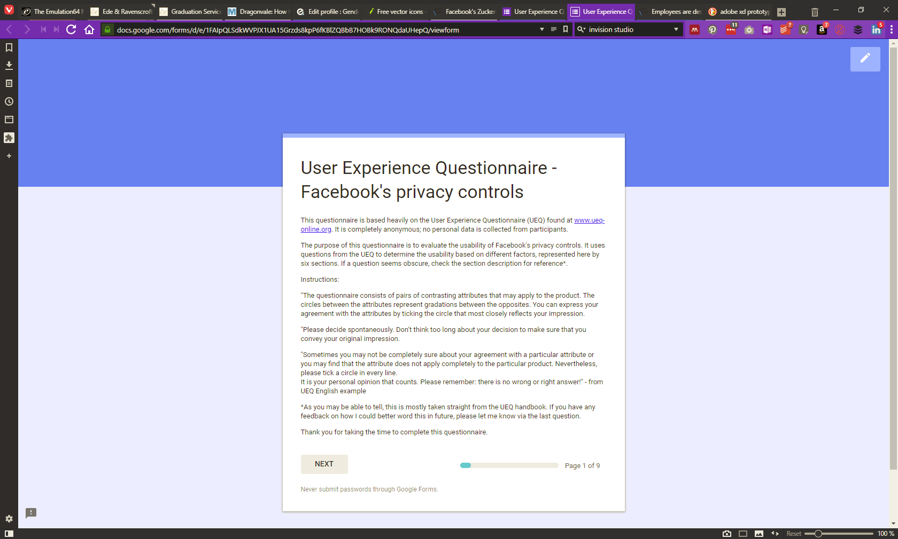
Figure 17: Intro section
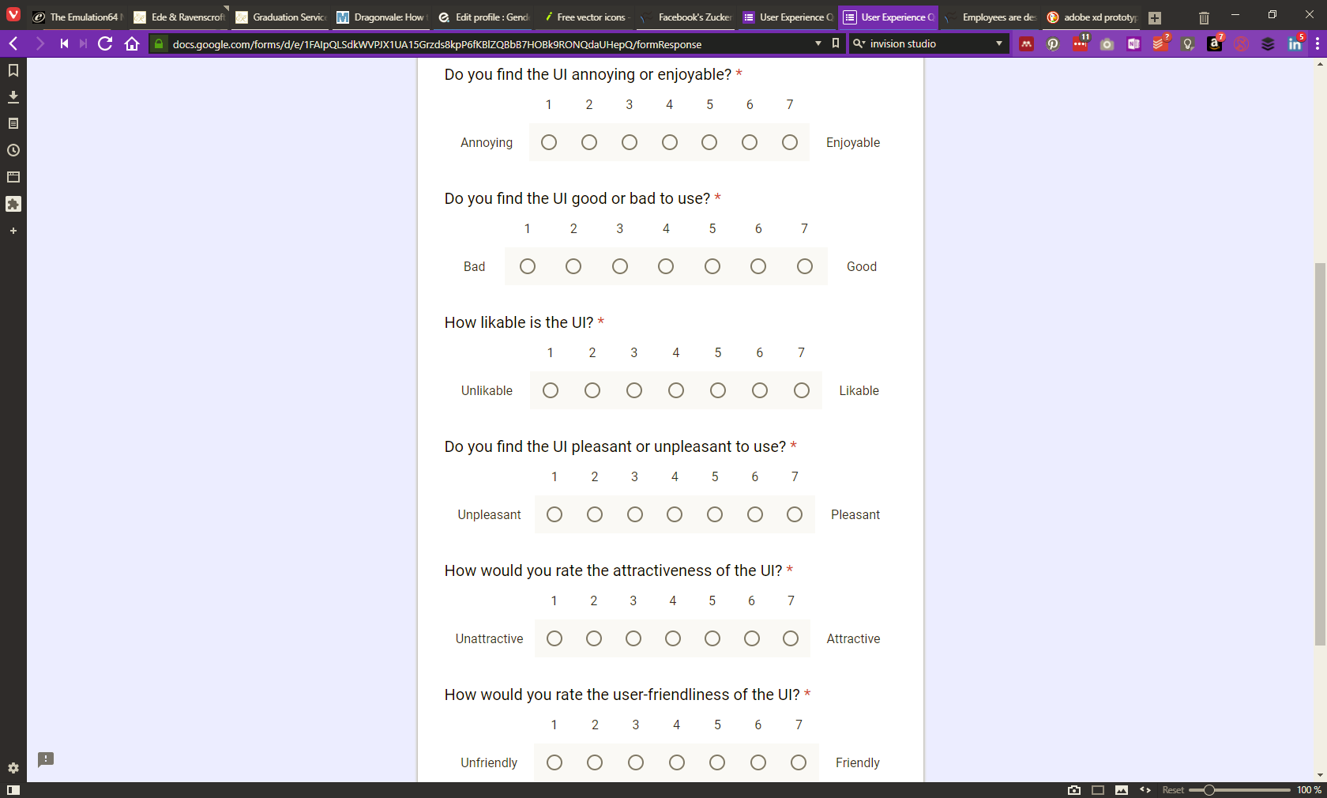
Figure 18: Section 1
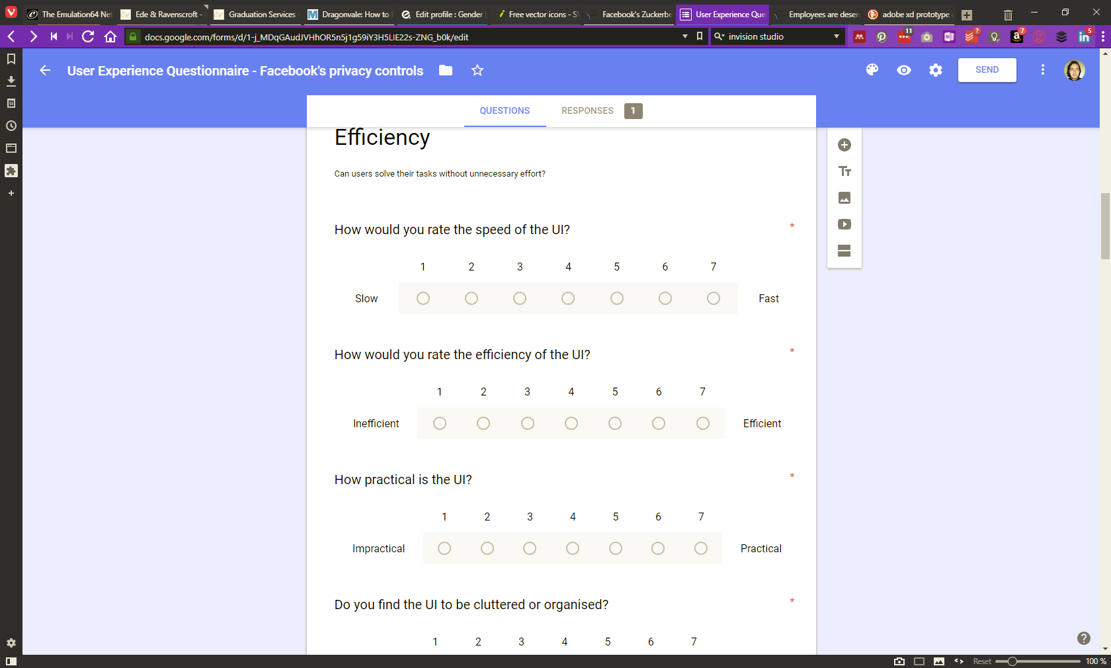
Figure 19: Section 2
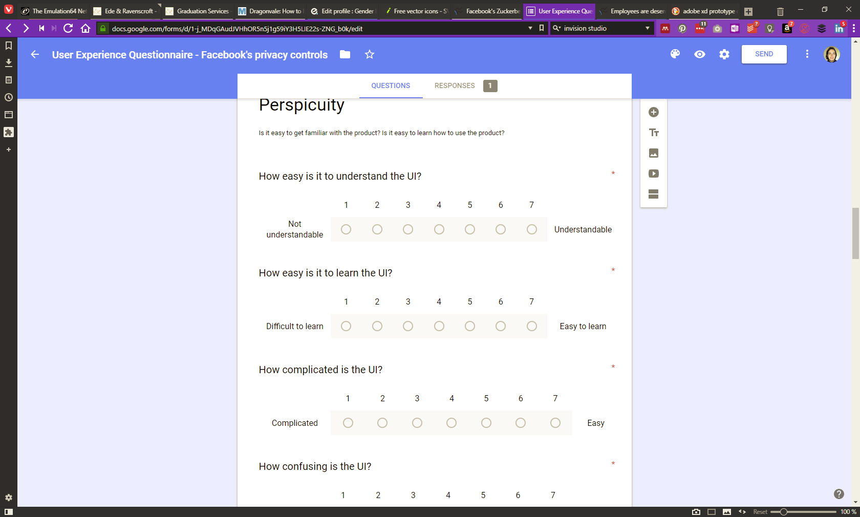
Figure 20: Section 3
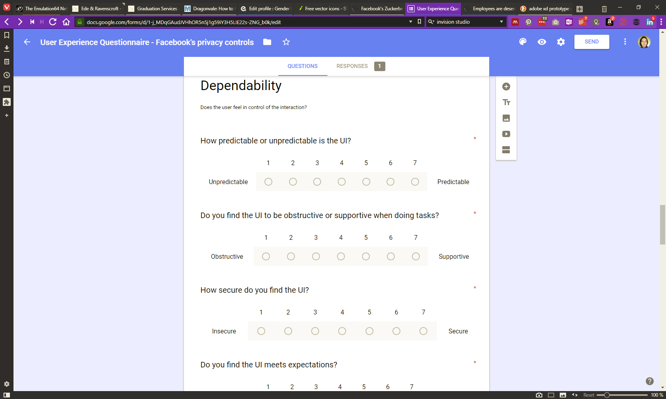
Figure 21: Section 5
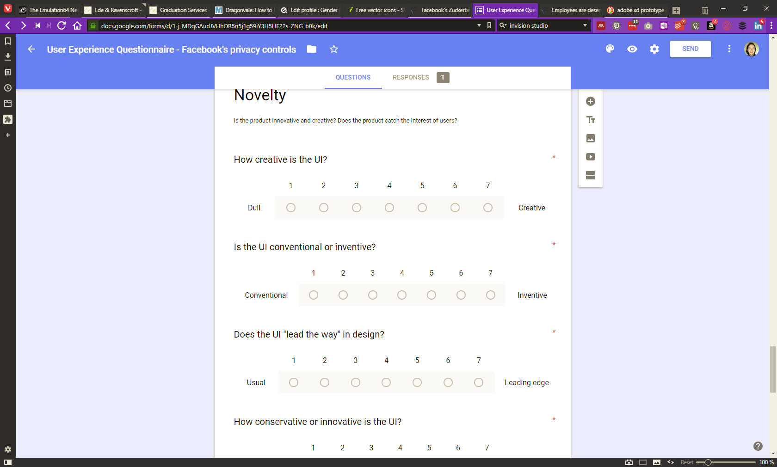
Figure 22: Section 6

Appendix 3: UEQ results
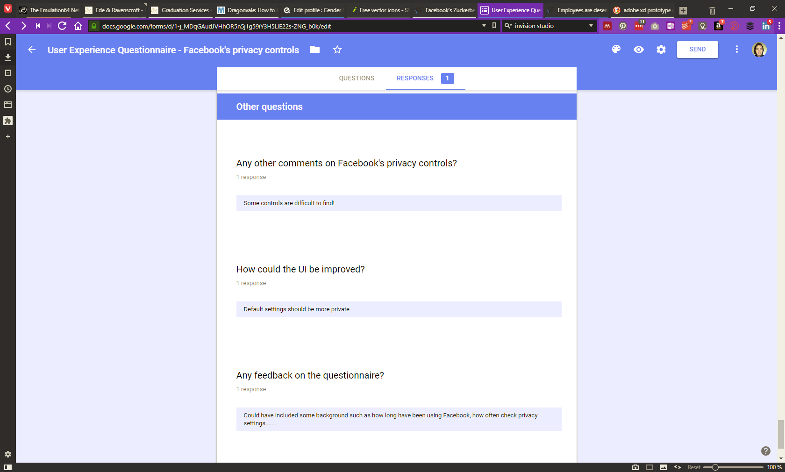
Figure 23: Screenshot of additional questions asked

Results as interpreted by the UEQ’s included data analysis excel file. Note that the above chart summarises only one result, so is not entirely reliable.

Appendix 4: Designs
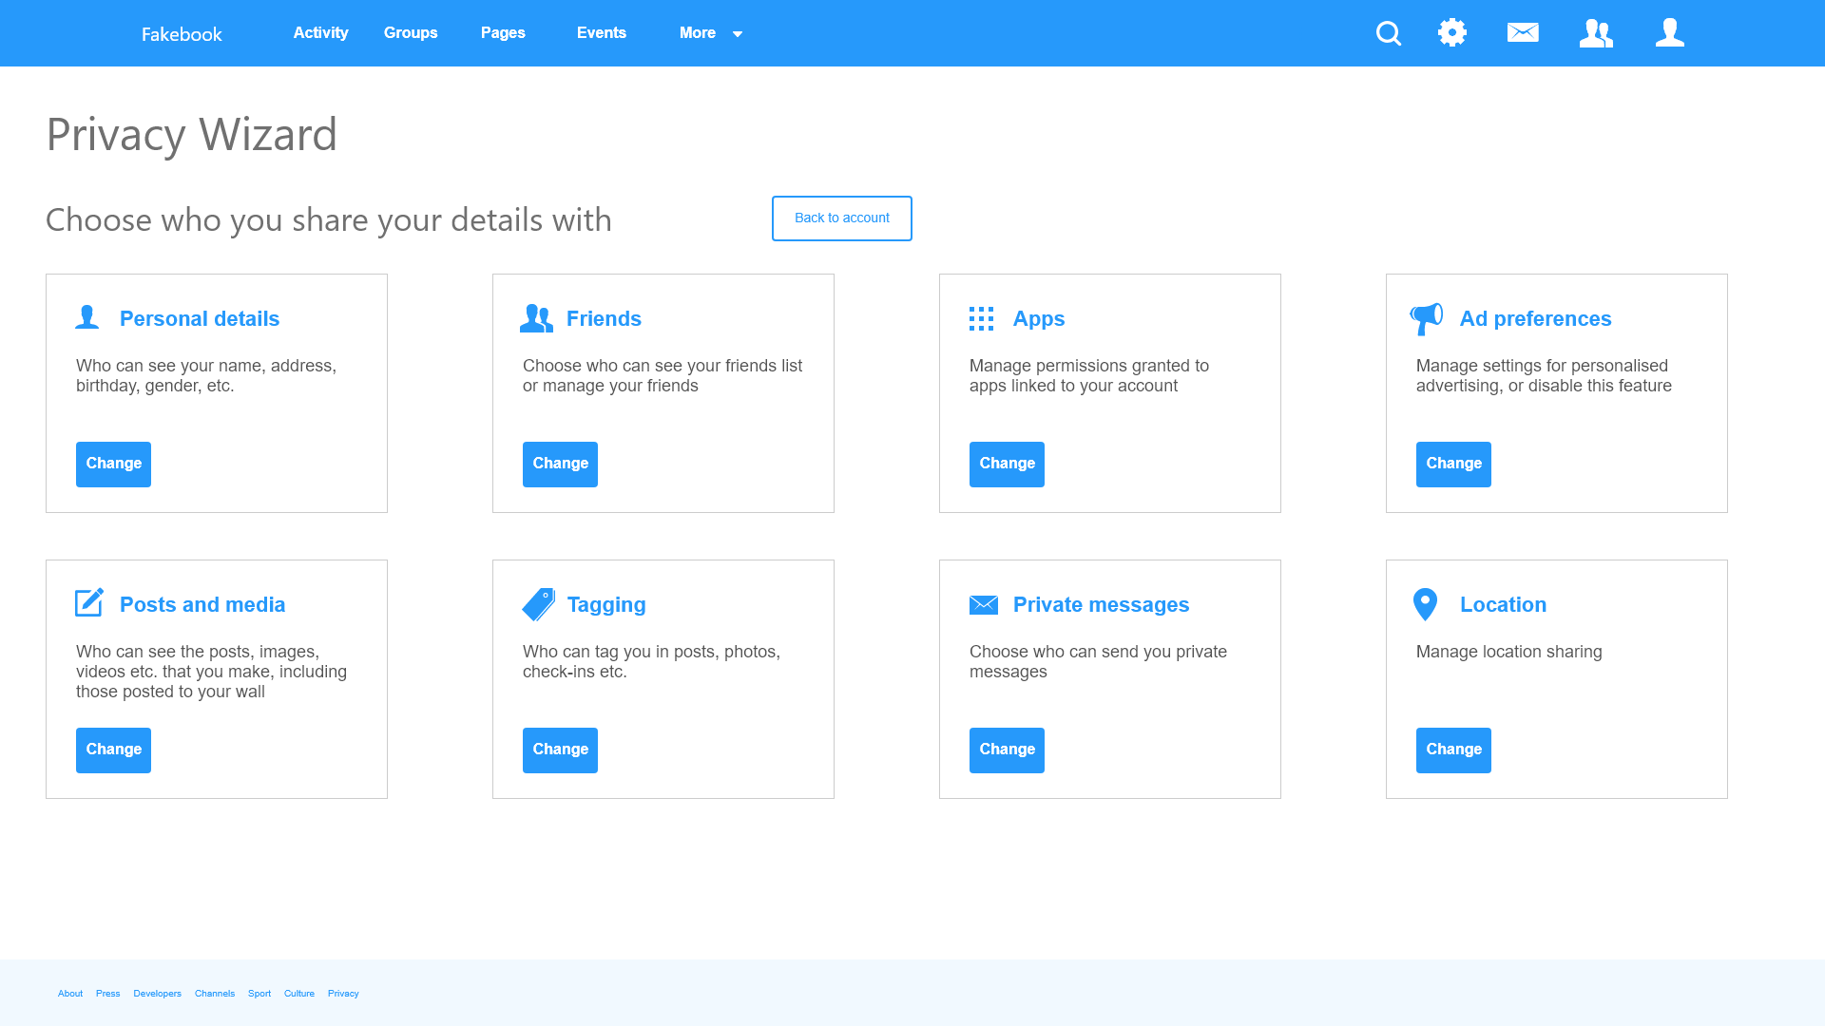
Figure 24: Privacy wizard design
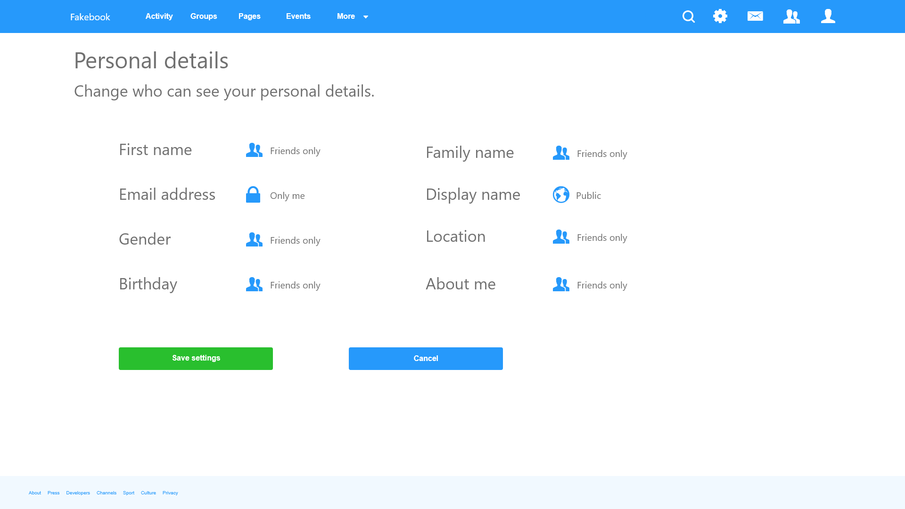
Figure 25: Personal details – design
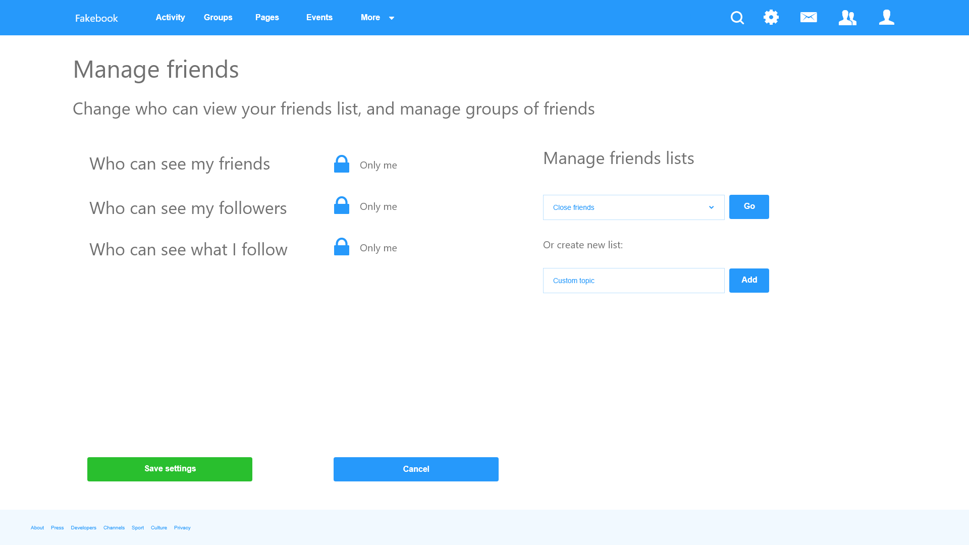
Figure 26: Manage friends – design

Link to interactive prototype: https://xd.adobe.com/view/bddaeeb7-c288-4663-55d8-fe59b8411160-cbeb/

Appendix 5: Code
Note: this is not fully functional code, merely HTML code that offers a more functional prototype than Xd can offer.
Header.html:
<!DOCTYPE html>
<html lang="en-gb">
<head>
<meta charset="UTF-8">
<title>Privacy wizard</title>
<link rel="stylesheet" href="https://stackpath.bootstrapcdn.com/bootstrap/4.1.0/css/bootstrap.min.css" integrity="sha384-9gVQ4dYFwwWSjIDZnLEWnxCjeSWFphJiwGPXr1jddIhOegiu1FwO5qRGvFXOdJZ4" crossorigin="anonymous">
<link rel="stylesheet" href="css/sticky-footer-navbar.css">
<link rel="stylesheet" href="http://code.ionicframework.com/ionicons/2.0.1/css/ionicons.min.css">
</head>
<body>
<header>
<!-- Fixed navbar -->
<nav class="navbar navbar-expand-md navbar-dark fixed-top bg-primary">
<a class="navbar-brand" href="#">Fakebook</a>
<button class="navbar-toggler" type="button" data-toggle="collapse" data-target="#navbarCollapse" aria-controls="navbarCollapse" aria-expanded="false" aria-label="Toggle navigation">
<span class="navbar-toggler-icon"></span>
</button>
<div class="collapse navbar-collapse" id="navbarCollapse">
<ul class="navbar-nav mr-auto">
<li class="nav-item active">
<a class="nav-link" href="#">Home <span class="sr-only">(current)</span></a>
</li>
<li class="nav-item">
<a class="nav-link" href="#">Activity</a>
</li>
<li class="nav-item">
<a class="nav-link" href="#">Groups</a>
</li>
<li class="nav-item">
<a class="nav-link" href="#">Pages</a>
</li>
<li class="nav-item">
<a class="nav-link" href="#">Events</a>
</li>
<li class="nav-item dropdown">
<a class="nav-link dropdown-toggle" href="#" id="navbarDropdown" role="button" data-toggle="dropdown" aria-haspopup="true" aria-expanded="false">
More
</a>
<div class="dropdown-menu" aria-labelledby="navbarDropdown">
<a class="dropdown-item" href="#">Action</a>
<a class="dropdown-item" href="#">Another action</a>
<div class="dropdown-divider"></div>
<a class="dropdown-item" href="#">Something else here</a>
</div>
</li>
</ul>
<ul class="navbar-nav float-md-right lead">
<li class="nav-item">
<a class="nav-link" href="#"><i class="ion-person"></i></a>
</li>
<li class="nav-item">
<a class="nav-link" href="#"><i class="ion-person-stalker"></i></a>
</li>
<li class="nav-item">
<a class="nav-link" href="#"><i class="ion-email"></i></a>
</li>
<li class="nav-item dropdown">
<a class="nav-link dropdown-toggle" href="#" id="settings" role="button" data-toggle="dropdown" aria-haspopup="true" aria-expanded="false">
<i class="ion-android-settings"></i>
</a>
<div class="dropdown-menu" aria-labelledby="settings">
<a class="dropdown-item" href="#"><i class="ion-home"></i> Dashboard</a>
<a class="dropdown-item" href="#"><i class="ion-settings"></i> Settings</a>
<div class="dropdown-divider"></div>
<a class="dropdown-item" href="#">Logout</a>
</div>
</li>
</ul>
<form class="form-inline mt-2 mt-md-0">
<input class="form-control form-control-sm mr-sm-2" type="text" placeholder="Search" aria-label="Search">
<button class="btn btn-sm btn-outline-light my-2 my-sm-0" type="submit"><i class="ion-search"></i> </button>
</form>
</div>
</nav>
</header>

Footer.html:
<footer class="footer">
<div class="container">
<span class="text-muted">Place sticky footer content here.</span>
</div>
</footer>
<!-- Scripts -->
<script src="https://code.jquery.com/jquery-3.3.1.slim.min.js" integrity="sha384-q8i/X+965DzO0rT7abK41JStQIAqVgRVzpbzo5smXKp4YfRvH+8abtTE1Pi6jizo" crossorigin="anonymous"></script>
<script src="https://cdnjs.cloudflare.com/ajax/libs/popper.js/1.14.0/umd/popper.min.js" integrity="sha384-cs/chFZiN24E4KMATLdqdvsezGxaGsi4hLGOzlXwp5UZB1LY//20VyM2taTB4QvJ" crossorigin="anonymous"></script>
<script src="https://stackpath.bootstrapcdn.com/bootstrap/4.1.0/js/bootstrap.min.js" integrity="sha384-uefMccjFJAIv6A+rW+L4AHf99KvxDjWSu1z9VI8SKNVmz4sk7buKt/6v9KI65qnm" crossorigin="anonymous"></script>
</body>
</html>

Wizard.html:
<?php include_once 'header.html'; ?>
<!-- Begin page content -->
<main role="main" class="container">
<h1 class="mt-5">Privacy Wizard</h1>
<p class="lead">Choose who you share your details with<button class="btn btn-outline-primary float-md-right">
Back to account</button></p>
<div class="card-deck">
<div class="card">
<div class="card-body">
<h5 class="card-title text-primary"><i class="ion-person"></i> Personal details</h5>
<p class="card-text">Who can see your name, address, birthday, gender, etc.</p>
<a href="details.html" class="btn btn-primary">Change</a>
</div>
</div>
<div class="card">
<div class="card-body">
<h5 class="card-title text-primary"><i class="ion-person-stalker"></i> Friends</h5>
<p class="card-text">Choose who can see your friends list or manage your friends</p>
<a href="friends.html" class="btn btn-primary">Change</a>
</div>
</div>
<div class="card">
<div class="card-body">
<h5 class="card-title text-primary"><i class="ion-android-apps"></i> Apps</h5>
<p class="card-text">Manage permissions granted to apps linked to your account</p>
<a href="#" class="btn btn-primary">Change</a>
</div>
</div>
<div class="card">
<div class="card-body">
<h5 class="card-title text-primary"><i class="ion-speakerphone"></i> Ad preferences</h5>
<p class="card-text">Manage settings for personalised advertising, or disable this feature</p>
<a href="#" class="btn btn-primary">Change</a>
</div>
</div>
</div>
<div class="card-deck">
<div class="card">
<div class="card-body">
<h5 class="card-title text-primary"><i class="ion-compose"></i> Posts and media</h5>
<p class="card-text">Who can see the posts, iamges, videos etc. that you make, including those posted to your wall</p>
<a href="#" class="btn btn-primary">Change</a>
</div>
</div>
<div class="card">
<div class="card-body">
<h5 class="card-title text-primary"><i class="ion-pricetag"></i> Tagging</h5>
<p class="card-text">Who can tag you in posts, photos, check-ins, etc.</p>
<a href="#" class="btn btn-primary">Change</a>
</div>
</div>
<div class="card">
<div class="card-body">
<h5 class="card-title text-primary"><i class="ion-email"></i> Private messages</h5>
<p class="card-text">Choose who can send you private messages</p>
<a href="#" class="btn btn-primary">Change</a>
</div>
</div>
<div class="card">
<div class="card-body">
<h5 class="card-title text-primary"><i class="ion-android-pin"></i> Location</h5>
<p class="card-text">Manage location sharing</p>
<a href="#" class="btn btn-primary">Change</a>
</div>
</div>
</div>
</main>
<?php include_once 'footer.html'; ?>

Details.html:
<?php include_once 'header.html'; ?>
<!-- Begin page content -->
<main role="main" class="container">
<h1 class="mt-5">Personal details</h1>
<p class="lead">Change who can see your personal details.</p>
<form>
<div class="form-group row">
<label for="fname" class="col-form-label col-md-3">First name</label>
<div class="col-md-3">
<select class="custom-select" id="fname">
<option value=""><i class="ion-android-globe"></i> Public</option>
<option value=""><i class="ion-ios-people"></i> Friends of friends</option>
<option value="" selected><i class="ion-person-stalker"></i> Friends only</option>
<option value=""><i class="ion-locked"></i> Only me</option>
</select>
</div>
<label for="sname" class="col-form-label col-md-3">Family name</label>
<div class="col-md-3">
<select class="custom-select" id="sname">
<option value=""><i class="ion-android-globe"></i> Public</option>
<option value=""><i class="ion-ios-people"></i> Friends of friends</option>
<option value="" selected><i class="ion-person-stalker"></i> Friends only</option>
<option value=""><i class="ion-locked"></i> Only me</option>
</select>
</div>
</div>
<div class="form-group row">
<label for="email" class="col-form-label col-md-3">Email address</label>
<div class="col-md-3">
<select class="custom-select" id="email">
<option value=""><i class="ion-android-globe"></i> Public</option>
<option value=""><i class="ion-ios-people"></i> Friends of friends</option>
<option value=""><i class="ion-person-stalker"></i> Friends only</option>
<option value="" selected><i class="ion-locked"></i> Only me</option>
</select>
</div>
<label for="dname" class="col-form-label col-md-3">Display name</label>
<div class="col-md-3">
<select class="custom-select" id="dname">
<option value="" selected><i class="ion-android-globe"></i> Public</option>
<option value=""><i class="ion-ios-people"></i> Friends of friends</option>
<option value=""><i class="ion-person-stalker"></i> Friends only</option>
<option value=""><i class="ion-locked"></i> Only me</option>
</select>
</div>
</div>
<div class="form-group row">
<label for="gender" class="col-form-label col-md-3">Gender</label>
<div class="col-md-3">
<select class="custom-select" id="gender">
<option value=""><i class="ion-android-globe"></i> Public</option>
<option value=""><i class="ion-ios-people"></i> Friends of friends</option>
<option value="" selected><i class="ion-person-stalker"></i> Friends only</option>
<option value=""><i class="ion-locked"></i> Only me</option>
</select>
</div>
<label for="location" class="col-form-label col-md-3">Location</label>
<div class="col-md-3">
<select class="custom-select" id="location">
<option value=""><i class="ion-android-globe"></i> Public</option>
<option value=""><i class="ion-ios-people"></i> Friends of friends</option>
<option value="" selected><i class="ion-person-stalker"></i> Friends only</option>
<option value=""><i class="ion-locked"></i> Only me</option>
</select>
</div>
</div>
<div class="form-group row">
<label for="bday" class="col-form-label col-md-3">Birthday</label>
<div class="col-md-3">
<select class="custom-select" id="bday">
<option value=""><i class="ion-android-globe"></i> Public</option>
<option value=""><i class="ion-ios-people"></i> Friends of friends</option>
<option value="" selected><i class="ion-person-stalker"></i> Friends only</option>
<option value=""><i class="ion-locked"></i> Only me</option>
</select>
</div>
<label for="about" class="col-form-label col-md-3">About me</label>
<div class="col-md-3">
<select class="custom-select" id="about">
<option value=""><i class="ion-android-globe"></i> Public</option>
<option value=""><i class="ion-ios-people"></i> Friends of friends</option>
<option value="" selected><i class="ion-person-stalker"></i> Friends only</option>
<option value=""><i class="ion-locked"></i> Only me</option>
</select>
</div>
</div>
</form>
<a class="btn btn-lg btn-success" href="wizard.html">Save settings</a> <a class="btn btn-lg btn-primary" href="wizard.html">Cancel</a>
</main>
<?php include_once 'footer.html'; ?>

Friends.html:
<?php include_once 'header.html'; ?>
<!-- Begin page content -->
<main role="main" class="container">
<h1 class="mt-5">Manage friends</h1>
<p class="lead">Change who can view your friends list, and manage groups of friends.</p>
<form>
<div class="form-group row">
<label for="friends" class="col-form-label col-md-3">Who can see my friends</label>
<div class="col-md-3">
<select class="custom-select" id="friends">
<option value=""><i class="ion-android-globe"></i> Public</option>
<option value=""><i class="ion-ios-people"></i> Friends of friends</option>
<option value="" selected><i class="ion-person-stalker"></i> Friends only</option>
<option value=""><i class="ion-locked"></i> Only me</option>
</select>
</div>
<div class="col-md-6">
<h5>Manage friends lists</h5>
<select class="custom-select" id="friendslist">
<option value=""><i class="ion-android-globe"></i> Family</option>
<option value="" selected><i class="ion-ios-people" ></i> Close friends</option>
<option value=""><i class="ion-person-stalker"></i> Acquaintances</option>
<option value=""><i class="ion-locked"></i> Restricted</option>
</select>
<button class="btn btn-primary">Go</button>
</div>
</div>
<div class="form-group row">
<label for="followers" class="col-form-label col-md-3">Who can see my followers</label>
<div class="col-md-3">
<select class="custom-select" id="followers">
<option value=""><i class="ion-android-globe"></i> Public</option>
<option value=""><i class="ion-ios-people"></i> Friends of friends</option>
<option value=""><i class="ion-person-stalker"></i> Friends only</option>
<option value="" selected><i class="ion-locked"></i> Only me</option>
</select>
</div>
<div class="col-md-6">
<p class="lead">Or create new list:</p>
<input type="text" class="form-control" placeholder="Name your new list"/>
<button class="btn btn-primary" data-toggle="newList">Add</button>
</div>
</div>
<div class="form-group row">
<label for="following" class="col-form-label col-md-3">Who can see what I follow</label>
<div class="col-md-3">
<select class="custom-select" id="following">
<option value=""><i class="ion-android-globe"></i> Public</option>
<option value=""><i class="ion-ios-people"></i> Friends of friends</option>
<option value="" selected><i class="ion-person-stalker"></i> Friends only</option>
<option value=""><i class="ion-locked"></i> Only me</option>
</select>
</div>
</div>
</form>
<a class="btn btn-lg btn-success" href="wizard.html">Save settings</a> <a class="btn btn-lg btn-primary" href="wizard.html">Cancel</a>
</main>
<?php include_once 'footer.html'; ?>

.htaccess (i.e. how it was possible to include php code in an html file):
AddType application/x-httpd-php .html

Link to Bootstrap prototype: http://prototype.phoenixsites.gq/wizard.html

