Student name and ID: Sevdalina Velinova 2017540

Programme: BSc Health and Social Care

Module name and code: Changemakers: Creativity and Value Creation
BMHP5014_BIRM

Assignment Title: Part 1 E-Portfolio evidence of learning comprising of 2 separate artefact items.

Lecturer: Robert Nartowski

Table of contents:

Introduction...............................................................3

Mind Map..................................................................4

Mind Map explanation...............................................5

Blog post...................................................................6

Blog post explanation..............................................10

Conclusion...............................................................10

Refreneces...............................................................11
Introduction

In this e-portfolio, I have chosen two artifacts to showcase my learning of creativity and innovation. These artifacts are a mind map and a blog post. While the mind map is a visual representation of my ideas and thoughts on the topic of "importance of physical activity in ASD", the blog post provides a more comprehensive understanding of the topic.

To begin with, the mind map provides a structured representation of my ideas and highlights the key elements of the topic that are interconnected. It is a visual representation of the concept of the importance of physical activity for individuals with ASD. It showcases the relationship between physical activity, child well-being, and the potential of children with ASD to reach their full potential.

Moving on to the blog post, it delves deeper into the topic and provides a more detailed understanding of the subject. The blog post emphasizes the importance of physical activity for children with ASD, as well as how it contributes to their well-being. It also provides relevant examples and explanations to support this idea.

As a result, the combination of the mind map and the blog post represents my learning of creativity and innovation in relation to the topic of "importance of physical activity in ASD". I hope that my blog post will help increase awareness of the importance of physical activity for children with ASD and make a positive impact on the quality of their lives.

Mind Map -Importance of Physical activity for ASD
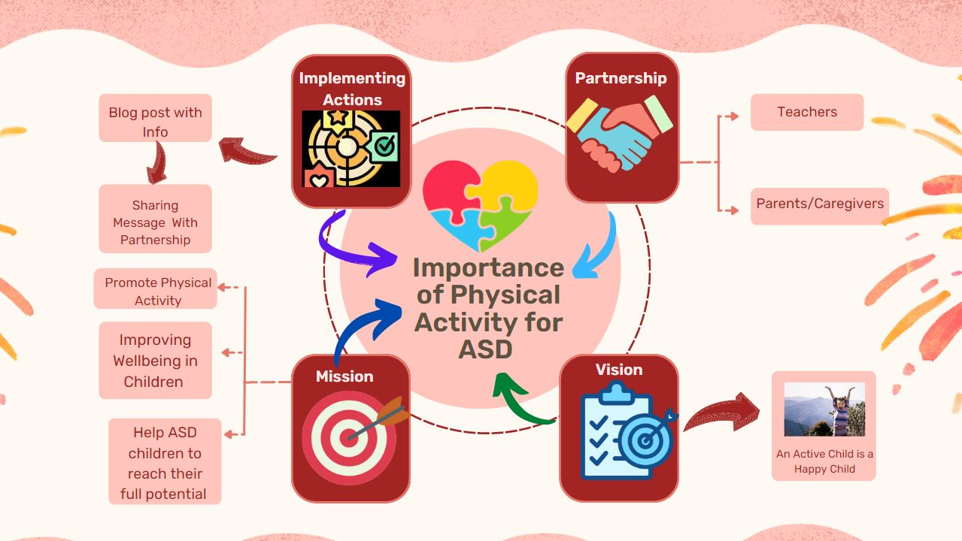

Mind Map Explanation
Mind map shows the following points:

Mission: Promoting Physical Activity and Improving Wellbeing
My mission is to promote physical activity and improve the wellbeing of children with autism. Physical activity has many benefits for children with autism, including improving their social skills, sensory regulation, and behaviour. By promoting physical activity, I aim to help children with autism reach their full potential.

Vision: A Child's Normal and Happy Life

The goal of this blog post is to promote the importance of physical activity in the lives of children with autism and to improve overall wellbeing. A child's normal and happy life is what I aspire for, and I believe that I can make this vision a reality.

Partnership: Bringing Together Teachers, Health Professionals, Parents and Caregivers
In order to achieve my mission, collaborative work is the key. I want to work with educators, parents, and caregivers to promote the importance of physical activity for children with autism. By working together, we can help to create a supportive environment that will allow children with autism to thrive.

Implementing Action: Engaging with Other Bloggers and Sharing Our Message
The primary way that I plan to implement my mission is through creating this blog post and engaging with other bloggers. By sharing the message, hope to reach a wide audience.

Joy: Your Guide
I believe joy should be the guide when working with children with autism. By making physical activity fun and enjoyable, children with autism will be more likely to engage in the activity and to reap the benefits. By making joy your guide, you can also ensure that children with autism have a positive and enjoyable experience.

Blog post - Promoting Physical Activity for Autism Spectrum Disorder

The importance of Physical Activity for Children with ASD

As a care provider, educator, or parent of a child with autism spectrum disorder, you aware of the challenges faced by these children in terms of communication, social skills, behaviour, and sensory stimulation. Despite the numerous benefits of physical activity for children, many education and support programs often focus on communication skills, behaviour changes, and social skills, without addressing the importance of physical activity. This is the main reason for creating this blog post , to fill the gap in service by understanding importance of providing physical activity options for children with autism spectrum disorder. Raising awareness about this issue may lead to their healthier and fulfil lives.

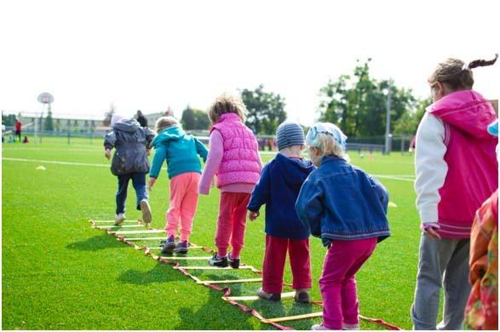
“Physical fitness is not only one of the most important keys to a healthy body, it is the basis of dynamic and creative intellectual activity.” John F. Kennedy

(Autism care Today)

Why is Important Physical Activity for Children with ASD?

Physical activity is not just a form of exercise; it's essential to a child's growth and development. Research has shown that regular physical activity can positively impact children's physical, mental, and emotional well-being (Janssen & LeBlanc, 2010). For children with autism spectrum disorder, physical activity can be especially beneficial.

Let's explore the benefits of Physical activity for children with ASD.

- Improving Physical Health: Regular physical activity can help children with an autism spectrum disorder to maintain a healthy weight, reduce the risk of chronic diseases, and improve overall physical fitness (NCCIH, 2020).
- Enhancing Social Skills: Physical activity can provide children with autism spectrum disorder with an opportunity to interact with their peers and develop social skills (Schleien, S., et al., 2017).
- Cognitive Development: Not only does physical activity provide numerous physical and mental health benefits, but it also supports cognitive development. The Piaget theory of cognitive development highlights the importance of physical activity in children's learning and development. According to this theory, children learn through active exploration and manipulation of their environment, which is facilitated through physical activity.(Piaget, 1952)
- Reducing Stress and Anxiety: Regular physical activity can help to reduce stress and anxiety in children with autism spectrum disorder (Wigram & Gold, 2002).
- Boosting Self-esteem and Confidence: Physical activity can help children with autism spectrum disorder to feel good about themselves, build self-esteem and confidence, and improve their overall quality of life (NCCIH, 2020).

The Pygmalion Effect is a phenomenon where a person's expectation of another individual can influence that person's behaviour and performance. This concept can be applied to children with autism spectrum disorder (ASD) and the importance of physical activity. When teachers, educators, and parents/caregivers have high expectations for children with ASD and promote physical activity, they can positively impact the child's behaviour and performance. Setting high expectations can encourage the child to engage in physical activity, develop social skills, and improve their overall quality of life.

Incorporating the Pygmalion Effect into promoting physical activity for children with autism spectrum disorder can significantly impact the child's behaviour and performance. By setting high expectations, providing consistent support and encouragement, and creating a positive and supportive environment, we can help children with autism spectrum disorder reach their full potential and lead healthy and active lives.

Moreover, by consistently providing support, encouragement, and positive reinforcement, the child with ASD can develop a growth mindset and improve their self-esteem. This can, in turn, lead to better physical performance, increased enjoyment of physical activity, and, ultimately, a better quality of life.

It's time to act and make a difference in the lives of children with an autism spectrum disorder.
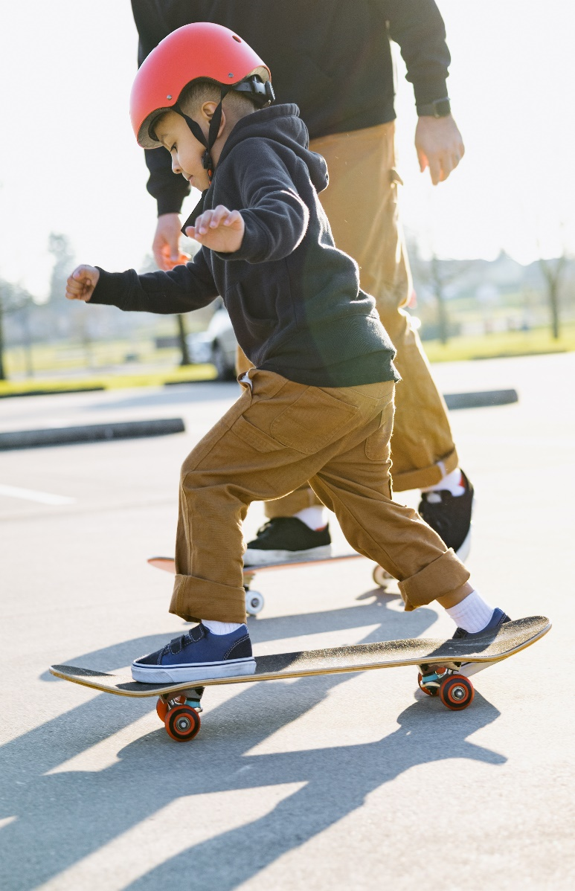
There are several ways to implement this change:
● Incorporating Physical Activity into the Daily Routine: Encourage children with an autism spectrum disorder to engage in physical activity for a minimum of 60 minutes daily (WHO, 2020).
● Creating a Supportive Environment: Provide children with autism spectrum disorder with a safe and supportive environment for physical activity. This can include having the right equipment, plenty of space, and access to physical activity opportunities (Schleien, S., et al., 2017).
● Encouraging Participation in Sports and Physical Activity Groups: Encourage children with an autism spectrum disorder to participate in sports and physical activity groups. This will allow them to interact with their peers, develop social skills, and have fun (Schleien, S., et al., 2017).

Image: Creative Commons

  - Encourage physical activity through play.
  - Capture the child's attention with engaging activities.
  - Increase child's enjoyment through fun experiences.
  - Support cognitive development through active exploration.
  - Enhance sensory regulation, social skills, and overall well-being.

Smart Tips:

- Make joy your guide when implementing physical activity for children with autism spectrum disorder.
- Use engaging and fun activities that bring happiness to the child.
- Prioritize play and make it the central focus of the physical activity experience.
- Use play as a tool for learning .

Always keep the child's enjoyment at the forefront of your mind.

Learn more:
If you're interested in learning more about the importance of physical activity for children with ASD, there are several additional resources you can explore. The NHS website has a wealth of information on the benefits of physical activity and how to get started. Additionally, there are several YouTube channels focused on ASD and physical activity.
Remember, the more we learn and understand about ASD and the ways in which we can support individuals on the spectrum, the better equipped we are to help them reach their full potential. So, if you want to explore this topic further, be sure to check out these resources and keep the conversation going. Here are some channel links below which you can watch to learn more about Autism and role of physical activity in autism :
1. Autism Live
2. Spectrum Sense for Families
3. NHS Autism

These channels offer a variety of resources, tips, and personal stories related to physical activity and ASD. Watching videos from these channels can provide additional insight and ideas for incorporating physical activity into the lives of children with ASD.
Let's work together to create a brighter future for children with ASD by promoting physical activity and providing opportunities for learning, growth, and development.

Blog post explanation
The blog post can be promoted in several ways, including:
- Social Media: Utilizing social media platforms such as Facebook, Instagram, and Twitter to spread awareness about the benefits of physical activity to individuals with autism spectrum disorder.
- Partnering with Organizations: Partnering with organizations that work with individuals with autism, such as schools, special needs centres, and support groups. These organizations can help reach a wider audience and provide resources and support .
- Online Platforms: Utilizing online platforms, such as websites and forums, to provide information about the and to connect with individuals with autism and their families.
- Collaborating with Health Care Providers: Collaborating with health care providers, such as doctors, therapists, and psychologists, to provide recommendations and referrals for the blog post. This can increase the visibility and help reach individuals who may benefit from it.
- Media Outreach: Reaching out to local media outlets, such as newspapers. This also can help generate interest in the program and attract new participants .

The success of promoting physical activity for children with autism spectrum disorder by blog post lies in partnerships between teachers, educators, and parents/caregivers. Teachers can implement the knowledge of blog post by incorporate physical activity into their lessons, while parents/caregivers can encourage physical activity at home. By working together, we can ensure that children with autism spectrum disorder get the physical activity they need to thrive.

Conclusion:

Promoting physical activity for children with autism spectrum disorder is crucial for their overall development and well-being. With the prevalence of ASD increasing, it is vital that we prioritize physical activity as part of their daily routine.
Moreover, it is not just parents and caregivers who can help promote physical activity for children with ASD. Teachers can also play a significant role in this regard, as they can facilitate activities and games that are both fun and educational. By partnering with parents and caregivers, teachers can create a holistic approach to promoting physical activity, which can benefit the child's development.

References:

Autism speaks , Autism and Exercise: Special Benefits (2018) https://www.autismspeaks.org/expert-opinion/autism-exercise-benefits

Janssen, I., & LeBlanc, A. G. (2010). Systematic review of the health benefits of physical activity and fitness in school-aged children and youth. International Journal of Behavioral Nutrition and Physical Activity, 7(1), 40. https://doi.org/10.1186/1479-5868-7-40

NCCIH. (2020). Exercise for Children. National Center for Complementary and Integrative
Health. https://www.nccih.nih.gov/health/exercise-for-children

NHS (2021)Physical activity guidelines for children and young people https://www.nhs.uk/live-well/exercise/exercise-guidelines/physical-activity-guidelines-children-and-young-people/

NHS (2021)Physical activity guidelines for children (under 5 years old )
https://www.nhs.uk/live-well/exercise/exercise-guidelines/physical-activity-guidelines-children-under-five-years/

Pan, C. Y. (2010). The efficacy of an aquatic program on physical fitness and aquatic skills in children with and without autism spectrum disorders. Research in Autism Spectrum Disorders, 4(4), 657-665.

Piaget, J. (1952). The Origins of Intelligence in Children. New York, NY: International Universities Press.

Rosenthal, R., & Jacobson, L. (1968). Pygmalion in the Classroom. Holt, Rinehart and Winston.

Schleien, S., Green, J., Schiller, B., & Schreibman, L. (2017). Physical activity and sport participation for children with autism spectrum disorder. Physical & Occupational Therapy in Pediatrics, 37(1), 1-13. https://doi.org/10.1080/01942638.2016.1207303

Sowa, M., & Meulenbroek, R. G. (2012). Effects of physical exercise on autism spectrum disorders: a meta-analysis. Research in Autism Spectrum Disorders, 6(1), 46-57.

Wigram, T., & Gold, C. (2002). Music therapy in the assessment and treatment of autistic spectrum disorder: Clinical application and research evidence. Child: Care, Health and Development, 28(2), 111-121. https://doi.org/10.1046/j.1365-2214.2002.00277.x

WHO. (2020). Physical activity. World Health Organization. https://www.who.int/news-room/fact-sheets/detail/physical-activity

