
Skills for the Workplace
Module Assignment Submission
Student Name: | Siraje Sekawunde
Student Number: | 1706807
Module No: | BMSK4002
Module Title: | Effective Team Working and Communication

Statement of Confirmation of Authenticity
By the act of making this submission, the student declares that this is the work of the student named above. The work has not, in whole or in part, been knowingly presented elsewhere for assessment, or where assessment has been built on a previous assessment, this has been identified. Where materials have been used from other sources it has been properly acknowledged. If this statement is untrue, the student acknowledges that an assessment offence has been committed.
Attention is drawn to the plagiarism and unfair practice policies of both the University and of ILM.

Table of Contents
Introduction 3
What is communication skill? 4
Importance of communication within an employment context 4
Conflict in workplace related to communication 6
Relevant theories of communication to workplace 9
Inter-personal communication 12
Written communication 13
Conclusion 14
Bibliography 15
Bibliography 15

Introduction

This report will be focused on the importance on communication skill within an employment environment and implement those skills properly in the workplace. During the report the importance of communication within and employment context from real life experience, some of the conflicts in workplace which is related to communication, relevant theories of communication to workplace, inter-personal communication and written communication will be discussed. Communication is the most important skill in the workplace, business and also in profession life. While working in a team or sometimes it can be found that the assured situations which are more challenging to handling those circumstances, and at that time communication skills become convenient. While working in a team it is important to ensure a good communication network. Because of a poor communication a team may not be able to reach its goal. For example, Steve Jobs communication style and he is concerning as someone who had the greatest presentation skills and also best business cooperation skills. By born some people get those skills. Without great communication skills it is impossible to bring success in the professional life and also in business.

What is communication skill?

(Doyle, 2017). Communication skill is important skill in the workplace, and also in professional life. It is one kind of capability to communicate efficiently with other workers or with others in the industry you are working. Decent communication skills will help to bring success in the field of career.
(Andrew , Michaela , & Paul , 2017). Some of the communication skills are-
- Listening
- Nonverbal Communication
- Clarity and Concision
- Friendliness
- Confidence
- Empathy
- Open-Mindedness
- Respect
- Feedback
- Picking the right medium

Importance of communication within an employment context
(Libraries , 2017). Communication is vital in a workplace because people need to communicate and cooperate with one another so that they can get the job done as fast as possible. Communication skills help you to understand yourself and others. Solving problems become easier and helps to learn new things and finally supports to build a better carrier. For example, after graduation a graduate when go for internee, he/she begins to learn how to communicate effectively with others in that workplace. It is one kind of real life example a graduate gets while go for the internee. (Belbin, 2017).
- Workplace communication expands worker efficiency
- Can rise employee job satisfaction
- Communication stimuli your thinking about yourself and also others
- Communication influences in what way you acquire
- Communication characterises you and your employer
- Communication skills are anticipated by professional and industry
- Build relationships
- Simplifies innovation
- Handling employees
- Contributes to development of the company
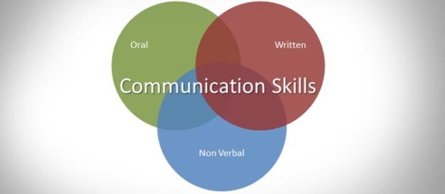

- Benefits of effective communication in the workplace:
(Johnson, 2017). Communication skills are the important elements in the workplace. It can be verbal or nonverbal communication skills. There are many companies who spend a lot of money to train their employees how to work effectively. Good communication skills help the eradicate the barriers because of language or cultural differences. Effective communication helps to increase the productivity and decrease the errors.
- Helps with diversity
- International business
- Team building
- Employee ethical

Conflict in workplace related to communication
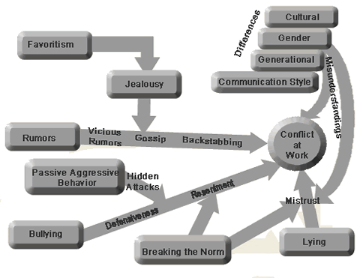
(III, 2017). Without effective communication, company can face a lot of problems. Because it becomes unable to interchange information necessary to daily operations. Understanding examples of conflict in workplace which are related to communication will help to build policies that will identify problems and create an effective communication link in the office. Origins that may lead to conflict in the workplace related to communication -
- Poor teamwork:
While teamwork, if member of the team does not communicate well with each other, becomes quite impossible to clear what responsibilities each and every individual member must adopt. Because of poor teamwork, the team will not be able to achieve their goal.
- Rumours & Gossip:
Sometimes poor communication can spread rumours and gossip and it can create an anxiety moment to employees. For example, there is a rumour about some employees are going to be eradicated. Because of this employee who actually panic they will lose their jobs. This is one kind of conflict at work.
- Language Barriers:
Language barrier which sometimes happen in a diverse workplace or can be at any workplace and may turn into a communication problem. Between people of altered ethnic backgrounds, people of diverse ages and different stages of industry experience language barriers occur sometimes. Any kind of language barrier is can make the communication process slow.
- Personal issues:
If any employees permit personal issues to disturb the company communication, there might be a communication problem which could take a lengthy time to resolution. People who decline to communicate established on a personal disagreement are reducing the development of the organization.

- Lack of feedback:
If there is lack of feedback that means, there is a conflict in the communication. Workers and managerial staff should deliver feedback at all times because it progresses the quality of information spread in which the information is conveyed.
- New Hires:
When new employees are hired in the organization or brought, they need to give the proper direction how to work and cope up with the new working environment. If there is lack of giving proper training, new hire orientation courses will be required to fight with new hires.
- Cultural Barriers;
Different Employees come from different cultures and follow different practices in a workplace. This kind of cultural variety among the employees act as blockade at workplace.
There are many other conflict in workplace related to communication such as creating uncertainty, sharing resources and so on.

Relevant theories of communication to workplace
(MODELS OF COMMUNICATION, 2017).
- Shannon & Weaver:
A model named, the Shannon & Weaver was actually planned to reflect the working of radio & telephone technology. In this model there are main 3 parts and they are- sender, channel and receiver. Shannon with Weaver acknowledged that often static or background sounds might interfere the process of the other partner in a telephone dialogue and so they both mentioned this as a noise. They in this regard resolved that certain sorts of background sounds can also point the lack of a signal.
The simplicity, generality, and quantify ability are the strengths of this kind of model. Shannon & Warren Weaver, these two mathematicians structured the cited model on the basis of the elements as follows:
- A data source (creates a message)
- The spreader (encode the full message into gestures)
- The channel (indications are reformed mainly for the transmission)
- The receiver (decode the full message)
- Destination (message arrival place)

They also stated that there are also three types of problem-
- The technical problem
- The semantic problem
- The effectiveness problem

- Linear Model:
It is a kind of model through which it is possible to communicate with others. It is consisted of the sender’s programming message and channelling it with noise to the receiver. Draw backs of Linear Model are: The linear model accepts having a clear cut commencement and conclusion of communication. Moreover, it does not display any feedback from the receiver, like- no letter, email, text message or lecture.
- Berlo’s S-M-C-R Model:
David K. Berlo, developed S-M-C-R model in the year 1960. In this model Berlo indicated the main importance about the psychological view.
Berlo’s S-M-C-R means-
(S = Source
M = Message
C = Channel
R = Receiver)
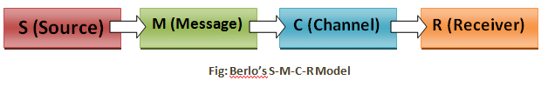

Explanation of the elements of Berlo is given below:
- Source: The source is the first component of this model. It means that all communication originates from some sources (may be a one person or a company with some people of). Moreover, the model shows that Several things decides about the function of the source in the main communication procedure. Such as:
- Skills of communication, means- thinking capabilities, put pen to paper, draw and express ideas.
- Approaches toward spectators (the topic matter)
- Subject Knowledge (audience & situation)
- And, social background, learning, associates, pay, values and so on.
- Message: Message here means that it is the information which observe opinions and that is conducted by the source. And also it important to be noted the source should select code/language, because it will send the message.
- Channel: Channel, as the method- telegraph, radio, message, poster and so on where the message will transmit from one place to another.
- Receiver: It is the last element and here the receiver is mainly indicated as the audience.

Inter-personal communication
(Deborah & Lois , 2010). Interpersonal communication is the process of communication which people can interchange information, feelings and also their meaning over verbal or nonverbal communications.
- Body language:
(skillsyouneed, 2017). Body language is a non-verbal communication. Facial expressions, gestures, body attitude, eye movement, touch of the body are such behaviours included in the body language. This body language is also known as kinesics. This language does not have a grammar and it should be interpreted broadly. Body language is important because sometimes we cannot provide our messages by spoke or in written languages. That’s why we use this language to deliver our messages through gesture, moving some facial expressions.

- Active listening:
(skillsyouneed, 2017). It is a kind of skill that can be achieved through practise. It is essential to concentrate on what is being said and listen carefully. Active listening also includes attending with all senses.

- Personal presentation:
(skillsyouneed, 2017). Personal presentation is kind of marketing you, the trademark that is you. Personal presentation is part of communication skills. You may be sometimes representing yourself or your organization when you are speaking in front of public. First impressions are very essential. Personal presentations important parts are such as facial expressions, personal image and so on.
- Context awareness:
(Ieeexplore, 2017). Context awareness is an enormous research area. It comprises variety issues which is ranging from physical capacity of a given situation which is associated to the question of social acceptance.

Written communication
It is important to focus on the format and the structure while writing something. Because it makes more clear to the reader what have been written and what has been described about.
- Format:
(Narayan, slideshare, 2011). It is important to focus on format. Formats of written communication are-
1. Lay Out Of Letters
2. Layout of Memoranda
3. Layout of a Notice
4. Layout of a Circular
5. Layout of Minutes of a Meeting
6. Writing a Report
7. Curriculum Vitae

- Structures:
(Narayan, slideshare, 2011). Written communication structure mainly includes three basic parts and they are- Introduction, Body and Conclusion. When someone is writing anything one must certify that the is well structured. While writing one can distributed into a separate paragraph for each new point and also with innovative titles. For example, a clue in, ingredient of the matter, and finally statement on future action.

Conclusion

Working together has many advantages because it helps more to complete the task easily and also make an effective communication network among the group mates. Also, because of poor communication sometimes it may cause tension and nervousness among the group mates. Effective communication eliminate helps to reduce those negative feelings. It is also vital for the business owners that he should inspire their employees to communicate well with one another while operating as a team. Communication skills can be improved through motivation and inspiration to the employees.

Bibliography

Bibliography
(2017). Retrieved from Libraries : http://open.lib.umn.edu/businesscommunication/chapter/1-1-why-is-it-important-to-communicate-well/
(2017). Retrieved from skillsyouneed: https://www.skillsyouneed.com/ips/body-language.html
(2017). Retrieved from skillsyouneed: https://www.skillsyouneed.com/ips/active-listening.html
(2017). Retrieved from skillsyouneed: https://www.skillsyouneed.com/ps/personal-presentation.html
(2017). Retrieved from http://ieeexplore.ieee.org/document/5681018/
(2017). Retrieved from Ieeexplore: http://ieeexplore.ieee.org/document/5681018/
Andrew , M., Michaela , S., & Paul , T. (2017, September). Retrieved from sage publishing: https://uk.sagepub.com/en-gb/eur/certificate-in-higher-education-skills-for-the-workplace-student-yearbook/book260960
Belbin, M. R. (2017). Retrieved from amazon.co.uk: https://www.amazon.com/Team-Roles-Work-Meredith-Belbin/dp/1856178005
Deborah , D., & Lois , B. (2010, February 17). Retrieved from amazon.co.uk: https://www.amazon.co.uk/Developing-Influencing-Credibility-Trustworthiness-Communication/dp/1849370222
Doyle, A. (2017, November 28). Retrieved from thebalance: https://www.thebalance.com/communication-skills-list-2063779
III, G. N. (2017). Retrieved from Chron: http://smallbusiness.chron.com/examples-communication-problems-workplace-11243.html
Johnson, R. (2017). Retrieved from Chron: http://smallbusiness.chron.com/benefits-effective-communication-workplace-20198.html
MODELS OF COMMUNICATION. (2017). Retrieved from iacat: http://www.iacact.com/?q=models
Narayan, D. (2011, December 12). Retrieved from slideshare: https://www.slideshare.net/DeepNarayan2/written-communication-10562913
Narayan, D. (2011, December 12). Retrieved from slideshare: https://www.slideshare.net/DeepNarayan2/written-communication-10562913
thebusinesscommunication. (2017). Retrieved from thebusinesscommunication: https://thebusinesscommunication.com/types-of-communication-model/

