I confirm that I have not used any AI tools in the research and creation of this

Assignment. I confirm that I have not presented any AI generated materials as my own

Work. I confirm I have copies of my drafts, notes, and other resources I used, which I

May be asked to provide in evidence.

Portfolio of Competencies

Shadan Zeinelabdien Taha Elsherif 2436823
BSc Psychology
ECPS5016
Dr Katie Sullivan
5 May, 2026

Reflective Log
We had split the assignment among the 4 group members as pairs, so I worked with one person throughout this module. We were both frequently late to submit the weekly tasks such as the proposal form. On the day the proposal form was due, I was traveling and my groupmate was also busy, yet both of us were not done with our parts. Communication was difficult for both of us as my signal was unstable and she was slow to reply. We were also unable to work on the incomplete parts during the day without internet connection on my side and access to a laptop on hers. I insisted that she contacted the lecturer to inform her of her circumstances since my part was mostly done and could have been submitted on time, but hers was far from completion. I offered to complete the ethical considerations section of the form for her, where she said she might need my help. I forgot to read the paragraph she sent me over WhatsApp in the midst of this rush and didn’t notice that she sent me the ethical consideration section, and not her main part, the background, and I wrote an ethical consideration paragraph as well. I then frequently messaged her reminders to send the background and reference list for her parts over the next 2 days.
I regretted not completing this task as soon as it was assigned and instead, pressured both my groupmate and I. I felt frustrated and stressed over the 3-day span of this conversation. I also felt guilty for speaking to her in an unprofessional and rude way at times of frustration after we submitted and I had calmed down. I think most people would also feel frustrated when they do not receive complete work or replies for hours as I did. I feared this might be a repetition of my previous experiences with group work, where I was left to complete other people’s work in a rush. However, I now think that would not justify speaking in that manner to peers or anyone in general. Especially when she remained professional and kind throughout the whole module.
I wasn’t new to this experience, yet I was very upset about it since I didn’t expect this from her and I didn’t know the reason behind her late replies, or lack or replies, put less nicely. I gave up being as nice as I normally acted in these situations, which was the largest mistake in this situation. Thankfully, this did not reoccur again in the other parts of the assignment. We were both equally late due to other assignment submissions and we calmly discussed how and when we’d complete our tasks. I wish I could say that we simply managed our time better in the tasks that followed, but unfortunately, we were both too busy with the assignments. However, I did gain through this experience that I should be more careful with my tone, especially when the other party is respectful and I am required to work with them on the long term.
I think one of the main reasons she was late to reply was due to spring break. I later on heard she had traveled as well, and I believe she was busy preparing for that. However, these are all my own assumptions. I had let my previous negative experiences with my groupmates cloud my vision and rush into assuming the worst first. I assumed I would have to do her parts as well. I was also upset at myself for procrastinating, so I might have been more upset than I usually would be with group members.
She did inform me she would be late to reply at times, so I eventually wasn’t too upset, but it was later than I expected. She was very apologetic so it helped bring me back to my normal sympathetic state. Above all, she did do her part eventually, and although I could tell she relied on AI, she rephrased and referenced it well enough to not be noticeable at first glance. It showed the effort she put into fixing the situation.
Since it seems I frequently have issues with group members, I did some research on how to handle clashes with peers. Hills (2008) recommends assessing the situation first. This entails calming down and thinking objectively, where the situation is reviewed from different perspectives. Additionally, determining whether this specific person or situation made you upset or whether it was something unrelated that carried the feelings over was also mentioned. This is strongly related to my situation where I was projecting my previous experiences on her, as well as the feeling of being upset with myself as well. More importantly, Hills (2008) recommended giving the benefit of the doubt, where we shouldn’t assume and jump to conclusions. I have done this positively by assuming she was busy preparing for travel, and negatively, by assuming she’s trying to make me do her work.

I learnt that I should be more understanding of people’s circumstances even if they do not let me know what they are, as that is part of their private lives. This was not a final submission, so it would not have hurt to simply email the lecturer about the circumstances and help my group mate in this special situation. Furthermore, she had shown willingness to do the work which she did do, so patience would have definitely led to a better emotional experience for the both of us.

In future group projects, I will maintain a calm tone and try my best to give them the benefit of the doubt. I will remind myself that they also have private lives and circumstances I might not be aware of, and try to support them whenever they have difficulties with their work. However, I will maintain some sense of judgement, as some people do in fact avoid completing their work. However, I shall leave that to the lecturers to decide and avoid clashing with peers.

Competency 1: Data Collection (Question sheet, Consent Form, Information sheet, Debrief sheet)

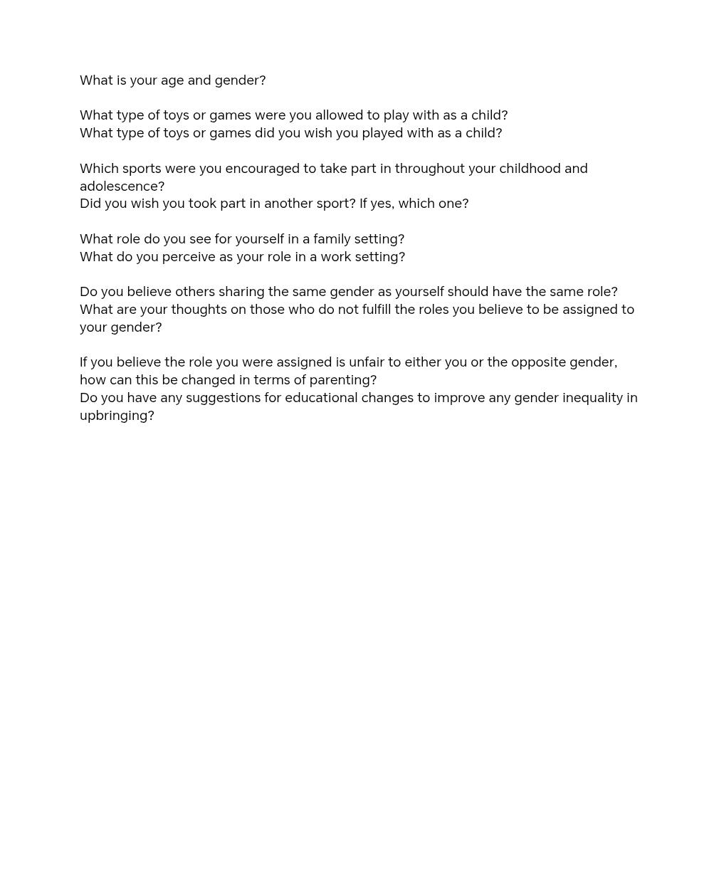

Question sheet
I created this question paper after seeking advice from the lecturer on how general or specific the questions should be. After the discussion, I decided to group a question about the participant’s experience with a toy or sport followed by question on their perception. It has much room for improvement with the abrupt jump into how it affected their perceptions of gender roles. The questions are also quite short and direct, which may lead to limited answers with little room for insight from the participant.
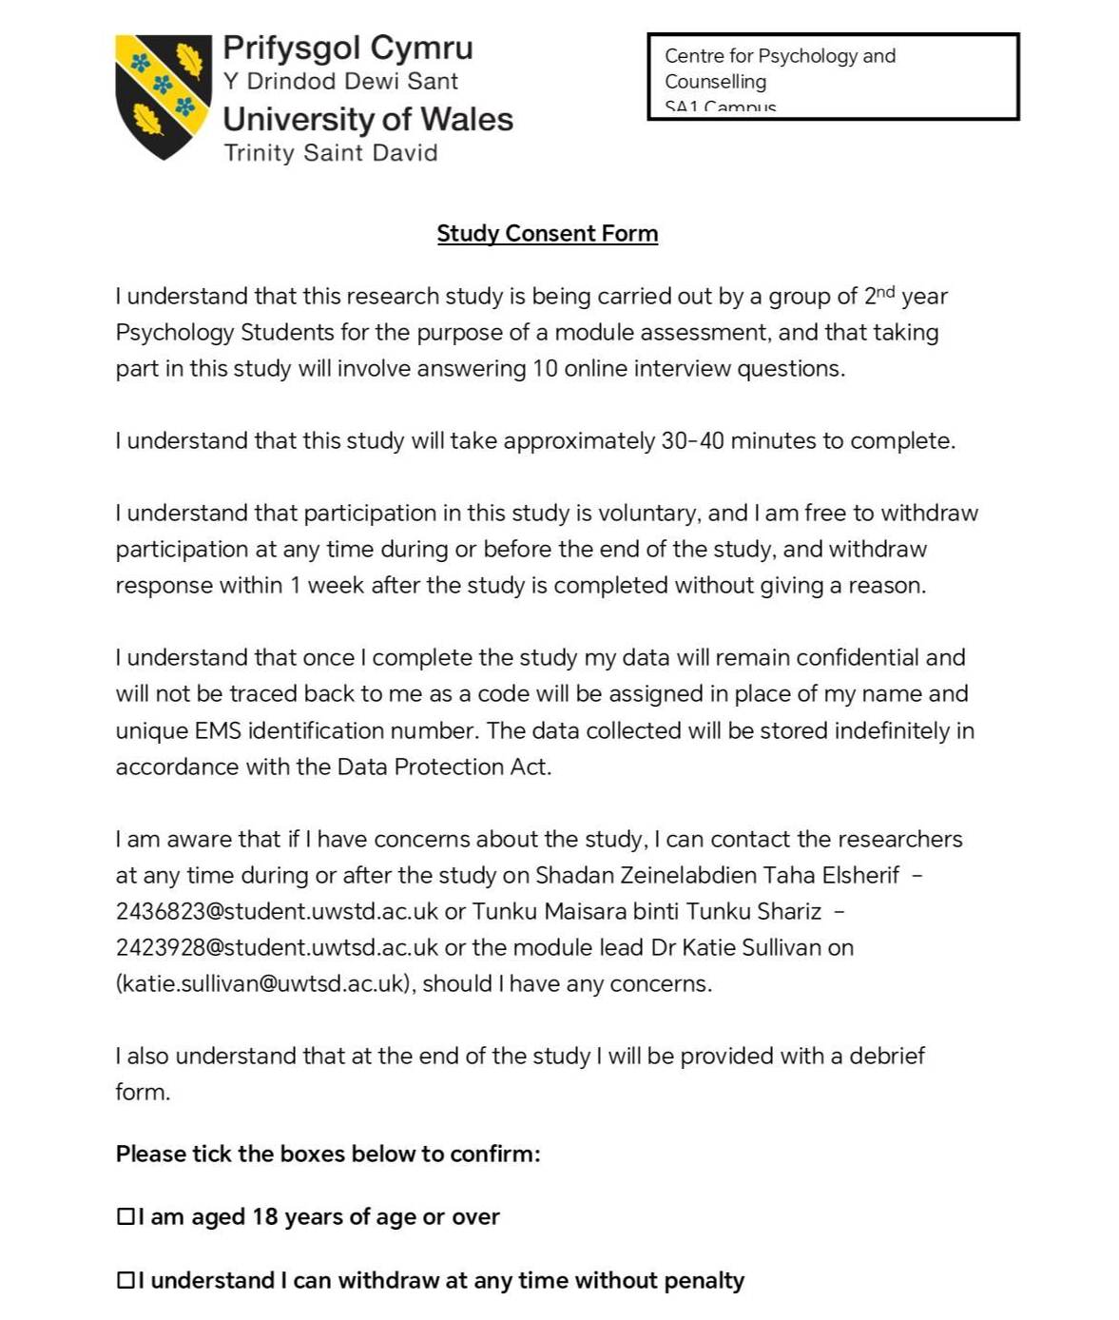
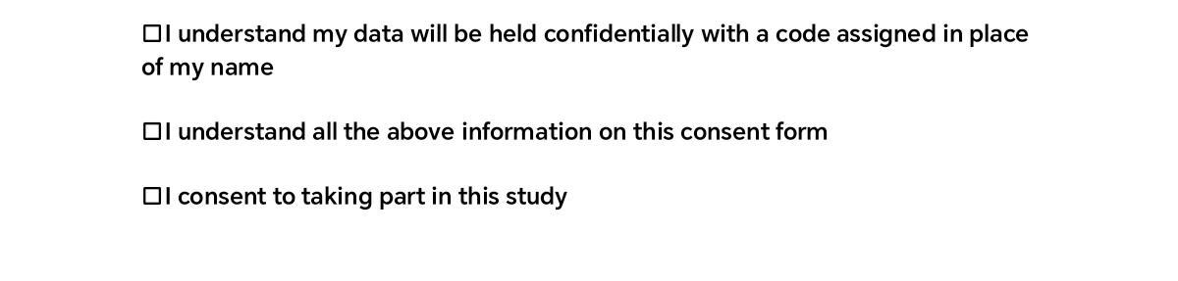
I was tasked with forming the consent form individually. We had another assignment which required a consent form as well, so I took inspiration from both that assignment and the example provided to us on Moodle to make this form. A mistake made in this form would be mentioning 10 interview questions when they are actually 11 if the demographic question is counted, which may be misleading.
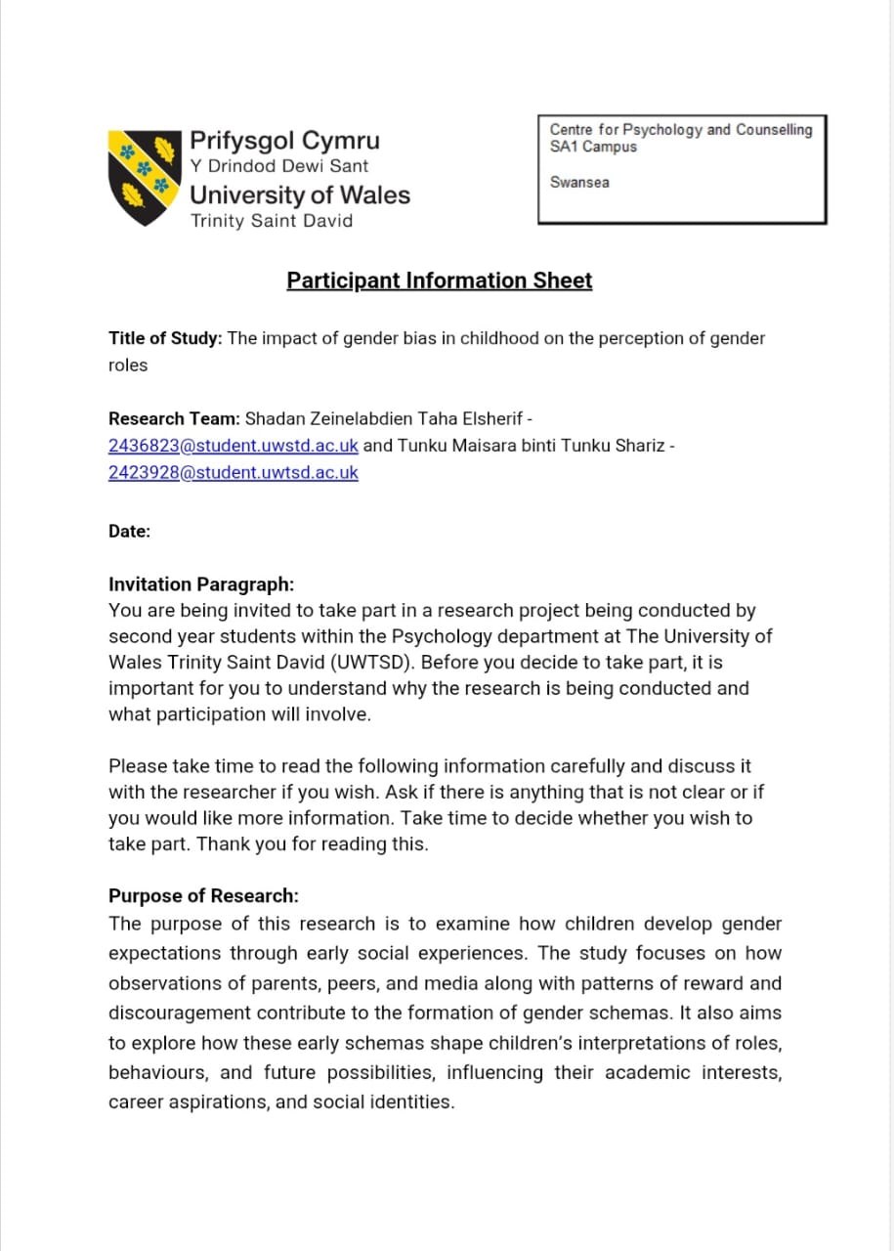
My groupmate and I completed this form together. I was tasked with the invitation paragraph, Data collection and storage, and the details of participation sections. For the highest level of honesty, the invitation paragraph was mostly the same as the example, I only had to change some terms to match our details, such as being second year students. I would prefer to write one completely on my own in the future if there were no time constraints to learn better literary skills used in research.
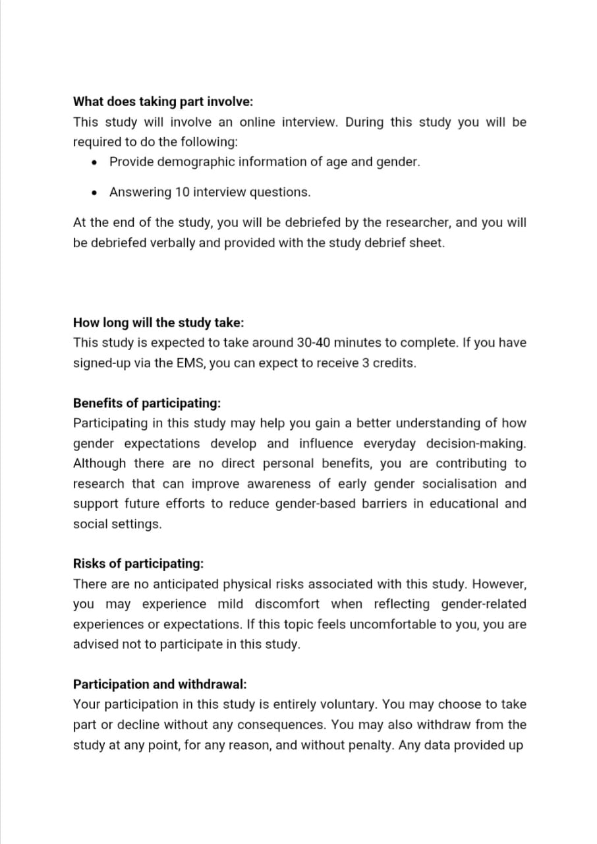
I have also completed these parts, carrying on the mistake of the “10” questions. I completely estimated the time it may take based on previous interviews I participated in and the risk of it being too long, losing the participant’s interest. For future studies, I would read through similar studies and check the average time it took for them to complete the study instead.
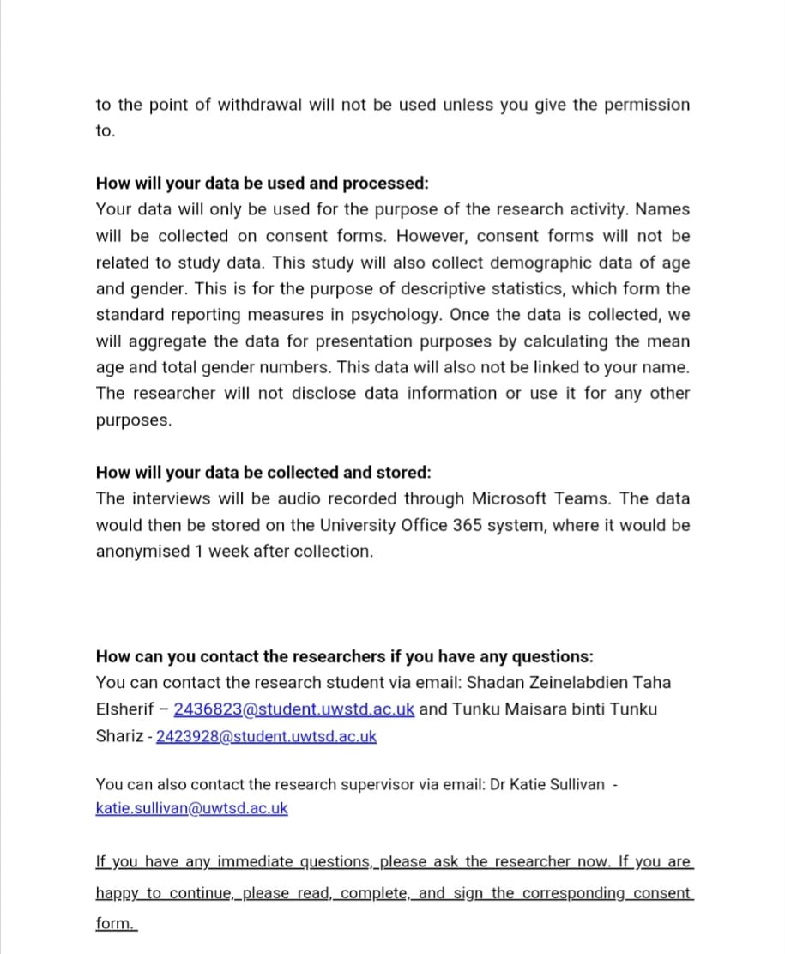
This part was revised after feedback from the ethics form, where private computers where mentioned to be the method of storage. After the revision, it was changed to use University devices to maintain confidentiality and security.

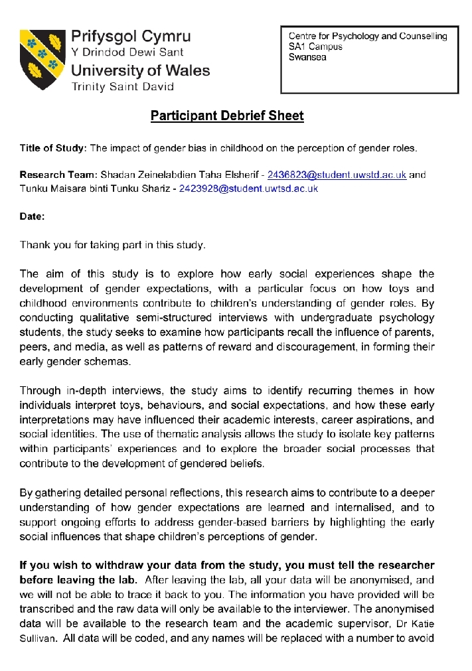
I was not tasked with this form, so instead, I revised it and added some lines to the withdrawal section. I gave more details about the withdrawal process compared to the original document which stopped at mentioning the anonymized data would not be traced back to the participants
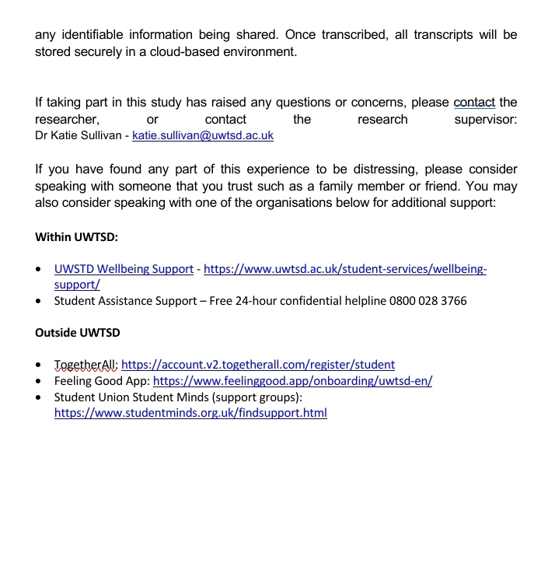

Competency 2: Applied research skills (Proposal form)
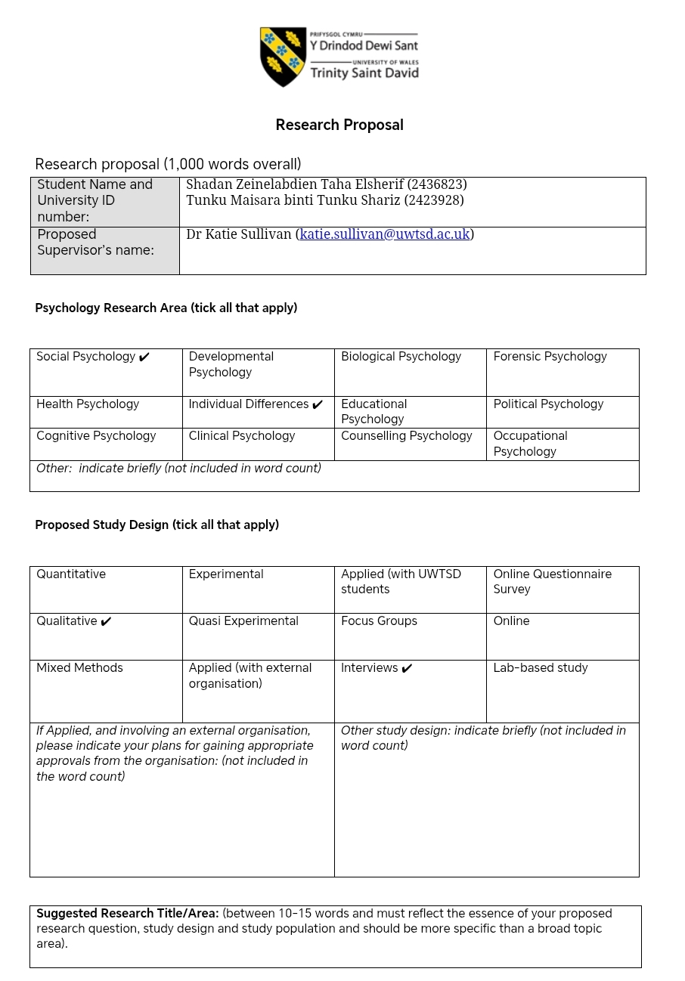
We initially planned to hold it these interviews physically so this form is missing a tick on the “online” box. This was changed during the completion of the ethics form so this mismatch could have caused issues if this study were to be conducted. Similarly, I had also ticked lab-based study as we assumed it would take place in the rooms we called labs on campus. The supervisor then kindly let us know that interviews do not require labs unlike experiments which require special equipment
Initially, I suggested that the study included the areas of developmental and educational psychology as well, since we wanted to include aspects of sports encouraged in schools (educational) and toys encouraged at home (developmental). After discussing with the supervisor, we understood that it isn’t the focus of our study. According to my understanding, Social Psychology would be a better option since we are investigating the source of these gender roles.
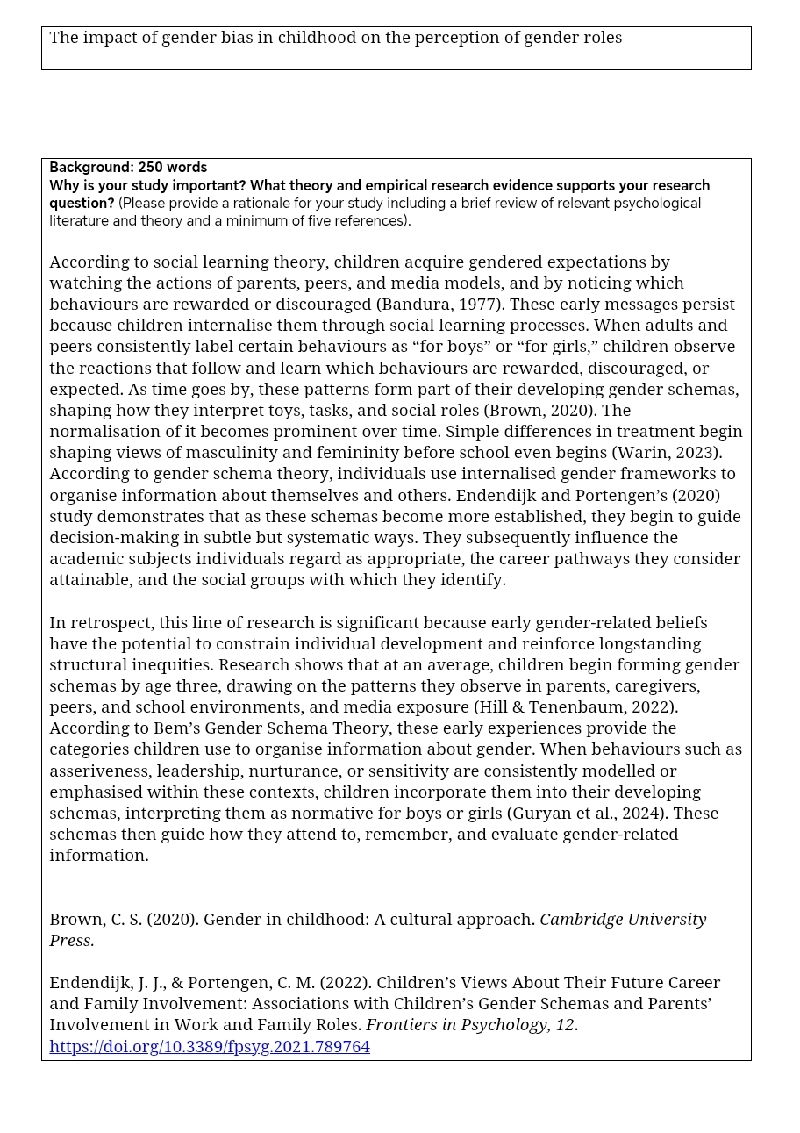
After many revisions and feedback from the supervisor, I combined the title suggested by the supervisor with the old one to make this short and concise title. I still believe it is quite general and does not grab a readers attention, but it conveys the idea. My groupmate changed it in the ethics form later on and we had made another mistake of not matching the proposal form with the ethics form
I was not tasked with this section so I simply added it to the document since my groupmate was unable to use her laptop and revised it to fixed a few of the spelling errors
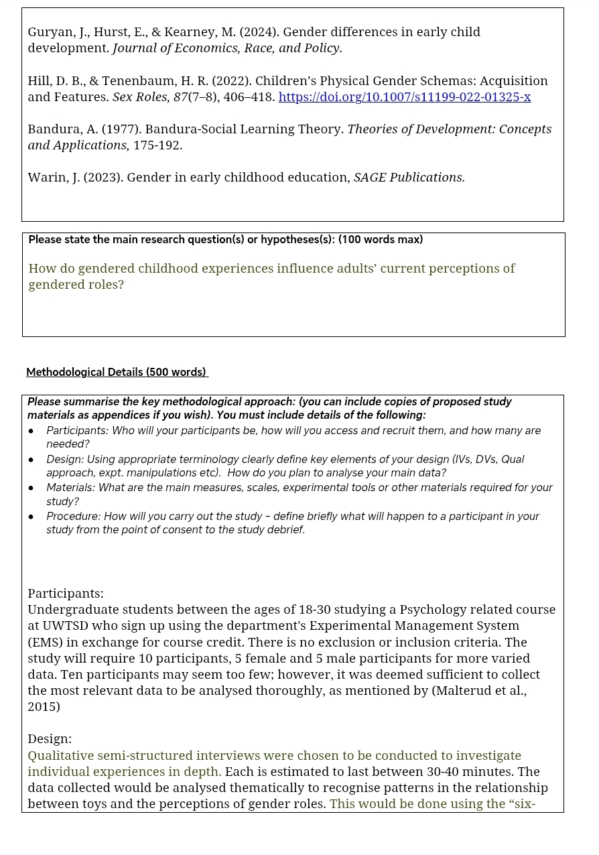
I created the research question (it is green to track some of the parts I edited after the feedback), and learnt that qualitative studies do not require hypotheses. I do not have any prior experience with qualitative research so this was very insightful. I assumed all studies have hypotheses prior to this assignment.
I completed the methodological details section individually as well. The language I chose was often lacking in detail compared to my groupmate. I had many notes in this part to be changed. I initially stated that it would be a standardized interview due to the lack of knowledge on the types of interviews and lack of research as I only checked the first website on this topic. The lecturer then advised a semi-structured interview would be more suitable and I was happy to learn there is an option in interviews that is neither too unorganized nor too rigid. Due to my lack of knowledge on qualitative research, I also simply stated we would use thematic analysis with no knowledge of what it entails after overhearing my classmates and lecturer from another module mention it. The supervisor instructed that an explanation and justification of the usage of thematic analysis is added where I finally learnt what it meant.
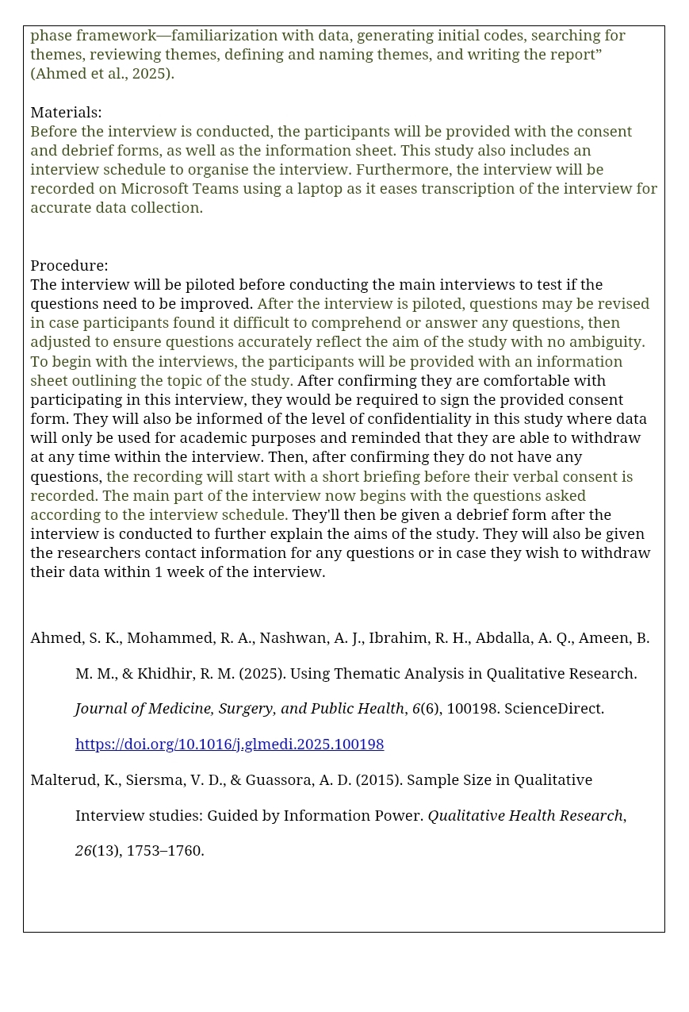
I was instructed to add a part about piloting. I also did not know the sequence of which the forms would be given to he participant so after some feedback, I reorganized it to be the information sheet followed by the consent form. I was always under the impression that consent was to be obtained before anything, without considering that the participant must be aware of what they're consenting to through the information sheet.
I initially assumed that materials only mean physical tools to be used so I only included laptops for recording the interview. The supervisor then instructed me to add all the forms which would be used as well since that is also considered materials we generated for the study.
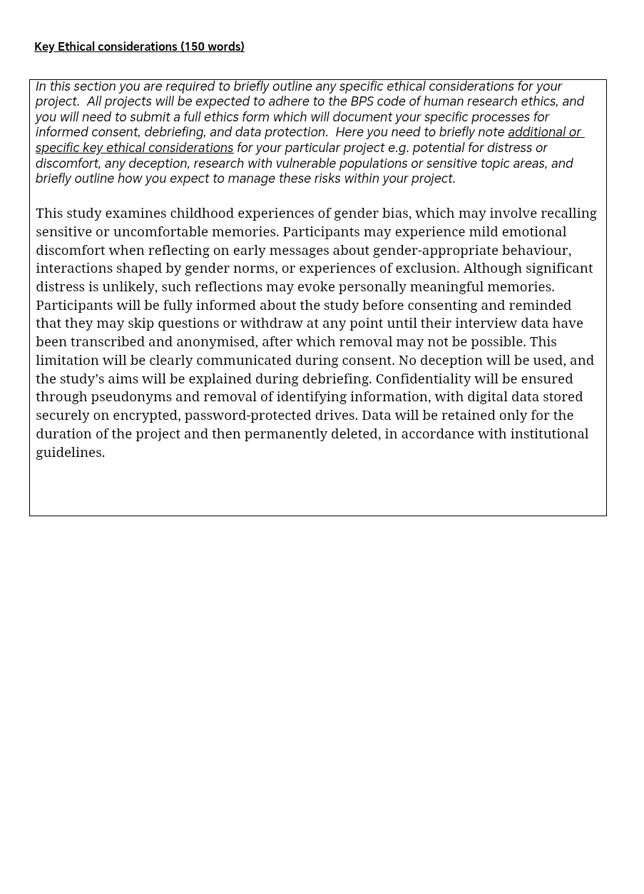
I was also not tasked with this section so I simply added it to the document and revised it for errors as well
Competency 3: Ethical considerations (Ethics form)
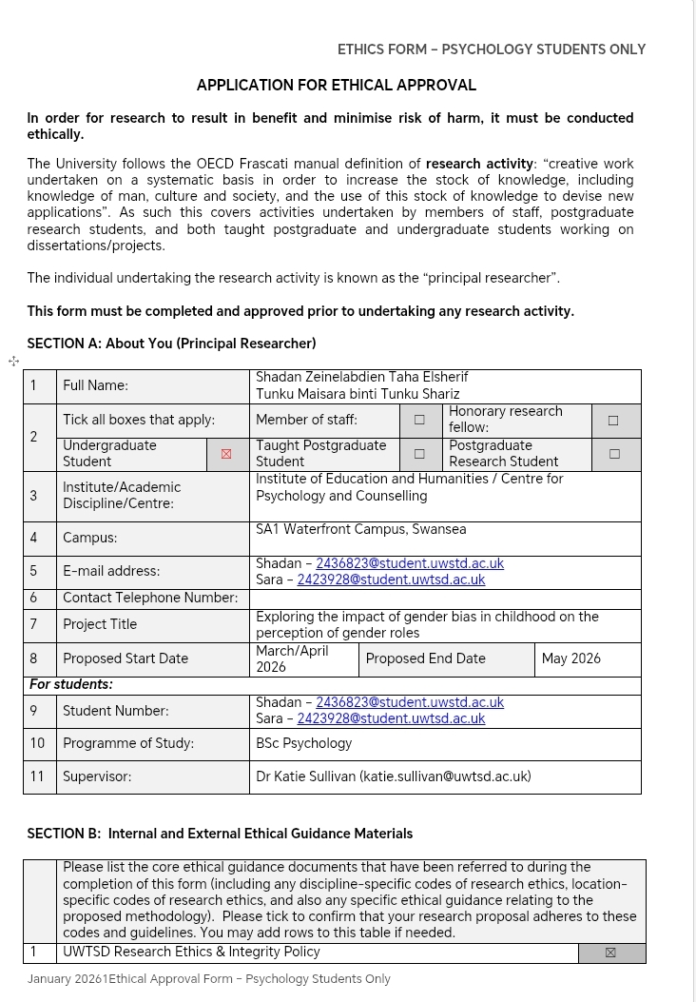
This is the title which was changed by my groupmate. She only added the word exploring, yet it seems more interesting than the title in the proposal form. We should have both cross checked the documents and discussed which one to choose. I plan to be more careful with this in future studies
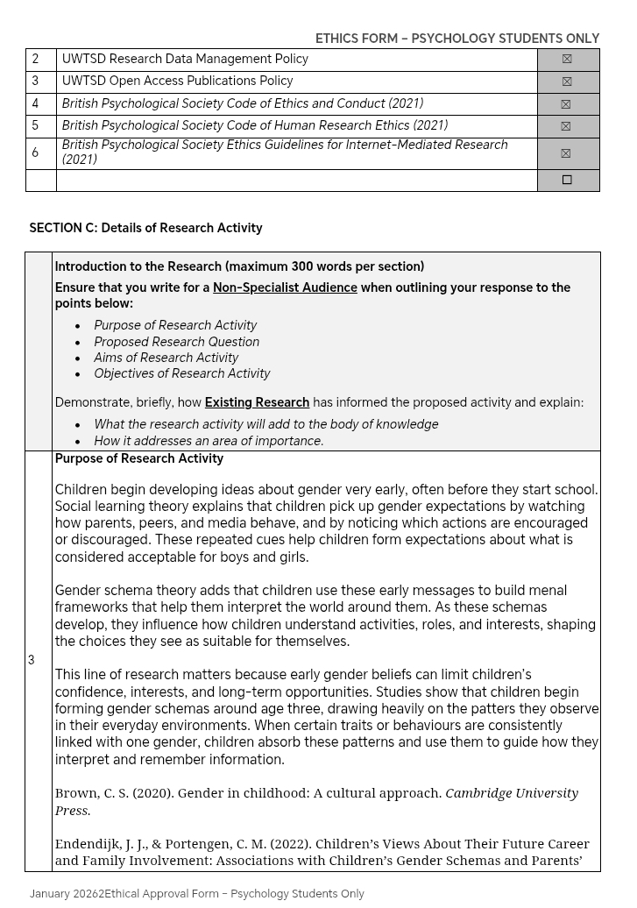
This part was done by my groupmate where I only revised it and checked for errors.
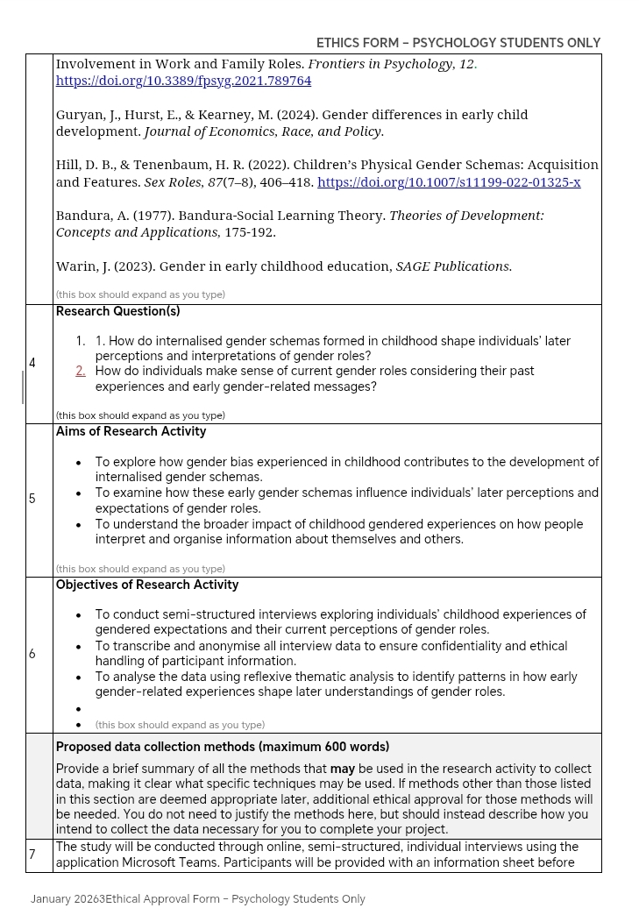
In relation to my previous part I the proposal form, I chose to complete the data collection methods while my groupmate completed the rest of section C (research questions, purpose, aims, and objectives). This made my part easier as I was familiar with the methodology already; however, I did not get to experience completing the rest of section C other than simply revising it. I believe Shorter intervals in tasks allocated would be better for future studies so everyone is able to experience some part of every section. My groupmate also did not have an opportunity to contribute to the methodology throughout the assignment due to this familiarity task allocation, which led to missed learning experience. This part also has a mismatch with the proposal form as the ethics form has 2 research questions while the proposal has 1. As this part was assigned to different people in each form, they were not as familiar with the previous work; however, this could have been solved with clearer communication and not necessarily repeating task themes.
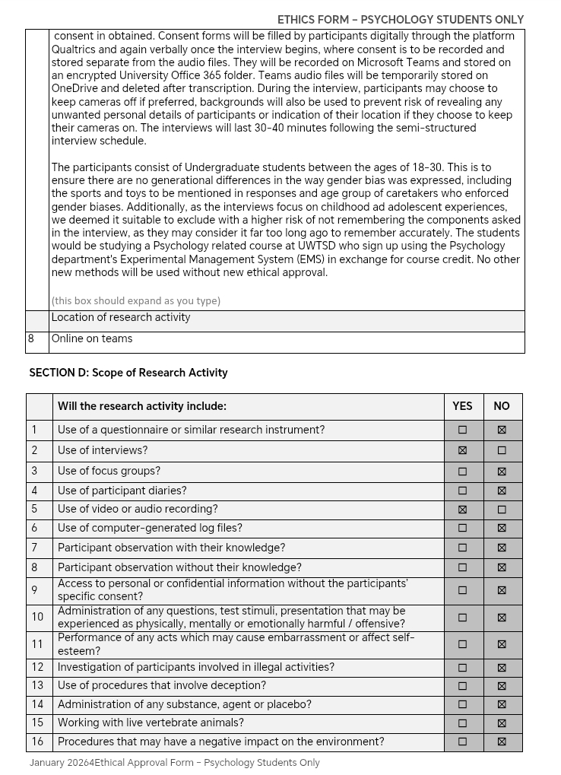
This part was completed mostly by me as I suggested an answer and my groupmate agreed. This was due to a lag in the check list which would not update on our shared access file on her device. At times we’d stop to discuss some lines and ask for guidance from the supervisor as we decided to do simple parts such as this one during class hours, and longer essay-like sections on our on time.
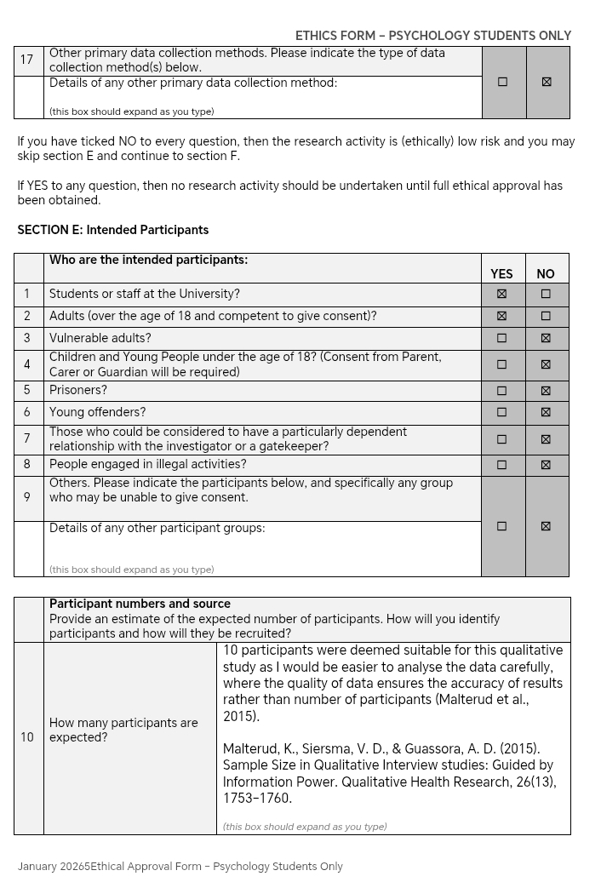
As previously mentioned, we decided to rely on similar past topics to assign tasks, so I was allocated the participant details as well. Initially, I did not include a justification or evidence as to why 10 was suitable as I had simply estimated this number would give enough validity to the results without the need to transcripts and analyze a large amount of data. After feed back from the supervisor, there were many sections including this ones where I had to add more details and justification for. I was reminded that the ethics board may not be familiar with psychology experiments so everything must be clearly justified without relying on the assumption that they know the usual number of qualitative research participants.
This part did not require much discussion so I simply quickly did it while my groupmate checked the answers
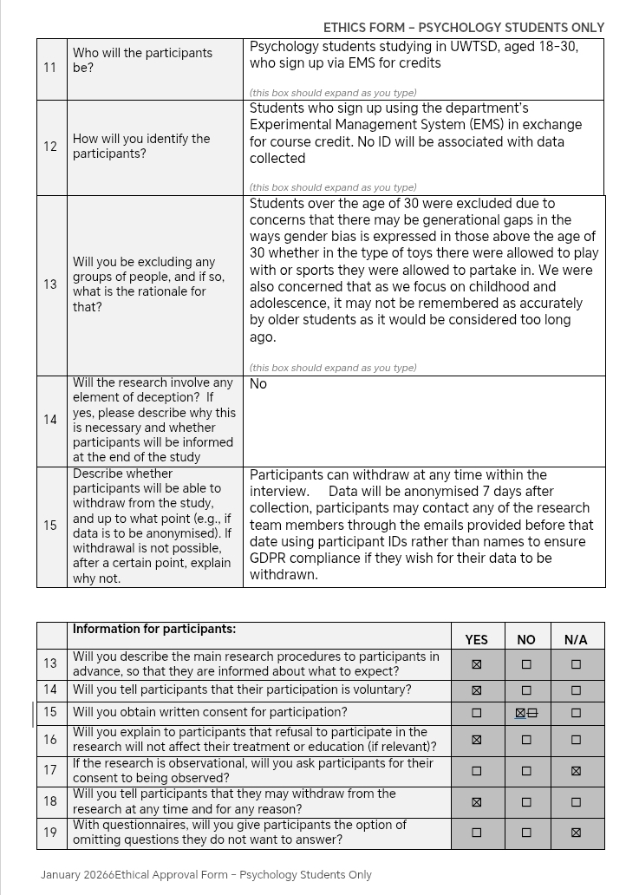
While we did have an age range, I did not consider that to be part of the exclusion and inclusion criteria and assumed we did not have any exclusion or inclusion criteria. This was another instance where I was instructed to add a justification as to why we chose to include this age range and exclude anyone older or younger.
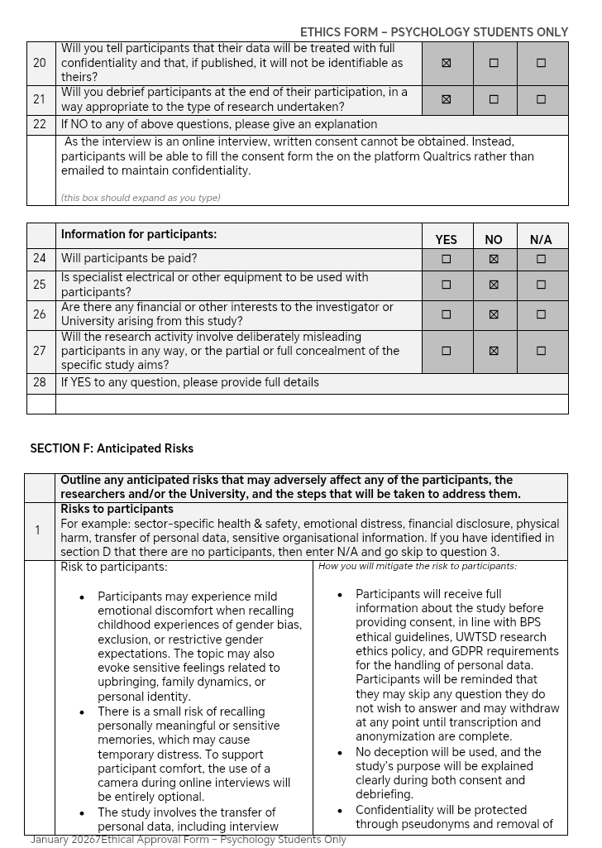
We faced an issue with obtaining consent as we simply stated the interview would be online but failed to consider how we would maintain confidentiality and security if we would need to email the consent form and have it sent back. We also failed to consider how this would occur while the participants is on the call and how time consuming this process would be. The lecturer asked if it would be using the platform Qualtrics, so I mentioned that in the explanation box since “no” was ticked to written consent. I found this part quite challenging as I every solution I thought of risked confidentiality in some way. I was unaware such platforms existed which made me curious to learn more about the tools which can be used for psychological research.
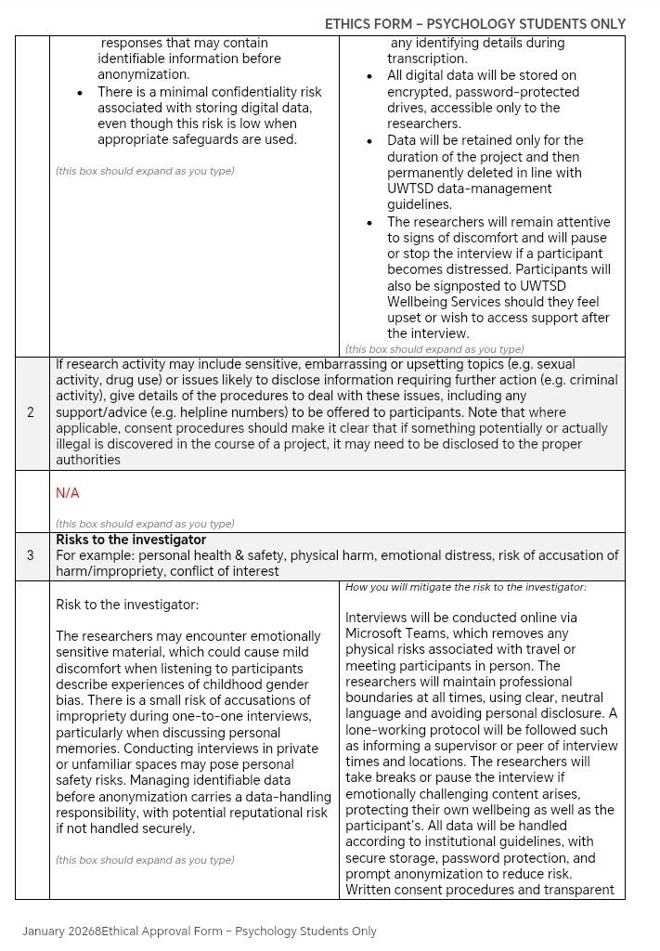
Section F was done by my groupmate where I, again, only revised.
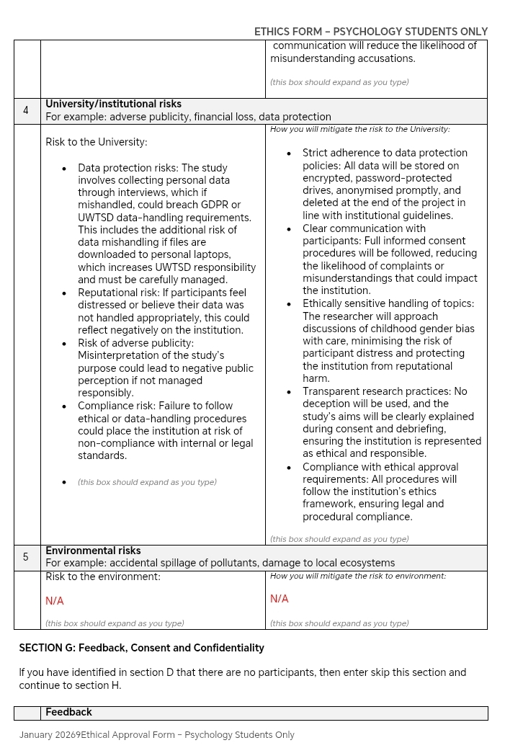
Section F was done by my groupmate where I, again, only revised.
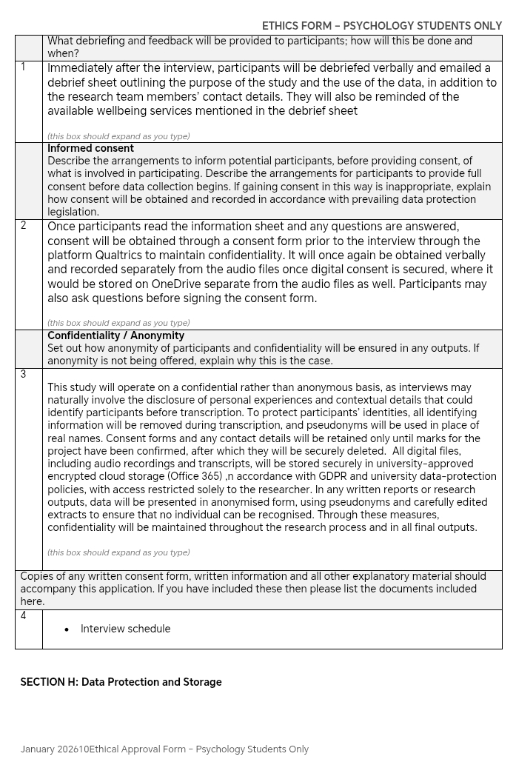
I have also completed the feedback and informed consent as they were similar to the methodology and consent for I had previously done. This part was updated after feedback to include how the consent would be obtained through Qualtrics and stored on OneDrive as we, again, previously assumed personal devices and physical forms would be used.
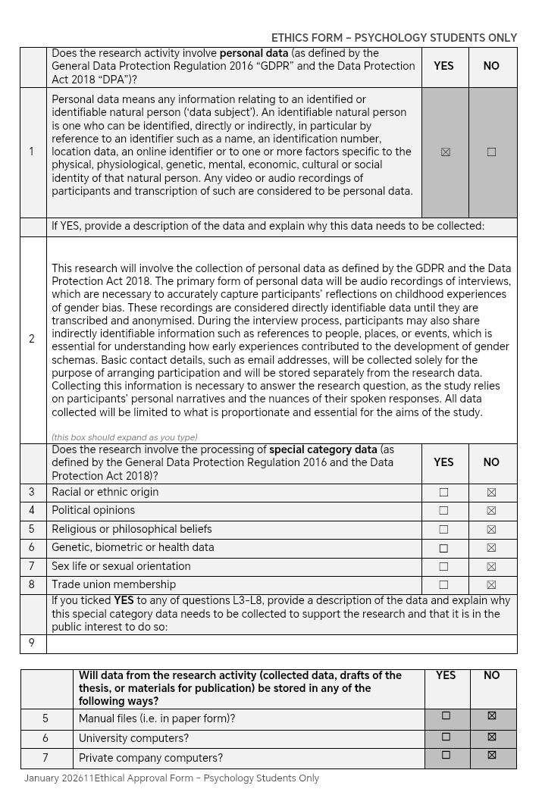
We completed this part together in class to ensure the checklist was up to date across our files. We asked the supervisor whether racial origin or religion might be included but we were advised this was for studies with more sensitive questions and not simple demographic questions like ours where they aren’t main factors we are considering. I have learnt that it would be relevant for future research to consider these factors; however, it would be too complicated at our level.
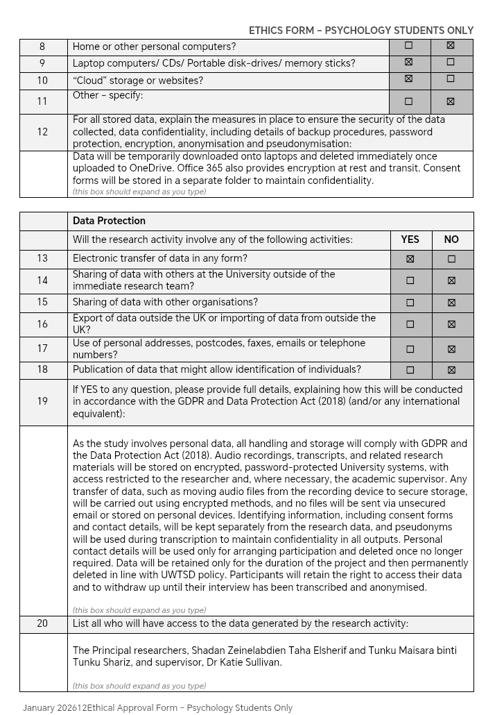
I had completed this with no knowledge of what GDPR or the Data protection act were. I had to do some research since ethics forms were not required in the previous studies I had completed in Malaysia. I was also instructed to edit many parts as it was too short and did not show knowledge of the topic, which was the case as I did not have such knowledge. This section was also assigned to another group member for the other qualitative assignment I was doing this semester. This once again highlights the disadvantage of assigning large sections to one person as I would not have faced as much difficulty if I had experienced this section previously. Simply reading through other members’ sections does not give as much experience as writing it. A solution for this may be choosing similar themes in throughout the same assignment, and choosing the rest of the sections for another assignment.
I have completed the security measures section with a potential mistake. I have not made it clear whether private devices will be used since I have mentioned laptops here. I aim to gain more experience with data storage and protection sections as I still find this challenging and I’m not quite sure if temporarily storing it on the laptops is still secure. To my understanding, since the University Office 365 would be on the personal laptop, it should not be a large security risk. However, this is not clear to the ethics board member reading this form.
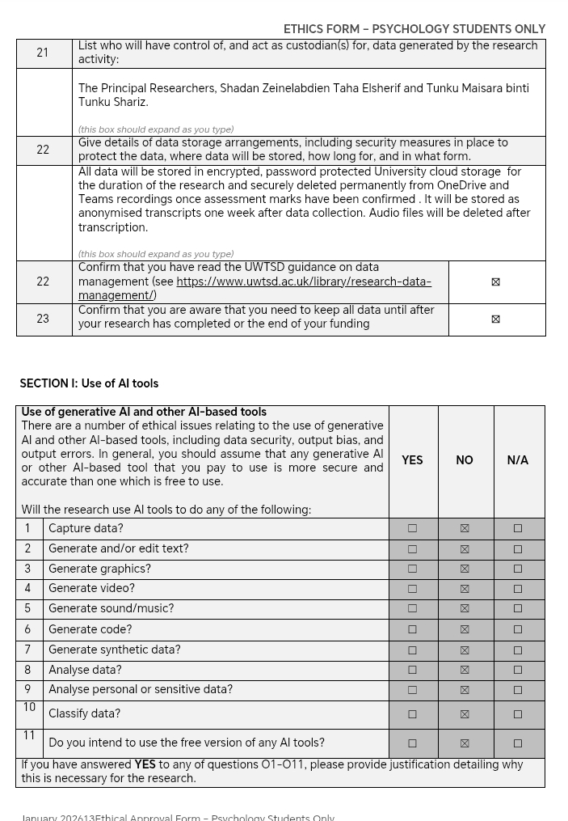
Similar to my previous sections, I also completed this section about data storage. It was simply a repetition so this section wasn’t as difficult as I had understood data storage and protection by this stage.
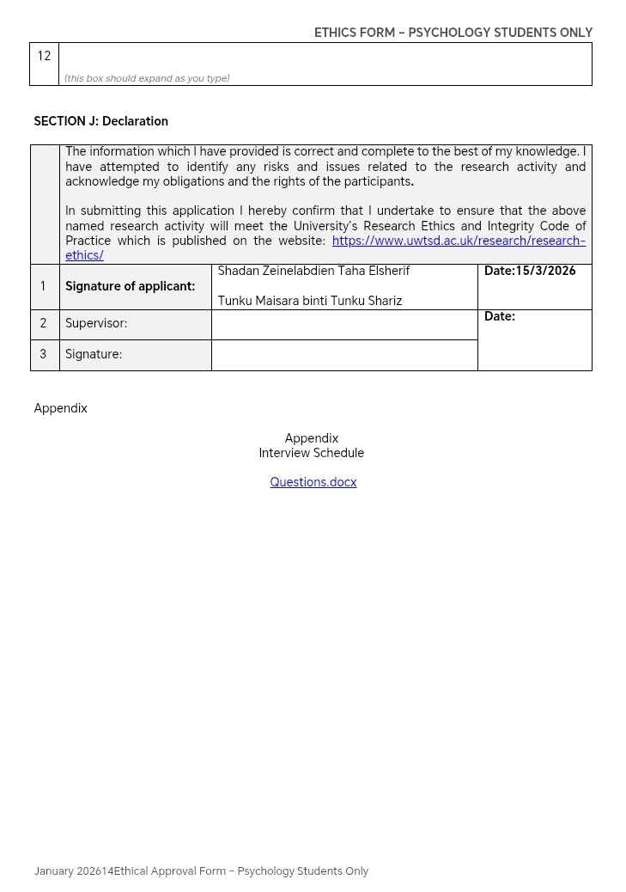
I was meant to make an interview schedule. I made the questions first, then the interview schedule, but I missed the deadline to include the schedule. Hence, an incomplete Appendix was made with only the questions. I would like to highlight that I do know how an appendix is made; however due to time constraints, my groupmate deemed it more suitable to simply submit what we have.

References
Ahmed, S. K., Mohammed, R. A., Nashwan, A. J., Ibrahim, R. H., Abdalla, A. Q., Ameen, B. M. M., & Khidhir, R. M. (2025). Using Thematic Analysis in Qualitative Research. Journal of Medicine, Surgery, and Public Health, 6(6), 100198. ScienceDirect. https://doi.org/10.1016/j.glmedi.2025.100198
Hills, L. S., M.A. (2008). How to Handle Clashes and Difficulties with Co-Workers: 25 Strategies. The Journal of Medical Practice Management : MPM, 24(1), 41-3. https://www.proquest.com/scholarly-journals/how-handle-clashes-difficulties-with-co-workers/docview/219962270/se-2
Malterud, K., Siersma, V. D., & Guassora, A. D. (2015). Sample Size in Qualitative Interview studies: Guided by Information Power. Qualitative Health Research, 26(13), 1753–1760.

