Marketing Management

STUDENT NAME: Susan Akinfe

LECTURER’S NAME: Richard Small

STUDENT ID: 1710216

WORD COUNTS: 3,498

BRAND AUDIT FOR COCA-COLA
Brand is a key image of an organisation to communicate, it is a trademark and a protection legally which helps to differentiate a company’s goods from others, for instance, Sony electronics is made by Japanese which is Technology. Kotler (2016) defines brand as the key element in the company’s relationships with consumers because it represents consumers’ perceptions and feelings about a product and its performance with everything that the product or service means to the consumers. Coca-Cola trademark is uniquely designed to distinguish it from other beverage products.
The winning culture for Coca-Cola as of recent is the attitude of the consumer it is willing to capture. It is a leader in market of beverages because of its excellent quality, long time existence and brand image which is widely associated with pleasure, innovativeness and optimism. Coca-Cola is well known by its trademark in the world and has a respectable business status, the unique trademark is simple yet vocalise and the packaging or logo can be visualised.
Brand Advantage and Brand Benefit.
The advantages of branding are to identify and differentiate it in some way from other products, which is designed to satisfy the same need of customers, creates preference and generate loyalty which is long-time profit for an organisation, also generate power over distributors.
Coca-Cola promises to achieve and deliver experience in a positive way; this promise is conveyed to people by everything (touch, see or hear). Their brand touches millions of hearts every day (Coca-Cola, 2010). Thousand of people share their stories of the brand given exceptional childhood memories which is cherished in many lives. Coca-Cola goal is to offer people with active and healthy lives by offering quality beverages.
Branding Range
The Coca-Cola develop and sell different ranges of product and label any range with a separate brand name. The advantage of this is to target different consumers’group, such as diet coke is targeted at women.
Business Strategy and Marketing Strategy
Kotler and Keller (2009) suggest that brands indicate a positive level of quality which satisfied buyers to repurchase the product again. For Coca Cola it manages to create brand development strategy which effectively maintain the brand image over 100 years ago, it is a heritage brand which creates loyalty with their consumers. According to Kotler (2009) brand loyalties offers certainty and protection of demand for the company and create barriers to entry for others. The brand image serves as a mechanism for keeping the brand loyalty, the company’s portfolio is built around ‘consumer-centric brands’ shifting focus from what the company want to sell, to what the consumers want to buy using the pull and push mechanism (Moye, 2017). Part of the business strategy begun from the goal of making low and no-sugar drinks visible and easier to find, such as organic tea, coconut water, juices and purified waters in more places.
Marketing Strategy is consciousness of building their low and no-sugar drinks by using ‘One Brand’ global marketing strategy launched in 2016 of its four Trademark Coca Cola brands, coke zero, Diet coke, Coca Cola light and Coca Cola life “Taste the feeling” campaign (Moye, 2017). Its marketing strategy has forever associate with happiness, positivity and good life with its products, this is why it is able to create high mind awareness with its consumers.
Coca-Cola uses one brand name as the key identify for different variety of products they produce such as, Sprite and Fanta. The company capitalised on these main names as an advantage for them to gain more consumers, revenues and competitive advantage. However, when something goes wrong it may affect the company because they are related, they are all under one corporate umbrella branding.
In 2001 Coca-Cola has 10 percent (%) growth in still drinks such as sparking beverages of 90 %, water at 6% and other at 4%. Since then it has increased to 30% in 2016 to diverse portfolio which includes water 18%, juice 7%, sparkling beverages at 62%, low and no calorie sparkling beverages at 8%, RTD tea at 4% and Energy and other at 1% (Coca-Cola Annual, 2016).
The company pledged in 2017 to reduce sugar in more than 500 drinks around the world, adding 30 percent to 3,900 soft drinks previously fall into group of low sugar. The company envisages improving macroeconomic conditions from 2016 to 2020 and expect growth from emerging markets of +3.3% between 2018 and 2020 (Coca-Cola Annual, 2016).
Operations: Coca -Cola contract out the bottling License and facilitate the company to capture vital boost opportunities in non-carbonated drink segment and entering strategic acquisitions agreements with Coca -Cola Company.

Cost Regulator: Through expansion of collection product the company contracted out to cut cost to boost their profitability and economies of scale.
Coca-Cola collection offers strong, powerful and extensive portfolio of soft drinks to consumers and constantly determines to capture growth in different market.

Distribution Strategy
The company have one of the well-planned distribution system in place. Coca-Cola position their self on consumers mind which makes it indispensable to retailers and wholesaler for their business success. The company achieved their goal because of their visibility and availability even in some remote areas. Coca-Cola has numerous distribution channels from company direct to wholesalers to distribution, retailer to super markets and small stores. Threy sell to restaurants, night clubs and cafes and also to petrol stations and vendor machines depending on market, consumer’s outline and geographic situations. See below the distribution channels.
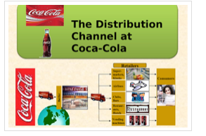
Adopted from Lu and Tiwana (2015).

Brand Equity
Coca-Cola consumers are recognisable with its brand and have strong positive associations about the brand in memory (Keller, 1993). The product is well recognised by people around the world. The brand equity is about its value, description, reminiscences and associations and connects with people. This equity is the result of people’s readiness to pay for the brand quality and the reluctance to receive alternatives. Consumers are mindful of Coca-Cola products, for this reason they stay loyal to the brand by having repeated purchase behaviour (Ming- lee, 2011).

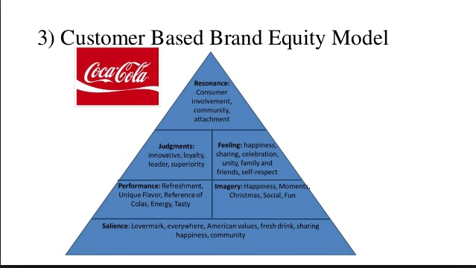
Adopted from Coca-Cola, 2016

Brand Salience
Coca-Cola outstand their competitors due to their eye catching bold red and white colour and well design logo on its packages either bottle or can and activities, such as vendor machines, advertising, stores, Facebook, website, LinkedIn and twitter. (Ralf, 2008).

Brand Performance
Numerous advertisement and continuous improvement, has positive effect on their strategies, market and financial performance which will be reveal in the report (Luxtona, 2015).
Brand Image
Keller defines brand image as the understandings mirrored by the brand memory that is held in consumers’ memory. Coca-Cola consumers have experiential, tasted and drank the products and many had testified that they feel good and happy.
Brand Feelings
Consumers buys Coca-Cola product because of the expectations they have towards it and their purchase, they feel satisfied and feel positive with the brand, which create enormous brand advocate (by word of mouth). The good and positive experience feelings stay in the consumers mind. Conversely, if it is a bad experience, the negative feelings may be left with the consumer which is judgements (Keller, 2009)
Brand Judgements
There are different ways of judgements, it could be good or bad because it depends upon the individual’s perception. A consumer may find the products experience excellent with good customer service and for that consumer the judgement may be that product expectations is superior then repeat purchase. But, if the consumer has never experienced the brand and heard some negative words of the brand, a judgement can be made about the brand. For Coca-Cola the consumers feelings were met because of the holistic marketing at various touch points of their brand.
Brand Resonance
This is the final level of Keller’s brand equity pyramid model. In this level Coca-Cola consumers have a vast social and psychological association with the brand. Consumers are enthusiastic, loyal and involved with Coca-Cola brand that they will protect it from any bad publicity.
Keller’s Brand Equity model stands for consumer-based brand equity (CBBE) in fact, it is a pyramid that helps to understand consumers and therefore implement strategies. Where there is connection between consumer and brand this result in positive brand equity, which gives enhanced ability of obtaining and sustaining consumers, thus provide massive advantage to the company and products which is consider as “brands” (Keller, 1993). Brand Identity is how consumers visualise the brand and distinguish different brand from another through the brand image.
Keller Limitation of model
Keller model is fixed mainly on individuals’ brands perceptions in the appraisal of product equity, conversely, other influences may have an effect on business to business framework on brand equity as well.
Brand meaning is connecting palpable and impalpable associations. Brand meaning is categorised in brand image related. Practical attributes are product consistency, strength and serviceability, service value, effectiveness and understanding. Image relate to associations includes, the properties of product which are operator outlines, purchase and custom situations, heritage and experience and personal values, (Keller, 2003).
Through means of difference, Low and Blois (2002) argues that components of brand value has other included support services, such as product and distribution in the organisation, with each having basics of both intangible and tangible which Keller’s model disregard relating to specific bond between the service provider and consumer and company that could have better reputation in B2B framework. Equally recognised by Thompson (1998) other brand features connected with B2B buying procedure. Attributes such as consistency, technical ability and awareness were not included in Keller brand meaning construct.
Keller’s other step brand model signifies views and valuations of brand based on a blend of associations acknowledged in brand meaning which includes decisions on quality, reflection, reliability and advantage, all these sensitive feelings are consumers responses to brand. This tactic reflects a consumer emphasis on the practical, sensitive and self-expressive rewards of the brand. In contrast, brand manufacturing management is branded by marking at the corporate level, with better reputation consumer hazard decrease than on sensitive rewards (Mudambi, 2002). The only means to decrease hazard and manage ambiguity for organisation is purchase from reputable companies. This importance of emotional state and descriptions support those specified by Keller and may required in B2B brand equity model.

Five Consumer Gaps Model of Coca-Cola
These are service gaps which organisations need to minimise for consistency and excellent delivery. For organisation to meet and exceed consumers’ expectations, they have to minimise each gap which contribute to their capacity (Parasuraman & Berry, 1985).
Core Benefit of Coca–cola is to extinguish dehydration. However, in management Perception, this can exist between management understanding of consumer expectations and the real consumers expectations. In a situation where management gets it wrong, it affects the organisation, such as when Coca-Cola that dominated the beverage market for decades. However, early 1980’s it introduces a ‘new Coke’ thinking that consumers will like the modern taste but failed because the consumer did not like and sales plummeted. It shows that management misunderstood their market and their wrong decision resulted in sales downturn. When first Gap is created whatever the organisation does it takes them away for offering what consumer want.

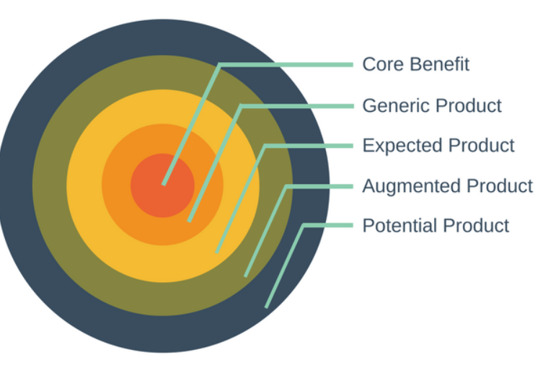
Coca-Cola by Kotler (1960)

Generic product is a smelling of black carbonated and sweetened fizzy drink. Understanding consumers expectations of those they cater for. Gap may emerge if translation of expectation into service standards is mistaken. Service standard are efficiently outlines and methods which is put in place to ensure consistently meeting the expectations of the consumers.
Expect product consumer’s find the drink cold. If this is not the case that means expectations are not met and in the mind of the consumer the drink did not taste at its best and human error may create this gap.
Augmented product Coca-Cola offers Diet-Coke, which exceed consumer expectations by offering great taste with zero calories. A market communication gap can be created here if the information is not rightly correct.
Potential Product Coca-Cola delights its consumers by organising competitions. The competition rewards are things money cannot buy. For instance, celebrity experiences and delight consumer in excess of time by changing competition rewards regularly.
This five-product level has advantages to it because it enables the company to recognise the needs and wants of consumers so that it can then match the characteristics they create to the consumer wants. Match marketing hard work to appeal to consumers wants and eventually assists the company to differentiate itself from its competitors in a way that support the wants and needs of its consumers.

Consumer Satisfaction
Coca-Cola measured its ability to meet and exceed consumer needs by tracking consumer view through GFK marketing research company where it interview over 14,000 consumers in 2017, in its outlets and nearly 800 customers with main account in their head office. 78.8 percent of the customers from headquarter were satisfied, while 64.8 percent are satisfied from the outlets.
97.2 percent claimed that deliveries are on time and correctly invoiced, while 94.2 percent of customer expectation was met or exceeded and 89 percent employee engagement 92 percent (Coca-Cola, 2017).

Consumer Touch Points
The rises in technology has led to a whole sale shift in consumer purchasing behaviour and reflect in the way Coca-Cola engage with consumers by redefining consumer track preferences.
Consumer now encounter a brand before, during and after buying, form reading online testimonials, engage in live chatting with consumer service staff for product and returns support. Obtaining consumer significant experiences metrics involves evaluating every consumer touch point and the value it offers.
Social Media Monitoring
The company handles queries and responds to both negative or positive feedback shapes and drive consumer perception. Gaining consumer complete experience picture requires them to control and analyse social media data and of their competitors, getting to consumers’ desires root.

Communication Models
It is used in explaining the human communication process following the basic concept of sending and receiving messages or transferring information from one sender to another receiver (Shannon, 1949). Effective and integrated communication is important for any organisation to strive in the market place, not having an effective and integrated communication scheme Coca-Cola may be incapable to develop suitable structure for their corporate communication strategy which requires careful communicating views and organisation’s objectives to both internal and externalstakeholders.

Integrated Marketing Communication
This is an easy perception of integrating all promotional devices together to work in harmony. One of the marketing blend is advancement which owns its message devices, all the messages devices work well together than in isolation (if only they speak constantly every time with single speech).
Integration improved when is beyond just elementary messages devices and strengthen integrated communications involving other stages of integration as Parallel, Vertica, Internal and External data.
Coca-Cola use the parallel integration transversely their marketing functions from creation to finance, distribution and working together to make a conscious decisions and actions in sending their messages to consumers (Sutherland and Canwell, 2004).
This is done through the sales department, directly by mail and advertising which does assist data integration through collections and shares of relevant marketing information system data across different departments (Fombrum, 1984).
Vertical integration is completed by the organisation marketing and communications objectives which assist their sophisticated corporate level missions and purposes. In meantime, all staff requires internal integration to be informed and motivated on any growths from fresh announcements to innovative business, individualities and standard innovative service (Cornelissen, 2008).
On other hand, External integration for Coca-Cola is requiring advertising and agencies PR work closely together to enable them to deliver a cohesive and combined message.
The integrated marketing communications benefits is, it creates competitive advantage, it saves money, boost sales and profits for Coca-Cola. It helps controls consumers by moving them through stages of purchasing procedure. Coca-Cola joins its image and develop a discussion by nurturing their relationship with consumers which strengthens the loyalty bond with consumers, this defend the organisation for foreseeable invasive form competition. The ability to keep consumer for life is their strong competitive advantage (Argenti, 1998).

Integrated Marketing Communication Barriers
Communication does have its own obstacles such as useful Silos, restrict Creativity, Time horizon Conflicts and lack of management just to mention few.
Useful Silo, Organisation with rigid structure may be verminous with managers protecting both budgets and power base, this may affect the organisation because of lack of communication. For instance, marketing department are not communicating well with PR or inform sales reps about promotional offer, this may cause a communication havoc.
Restrict Creativity, the pleasure of extensive creativity may be muffled, however, inspired challenge may be bigger and eventually sustaining when operating within a combined, tighter and creative brief.
Time horizon creates barrier to IMC because if design to foster brand over long period is conflicted with short period advertising these two objectives can cause a barrier if not carefully planned. Coca-Cola seems to have production of discipline agencies.
Communication Model
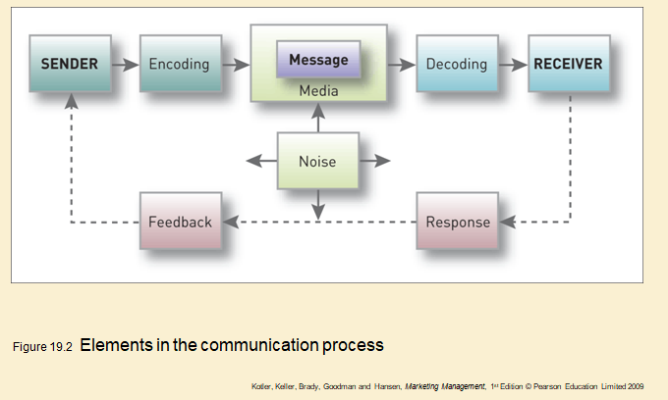
Adopted from Kotler, 2009.

Noise is an obstacle to a smooth transmission of communications message, Coca-Cola work immensely to limit barrier and obstacle in their communication.
Digital Marketing
It plays an important role in Coca-Cola business because technology has impacted a change in the way their consumers are been served. Sandy Douglas the North America executive president claimed that technology gives people opportunity to reach out to their products which creates further growth. He argues that technology is a ‘merchandising opportunity and a chance for them to sell more beverages’ (Douglas, 2017).
IMC Campaign for Coca-Cola
The Coca-Cola returned to its origin with the biggest advertising on Feb 4 2018, national presentation of 60 seconds spot titled “The Wonder of us” this was air for new brand “A coke for everyone” the platform includes Social and Experiential. Its celebrates values of cheerfulness, diversity and inclusion which is what the brand stands for since 1886. It creative illustration is no matter how unique people are there is a coke for everyone (Coca-cola, 2018).

Sustainability Campaign promoting plastic recycling
The company campaign regarding the plastic recycling is to raise an awareness that Coca-Cola plastic bottles are reused and encourage people to recycle by putting recycling at the heart of the advert message, this campaign is the biggest consumer communication campaign on recycling and their sustainable packaging strategy. The company pledge to use plant bottle for their product which is easily recyclable increasing the recyclable bottle to 50% by 2020 (Vizard, 2017).

Coca-Cola uses different of communication to capture their consumer by engaging in advertising, making the use of media (television, cinema, outdoor bill board), public relations sponsorship such as games for brand recognition/awareness and celebrity endowments and direct marketing. The biggest of all is digital marketing delivered through digital channels such as search engines, websites, social media.

Consumer Behaviour
Psychological and Sociological effect consumer behaviour. Coca-Cola is successful in creating impact on consumer behaviour because its business penetrated in every walk of life and sustained to deliver its brand value both psychological and sociological to consumer.
Consumers collects lot of information before making their purchase decision about appearance, sound, taste, smell and touch of the product. All this information produces sensation and perception in consumer mind which creates basic acceptance of the brand, knowledge and memory boosting the acceptance. Consumers believed and decisions may be affected and psychological factor may change the consumer behaviour differently (Iacobucci, 2014).
Sociological Effect
Consumer attributes and decision to buy product and to repeat purchase is significant, because this attitude result from psychological perception and memory that leads to sociological effect. An important factor which has effect on consumer making decision is social-cultural changes between brand and consumers preferences. For instance, Westerners have the habit of fast food eating with cola drinks. But, Eastern Asia countries have less accessible for cola drinks, people a more concern or health conscious in recent days about sugar (Thogersen,2012).
Coca-Cola is changing and innovating products categories including coffee, organic tea, water and offers low sodium drinks to consumer with special needs, they can choose an ideal product according to their age, regions, and countries. Consumers purchased decision is based on the condition that Coca-Cola is highly accepted (Coca-Cola, 2016).

Conclusion
Branding is a powerful means of gaining a competitive advantage, staying different from competitors’, building connection, familiarity and identification with consumers and with their products.
Coca-Cola is trusted and loved brand with strong heritage and brand loyalty. They have confidence in their products and can influence their heritage in beverages to strive successfully in the market. If they travel down the route of producing healthy drinks, this will increase their sales and profitability.
Marketing and advertising has been the most significant function that has taken Coca-Cola to new heights, its innovating marketing methods has greatly help the company growth through technology.
Coca-Cola utilised their integrated marketing communication strategies well, with both internal and external stakeholder which is essential and reflection of the company’s image, identity and reputation, connecting the desires of the internal and external stakeholds to achieve an effective organisation.

References

References
Fombrun, C. J. and Riel, C. B. M, 1984. Strategic Human Resources Management. New York: John Wiley.
Argenti, P. A., 1998. Corporate Communication. 2nd ed. Boston, Ma: Irwin McGraw-Hill.
Coca-Cola, 2016. [Online]
Available at: https://www.cocacola.com
[Accessed 05 05 2018].
Coca-Cola, 2016. Coca-Cola.com. [Online]
Available at: https://www.Coca-Cola.com
[Accessed 05 o5 2018].
Coca-cola, 2018. Intergrated Marketing Communications. [Online]
Available at: http://www.coca-cola-imc-campaign
[Accessed 02 04 2018].
Cornelissen, J. P., 2008. Corporate Communication: A Guide to Theory and Practice. 2nd ed. London: Sage Publications Ltd.
Douglas, S., 2017. Coca-Cola ecommerce. [Online]
Available at: https://coca-cola-Ecommerce-should-not-be-seen-as-a-channel
[Accessed 24 April 2018].
Hsiang-Ming, L., Ching-Chi, L. and Cou-Chen, W. , 2011. "Brand image strategy affects brand equity after M&A". European Journal of Marketing, 45(7/8), pp. 1091-1111.
Iacobucci, D., 2014. Marketing Management in customer satifaction and Relationships. 4th ed. London: Cenage Learning.
Keller, K. L., 1993. "Conceptualising, measuring and managing customer-based brand equity",. Journal of Marketing, 57(1), pp. 1-22.
Keller, K. L., 2003. Strategic Brand Management: Building, Measuring and Managing Brand Equity. 2nd ed. New Jersey: Prentice Hall.
Keller, L., 2016. Keller Model Overview. [Online]
Available at: https://cocacolabranding.wordpress.com/2016/09/01/keller-model-overview/
[Accessed 05 05 2018].
Kotler, P., Keller, K. L., Brady, M., Goodman, M. and Hesen, T., 2009. Marketing Management. 11th ed. s.l.:Prentice Hill.
Kotler, P., 1960. Marketing Management. 15th ed. s.l.:s.n.
Kotler, P., 2003. Marketing Management. 11th ed. New Jersey: Prentice Hall.
Low, J. a. B. K., 2002. "The evolution of generic brands in industrial Marrkets:The challenges to owners of brand equity". Industrial Marketing Management, 31(5), pp. 385-392.
Lu, L. a. T. S., 2015. Coca-Cola distribution channels. [Online]
Available at: https://mpk732.wordpress.com/2015/05/17/thecoca-cola-company's-distribution-strategy/
[Accessed 05 05 2018].
Luxtona, S., Reid, M. and Mavondoc, F., 2015. Integrated Marketing Communication Capability and Brand Performance. Journal of Advertising, 44(1), pp. 37-46.
Moye, J., 2017. Coca-Cola way forward. [Online]
Available at: https://www.coca-cola.co.uk/stories/cokes-way-forward-new-business-strategy-to-focus-on-choice-convenience-and-the-consumer
[Accessed 02 May 2018].
Mudambi, S., 2002. "Branding importance in business-to-business markets:Three buyer Clusters". Industrial Marketing Management, 31(6), pp. 525-533.
Shannon, C. E. &. W. W., 1949. The Mathematical theory of communication. Illinois: University Press.
Sutherland, J. a. C. D., 2004. Key concepts in Human Raesource Management. New York: Palgrave Macmillan.
Thogersen, J., Jorgensen, A. K., and Sandager, S., 2012. "consumer decision making regarding"green" everyday product". Psychology and Marketing, 29(4), pp. 187-197.
Thompson, K. E., Knox, S. D. and Mitchell, H. G., 1998. "Business to business brand attributes in a changing purchasing environment",. Irish Marketing Review, 10(2), pp. 25-32.
Van der Lans, Ralf; Pieters, R., Wedel, M., 2008. Marketing Science. Competitive Brand Salience, 27(5), p. 922.
Vizard, S., 2017. Coca-Cola launches first sustainability campaign to promote plastic recycling. [Online]
Available at: htpps://www.Coca-Cola%launches%20first%20sustainability%campaign%20%20promote%20plastic%20recycling
[Accessed 02 may 2018].

