8/14/2026
Network Operating Systems and Services
Task 2
Maria del Carmen Serrano Sanchez 2328383

Task 1 – Routing

Objective of the assessment
Configure routing in the Birmingham and London networks so that both sites can exchange traffic securely and reliably.

1.1 - Routing in Birmingham Network

Part 1. Install the Routing and Remote Access Service (RRAS)
Windows Server cannot act as a router by default. Therefore, the Routing and Remote Access Service (RRAS) role is installed to provide the routing capabilities required for communication between the Birmingham and London networks. The routing functionality will be enabled during the RRAS configuration in the next step.

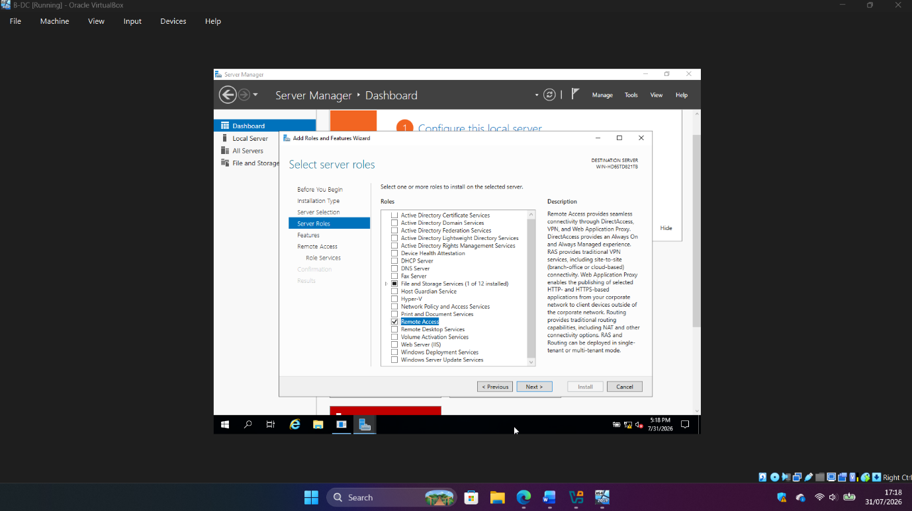
Figure 1. Selection of the Remote Access role on B-DC.

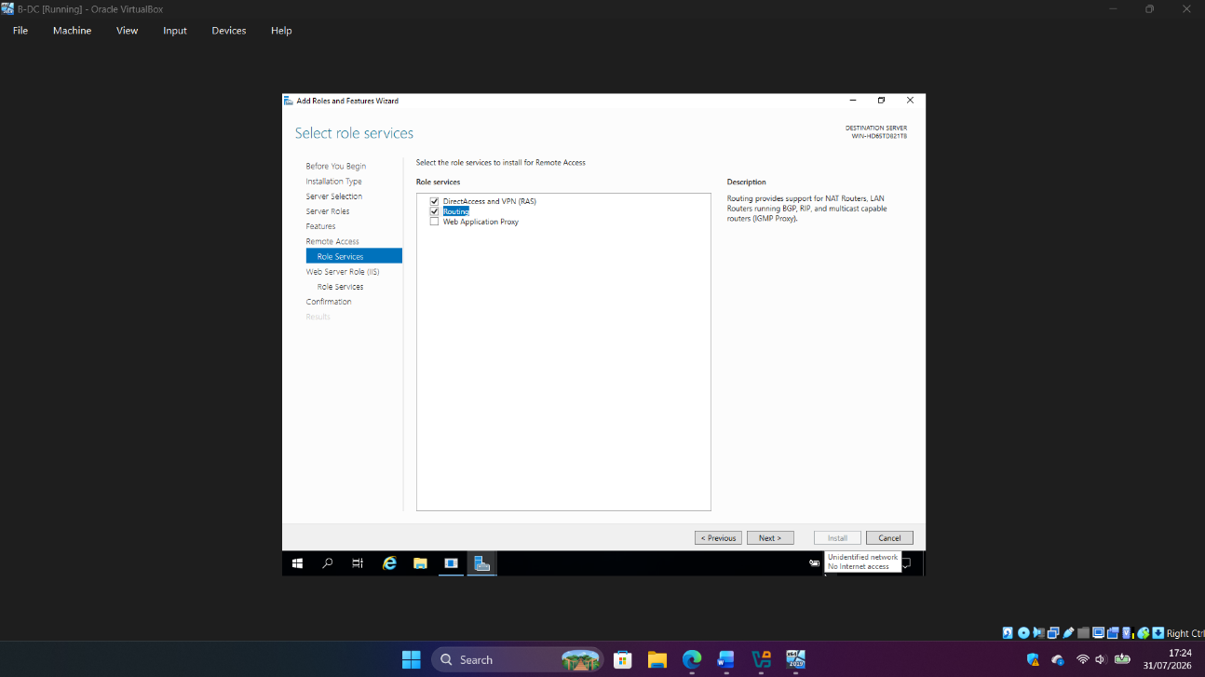
Figure 2. Selection of the Routing and DirectAccess and VPN (RAS) role services.

After confirming the installation options, the Remote Access role is successfully installed on B-DC.

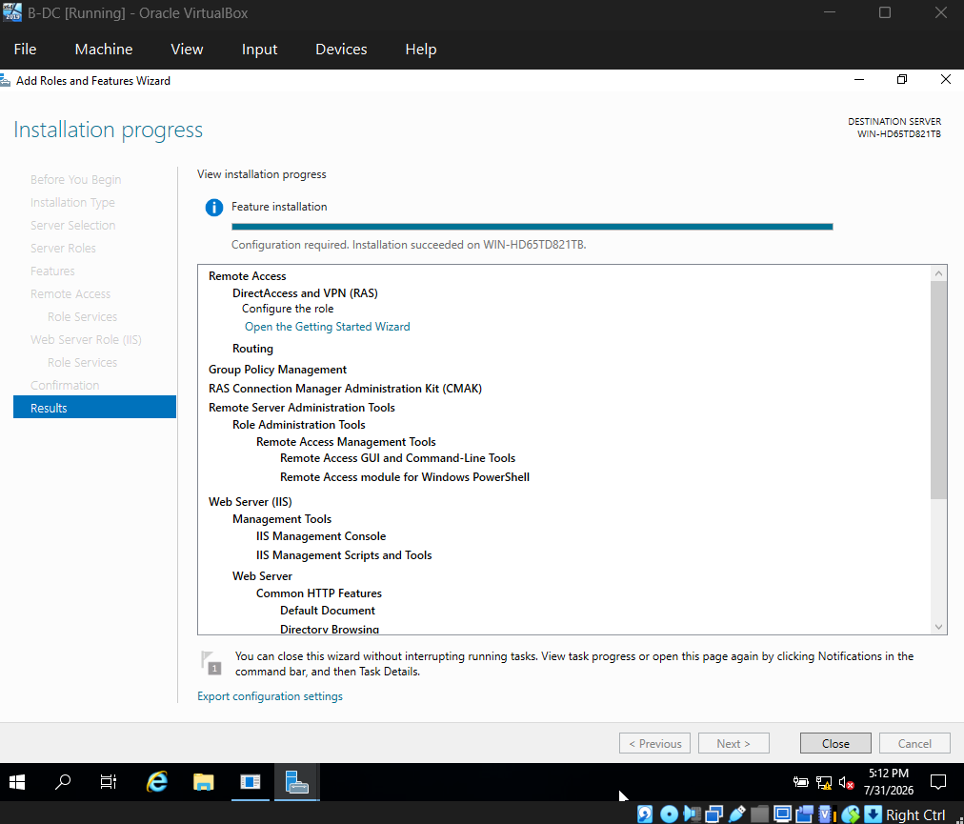
Figure 3. Successful installation of the Routing and Remote Access Service (RRAS) on B-DC.
Part 2. Configure RRAS as LAN Router
Installing RRAS only adds the routing functionality to Windows Server. The service must then be configured to enable LAN routing between the Birmingham and London networks. After selecting the LAN Routing option, B-DC can forward network traffic between its two network interfaces.

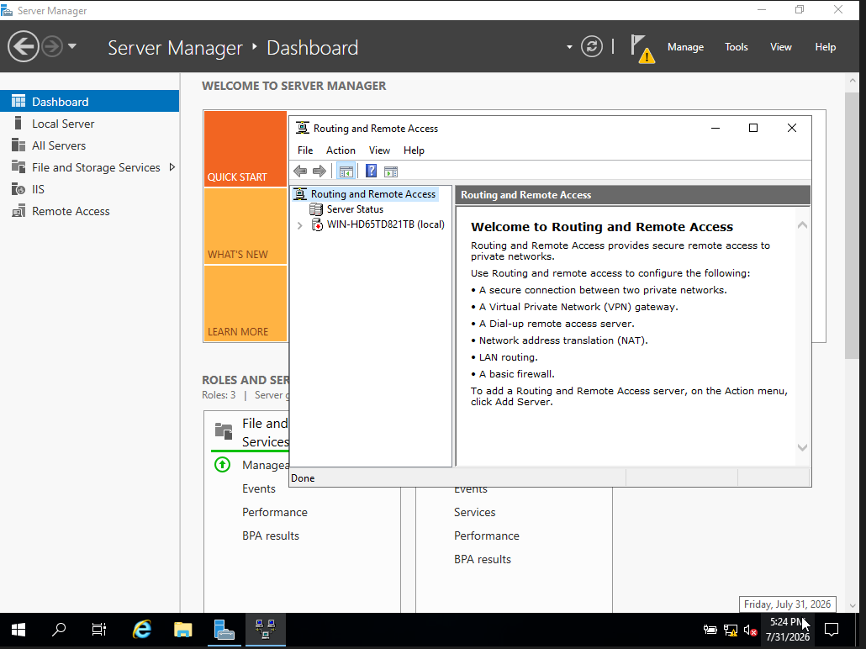
Figure 4. Routing and Remote Access console before configuration.

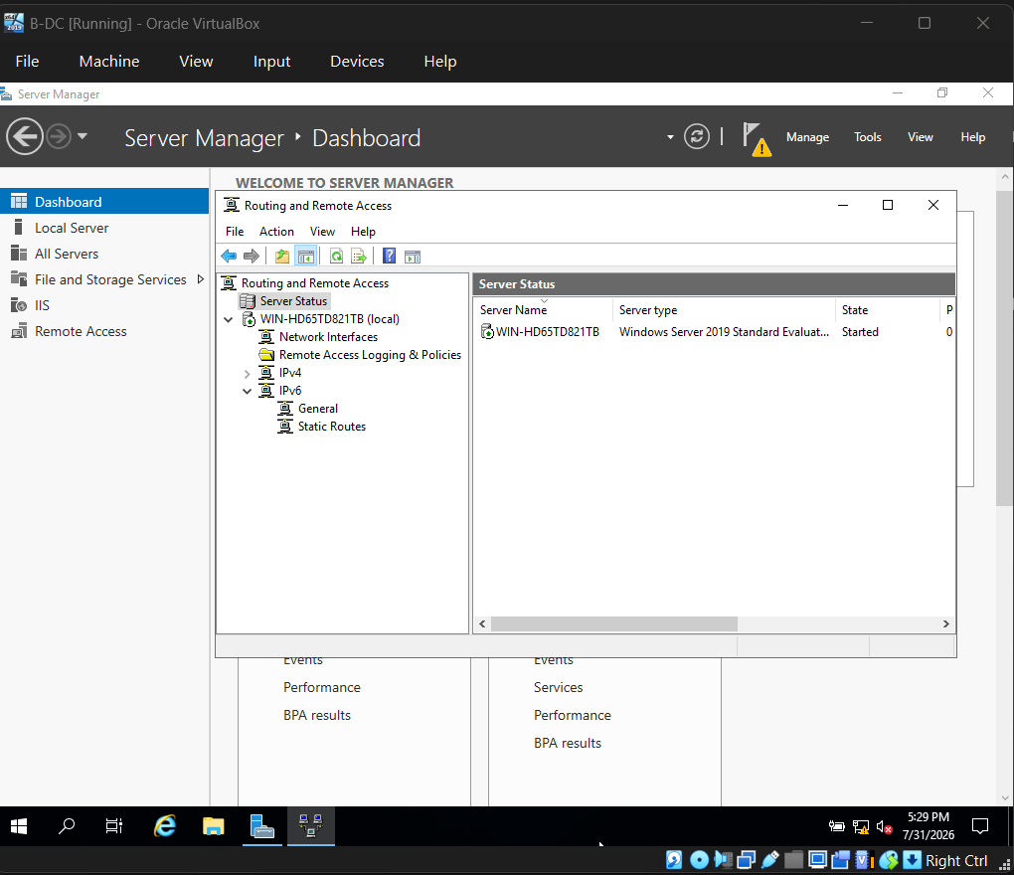
Figure 5. Routing and Remote Access Service (RRAS) successfully configured and running on B-DC.
Part 3. Configure Windows Firewall to Allow ICMP Traffic
The ICMP Echo Request rule was enabled in Windows Defender Firewall to allow the server to respond to ping requests. This simplifies network connectivity testing during the routing configuration.

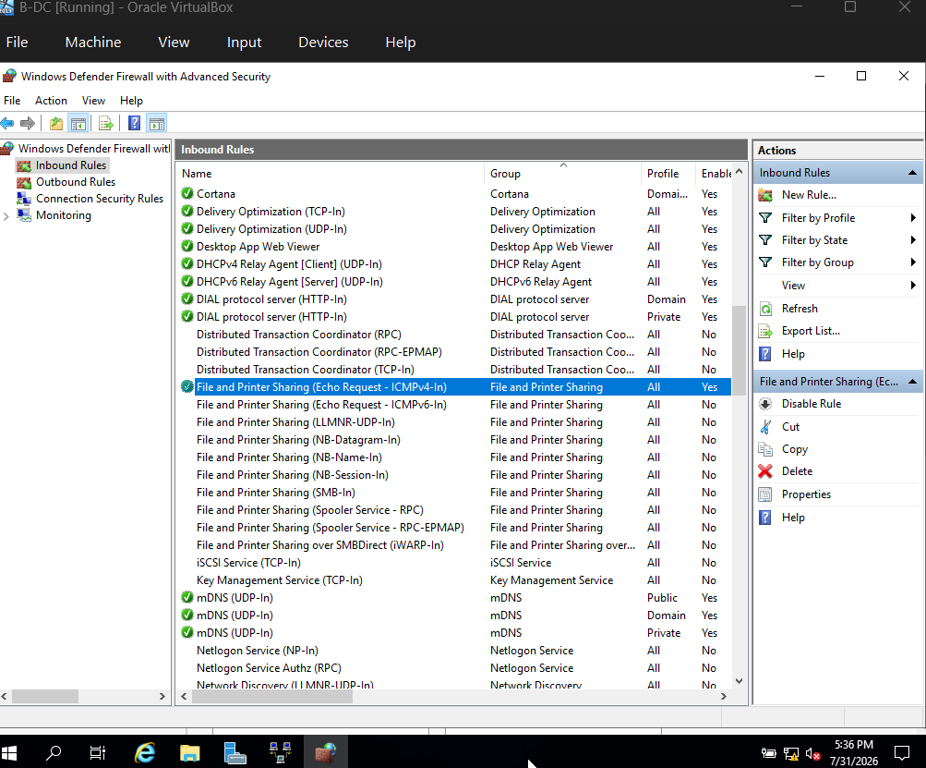
Figure 6. ICMPv4 Echo Request rule enabled in Windows Defender Firewall.

1.2 - Routing in London Network

Part 1. Configure Persistent IP Forwarding
Linux does not forward packets between network interfaces by default. To allow L-CD to route traffic between the London LAN and the point-to-point link connected to B-DC, persistent IP forwarding was enabled by creating a configuration file in the /etc/sysctl.d/ directory.

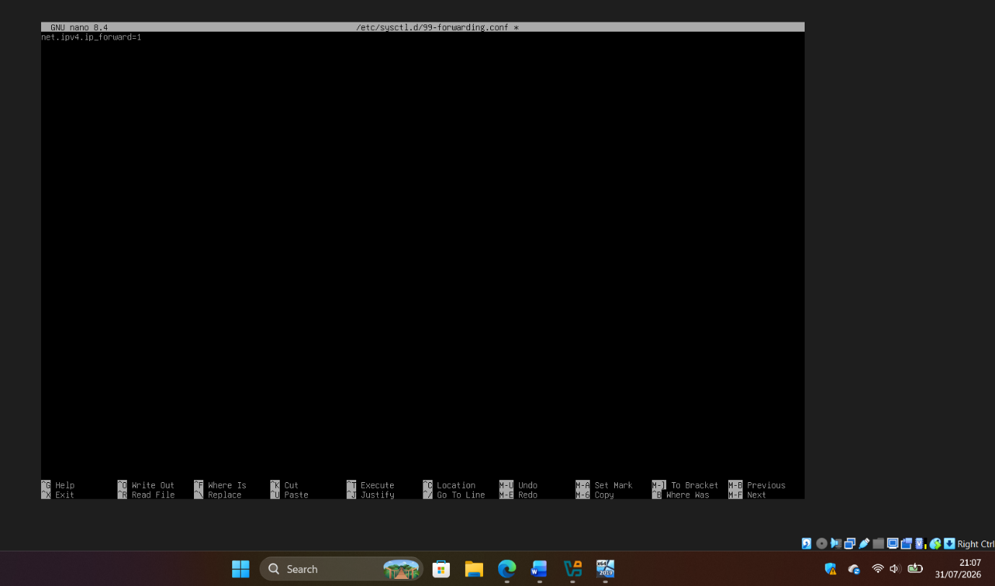
Figure 7. Creation of the persistent IP forwarding configuration file (99-forwarding.conf) on L-CD.

The new kernel parameter was applied using the sysctl utility. After applying the configuration, IP forwarding was verified to confirm that packet forwarding had been successfully enabled.

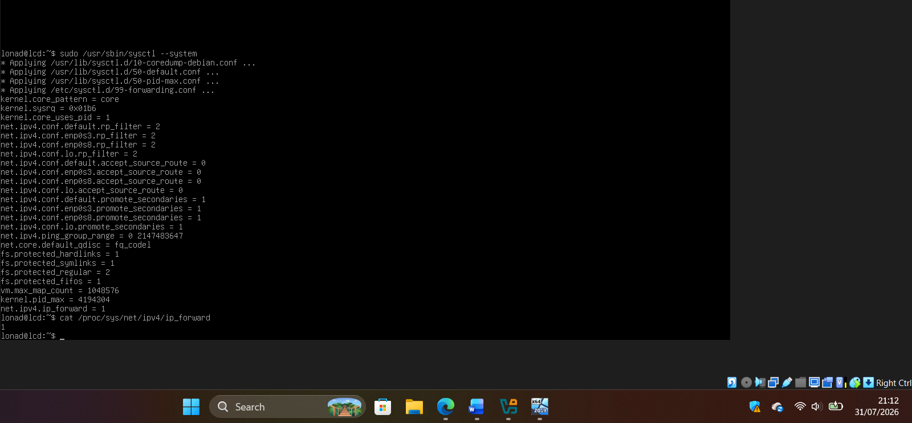
Figure 8. Persistent IP forwarding successfully enabled on L-CD.

Part 2. Verify the Routing Table

The routing table was verified using the ip route command. The output confirmed that the Linux kernel automatically created routes for both directly connected networks, allowing L-CD to route traffic between the London LAN and the point-to-point link connected to B-DC.


Figure 9. Routing table on L-CD showing the directly connected networks.

With RRAS enabled on B-DC and persistent IPv4 forwarding enabled on L-CD, both servers were configured to operate as routers, providing the routing infrastructure required for communication between the Birmingham and London networks.

Task 2 – Domain Server (Birmingham)

Active Directory Domain Services (AD DS) provides centralised authentication and management of users and computers within a Windows domain. In this task, B-DC was promoted to the first Domain Controller of the mariasan.acca forest and configured with forward and reverse DNS resolution.

Part 1. Install AD DS and Create the Active Directory Forest

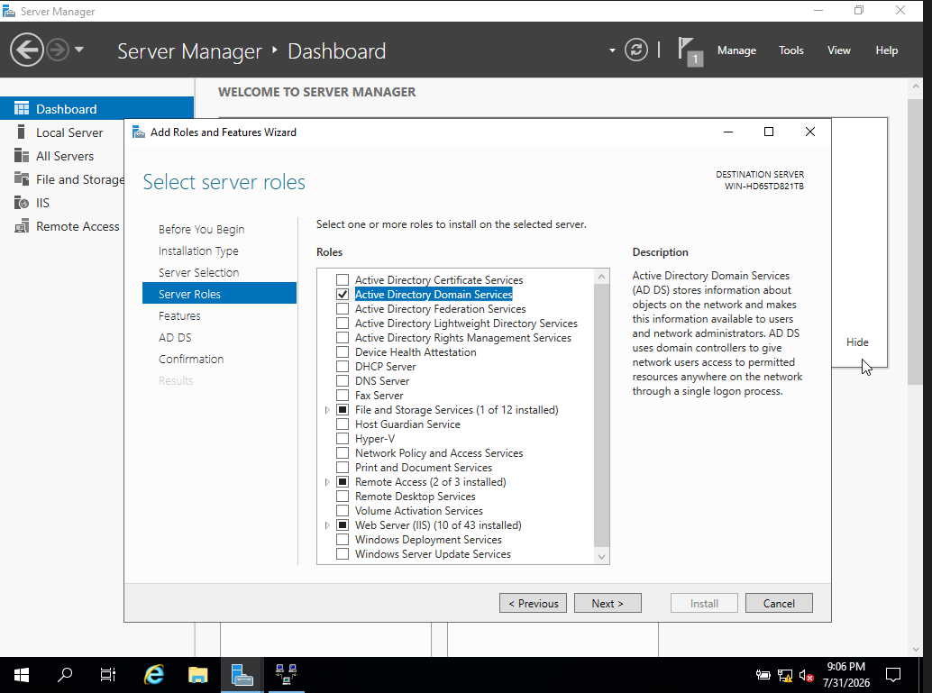
Figure 10. Selection of the Active Directory Domain Services (AD DS) role on B-DC.

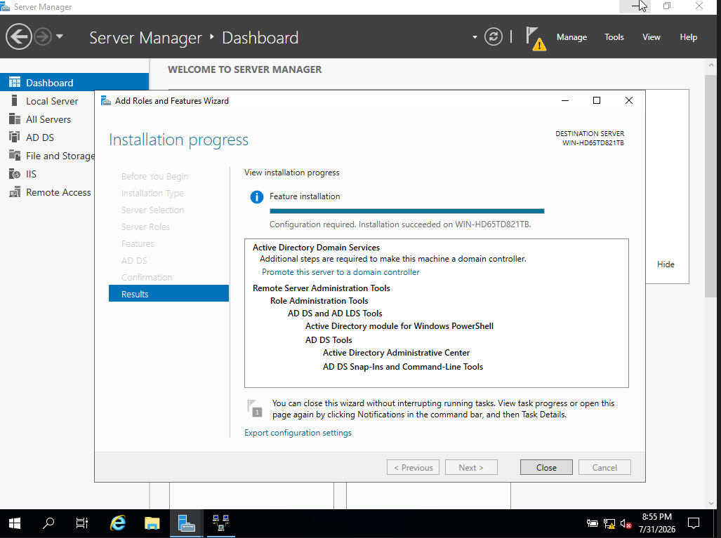
Figure 11. Active Directory Domain Services (AD DS) successfully installed on B-DC.

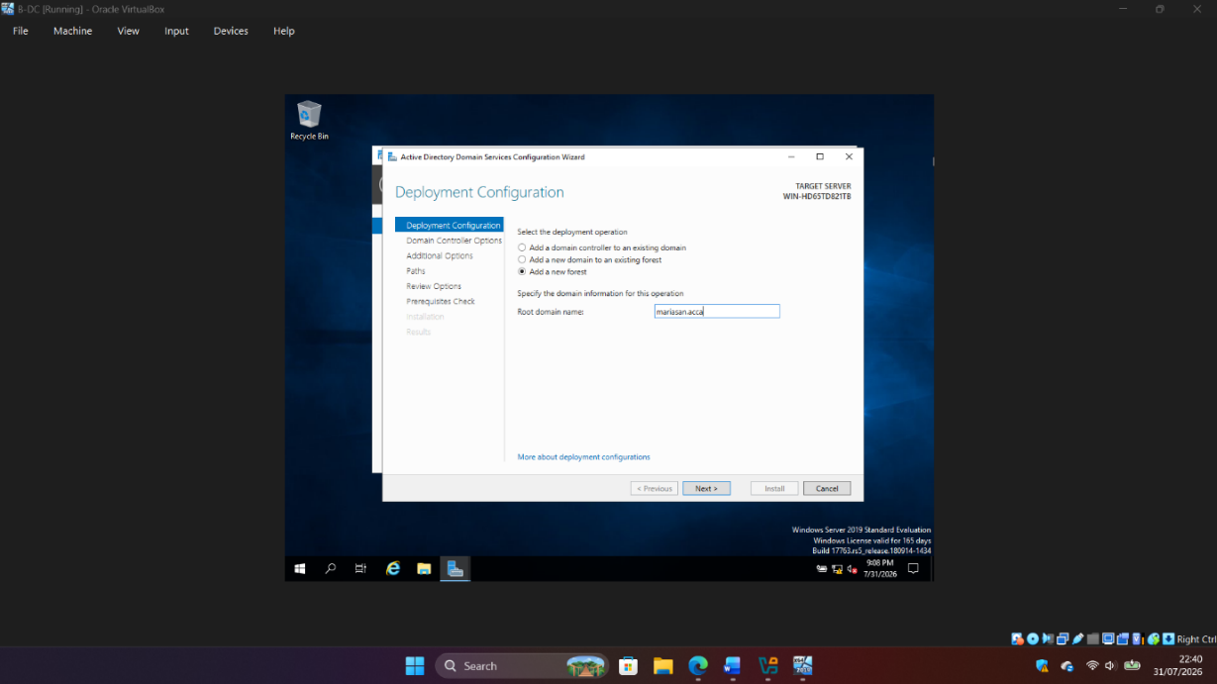
Figure 12. Deployment configuration for creating the new Active Directory forest (mariasan.acca).

The DNS delegation warning is expected because the new forest does not have an existing parent DNS zone. No DNS delegation was required in this isolated laboratory environment.
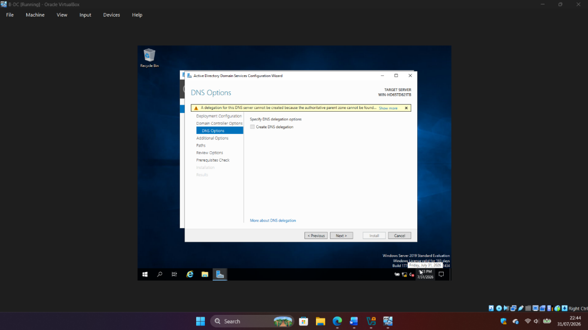
Figure 13. DNS delegation warning during the creation of the new Active Directory forest.

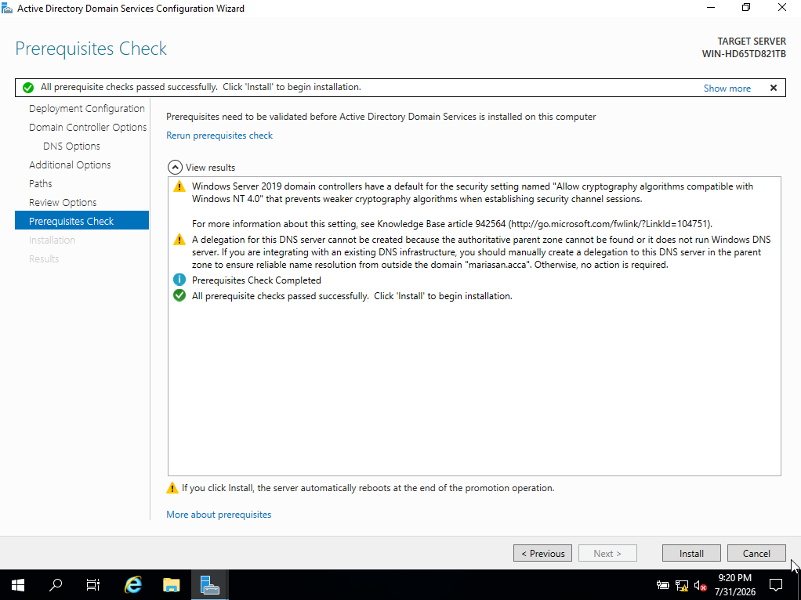
Figure 14. Active Directory prerequisites successfully validated before promoting B-DC to a domain controller.

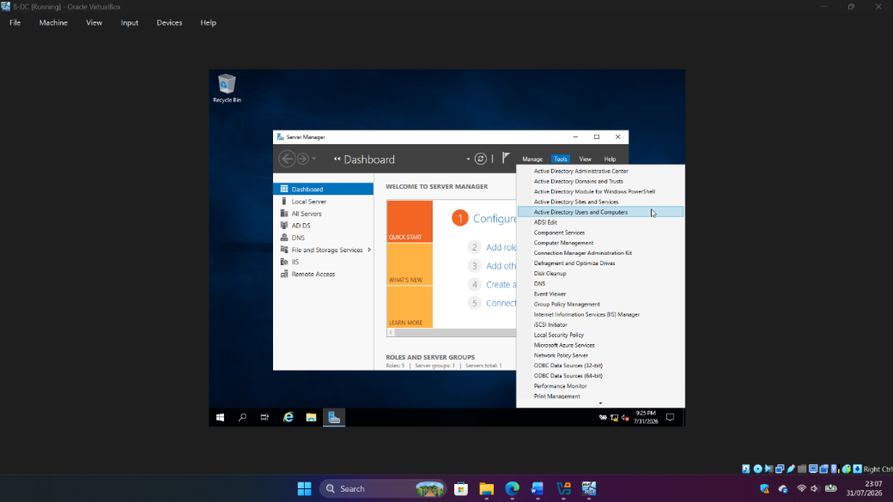
Figure 15. Active Directory management tools available after promoting B-DC to a domain controller.

B-DC was successfully promoted to the first domain controller in the new mariasan.acca forest. DNS and the Active Directory administration tools were installed as part of the deployment.

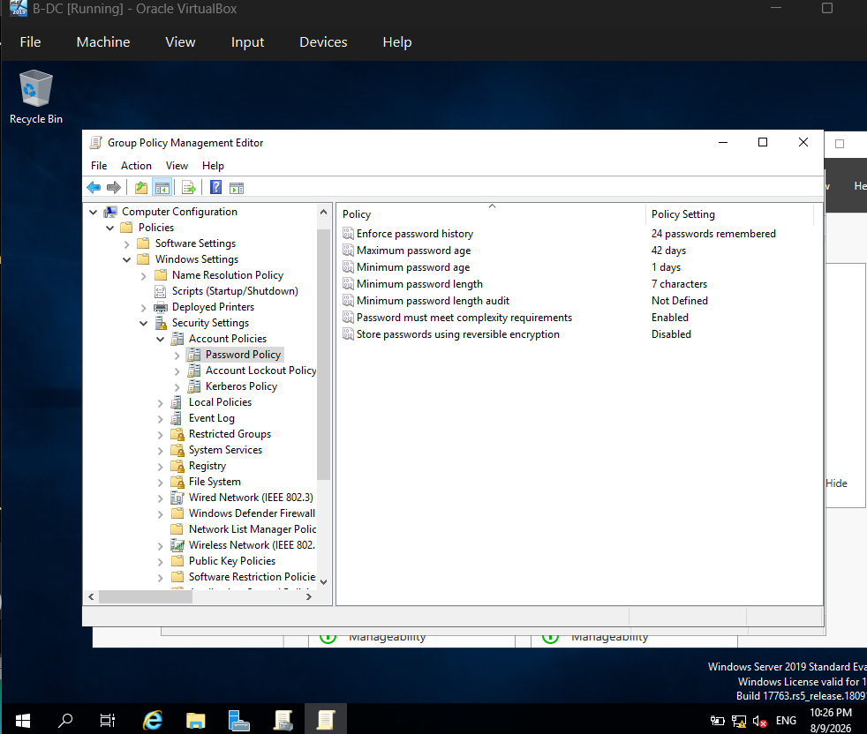
Figure 16. Secure domain password policy configured for mariasan.acca.
Part 2. Configure Forward DNS Resolution

Once the domain controller had been deployed successfully, additional DNS A records were created to allow systems on both the Birmingham and London networks to resolve hostnames correctly. These records map the hostnames of the servers and client computers to their corresponding IPv4 addresses, enabling name resolution across both network sites.

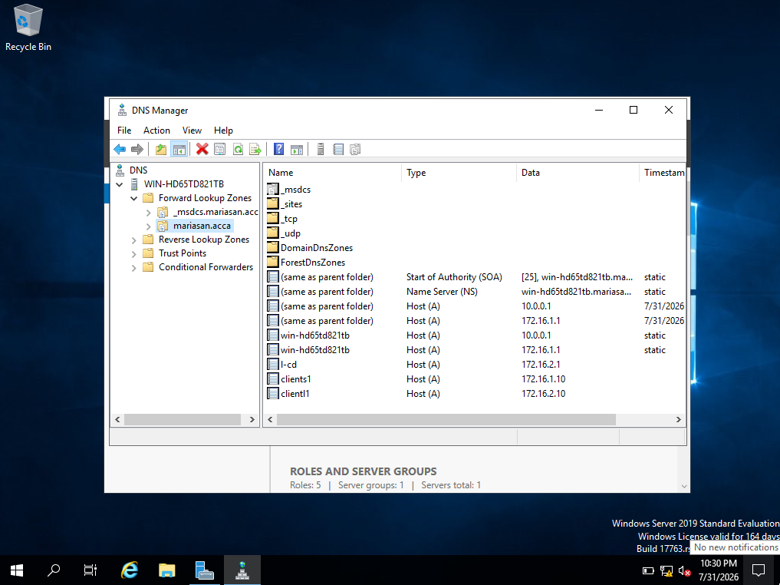

Figure 17. Forward DNS zone showing the A records configured for the Birmingham and London infrastructure.

Part 3. Configure Reverse DNS Resolution

Reverse lookup zones were created for the Birmingham (172.16.1.0/24) and London (172.16.2.0/24) subnets. PTR records were then configured to resolve the IPv4 addresses of servers and clients back to their corresponding hostnames, supporting administration and troubleshooting.

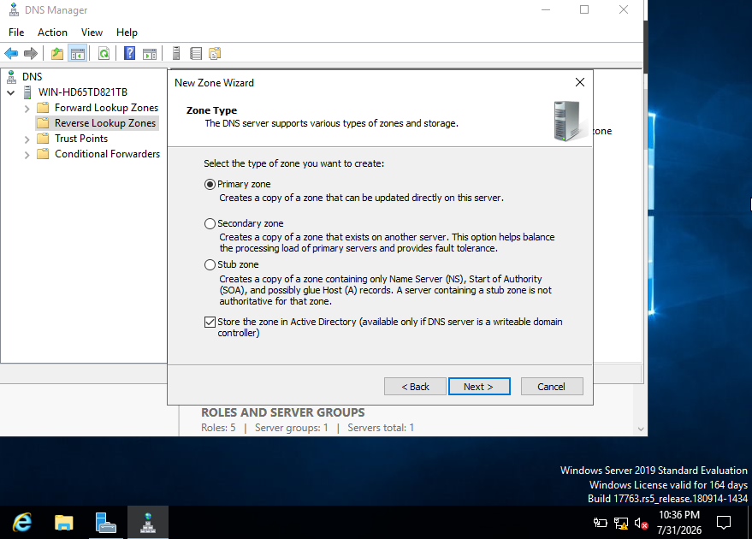
Figure 18. Configuration of the reverse lookup zone as an Active Directory-integrated primary zone.

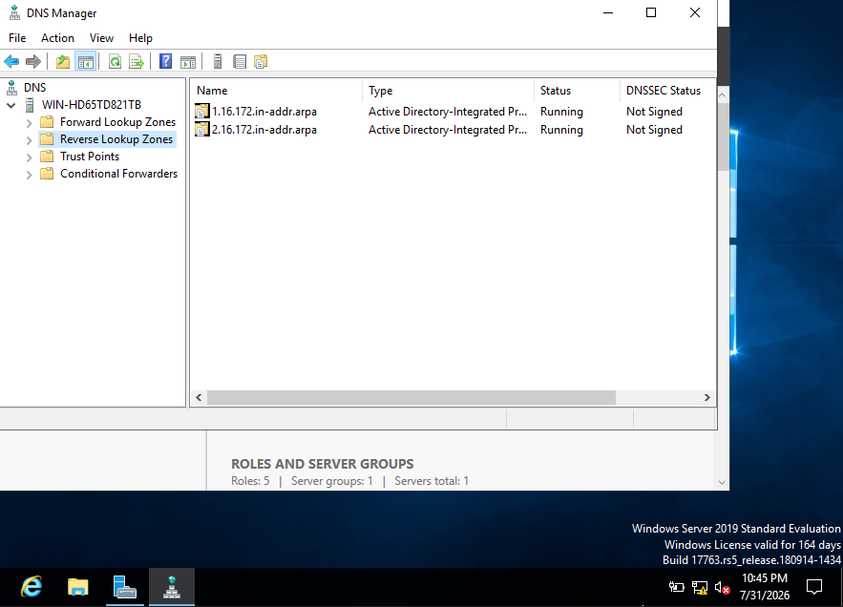
Figure 19. Reverse lookup zones created for the Birmingham and London IPv4 subnets.
Figure 20. PTR records configured for the Birmingham and London servers and client computers.
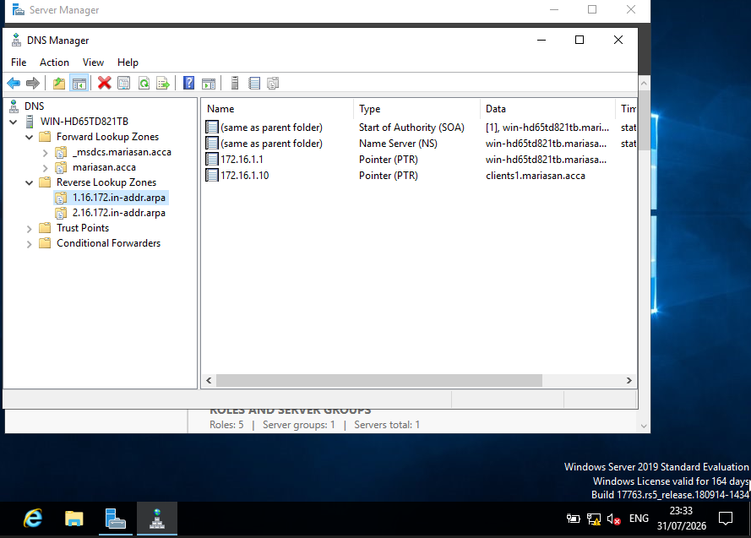

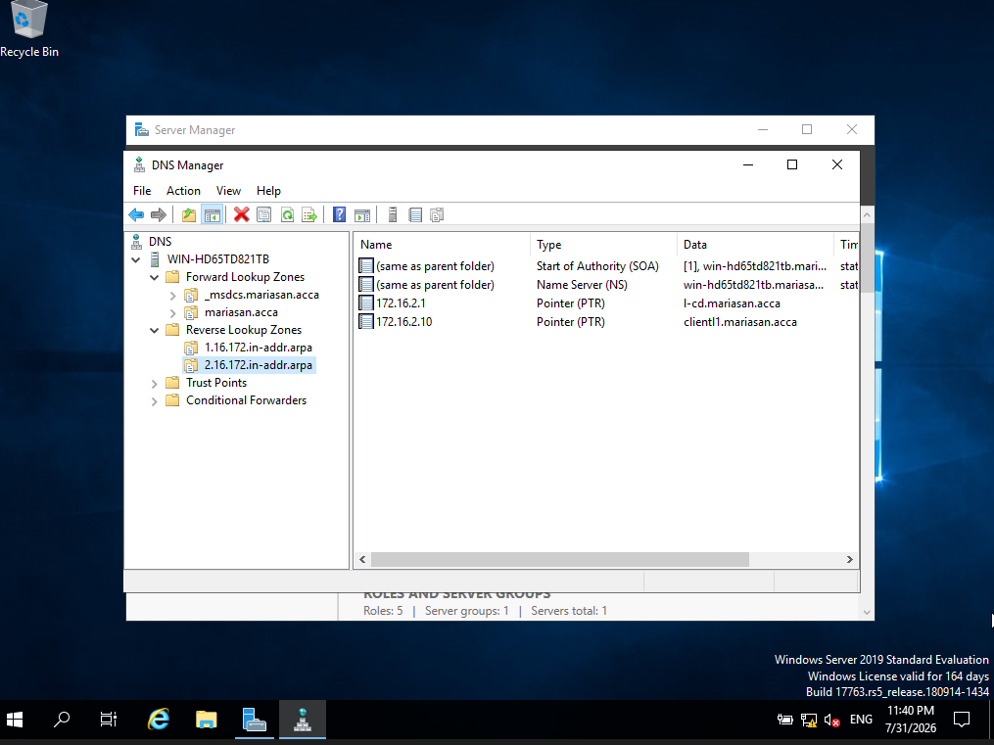

Task 3 – Encrypted Connection between Birmingham and London

3.1 Configure Site-to-Site VPN to London Network.
A Site-to-Site VPN provides secure communication between geographically separated networks by protecting traffic through authentication and encryption. In this implementation, RRAS on B-DC was configured using IKEv2 to demonstrate secure VPN connectivity.

Figure 21. VPN protocols enabled in Routing and Remote Access (RRAS).
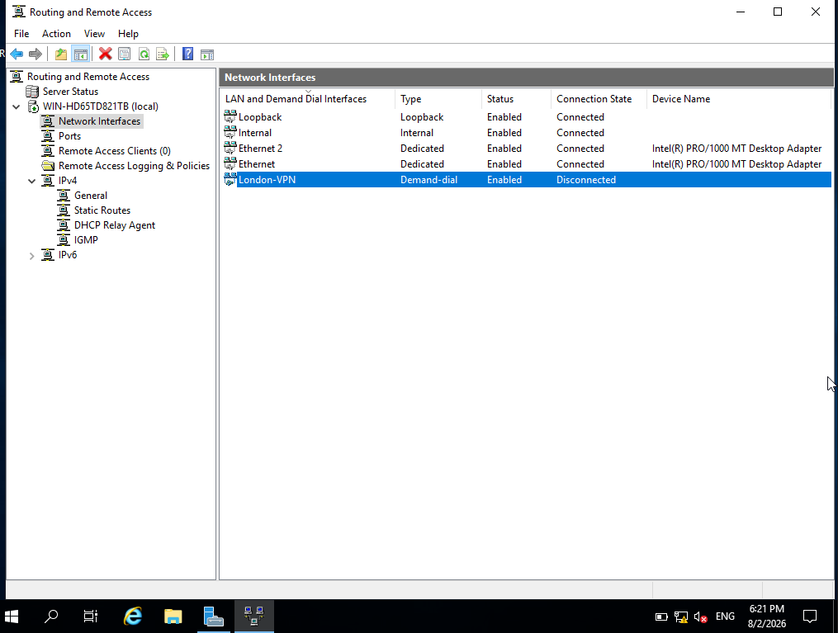

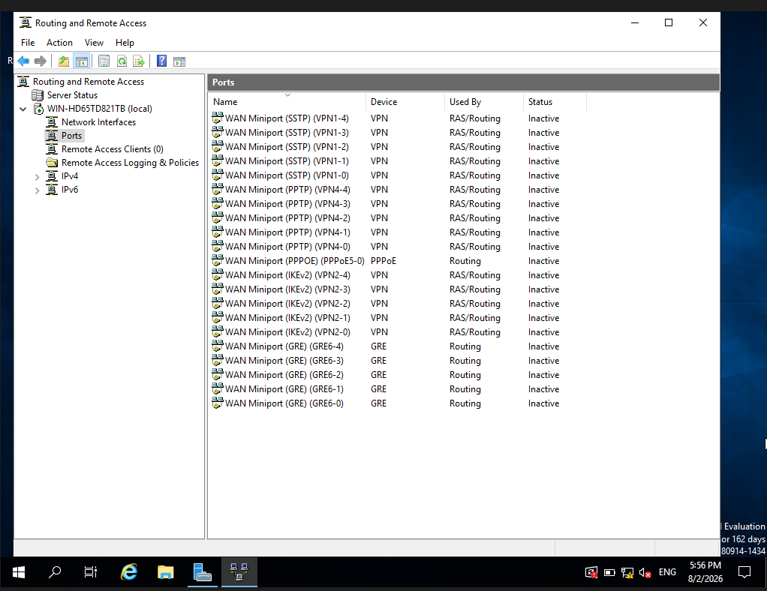
Figure 22. Demand-Dial VPN interface configured for the London site in RRAS.

Implementation note: Following clarification from the lecturer, configuration of the Linux VPN endpoint was not required. Therefore, the IKEv2 VPN configuration was demonstrated on B-DC using RRAS.

Task 4 – Users

Objective of the assessment
Create domain user accounts in the mariasan.acca domain using the required SAM Account Name convention (first initial, dot and surname).

4.1 Creating users
Following clarification from the lecturer, no user list was provided. Therefore, two sample domain accounts were created using the PowerShell New-ADUser cmdlet to demonstrate automated user creation and the required SAM Account Name convention. Secure passwords were assigned and the accounts were enabled and verified in Active Directory.

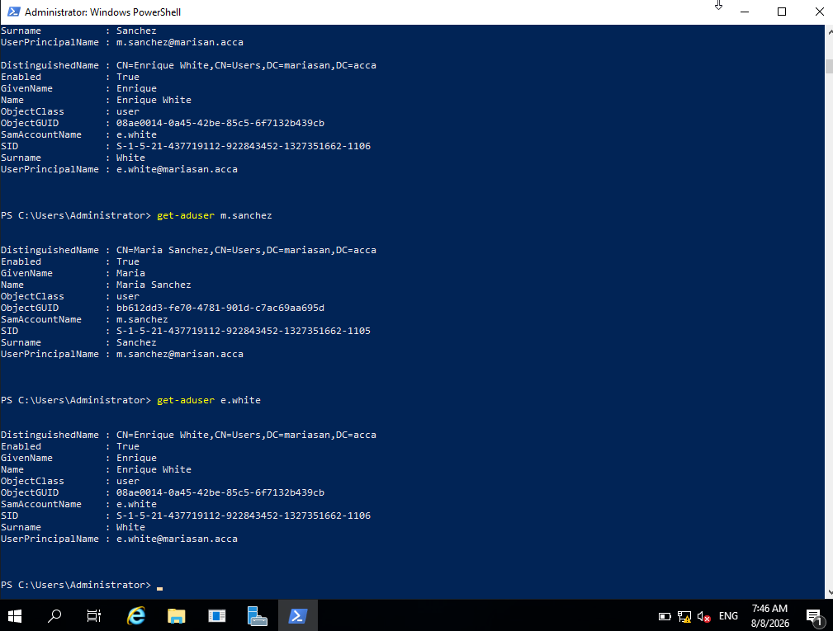
Figure 23. Verification of the domain user accounts created in Active Directory using PowerShell.

Figure 24. Domain user accounts displayed in Active Directory Users and Computers.
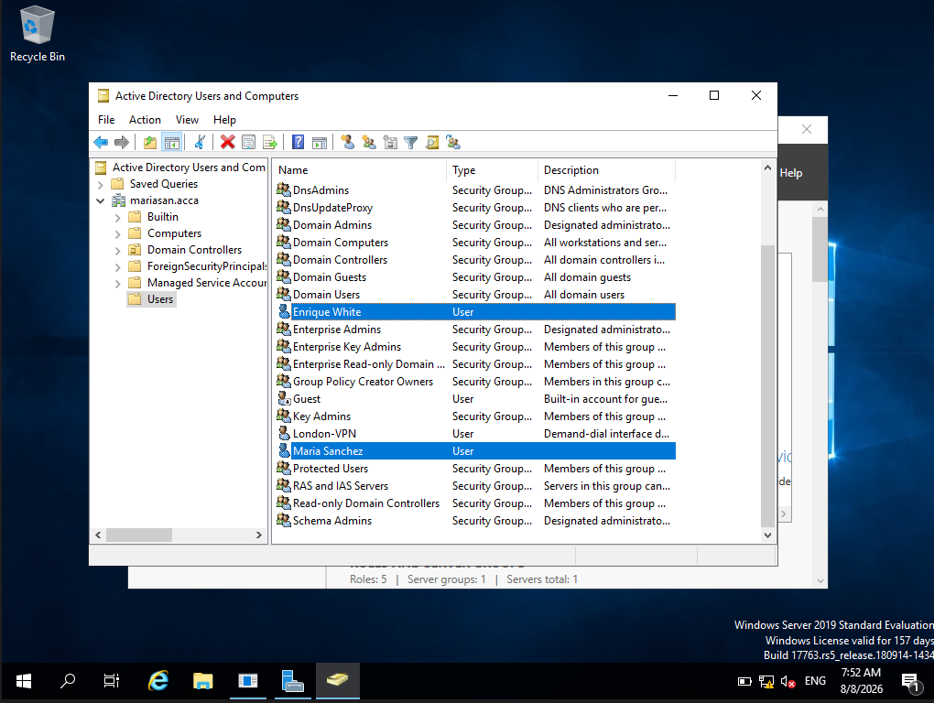

Task 5 – Domain Membership

Objective: Join L-CD, ClientS1 and ClientL1 to the mariasan.acca domain and verify their integration with Active Directory.

ClientS1 was configured to use B-DC (172.16.1.1) as its default gateway and DNS server, allowing communication with the Domain Controller and DNS resolution for mariasan.acca. The client was then joined to the domain using administrator credentials and restarted.

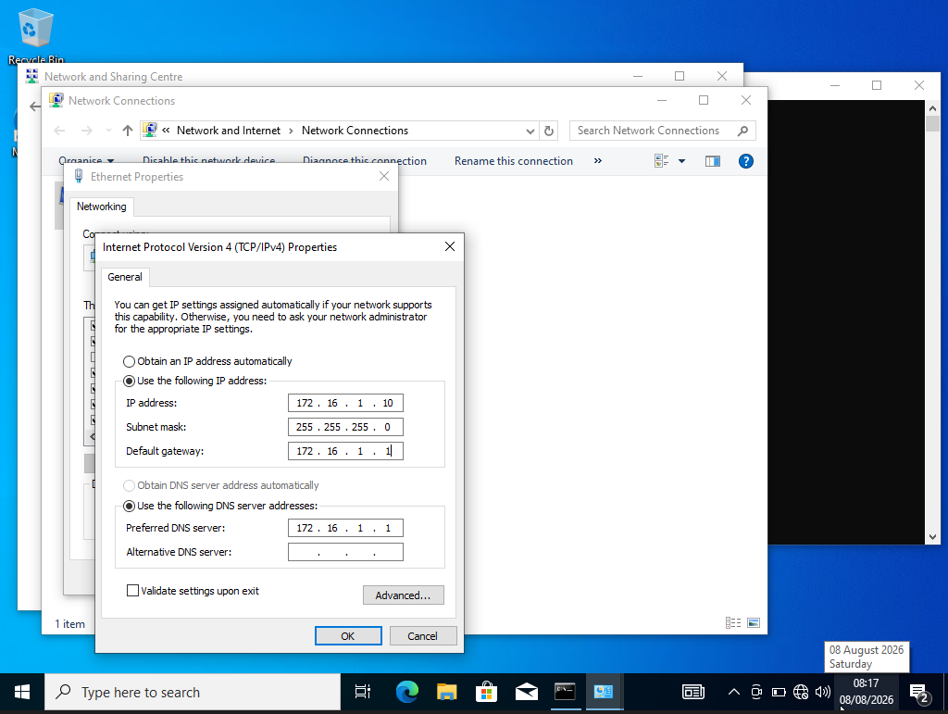
Figure 25. IPv4 configuration of ClientS1 showing B-DC as the default gateway and preferred DNS server.

Figure 26. ClientS1 successfully joined to the mariasan.acca domain, replacing the previous WORKGROUP membership.
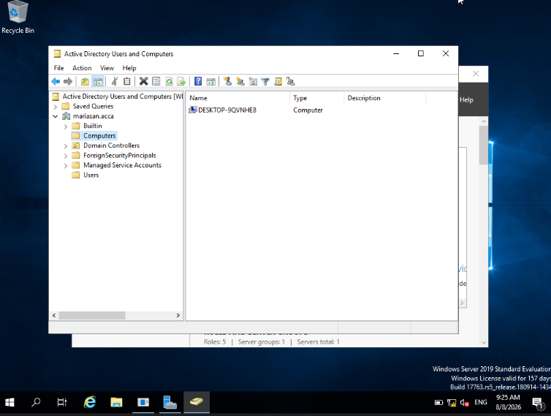

Figure 27. ClientS1 computer account registered in Active Directory Users and Computers after joining the mariasan.acca domain.
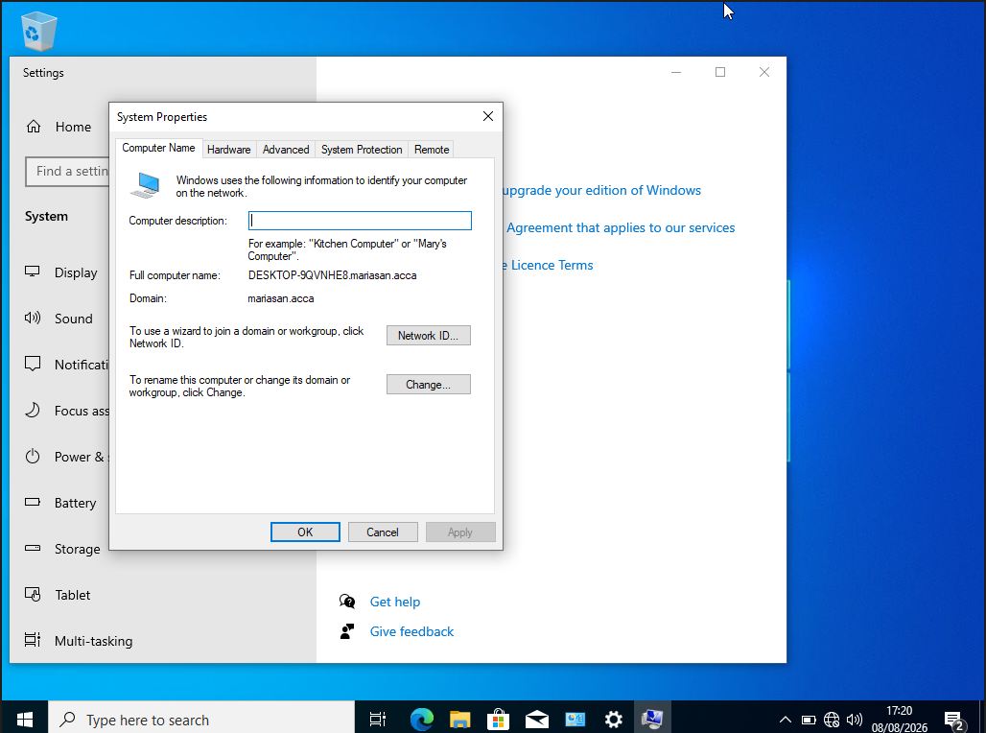

Figure 28. ClientL1 successfully joined to the mariasan.acca Active Directory domain, with realm list confirming Kerberos membership and SSSD integration.
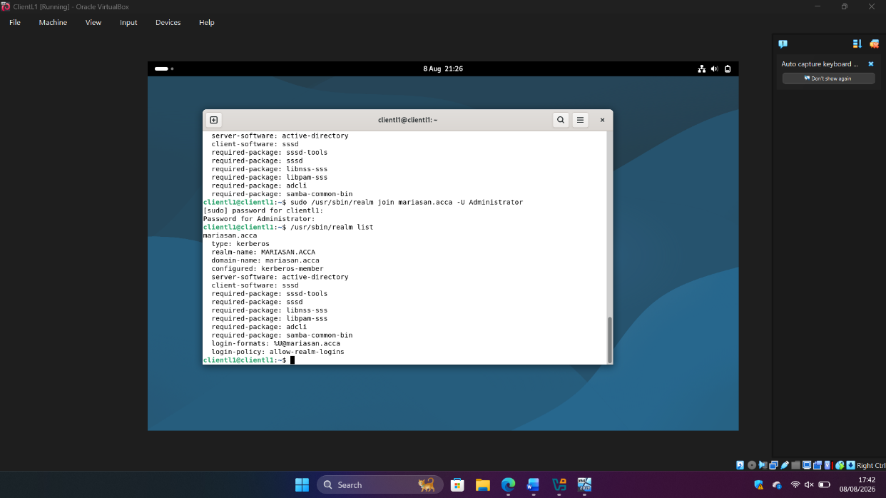

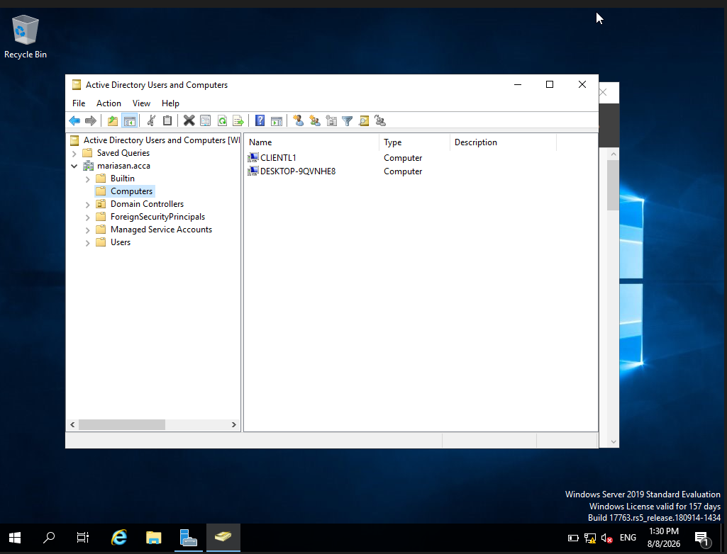
Figure 29. Active Directory Users and Computers on B-DC confirming that CLIENTL1 has been successfully added to the mariasan.acca domain.

Task 6 – DHCP Server and Relay Configuration

DHCP (Dynamic Host Configuration Protocol) automatically provides clients with network configuration such as IP addresses, default gateway and DNS settings. In this network, B-DC was configured as the central DHCP Server, while L-CD provides DHCP Relay functionality for the London network.

6.1 B-DC DHCP Server Configuration
B-DC was configured and authorised in Active Directory as the central DHCP Server. A scope for the 172.16.2.0/24 London network was created with the required 172.16.2.10–172.16.2.20 allocation range and appropriate gateway and DNS options.

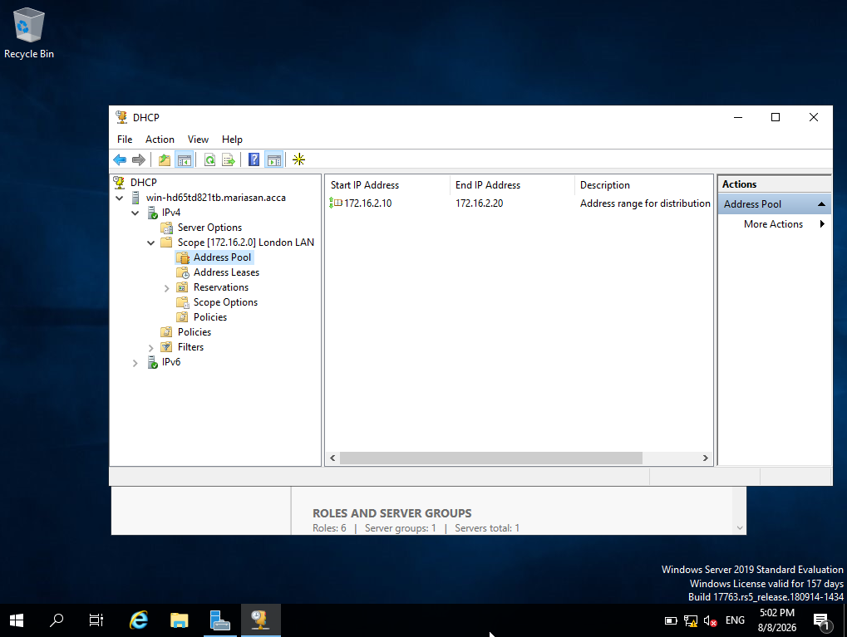
Figure 30. DHCP address pool configured on B-DC for the London LAN, providing the address range 172.16.2.10–172.16.2.20.

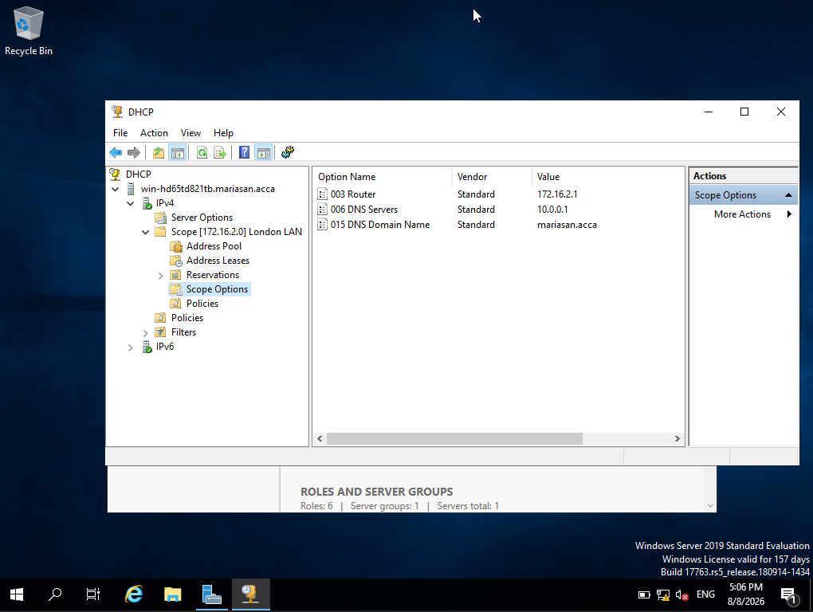
Figure 31. DHCP scope options configured on B-DC, providing the L-CD gateway (172.16.2.1), B-DC DNS server (10.0.0.1) and the mariasan.acca domain name.

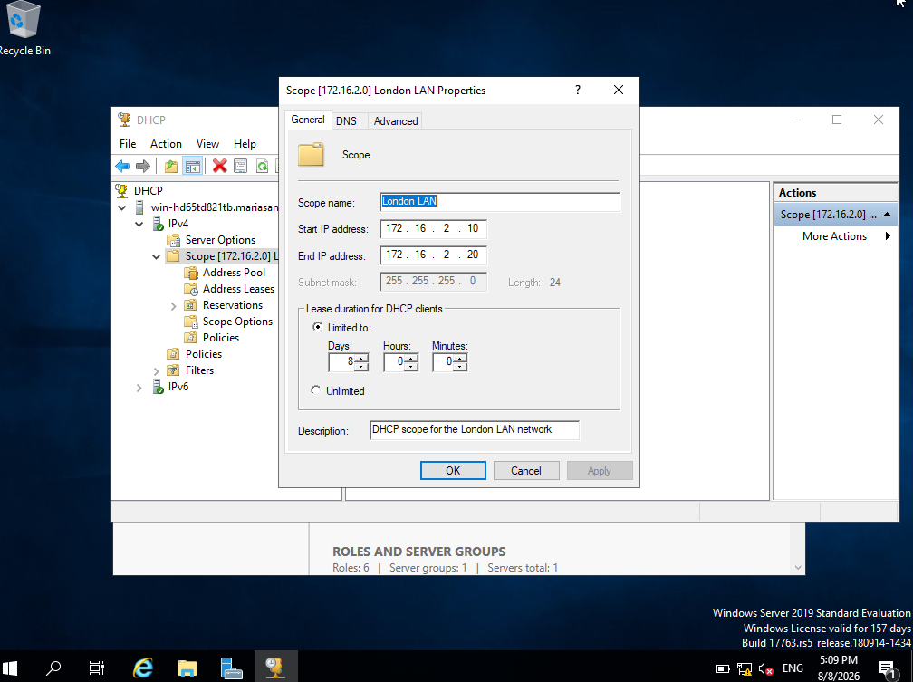
Figure 32. DHCP London LAN DHCP scope properties on B-DC, showing the 172.16.2.10–172.16.2.20 allocation range, /24 subnet and an eight-day DHCP lease duration.

An eight-day lease duration was configured to provide stable address allocation while allowing the DHCP server to periodically reclaim and redistribute unused addresses.

6.2 L-CD DHCP Relay Server Configuration
L-CD was configured as a DHCP Relay to forward DHCP requests from the London network to the central DHCP Server on B-DC (10.0.0.1), allowing clients on a different subnet to obtain their network configuration automatically. The active service status confirmed that the relay was operational.

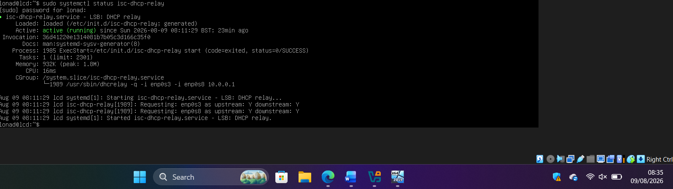
Figure 33. DHCP relay service running on L-CD, configured to forward DHCP requests between enp0s3 and enp0s8 to the B-DC DHCP server at 10.0.0.1.

6.3 Automatic DHCP Address Allocation to Clients
ClientL1 was changed from static to automatic IPv4 configuration and successfully received 172.16.2.10/24 from B-DC through the L-CD relay, together with the correct gateway (172.16.2.1), DNS server (10.0.0.1) and domain settings. The corresponding lease was verified on B-DC, and subsequent connectivity and DNS tests completed successfully.

Figure 34. ClientL1 successfully obtaining the dynamic IPv4 address 172.16.2.10/24 through DHCP from B-DC via the L-CD DHCP relay.
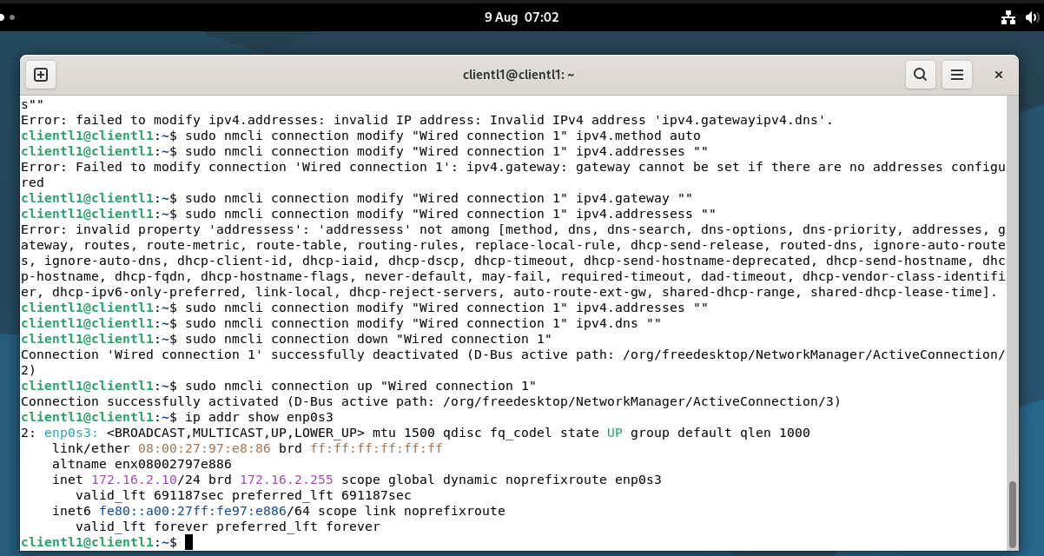

Figure 35. DHCP lease recorded on B-DC for ClientL1, confirming the successful allocation of 172.16.2.10 from the London LAN DHCP scope.
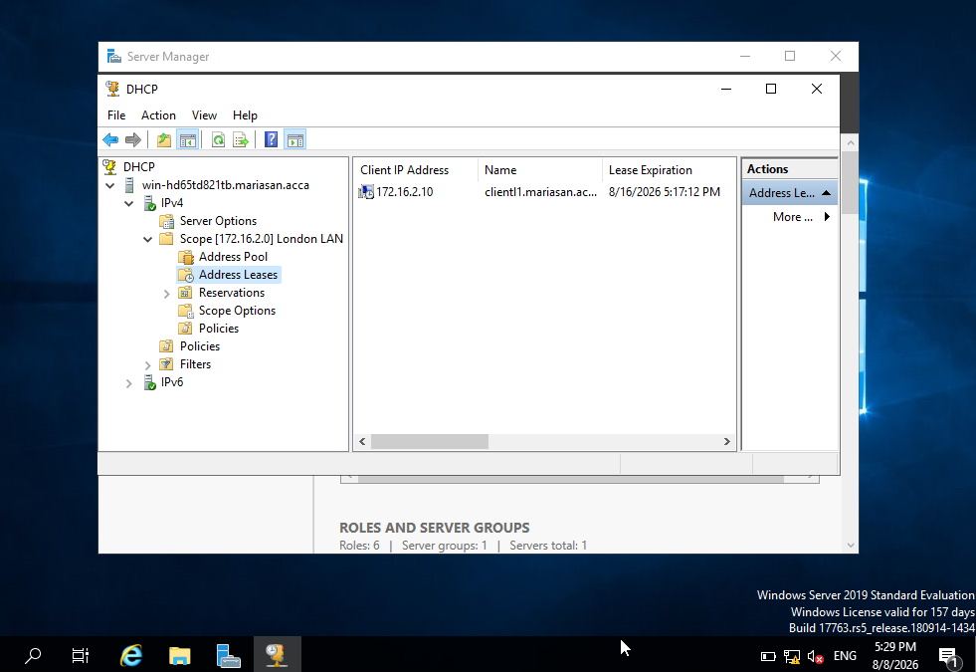

Figure 36. DHCP network configuration received by ClientL1, showing the dynamically assigned IPv4 address, default gateway, DNS server and mariasan.acca domain.
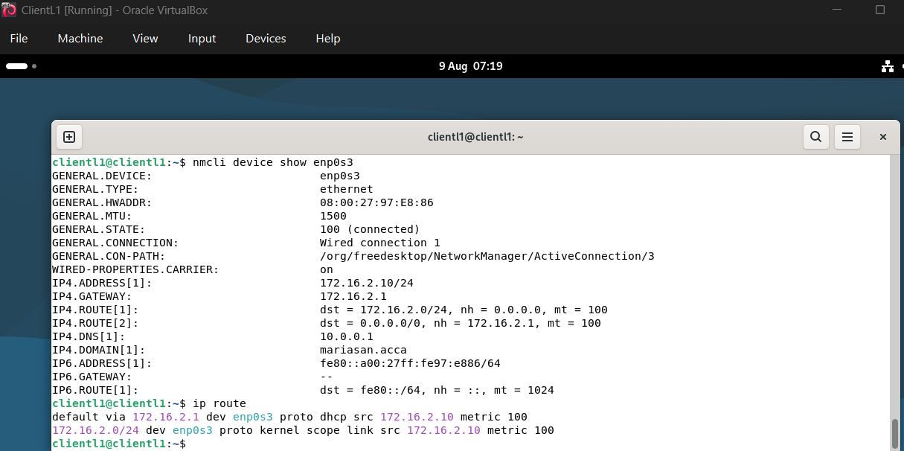

Figure 37. Successful connectivity and DNS resolution from ClientL1 after receiving its network configuration via DHCP.
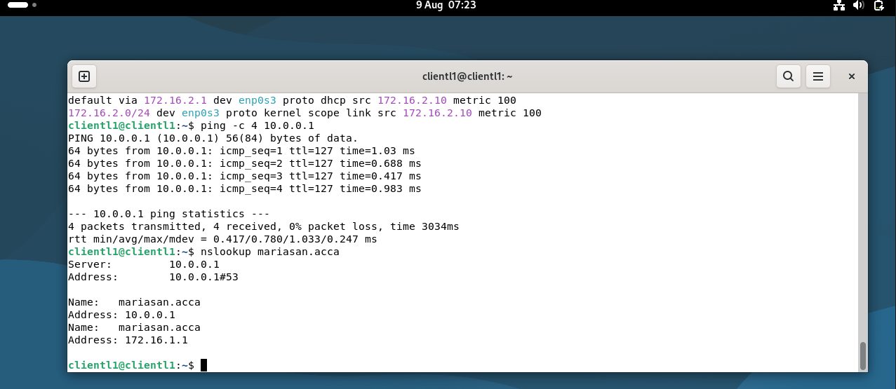

Following the DHCP allocation, ClientL1 successfully communicated with B-DC (10.0.0.1) with no packet loss and resolved the mariasan.acca domain using B-DC as its DNS server. This confirms that the DHCP-assigned configuration provides full connectivity to the domain infrastructure.

6.4 DHCP Security and Group Policy Enforcement
Additional security controls were implemented by authorising B-DC as the DHCP server in Active Directory and using Group Policy to enforce Automatic startup of the DHCP Server service, supporting consistent and centrally managed DHCP availability.

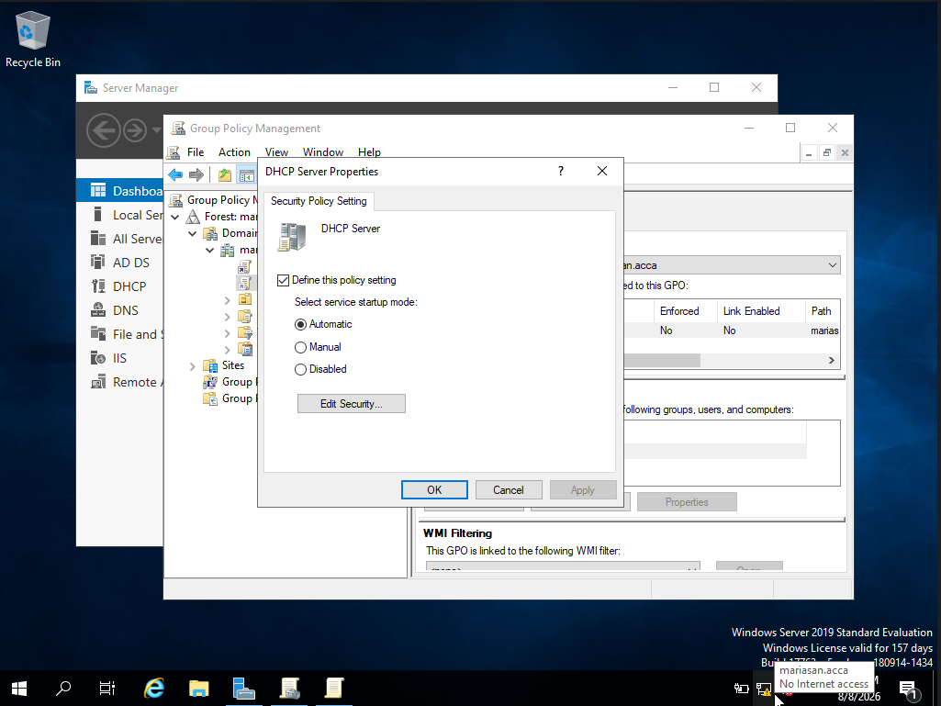
Figure 38. Group Policy security setting configured to enforce Automatic startup of the DHCP Server service.

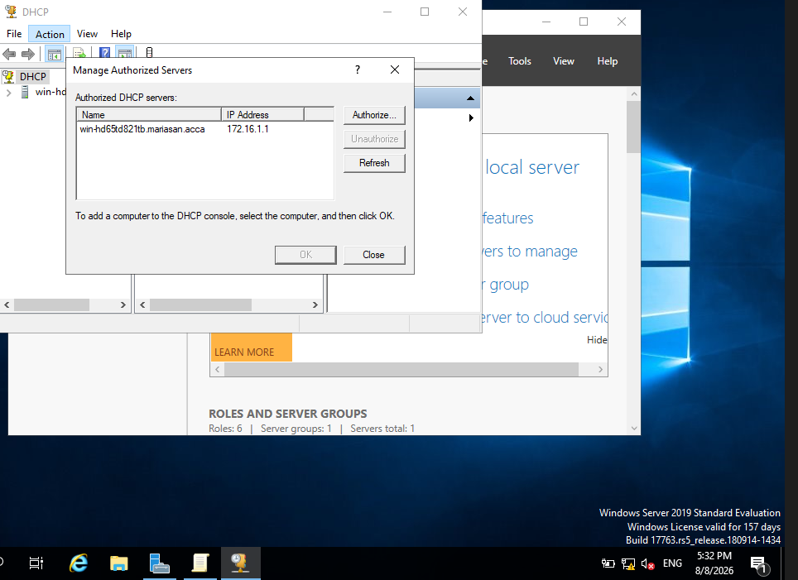
Figure 39. B-DC listed as an authorised DHCP server in Active Directory.
Task 7 – Test and Troubleshoot

Following the completion of the network and DHCP configuration, connectivity tests were performed to verify communication between the Birmingham and London networks. Testing was carried out between the Windows Server, Linux routing/relay infrastructure and domain client machines using ICMP echo requests. These tests confirm that hosts located on different network segments can communicate successfully through the configured routing infrastructure.

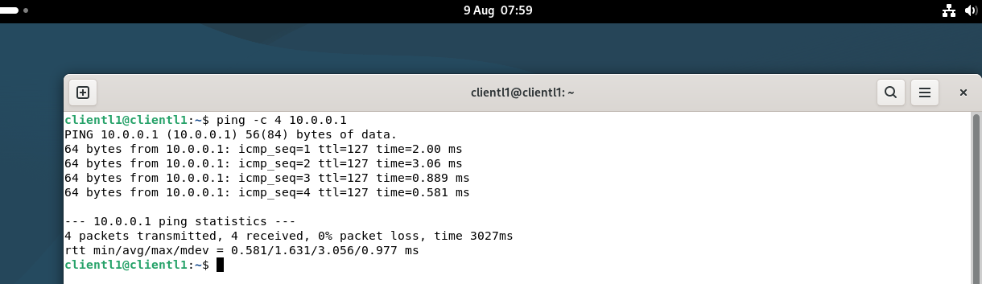
Test 1: ClientL1 – B-DC

Figure 40. Connectivity test from ClientL1 to B-DC

ClientL1 successfully communicated with B-DC (10.0.0.1) using ICMP echo requests. All four packets were received with no packet loss, confirming successful connectivity from the London client network to the server infrastructure.

Test 2: B-DC – ClientL1

Figure 41. Connectivity test from B-DC to ClientL1
B-DC successfully communicated with ClientL1 (172.16.2.10). All ICMP echo requests received a response with no packet loss, confirming bidirectional connectivity between the server and the London client network.
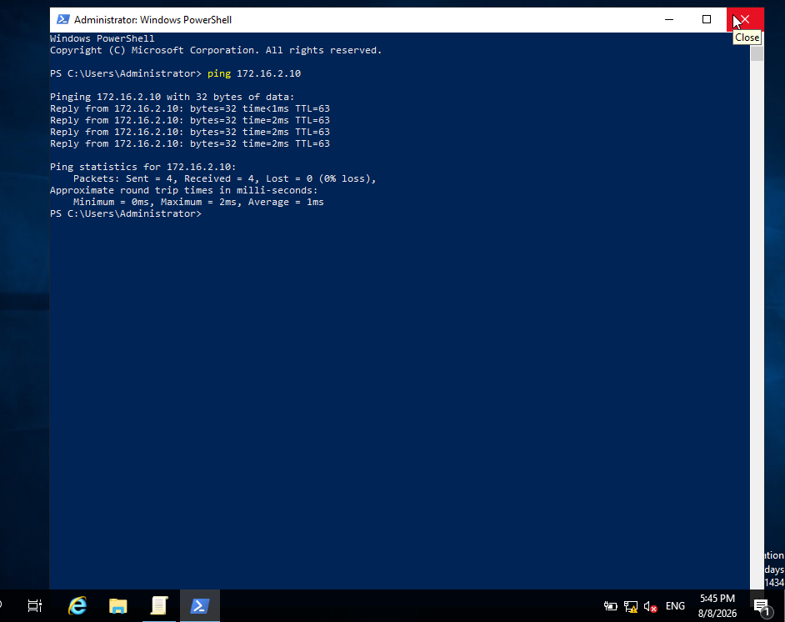

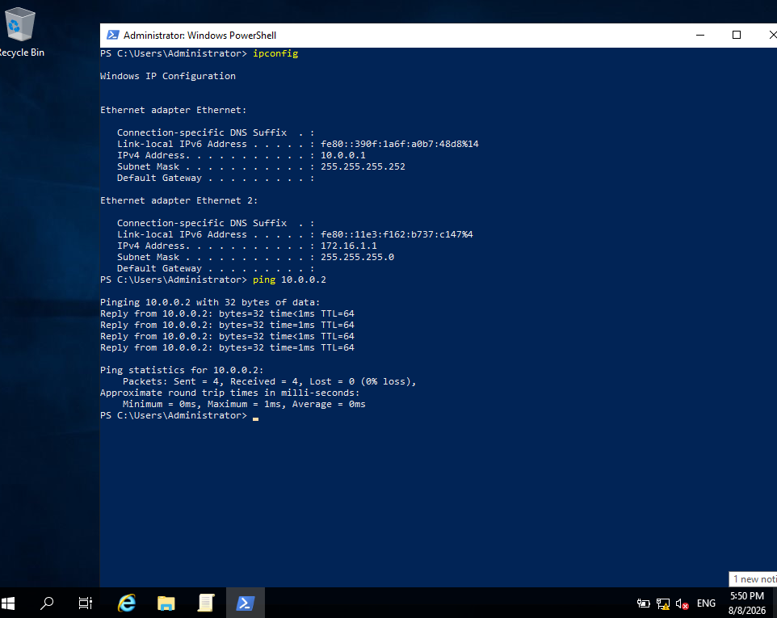
Test 3: Windows B-DC - Linux L-CD

Figure 42. Connectivity test from Windows B-DC to Linux L-CD on the same network

B-DC successfully communicated with L-CD (10.0.0.2) on the 10.0.0.0/30 network. The successful ICMP responses confirm connectivity between the Windows and Linux machines on the same network segment.
Test 4: Linux L-CD - Windows B-DC


Figure 43. Connectivity test from Linux L-CD to Windows B-DC on the same network

L-CD successfully communicated with B-DC (10.0.0.1) on the 10.0.0.0/30 network. All ICMP echo requests were successfully received, confirming bidirectional connectivity between the Linux and Windows systems.

Figure 44. Troubleshooting and successful connectivity from Birmingham ClientS1 to London ClientL1.
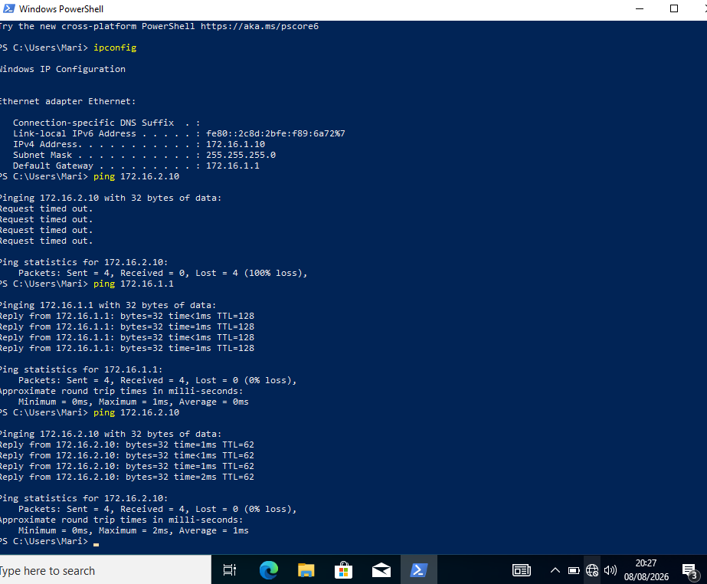

Initial connectivity testing from ClientS1 (172.16.1.10) to ClientL1 (172.16.2.10) resulted in 100% packet loss. Connectivity to the local gateway (172.16.1.1) was successfully verified, indicating that the Birmingham client configuration was operational. The routing configuration on L-CD was then corrected by adding a route to the Birmingham 172.16.1.0/24 network via B-DC (10.0.0.1). Following the correction, the test was repeated successfully with four replies and 0% packet loss, confirming connectivity between the Birmingham and London networks.

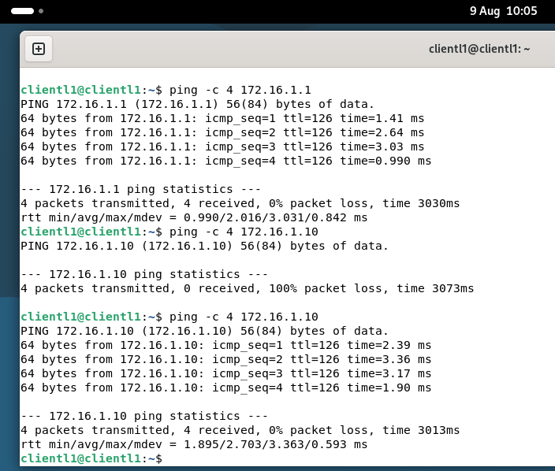
Figure 45. Troubleshooting and successful connectivity from London ClientL1 to Birmingham ClientS1.

Connectivity testing confirmed that ClientL1 could successfully reach the Birmingham gateway (172.16.1.1), while the initial connection to ClientS1 (172.16.1.10) resulted in 100% packet loss. Troubleshooting identified the Windows Firewall on ClientS1 as the cause. After allowing inbound ICMPv4 Echo Requests for the Domain profile, the test was repeated successfully with four packets received and 0% packet loss, confirming end-to-end connectivity between the London and Birmingham networks.

Task 8 – Disk Drive

A secondary disk was configured on B-DC as E:\BirminghamFiles to provide centralised network storage with controlled access for domain and network users.

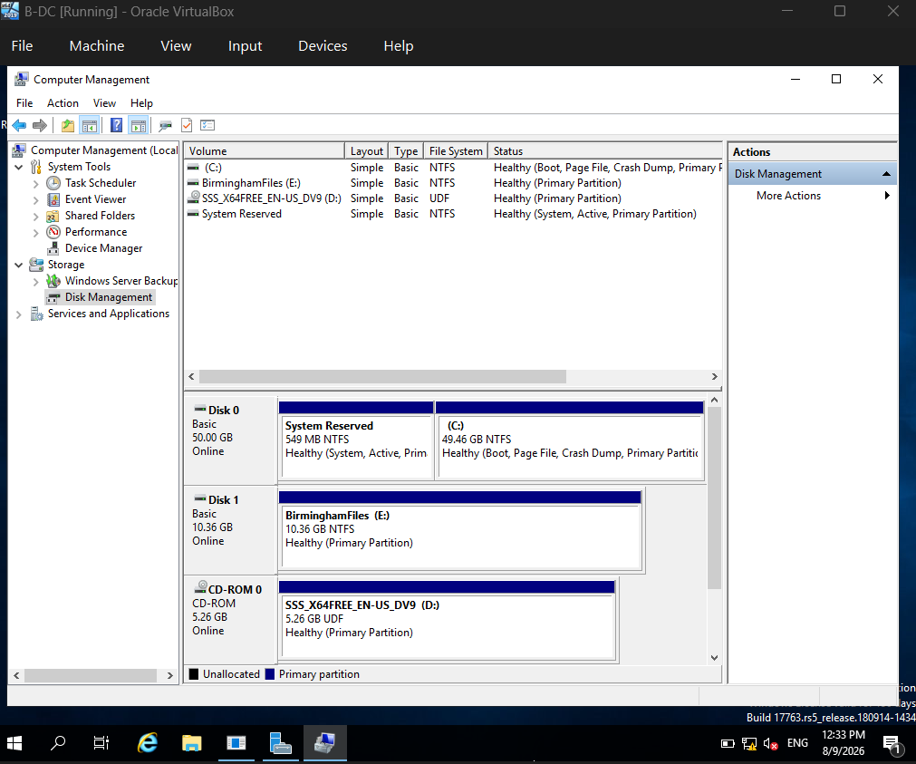
Figure 46. Secondary disk drive configured as BirminghamFiles (E:).

A secondary 10.36 GB disk was added to B-DC, initialised and formatted using the NTFS file system. The disk was assigned drive letter E: and labelled BirminghamFiles, providing dedicated storage for the Birmingham shared network resources.

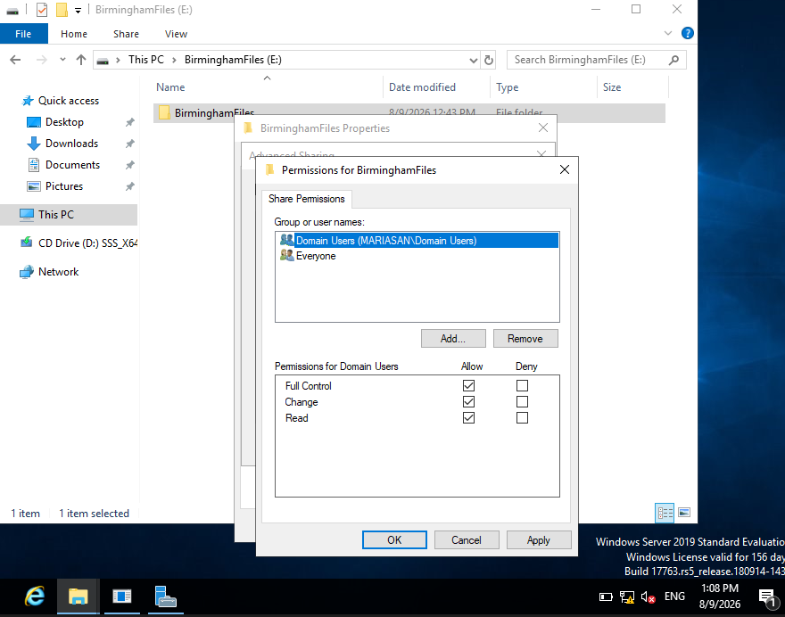
Figure 47. Share permissions configured for Domain Users on BirminghamFiles.

Figure 48. NTFS permissions configured for Domain Users on BirminghamFiles
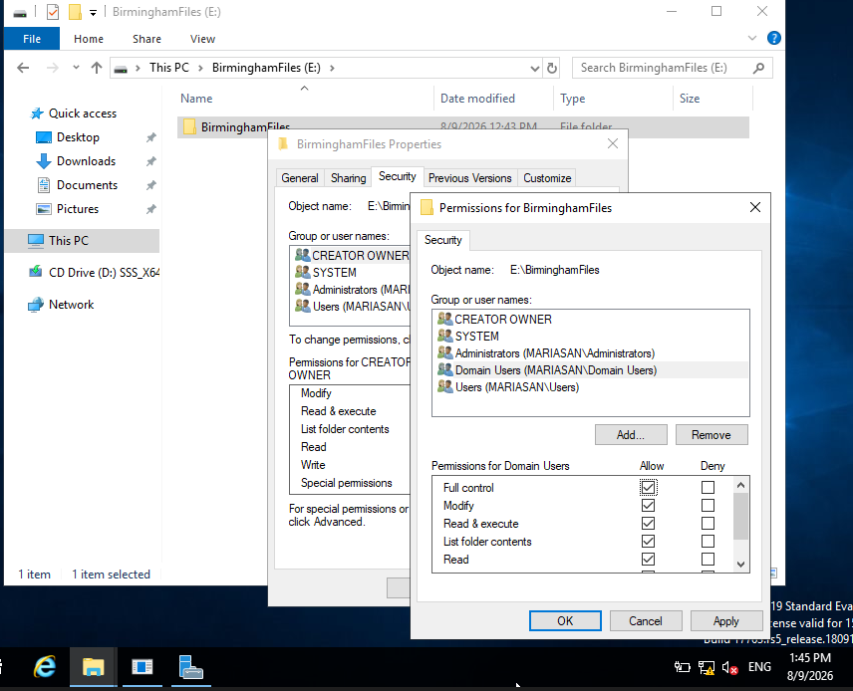

Share and NTFS permissions were configured to grant MARIASAN\Domain Users Full Control, allowing authorised users to read, create, modify and delete files, while other network users were restricted to read-only access.
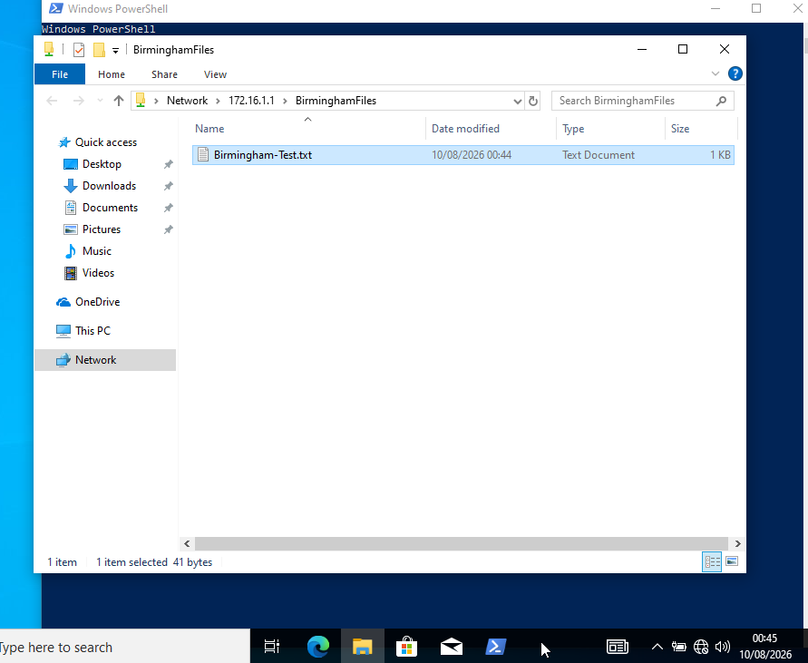
Figure 49. Successful access to the BirminghamFiles shared drive from the Birmingham network.

The Birmingham client successfully accessed the BirminghamFiles shared resource hosted on B-DC. Using a Domain Users account, the client was able to create and save Birmingham-Test.txt, confirming network access and Full Control permissions.

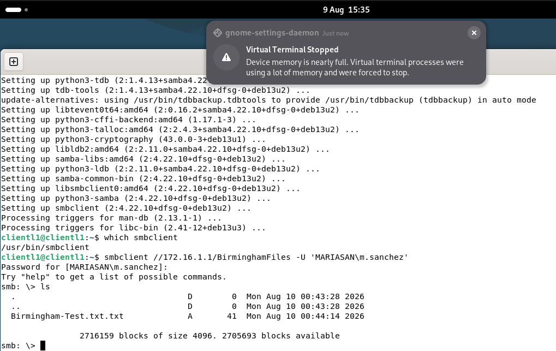
Figure 50. Successful access to the BirminghamFiles shared drive from the London network.

ClientL1 successfully accessed the BirminghamFiles share from the London network using the MARIASAN\m.sanchez domain account. The file previously created from Birmingham was successfully listed, confirming cross-network access to the shared storage.
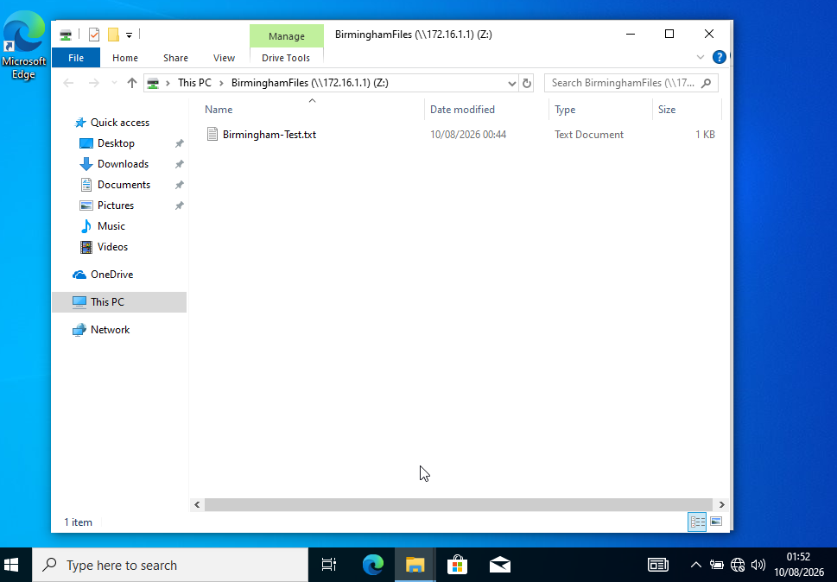
Figure 51. BirminghamFiles server share mapped as a network drive on ClientS1.

The BirminghamFiles share was successfully mapped as network drive Z: on ClientS1 and configured to reconnect at sign-in, providing direct access to the centralised server storage.

Task 9 – IIS Server

Internet Information Services (IIS) was configured on B-DC to host the internal website webs.mariasan.acca using HTTPS and Windows Authentication, restricting access to authenticated domain users.

Figure 52. Windows Authentication enabled in IIS.
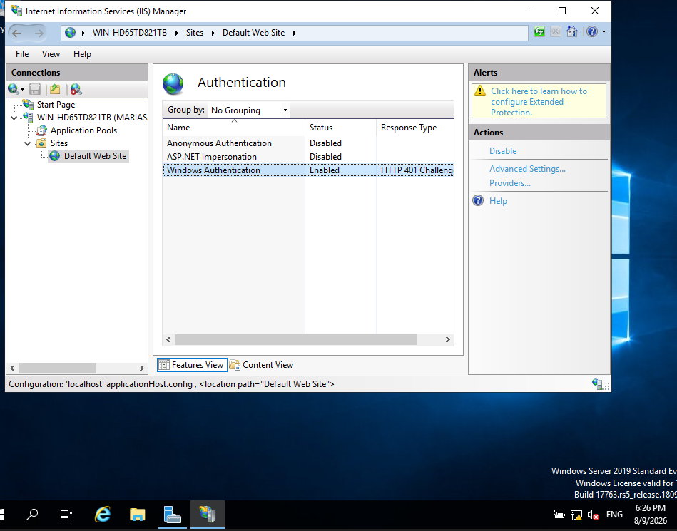

Windows Authentication was enabled and Anonymous Authentication disabled, requiring users to authenticate with their Windows domain credentials before accessing the website.

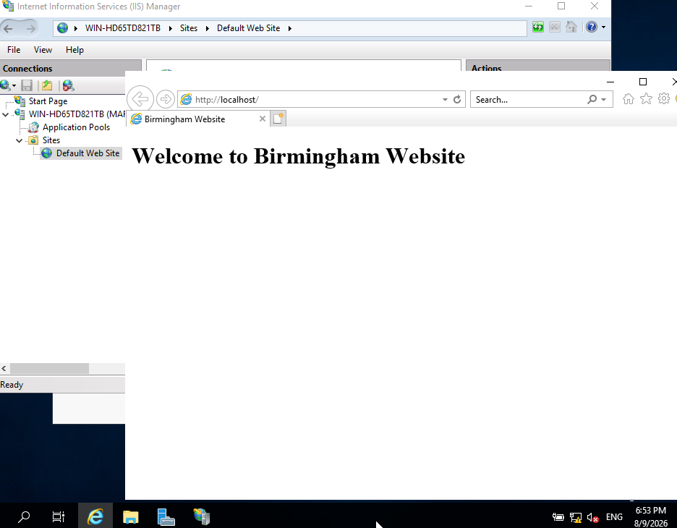
Figure 53. Birmingham Website successfully hosted on IIS

The custom IIS page was successfully hosted on B-DC and displayed the required message “Welcome to Birmingham Website”, confirming that the web server was operational.

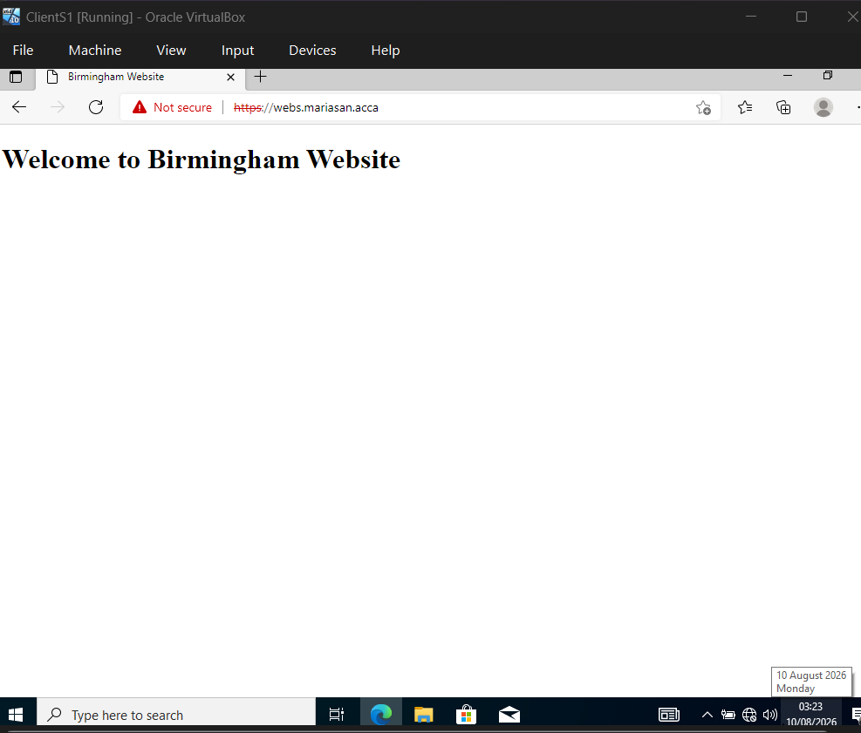
Figure 54. Birmingham Website accessed securely using HTTPS from ClientS1.

ClientS1 successfully accessed https://webs.mariasan.acca, confirming DNS resolution, HTTPS and IIS website availability. The browser security warning resulted from the self-signed certificate used in the laboratory environment.
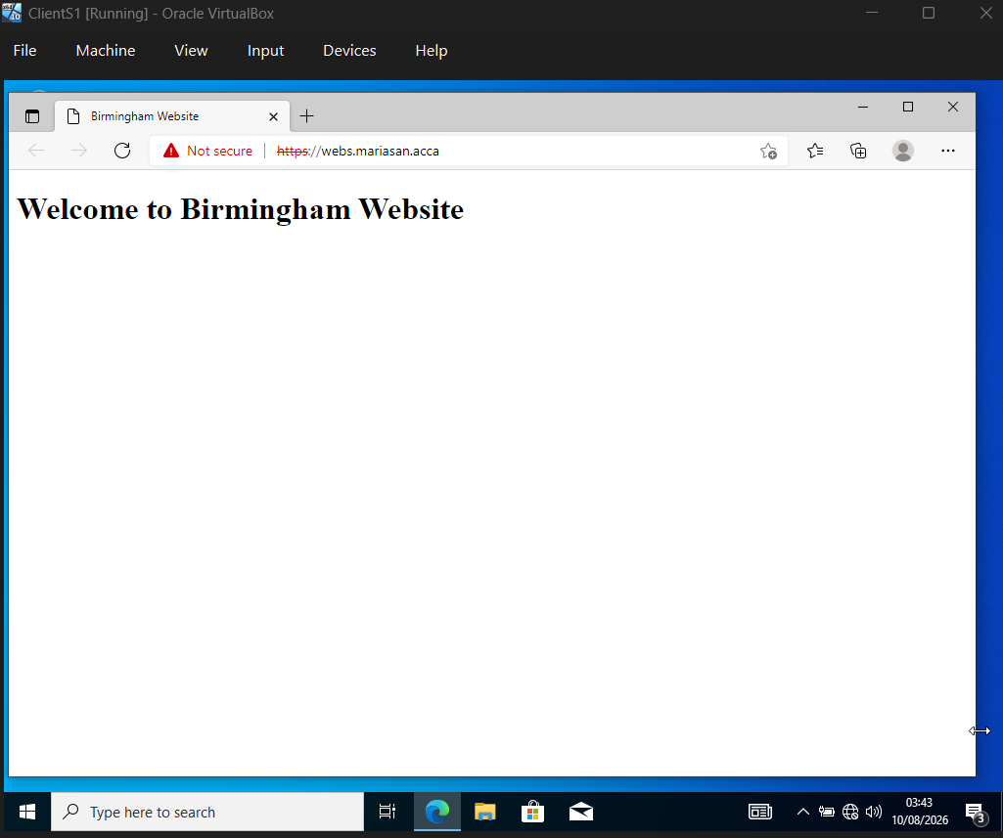
Figure 55. Authenticated access to the Birmingham IIS website from ClientS1

Windows Authentication required valid domain credentials before granting access, confirming that the website was restricted to authenticated domain users.

Task 10 – Remote Desktop Services

This task involved configuring Remote Desktop Services to provide secure remote access to the Birmingham Domain Controller (B-DC) from other machines on the network. Remote Desktop enables authorised administrators and users to remotely access and manage systems without requiring physical access to the server. The configuration was also extended to provide secure web-based Remote Desktop Services access through https://rds.mariasan.acca.

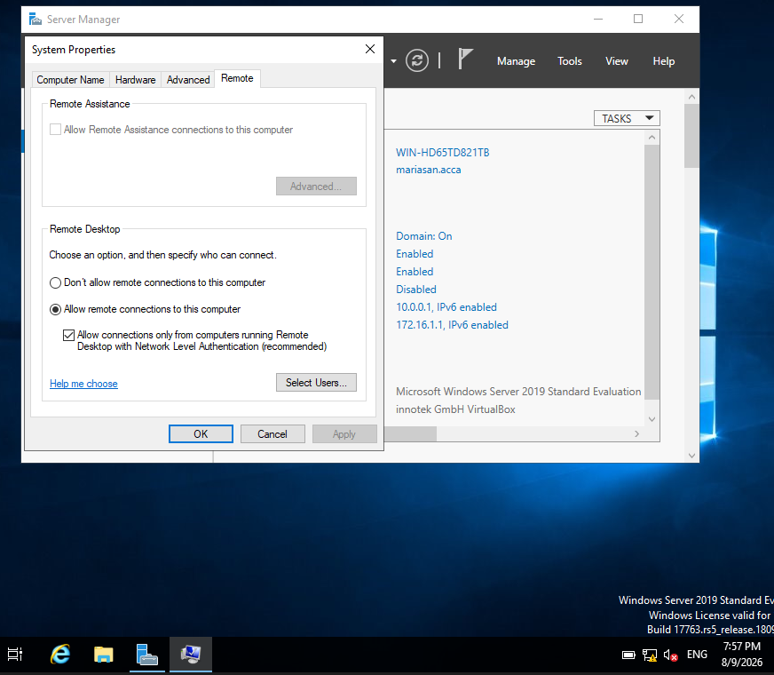
Figure 56. Remote Desktop enabled on B-DC.

Figure 57. Remote Desktop connection from ClientS1 to B-DC
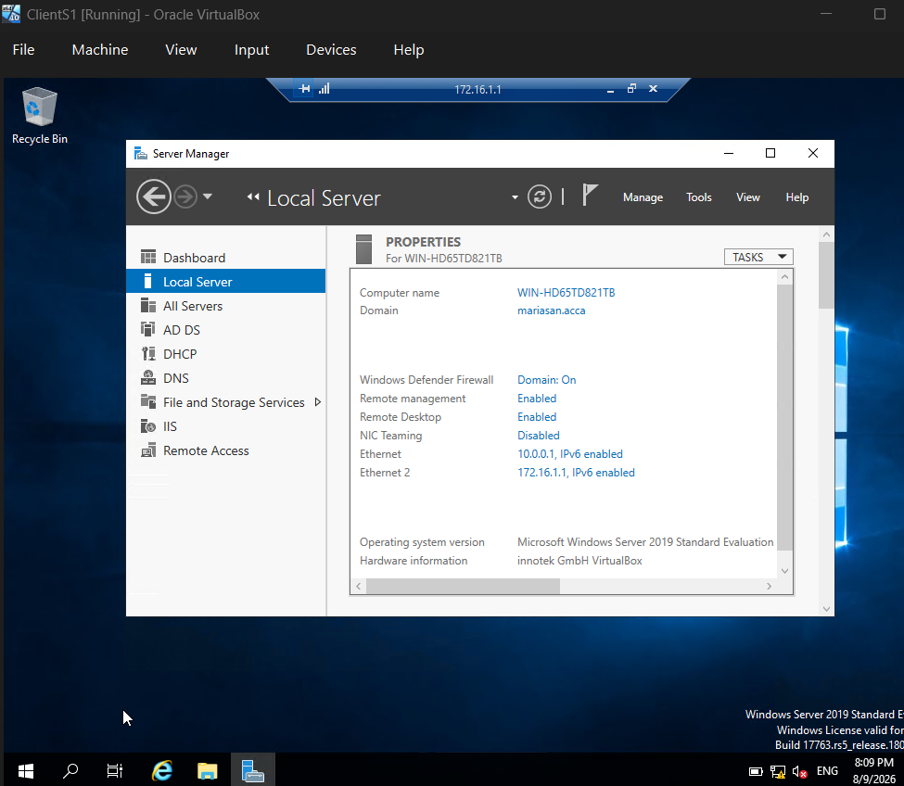

ClientS1 successfully established a Remote Desktop connection to B-DC at 172.16.1.1 using administrator credentials. The B-DC desktop and Server Manager were successfully accessed remotely, confirming that Remote Desktop was enabled and operational across the Birmingham network.

Figure 58. RD Web Access authentication page for rds.mariasan.acca, requiring domain user credentials.

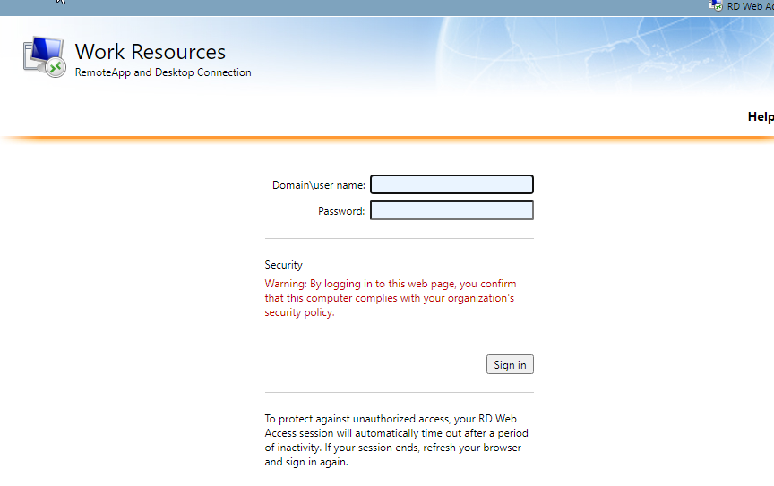

Figure 59. Authenticated RemoteApp resources available through RD Web Access


