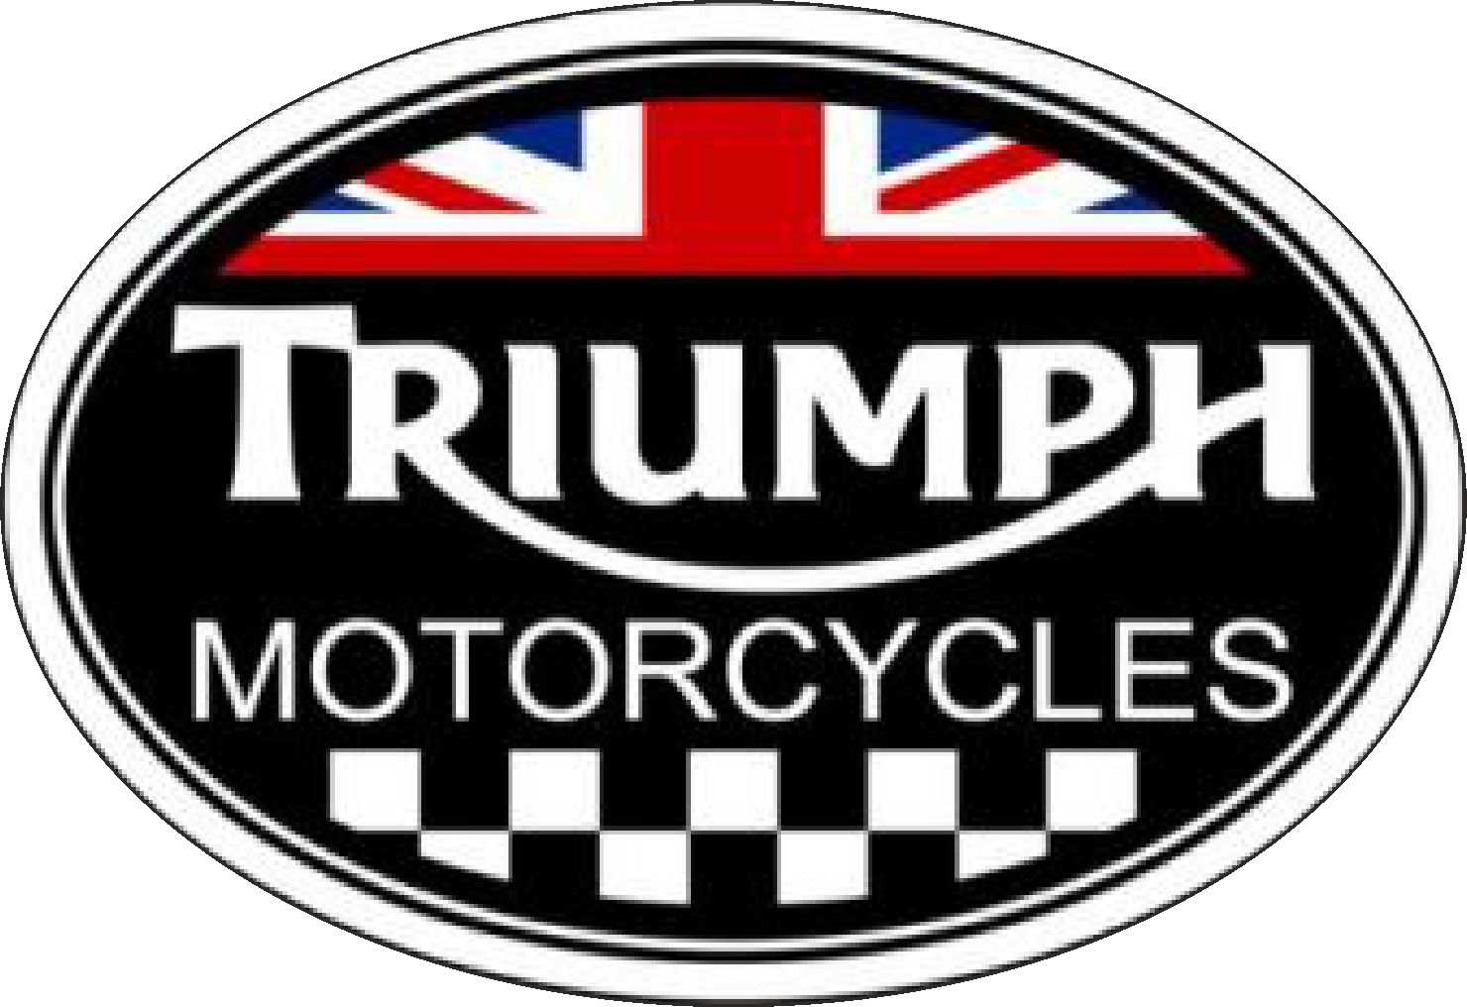
Operations Management
Ian Newberry (1703128)

2020

Contents
Introduction 2
Customers and business relationship. 3
Products and Services 3
Triumph’s Customer Base 6
Quality expectations 6
Performance objectives 7
Speed Objective 8
Dependability Objective 9
Flexibility Objective 9
The Cost Objective 10
Potential Operational Problems 10
Conclusion 11

Introduction
Within every organisation there will be a plan for their operations management. Effective operations management will govern almost every aspect of the organisation, this should mean that the organisation is always working at its most optimum level, keeping production costs down and profitability up. For this to happen, every department of every part of the organisation has to work in complete harmony with each other. If one department is not working at the optimum level it can impact on the whole organisation. This will report will look specifically at Triumph Motorcycles and how their operations management has affected the organisation and it’s ability to trade

Customers and business relationship.

Products and Services
To understand Triumph Motorcycles operations management strategy it is important to understand their main products and services Triumph Motorcycles main product is, unsurprisingly, motorcycles. There are several broad categories that motorcycle designs fit into, which dictate certain aspects or characteristics of the motorcycle design and functionality. As a manufacturer Triumph focus on a relatively small number of the categories available to them. A sports bike that is designed to have a high performance engine set up to generate high top speed with the chassis and body work of the bike designed to be as aerodynamic as possible, meaning it cuts through the air better reducing the effect of the forces acting opposite the bike. These forces are known as drag. Due the aerodynamic design sport motorbikes are seen by many as a short distance motorcycle as they can become uncomfortable after long journeys or a longer time in the saddle.

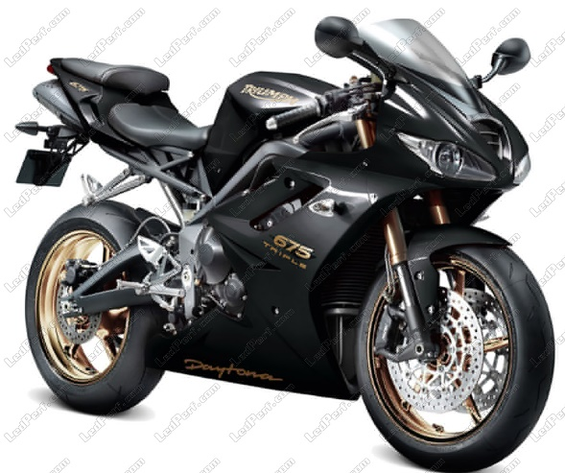
Fig. 1. Triumph Daytona sports bike.

A cruiser style, usually having a big low revving engine and more upright sitting/riding position that earned the nickname of “sit up and beg” bikes. These are designed for comfort and lower speed pleasure riding, or cruising. Some are adapted to become longer distance touring bikes.
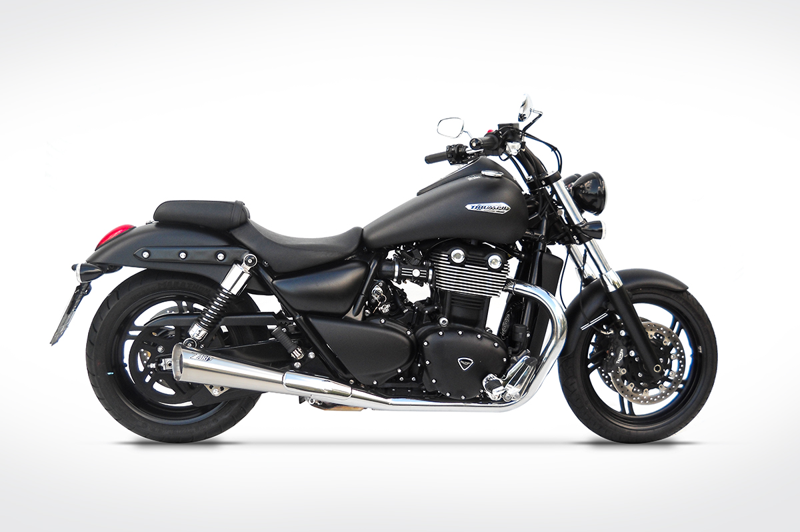
Fig 2. Triumph Thunderbird, an example of Triumph’s cruisers.

The Triumph Sprint is an example of a sports tourer. This is a hybrid class that combines elements of the tourer and modified cruisers and the sports bike classes. The main purpose of a sports tourer is cover long distances in comfort but with aspects of the sports motorbikes performance. This type of motorbike is also the ideal commuter motorbike and a popular choice with motorcycle couriers. 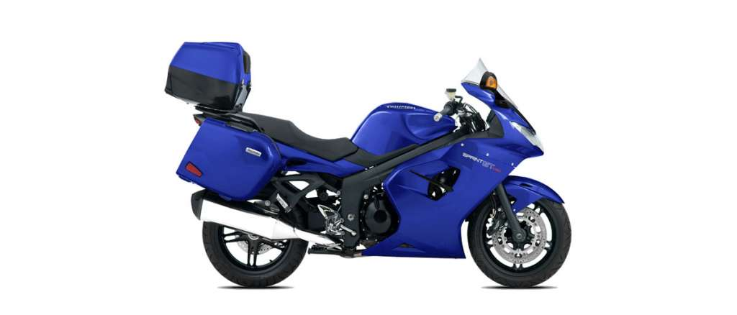
Fig. 3 Triumph Sprint sports tourer

Then they have their retro class of bikes. These don’t have a specific function like the sports of the cruiser and are throwback, at least style wise to their earlier models made popular in the 1960’s and ‘70’s. Riders of these style motorbikes generally choose them for their aesthetic appeal. In most cases it reminds them of the motorbikes they had when they were younger. This class is also regularly modified into another hybrid class called the café racer, which is also a tribute to the 1960’s and ‘70’s motorcycle culture.
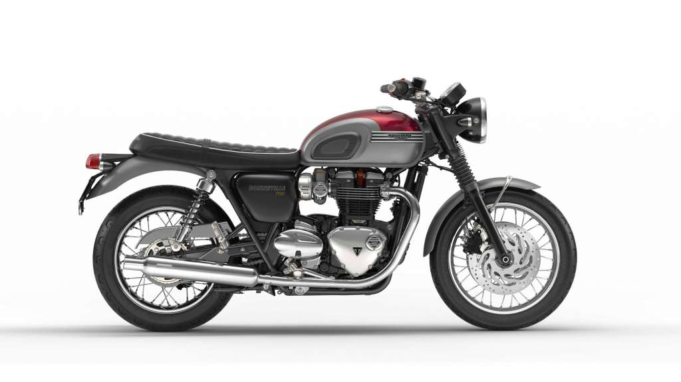
Fig. 4 Triumph Bonneville retro
The modern version of the retro style Bonneville is the Naked Sports class. Triumph Motorcycles entry into this class is the Triple. Comprising of two engine sizes, the Street Triple has the smaller engine coming in at 765cc while the Speed Triple has the 1050cc engine.
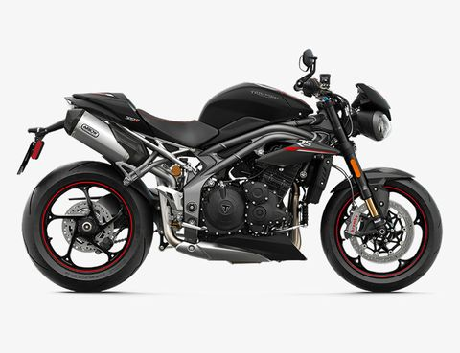
Fig. 5 The Naked Sports class Triumph Speed Triple

Triumph’s approach to their motorcycle is to utilise interchangeability of parts. The engine from the Triumph Bonneville, for example is also used in this Triumph Thunderbird. This interchangeability allows Triumph’s research and development teams to focus on other areas. This also reduces overall costs. (Bendall, 2019)

Triumph’s Customer Base
While the range of motorcycles Triumph offer is not as large as some other motorcycle manufacturers, they do manage to cover all the major classes. This means that they have a wide ranging customer base, lots of different types of customers seeking different qualities from their motorcycle. There are some traits that Triumph has cultured over the years that will cross over between several of their customer base types. There is a degree of reliability with their motorcycles that was not there during the “heyday” of British motorcycle manufacturers in the 1960’s and 1970’s. This will appeal to all types of motorcycle enthusiasts and riders, no one likrs to be sat on the side of the road, broken down. Another trait that Triumph motorcycles have that a lot of other manufacturers do not have is an element of uniqueness. Specifically, with their engine designs and format. As an example the Street and Speed Triple series get their names from the fact that they use a three cylinder engine, one of only a few modern production motorcycles that do. A three cylinder engine has both pros and cons over the more standard four cylinder engines. One of the major differences is the sound that they produce and the way the power is delivered. These are both major factors to some people when choosing their motorcycle. Then there are the customers who are looking to relive their youth to a certain extent but do not want the reliability issues that come with the older model Triumph’s from the 1960’s and 1970’s as mentioned earlier, this type of customer is usually drawn to the Bonneville and the hybrid styles that are based on it. (Ibanez, 2020)

Quality expectations
There are two dictionary definitions of the word quality:
“1.
the standard of something as measured against other things of a similar kind; the degree of excellence of something.
"an improvement in product quality"”
“2.
a distinctive attribute or characteristic possessed by someone or something.
"he shows strong leadership qualities"”
(Oxford English Dictionary, 2020)

Both of these definitions will have importance to Triumph’s customer base. The importance of these will vary according to each individual customer. Also there maybe more than one item or category within a definition. For example, taking the first definition, a customer may be defining the standard of Triumph’s products, I.E their motorcycles, in this they would be looking at how well the motorcycles are built, how smooth the ride is and other qualities pertaining to the building and using of their motorcycles.
The other major category in the first definition would be how good Triumph’s after sales customer service is. There are other important reasons to off good after sales including, but not limited to the ability generate brand loyalty, which in turn will promote positive endorsements and online reviews from customers whose service expectations have been met or exceeded. Studies show that 70% of people who experience excellent customer service will return and spend more money with company in the future. In terms of a positive endorsement, the same study shows that 90% or people will recommend a company based on their customer service being perceived as excellent. There is not better advert than word or mouth and this works in the opposite direction as well. If a consumer decides that the level of service is below par, it is highly unlikely that they will return for future products or services, with 59% of people saying that they would use a different company in the future (Ameritas Insight, 2020)

The second definition of quality defined as a unique trait will also play an important part in decision making for a lot of potentially new and returning customers. Referring back to Triumph’s triple engine layout, there are few other companies that run this type of engine and the Bonneville name has become synonymous with a certain style of motorcycle that will add to the brands uniqueness. (Ibanez, 2020)

Performance objectives

Almost all organisations have five basic Performance Objectives. These are quality, speed, dependability, flexibility, and cost. Broadly speaking all types of organisations key performance indicators can be attributed to these five objectives, how they relate to them will form the basis of an organisations operations management plan. (Slack, 2010)

  - Quality Objective

As previously mentioned, quality can mean an organisations products or services meeting or exceeding an expected minimum based on the customer or organisations expectations. Some of the customers expectations have been covered already, but what about the organisation’s quality expectations. In the case of Triumph Motorcycles the quality expectations are likely to include, but not limited to motorcycle parts and components that have their manufacturing outsourced to third party companies, then shipped in for assembly. These parts have to be manufactured to a certain standard every time because Triumph’s customers are not going to differentiate an outsourced part from the rest of the motorcycle. Therefore should an outsourced part fail, to the consumer, the Triumph Motorcycle has failed them. Not the individual part made by the third company. To this end the third party company would have quality control checks in place before the products leave them, but Triumph will also have quality control checks in place when the parts or components arrive at their factories to ensure that not faulty, or as few as possible, faulty parts are fitted. (Slack, 2010)

Speed Objective

In the case of Triumph Motorcycles, the most relatable speed objective is likely to be how long it takes them to build a motorcycle based on the specifications of a new order from their dealership. As far as the consumer is concerned this speed falls under the after sales service element. If it is a quick turn around from the initial order of the motorcycle to delivery, they are more than likely going to be impressed with this level of service. If it is a long time then less so. This comes back to their expectations and how they talk about Triumph’s level of service with other people and potentially advertising Triumph’s motorcycles for free.

There are other speed objectives that will affect Triumph internally, such as their ability to get parts and components from their third party suppliers in a timely manner meaning that their production cycles are not held up. This means that the organisation do not have to have inventory on site at all times, the components can be delivered straight to the manufacturing plant and installed almost immediately. This means that costs will be reduced, not having to pay for storing these parts. Using this just in time method of supply from their third party suppliers also makes forecasting future events a lot easier since the current plan and supply levels will only last a day or two at most Triumph are not trying to forecast a year or more in advice, forecasting what will happen in a couple of days time will be a lot more accurate than trying to forecast a year or more into the future when anything can happen. (Slack, 2010)
A perfect example of this is the 2020 Covid-19 pandemic, it would have been completely impossible for Triumph in 2019 to predict that every aspect of life 2020 would have been absolutely ravaged by the pandemic. According to the BBC Triumph sales during the pandemic have taken such a hit that they have had to make approximately four hundred staff redundant. (BBC, 2020)

Dependability Objective

The dependability objective is essentially making sure that things are done on time. Or when they are agreed to be done. For Triumph this can be anything from making sure their new motorcycles are delivered to the dealerships on time to be sold. Or if there’s repair work being undertaken being sure to have it finished on time. Again the implications of if the dependability objectives are not met are numerous. Including, but not limited to delays in the production line, delays with deliveries, increased costs and because these will eventually impact on the consumers, a loss of earnings when customers spread word that the level of service and the timescales are not as good as they were expecting.

Being a dependable organisation has huge benefits, not just the opposite of the aspects listed above but also it will generate more reliability with individual departments because they do not have to continually chase up parts or services required from other departments meaning they can focus on solely on their role within in the organisation. This in turn has a positive on the whole organisation. In Triumphs example having dependable manufacturing departments will allow for the motorcycles to be built in a timely and efficient manner. Which in turn allows the research and development team the piece of mind to know that they can just simply get on with their jobs unhindered by lack of resources from other departments or having to reassign resources to help with potential delay causing lack of resources in other departments. (Slack, 2010)

Flexibility Objective

Flexibility within an organisation means that the organisation is able to change and adapt if and when needed. These charges are usually driven by ever changing customer demands, whether they be based in their needs or desires. There are usually four categories that an organisation needs to be flexible in;

Products and/or services, the ability change the product line, in Triumphs case this could be new motorcycles or modifying an existing line. In terms of services they offer, flexibility maybe needed in the way their dealerships deal with bookings for MOT’s or the actual MOT process if the government changes the guidelines on how they are to be done, which, since the MOT is to guarantee the roadworthiness and safety of a vehicle is likely whenever new technology becomes more available to mainstream motorcycles. (Slack, 2010)

Mix flexibility, this is the ability to produce a wide range of products and services. Triumph have this covered in several ways. They have a wide range of motorcycles and motorcycle classes available. They also offer a wide range of branded clothing and protective equipment. These clothing and protective products offer another stream of revenue for Triumph, while offering their customers the ability to show their brand loyalty. (Slack, 2010)

Volume flexibility, which is linked to both products and services and mix flexibility is the organisations ability to change it’s quantity levels of output. This has been an issue with the Covid-19 pandemic affecting their sales as mentioned earlier, the only way they have been able to cope with the drop in revenue caused by the drop in sales and having to close temporarily is to reduce their workforce by around four hundred people. It is unclear at this time if this is a temporary measure or permanently. (Slack, 2010)

Delivery flexibility is the ability of the organisation to change delivery schedules to match up with dealership and customer requirements. This may need to be negotiated and have a timed, stepped approach to the change, depending what and how the big the change is. (Slack, 2010)

The Cost Objective

Quite possibly the most important of all of the objectives and the one that links all of the others most closely together. Being a manufacturer of motorcycles their primary aim is to sell these motorcycles and take market share from their competitors. By combining all the other objectives Triumph are able to produce motorcycles to the standard that their customers expect with the best economy possible meaning that they are able to sell the motorbikes at a more affordable price while still maintaining a decent profit margin. There is a fine balance between all of these objectives that allow Triumph to operate at maximum efficiency while keeping manufacturing costs at the optimum level while still being competitive in the sales markets. (Slack, 2010)

Potential Operational Problems

The only problem for Triumph Motorcycles at this moment in time has been the Covid-19 pandemic which forced them to reduce their workforce significantly. As an organisation there is potential for their just in time method of production to hit delays if there are significant problems with any of their third party suppliers.

Conclusion

So while maintaining a balance of all of the performance objectives is a huge and finely tuned operation, that runs right through every aspect of the organisation, until the Covid-19 pandemic struck Triumph Motorcycles were handling it well while making profits. As an organisation Triumph had seen the potential of the just in time production method and were making it work in their favour.

References
BBC News. 2020. Coronavirus: Triumph Motorcycles To Cut 400 Jobs. [online] Available at: <https://www.bbc.co.uk/news/uk-england-leicestershire-52882805> [Accessed 9 November 2020].
Bendall, S., 2019. The Complete Triumph Buying Guide: Every Model, Explained. [online] Gear Patrol. Available at: <https://www.gearpatrol.com/cars/motorcycles/a588930/the-complete-triumph-buying-guide-every-model-explained/> [Accessed 9 November 2020].
Ibanez, V., 2020. Why Should You Buy A Triumph?. [online] Blog.tamaritmotorcycles.com. Available at: <https://blog.tamaritmotorcycles.com/en/why-you-should-buy-a-triumph> [Accessed 9 November 2020].
Our Insight. 2020. Why Good Customer Service Is Important. [online] Available at: <https://www.ameritasinsight.com/employee-benefits/industry-buzz/why-good-customer-service-is-important#:~:text=Retains%20customers,and%20provides%20good%20customer%20service.> [Accessed 9 November 2020].
Slack, N. and Brandon-Jones, A., 2010. Operations Management. 6th ed. Harlow: Pearson Education Ltd.
Stevenson, A. and Waite, M., 2020. Concise Oxford English Dictionary. Oxford: Oxford University Press.

