Unit three homework sheet
1. Practise writing the characters for number one to ten
yī
un
èr
dau
sān
tri
sì
ped-war
wǔ
pump
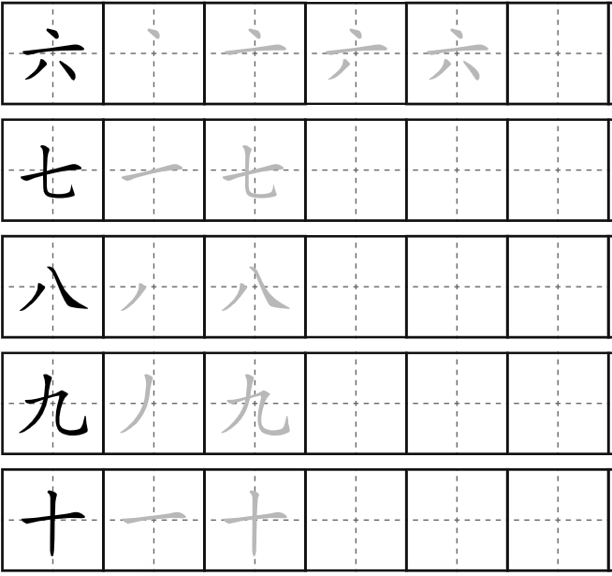
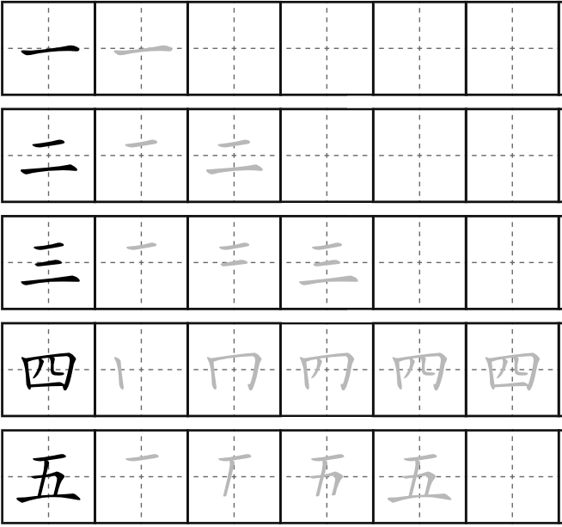
liù
che-wch
qī
saith
bā
wyth
jiǔ
naw
shí
deg

2. Translate the following numbers into English and a third language and record yourself reading the numbers
Chinese character | English | Welsh/L3
十三 | thirteen | Un deg tri
二十五 | Twenty five | Dau ddeg pump
三十六 | Thirty six | Tri deg chewch
四十九 | Forty nine | Pedwar deg naw
五十八 | Fifty eight | Pum deg wyth
七十六 | Seventy six | Saith deg chwech
一百 | One hundered | Un cant
一百三十四 | One hundered and thirty four | Un cant a tri deg pedwar
五千九百 | Five thousand nine hundred | Pump mil naw cant
七万八千六百 | Seventy eight thousand and six hundered | Saith deg with mill chew chant

3. Answer the following questions in Chinese characters.
e.g. :
Tom d uō dà
Q：Tom多大？（20）
tā èr shí suì
A：他二十岁。
Sioned duō dà
Q：Sioned多大？（17）
tā shí qī suì
A：她十七岁。

- Q： Jane 多大？（13）
A：她是十三岁。
- Q：Jeremy多大？（28）
A：他是二十八岁。
- Q：Alice多大？（32）
A：她是三十二岁。
- Q：Ross多大？（74）
A：他是七十四岁。
- Q：Mary多大？（59）
A：她是五十九岁。

4. Type the following sentences in Chinese characters and then video record yourself saying them.
Hi, I’m (name). I’m (nationality). I’m xx years old. What’s your name? What nationality are you? How old are you?
你好我叫多米。我是威尔士人。我是二十九岁。你叫什么名字？你是哪国人？你多大？
5. Cultural study
https://us02web.zoom.us/rec/share/0g0Qa58GY8Sp6cTdwoJl1-l1Hy43IaXDx89gloN6N8jmuUQEOcsHwPo-HAIR48-X.h1gUjVN5Es3wZD6J
Passcode: b6fx&$J6

Research questions:

How is Western calligraphy different from Chinese calligraphy?
Calligraphy isn’t as common in the west as it is in Asian or even Middle Eastern cultures. We don’t in modern western culture see calligraphy as an art form, even though we should as its all around us, just look at some advertising posters.
- To what extent is the writing style determined by the writing instrument?
- What are the benefits of practicing calligraphy?
Because the more practice you have the better calligrapher you become.
- Do you think children should learn calligraphy in school?
I believe, like all art, calligraphy could be a positive introduction for the wellbeing of students. You need to have a lot of concentration, but this allows the student to focus only on this. It is like meditation. I think introducing this to schools would help students develop the skills to help them deal with the stresses of modern day life.

