

Student Name: Harshkumar Manojkumar Patel

Student ID: 2503790

Module Name: Marketing Management

Module Code: LCMB7024

Lecturer Name: Dr Laila Maazouz

Poster – Marketing Strategy Pitch

Term 1

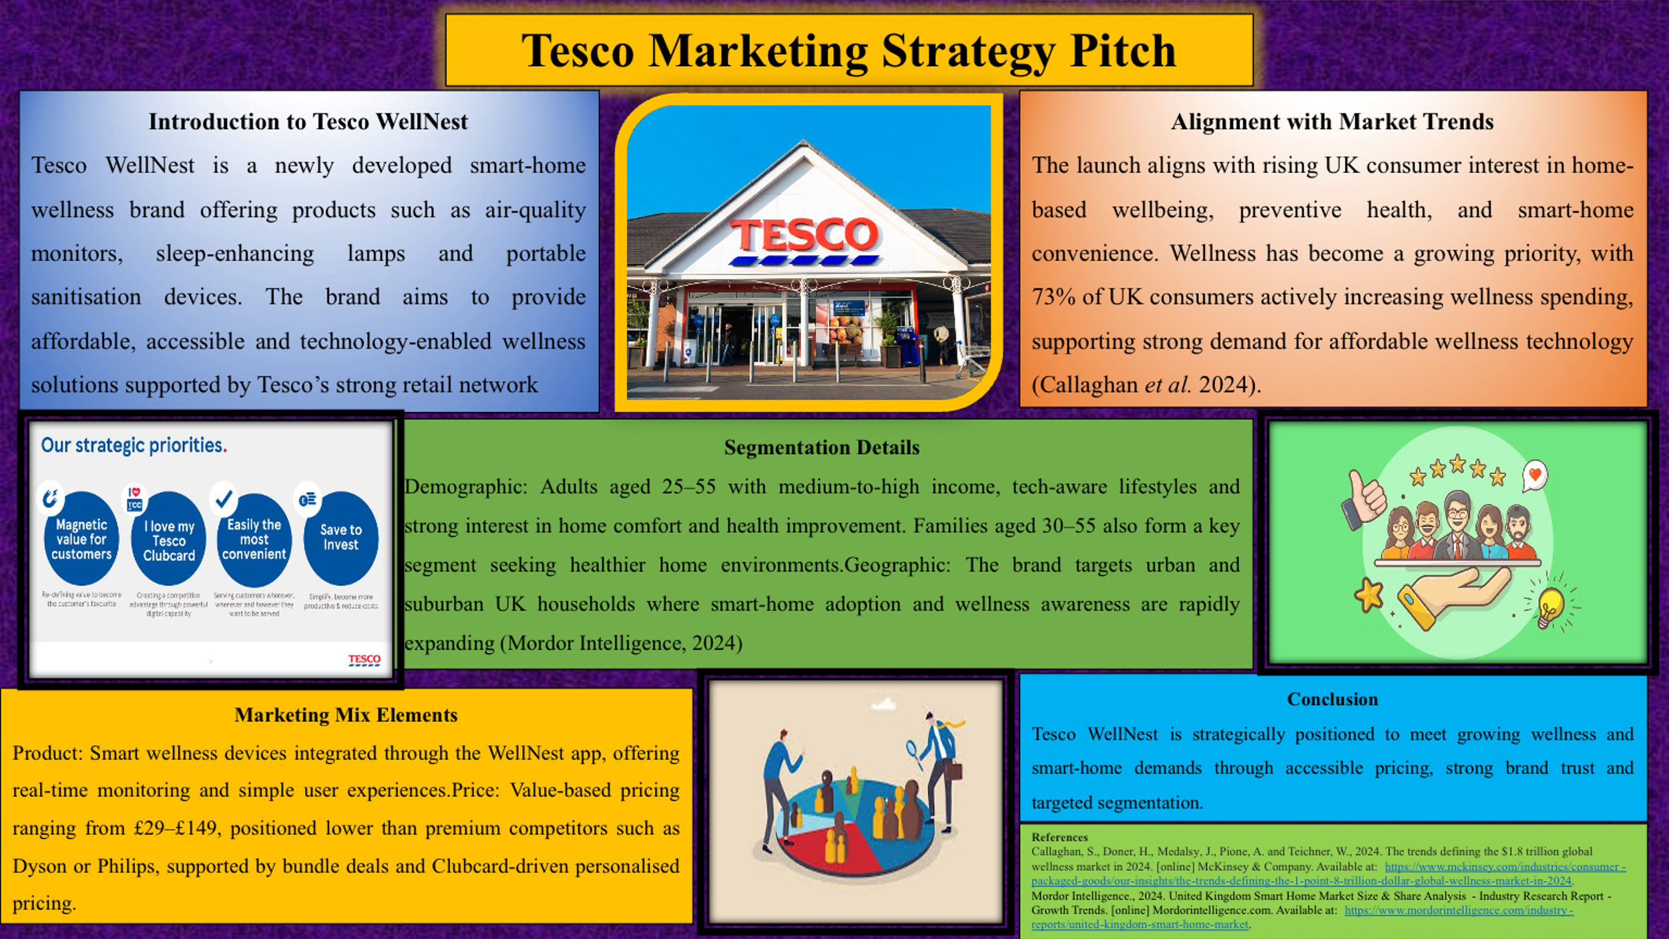

References
Callaghan, S., Doner, H., Medalsy, J., Pione, A. and Teichner, W., 2024. The trends defining the $1.8 trillion global wellness market in 2024. [online] McKinsey & Company. Available at: https://www.mckinsey.com/industries/consumer-packaged-goods/our-insights/the-trends-defining-the-1-point-8-trillion-dollar-global-wellness-market-in-2024.
Mordor Intelligence., 2024. United Kingdom Smart Home Market Size & Share Analysis - Industry Research Report - Growth Trends. [online] Mordorintelligence.com. Available at: https://www.mordorintelligence.com/industry-reports/united-kingdom-smart-home-market.

