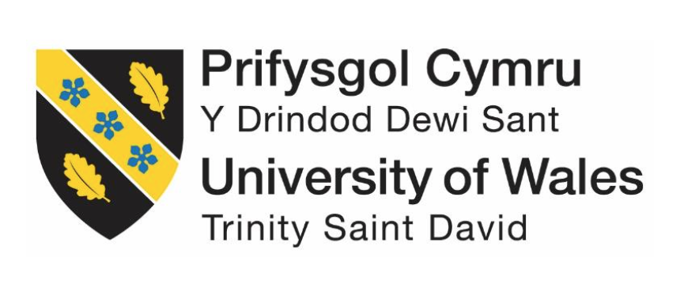

Aetna: Investing in Diversity

Module: Managing in Complex Environments: Strategies, Insights and Solutions
Module Code: LCDB7002
Assignment: 1
Module Lecturer: Mary March
Submitted By:
Arman Hossain
Student Number: 1806706

January 2020

Executive Summary
The impact of globalization is nothing new to the business firms. In the last few decades globalization has changed the business strategies of the companies. The current consultancy report has tried to evaluate the Aetna’s diversity approaches named ‘The Aetna Way’ policy along with its complexity of implementation in people management issues. The report is categorized as follows. The first part of the report has discussed about the background of investigation. The following part has analysed some closely related literatures related to the context. This past basically narrate the theme of recruitment and retention policy along with talent management process and its significance for the company. The third part of the report has assessed the Aetna’s recruitment and retention policies. This part also evaluates Aetna talent management process and policies and describes some recent motivational theories for sustainable motivation program for managing talents in Aetna. After that in fourth part, the report points some recommendations with justification. The report has recommended the Aetna, to provide a direction to the employees for progressing in career. Then support the employees to foresee intrinsic and extrinsic rewards in the process of long-term career advancements. After that, make the employees foresee value in the rewards they get as part of their career advancements. Finally, ensure that the career advancements of the employees lead to professional and leadership development. In fifth part the report assesses LAMP model of Aetna’s talent management strategies. In six parts, the report designs an action plan for motivating the Aetna’s talented employees. Finally, the report ends with constructive conclusion.

Table of Contents
1. Introduction 3
2. Literature review 4
2.1 Concept of diversity in the workplace 5
2.2 Diversity in workforce recruitment and retention 6
2.3 Talent Management: Diversity Perspective 7
3. Analyses of the selected key people management issues at Aetna 9
3.1 Workforce recruitment and retention at Aetna: Diversity Perspective 10
3.2 Talent management at Aetna: Diversity Perspective 14
Make strategies and plans for the company’s talent management. 14
3.3.1 Sustainable Motivation for Aetna People Management 16
3.3.1.1 Employee Motivation: Diversity Perspective 16
3.3.1.2 McClelland’s motivation theory 17
3.3.1.3 Goal setting theory 17
3.3.2 Sustainable Motivation Framework 18
3.3.3 Sustainable Motivation for Talent Management 20
3.3.3.1 Direction: Keep the Employees Moving 20
3.3.3.2 Support: Create Long-term Career Achievement Rewards 21
3.3.3.3 Value: Facilitate 360-Degree Career Choices 21
3.3.3.4 Self-efficacy: Professional and Leadership Development 21
4. Recommendations 22
5. LAMP Model 24
6. Implementation Plan 25
Conclusion 26
Reference 27
Appendix 29

Introduction
Aetna is named as one of the world’s leading diversified health care service provider listed in Fortune 100; world’s most admired US based companies list. The company also upholds hundreds of years heritage established in 1853 in Hartford, CT, USA. At present, Aetna has around 49500 workers employed providing health care related service to its 39 million members worldwide (Aetna, 2018).
Aetna has always been actively pursuing diversity in order to enhance creativity and productivity of the workforce as a leverage of competitive edge. Therefore, diversity remains key priority of the Aetna’s business operation strategies in relation to continuous business development. However, the economic recession during 2007 and 2008 had an inevitable adverse financial impact on Aetna’s business operation, Cascio. W, (2009). In such scenario, the managing board are determined to review those business initiatives which may not seem to bring expected benefits to the company will not be retained or extended further. In order to tailor their business operation cost in any way possible. Diversity management is one of the selected initiatives that board directors intended to examine its direct and indirect benefits and analysis its systematic risk which can create additional challenges for the company. However, diversity is one such business strategy which is not rewarding immediate outcome for the company but in the long run it plays a crucial part by creating competitive business advantage. On the other hand, maintaining diversity no doubt needs huge investment, which is concerning the board to be an economic burden for Aetna in the prevalent economic situation. Thus, Aetna’s board members are intended to deeply understand the diversity perspective, whether the diversity initiative will bring the expected business outcome in return of its retaining or extending cost.
The purpose of this report, as a result, is to highlight the overall value that comes from diversity which results in long term relationships not only with the customers but also with the employees even though the investment in this sector might look daunting. Through the report, the author will look into diversity in workforce recruitment and retention at Aetna and diversity in talent management at Aetna. This way, their final outcome in relation to retaining the customers for building a profitable relationship will be evaluated since the employees at Aetna are the ones that come to close contact with the final customers. To do so, a brief literature review on diversity, recruitment and retention and talent management will be done. Finally, recommendations will be provided in favour of recruitment and retention and talent management. The LAMP model will be utilized to understand the return on investment of Aetna’s talent management initiatives.

Literature review

2.1 Concept of diversity in the workplace

According to Bari A. Williams, (2017), true diversity at workplace comes with the inclusion of people from different backgrounds, knowledge, and aspects of life. which ensure the inclusion of innovation and efficiency at the workplace. The innovation and efficiency come from the ability to look at a given problem from different perspectives as diverse people in the organization has different approach to a given problem. However, Bais, (2014) believes that diversity is not only including people from different backgrounds but also the inclusion of people from different experience levels and training that are done within the organization. Bari A. Williams, (2017) stated that in order for a diverse workplace to be successful employer need to create a culture in which equality has to be incorporated where everyone can become part of it and get equal access to the resources.

Collins, (2015) identified that managing diversity at the workplace has a long-term impact on organizational success because employees from different backgrounds can interact with the different customers segment better. For example, employees from Asian backgrounds, knowing their culture better, can create a sustainable relationship with the customers which is effective for customer retention over time. Colton, (2018) further added that employees are the ones that represent the organization and when these employees shift to other organizations, they take the customers with them as well because the customers find it difficult to build a new relationship with new employees of that organization. As a result, Crosby, (2016) emphasized managing a diverse workplace in order to ensure that the employees are building a long-term relationship with the customers so that, they can keep the relationship even during the crisis situations like the approach of many automobile organizations during the financial collapse of 2008. The study identified that even though many of the automobiles started to implement employee layoff, some did not and those who did not ensure that the customers are coming back to the organization because of the relationship built with the employees.
However, many issues of diversity at the workplace was noted from management perspectives as Elliott and Kaufman, (2019) identified that lack of respect, difference in belief, generation gaps and language barriers are the key issues that can arise from diversity at workplace. The study, however, identified that these issues can be resolved by training the employees, utilizing a culture that enforces diversity in its value system, support from top management and ensuring a collaborative and friendly work environment.

2.2 Diversity in workforce recruitment and retention
According to Fischler, (2015) a diverse workforce can enhance creative problem-solving ability, innovation, exploration of new markets, adaptation of new views and ideas by generating insight from different individuals at the workplace. Hence, Flaming, (2016) believes that the recruitment system has to be directed towards attracting diverse individuals in the industry that can bring positive changes with their differences in perspectives. However, according to Gberevbie, (2017) in many cases, organizations focus only on bringing local talents in the organization due to the thought that local employees can connect with local customers better. Arguing this Gendron and Hille, (2018) identified that in the age of globalization, customers have differentiated needs and the needs have to be evaluated from different perspectives since new opportunities are always there on the horizon. The organizations that do not see or oversees these opportunities fail in the long run due to the lack of insight and diverse recruitment system can be a viable solution to the problem.

Huang, (2019) believes that recruiting employees is not enough retention of the employees is also an important aspect due to the extent of training and development efforts put in order to get a better outcome from the employees. According to CIPD (2015) reported that it is five times more costly to attract and recruiting new employee, it can cost up to 3 times more to get the level of efficiency from a new recruit than the one that left after 2years. In another report noted that it has become a challenge to retain employees in the highly competitive labour market since other organizations are also looking for highly experienced individuals and better packages with better working environment can cause employees voluntary turnover for better employment opportunities, CIPD, (20017).

In order for implementing diverse employee recruitment and retention policy, Flaming, (2016) suggests that the organizational objectives, organizational culture, individual employee needs, and organizational resources have to be taken into consideration. This is due to the fact that if the organizational objectives and culture do not promote diversity and the resources are not ample at the organization, it is hard to fulfil the needs of the employees. As Gberevbie, (2017) indicated that different types of people have different needs that have to be fulfilled accordingly, in the retention policy, the rewards and benefits also have to be consistent with the individual needs. However, Isukapally, (2018) argued that it is hard to identify and satisfy the individual level needs of the employees because different types of resources have to be placed in that case. HUGHES et al., (2011) provides a suggestion to the situation which is to make the recruitment process more elaborative of the organizational culture and the business objectives so that only those who have a fit with the organization get selected through talent management.

2.3 Talent Management: Diversity Perspective
Armstrong (2010) defines ‘talent management’ as management succession planning and management development activities. Which are done in order to attain, develop and retain a workforce that can bring positive changes to the organization which is different from recruitment because it starts before recruitment and branches out way much after recruitment. In this highly competitive business environment, talent management has come out as the most important concept for all organisations. Moreover, the success of any organisation is directly related to the talent it has and how the talent is being utilised. Talent management is the process through which organisations determine the employees having capability to perform leadership role in future. To make talent management process effective, organisations needs to place a formal process wherein several people should be involved with proper coordination between leadership and talent to translate it into valued based organisational behaviours. Most of the organisations that focus on talent management are able to attract and retain the right set of people with right set of skills (Malikeh, et. al, 2012).

However, managing and building talent requires strategic approach. Talent management is a bundle of activities to be undertaken in a comprehensive manner by management, shown in the diagram below.

Figure 4: Talent Management
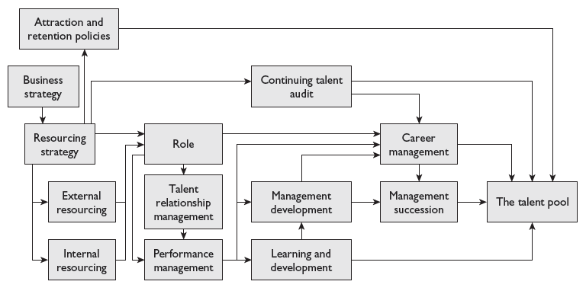
Source: Armstrong (2016, p.205)
As presented in the above framework, talent management is all about building a group of talented people i.e. talent pool. This however requires strategic approach with a range of intermediating variables. An organisation develops talent in accordance to the business strategy. This leads to identifying the right person for the defined job, which are undertaken trough resourcing practices.

Ward (2012) in this regard note that talent is better built when organisational needs of Skill, Knowledge and Attitude match to that of employees.
Figure 5: The Matching Criteria
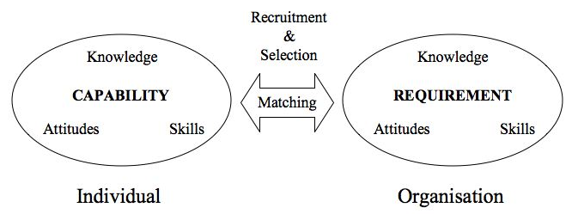
Source: Ward (2012, p.2)
The aim of building a talent pool is to secure the flow of talent, importantly because it is a major corporate resource. However, the competitive environments within which firm are operation has resulted in ‘War for Talent’ situation wherein the HR practitioners are infusing turnover intent among the key talents of the competitive firms (CIPD, 2012).

However, Khalid, K. et. al. (2018) argued that talent management required ample effort and comes with high cost because the organization tries to build relationship with individuals. Whereas, Kohnen, (2017) stated that individuals from diverse backgrounds are attracted through talent management because talent management is more spread toward training and skill development, achievement or leadership traits. On the other hand, Kotter, (2015) identified that employee engagement is one of the key aspects of talent management that works in order to develop the required talent among the employees which can be motivation, rewards, equality, and equity centred organization and so on. Kozan and Ergin, (2018) noted in a study that the organizations that invested in talent management during the financial downturn of 2008 focused more on customer relationship building so that after the downturn, these customer segments become loyal. Kwon and Yoo, (2015) however, argued that employee engagement does not work unless the employees have self-drive to develop career, achievement or leadership otherwise the investment goes in vain.

According to Levine, (2015) business strategy can be aligned to talent management by creating a culture supportive towards talent management, teamwork environment, identification of talents that matches the position, identification, and fulfilment of individual needs and upper management support. Mahmood, (2017) however, argued this process for being time-consuming and costly because the current process has to be consistent with talent management, otherwise it takes much more time to adapt the current employees with a new organizational culture. Mamman, (2019) believes that diversity, in this case, can be a solution that any organization in the global setting already practices as a diverse workplace has some elements of talent management like teamwork for solving a given problem.

Analyses of the selected key people management issues at Aetna
In this section the study will critically analyse Aetna Inc.’s overall HR strategies and then select two key people management issues for assessing. The issues are diversity in Aetna’s workforce and the employee resourcing techniques of Aetna Inc. After critically assess and analyse the two key people management issues then the report will try to compare the above two people management issues with the company’s competitors’ strategies. At the end of this section the study will try to draw some recommendation based on analysis.

3.1 Workforce recruitment and retention at Aetna: Diversity Perspective
The people management strategy is aligned with the organizational strategy. Company desires an extraordinary quality through cost-effective services in health care and associated solution for its ultimate customers. The consequences of that strategy, the HR is liable to develop an advanced, well diversified, and well performed workforce who can lead the company to become a sustainable one (Cascio, 2009). Aetna Inc. has three separate goals in people management activities. The first goal is to supply a long-term qualified workforce to support the sustainable goal of the organization. The second goal is to identify the core competencies in HR through select, develop, employ, and retain the most talented ones. The third goal is to apply the team management activities for enhancing the growth of the firm (Cascio, 2009). The company place an open-door employment opportunity for the mostly talented HR people beyond the origin rather to committed for their career and organizational growth (Aetna, 2019). The organization centres it recruitment and selection activities for the individuals who are from any gender, race, origin, age range, or ethnic groups. The above approaches highlight about the significance of workforce recruitment and retention diversity in Aetna Inc.

According to Bari A. Williams, (2017), organizational success depends on recruiting and integrating intergenerational workforce in the dynamic business environment. When it comes to leadership, developing an intergenerational workforce is the only way to advancement of a diverse, high-performing workforce to sustain organisational leadership. Although, Aetna’s current recruitment practices endeavoured to build a generationally diverse workforce to provide differentiated and cost-effective service to the diverse customers of the company, yet the gap in the generational employee capital is noticeable, only a quarter of Aetna’s workforce are the younger population. For example, Aetna’s employees age range between 18 and 89 years, the average age of the employee 62 years in USA. Among them Only 15% percent of the employee who have worked for the company more than 20 years. while only 25 percent of the employ age between 22 to 37 years, Aetna, (2019). Which indicates Aetna’s leaders need to expand recruitment efforts to acquire a balanced distribution of intergenerational talent capital. consequently, which will encourage participation and promote shared responsibility among the employees for instance, who has worked over 15 years at Aetna can share their experiences with newcomer who just join the company with positive energy and intend to work-hard.
In order to create this opportunities, Aetna’s leaders need to consider some specific strategic plan to establish, such as coaching and mentoring programs and shared activities. According to CIPD, (2019) coaching and mentoring programs can be effective approaches enabling employees to develop knowledge and skills to work effectively with all generation. Moreover, shared activities will promote collaboration in workplace among the different generations. Therefore, Aetna’s leaders can trigger strategies which will bring generations together in the workplace. In this case, they can create intergenerational training program and other development opportunities to promote collaboration in workplace. Participating in mentoring and shadowing program Aetna’s experience employees can pass along their knowledge, skills and experience to new employees and vice versa. These initiatives will break down the generational barrier as it creates opportunity for each unit to learn from each other Maulik S. Joshi, (2014).
However, such initiative requires organisation to play an active role in educating workers on generational issues. Consequently, it will enhance mutual understanding and respect resulting greater productivity among different units of the workforce. Understanding the difference of each generation will help Aetna’s leaders to bridge the generation divide at workplace. These activities should not be limited to the bottom level of the workforce, it should also take place enterprise wide at the leadership level of the company such as CEO, VPs, and executive management teams that lead by example will significantly promote efficiency and productivity among employees from diverse group.

This way, Aetna will be able to build a strong foundation of future leadership and gain competitive advantage in the marketplace. According to Maulik S. Joshi, (2014) to create this competitive advantage business leaders need to endeavour an inclusive culture in the promotion of intergenerational teams based on three interdependence strategic initiatives. First of all, build a strong generational foundation, secondly, implement an effective generational management practice and finally, foster generational competence. Each of these initiatives have influenced other as shown in the diagram thus it requires to establish strategically. A brief explanation of the diagram is shown below.

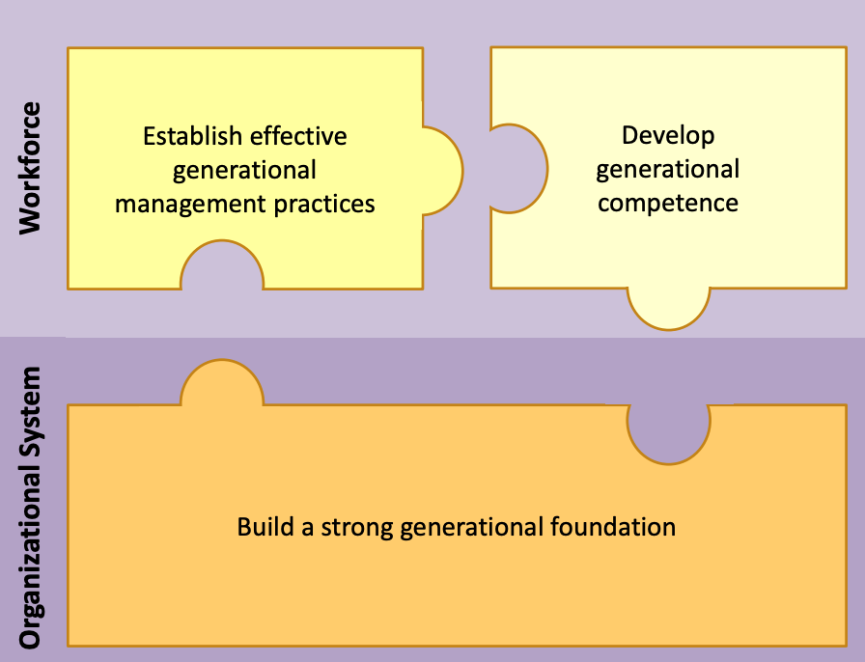

Source: AHA CPI, (2014)
In order to establish the solid generational foundation, it requires business leaders to understand the profile of the workforce they have and design the plans and policies to acquire and retain generationally divers employees. Following this, it requires business leaders to effectively identify each generations’ strengths so that, organisations’ communication and management style can be tailored in order to leverage the strength of each generation. Afterwards, customising and developing management and communication styles, business leaders need to ensure entire workforce understand and value the generational diversity and inclusive culture of the organisation, this, in turn, will impact company’s accusation and retention plans and policies positively.
In this case, Aetna needs to focus on building generational teams by hiring and integrating intergenerational employees. Diversity of age and experience yield the business noticeable outcome, this is the benefit of integrating intergenerational employees by customising recruitment strategy, Bari A. Williams, (2017). Therefore, organizational recruitment effort has to be optimised and aligned with the requirement of the company’s business strategic plan. According to Colton, (2018) employees are the ones who represent the organization and provide differentiated service understanding the unique needs of the diverse customers group. Lack of appropriate recruitment can impact the customer service quality, which will lead to early exit of the employee. Therefore, company needs to have an effective targeted recruitment policy to employ the right fit in the organization. In order to target the right fit for the job role company should tailor communication of its vision and value effectively to each generation which will attract talent across the age spectrum. For example, job fulfilment is more valuable to most of the younger generation (millennials) than the financial rewards and compensation. Targeting this generation to recruit, organisation need to explain in their job descriptions that how the job role will contribute to the mission and values of the company. Because Millennials are more keen to know that their work has purpose. As a result, they feel motivated to achieve it Browning, W. (2012).
However, diversity of age and experience in recruiting workforce does not guarantee that they will stay in the organisation, but proper retention strategies keep them within the organisation and drive profitable growth. Therefore, organisation needs to design customised retention policies including an effective rewards and benefits plan to retain innovative, result focused, diverse workforce. This is where Aetna probably need to put more attention, for example, Aetna has only 14% employees who are working with the company over 20 years, while 38% of the employees have been working with the company over 5 years and rest of the total employees work for the company less than 5 years. Therefore, Aetna’s HR retention policy need to focus on maximising the percentage of those employee who are working more than twenty years and minimising the percentage of those employee who work less than five years.
In order to achieve this goal, Aetna’s HR management needs to finds effective ways to increase their multigenerational workforce job satisfaction and motivation so that they can retain the best talent within the organisation. Although, each generation respond to different motivating factors, Aetna’s management must recognize that each and every employee has a range of needs that needs should be met accordingly. In this situation the ERG motivation concept can be employed to the Aetna’s employees. If the administrator or manager concentrates just on single need of an employee at a time, the manager will not be able to inspire or motivate that employee effectively. Prioritization along with the sequence of existence, relatedness, and growth needs can be diverse motivating approach for each of the individual, D. Thiagaraj, et al., (2017). In addition, in case of Aetna’s generational diversity in need or requirement for power the management can apply the McClelland’s (1961) motivation theory of need for achievement, affiliation and power. Where achievement is compelling desire to excel and affiliation means desire to be part of a team having a close interpersonal relationship. While need of power is to direct or control over individual’s own task or the task of others. Among these factors one of the factors will be dominating motivators for each employee but each individual’s dominating factor is a different one. By using McClellan motivation theory Aetna’s leader can determine which motivating factor is dominating for each generation of workforce, then they can tailor their accusation and retention motivation approach geared to each generation. AARP report, (2014) distinguished the motivating drives of each generational workforce. for example, millennials’ motivation is driven by connecting their actions to their personal and career goal. On the other hand, Baby Boomers tend to be motivated when their leaders get them involved and treat them as equals. Whereas, generation X get motivated when their leaders are flexible and supportive of training and growth.

Aetna can manage these types employees through learning their achievement needs then affiliate them with the company and finally give them some power based on their ability to hold on along with their accountability and responsibility on their job position across the organization. this, in turn, will help Aetna to be turnover savings by promoting employee satisfaction.

3.2 Talent management at Aetna: Diversity Perspective
Aetna Inc. has its own “Compensation and Talent Management Committee” to support the TM activities. The prime objective of the committee is to reduce the responsibilities of the board of directs regarding the compensation and talent management related issues of Aetna (Aetna, 2019). In case of talent management practices for Aetna, the committee assesses the executive officials’ performance both the individual and corporate, based on outcomes of their performance the company designs compensation plans along with different benefit plans for the employees. In addition, the company intends compensation plans which is related to equity-based incentives and review and update the overall strategies regarding company’s diversity in talent management issues. The approach boosts up moral building of their employees and enhances more engagement towards the company as well. Table 4 shows Aetna’s diversity in Talent Management practice at a glance.
Table 4. Aetna Inc.’s talent management strategies and activities
Compensation and Talent Management Committee
Step 1 |  | Make strategies and plans for the company’s talent management.
Step 2 |  | Assess the performance (personal & corporate) of executive officials.
Step 3 |  | Offer new compensation and benefits (equity-based incentive) plans for the evaluated officials.
Step 4 |  | Review and update the overall diversity driven talent management strategies.

Source. Aetna, (2019)
Aetna Inc. believes the strategic importance of talent management practices and that have been considered as one of the key sources of competitive advantages for organizational success in 21st century, Cascio, W.F. (2010). So, the Aetna Inc. is investing more purposefully on managing and solving the problem related to the talent management issues. However, reviewing Aetna’s current talent management practise a key gap can be seen in identifying, developing, utilising and retaining talent with leadership and functional capabilities. A discussion of the key gap in talent management is shown in below:
3.3 Aetna’s Diversity Perspective – a Key Gap in Talent Management
The diversity perspective of Aetna as discussed and as presented in the case has helped the company in attaining competitive advantage in the health care market it operates. However, this has resulted in high HR costs. Considering the market conditions and the prevalent economic situation, the management has its own speculations of the sustainability of the competitive advantage. The diversity strategy of Aetna when contrasted with the talent management concept (see figure-4) a key gap in human resource management strategy can be seen, specifically in terms of talent management. Talents in Aetna’s are developed through people resourcing practices that fit a particular segment of customer it intends to serve. This limits such people’s progression in career. It is important for Aetna to understand that the talent pool should be developed from ‘learning and development’ and ‘career management’. This will result in not only minimising the HR costs but also developing such talents that remain for long with the company.
For example, Cornerstone (2018) in a study notes that the best of talent building strategy in a workplace built on diversity is ‘Talent Mobility’. Employees when keep on moving in career will contribute to attain sustainable competitive advantage. The key gap of the diverse workforce in Aetna is lack of creating a long-term and meaningful career path for the employees. Talent mobility for Aetna, as presumed by this study is through ‘Sustainable Motivation’ strategy.

3.3.1 Sustainable Motivation for Aetna People Management
Aetna, of the issue of overcoming HR costs can adopt ‘Sustainable Motivation’ strategy for sustainable competitive advantage

3.3.1.1 Employee Motivation: Diversity Perspective
Motivation, as informed by Boshoff and Allen (2013) is “...the development of a desire within an employee to perform a task to his/her greatest ability based on that individual’s own initiative”. In a recent study, Shadare et al, (2015) observes that employee motivation plays the most important role in organisational policies developed by HR to enhance the productivity of the employees for better performance in the organisation. Once the employees are motivated, they will respond to the objectives and goals more passionately and put all of their efforts in the direction to achieve the set goals and objectives.
Within the case of Aetna, of its diversity perspective, there is little evidence to determine motivational strategies of the Aetna’s human resource management policies and practices. The only motivation that can be seen in Aetna case is its approach of diversity which has facilitated people from different sexual, cultural, ethical, and geographical regions to find a source of employment. Such employment created by the company has resulted in generation of jobs to people rather than helping them to build a career. This is more specifically because, the company has been consistently involved in exploring new markets for which people have been identified through diversity inclusion Cascio. W, (2009).

In human resource management literature, scholars have found many theories related to employee motivation in respect to contemporary human resource practices. Nevertheless, the most used modern theories and the ones adopted by the scholars are McClelland’s Need for achievement, affiliation and power theory, and Edwin Locke’s goal setting theory based on human relations (Haque et al, 2014). Accordingly, each of them is examined.

3.3.1.2 McClelland’s motivation theory
As per Cornelius, (2018) McClellan motivation theory highlights three Motivators of human needs. This theory postulates that workers tend to be motivated at workplace mainly by three motivating drivers: Achievement, Affiliation and power. The main source of employee motivation can be found within one of these drives. One of the three motivating need or drives will be dominant in individuals’ behavior but for each person dominating drive is a different one. By determining which motivating factor is the dominating one for the employee, organisation can tailor their approach specially to give them what they need, Cornelius, (2018). McClelland’s motivation theory differs from the Maslow’s as well as Alderfer’s motivation theory as; the theory focuses on satisfying the present needs instead of developing or creating needs. This dominant or powerful motivator relies on the individual’s culture as well as life experiences. However, certainly the three distinct motivators are stable or permanent McLeod (2016) in his research states that this theory is one of the best theories on workplace motivation.

In case of Aetna, the enterprise wide recruitment and selection of people from diverse backgrounds, undertaken with intent of augmented employee engagement and productivity for business impact can be argued to be fulfilling the employees’ dominant needs of Achievement, Affiliation and Power. However, the scope of meeting such employee’s motivation needs is one of the many complex layers that Aetna’s HR management need to understand.

3.3.1.3 Goal setting theory
Edwin Locke first introduced goal setting theory in 1968. The central reference of this theory is employee work towards achieving goals. Which ultimately happen to be major source of employees’ motivation at workplace, Locke and Latham, (2002). The assertion of this theory reflects underlaying explanations of most common motivation theories including Maslow’s hierarchy of need theory, Herzberg’s motivation and hygiene theory or Vroom’s expectancy theory. As per Lunenburg (2011), goal setting theory come up with the direct and simplest explanation of employees’ compelling desire of excelling performance to achieve the goal at workplace. In a subsequent study Earley and Erez (1990), found positive influence of setting up goals to achieve on employees’ behaviour and work performance. Thus, this modern concept of motivation is widely accepted by organisations in the promotion of employees’ consistent better performance.

Aetna has set three strategic goals defined in the Aetna’s ‘Integrated Workforce-Management Strategy’ are aimed at ‘Workforce Management’, ‘Leadership and Key Talent Management’ and ‘High Performance Organisation’. The base for these goals is parallel to the organisational ‘Business Priorities’ and ‘Success Measures’ (Cascio, 2009 p.7). The stated goals though identify the need to train the employees and facilitate career progression through talent management; this is however, more or less undertaken in a paternalistic style of management. Such kind of management as argued by Thoo and Kaliannan (2013) can hardly sustain in the modern era wherein people are exposed to information and technology for personal and professional career development. However, there is little evidence to determine how Aetna’s integrated strategic goals drive the individual employees to grow and advance in career, specifically employee’s career advancement beyond the line managerial position (Guest et al, 2012). This study as such is of the view that: Employee motivation at Aetna is grounded at bottom level. This principally limits career progression for building future leaders.

3.3.2 Sustainable Motivation Framework
Evaluation of employee motivation at Aetna in the context of its diversity approach indicates that the employees are satisfied because of two reasons:
- First, their skills, knowledge and attitude meet the firm’s needs of serving the target customers.
- Second, the HR policy of the firm motivates the employees to perform and attain targets. This is specifically facilitated the company to attain competitive advantage in the market it operates.
However, sustainability of the same cannot be ascertained as Armstrong (2009) is of the view that effective leadership development in a company is proportional to the employee motivation that goes beyond intrinsic and extrinsic factors. In respect to the gaps available in employee motivation at Aetna, this study is of the view that; Aetna can transform the competitive advantage into sustainable competitive advantage when career progression at Aetna should go beyond the line-managerial leadership

According to Brophy (2014) through modern motivational approaches firms can aptly motivate the employee to perform. The same however does not provide direction to the employees to build leadership. According to Cornerstone (2018) leadership needs to be built through talent mobility. This requires a sustainable motivation strategy (figure 8).

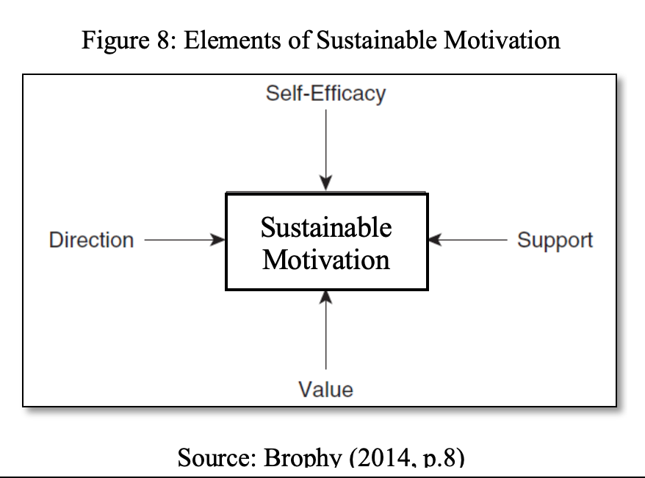

A sustainable motivational strategy as informed by Brophy (2014) is where employees foresee value in the job they perform, foresee direction of the job and the self (work and life), the support they get from the manager, management, and leadership, and building ability among the employees to perform on their own without depending on others i.e. self-efficacy. Employees when motivated through these elements move on the hierarchy of the company. Talent mobility as in figure-4 is all about management succession through career management leading to talent pool.

Aetna can design a sustainable motivation framework through goal setting theory. Under this motivation concept, Aetna can learn the individual goals of their employees. Based on the personal goal of an employee Aetna can match its organizational goal. For that consequence the employee will be more motivated and increase his or her effort to achieve their intended goals. Whenever the organizational goals match with that employee’s career development goals then the employee will be more devoted to his/her work as well as the Aetna’s organizational goal. To achieve the organisational goal, recently, modern managers around the world are using different form of goal setting programs such as MIS- management information systems, Benchmarking, HPWPs- High-performance work practices and MBO-Management by objectives etc. Accordingly, Aetna can design a specific goal setting program which can be best suit to their organisational goal along with their employees’ career development goals which will create sustainable motivation at workplace, Lunenburg (2011).
In addition, Aetna can design another motivation plan for their employees through McClelland’s motivation theory. Under this theory the management can try to learn the achievement need of their employees. As the human being nature is to become successful by applying their control, skills, or own pattern of standards. So, the management of Aetna can support their employees to show their skills and try to set the organizational goal nearly match to the achievement needs of the employees. After that, an employee will work hard and try to secure his/her position in the organization and willing to be affiliated to the organization. Then the management can give the employee a suitable job position to fulfil than employee’s affiliation needs. Finally, upon satisfied with the performance of that employee then Aetna should give the employee more power from the past and the employee will be more motivated to his/her work and will try to reach the next level of achieving power.

3.3.3 Sustainable Motivation for Talent Management

3.3.3.1 Direction: Keep the Employees Moving
Direction in sustainable motivation is the way in which the employee is moving in a role; move on in a job (Brophy 2014). Direction for the employees at Aetna as noted in the case is defining a specific job for the diverse people. This is specifically allocated in accordance to the customer segments the company wants to target. Now the question is what next, when all the segments are targeted and served. In such scenario, the company would certainly be in a situation where in such diverse employees has little scope of moving on a progressive career path. Cornerstone (2018) however is of the view that of the employee’s performance, the HR policies of engagement shouldn’t be limited to performance but also set a direction for progression. The target orientation of the business goals directs the employees towards task accomplishment, rather than foreseeing a leadership role.
Reflective to the above literary opinion, direction for the employees at Aetna need to be not just limited to task accomplishment but also a direction for the employees to progress in career.

3.3.3.2 Support: Create Long-term Career Achievement Rewards

Support in sustainable motivation is all about encouragement and modelling of job and responsibilities that builds a sense of hope and desire of achievement at the intermediate level, and the rewards for achievements (Brophy 2014). Aetna’s diversity approach identifies ‘support’ to the employees at several stages of the job tasks and the responsibilities given to them. For example, the ‘Integration-Communication-Education’ framework of the company, in accordance to its business goals rightly identifies the need of inter and intra communication tools to effectively manage the performance of the employees. However, focus is specifically laid in identifying such tools that are necessary in augmenting the competencies of the employees for attaining the business goals and the marketplace needs. There is however little evidence in Aetna’s HR policy to determine that employees are also supported for personal growth to set a long-term career and develop leadership skills.

The above argument testifies the opinion of Cornerstone (2018) that fewer than 8% of surveyed companies (based on Gallup’s research) have set support initiatives in their human resource practices wherein career paths for the progression of employees is determined.

3.3.3.3 Value: Facilitate 360-Degree Career Choices

Value in sustainable motivation is all about the outcome of a tasks/job an employee foresees in the roles defined for them (Brophy 2014). The diversity perspective of Aetna is where diverse people are employed in accordance to their skill sets, and areas of interest. This is anticipated to provide optimum value perception to the employees. For example, the diversity implications defined as against the firm’s strategic focus identifies creation of a work environment where individual employees’ productivity and contribution is maximised. This provides ample scope for the employees to feel valued of their contribution to the firm’s strategic focal points. However, the initiative seems to be unidirectional i.e. attaining firm’s objective. Thus, at Aetna, the scope of individual employee’s career choice is limited

3.3.3.4 Self-efficacy: Professional and Leadership Development

Self-efficacy in sustainable motivation is the ability of the employees to perform on their own (Brophy 2014). Inclusion of diverse employees across leadership and supervisory roles determines Aetna’s diversity strategy of motivating the employees to act on their own and lead the people assigned to them. For example, employees of colour hold significant percentage of role to play in supervisory and senior leaderships. Similar initiatives can also be seen in terms of gender equality. Till now the organization has 32% of employees are persons of colour. Amongst those 19% of the employee are holing managerial post and 14% are working as executives. On the other hand, 32% of women are holding executive positions in the organization. The Aetna has 4% of employees who are belong to lesbian, gay, bisexual, transgender. That reflects the diversity in LGBT (Aetna, 2018). That means the organization try to maintain EEO (equal employment opportunity) practice across the organization. However, the initiative does not determine the scope of the passion employees develop for the tasks. The above argument is of specifically important because Cornerstone (2018) is of the view that inspiration motivates employees to be innovative in job and passion for the tasks. Thus, Aetna needs to focus upon innovation and passion supported by multiple ways for facilitating career progression and leadership development

Recommendations
In reflection to the evaluation of the case of Aetna of its diversity inclusion as a strategic human resource management initiative, of which a need is determined to reduce the HR costs in the company, this study identifies the elements of Sustainable motivation as a strategic human resource management of employee motivation. Accordingly, the following set of four key recommendations is made:
- Provide a direction to the employees for progressing in career: Keeping the employees moving in career will help Aetna to largely reduce the HR costs of recruitment and selection.
Research in human resource planning has shown that majority of the HR costs are in the form of head hunting and talent hunt. Thus, internal employees when provided with ample scope for career progression, will not only remain with the firm for longer time, but will also get themselves committed to find people to replace their earlier roles. This will largely reduce the HR costs of talent hunting.
- Support the employees to foresee intrinsic and extrinsic rewards in the process of long-term career advancements: when employees’ evolving needs of long-term career advancement are address by the management establishing a well-designed intrinsic and extrinsic rewards plan, employee become motivated and stay committed to the organisation, which ultimately retain the talents within the organisation and reduce turnover rate.
- Employees turnover intent when minimised will largely reduce the HR costs occurring of not only finding a suitable replacement but also the subsequent costs of induction programs, performance management, training and development etc.
The above initiative is specifically important for Aetna to provide 360-degree career choices to the employees. This is because focus of Aetna has been principally in accommodating diverse people, which is specifically unidirectional with an aim to meet the needs of the external customers, ignoring the internal customers.
- Make the employees foresee value in the rewards they get as part of their career advancements: Employees value perception of the job role they do is as much important for Aetna as it foresees to create value to its customers.
Aetna needs to identify its employees as internal customers and focus upon creating value to them.
Employee’s value perception is largely determined when they foresee a sense of responsibility in the job task they do, and they anticipate performing when they make progression in career.
The above initiative will largely reduce the HR costs of training and development as employees when foresee value in the job tasks they will come out with innovative ideas to perform the tasks effectively and efficiently.
- Ensure that the career advancements of the employees lead to professional and leadership development: Aetna has most been considering accommodating diverse people in supervisory, management, and senior management roles. It is however important for Aetna to note that managerial position and leadership development are different aspects.
The career advancement of the employees in the company needs to be more focused on leadership development. Employees when provided with career advancement to take leadership roles tend to become more professional in their job roles and will find innovative ways to develop their team.
The above initiative is certain to again the employees to the organisational vision and mission, and subsequently reduces HR costs in several aspects of human resource management.
This report, reflective to the conclusions drawn and the recommendations made also defines a implementation plan to minimise HR costs of HRP, by way of developing leaders through talent mobility strategy.

LAMP Model
The LAMP model can be utilized to understand the return on investment of Aetna’s talent management initiatives. The activities can be divided into four sections, logic, analytics measure and process, (Cascio, 2009).

- Logic: Aetna’s logical concentration on future investment, HR practices, and other organizational issues will enhance the overall performances and reduce the unwanted and overstate costs.
- Analytics: Active analytics on the diversity issues and data base decision may make the organization more competitive among the competitors.
- Measure: Effective measurement on organizational performances and diversity management issues may support the aim of Aetna.
- Process: Effectiveness and efficiency in managing talent process for developing human capital in Aetna and future supply of the employees may be strengthen the Aetna’s talent management goals.

Implementation Plan
The four key initiatives that the study has recommended for Aetna are reflective to the Sustainable motivation strategy which is anticipated to build talent in the company with minimum HR costs. This study is of the view that a 30-Months (2 ½ Year) plan in four segments of 6-months will certainly help Aetna in not only retaining its successful diversity inclusion, but also in a cost-effective manner. The same is as follows:
- Stage-1 (0-6 Months):
Define and publicise a talent mobility strategy for employee’s progression in career.
The HR planning needs to design an organisational chart for the employees to foresee the probable progression they can make in their career. This will keep the employees committed to a specific job role and committed to the organisation of the probable progression they can make.
- Stage-2 (7-12 Months):
Identify workforce with competencies to progress in career.
In the process of dreaming of a career opportunity the committed employees are certain to demonstrate their competencies. Such people need to be motivated further to make progression in their career. Rewards of intrinsic and extrinsic nature at this juncture will keep the employees aligned to the company’s business objective with least HR costs of training and development.
- Stage-3 (13-18 Months):
Create opportunities of long-term career paths for the early birds aiming to take leadership roles in the company.
When competent people are identified and facilitated progression in career and become leaders within the company, they also tend to motivate other employees to take similar initiatives to progress in career.
- Stage-4 (18-24 Months):
Facilitate 360-degree career choices for the employees to find a fit of skills, knowledge and attitude as required for the firm’s business operations and as possessed by the employees.
- Stage-5 (25-30 Months):
Create opportunities to the employees to take leadership positions through professional development areas.
Employees when given the opportunities to take a leadership role with decision making opportunities are certain to be more professional in personal growth and contribute to business growth. This helps them maintain a perfect work-life-balance.

Conclusion
Now a days, global organizations are promoting and emphasizing the diversity driven and environmentally friendly strategies. It is proven truth that the people management policies should be align with the organizational overall strategies. From the above analyses and discussions, it can be observed that Aetna Inc. is emphasis and successfully implemented on diversity management practices. Nevertheless, each of the company has some pros and cons in their strategies and in case of Aetna there is no exception of that rules. The report centres Aetna’s recruitment and retention policies along with talent management policies. The report is also trying to compare the selected policies with the Aetna’s competitors as well as top performing companies across the globe. The report reveals that, Aetna should still to go a long way in compare to the other companies. The company should change the traditional recruitment policy and give more concentration on employees’ retention rate. Technology driven talent management practices should be the time worthy policy of the Aetna. Focusing more on LAMP frameworks would enhance the effectiveness and efficiency in recruitment, retention, and talent management policies for the Aetna.

Reference

- Aetna.com, (2018) Together, All the way. 2018 annual report. [online] available at: https://www.cigna.com/assets/docs/annual-reports-and-proxy-statements/cigna-2018-annual-report.pdf [Accessed on 20th Nov 2019]

- Aetna.com, (2010) Embraced. Empowered. Engaged. 2010 diversity annual report. [online] available at: http://www.aetna.com/diversityannualreport/mobile/pdf/2010_DiversityAR.pdf [Accessed on 20th Nov 2019]

- Aetna.com, (2009) Financial Report to Shareholders. 2009 annual report. [online] available at:
http://www.annualreports.co.uk/Company/aetna-inc [Accessed on 24th Nov 2019]

- Aetna.com, (2008) the strength of diversity. 2008 diversity annual report. [online] available at: http://www.aetna.com/about/aetna/diversity/data/AetnaEnglish_2008.pdf [Accessed on 19th Nov 2019]

- Armstrong, G. and Kotler, P. (2014), “The Principles of Marketing, 16th Edition, University of North Carolina, Prentice Hall”, [online] available at https://archive.org/stream/PrinciplesOfMarketing16thGlobalEditionByPhilipKotlerGaryArmstrong_201802, [Accessed: December 18, 2018].

- Armstrong, M. (2010), "Armstrong’s Handbook of Human-resource Management Practice (11th ed.)", Human Resource Management International Digest, Vol. 18 Issue: 4, [online] available at: https://doi.org/10.1108/hrmid.2010.04418dae.001, [Accessed: November 20, 2018].

- Armstrong, M. (2016), “Essentials of Human Resource Management Practice, A Guide to People Management”, [online] available at https://www.koganpage.com/product/armstrong-s-essential-human-resource-management-practice- ISBN: 978-0-7494-5989-5, [Accessed: December 18, 2018].

- Armstrong, M. (2016), “Essentials of Human Resource Management Practice, A Guide to People Management”, [online] available at https://www.koganpage.com/product/armstrong-s-essential-human-resource-management-practice- ISBN: 978-0-7494-5989-5, [Accessed: December 18, 2018].

- AARP report, (2014) “Leading multigenerational workforce,” AARP report 2014. [online] available at: https://assets.aarp.org/www.aarp.org_/cs/misc/leading_a_multigenerational_workforce.pdf [Accessed on 20th Nov 2019]

- Bari A. Williams, (2017) ‘8 ways to measure diversity that have nothing to do with Hiring’ Fortune Magazine. [online] available at: https://fortune.com/2017/04/20/workplace-diversity/

- Browning, W. (2012). Due in part to recession, 4 generations in workforce for ‘first time’. The Florida Times Union. [online] available at: http://jacksonville.com/news/metro/2012-10-14/story/ due-part-recession-4-generations-workforce-first-time [Accessed on 8th Dec 2019]

- Bais, D. (2014). Employee Retention Management: some Issues. International Journal of Scientific Research, 1(4), pp.22-24.

- Brophy, J. (2014) Motivating Students to Learn, 6th Edition, Mahwah, New Jersey: Lawrence Erlbaum Associates, Publishers, Michigan State University.

- Boshoff, C. Allen, J. (2000), “The Influence of Selected Antecedents on Frontline Staff’s Perceptions of Service Recovery Performance”, International Journal of Service Industry Management, 11 (1), pp. 63-90.

- Cascio. W, (2009), ‘Aetna: Investing in Diversity Case,’ Society for Human Resource Management. [online] available at: https://www.shrm.org/Membership/student-resources/Documents/Aetna%20Investing%20in%20Diversity%20Case_Final.pdf [Accessed on 20th Nov 2019]

- CIPD (2017), Resourcing and talent planning’. 2017 Survey report. [online] available at: https://www.cipd.co.uk/Images/resourcing-talent-planning_2017_tcm18-23747.pdf [Accessed on 20th Nov 2019]

- CIPD, (2012), “Managing for sustainable employee engagement developing a behavioral framework”, [online] available at https://engageforsuccess.org/wp-content/uploads/2017/05/Managing-for-sustainable-employee-engagement Developing-a-behavioural-framework.pdf, [Accessed: December 05, 2018].

- Cascio, W.F. 2010, “Managing human resources: productivity, quality of work life, Profits,” Eighth edition, Burr Ridge, IL: McGraw-Hill-Irwin

- CIPD, (2015), ‘Measuring the cost of staff turnover and putting a value on retention’ CIPD. [online] available at http://www.managementaccounting.info/wp-content/uploads/2015/10/measstaffcost0205.pdf [Accessed on 20th Nov 2019]

- Collins, S. (2015). Employee Recruitment. The Health Care Manager, 26(3), pp.213-217.

- Colton, B. (2018). What are the Effects of Employee Voice Mechanisms on Performance, Diversity, and Employee Satisfaction Dimensions in Public Corporations?. SSRN Electronic Journal.

- Crosby, D. (2016). Improving Employee Retention in the Public Sector by Increasing Employee Engagement. SSRN Electronic Journal.

- Cornerstone (2018) “The Best Way: A Talent Mobility Strategy that Builds Learning, Leaders, Careers and Businesses”, [online] available at: https://www.cornerstoneondemand.com/resources/whitepaper/the-best-way-a-talent-mobility-strategy-that-builds-learning-leaders-careers-and organizations/5204?_escaped_fragment_=&page=10, [Accessed: December 05, 2018].

- Cornelius, (2018) “Strategies for Motivating a Multigenerational Workforce” Walden university scholar work. [online] available at: https://pdfs.semanticscholar.org/362f/dd7cee6815984a949dcfbb5a98d65754429e.pdf
[Accessed on 20th Nov 2019]

- D. Thiagaraj, et al. (2017). “THEORETICAL CONCEPT OF JOB SATISFACTION - A STUDY.” International Journal of Research - Granthaalayah, 5(6), 464-470. [online] available at: https://doi.org/10.5281/zenodo.822315.

- Elliott, M. and Kaufman, S. (2019). Enhancing Environmental Quality and Sustainability through Negotiation and Conflict Management: Research into Systems, Dynamics, and Practices. Negotiation and Conflict Management Research, 9(3), pp.199-219.
- Earley, P. C., & Erez, M. (1990). Time dependency effects of goals and norms: The role of cognitive processing on motivational models. Unpublished manuscript, Department of Strategic Management & Organization, University of Minnesota. Financial Times. pp. 41-76

- Fischler, M. (2015). Culture, Conflict and Change. The International Journal of Community Diversity, 12(2), pp.35-39.

- Flaming, D. (2016). Minority Recruitment and Retention. Physical Therapy.

- Gberevbie, D. (2017). Employee Retention Strategies And Organizational Performance. IFE Psychologies, 16(2).

- Gendron, R. and Hille, C. (2018). Conflict Resolution Practices of Arctic Aboriginal Peoples. Conflict Resolution Quarterly, 30(3), pp.347-367.

- Haque, A. U., Faizan, R., Zehra, N., Baloch, A., Nadda, V. and Riaz, F. (2014) Leading Leadership Style to Motivate Cultural-Oriented Female Employees in the Developing Country: I.T Responses from Pakistan. International Journal of Academic Research in Business and Social Sciences . Vol. 5, No. 9, pp. 280 - 302.

- Huang, J. (2019). Unbundling task conflict and relationship conflict. International Journal of Conflict Management, 21(3), pp.334-355.

- HUGHES, R., ODGERS-JEWELL, K., VIVANTI, A., FERGUSON, M. and LEVERITT, M. (2011). A study of clinical dietetic workforce recruitment and retention in Queensland. Nutrition & Dietetics, 68(1), pp.70-76.

- Isukapally, M. (2018). Employee Retention-Talent Management. SSRN Electronic Journal.

- Khalid, K. and Nawab, S. (2018). Employee Participation and Employee Retention in View of Compensation. SAGE Open, 8(4), p.215824401881006

- Kotter, J. (2015). Leading change: A conversation with John P. Kotter. Strategy & Leadership, 25(1), pp.18-23.

- Kozan, M. and Ergin, C. (2018). THE INFLUENCE OF INTRA CULTURAL VALUE DIFFERENCES ON CONFLICT MANAGEMENT PRACTICES. International Journal of Conflict Management, 10(3), pp.249-267.

- Kwon, H. and Yoo, O. (2015). Employee Retention and Job Assignment Strategies of Entrepreneurial Firms under Uncertainty in Employee Capability. SSRN Electronic Journal.

- Levine, D. (2015). The Ideal of Diversity in Organizations. The American Review of Public Administration, 33(3), pp.278-294.

- Locke, E. A., & Latham, G. P. (2002). Building a practically useful theory of goal setting and task motivation. American Psychologist, 57(9), 705-717.

- Lunenburg, F. (2011), Expectancy Theory of Motivation: Motivating by Altering Expectations. INTERNATIONAL JOURNAL OF MANAGEMENT, BUSINESS, AND ADMINISTRATION VOLUME 15, NUMBER 1. [Online] Available from: http://www.nationalforum.com/Electronic%20Journal%20Volumes/Luneneburg,%20Fred%20C%20Expectancy%20Theory%20%20Altering%20Expectations%20IJMBA%20V15%20N1%202011.pdf [[ Accessed 7th Dec, 2019]

- Malikeh, et. al, (2012), “Effective Talent Management: a Vital Strategy to Organizational Success’, International Journal of Academic Research in Business and Social Sciences, vol. 2 (12), pp. 227-234”, [Online] available at: http://www.hrmars.com/journals [Accessed: December 05, 2018].

- Mahmood, M. (2017). Strategy, structure, and HRM policy orientation: Employee recruitment and selection practices in multinational subsidiaries. Asia Pacific Journal of Human Resources, 53(3), pp.331-350.

- Mamman, A. (2019). A Diverse Employee in a Changing Workplace. Organization Studies, 17(3), pp.449-477.

- Maulik S. Joshi, (2014) “Managing intergenerational workforce: strategies for Health care transformation” A report from the AHA Committee on Performance Improvement [online] available at:
https://www.aha.org/system/files/2018-01/managing-intergenerational-workforce-strategies-health-care-transformation-2014.pdf [Accessed on 20th Nov 2019]

- MacLeod, D and Clarke, N (2009) “Engaging for Success: Enhancing performance through employee engagement, Department for Business Innovation and Skills, London”, [online] available at https://dera.ioe.ac.uk/1810/1/ https://dera.ioe.ac.uk/1810/1/file52215.pdffile, [Accessed: December 18, 2018].

- Shadare, O.A. & Hammed, T.A. (2015), “Influence of work motivation, leadership effectiveness and time management on employees’ performance in some selected industries in Ibadan, Oyo State, Nigeria, European Journal of Economics, Finance and Administrative Sciences, vol. 16, pp. 7-17”, [online] available at https://www.coursehero.com/file/p5n0qoh/Shadare-O-Hammed-A-and-Ayo-T-2009- [Accessed: December 18, 2018].

- Thoo, L. and Kaliannan, M. (2013), “International HR assignment in recruiting and selecting: challenges, failures and best practices’, International Journal of Human Resource Studies, vol. 3 (4), pp. 143-158”, [Online] available at: http://www.macrothink.org/ijhrs [Accessed: December 05, 2018].

- Ward, R. (2012), “Recruitment and Selection Process, The Person and the Organization”, [online] available at http://www-users.york.ac.uk/~aew6/Courses/People and Quality/peoqa.html, [Accessed: December 05, 2018].

Appendix

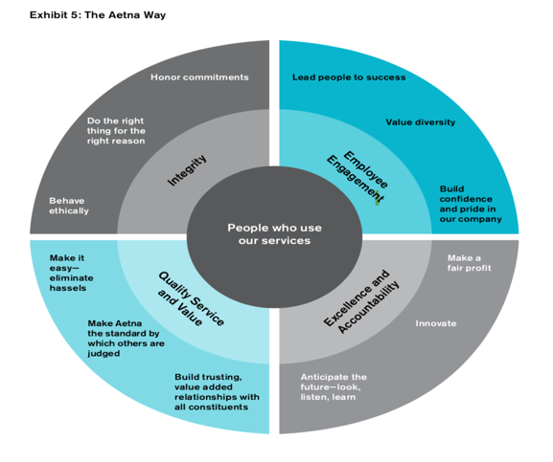
- The Aetna way.

Source: Source: Cascio, (2009)
- LAMP Model

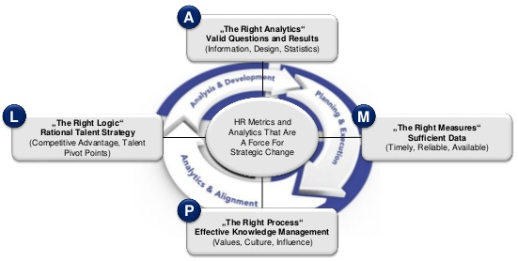
Source: Cascio, (2009)

