Learning in the Digital ERA.
BMPL4007/C.
Cerys Bowen.

Contents
Table of Contents
Summary 3
Mind map 4
Video 4
Reflection 6
References 7
Bibliography 7

Summary

As students prepare for the next big step in life coming to terms with the necessities of university life is essential. The main key aspect of university is being able to study effectively. When it comes to studying being able to have the most suitable environment to do this is what will contribute to being the best to your ability. According to McMillan, (2012) “Whatever your accommodation, you will need time, space and peace to study.” Therefore, when considering productive studying other factors should be considered such as when there will be the least number of distractions or even when you feel most productive. As an individual knowing your strengths and weaknesses will ensure that things such as time and management is a strong skill you must work on. Being able to organize your time effectively is a challenge that every individual will face throughout university. Following from this being able to put a plan together will introduce a form of achieving, therefore having a clear plan will avoid things from falling apart. As noted by Moore, (2012) when mentioning structured decisions “involving an organized and sequential approach to making decisions.” This suggests a far more productive outcome to achieve a better performance. By having a plan this supports being able to prioritize effectively allowing you to be efficient with your time and workload. As students have different past experiences as well as interests choosing the appropriate course will make the difference between how much you interact with the course. According to Sternberg, (2016) he mentions to “take some intellectual risks with courses, activities, and what they say to adults-to develop a sense of how to assess risks.” By doing this it will lead to choosing the most suitable course that will allow a more successful outcome. When considering what course students find most suitable, they must also research into what University is most suitable for them as individuals.
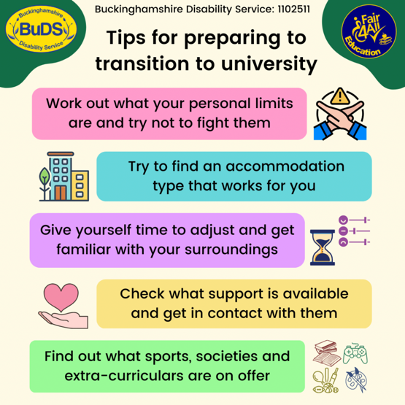
(Hobbs, 2022)

Mind map

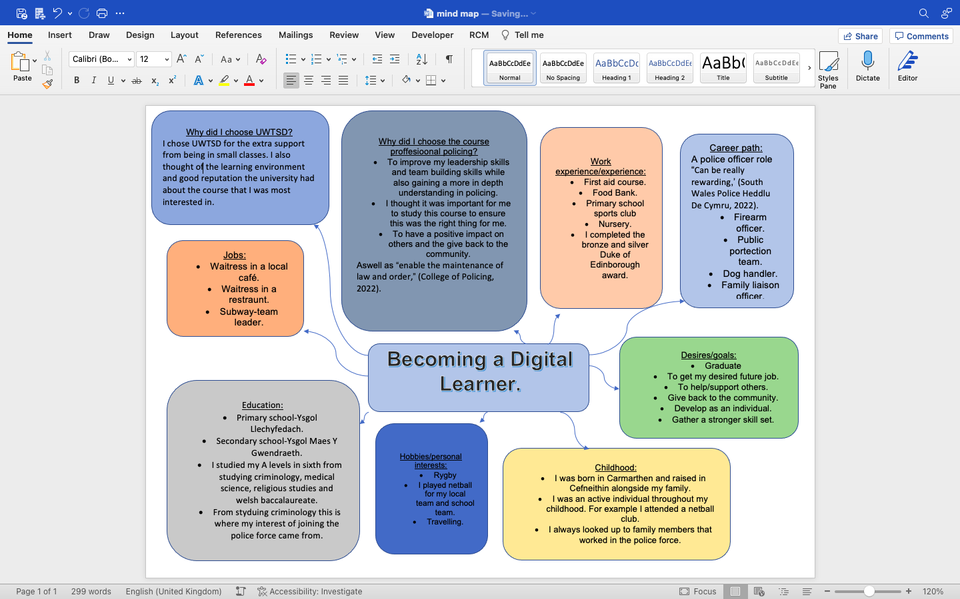

Video
https://youtu.be/AjZE27FDLDE

Reflection
Once starting university my main concern was being able to write assignments that were up to standard. I was nervous about this as I had no experience in writing assignments. I was conscious that the assignments were going to be a lot harder and to a higher standard compared to my previous education. From this experience I’ve learnt not to overthink and take everything step by step. This is suggested by Taylor, (2017) “identify the key themes and topics you are writing about.” By doing this I’m taking it bit by bit allowing me to put all my effort into it. Aswell as this I’ve learnt to look at the assessment specification to know exactly what is expected from my work. Another concern of mine once starting university was my time management skills and having to keep up with the workload. This is reinforced by Forsyth, (2013) “unless the right attitude is adopted, then time management will never be.” I was unsure whether I would get overwhelmed and overly stressed with having to prioritise my work. From this experience I have learnt that its essential to have a plan and structure in place to be able to organize my time effectively. By organizing my time effectively, I complete all my tasks and assignments before the deadlines and have time spare to be able to study. As I started university, I wasn’t fully aware of getting to grips with online learning and the resources. Because of this I wasn’t as confident when asked to complete tasks online or understand fully how to reference. When considering this I was able to learn from other students as some of their courses were online all together for example “2.97 million took some of their courses in this manner,” (Whiteside, 2017). I’ve learnt how to use the resources to assist my assignments and work and fully understand the online learning aspect.

References

Bibliography
College of Policing, 2022. Police Constable. [Online]
Available at: https://profdev.college.police.uk/professional-profile/police-constable/
[Accessed 18 October 2022].
Den, O., 2007. Exploring effectiveness of team communication: Balancing synchronous and asynchronous communication in design teams. Engineering, construction, and architectural management, 14(5), pp. 408-419.
Drummond, J., 2020. Self-identity and personal identity. Heidelberg: Dordrecht: Springer Netherlands.
Forsyth, P., 2013. Successful time management. 3 ed. Lonodn: Kogan Page Ltd..
Hobbs, C., 2022. Preparing to transition to university. [Online]
Available at: https://buds.org.uk/preparing-to-transition-to-university/
[Accessed 12 October 2022].
Hoff, K. & Pandey, P., 2014. Making up people—The effect of identity on performance in a modernizing society. Journal of development economics, Volume 106, pp. 118-131.
Jaspal, R., 2014. Identity process theory : identity, social action and social change. Cambridge: Cambridge University Press.
McMillan, K., 2012. The study skills book. 3 ed. London: Pearson Education.
Moore, S., 2012. The ultimate study skills handbook. 1 ed. Berkshire: Open University Press.
Nixon, M., 1994. Ethical Reasoning and Privileged Information: Resolving Moral Conflict. Journal of business ethics, 13(7), pp. 571-577.
South Wales Police Heddlu De Cymru, 2022. The Police Officer Role. [Online]
Available at: https://www.south-wales.police.uk/police-forces/south-wales-police/areas/careers/careers/uniformed/police-officer-role/
[Accessed 18 October 2022].
Sternberg, R., 2016. A New Model for Preparing Students for Active Concerned Citizenship and Ethical Leadership. What Universities Can Be, 64(1), pp. 37-71.
Stets, J. E. & Burke, P. J., 2009. Identity theory. Oxford: Oxford University Press.
Taylor, D., 2017. Get a better grade : seven steps to excellent essays and assignments. London: SAGE Publications Ltd.
Whiteside, A., 2017. Social presence in online learning : multiple perspectives on practice and research. Eastcastle: tylus Publishing.

