Shalena Brown / Enw
2240360 / Rhif myfyiwr
E-portfolio report
ADRODDIAD E-BORTFFOLIO
Learning in the Digital Era / Dysgu yn yr Oes Digidol – BMPL4007/BMPS4009
Table of Contents
Task 1 – Written summary / Tasg 1 - Crynodeb Ysgrifenedig 2
Task 2 – Mind map / Tasg 2 – Map meddwl 3
Task 3 – Presentation / Tasg 3 - Cyflwyniad 4
Task 4 – Reflection / Tasg 4 - Myfyrdod 5
Task 5 - PDP/ Tasg 5……………………………………………………………………………………………………………………………
Reference list / Rhestr Cyfeirnodi 6

Task 1 – Written summary / Tasg 1 - Crynodeb Ysgrifenedig

Stefanie chose to get into higher education because they were sick of being stuck. They had spent most of their adult life either in or out of hospital with various illnesses. Now they’re at a better point where everything is manageable, they wanted to do something for themself. Throughout their childhood they were told because of the conditions they were born into; they would never amount to nothing. They would just be another single mum sponging off the government. They read a quote by (Germany Kent 2019) that reads “Never underestimate the power you have to take your life in a new direction.” This ultimately fuelled their desires to go back into education and set goals for themself to be a good example for their daughter.

“Working parents can influence their children positively and teach them practical life skills while providing for their financial needs. For instance, children can learn time management skills by closely observing how their parents manage their time (Parent Herald 2022)”.
Having access to higher education helps prepare people without any existing qualifications to study at university. It is delivered by a variety of organisations and colleges and is available in many different subjects. To prepare themselves for their future goals they researched what qualifications they would need for completion, how long it would take them and anything they could do outside of studying for example an internship to help boost their accessibility in their chosen field as well as looking into financing to help them fund their chosen course. They managed to find a university that was in close proximity to their home and their daughter’s school so there wouldn’t be any interruptions to their daughter’s education and welfare. Having their own home made it easier for them as they didn’t need to look for accommodation. “Go confidently in the direction of your dreams! Live the life you’ve imagined.” (Thoreau 1854).

Task 2 – Mind map / Tasg 2 – Map meddwl
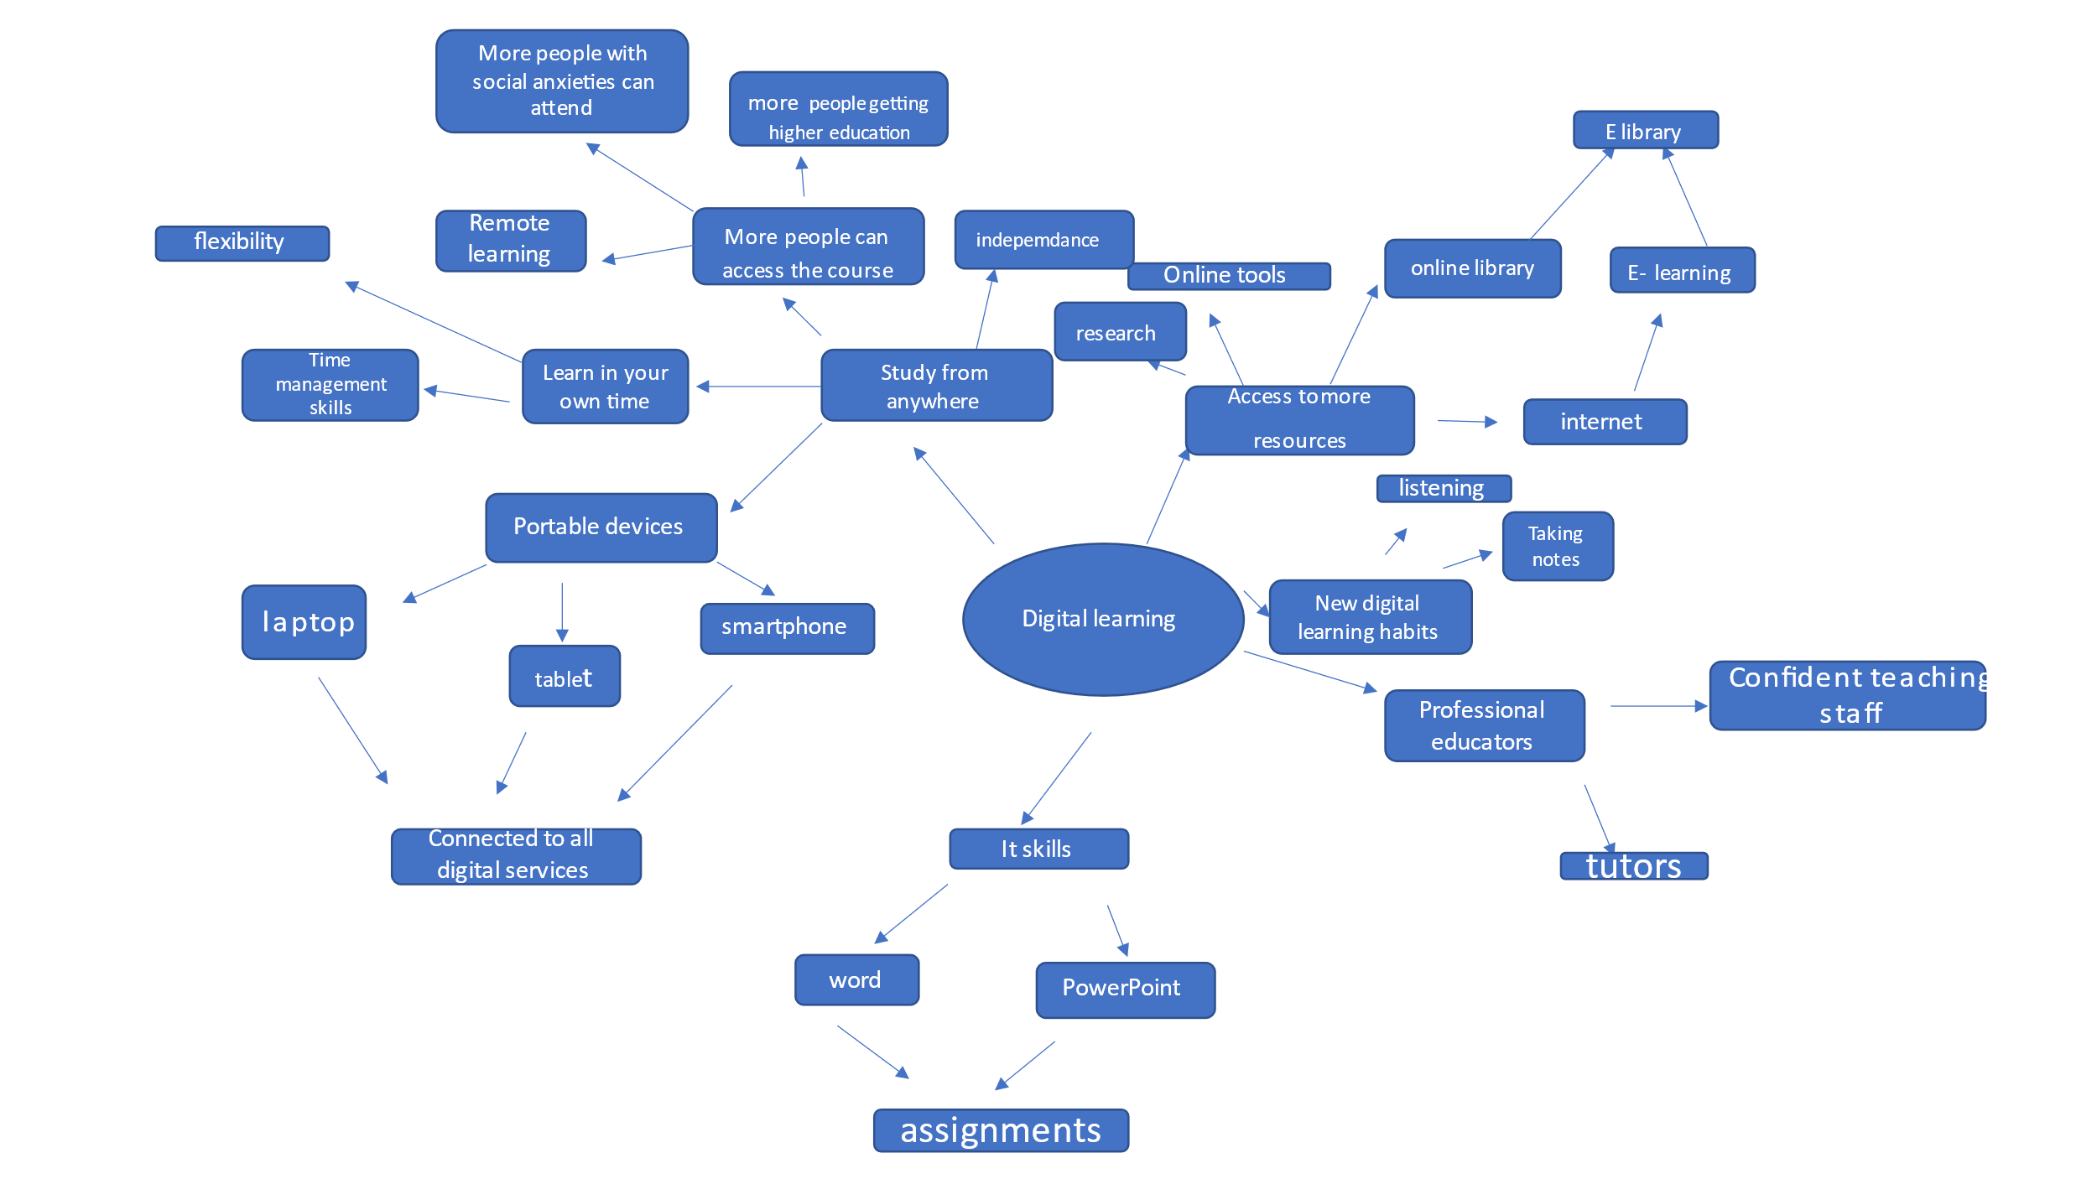

Task 3 – Presentation / Tasg 3 - Cyflwyniad
Please follow this link to view my presentation: / Dilynwch y cyswllt isod i wylio fy nghyflwyniad

https://youtu.be/9tQu3e7pQ1c

Task 4 – Reflection / Tasg 4 - Myfyrdod

My experiences starting University.

Starting university has been a difficult process. Going back into education after being out of education for 17 years has been a massive learning journey. For the past 4 years I wanted to become a judge but knew the process was long, and my first step would be signing up. Scrolling through social media I came across a pop-up from talent care education about getting back into education which offered the course in which I wanted to attend. During the process I had someone from talent care education guide me in every step from completing my forms for uni and the interview process to even now checking in to make sure I’m satisfied with the course I have chosen. I was accepted and officially enrolled into university on the 24^{th of} April 2023. I was ecstatic as I knew this was the start of my journey to becoming a judge.
“Starting university can be a wonderful and exciting experience, but it can also bring its own challenges. It’s natural to feel nervous or overwhelmed during the first few weeks at university and it can be a while before you feel like you have found your feet” (student minds-2009). When I got accepted into university I was overwhelmed with happiness, anxiety, and nervousness. Making it on the course was huge as I never thought I was smart enough to be able to get this far. Now the only thing that was stopping me was my own mind, that’s where the anxiety kicked in. Some of the questions going through my head were “Can I actually do this?” “Am I going to understand and take in anything that I’m taught?” “Am I smart enough to complete the course and move forward?” “Is the stress from studying going to affect my mental and physical health?”. Starting my first assignments was difficult because I felt I lacked the relevant knowledge and information to complete the assignments successfully. Writing my first assignment was a challenge. Getting to grips with using a laptop after so many years was stressful and I’m still now getting to grips with the software installed on it. The pressure from it all is sometimes unbearable but I think about the end goal and that keeps me motivated. I felt I needed to do more research before joining the course to be more mentally prepared for the information I was about to take in. I read a quote that says “Motivation, both intrinsic and extrinsic, is a key factor in the success of students at all stages of their education, and teachers can play a pivotal role in providing and encouraging that motivation in their students.” (Teach Thought 2023).
Since starting the course, I feel more confident with each session that goes by. With the support of a few others on the course, we set up a group chat where if anyone feels lost or confused, we can share information and ask questions.
We are almost 4 weeks into our course, and I have had some good experiences and some bad ones. Some of my better experiences are:
- Meeting new people
- Meeting people who seem to suffer from the same anxieties and crippling fears.
- Everyone showing support and helping each other.
- Being able to openly express my thoughts during activities.

Some of my bad experiences have been:
- Missing classes due to health reasons
- Having trouble with sound so missing a lot of information from class
- Going into activities and no one communicating, so then when putting things into practice things are going unlearnt.
- When going through the work on Moodle, not being able to understand because the words spoken don’t always match what’s written on the slides.
Although a lot of my experiences I could have never anticipated would happen, it has made me more motivated to not only finish this course but pass it and move on to the next level up.
I feel like things went well because not only did I have the right qualifications, but I had proved to them I was worthy to be on the course by putting knowledge and my research skills into action to prepare for the interview. To pass the interview process I had to research and that’s what most assignments are about. This shows I’m more than capable of doing the course. Keeping myself motivated throughout the course was going to be a big challenge.
What I have learned so far is I do lack organisation skills and need to organise my time better so I have set times for home life and set times to study is I can achieve a lot more. I have bettered my communication skills with my peers and learned that all questions are good questions. What I haven’t learned is that if I need to ask my tutor something to not be shy and ask. “So, the next time you want something and are hesitant to go for it, remember, if you don’t ask, you won’t get and if you don’t try you will never know what might have been” (Salah 2014). I do need to focus on my time management because currently I have no real commitments and do whatever I like whenever I like. This will also in turn show my daughter the skills she will need to prepare for secondary school and how to organise her time when it comes to homework and fun time. I also need to incorporate my learning style into my learning to make understanding the assignments easier for me. “By failure to prepare, you prepare to fail” (Franklin, 1790).
Before applying for a course next time, I would do more research on what the course entails, pre-plan my time so I know when I’m going to study and look at pre-recoded lectures. A study timetable would help me a lot. I can make sure of this by reminding myself of all the feelings I felt and the struggles I felt from starting this course. “Success is not about good luck. Many people go through their whole life believing they are either lucky or unlucky, academically able or not academically able. But you can get good grades through perseverance and razor-sharp focus on your longer-term goals.” (Russell. L 2019).

Task 5– Personal Development Plan

Student Name |  | Student Number |  | Module |  | Code
Shalena Brown |  | 2240360 |  | Learning in the Digital Era |  | BMPL4009
What goals do I want to achieve? | How will I measure my progress? |  | What resources or support will I need? |  | How is the objective relevant to my personal aspirations? | What is the timeframe for the achievement of my goals?
Specific | Measurable |  | Achievable |  | Relevant | Timebound
Assignments in on time.  Time keeping  Organisational skills  Get better at listening.  Get better at focusing.  Learn how to communicate better.  Better my study skills  Better my research skills  Communication skills  Better mental health  Better physical health  Look into becoming a magistrate.  Look into the process of becoming a judge.  Complete assignments  Achieve better confidence.  Better my social skills  Better at doing job interviews.  Better faith, pray a minimum of 3 times a day.  Learn arabic.  Finish decorating my home.  Search for secondary schools for my daughter. | Meeting deadlines  Timetabling to help set times for uni work, family, gym and general household activities such as cleaning and food shopping etc.  Create a calming workspace so I’m not easily distracted.  Setting specific times for studying research and assignment writing.  Read books.  Online research.  Apply for opportunities that help towards my career goals.  Find and attend local library.  Attending courts to see first-hand how they operate.  Find a gym.  Find personal trainer.  Attend physiotherapy sessions.  Go see my therapist regularly.  Take my medication daily.  Practice speaking in front of friends or family.  Read my Quran.  Arabic tutor.  Arabic tests, exams  Visiting local schools |  | Notebook  Wall calendar  Mobile calendar  Calendar on outlook  Alarms  lavender oil, burner (The smell is calming to me and helps me concentrate)  Gym equipment and clothing  Gym membership  Yoga club  Swim club  Diet plan  Dosette box  Laptop  A variety of Arabic books  An Arabic tutor  Talk to my friend who’s a solicitor.  Attend Study Skills sessions.  Speak to tutor when needed.  Talk to mental health speacialist.  Support from Friends and family. I dont really leave the house due to severe anxiety which effectively leaves me with no social life or Friends.  Prayer Counter  Set up a savings account and work out incomings and outgoings So i can Transfer money over each month.  Talk to other parents that are originally from Leicester, see their views on which schools are best. |  | To be able to achieve my end goal, all my specific goals need to be achieved.  I need to be at my happiest, healthiest point mentally and physically to be able to do my dream job efficiently. I do see myself in the future a more confident, strong person so every day I aspire to be the future Shalena.  Better physical and mental health= a happier Shalena  Support from friends and family will help enable to get out of the house, socialise and be able to hold down and maintain a job without anxiety attacks or living my life in fear of the outside world.  Teaching myself about saving. Get better at saving money for future. I can then use this for further plans i.e. saving for a house.  I aspire for my daughter to go to a quality school to get the best education she could possibly have. | Make sure my assignments are submitted by the deadline.  I have a 5-year plan with goals I want to achieve for each year for example this year I want to have passed my course, have better physical health and have read the whole Quran translated to English.  I will check my progress every 3 months and rectify and goals that have been missed or unachieved.  Mental health is going to be the longest running goal to achieve. I am setting myself a good 5 years to make sure I have had time to speak to a therapist, get on the right treatment plan that works for me. With the problems in the mental health providers and so many on the wait list to speak and receive treatment I believe this is more than enough time.  I’m setting myself a 2-year goal to completely learn arabic so I can read the Quran without needing English translation. Having a second language behind me can also be helpful for work, travel abroad and to talk to my future husband’s family.  Less than 1-year to find a appropriate secondary school.

Reference list / Rhestr Cyfeirnodi

www.itsallyouboo.com
https://blog.bit.ai/teamwork-quotes/2021/
https://blog.westminster.ac.uk/wbs/2014/10/09/if-you-dont-ask-you-dont-get/#:~:text=So%20the%20next%20time%20you,know%20what%20might%20have%20been
https://www.brainyquote.com/quotes/benjamin_franklin_138217
https://www.goodreads.com/quotes/8105541-go-confidently-in-the-direction-of-your-dreams-live-the
www.parentherald.com/articles/102418/20200522/pros-cons-both-parents-working.htm
www.studentminds.org.uk/about.html
Improve Student Motivation With These 20 Ideas (teachthought.com)
https://www.theyarethefuture.co.uk/exam-confidence-motivational-quotes/

