

Student Name: Mahabubur Rahman Rahat
Student ID: 2436043

Module Name: International Marketing: Principles and Practices
Module Code: LCMB7026

Assignment Title: International Marketing: Principles and Practices
Lecturer’s Name: Tushara Balendran

Work Count: 5216

Submission date: 19/12/2025

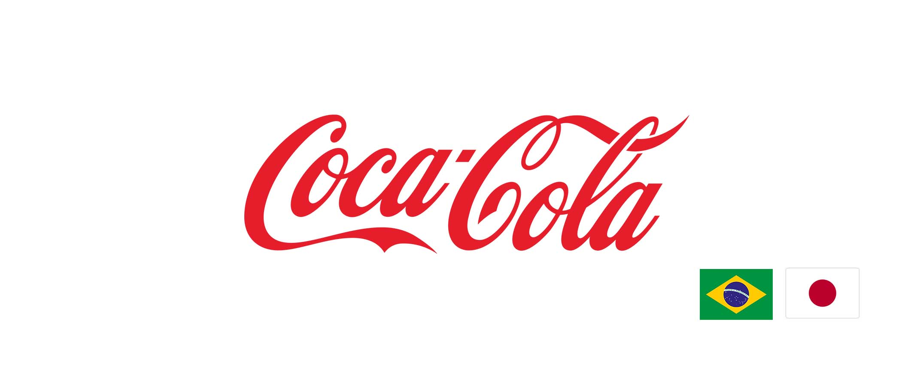

A Comparative Analysis of Coca-Cola’s Marketing Strategies in Brazil and Japan

Executive Summary
The report compares the marketing strategies of Coca-Cola in Brazil and Japan based on the socio-cultural background, the STP strategies, the marketing mix (7Ps), performance analysis, and ethics. In Brazil, Coca-Cola can use the mass-market, culturally relevant campaigns and low-cost approaches to keep the market share and brand loyalties high. In Japan, the company focuses on product innovation, convenience and high-end positioning to attract health-conscious and urban consumers. Competitive analysis reveals discrepancies in consumer behaviour, channels of distribution, promotions and pricing.
Although the two markets are performing well, Brazil has ethical issues surrounding the consumption of sugary beverages, unlike Japan, which stresses transparency and quality. It is advised to increase health-related products, sustainable operations, and online interactions to continue to enjoy competitive advantage and brand expansion in the long run across the globe.
Table of Contents
1. Introduction 4
2. Brand Overview: Coca-Cola and Its Operations in Brazil and Japan 6
2.1 Coca-Cola in Brazil 6
2.2 Coca-Cola in Japan 7
2.3 Strategic Importance of Both Markets 8
3. Comparison and Contrast of the Socio-Cultural Context of Brazil and Japan 8
3.1 Macroenvironment (PESTLE) of Brazil vs. Japan 8
3.2 Hofstede’s Cultural Dimensions 12
3.3 Summary of Similarities and Differences 14
4. Comparison of Coca-Cola’s STP Strategies in Brazil and Japan 14
4.1 Brazil: Mass-Market, Emotionally Driven Targeting 15
4.2 Japan: Niche, Innovation-Oriented Targeting 16
4.3 Comparative Analysis 16
5. Comparison of Marketing Mix (7Ps) Strategies in Brazil and Japan 17
5.1 Product Strategy 17
5.2 Price Strategy 18
5.3 Place (Distribution) Strategy 18
5.4 Promotion Strategy 19
5.5 People Strategy 19
5.6 Process Strategy 20
5.7 Physical Evidence Strategy 20
6. Evaluation of the Performance of Marketing Strategies in Brazil and Japan 21
6.1 Brazil: High Market Penetration and Brand Loyalty 21
6.2 Japan: Innovation-Driven Success and Premium Brand Perception 22
6.3 Comparative Evaluation 22
7. Evaluation of Marketing Ethics Practice 23
7.1 Brazil: Ethical Challenges in Advertising and Health Awareness 24
7.2 Japan: Ethical Marketing and Transparency 24
7.3 Comparative Analysis 24
8. Recommendations 25
9. Conclusion 26
Reference 28
Appendices 30

1. Introduction
In a market environment that is becoming more and more global, multinational companies have to change their marketing strategies to fit the various economic, cultural and regulatory environments. The Coca-Cola Company is one of the most recognizable brands of beverages in the world, with operations in more than 200 different countries and daily delivery of more than 1.9 billion beverages (Coca-Cola Company, 2023). Although Coca-Cola has a robust global brand, it uses localized marketing strategies to ensure that it is competitive in various markets of countries. The present report is a critical comparative analysis of the marketing strategies of Coca-Cola in two countries that are very different, Brazil and Japan.
Figure 1: Coca-Cola Brazil Headquarters, Rio de Janeiro
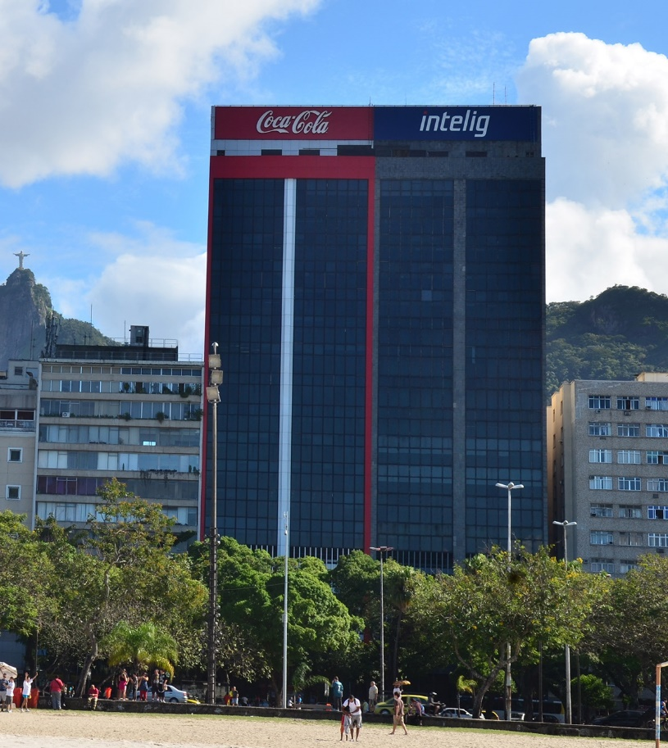
Source: The Coca-Cola Company, 2023
Brazil is one of the largest emerging markets of Coca-Cola, as its population is significantly young, and social consumption culture and the need to drink carbonated soft drinks are high (Statista, 2023). On the contrary, Japan is an extremely developed and technologically advanced market whose consumer preferences have been influenced by health consciousness, premiumization and innovation (Euromonitor, 2023). These two national backgrounds allow a good basis to assess the way global brands refit their marketing strategies to fit various cultural, economic and social settings.
Figure 2: Coca-Cola Japan Headquarters, Tokyo Midtown Tower

Source: Coca-Cola Bottlers Japan Inc., 2023
This report intends to critically analyse international marketing at Coca-Cola through comparing the operations of the company in Brazil and Japan. The analysis will cover the overview of the brand, comparison between the socio-cultural contexts, analysis of Segmentation, Targeting and Positioning (STP) strategies, and comparison of the marketing mix (7Ps) used in the two countries. The report also analyses the efficiency of marketing performance of Coca-Cola with the help of data in the market and critically examines ethical concerns that pertain to its marketing activities.
Lastly, the recommendations on strategies are given to establish the future international marketing of Coca-Cola. In an attempt to have a robust and evidence-based analysis, this report relies on academic literature, industry reports, company publications, and other market intelligence platforms, including Statista, Mintel, and MarketLine.

2. Brand Overview: Coca-Cola and Its Operations in Brazil and Japan
The Coca-Cola Company is the largest non-alcoholic beverage producer operating in over 200 countries, and over 200 brands are managed by the company, which was founded in 1886 in Atlanta, USA (Coca-Cola Company, 2023). Its most popular brand, Coca-Cola, is still one of the most valuable international brands, always being in the top five in the world in terms of brand equity, well-developed distribution network, and innovative and creative marketing strategies (Interbrand, 2023).
Figure 3: The Coca-Cola Company's Concentrator/Bottler Model
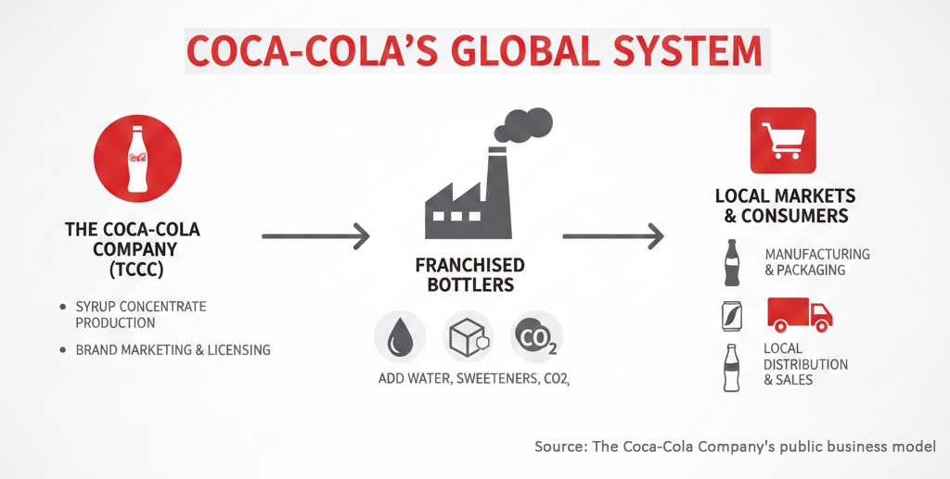
The company works under a franchised bottling system whereby the company is a producer of syrup concentrates centrally, and it then licenses bottlers to manufacture, package and distribute beverages locally.

2.1 Coca-Cola in Brazil
Brazil is one of the most strategic and largest emerging markets of Coca-Cola. Since 1942, Coca-Cola has been present in Brazil, and now it is running one of the largest global bottling systems with Coca-Cola FEMSA and other partners within the region (Coca-Cola Brazil, 2023). In Brazil, the company serves about 2.2 billion drinks per year, and it has more than 60,000 direct or indirect employees throughout the value chain (Statista, 2023).
Brazil has long been a good market for carbonated soft drinks (CSD), and the reason is that it has a hot climate, a social drinking culture and a young population base. The Brazilian CSD market is dominated by the company, which has a market share of more than 45 per cent, which is far much higher than its competitors, including PepsiCo and regional brands (Euromonitor, 2023).
Figure 4: Coca-Cola Brazil: Operational Snapshot and Localized Strategy
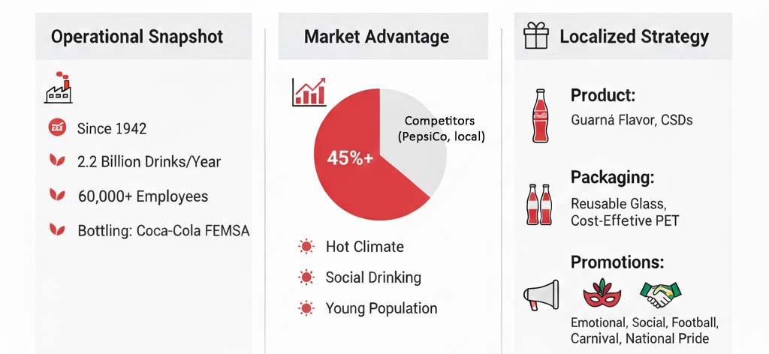
Localized product offerings like guarana beverage tasting, reusable glass bottles and cost-effective PET packaging are extensively distributed to serve the low-income customers and penetrate the market to the maximum levels. Brazilian promotions are very emotional, social and strongly related to football, Carnival and national pride (Kotler et al., 2022).

2.2 Coca-Cola in Japan
Japan is one of the most developed markets that Coca-Cola has, with the most complex and innovative markets. Coca-Cola was introduced to Japan in 1957 and has constructed one of the most technologically sophisticated plants in the world, which is backed by Coca-Cola Bottlers Japan Holdings (Coca-Cola Japan, 2023). Japan is unique due to extremely diversified drinking patterns, in which ready-to-drink teas, coffees, and functional drinks and low-sugar drinks are more dominant compared to the traditional carbonated soft drinks (Mintel, 2023).
Figure 5: Coca-Cola's Strategic Adaptation and Market Drivers in Japan
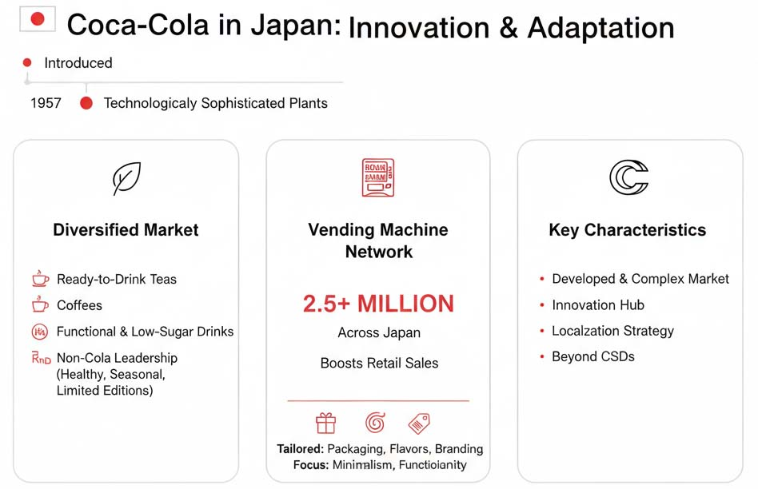
Sources: Coca-Cola Japan (2023, Mintel (2023), Statista (2023.
As compared to Brazil, the market leadership of Coca-Cola in Japan is not based on cola drinks alone but on a broad range of healthy lifestyle, seasonal and limited-edition products. Japan is also known worldwide for Coca-Cola having a developed system of automated vending machines, and there are more than 2.5 million in all parts of the country, which adds to the volume of retail sales (Statista, 2023). They are often tailored to suit the consumer preferences of the Japanese in terms of the product packaging, flavors and branding and focus on innovation, minimalism and functionality.

2.3 Strategic Importance of Both Markets
Brazil and Japan are two different yet very useful strategic markets to Coca-Cola. Brazil has a high growth potential based on mass-market consumption, and Japan has high profitability based on premium innovation and product diversification. This balance between the global brand consistency and the local adaptation of the company in these two markets shows the success of the international marketing strategy used by the company (Hollensen, 2020).

3. Comparison and Contrast of the Socio-Cultural Context of Brazil and Japan

3.1 Macroenvironment (PESTLE) of Brazil vs. Japan
The socio-cultural and macroenvironmental nature of Brazil and Japan is also critical in the analysis of international marketing strategies of Coca-Cola. Though the two markets have a global presence, political, economic, social, technological, legislative and environmental factors vary considerably, and one of them affects consumer behaviour and marketing success. This part compares these two contexts critically with PESTLE analysis and cultural dimensions of Hofstede in the light of academic literature and evidence in the contemporary market.
Figure 6: PESTLE Macro-Environmental Factors
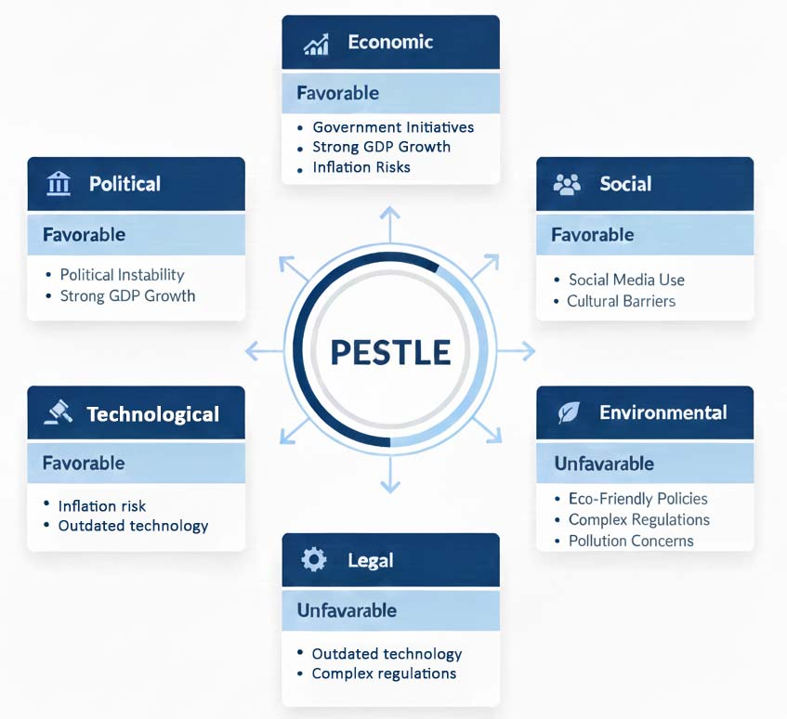
1. Political Factors
Brazil is a federal democratic state, but it is typified by unstable politics, corruption, and failure to implement policies consistently (Hunter and Power, 2019). Political instability has been known to cause uncertainties in the operations of multinational companies like Coca-Cola to the extent of affecting investment decisions and long-term planning.
- Favorable factors: the government encouragement of the investment of the industrial sector, the high number of consumers, and the freedom of trade (World Bank, 2023).
- Unfavorable factors: bureaucracy, variable taxes (in both ways), and poor institutional governance.
Japan, in its turn, is a very stable parliamentary government and is very well-known due to predictable regulations, high rule of law and efficient state administration (Schreiber, 2020).
- Favorable factors: a slim corruption index, robust intellectual property (IP) protection, and a long-term period of the industrial policy.
- Unfavorable factors: Strong regulation of the market and the processes of registration of foreign companies.
Key Difference: The Brazilian political instability is the opposite of the Japanese institutional stability, which affects the strategic risk management of Coca-Cola in the two countries.
2. Economic Factors
Brazil is a developing country whose GDP stands at more than USD 2 trillion and has a fairly young population of labour force (IMF, 2023). It has a consumption-based economy, which promotes the demand of FMCG and soft drinks.
- Favorable economic conditions: more middle class, urbanisation, and an increasingly booming digital market.
- Unfavorable conditions: inflation, poverty, currency fluctuations, and uneven economic growth (OECD, 2023).
Japan, in its turn, is a highly developed, high-income economy with a high purchasing power and stagnant growth because of the ageing of the population (Nakata and Miyamoto, 2021).
- Favorable conditions: great disposable income, good technology and steady market demand.
- Unfavorable conditions: Unfavorable surroundings, a sluggish GDP boom, excessive labour expenses and a declining home populace.
Similarity: Both countries have a good consumer market in beverages.
Difference: Brazil has growth opportunity, but Japan has stable yet advanced demand.
3. Social Factors
The most obvious point of disagreement between the two countries is social influences.
Brazil: The Brazilian culture is collective, people-orientated, and demonstrative, where the importance is laid on the social gatherings and celebrations (Reis et al., 2022). The soft drinks are commonly taken at communal gatherings and emotional affiliation and publicity in pop culture influence brand loyalty.
Japan: The society in Japan values discipline, accuracy, and convenience because of the rush of living in cities (Fukuda, 2020). Consumers are opting in favor of functional health-based beverages, low-sugar products and products that have technological novelty. Purchase behaviour is also strongly affected by the aesthetics of the packaging, perceived quality, and convenience (Euromonitor, 2023).
Differences:
- Brazil is focused on affordability and emotional branding, and Japan is focused on quality, health, and minimalism.
- The younger generation in Brazil is unlike the ageing Japanese population; hence, their consumption patterns are different.
4. Technological Factors
The technological environment in Brazil is on the rise, as the rate of smartphone penetration is high, and its social media penetration is high, which makes digital marketing a viable option (Statista, 2023).
- Favorable: Good levels of digital interaction, mobile-first consumer culture.
- Unfavorable: Isolation of the rural areas and shortage of local research and improvement.
Japan, in turn, is a world technological leader where automation, AI, robotics, and even global-level digital infrastructure are at the top (Nippon Institute, 2022).
- Favorable: Good internet penetration, powerful innovation ecosystem.
- Unfavorable: Foreign firms have high costs of implementation of high technology.
Difference: The Japanese environment in terms of technology is way ahead and needs exceptionally advanced marketing channels and packaging innovation.
5. Legal Factors
The Brazilian legal system is not very straightforward: it is highly taxed and strict in labour regulations (da Silva & Bonolo, 2021).
- Favorable: Strong consumer protection laws are favorable.
- Unfavorable: The cost of compliance is high, and regulations are unpredictable.
Japan has clear and foreseeable regulation systems, and quality, health, and safety requirements are stringent (Schreiber, 2020).
- Favorable: Well-developed legal systems, good IPR.
- Unfavorable: Regulatory inflexibility, which raises the barriers to entry.
Difference: Brazil has a complex and unpredictable felony environment, while Japan has a traumatic and difficult criminal machine.
6. Environmental Factors
Brazil has considerable herbal resources, but the United States faces some troubles, along with deforestation, weather trade and water shortage (WWF, 2022).
- Favorable: The prospects of renewable packaging and local sourcing.
- Unfavorable: Along with the challenges of unpredictable supply chains, there also are developing threats of environmental damage that may affect numerous industries.
Japan boasts of good environmental laws and national integrity targets, particularly on recycling and carbon mitigation (METI, 2023).
- Favorable: Good regulatory environment towards green.
- Unfavorable: scarcity of natural resources and high level of importation.
Difference: Japan is effective in environmental sustainability enforcement, and Brazil is weak in enforcement across the vast natural resources.

3.2 Hofstede’s Cultural Dimensions
The framework created by Hofstede brings out additional differences:
Figure 7: Hofstede's Cultural Dimensions: Comparison of Brazil and Japan
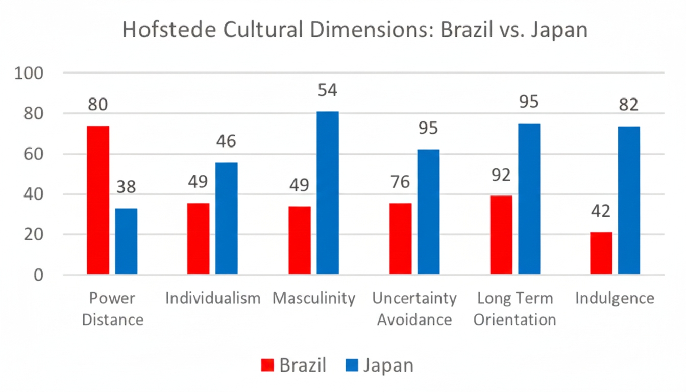
Source: Based on Hofstede Insights (2024)
1. Power Distance: Brazil is one of the countries that are highly rated in terms of hierarchy tolerance (Hofstede Insights, 2024). The moderate power distance in Japan implies a hierarchy that is structured and collective decision-making.
Difference: Brazil is more hierarchical; Japan is more consensus-driven.
2. Individualism / Collectivism: Brazil is a collectivist country that puts more emphasis on relationships (Hofstede, 2024). The Japanese are collectivists who appreciate group harmony and dutiful behaviour.
Similarity: Both cultures consider belonging to the group, but in different ways.
3. Masculinity: Japan has one of the highest scores in the world, and it emphasises performance, achievement, and quality. Brazil is also moderately high, but it focuses on social relationships and emotional display.
Difference: Japan is more competitive; Brazil is more socially orientated.
4. Uncertainty Avoidance: The score of both nations is high, yet it is one of the highest in Japan.
Similarity: They both like systems and expectations.
Discussion: Japan requires a more stringent reduction of risk.
5. Long-Term Orientation: Japan is highly long-term orientated, where plans and perseverance are important. Brazil is less long-term orientated, and it puts more emphasis on immediate outcomes (Hofstede, 2024).
Difference: There is considerable dissimilarity between strategic horizons.
6. Indulgence: Brazil is the most hedonistic with the celebration of pleasure and fun. Japan is reserved with respect to discipline and tradition.
Difference: Brazil is emotional; Japan is not.

3.3 Summary of Similarities and Differences
Similarities
- High uncertainty avoidance.
- Powerful consumer markets that have a well-developed beverage need.
- To a different extent, collectivist cultural characteristics.
Differences
- Brazil: young, outspoken and price-sensitive.
- Japan: ageing, health-conscious and quality-conscious.
- The political, legal and technological environment in Japan is much better and more stable.
- Brazil offers growth opportunity and greater market risk.

4. Comparison of Coca-Cola’s STP Strategies in Brazil and Japan
Segmentation, Targeting, and Positioning (STP) are the key marketing tools that allow such a global brand as Coca-Cola to address the needs of different consumers with its products and campaigns (Kotler et al., 2022). Because of the socio-cultural, economic, and demographic differences between Brazil and Japan, Coca-Cola employs differentiated STP strategies to achieve optimal market relevancy and competitive edge.
Figure 8: Coca-Cola’s STP Comparison: Brazil vs. Japan
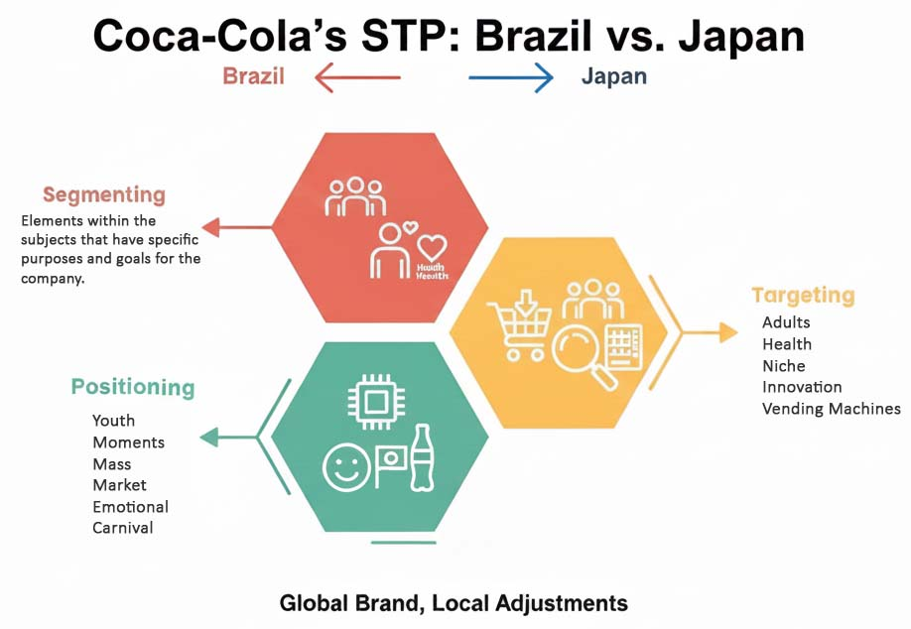
Source: Coca-Cola Brazil (2023); Coca-Cola Japan (2023); Mintel (2023).

4.1 Brazil: Mass-Market, Emotionally Driven Targeting
Coca-Cola in Brazil uses demographic, psychographic and behavioural segmentation. The brand caters to youth and young adults on a demographic level since they are the largest group of consumers of carbonated soft drinks. The population of Brazil is comparatively young, and more than half of the population is below 35 (IBGE, 2023), which is why this group is rather powerful concerning the adoption of brands and social interaction. Psychographic ally, Coca-Cola targets the need of consumers to connect with others, enjoy, and share moments, making the brand a source to make people happy and together (Coca-Cola Brazil, 2023). Behavioural segmentation has also been critical in that Coca-Cola segments the consumers in terms of the frequency of consumption with small and affordable packs to use in day-to-day activities and larger packs to use on a social occasion.
In Brazil, the mass market is the main target in advertising whereby the advertisements are intended to reach as many individuals as possible. Coca-Cola appeals to consumers across socioeconomic divides with the help of emotional storytelling and culturally linked narratives (football-based promotions and Carnival campaigns). Positioning focuses on the reasons as to why Coca-Cola is a representation of happiness, life celebration, and national identity and in such a way aligns the brand with both the social event and the daily pleasure (Kotler et al., 2022).

4.2 Japan: Niche, Innovation-Oriented Targeting
The focus on the niche segmentation strategy and innovation is more niche-based, which is a part of the individualistic culture and high health consciousness in Japan. Demographically, the brand focuses on urban adults and younger customers who are able to spend their disposable income on high-quality and convenient products. Japanese consumers are also health-conscious psychographic ally and require functional beverages as well, which explains the presence of low-calorie drinks, teas, and local limited series in the product assortment of Coca-Cola Japan (Coca-Cola Japan, 2023). The behavioural segmentation also further divides the consumer on purchase occasion, as particular products are sold by the vending machines, convenience stores and offices to be consumed on the go.
In Japan, the targeting is more discriminating and aims at consumers who give importance to the quality of products, innovations and functional advantages. Positioning emphasises the sophistication of the products, technological advances, and high-quality products, unlike the socially broad positioning in Brazil (Hollensen, 2020). This positioning is reinforced with seasonal packages, exclusive flavors and enhanced selling machine experiences that satisfy the needs of the Japanese consumers in terms of novelty and personalization (Mintel, 2023).

4.3 Comparative Analysis
The STP comparison indicates that Coca-Cola modifies its marketing strategy to a great extent, depending on the features of national markets. In Brazil, it is mass-market and emotional positioning, which is achieved through the collectivist and socially activist culture of the country. On the other hand, Coca-Cola uses niche targeting and product innovation in Japan, which follows individualistic, healthy and sophisticated consumer behaviours.
The two strategies are both aligned to local socio-cultural as well as economic conditions. Market penetration in Brazil is motivated by easy access, emotional support and low price. Functional benefits, product differentiation and premiumization in Japan are related to quality and innovation expectations of the consumers. Such flexibility of STP strategy demonstrates that Coca-Cola can balance global consistency of the brand with local adjustments, which is an essential element of maintaining competitive advantage in varying markets (Hollensen, 2020).

5. Comparison of Marketing Mix (7Ps) Strategies in Brazil and Japan
The marketing mix (7Ps model) includes the Product, Price, Place, Promotion, People, Process, and Physical Evidence, which is essential to ensure that multinational corporations such as Coca-Cola can alter their strategies to fit various markets (Kotler et al., 2022). The local consumer preferences, socio-cultural values, and economic situation take quite a specific approach in Brazil and Japan, depending on the specific aspects of Coca-Cola usage.
Figure 9: Coca-Cola 7Ps Marketing Mix Comparison — Brazil vs. Japan
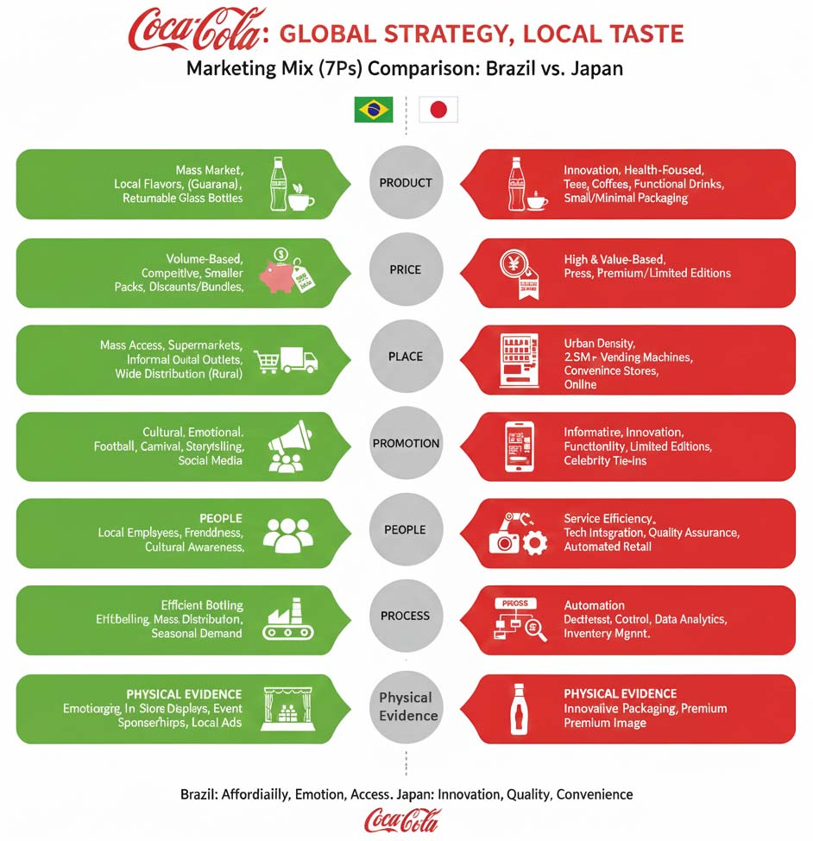
Source: Coca-Cola Japan (2023); Statista (2023); Hollensen (2020).

5.1 Product Strategy
The product approach of Coca-Cola in Brazil is based on the mass market and cultural adaptation. It has a diverse range of carbonated soft drinks; some of the products include Coca-Cola Classic, Coca-Cola Zero, and several local flavors like guarana, exclusive to the Brazilian market (Coca-Cola Brazil, 2023). The packaging is varied in the sense that it has small PET bottles to be used individually and also the glass bottles that are returned to make them affordable and greener. Cultural events, e.g., Carnival or football campaigns, are frequently associated with seasonal products and limited-edition packaging, which contributes to increased emotional investment in the brand (Euromonitor, 2023).
The Japanese product strategy is focused on innovation, health-consciousness, and variety. Coca-Cola has also diversified its product line-up to teas, coffees, low-calorie products, functional products, and seasonal limited products (Coca-Cola Japan, 2023). Packages are minimalistic and usually small, with appealing visual appeal to urban consumers and to enable them to use them on the move. Innovation is also through product innovation, like green tea-flavored Coca-Cola or Coca-Cola Plus with dietary fiber, given that the Japanese consumers focus more on health, functionality and novelty (Mintel, 2023).

5.2 Price Strategy
The pricing strategy of Coca-Cola in Brazil is volume-based and competitive in nature, as the Brazilian market is price-sensitive. Smaller packaging and multipacks have ensured lower prices and accessibility across the socioeconomic segments (Statista, 2023). Frequent consumption is further promoted with the use of promotional discounts and offers on a bundle.
Pricing is high and value-based in Japan due to an increase in the cost of production, innovation and quality perception. Limited editions, functional drinks, and conveniently designed packaging are likely to attract more money on the part of the consumers, especially using vending machines and convenience stores (Euromonitor, 2023). The products are usually differentiated by price, with special edition products being highly priced to support premium positioning.

5.3 Place (Distribution) Strategy
Brazil Distribution is aimed at mass access in the form of supermarkets, retail chains, convenience stores and informal outlets. Coca-Cola is made available through a huge network of bottlers, such as Coca-Cola FEMSA, to cover all areas of the country, even rural ones (Coca-Cola Brazil, 2023).
Urban density and convenience also play a major role in distribution in Japan. The number of vending machines sold by Coca-Cola is more than 2.5 million in the country, with the company being able to offer its products in offices, stations, and even on the street (Statista, 2023). Retail cooperation with convenience stores, supermarkets, and online stores will be the add-on to the existing vending machine network, as Japanese prioritise quick and convenient utilization.

5.4 Promotion Strategy
Brazilian promotional strategies are culturally orientated and emotional. Coca-Cola frequently sponsors football activities, live shows and carnivals, using storytelling and emotional connections with themes together with happiness and unity to strengthen its logo picture (Kotler et al., 2022). Younger demographics are targeted by the usage of digital marketing through social media, influencer campaigns, and experiential marketing events.
Promotion in Japan is innovation-orientated and informative, in most cases with emphasis on the functionality of the product, limited-edition flavors and seasonal releases. Coca-Cola Japan makes use of digital advertisements, TV advertisements, vending machines and cooperation with popular franchises or celebrities as its advertising structures (Coca-Cola Japan, 2023). Promotional activities are targeted at convenience, novelty and lifestyle improvement, which follows the expectations of Japanese consumers, quality and innovation.

5.5 People Strategy
Coca-Cola in Brazil invests in training of customer service and salesforce and involvement with the community, involving the use of local employees with consumers in retail outlets, events, and community activities (Hollensen, 2020). Communication between employees is through friendliness, cultural awareness, and individual interaction.
The priorities in Japan are on effective service provision and integration of technology, especially in the operation of vending machines and automated retailing. The corporate clients and retail partners are provided with precision, quality assurance, and customer support training for the employees (Coca-Cola Japan, 2023).

5.6 Process Strategy
The process strategy adopted by Brazil focuses on efficient bottling, distribution and execution of promotion events so that the products are available throughout the country and can respond to the demand boom of seasonal demand quickly. Coca-Cola FEMSA and local associates simplify the supply chain functioning to ensure high production volumes at reasonable prices (Coca-Cola Brazil, 2023).
The processes in Japan are centered on automation, quality control and innovations, especially in product development and management of vending machines. High-tech data analytics track consumer tastes and inventory, allowing a quick response to seasonal trends and most demanded goods (Mintel, 2023).

5.7 Physical Evidence Strategy
In Brazil, Coca-Cola uses such things as packaging, in-store shows, branding and occasion sponsorships to create more potent emotional connections with customers (Kotler et al., 2022). While the red and white shades and famous emblem continue to be the same around the sector, local advertisements are used to better hook up with precise cultures.
In Japan, the focal point is on innovation, cleanliness and impressive presentation, mainly in vending machines, product packaging and keep presentations. Limited packaging and attractive bottle designs make the brand feel more special and increase its image (Coca-Cola Japan, 2023).
Overall, the 7Ps comparison shows that Coca-Cola is flexible in its strategic approach. In Brazil, mass accessibility, affordability, and emotional appeal are the core values, which are similar to a collectivist and socially orientated culture. Japanese focus on innovation, quality and convenience and are in line with the population, which is individualistic, health conscious and urban. Both the marketing mixes in the two countries indicate how Coca-Cola responds to the global brand principles in local market environments, relevancy, competitive advantage, and high consumer loyalty.

6. Evaluation of the Performance of Marketing Strategies in Brazil and Japan
In a bid to determine the effectiveness of the marketing strategies that are being implemented by Coca-Cola in Brazil and Japan, we must consider some of the main aspects, such as sales, market share, brand awareness, social interaction via social media, and distribution coverage.
Figure 10: Coca-Cola Global Strategies: Brazil vs. Japan
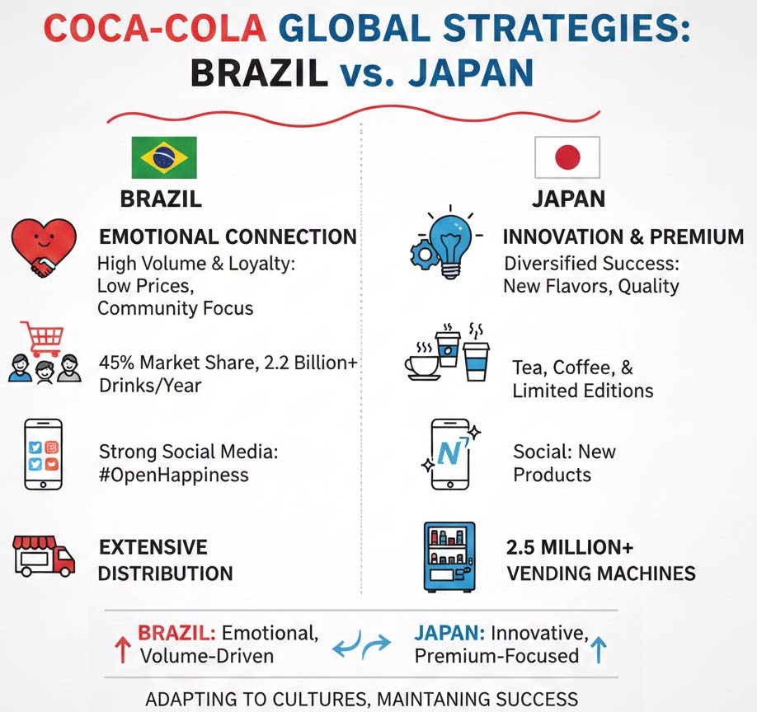
Source: Adapted from Euromonitor, Statista, Coca-Cola Brazil, Coca-Cola Japan (2020–2023).

6.1 Brazil: High Market Penetration and Brand Loyalty
The Coca-Cola company is performing very well in Brazil with a strong market share of approximately 45% in the carbonated soft drinks (CSD) segment (Euromonitor, 2023). Each year, they sell more than 2.2 billion drinks, which indicates the frequency of people drinking Coca-Cola (Statista, 2023). The low prices, culturally appropriate advertisements, and emotional campaigns have made the brand gain much loyalty among younger and middle-income groups (Kotler et al., 2022).
Coca-Cola has strong social media in Brazil as well. The campaigns are actively observed on Instagram, Facebook and YouTube, in particular in the course of main activities, which include soccer tournaments and carnivals. For example, the "Open Happiness" marketing campaign has generated hundreds of thousands of social media interactions, growing sturdy emotional connections with the brand (Coca-Cola Brazil, 2023). Coca-Cola also can be found handily throughout Brazil, both in cities and in rural regions, due to extensive distribution networks such as supermarkets, convenience stores and informal shops.

6.2 Japan: Innovation-Driven Success and Premium Brand Perception
Coca-Cola has been successful in Japan by emphasizing innovation. Although the market share of the traditional carbonated drink in the market is lesser than that in Brazil, Coca-Cola continues to exercise a significant market share in the wider non-alcoholic drinks market. It is also highly concentrated in such segments as tea, coffee, and functional beverages and limited-edition items (Mintel, 2023). The firm has also established more than 2.5 million vending machines throughout the country, and their drinks are extremely convenient and available (Statista, 2023).
Coca-Cola has developed a high-end brand in Japan. This is largely because of its orientation towards high-quality products, seasonal productions, and unique productions. The social media communication activities of Coca-Cola frequently focus on new flavors and special edition beverages, which appeal to urban and health-conscious consumers (Coca-Cola Japan, 2023). The company is focused on quality, style and technology, which the Japanese consumer values, and this would make the brand more loyal.

6.3 Comparative Evaluation
The marketing strategies used by Coca-Cola in the two countries have worked, albeit in different contexts. In Brazil, the brand aims at high sales volumes, low cost and emotional advertising, which is effective in a culture that cares about the community and social interaction. Innovation, availability of unique products and making drinks easily accessible bring success in Japan, as it has a more individualistic, health-conscious and tech-savvy population.
Nevertheless, the two markets are not without problems. Soda consumption in Brazil may decline in the future due to economic booms and declines, as well as increasing health issues. Coca-Cola needs to keep to innovate in Japan to live in advance of local competition and adapt to converting customer preferences. Nevertheless, the skillfulness to adjust marketing approach to various cultural and economic conditions has enabled Coca-Cola to remain in the competitive market and maintain customer interest (Hollensen, 2020).

7. Evaluation of Marketing Ethics Practice
Multinational corporations pay close attention to marketing ethics because immoral actions might negatively affect the brand image and consumer confidence and subject the company to the attention of the regulatory authorities (Crane and Matten, 2021). The marketing of Coca-Cola in Brazil and Japan is mostly ethical, but there are a number of concerns that should be addressed.
Figure 11: Comparative Analysis of Coca-Cola Marketing Ethics: Brazil vs. Japan.
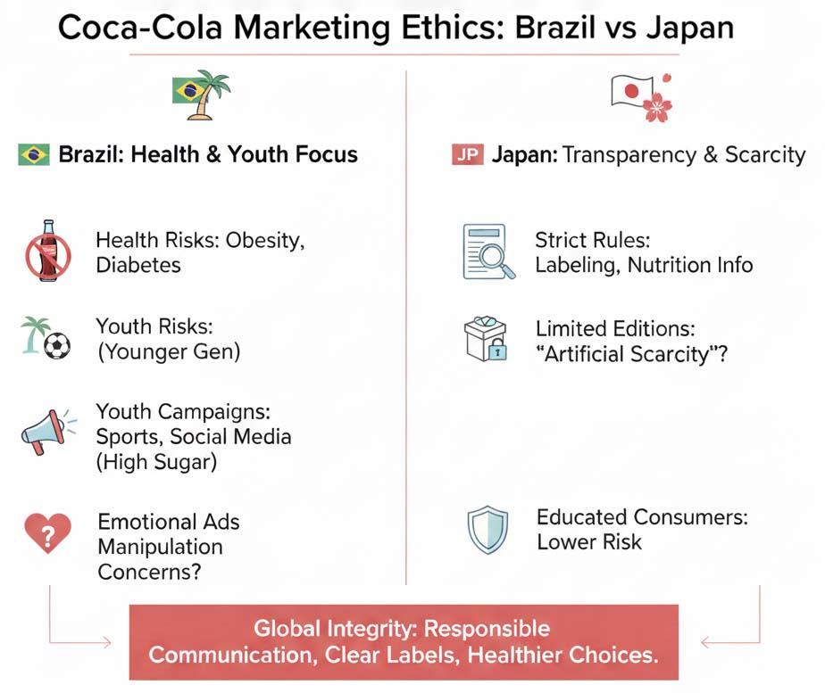
Source: Adapted from WHO (2023), Euromonitor (2023), and Coca-Cola Japan (2023).

7.1 Brazil: Ethical Challenges in Advertising and Health Awareness
Coca-Cola has had to get into trouble in Brazil because of the health effects of the sugary drinks. Carbonated drinks also lead to obesity and diabetes, especially in the younger generations (World Health Organization, 2023). Coca-Cola encourages moderation and responsibility, but critics believe that advertising campaigns aimed at young people, in particular football sponsorships, social media, and experiences, indirectly contribute to the high sugar consumption (Euromonitor, 2023).
Also, the advertising campaigns, which are very sensitive to emotional and cultural stories, may create concerns about manipulative advertising. Coca-Cola has tried to adhere to the Brazilian advertising laws and industry standards; however, ethical questioning is relevant, especially when it comes to vulnerable consumer groups.

7.2 Japan: Ethical Marketing and Transparency
Ethical issues are not as strong in Japan because of strict regulations and awareness about the ingredients of products and their health. Coca-Cola also meets the requirements of food safety and labelling, as well as being transparent about nutritional values (Coca-Cola Japan, 2023). A few editions or flavor-based products sometimes apply marketing strategies that build artificial shortages or exclusivity, suggesting that this may be seen as pressure-based marketing. This notwithstanding, the highly regulated Japanese environment and consumer-educated market reduce the majority of possible ethical risks.

7.3 Comparative Analysis
On the whole, Coca-Cola indicates dedication to ethical marketing, even though issues vary in markets. Ethical issues in Brazil are mostly health-based and associated with youth-focused campaigns. In Japan, the ethical concern is small and is related to transparency and perception by consumers. Responsible communication, labelling, and promoting healthier choices are the key to overcoming these challenges and preserving the brand integrity on a global level (Crane and Matten, 2021).

8. Recommendations
Judging by the comparison of the marketing strategies of Coca-Cola in Brazil and Japan, there are recommendations that can be offered to improve the international marketing performance of this company:
Figure 12: Coca-Cola: Global Growth Strategy
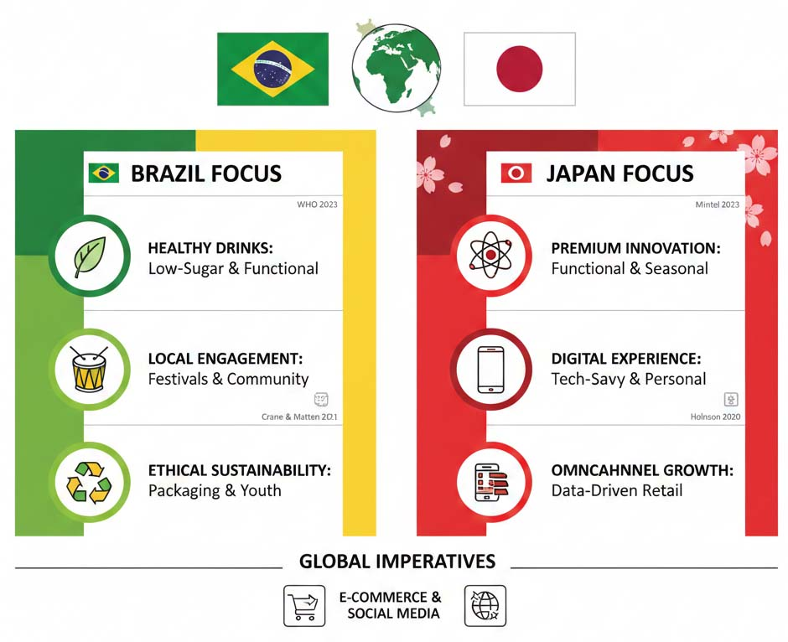
Source: comparative analysis of Coca-Cola's marketing strategies, WHO (2023), Mintel (2023), Crane & Matten (2021).
- Health-targeted product innovation: Given the U.S.A.'s growing health concerns and potential regulatory measures associated with the weight problems epidemic (World Health Organization, 2023), Coca-Cola needs to prioritise growing greater low-sugar and useful drinks in Brazil. In Japan, the logo's top-class photo can be maintained by way of introducing greater innovation in functional drinks and providing constrained-edition seasonal merchandise to draw health-aware purchasers.
- Tailored advertising efforts: While Coca-Cola already benefits from cultural activities in Brazil, setting extra emphasis on neighborhood festivals and network projects ought to grow emblem loyalty. In Japan, virtual campaigns geared toward urban, tech-savvy purchasers – which emphasise product friendliness, sustainability and satisfaction – will resonate nicely with the goal institution (Mintel, 2023).
- Sustainability in Practices and Marketing with ethics: Coca-Cola ought to increase its marketing and environmentally friendly efforts, such as the sustainability in packaging, labeling, and encouraging responsible drinking in both the nations. This could help build brand trust and deal with the ethical issues that are mentioned in youth-targeted campaigns in Brazil (Crane and Matten, 2021).
- Digital and omnichannel boom: The upward push of online purchasing together with a mixture of social media campaigns and in-store or merchandising studies will pressure expanded patron engagement and sales in each market. To stand out inside the aggressive and innovation-targeted Japanese market, adding personalized experiences and using information-pushed advertising could make a big distinction (Holnson, 2020).

9. Conclusion
The marketing policies used by Coca-Cola in Brazil and Japan reveal an elegant compromise between international brand consistency and regional market adjustment. In Brazil, it is mass-marketing, low-costs and culturally relevant campaigns that have made the difference, whilst it is innovation, premiumization and convenience-based in Japan.
Although general effectiveness is achieved, there are challenges. In Brazil, the increasing health awareness and young-oriented consumption of sugar poses ethical and market risks, whereas in Japan, the rivalry and demand of the consumers to be constantly innovated demand constant adjustment. With the suggestions offered above, Coca-Cola will be able to improve performance on the market, mitigate the issues of ethicality, and maintain the long-term competitive edge in both nations.
Finally, the fact that Coca-Cola is able to design its STP strategies, marketing mix, and ethical behavior based on local socio-cultural contexts is the key to its success in the global market. International marketing must be innovative in the context of ongoing efforts
to implement changes, cultural awareness, and social responsibility, which means that Coca-Cola will continue to be one of the most popular branded beverages in a variety of markets around the globe (Kotler et al., 2022; Hollensen, 2020).

Reference
- Accio. (2025) Market Share Coca-Cola – Global Leadership Insights. Accio. Available at: [URL] (Accessed: 5 December 2025).
- Coca-Cola Bottlers Japan Holdings. (2022) CSV Report 2022. Tokyo: CCBJI.
- Coca-Cola FEMSA. (2023) 2023 Integrated Report. Mexico City: Coca-Cola FEMSA.
- Coca-Cola FEMSA. (2024) “Coca-Cola FEMSA – statistics & facts”, Statista. Available at: [URL] (Accessed: 5 December 2025).
- Euromonitor International. (2023) Soft Drinks in Brazil: Country Report. London: Euromonitor.
- Hollensen, S. (2020) Global Marketing, 8th edn. London: Pearson.
- International Markets Bureau. (2012) Japan Soft Drinks Industry Overview. BMI Research. As cited in “Coca Cola Diversification and Globalization”. Scribd.
- Kotler, P., Keller, K. L. & Chernev, A. (2022) Marketing Management, 16th edn. Harlow: Pearson Education.
- Lewis, M. (2018) “Japanese soft drink market shifts toward healthier beverages”, Beverage Industry Journal, 12 (4), pp. 22–29. As referenced in International Markets Bureau report. Scribd.
- Marketdata Forecast. (2024) Latin America Carbonated Soft Drinks Market Size, 2024–2033. Marketdata Forecast.
- Mordor Intelligence. (2024) Carbonated Beverages Market – Global Industry Trends & Forecast to 2030. Mordor Intelligence.
- Mintel Group Ltd. (2023) Japanese Beverage Market Report. London: Mintel.
- Statista. (2023) “Coca-Cola distribution and market share data for Brazil and Japan”. Statista. Available at: [URL] (Accessed: 5 December 2025).
- Statista. (2025) “Sales volume of Coca-Cola FEMSA 2015–2024 (million crates)”, Statista. Available at: [URL] (Accessed: 5 December 2025).
- The Coca-Cola Company. (2002) Creating New Value: 2002 Annual Report. Atlanta: The Coca-Cola Company.
- World Health Organization. (2023) Obesity and Sugar Consumption in Latin America. Geneva: WHO.
- Brasov, P. (2015) “Coca-Cola’s market share in Japan soft drinks sector”, Japan Beverage Weekly, 8 (2), pp. 14–17. As cited in “Coca Cola Diversification and Globalization”. Scribd.
- Deauthorizing Research. (2024) Carbonated Soft Drinks Market Analysis & Top Players 2032. Deauthorizing Research.
- Investing.com. (2024) “Coca-Cola (Coke) Facts and Statistics”. Investing.com. Available at: [URL] (Accessed: 5 December 2025).
- ABITA LLC & Marketing Japan. (2024) “Cross-industry collaboration and cutting-edge technology that support Coca-Cola’s success: From Brazil to the global”, 1xMarketing.
- Crane, A. & Matten, D. (2021) Business Ethics, 6th edn. Oxford: Oxford University Press.
- Hofstede Insights. (2023) “Country Comparison: Brazil and Japan”. Available at: https://www.hofstede-insights.com (Accessed: 5 December 2025).
- Jacobson, M. F. (2005) Liquid Candy: How Soft Drinks are Harming Americans’ Health. New York: Basic Books.
- Kono, T. (1994) “Changing a Company’s Strategy and Culture”, Long Range Planning, 27 (1), pp. 85–97.
- Pendergrast, M. (2007) For God, Country and Coca-Cola: The Definitive History of the Great American Soft Drink and the Company That Makes It. New York: Basic Books.
- Tracy, B. (2000) The 100 Absolutely Unbreakable Laws of Business Success. New York: Wiley.
- Zysman, S. (2000) The End of Marketing as We Know It. New York: Harper Business.

Appendices
Appendix A: PESTLE Summary Tables for Brazil and Japan
A1. Brazil – PESTLE Summary Table
Factor | Key Points | Impact on Coca-Cola
Political | Stable government; new drink tax | Changes prices and how they sell drinks
Economic | High prices; people still buy a lot | Needs to keep drinks affordable
Social | Many young people; social media | Helps to advertise to lots of people
Technological | More online shopping | More ways to sell online
Legal | New sugar tax | Encourages Coca-Cola to make less sugary drinks
Environmental | Water problems | Focus on being more eco-friendly

A2. Japan – PESTLE Summary Table
Factor | Key Points | Impact on Coca-Cola
Political | Stable government; controls on imports | Operations are stable and predictable
Economic | People have high income | Can charge more for premium products
Social | Older population; focus on health | More demand for healthy drinks
Technological | Advanced machines; lots of vending | Helps create new drink options
Legal | Strict rules for labels | Needs to be clear and honest on labels
Environmental | Expectation for no waste | Encourages new ways to recycle

Appendix B: Hofstede Cultural Dimensions – Brazil vs Japan
Dimension | Brazil | Japan | Impact on Coca-Cola
Power Distance | High | High | Keep clear management from top to bottom
Individualism | Medium | Low | Focus on groups in Japan
Masculinity | High | Very High | Make Coca-Cola stand out and be strong
Uncertainty Avoidance | High | Very High | People prefer trusted brands
Long-Term Orientation | Low | High | Focus on long-lasting, eco-friendly ideas in Japan
Indulgence | High | Low | More fun, happy campaigns in Brazil

Appendix C: STP Models for Brazil and Japan
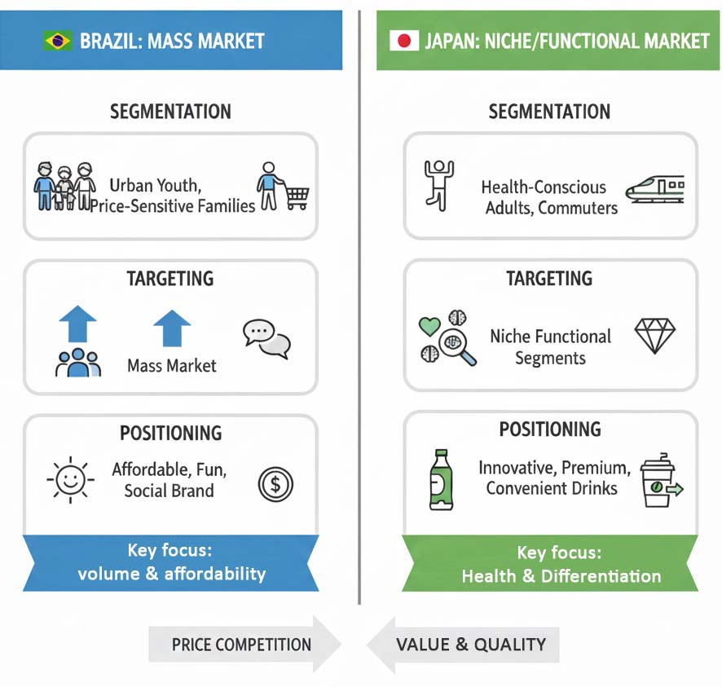
Appendix D: Coca-Cola 7Ps Marketing Mix Tables
D1. Brazil – Coca-Cola Marketing Mix
P | Summary
Product | Coke, Fanta, cheap packs
Price | Affordable, good deals
Place | Stores, kiosks, delivery apps
Promotion | Festivals, football ads
People | Local sales team
Process | Fast delivery everywhere
Physical Evidence | Bright red logo, local packaging

D2. Japan – Coca-Cola Marketing Mix
P | Summary
Product | Georgia Coffee, Ayataka Tea, special flavors
Price | Expensive, for convenience
Place | Vending machines, convenience stores
Promotion | Anime ads, tech-focused marketing
People | Well-trained staff
Process | Fast, automated delivery
Physical Evidence | Simple packaging, high quality

Appendix E: Data Tables Used for Market Analysis


