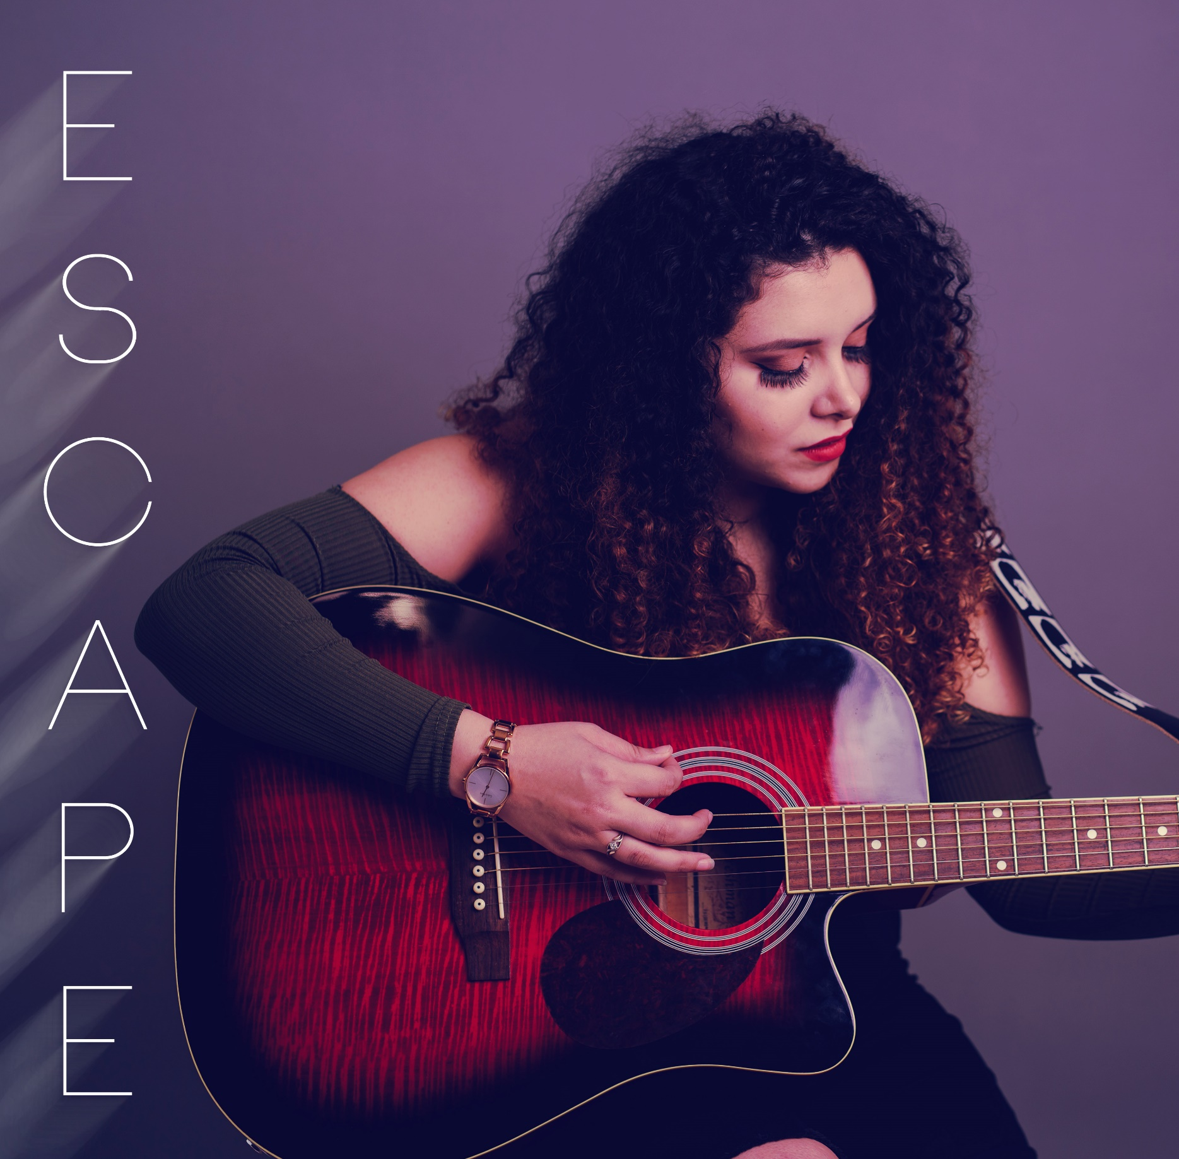

ESCAPE EP

2019

01/05/19

Authored by: HAYLEIGH SMITH
University of Wales Trinity Saint David



Contents

Chapter 1: Introduction ……………………………………………………………………………….. Page 3

Chapter 2: Background Research ……………………………………………………………..….. Page 4

Chapter 3: Creating the EP……………………………………………………………………………. Page 8
Chapter 3.1: Stage 2 – Product Design …………..…….…………………….………….…. Page 11

Chapter 4: Releasing the EP …………..……………………………………………………………… Page 13

Chapter 5: Conclusion …………………………………………………………………………………… Page 14

Chapter 6: References ………………………………………………………………………………….. Page 15

Chapter 7: Appendices …………………………………………………………………………………. Page 17

Chapter 1: Introduction

This Major Project is an attempt to write and release an EP composed of six songs. Focusing on the song-writing and launch of my EP, I will have to arrange to have my songs recorded, produced, mixed and mastered once the song writing stage is complete. I will also have to research how best to release my EP and discover what assistance I will need to make my project a success.

My inspiration for taking on this task is my passion for music. With music being such a major influence in fashion, media and just day to day life, it’s hard to fight the urge to want to be a part of something so globally recognized and influential. This passion is what fuelled me to study music in education for five years to now being able to use this major project as an opportunity to write and develop my own song writing ability. Seeing this as an opportune chance to insert myself into the local music scene and debut my musical career, I will also be releasing my music through CD’s, streaming sites and as an added extra I will also be planning and hosting a launch event for my EP.

Chapter 2: Background Research

The first stage towards the creation of my EP involved a great deal of background research. I needed to find out:
- Where could I record my songs?
- Who will produce them?
- How many songs should I write?
- How should I name my EP?
- Where could I hold the launch event?
- How am I going to distribute songs?
Through this research I found that it was common for music artists to name their EP or Album after either a concept or after the lead song of the EP/Album. For example:
- Demi Lovato – Tell Me You Love Me (Lead Song)
- Ariana Grande – Dangerous Woman (Lead Song)
- Sam Smith – The Thrill of it All (Lead Song)
- Anne Marie – Speak Your Mind (Concept)
Because artists like Demi Lovato and Sam Smith have been a big influence on me musically, I decided to follow them by naming my EP after my own lead song Escape. It wasn’t until I had finished the song writing stage that I could look at my songs and choose a lead track. I chose Escape as my lead song because I wanted it to represent me. Also, I wrote the song about one of the hardest times in my life dealing with mental health problems and therefore I believed this song was the most real and the most me.
As well as choosing an EP title I wanted to discover how many songs make up an Album or EP. I wanted to find out how many songs made up an album because I had started my major project with the intent of creating an Album of 7-8 songs. According to iTunes any release with seven or more tracks is considered an album which means that my original project idea would have had a sufficient amount of songs. However, when researching the number of songs required, I found an article at Recording Revolution where Casimiro (2019) argues releasing an EP to focus on quality over quantity and making really great songs compared to releasing an album where you will have 7-10 okay songs. Letang (2019) explains that an EP is a collection of songs by a musician that is usually longer than a single but shorter than an album. The requirement of songs for an EP is only 4-6 songs.
It was partly because of this research that I later decided to put my album goal on hold to focus on a lesser number of good quality songs and create my EP of six songs. Once I had established how many songs were going to be on the EP and what I was going to name it, I needed to find someone to record, mix and master my songs.
I decided to hire a professional because it was important to me that my first time releasing my music sounded as professional as possible.
According to Recording Connection Audio Institute:

“A large responsibility of a music producer is to help provide an overall vision for the album.”

This is exactly what I needed, I needed someone to help bring my songs to life and share my vision of what I wanted the songs to become.
When searching for possible candidates I didn’t limit the search to my local area as I’m aware that it is possible to get your tracks produced remotely. The first producer I found was Aubrey Whitfield, listening to past songs that she helped produce I was positive she could bring my songs to life in the image that I wanted. Based in London her studio was still in the UK so any meetings in person would be difficult to arrange. However I emailed her to enquire about prices and how long she would need to be able to produce the songs just to get an idea of whether she was compatible with my budget. Although she promised she could produce and mix and master the songs within a month, she wanted £2500 to do so which was unfortunately way out of budget. I then wanted to have a look in my local area so I asked fellow musicians if they knew of any producers in the Neath Port Talbot/Swansea area. I eventually got a recommendation for James Weaver.
James’ studio is based in Mumbles, Swansea so it meant it was only a half hour drive for me so I could meet and talk to him about what he could do with my songs, what timescale he would need to get them completed including backing tracks for my EP Launch Event and most importantly to see if he could do it all within my budget.
Charging £100 per day for studio use (recording, producing, plus mixing and mastering) and only requiring two days in the studio to record everything it was affordable. He was also very accepting of all of my ideas and helped guide my songs to the direction of what I heard them becoming. It was an incredible experience to be able to work with someone experienced and learn that trying out all of our ideas for the tracks such as different instrumentation or effects could mean stumbling into something great and pushing the songs in a new but fitting direction. Because I wanted my debut EP to really kick start my career with music, I wanted to release it on as many platforms as I can to whoever will listen so I researched different distribution companies.
The first company I came across or had already heard of was Ditto. They offer distribution to various different music streaming sites such as Spotify, iTunes, Apple Music, Amazon Music and more. They do this for just £19.99 for the year and then it is paid annually to keep your music up and for further music releases. I liked the fact that they had an express option to get your music uploaded as soon as possible because unfortunately due to personal circumstances my project got put on hold for two months and I was worried that the music would not be released in time for the Launch Event but this put my mind at ease. There was also an option for an additional payment to allow your music to be eligible for the National Chart Distribution which is an added platform that can get my music to the public if accepted.
Another online distribution company I looked into was tunecore. Tunecore offered the same distribution services without the bonus of an express release although they did offer a social media promoting service for an additional £10 a month. The price of distribution was also more expensive than the services offered by Ditto. Therefore I decided to use Ditto’s distribution services to release my EP and lead song Escape.
Next, I researched different venues to hold the EP Launch Event. I first had a look at The Hyst in Swansea as it was local. Locality was a big requirement of mine because I invited a lot of family and friends to share the night with me and they were all local to the area. The Hyst was free to hire out for events and already included a stage area for the performance which made it a top contender to hold my event. However the acoustics are not the best in there and I didn’t have the right feel for what I wanted. Continuing my search I came across Cinema&Co. when I noticed another musician had held their EP Launch at the venue. Getting in contact immediately I went to have a look at the inside of the event and found it had an “Indie” feel which was perfect for my sit down songwriter night that I wanted to create. They also had really friendly and helpful staff so I confirmed their availability schedule and booked the 29th of April 2019 for my Event.

Chapter 3: Creating the EP
Stage 1 - Songwriting

During the songwriting stage I often began by setting aside 1-2 hours every other day with just me and my guitar or piano trying out different chord progressions, strumming patterns and melodies. The biggest tool for songwriting I’ve found through my major project experience is experimentation and trying out as many different ideas until you find one that works. I spent a lot of hours in the studio cutting parts of songs that I had finished writing but didn’t seem to work when I listened to them back.
The three main things I wanted to achieve when writing my songs were:
- Catchy Melody – I wanted my songs to be catchy so that they remain memorable in the listeners head. I achieved this with repetitive hooks and upbeat rhythms.
- Have a Message or Story – When writing lyrics I tend to write about personal experiences and so telling my story through my songs became very important to me. I attempted to make a lot of the songs upbeat in contrast to the sometimes serious or disheartened message so that the songs were still appealing to the listener but allowing me to still get my message across.
- Enjoyment – One of the most important aspects of songwriting for me was enjoying what I was writing because how can I expect anyone else to enjoy my songs if I don’t enjoy them myself.
When writing each song I made a point of what I wanted to achieve when writing and how I wanted the song to develop for my final project. Getting into the studio with the producer I mentioned in my background research James Weaver, we only spent two full days with very minimal breaks to record the vocals, piano, guitar and backing vocals. He took my ideas for the songs and really brought them all to life. We worked really closely for a month before my EP Release with him emailing me edited versions of the tracks and then using my feedback to guide how to re-work the song to a product I would be happy with. Below I have written a brief concept for each song.

Apology Song
For this song the message and lyrics was the most important part to express the emotions behind the song. I focused on making the song intense and ambient by using a drone effect and slowly building the songs texture from vocals and piano by adding a string section and guitar. Also I wanted there to be a notable variation between the verses, choruses and bridge by creating varying textures to the song through the addition and taking away of instruments.

Back When
This track was more spoken rather than sung as it contained a lot of words. By adding a strong beat and strings over the acoustic guitar I tried to attempt a Pop/Country approach to the song and took a lot of influence from Taylor Swift’s early music releases.

High on Your Love
I made this song slightly heavier than my other tracks on the EP by adding distorted guitars and a loud, in your face, intro to the song by having all the instrumentation (guitar, bass, drums and piano) right at the beginning of the song. I did this because I wanted to imitate the anger and want of understanding emotions behind this song. I wrote this song about being stuck in a toxic relationship and not being able to leave no matter how many times you get hurt. I really enjoyed getting to experiment on this song by adding an effect on the “high on your love” lyrics in the song.

Escape
Escape is my lead song on my ESCAPE EP and I chose this song because I wanted the lead song to be a representation of me and I felt like this song was the most real for me. I wrote this song about the hardest time of my life suffering with mental health issues and eventually overcoming it. I wrote the song very upbeat to show that even though the message is serious I did come out the other side it. It also allows me to create an appealing song that people can enjoy whilst also raising awareness for mental health. The hook “go, go, go” was written after I had finished writing the song but felt like it needed something else and so added it in. The song began as only me and acoustic guitar but developed in the studio to include bass, synth, drums and piano.
Unrequited Love
For this song I had two completely different directions in mind and so decided to include the two different versions on the EP.
Starting with the acoustic version, it shows how the song developed from having only me and piano. A song which was very minimal in instrumentation and almost pure because of this, focusses mainly on the lyrics. Written about the pain of being in a relationship and seeing the other person lose feelings and fighting whether you should stay and fight for the relationship or leave the sinking ship. This version really encompasses the emotions behind the song and so I knew I had to keep this version on my EP.
The second version of Unrequited Love is very produced, there’s a lot of effects on the lyrics, a lot of synth and a strong beat to create a Pop/Dance feel. I had a lot of fun working on this track with my producer and although he couldn’t hear this version when we started trying it out, by the end we both really enjoyed how it came together.

Stage 2 – Product design

Chapter 3.1: Creating the EP

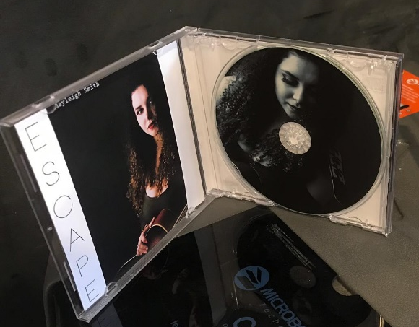
Once the song writing was completed I started to think how I wanted to release my songs, whether I wanted to offer online or offline distributions and decided to do both. Using Ditto as mentioned in my background research for online distribution I also wanted a physical copy of my EP and found a company called VP Online that offered CD printing, a case and a booklet all for one price.

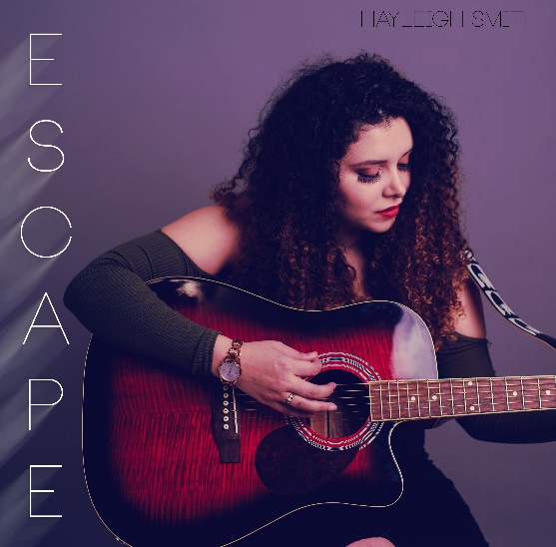
In an effort to have my CD cover look as professional as possible a hired a photography company under the name of Cross-Jones Photography. After discussing that I wanted a mix of serious and playful shots we arranged two different settings for my shoot. I had an indoor studio shoot and a contrasting outdoor shoot. Getting a range of serious and playful shots from both settings I was able to choose a cover photo that represented me. An image of me playing the guitar and looking at the guitar as I played, a very simple, gentle image and I believe it captures the feel of my music style.

The edited photos had a really quick turnaround and I began designing my CD straight away. Using different images from the photo shoot as a background for each page of my booklet, I wanted to include an About Me section to tell the person buying the CD a little bit about me and my background with music but most importantly I included lyrics for each song. Growing up and listening to CD’s the lyrics in the booklet was definitely my favourite part as it allowed me to sing along. I also included a track list on the rear of the CD so it’s easier to select a song that the listener maybe prefers over the others. Lastly, I chose a black and white image to be printed on the CD because it looked the most professional.

The CD printing company also offered duplication services, however as I had yet to receive my finished tracks I decided to burn the music on to my printed CD’s myself to ensure that the CD’s arrived in time for the EP Launch.

Chapter 4: Releasing the EP

Having never planned an event before it was a complete new experience for me and it opened my eyes to how much work really goes into planning a night.
After choosing my venue and setting my date I now had a deadline to work towards.

In order to promote my event I decided to create pages on social media (See Apendix A and B) for people to follow my musical journey in releasing my EP. I also created and designed a website (See Apendix C) to add another level of professionalism and to make it easier for people to find my merchandise and find out about any events coming up.

To make a successful launch I found three local support acts, designed physical tickets as well as an online page for tickets, arranged for live streaming and also hired a sound engineer for the night.

Chapter 5: Conclusion

Overall I really enjoyed the experience of getting to work with so many different people for my major project and I have written and released music that I can be proud of. The final mastered tracks were to a professional standard to the point that I got to release my single Escape on the radio. The CD looked very professional and included everything that I would look for in a CD and booklet myself. The night of the EP Launch ran smoothly and came together well which really made the months of preparation worth it to see everyone taking in my songs without anyone talking over the top.

It was interesting to see my original idea of an Album develop into an EP with an added EP Launch Event. If I could do the experience again I would definitely use my time more wisely because when my project got put on hold it was a rush during the last month before the EP Launch to get everything ready and delivered on time like the CD’s and merchandise. I also would not do a joint EP Launch again unless we were both on the same page about what we wanted to get out of it. I’m really excited to carry on with my music by submitting my tracks to BBC Introducing and attending radio interviews and more airplay for my music over in the Cayman Islands.

Chapter 6: References

Websites:
Casimiro, J. (2019). Short EPs Verses Full Length Albums - Recording Revolution. [Online] Recording Revolution.
Available at: https://www.recordingrevolution.com/short-eps-verses-full-length-albums/ (Accessed 1 May 2019).

Dittomusic.com. (n.d.). Sell Your Music. [Online]
Available at: https://www.dittomusic.com/sell-your-music (Accessed 28 Apr. 2019).

Letang, S. (2019). How To Make A EP Album – Step By Step To Extended Play Perfection. [Online] Music Industry How To.
Available at: https://www.musicindustryhowto.com/how-to-make-a-ep-album-step-by-step-to-extended-play-perfection/ (Accessed 28 Apr. 2019).

Recording Connection Audio Institute. (n.d.). What Does a Music Producer Do?. [Online]
Available at: https://www.recordingconnection.com/reference-library/recording-entrepreneurs/what-does-a-music-producer-do/ (Accessed 27 Apr. 2019).

TuneCore.com. (n.d.). TuneCore Pricing | Music Distribution & Publishing. [Online] Available at: https://www.tunecore.co.uk/pricing (Accessed 1 May 2019).

Weaver, J. (n.d.). James Weaver - Recording, Mixing, Mastering, Editing. [Online] jwsite-2018-2.
Available at: https://www.jamesweavermusic.com/ (Accessed 1 May 2019).
Whitfield, A. (n.d.). Aubrey Whitfield - Record Producer and Songwriter. [Online] Aubreywhitfield.com.
Available at: https://www.aubreywhitfield.com/ (Accessed 1 May 2019).

Chapter 7: Appendices
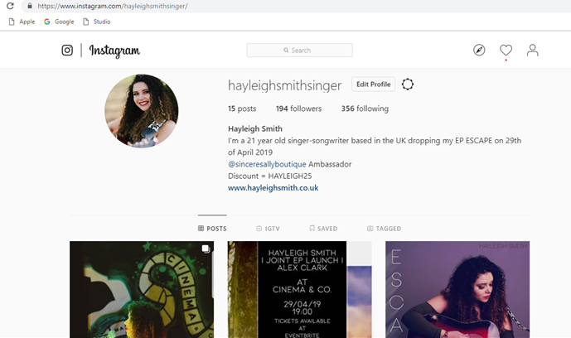
(Appendix A)
Image to show Instagram Artist Profile for ESCAPE EP Release where I post regular content to keep people up to date with my musical content.

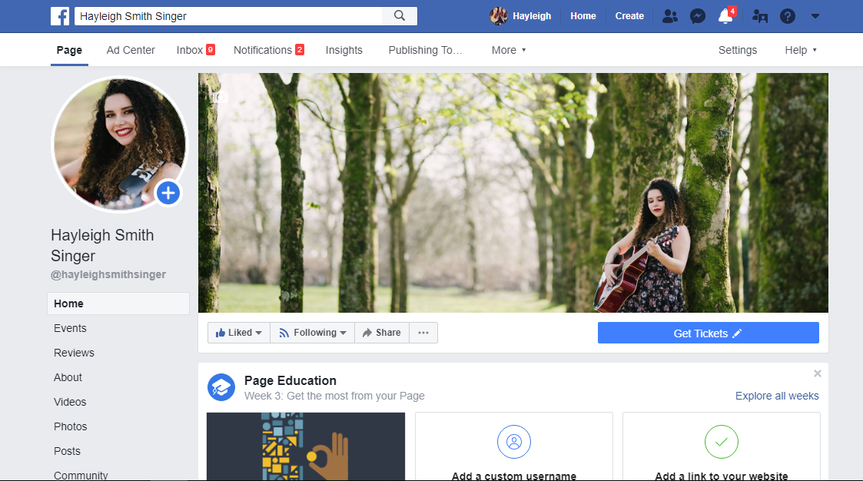
(Appendix B)
Image to show Facebook Artist Page for promotional use to keep people up to date with my EP Release and musical content.

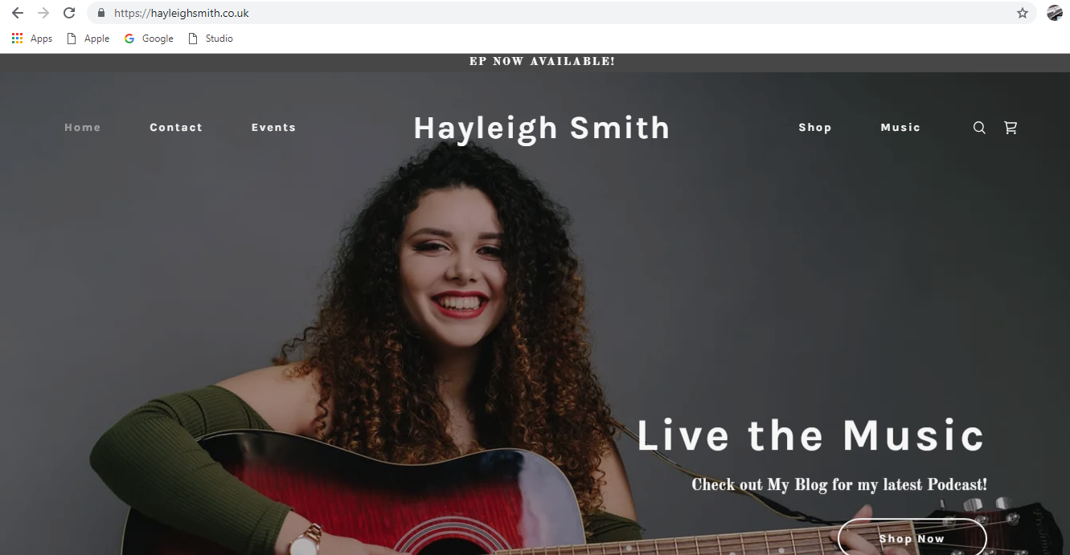
(Appendix C)
Image to show my artist website.

